Enhanced TEKS Clarification

Mathematics

Grade 1

2014 - 2015
Grade 1
§111.1. Implementation of Texas Essential Knowledge and Skills for Mathematics, Elementary, Adopted 2012.
Source: The provisions of this §111.1 adopted to be effective September 10, 2012, 37 TexReg 7109.
§111.3. Grade 1, Adopted 2012.
1.Intro.1 | The desire to achieve educational excellence is the driving force behind the Texas essential knowledge and skills for mathematics, guided by the college and career readiness standards. By embedding statistics, probability, and finance, while focusing on computational thinking, mathematical fluency, and solid understanding, Texas will lead the way in mathematics education and prepare all Texas students for the challenges they will face in the 21st century.

1.Intro.2 | The process standards describe ways in which students are expected to engage in the content. The placement of the process standards at the beginning of the knowledge and skills listed for each grade and course is intentional. The process standards weave the other knowledge and skills together so that students may be successful problem solvers and use mathematics efficiently and effectively in daily life. The process standards are integrated at every grade level and course. When possible, students will apply mathematics to problems arising in everyday life, society, and the workplace. Students will use a problem-solving model that incorporates analyzing given information, formulating a plan or strategy, determining a solution, justifying the solution, and evaluating the problem-solving process and the reasonableness of the solution. Students will select appropriate tools such as real objects, manipulatives, algorithms, paper and pencil, and technology and techniques such as mental math, estimation, number sense, and generalization and abstraction to solve problems. Students will effectively communicate mathematical ideas, reasoning, and their implications using multiple representations such as symbols, diagrams, graphs, computer programs, and language. Students will use mathematical relationships to generate solutions and make connections and predictions. Students will analyze mathematical relationships to connect and communicate mathematical ideas. Students will display, explain, or justify mathematical ideas and arguments using precise mathematical language in written or oral communication.

1.Intro.3 | For students to become fluent in mathematics, students must develop a robust sense of number. The National Research Council's report, "Adding It Up," defines procedural fluency as "skill in carrying out procedures flexibly, accurately, efficiently, and appropriately." As students develop procedural fluency, they must also realize that true problem solving may take time, effort, and perseverance. Students in Grade 1 are expected to perform their work without the use of calculators.

1.Intro.4 | The primary focal areas in Grade 1 are understanding and applying place value, solving problems involving addition and subtraction, and composing and decomposing two-dimensional shapes and three-dimensional solids.

1.Intro.4A | Students use relationships within the numeration system to understand the sequential order of the counting numbers and their relative magnitude.

1.Intro.4B | Students extend their use of addition and subtraction beyond the actions of joining and separating to include comparing and combining. Students use properties of operations and the relationship between addition and subtraction to solve problems. By comparing a variety of solution strategies, students use efficient, accurate, and generalizable methods to perform operations.

1.Intro.4C | Students use basic shapes and spatial reasoning to model objects in their environment and construct more complex shapes. Students are able to identify, name, and describe basic two-dimensional shapes and three-dimensional solids.

1.Intro.5 | Statements that contain the word "including" reference content that must be mastered, while those containing the phrase "such as" are intended as possible illustrative examples.

1.1 | Mathematical process standards. The student uses mathematical processes to acquire and demonstrate mathematical understanding. The student is expected to:
1.1A | Apply mathematics to problems arising in everyday life, society, and the workplace.  Apply mathematics to problems arising in everyday life, society, and the workplace.  Apply  MATHEMATICS TO PROBLEMS ARISING IN EVERYDAY LIFE, SOCIETY, AND THE WORKPLACE  Note(s):  - The mathematical process standards may be applied to all content standards as appropriate.  - TxRCFP:  - Developing an understanding of place value  - Solving problems involving addition and subtraction  - Analyzing attributes of two-dimensional shapes and three-dimensional solids  - Developing the understanding of length  - TxCCRS:  - X. Connections
1.1B | Use a problem-solving model that incorporates analyzing given information, formulating a plan or strategy, determining a solution, justifying the solution, and evaluating the problem-solving process and the reasonableness of the solution.  Use a problem-solving model that incorporates analyzing given information, formulating a plan or strategy, determining a solution, justifying the solution, and evaluating the problem-solving process and the reasonableness of the solution.  Use  A PROBLEM-SOLVING MODEL THAT INCORPORATES ANALYZING GIVEN INFORMATION, FORMULATING A PLAN OR STRATEGY, DETERMINING A SOLUTION, JUSTIFYING THE SOLUTION, AND EVALUATING THE PROBLEM-SOLVING PROCESS AND THE REASONABLENESS OF THE SOLUTION  Note(s):  - The mathematical process standards may be applied to all content standards as appropriate.  - TxRCFP:  - Developing an understanding of place value  - Solving problems involving addition and subtraction  - Analyzing attributes of two-dimensional shapes and three-dimensional solids  - Developing the understanding of length  - TxCCRS:  - VIII. Problem Solving and Reasoning
1.1C | Select tools, including real objects, manipulatives, paper and pencil, and technology as appropriate, and techniques, including mental math, estimation, and number sense as appropriate, to solve problems.  Select tools, including real objects, manipulatives, paper and pencil, and technology as appropriate, and techniques, including mental math, estimation, and number sense as appropriate, to solve problems.  Select  TOOLS, INCLUDING REAL OBJECTS, MANIPULATIVES, PAPER AND PENCIL, AND TECHNOLOGY AS APPROPRIATE, TO SOLVE PROBLEMS  Select  TECHNIQUES, INCLUDING MENTAL MATH, ESTIMATION, AND NUMBER SENSE AS APPROPRIATE, TO SOLVE PROBLEMS  Note(s):  - The mathematical process standards may be applied to all content standards as appropriate.  - TxRCFP:  - Developing an understanding of place value  - Solving problems involving addition and subtraction  - Analyzing attributes of two-dimensional shapes and three-dimensional solids  - Developing the understanding of length  - TxCCRS:  - VIII. Problem Solving and Reasoning
1.1D | Communicate mathematical ideas, reasoning, and their implications using multiple representations, including symbols, diagrams, graphs, and language as appropriate.  Communicate mathematical ideas, reasoning, and their implications using multiple representations, including symbols, diagrams, graphs, and language as appropriate.  Communicate  MATHEMATICAL IDEAS, REASONING, AND THEIR IMPLICATIONS USING MULTIPLE REPRESENTATIONS, INCLUDING SYMBOLS, DIAGRAMS, GRAPHS, AND LANGUAGE AS APPROPRIATE  Note(s):  - The mathematical process standards may be applied to all content standards as appropriate.  - TxRCFP:  - Developing an understanding of place value  - Solving problems involving addition and subtraction  - Analyzing attributes of two-dimensional shapes and three-dimensional solids  - Developing the understanding of length  - TxCCRS:  - IX. Communication and Representation
1.1E | Create and use representations to organize, record, and communicate mathematical ideas.  Create and use representations to organize, record, and communicate mathematical ideas.  Create, Use  REPRESENTATIONS TO ORGANIZE, RECORD, AND COMMUNICATE MATHEMATICAL IDEAS  Note(s):  - The mathematical process standards may be applied to all content standards as appropriate.  - TxRCFP:  - Developing an understanding of place value  - Solving problems involving addition and subtraction  - Analyzing attributes of two-dimensional shapes and three-dimensional solids  - Developing the understanding of length  - TxCCRS:  - IX. Communication and Representation
1.1F | Analyze mathematical relationships to connect and communicate mathematical ideas.  Analyze mathematical relationships to connect and communicate mathematical ideas.  Analyze  MATHEMATICAL RELATIONSHIPS TO CONNECT AND COMMUNICATE MATHEMATICAL IDEAS  Note(s):  - The mathematical process standards may be applied to all content standards as appropriate.  - TxRCFP:  - Developing an understanding of place value  - Solving problems involving addition and subtraction  - Analyzing attributes of two-dimensional shapes and three-dimensional solids  - Developing the understanding of length  - TxCCRS:  - X. Connections
1.1G | Display, explain, and justify mathematical ideas and arguments using precise mathematical language in written or oral communication.  Display, explain, and justify mathematical ideas and arguments using precise mathematical language in written or oral communication.  Display, Explain, Justify  MATHEMATICAL IDEAS AND ARGUMENTS USING PRECISE MATHEMATICAL LANGUAGE IN WRITTEN OR ORAL COMMUNICATION  Note(s):  - The mathematical process standards may be applied to all content standards as appropriate.  - TxRCFP:  - Developing an understanding of place value  - Solving problems involving addition and subtraction  - Analyzing attributes of two-dimensional shapes and three-dimensional solids  - Developing the understanding of length  - TxCCRS:  - IX. Communication and Representation
1.2 | Number and operations. The student applies mathematical process standards to represent and compare whole numbers, the relative position and magnitude of whole numbers, and relationships within the numeration system related to place value. The student is expected to:
1.2A | Recognize instantly the quantity of structured arrangements.  Recognize instantly the quantity of structured arrangements.  Recognize Instantly  THE QUANTITY OF STRUCTURED ARRANGEMENTS  Including, but not limited to:  - Group of objects (0 to 10)  - 0 – 5 objects  - 5 – 10 objects  - Subitizing – the ability to name the number of objects in a set without counting but rather by identifying the arrangement of objects  - Perceptual subitizing – the recognition of a quantity without using any other knowledge to determine the count  - Quantities of 5 or fewer  - Conceptual subitizing – recognition of a quantity based on a spatial arrangement, pattern, parts of the arrangement, etc.  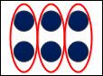  - Structured arrangements  - Organization of objects within a set aids in the instant recognition of the quantity based on the composition and decomposition of the parts.  - Various structured arrangements  - Ex: Ten frame mats, base-10 blocks, a Rekenrek counting rack, playing cards, dice, etc.  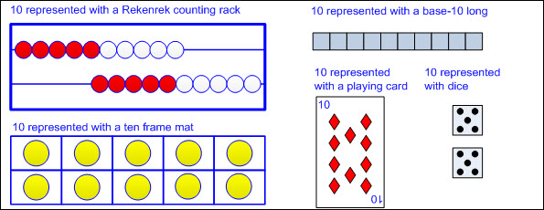  Note(s):  - Grade Level(s):  - Kindergarten recognized instantly the quantity of organized and random arrangements.  - Various mathematical process standards will be applied to this student expectation as appropriate.  - TxRCFP:  - Developing an understanding of place value  - TxCCRS:  - I. Numeric Reasoning  - IX. Communication and Representation
1.2B | Use concrete and pictorial models to compose and decompose numbers up to 120 in more than one way as so many hundreds, so many tens, and so many ones.  Use concrete and pictorial models to compose and decompose numbers up to 120 in more than one way as so many hundreds, so many tens, and so many ones.  Use  CONCRETE AND PICTORIAL MODELS OF NUMBERS UP TO 120  Including, but not limited to:  - Whole numbers (0 – 120)  - Counting (natural) numbers – the set of positive numbers that begins at one and increases by increments of one each time {1, 2, 3, ..., n}  - Whole numbers – the set of counting (natural) numbers and zero {0, 1, 2, 3, ..., n}  - Numeral – a symbol used to name a number  - Digit – any numeral from 0 – 9  - Place value – the value of a digit as determined by its location in a number such as ones, tens, hundreds, etc.  - Hundreds place  - Tens place  - Ones place  - Base-10 place value system  - A number system using ten digits 0 – 9  - Relationships between places are based on multiples of 10.  - The magnitude (relative size) of one hundred  - Ex: 100 can be represented as 1 hundred.  - Ex: 100 can be represented as 10 tens.  - Ex: 100 can be represented as 100 ones.  - Concrete models  - Proportional models – a visual representation that demonstrates the relative size of each place value using models with proportional dimensions, meaning the model of each place value is exactly 10 times larger than the place value model to the right (e.g., the base-10 long is exactly 10 times as big as the unit showing that one 10 is equal to ten ones)  - Linking cubes (proportional representation of the magnitude of a number with 1-to-10 relationship)  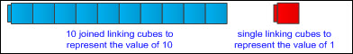  - Bundled sticks (proportional representation of the magnitude of a number with 1-to-10 relationship)  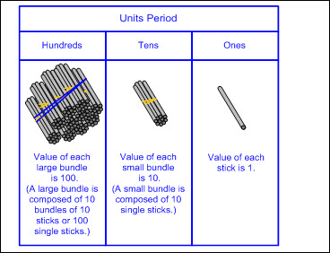  - Base-10 blocks (proportional representation of the magnitude of a number with 1-to-10 relationship)  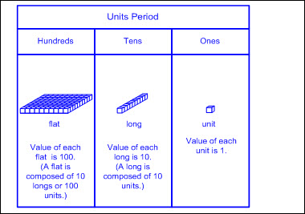  - Non-proportional models – a visual representation that does not maintain the proportional relationship of size, meaning the size of each place value model is not 10 times larger than the place value model to the right (e.g., the value of each place value disk is indicated by the numerical label and color but does not change in size)  - Place value disks (non-proportional representation with a 1-to-10 relationship)  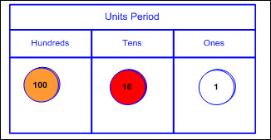  - Pictorial models  - Base-10 block representations  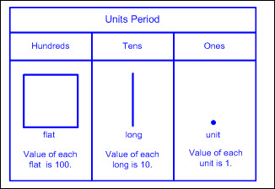  - Place value disk representations  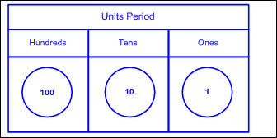  - Open number line – an empty number line where tick marks are added to represent landmarks of numbers, often indicated with arcs above the number line (referred to as jumps) demonstrating approximate proportional distances  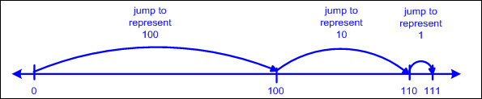  To Compose, To Decompose  NUMBERS UP TO 120 IN MORE THAN ONE WAY AS SO MANY HUNDREDS, SO MANY TENS, AND SO MANY ONES  Including, but not limited to:  - Whole numbers (0 – 120)  - Counting (natural) numbers – the set of positive numbers that begins at one and increases by increments of one each time {1, 2, 3, ..., n}  - Whole numbers – the set of counting (natural) numbers and zero {0, 1, 2, 3, ..., n}  - Compose numbers – to combine parts or smaller values to form a number  - Decompose numbers – to break a number into parts or smaller values  - Compose a number in more than one way.  - As so many hundreds, so many tens, and so many ones  - Ex:  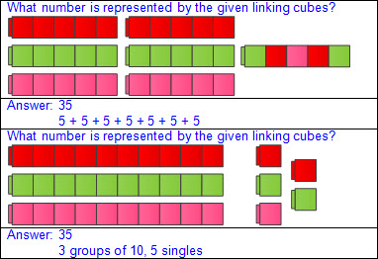  - Ex:  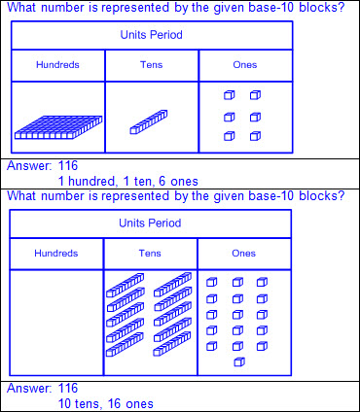  - Decompose a number in more than one way.  - As so many hundreds, so many tens, and so many ones  - Ex:  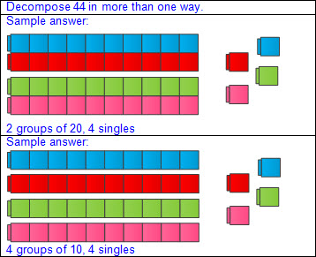  - Ex:  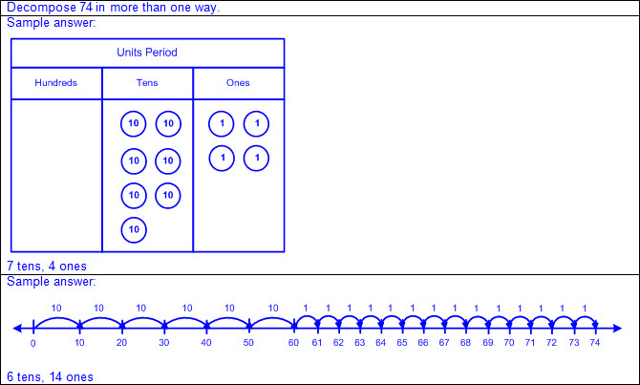  Note(s):  - Grade Level(s):  - Kindergarten composed and decomposed numbers up to 10 with objects and pictures.  - Grade 2 will use concrete and pictorial models to compose and decompose numbers up to 1,200 in more than one way as a sum of so many thousands, hundreds, tens, and ones.  - Various mathematical process standards will be applied to this student expectation as appropriate.  - TxRCFP:  - Developing an understanding of place value  - TxCCRS:  - I. Numeric Reasoning  - IX. Communication and Representation
1.2C | Use objects, pictures, and expanded and standard forms to represent numbers up to 120.  Use objects, pictures, and expanded and standard forms to represent numbers up to 120.  Use  OBJECTS, PICTURES, AND EXPANDED AND STANDARD FORMS TO REPRESENT NUMBERS UP TO 120  Including, but not limited to:  - Whole numbers (0 – 120)  - Counting (natural) numbers – the set of positive numbers that begins at one and increases by increments of one each time {1, 2, 3, ..., n}  - Whole numbers – the set of counting (natural) numbers and zero {0, 1, 2, 3, ..., n}  - Place value – the value of a digit as determined by its location in a number such as ones, tens, hundreds, etc.  - Objects  - Proportional models – a visual representation that demonstrates the relative size of each place value using models with proportional dimensions, meaning the model of each place value is exactly 10 times larger than the place value model to the right (e.g., the base-10 long is exactly 10 times as big as the unit showing that one 10 is equal to ten ones)  - Linking cubes (proportional representation of the magnitude of a number with 1-to-10 relationship)  - Bundled sticks (proportional representation of the magnitude of a number with 1-to-10 relationship)  - Base-10 blocks (proportional representation of the magnitude of a number with 1-to-10 relationship)  - Non-proportional models – a visual representation that does not maintain the proportional relationship of size, meaning the size of each place value model is not 10 times larger than the place value model to the right (e.g., the value of each place value disk is indicated by the numerical label and color but does not change in size)  - Place value disks (non-proportional representation with a 1-to-10 relationship)  - Pictures  - Base-10 block representations  - Place value disk representations  - Open number line – an empty number line where tick marks are added to represent landmarks of numbers, often indicated with arcs above the number line (referred to as jumps) demonstrating approximate proportional distances  - Place value stacking cards  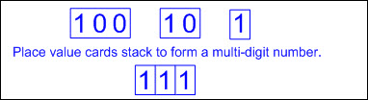  - Expanded form – the representation of a number as a sum of place values (e.g., 119 as 100 + 10 + 9)  - Zero may or may not be written as an addend to represent the digit 0 in a number (e.g., 107 as 100 + 0 + 7 or 100 + 7).  - Standard form – the representation of a number using digits (e.g., 118)  - Period – a three-digit grouping of whole numbers where each grouping is composed of a ones place, a tens place, and a hundreds place, and each grouping is separated by a comma  - Units period is composed of the ones place, tens place, and hundreds place.  - The word “unit” after the numerical value of the units period is not stated when read.  - The word “hundred” in each period is stated when read.  - The words “ten” and “one” in each period are not stated when read.  - The tens place digit and ones place digit in each period are stated as a two-digit number when read.  - Zeros are used as place holders between digits as needed to maintain the value of each digit (e.g., 107).  - Leading zeros in a whole number are not commonly used in standard form, but are not incorrect and do not change the value of the number (e.g., 037 equals 37).  - Ex:  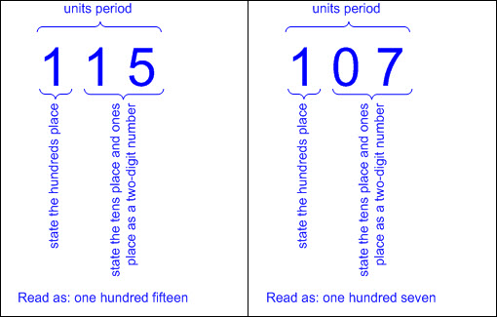  - Multiple representations  - Number presented in concrete or pictorial form represented in expanded form  - Ex:  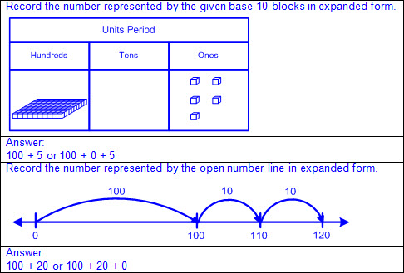  - Number presented in concrete or pictorial form represented in standard form  - Ex:  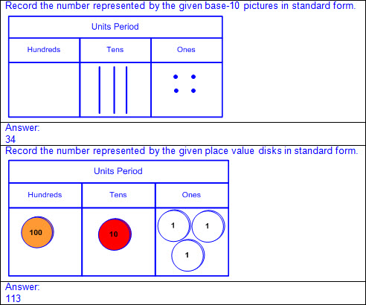  - Number presented in standard form represented in expanded form  - Ex:  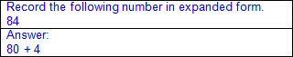  - Ex:  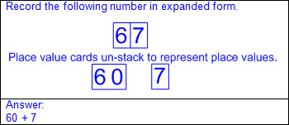  - Number presented in expanded form represented in standard form  - Ex:  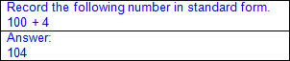  - Ex:  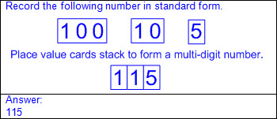  Note(s):  - Grade Level(s):  - Grade 1 introduces representing numbers in expanded and standard forms.  - Grade 2 will introduce representing numbers up to 1,200 in word form.  - Grade 2 will use standard, word, and expanded forms to represent numbers up to 1,200.  - Various mathematical process standards will be applied to this student expectation as appropriate.  - TxRCFP:  - Developing an understanding of place value  - TxCCRS:  - I. Numeric Reasoning  - IX. Communication and Representation
1.2D | Generate a number that is greater than or less than a given whole number up to 120.  Generate a number that is greater than or less than a given whole number up to 120.  Generate  A NUMBER THAT IS GREATER THAN OR LESS THAN A GIVEN WHOLE NUMBER UP TO 120  Including, but not limited to:  - Whole numbers (0 – 120)  - Counting (natural) numbers – the set of positive numbers that begins at one and increases by increments of one each time {1, 2, 3, ..., n}  - Whole numbers – the set of counting (natural) numbers and zero {0, 1, 2, 3, ..., n}  - Comparative language  - Inequality language  - Greater than, more than  - Less than, fewer than  - Place value relationships  - 1 more or 1 less  - Adding 1 in the ones place will generate a number that is 1 more than the original number.  - Ex: 65 + 1 = 66  - Subtracting 1 in the ones place will generate a number that is 1 less than the original number.  - Ex: 65 – 1 = 64  - 10 more or 10 less  - Adding 1 in the tens place will generate a number that is 10 more than the original number.  - Ex: 65 + 10 = 75  - Subtracting 1 in the tens place will generate a number that is 10 less than the original number.  - Ex: 65 –10 = 55  - Numerical relationships  - Counting order  - Skip counting  - Doubles  - Concrete and pictorial models  - Hundreds chart  - Moving one place to the right will generate a number that is 1 more than the original number.  - Moving one place to the left will generate a number that is 1 less than the original number.  - Moving one row down will generate a number that is 10 more than the original number.  - Moving one row up will generate a number that is 10 less than the original number.  - Base-10 blocks  - Adding unit cubes will increase a number by increments of 1.  - Removing unit cubes will decrease a number by increments of 1.  - Adding longs will increase a number by increments of 10.  - Removing longs will decrease a number by increments of 10.  - Number line  - Numbers increase from left to right.  - Numbers decrease from right to left.  - Calendar  - Moving one place to the right will generate a number that is 1 more than the original number.  - Moving one place to the left will generate a number that is 1 less than the original number.  - Moving one row down will generate a number that is 7 more than the original number.  - Moving one row up will generate a number that is 7 less than the original number.  Note(s):  - Grade Level(s):  - Kindergarten generated a number that is one more than or one less than another number up to 20.  - Grade 2 will generate a number that is greater than or less than a given whole number up to 1,200.  - Various mathematical process standards will be applied to this student expectation as appropriate.  - TxRCFP:  - Developing an understanding of place value  - TxCCRS:  - I. Numeric Reasoning  - IX. Communication and Representation
1.2E | Use place value to compare whole numbers up to 120 using comparative language.  Use place value to compare whole numbers up to 120 using comparative language.  Use  PLACE VALUE OF WHOLE NUMBERS UP TO 120  Including, but not limited to:  - Whole numbers (0 – 120)  - Counting (natural) numbers – the set of positive numbers that begins at one and increases by increments of one each time {1, 2, 3, ..., n}  - Whole numbers – the set of counting (natural) numbers and zero {0, 1, 2, 3, ..., n}  - Place value – the value of a digit as determined by its location in a number such as ones, tens, hundreds, etc.  - Hundreds place  - Tens place  - Ones place  To Compare  WHOLE NUMBERS UP TO 120 USING COMPARATIVE LANGUAGE  Including, but not limited to:  - Whole numbers (0 – 120)  - Counting (natural) numbers – the set of positive numbers that begins at one and increases by increments of one each time {1, 2, 3, ..., n}  - Whole numbers – the set of counting (natural) numbers and zero {0, 1, 2, 3, ..., n}  - Comparative language  - Inequality language  - Greater than, more than  - Less than, fewer than  - Equality language  - Equal to, same as  - Compare numbers – to consider the value of two numbers to determine which number is greater or less or if the numbers are equal in value  - Concrete models  - Compare the amount modeled in the highest place value position first.  - Proportional models – a visual representation that demonstrates the relative size of each place value using models with proportional dimensions, meaning the model of each place value is exactly 10 times larger than the place value model to the right (e.g., the base-10 long is exactly 10 times as big as the unit showing that one 10 is equal to ten ones)  - Bundled sticks (proportional representation of the magnitude of a number with 1-to-10 relationship)  - Ex:  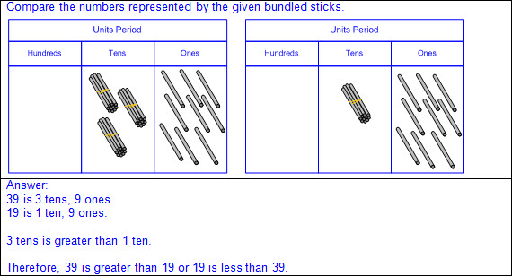  - Base-10 blocks (proportional representation of the magnitude of a number with 1-to-10 relationship)  - Ex:  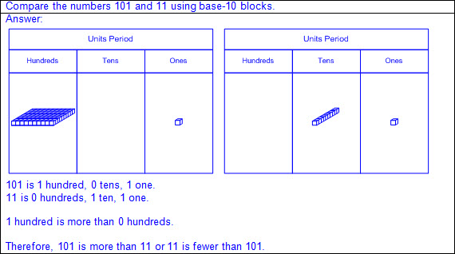  - Non-proportional models – a visual representation that does not maintain the proportional relationship of size, meaning the size of each place value model is not 10 times larger than the place value model to the right (e.g., the value of each place value disk is indicated by the numerical label and color but does not change in size)  - Place value disks (non-proportional representation with a 1-to-10 relationship)  - Ex:  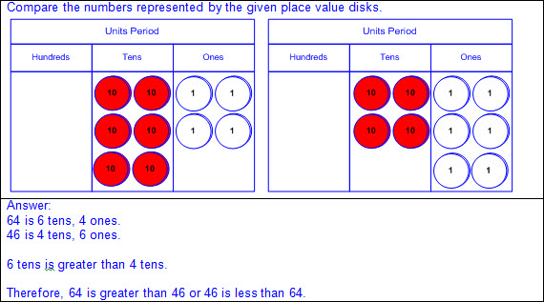  - Pictorial models  - Compare the amount represented in the highest place value position first.  - Base-10 block representations  - Ex:  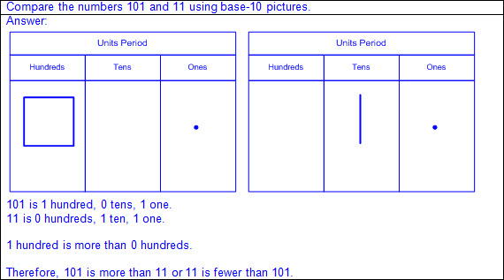  - Place value disk representations  - Ex:  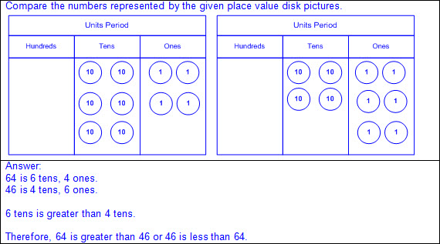  - Numerical  - Compare two numbers using place value charts.  - Compare digits in the same place value position beginning with the greatest place value.  - If these digits are the same, continue to the next smallest place until the digits are different.  - Ex:  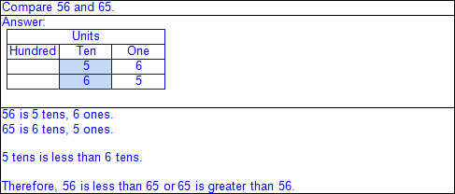  - Numbers that have common digits but are not equal in value (different place values)  - Ex:  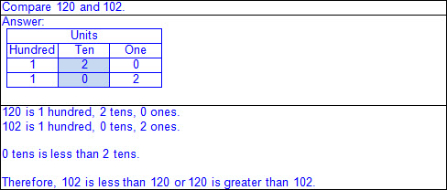  - Numbers that have a different number of digits  - Ex:  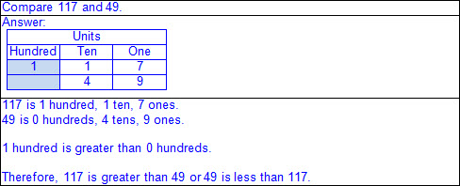  Note(s):  - Grade Level(s):  - Kindergarten used comparative language to describe two numbers up to 20 presented as written numerals.  - Grade 2 will use place value to compare and order whole numbers up to 1,200 using comparative language, numbers, and the symbols >, <, or =.  - Various mathematical process standards will be applied to this student expectation as appropriate.  - TxRCFP:  - Developing an understanding of place value  - TxCCRS:  - I. Numeric Reasoning  - IX. Communication and Representation
1.2F | Order whole numbers up to 120 using place value and open number lines.  Order whole numbers up to 120 using place value and open number lines.  Order  WHOLE NUMBERS UP TO 120 USING PLACE VALUE AND OPEN NUMBER LINES  Including, but not limited to:  - Whole numbers (0 – 120)  - Counting (natural) numbers – the set of positive numbers that begins at one and increases by increments of one each time {1, 2, 3, ..., n}  - Whole numbers – the set of counting (natural) numbers and zero {0, 1, 2, 3, ..., n}  - Order numbers – to arrange a set of numbers based on their numerical value  - Order a set of numbers using place value.  - Quantifying descriptors (e.g., between two given numbers, greatest/least, ascending/descending, tallest/shortest, warmest/coldest, fastest/slowest, longest/shortest, heaviest/lightest, closest/farthest, oldest/youngest, etc.)  - Ex:  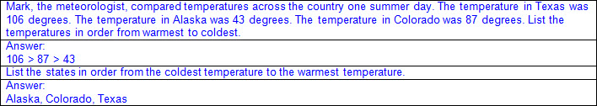  - Ex:  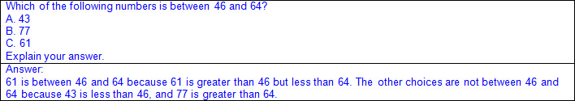  - Order a set of numbers using open number lines.  - Characteristics of an open number line  - An open number line begins as a line with no intervals (or tick marks) and no positions/numbers labeled.  - Numbers/positions are placed on the empty number line only as they are needed.  - When reasoning on an open number line, the position of zero is often not placed.  - When working with larger numbers, an open number line without the constraint of distance from zero allows the ability to “zoom-in” on the relevant section of the number line.  - The placement of the first two numbers on an open number line determines the scale of the number line.  - Once the scale of the number line has been established by the placement of the first two numbers, intervals between additional numbers placed are approximately proportional.  - The differences between numbers are approximated by the distance between the positions on the number line.  - Open number lines extend infinitely in both directions (arrows indicate the number line continues infinitely).  - Numbers increase from left to right on a horizontal number line and from bottom to top on a vertical number line.  - Points to the left of a specified point on a horizontal number line are less than points to the right.  - Points to the right of a specified point on a horizontal number line are greater than points to the left.  - Points below a specified point on a vertical number line are less than points above.  - Points above a specified point on a vertical number line are greater than points below.  - Landmark (or anchor) numbers may be placed on the open number line to help locate other numbers.  - Relative magnitude of a number describes the size of a number and its relationship to another number.  - Ex: 50 is closer to 0 on a number line than 120, so 50 < 120 and 120 > 50.  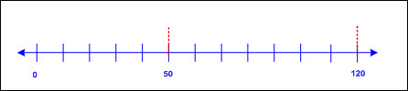  - Ex: 75 is further from 0 on a number line than 57, so 75 > 57 and 57 < 75.  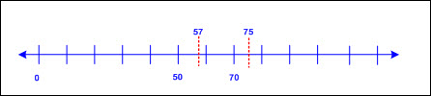  - Order a set of numbers on an open number line.  - Ex:  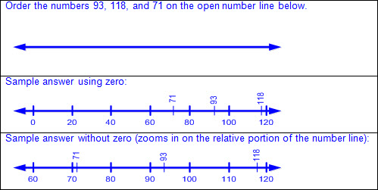  Note(s):  - Grade Level(s):  - Grade 1 introduces ordering whole numbers up to 120 using place value and open number lines.  - Grade 2 will use place value to compare and order whole numbers up to 1,200 using comparative language, numbers, and the symbols >, <, or =.  - Various mathematical process standards will be applied to this student expectation as appropriate.  - TxRCFP:  - Developing an understanding of place value  - TxCCRS:  - I. Numeric Reasoning  - IX. Communication and Representation
1.2G | Represent the comparison of two numbers to 100 using the symbols >, <, or =.  Represent the comparison of two numbers to 100 using the symbols >, <, or =.  Represent  THE COMPARISON OF TWO NUMBERS TO 100 USING THE SYMBOLS >, <, OR =  Including, but not limited to:  - Whole numbers (0 – 100)  - Counting (natural) numbers – the set of positive numbers that begins at one and increases by increments of one each time {1, 2, 3, ..., n}  - Whole numbers – the set of counting (natural) numbers and zero {0, 1, 2, 3, ..., n}  - Compare numbers – to consider the value of two numbers to determine which number is greater or less or if the numbers are equal in value  - Inequality words and symbols  - Greater than (>)  - Less than (<)  - Ex:  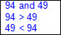  - Equality words and symbol  - Equal to (=)  - Ex:  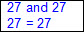  Note(s):  - Grade Level(s):  - Grade 1 introduces the comparison symbols >, <, and =.  - Grade 2 will use place value to compare and order whole numbers up to 1,200 using comparative language, numbers, and the symbols >, <, or =.  - Various mathematical process standards will be applied to this student expectation as appropriate.  - TxRCFP:  - Developing an understanding of place value  - TxCCRS:  - I. Numeric Reasoning  - IX. Communication and Representation
1.3 | Number and operations. The student applies mathematical process standards to develop and use strategies for whole number addition and subtraction computations in order to solve problems. The student is expected to:
1.3A | Use concrete and pictorial models to determine the sum of a multiple of 10 and a one-digit number in problems up to 99.  Use concrete and pictorial models to determine the sum of a multiple of 10 and a one-digit number in problems up to 99.  Use  CONCRETE AND PICTORIAL MODELS TO DETERMINE THE SUM OF A MULTIPLE OF 10 AND A ONE-DIGIT NUMBER IN PROBLEMS UP TO 99  Including, but not limited to:  - Whole numbers (0 – 99)  - Counting (natural) numbers – the set of positive numbers that begins at one and increases by increments of one each time {1, 2, 3, ..., n}  - Whole numbers – the set of counting (natural) numbers and zero {0, 1, 2, 3, ..., n}  - Addition  - Sum – the total when two or more addends are joined  - Addend – a number being added or joined together with another number(s)  - Digit – any numeral from 0 – 9  - Sums of a multiple of 10 and a one-digit number up to 99  - Multiples of 10  - 10, 20, 30, 40, 50, 60, 70, 80, 90  - Addition strategy based on patterns and place value  - Ex:  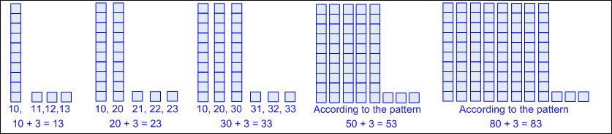  - Solutions recorded with a number sentence  - Number sentence – a mathematical statement composed of numbers, and/or an unknown(s), and/or an operator(s), and an equality or inequality symbol  - Number sentences, or equations, with equal sign at beginning or end  - Ex: 10 = 6 + 4; 6 + 4 = 10  - Concrete models  - Base-10 blocks, linking cubes, place value disks, etc.  - Pictorial models  - Base-10 pictorials, place value disks, number lines, strip diagrams, etc.  - Strip diagram – a linear model used to illustrate number relationships  - Mathematical and real-world problem situations  - Joining problems  - Ex:  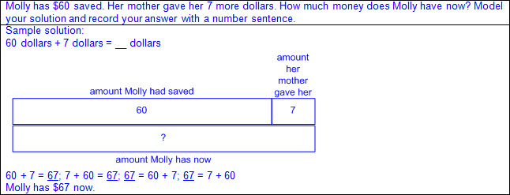  - Ex:  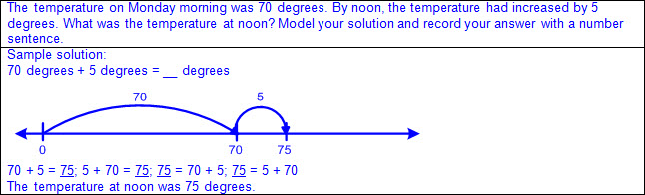  - Comparison problems  - Ex:  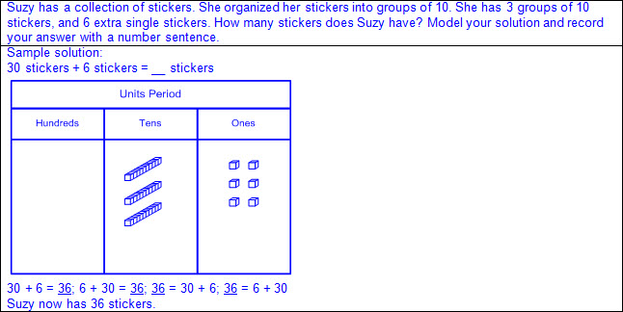  - Ex:  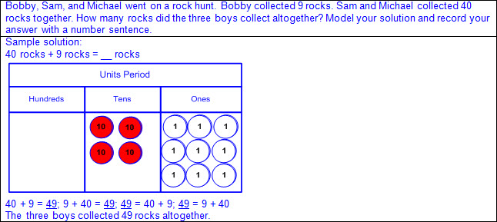  Note(s):  - Grade Level(s):  - Grade 2 will solve one-step and multi-step word problems involving addition and subtraction within 1,000 using a variety of strategies based on place value, including algorithms.  - Various mathematical process standards will be applied to this student expectation as appropriate.  - TxRCFP:  - Developing an understanding of place value  - Solving problems involving addition and subtraction  - TxCCRS:  - I. Numeric Reasoning  - VIII. Problem Solving and Reasoning  - IX. Communication and Representation
1.3B | Use objects and pictorial models to solve word problems involving joining, separating, and comparing sets within 20 and unknowns as any one of the terms in the problem such as 2 + 4 = [ ]; 3 + [ ] = 7; and 5 = [ ] – 3.  Use objects and pictorial models to solve word problems involving joining, separating, and comparing sets within 20 and unknowns as any one of the terms in the problem such as 2 + 4 = [ ]; 3 + [ ] = 7; and 5 = [ ] – 3.  Use  OBJECTS AND PICTORIAL MODELS TO SOLVE WORD PROBLEMS INVOLVING JOINING, SEPARATING, AND COMPARING SETS WITHIN 20 AND UNKNOWNS AS ANY ONE OF THE TERMS IN THE PROBLEM  Including, but not limited to:  - Whole numbers  - Counting (natural) numbers – the set of positive numbers that begins at one and increases by increments of one each time {1, 2, 3, ..., n}  - Whole numbers – the set of counting (natural) numbers and zero {0, 1, 2, 3, ..., n}  - Addition  - Sum – the total when two or more addends are joined  - Addend – a number being added or joined together with another number(s)  - Addition of whole numbers within 20  - Subtraction  - Difference – the remaining amount after the subtrahend has been subtracted from the minuend  - Minuend – a number from which another number will be subtracted  - Subtrahend – a number to be subtracted from a minuend  - Subtraction of whole numbers within 20  - Solutions recorded with a number sentence  - Number sentence – a mathematical statement composed of numbers, and/or an unknown(s), and/or an operator(s), and an equality or inequality symbol  - Number sentences, or equations, with equal sign at beginning or end  - Ex: 6 = 10 – 4; 10 – 4 = 6  - Unknown in any position  - Ex: a + b = __; a + __ = c; __ + b = c; a – b = __; a – __= c; __ – b = c  - Concrete models  - Sets of objects within 20  - Base-10 blocks, linking cubes, counters, etc.  - Pictorial models  - Base-10 pictorials, number lines, strip diagrams, etc.  - Strip diagram – a linear model used to illustrate number relationships  - Mathematical and real-world problem situations  - Problems involving action  - Joining problems  - Result unknown  - Ex:  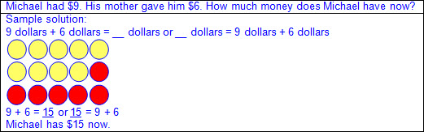  - Change unknown  - Ex:  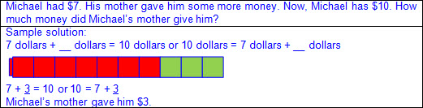  - Start unknown  - Ex:  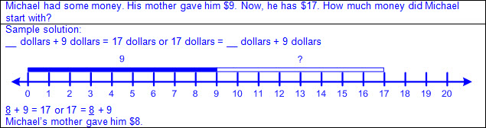  - Separating problems  - Result unknown  - Ex:  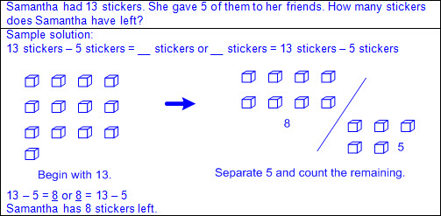  - Change unknown  - Ex:  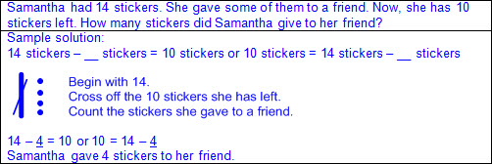  - Start unknown  - Ex:  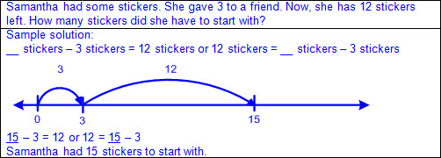  - Problems with no action  - Part-part-whole problems  - Whole unknown  - Ex:  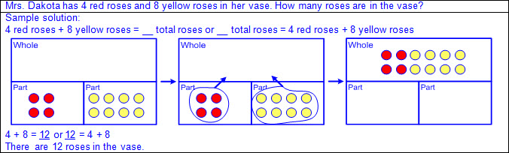  - Part unknown  - Ex:  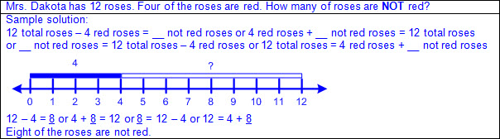  - Compare problems  - Difference unknown  - Ex:  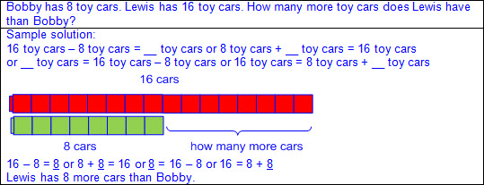  - Larger part unknown  - Ex:  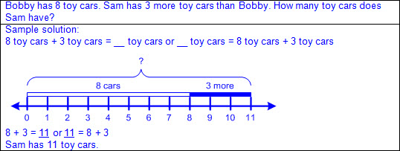  - Smaller part unknown  - Ex:  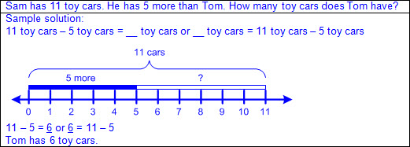  - Recognition of addition and subtraction as inverse operations  - Addition can be reversed by subtraction.  - Subtraction can be reversed by addition.  - Fact families – related number sentences using the same set of numbers  Note(s):  - Grade Level(s):  - Kindergarten modeled the action of joining to represent addition and the action of separating to represent subtraction.  - Grade 1 introduces comparison problems.  - Various mathematical process standards will be applied to this student expectation as appropriate.  - TxRCFP:  - Solving problems involving addition and subtraction  - TxCCRS:  - I. Numeric Reasoning  - II.D. Algebraic Reasoning – Representations  - VIII. Problem Solving and Reasoning  - IX. Communication and Representation  - X. Connections
1.3C | Compose 10 with two or more addends with and without concrete objects.  Compose 10 with two or more addends with and without concrete objects.  Compose  10 WITH TWO OR MORE ADDENDS WITH AND WITHOUT CONCRETE OBJECTS  Including, but not limited to:  - Whole numbers (0 – 10)  - Counting (natural) numbers – the set of positive numbers that begins at one and increases by increments of one each time {1, 2, 3, ..., n}  - Whole numbers – the set of counting (natural) numbers and zero {0, 1, 2, 3, ..., n}  - Compose numbers – to combine parts or smaller values to form a number  - Addend – a number being added or joined together with another number(s)  - Solutions recorded with a number sentence  - Number sentence – a mathematical statement composed of numbers, and/or an unknown(s), and/or an operator(s), and an equality or inequality symbol  - Number sentences, or equations, with equal sign at beginning or end  - Ex: 10 = 6 + 4; 6 + 4 = 10  - Commutative property of addition – if the order of the addends are changed, the sum will remain the same  - With concrete objects  - Linking cubes, counters, ten frame mats, color tiles, a Rekenrek counting rack, etc.  - Multiple compositions of 10 with two addends  - Ex:  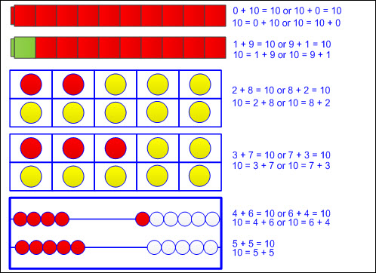  - Multiple compositions of 10 with more than two addends  - Ex:  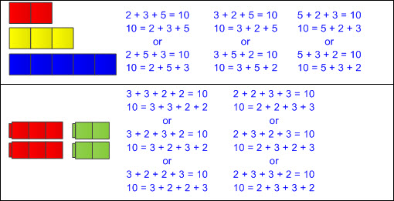  - Without concrete objects  - Multiple compositions of 10 with two addends  - Ex: 10 + 0 = 10 or 0 + 10 = 10; 9 + 1 = 10 or 1 + 9 = 10; 8 + 2 = 10 or 2 + 8 = 10; 7 + 3 = 10 or 3 + 7 = 10; 6 + 4 = 10 or 4 + 6 = 10; 5 + 5 = 10  - Ex: 10 = 10 + 0 or 10 = 0 + 10; 10 = 9 + 1 or 10 = 1 + 9; 10 = 8 + 2 or 10 = 2 + 8; 10 = 7 + 3 or 10 = 3 + 7; 10 = 6 + 4 or 10 = 4 + 6; 10 = 5 + 5  - Multiple compositions of 10 with more than two addends  - Ex: 5 + 2 + 3 = 10 or 3 + 2 + 5 = 10 or 2 + 3 + 5 = 10; 1 + 1 + 3 + 5 = 10 or 1 + 3 + 5 + 1 = 10 or 1 + 5 + 3 + 1 = 10; etc.  - Ex: 10 = 5 + 2 + 3 or 10 = 3 + 2 + 5 or 10 = 2 + 3 + 5; 10 = 1 + 1 + 3 + 5 or 10 = 1 + 3 + 5 + 1 or 10 = 1 + 5 + 3 + 1; etc.  Note(s):  - Grade Level(s):  - Kindergarten solved word problems using objects and drawings to find sums up to 10 and differences within 10.  - Various mathematical process standards will be applied to this student expectation as appropriate.  - TxRCFP:  - Solving problems involving addition and subtraction  - TxCCRS:  - I. Numeric Reasoning  - IX. Communication and Representation
1.3D | Apply basic fact strategies to add and subtract within 20, including making 10 and decomposing a number leading to a 10.  Apply basic fact strategies to add and subtract within 20, including making 10 and decomposing a number leading to a 10.  Apply  BASIC FACT STRATEGIES TO ADD WITHIN 20, INCLUDING MAKING 10 AND DECOMPOSING A NUMBER LEADING TO A 10  Including, but not limited to:  - Whole numbers  - Counting (natural) numbers – the set of positive numbers that begins at one and increases by increments of one each time {1, 2, 3, ..., n}  - Whole numbers – the set of counting (natural) numbers and zero {0, 1, 2, 3, ..., n}  - Addition  - Sum – the total when two or more addends are joined  - Addend – a number being added or joined together with another number(s)  - Addition of whole numbers within 20  - Solutions recorded with a number sentence  - Number sentence – a mathematical statement composed of numbers, and/or an unknown(s), and/or an operator(s), and an equality or inequality symbol  - Number sentences, or equations, with equal sign at beginning or end  - Ex: 10 = 6 + 4; 6 + 4 = 10  - Decompose numbers – to break a number into parts or smaller values  - Compose numbers – to combine parts or smaller values to form a number  - Basic fact strategies for addition  - Making 10  - Composing two addends to form a sum of 10  - Ex: 0 + 10 = 10; 1 + 9 = 10; 2 + 8 = 10; etc.  - Ex: 10 = 0 + 10; 10 = 1 + 9; 10 = 2 + 8; etc.  - Hidden tens  - Decomposing a number leading to a 10  - Ex:  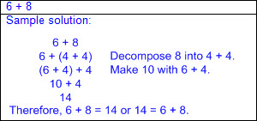  - Plus 9  - Adding 9 is equivalent to adding 10 and subtracting 1.  - Ex:  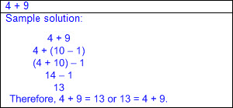  - Plus 10  - Add 1 ten in the tens place and add 0 in the ones place.  - Ex:  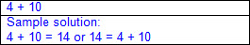  - Doubles  - Adding two of the same addend  - Ex: 1 + 1 = 2; 3 + 3 = 6; etc.  - Ex: 2 = 1 + 1; 6 = 3 + 3; etc.  - Double plus/minus 1  - Consecutive addends  - Double the smaller addend and add 1, or double the larger addend and subtract 1.  - Ex:  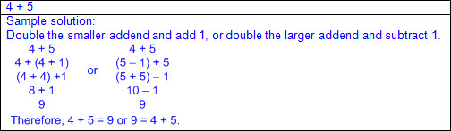  - Hidden doubles  - Decompose an addend to form a doubles fact.  - Ex:  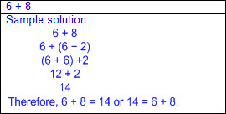  - In-betweens  - Addends that have exactly one number between them consecutively.  - Double the number between the addends.  - Ex:  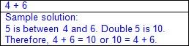  - Fact families – related number sentences using the same set of numbers  - Recognition of addition and subtraction as inverse operations  - Ex:  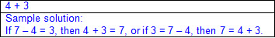  - Commutative property  - Sum does not change when the order of the addends are switched.  - Ex:  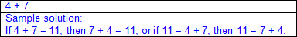  - Plus 0 (additive identity)  - Adding zero to a number does not affect the total.  - Ex: 1 + 0 = 1; 2 + 0 = 2; 3 + 0 = 3; etc.  - Ex: 1 = 1 + 0; 2 = 2 + 0; 3 = 3 + 0; etc.  - Plus 1  - Adding 1 related to sequential counting  - Ex: 9 + 1 = 10 or 10 = 9 + 1  - Counting on  - Begin with one addend and count on the amount of the other addend.  - Ex:  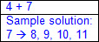  Apply  BASIC FACT STRATEGIES TO SUBTRACT WITHIN 20, INCLUDING MAKING 10 AND DECOMPOSING A NUMBER LEADING TO A 10  Including, but not limited to:  - Whole numbers  - Counting (natural) numbers – the set of positive numbers that begins at one and increases by increments of one each time {1, 2, 3, ..., n}  - Whole numbers – the set of counting (natural) numbers and zero {0, 1, 2, 3, ..., n}  - Subtraction  - Difference – the remaining amount after the subtrahend has been subtracted from the minuend  - Minuend – a number from which another number will be subtracted  - Subtrahend – a number to be subtracted from a minuend  - Subtraction of whole numbers within 20  - Solutions recorded with a number sentence  - Number sentence – a mathematical statement composed of numbers, and/or an unknown(s), and/or an operator(s), and an equality or inequality symbol  - Number sentences, or equations, with equal sign at beginning or end  - Ex: 6 = 10 – 4; 10 – 4 = 6  - Decompose numbers – to break a number into parts or smaller values  - Basic fact strategies for subtraction  - Counting back  - Begin with the minuend and count back the amount of the subtrahend.  - Ex:  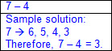  - Counting up  - Begin with the subtrahend and count up to the minuend.  - Ex:  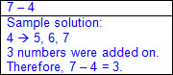  - Fact families – related number sentences using the same set of numbers  - Recognition of addition and subtraction as inverse operations  - Ex:  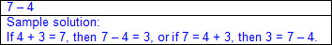  - Minus 0 (additive identity)  - Subtracting 0 from a number does not affect the total.  - Ex: 9 – 0 = 9 or 9 = 9 – 0  - Minus 1  - Subtracting 1 related to sequentially counting backward once  - Ex: 9 – 1 = 8 or 8 = 9 – 1; counted 9, 8  - Minus 2  - Subtracting 2 related to sequentially counting backward twice  - Ex: 9 – 2 = 7 or 7 = 9 – 2; counted 9, 8, 7  - Minus 9  - Subtracting 9 is equivalent to subtracting 10 and adding 1.  - Ex:  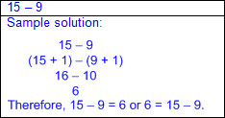  - Decompose the subtrahend  - Decompose the subtrahend to form a known fact.  - Ex:  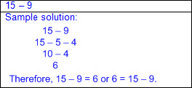  - Decompose the minuend  - Decompose the minuend to form a known fact.  - Ex:  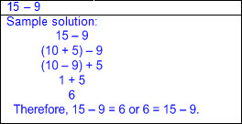  Note(s):  - Grade Level(s):  - Grade 1 introduces applying basic fact strategies to add and subtract within 20.  - Grade 2 will recall basic facts to add and subtract within 20 with automaticity.  - Various mathematical process standards will be applied to this student expectation as appropriate.  - TxRCFP:  - Solving problems involving addition and subtraction  - TxCCRS:  - I. Numeric Reasoning  - IX. Communication and Representation
1.3E | Explain strategies used to solve addition and subtraction problems up to 20 using spoken words, objects, pictorial models, and number sentences.  Explain strategies used to solve addition and subtraction problems up to 20 using spoken words, objects, pictorial models, and number sentences.  Explain  STRATEGIES USED TO SOLVE ADDITION AND SUBTRACTION PROBLEMS UP TO 20 USING SPOKEN WORDS, OBJECTS, PICTORIAL MODELS, AND NUMBER SENTENCES  Including, but not limited to:  - Whole numbers  - Counting (natural) numbers – the set of positive numbers that begins at one and increases by increments of one each time {1, 2, 3, ..., n}  - Whole numbers – the set of counting (natural) numbers and zero {0, 1, 2, 3, ..., n}  - Mathematical and real-world problem situations  - Addition  - Sum – the total when two or more addends are joined  - Addend – a number being added or joined together with another number(s)  - Addition of whole numbers within 20  - Subtraction  - Difference – the remaining amount after the subtrahend has been subtracted from the minuend  - Minuend – a number from which another number will be subtracted  - Subtrahend – a number to be subtracted from a minuend  - Subtraction of whole numbers within 20  - Detailed explanation of solution process and strategy  - Addition strategies  - Making 10  - Hidden tens  - Plus 9  - Plus 10  - Doubles  - Doubles plus/minus 1  - Hidden doubles  - In-betweens  - Fact families  - Commutative property  - Plus 0 (additive identity)  - Plus 1  - Counting on  - Subtraction strategies  - Counting back  - Counting up  - Fact families  - Minus 0 (additive identity)  - Minus 1  - Minus 2  - Minus 9  - Decompose the subtrahend  - Decompose the minuend  - Connection between information in the problem and problem type  - Addition situations  - Subtraction situations  - Part-part-whole situations  - Comparison situations  - Relationship between quantities of objects used, pictures drawn, and number sentences to the problem situation  - Explanation using spoken words  - Appropriate mathematical language for addition and subtraction situations  - Labels for quantities represented  - Explanation using objects  - Base-10 blocks, linking cubes, counters, etc.  - Explanation using pictorials  - Base-10 pictorials, number lines, strip diagrams, etc.  - Strip diagram – a linear model used to illustrate number relationships  - Explanation using number sentences  - Number sentence – a mathematical statement composed of numbers, and/or an unknown(s), and/or an operator(s), and an equality or inequality symbol  - Addition symbol represents joining  - Addend + addend = sum  - Sum = addend + addend  - Subtraction symbol represents separating  - Minuend – subtrahend = difference  - Difference = minuend – subtrahend  - Equal symbol represents a relationship where expressions on each side of the equal sign represent the same value  - Ex: 5 + 5 = 10  - Ex: 10 = 2 + 3 + 5  - Ex: 5 – 3 = 2  - Ex: 2 = 5 – 3  - Ex: Addition result unknown  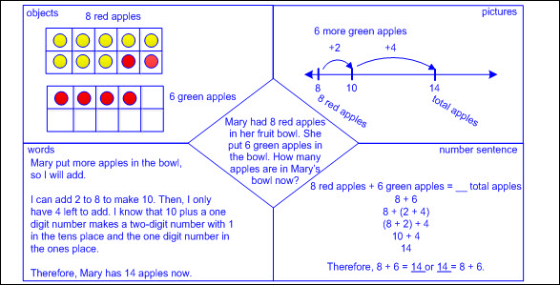  - Ex: Addition change unknown  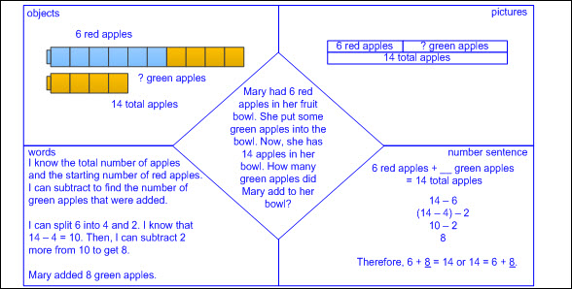  - Ex: Addition start unknown  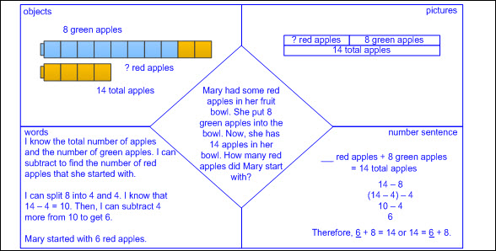  - Ex: Subtraction result unknown  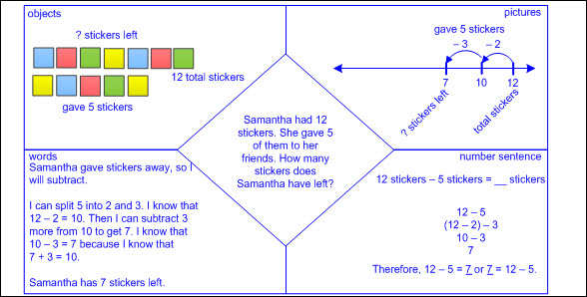  - Ex: Subtraction change unknown  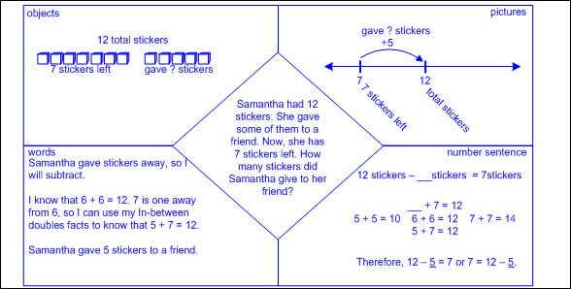  - Ex: Subtraction start unknown  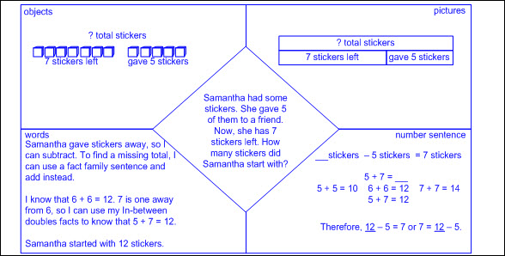  - Ex: Part-part-whole whole unknown  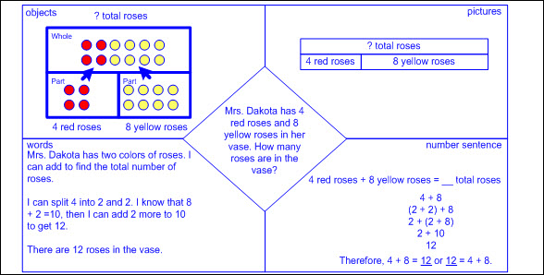  - Ex: Part-part-whole part unknown  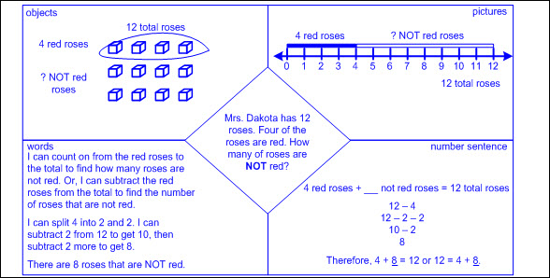  - Ex: Comparison difference unknown  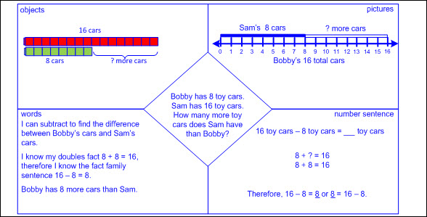  - Ex: Comparison larger part unknown  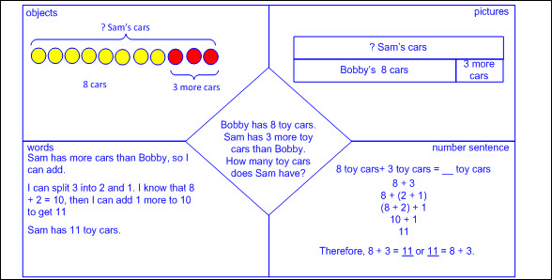  - Ex: Comparison smaller part unknown  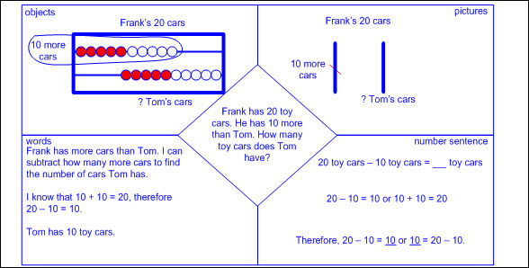  Note(s):  - Grade Level(s):  - Kindergarten explained the strategies used to solve problems involving adding and subtracting within 10 using spoken words, concrete and pictorial models, and number sentences.  - Grade 2 will add up to four two-digit numbers and subtract two-digit numbers using mental strategies and algorithms based on knowledge of place value and properties of operations.  - Various mathematical process standards will be applied to this student expectation as appropriate.  - TxRCFP:  - Solving problems involving addition and subtraction  - TxCCRS:  - I. Numeric Reasoning  - II.D. Algebraic Reasoning – Representations  - VIII. Problem Solving and Reasoning  - IX. Communication and Representation  - X. Connections
1.3F | Generate and solve problem situations when given a number sentence involving addition or subtraction of numbers within 20.  Generate and solve problem situations when given a number sentence involving addition or subtraction of numbers within 20.  Generate, Solve  PROBLEM SITUATIONS WHEN GIVEN A NUMBER SENTENCE INVOLVING ADDITION OR SUBTRACTION OF NUMBERS WITHIN 20  Including, but not limited to:  - Whole numbers  - Counting (natural) numbers – the set of positive numbers that begins at one and increases by increments of one each time {1, 2, 3, ..., n}  - Whole numbers – the set of counting (natural) numbers and zero {0, 1, 2, 3, ..., n}  - Addition  - Sum – the total when two or more addends are joined  - Addend – a number being added or joined together with another number(s)  - Addition of whole numbers within 20  - Subtraction  - Difference – the remaining amount after the subtrahend has been subtracted from the minuend  - Minuend – a number from which another number will be subtracted  - Subtrahend – a number to be subtracted from a minuend  - Subtraction of whole numbers within 20  - Number sentence – a mathematical statement composed of numbers, and/or an unknown(s), and/or an operator(s), and an equality or inequality symbol  - Number sentences, or equations, with an equal sign at the beginning or end  - Ex: 10 = 6 + 4; 6 + 4 = 10  - Ex: 6 = 10 – 4; 10 – 4 = 6  - Unknown in any position  - Ex: a + b = __; a + __ = c; __ + b = c; a – b = __; a – __= c; __ – b = c  - Generate and solve mathematical and real-world problem situations when given an addition number sentence.  - Appropriate mathematical language  - Connection between information in the problem and problem type  - Addition situations  - Ex:  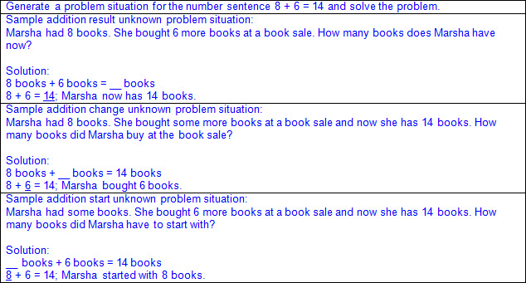  - Part-part-whole situations  - Ex:  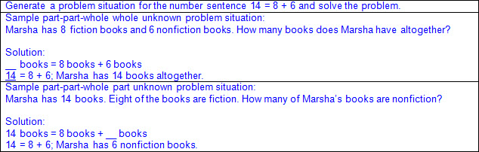  - Comparison situations  - Ex:  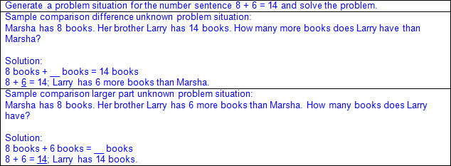  - Start unknown situations  - Ex:  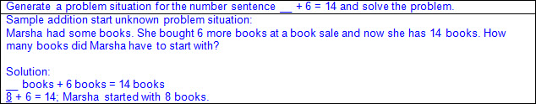  - Change unknown situations  - Ex:  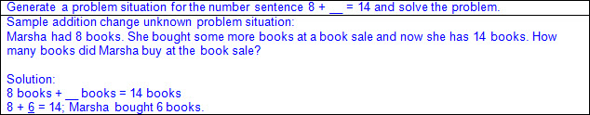  - Result unknown situations  - Ex:  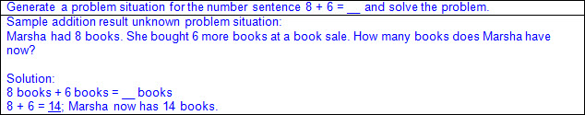  - Generate and solve mathematical and real-world problem situations when given a subtraction number sentence.  - Appropriate mathematical language  - Connection between information in the problem and problem type  - Subtraction situations  - Ex:  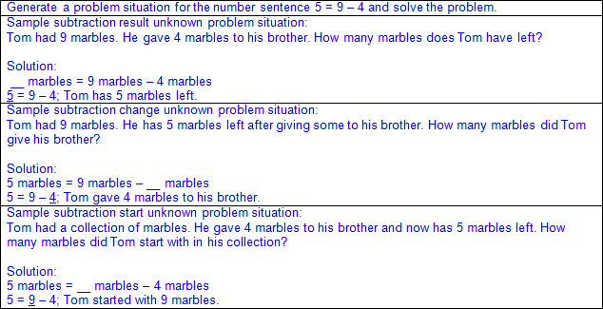  - Part-part-whole situations  - Ex:  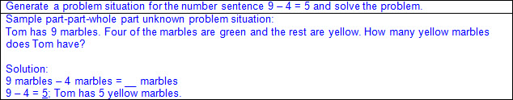  - Comparison situations  - Ex:  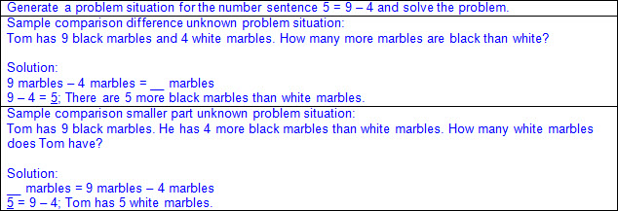  - Start unknown situations  - Ex:  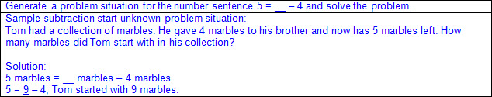  - Change unknown situations  - Ex:  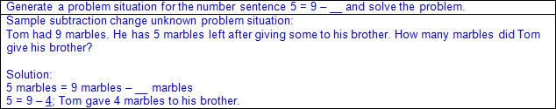  - Result unknown situations  - Ex:  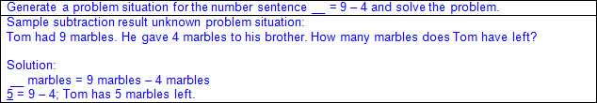  Note(s):  - Grade Level(s):  - Grade 1 introduces generating and solving problem situations when given a number sentence involving addition and subtraction of whole numbers within 20.  - Grade 2 will generate and solve problem situations for a given mathematical number sentence involving addition and subtraction of whole numbers within 1,000.  - Various mathematical process standards will be applied to this student expectation as appropriate.  - TxRCFP:  - Solving problems involving addition and subtraction  - TxCCRS:  - I. Numeric Reasoning  - II.D. Algebraic Reasoning – Representations  - VIII. Problem Solving and Reasoning  - IX. Communication and Representation  - X. Connections
1.4 | Number and operations. The student applies mathematical process standards to identify coins, their values, and the relationships among them in order to recognize the need for monetary transactions. The student is expected to:
1.4A | Identify U.S. coins, including pennies, nickels, dimes, and quarters, by value and describe the relationships among them.  Identify U.S. coins, including pennies, nickels, dimes, and quarters, by value and describe the relationships among them.  Identify  U.S. COINS, INCLUDING PENNIES, NICKELS, DIMES, AND QUARTERS, BY VALUE  Including, but not limited to:  - U.S. coins by value  - Penny: 1 cent  - Nickel: 5 cents  - Dime: 10 cents  - Quarter: 25 cents  - Non-proportional relationship between size and value of coin  - Ex: A dime is greater than a nickel in value but smaller than a nickel in size.  - Attributes of pennies, nickels, dimes, and quarters  - Color  - Copper: penny  - Silver: nickel, dime, and quarter  - Size  - Relative sizes  - Largest to smallest: quarter, nickel, penny, dime  - Smallest to largest: dime, penny, nickel, quarter  - Texture  - Smooth edges: penny, nickel  - Ridged edges: dime, quarter  - Informal references  - Heads: front of coin  - Tails: back of coin  - Traditional head designs  - Presidents  - Penny: Abraham Lincoln  - Nickel: Thomas Jefferson  - Dime: Franklin Delano Roosevelt  - Quarter: George Washington  - Traditional tail designs  - Symbols  - Penny: Lincoln Memorial or union shield  - Nickel: Monticello  - Dime: Torch (liberty), Olive branch (peace), Oak branch (strength and independence)  - Quarter: Presidential coat of arms (eagle with outstretched arms)  - Special designs  - State coins  - U.S. territories  - Commemorative issues  - Concrete and pictorial models  - Views of both sides of coins  Describe  THE RELATIONSHIPS AMONG U.S. COINS  Including, but not limited to:  - U.S. coins  - Penny  - Nickel  - Dime  - Quarter  - Relationships by value  - Penny to nickel, dime, quarter  - 5 pennies = 1 nickel; 10 pennies = 1 dime; 25 pennies = 1 quarter  - 1 penny < 1 nickel; 1 penny < 1 dime; 1 penny < 1 quarter  - Nickel to penny, dime, quarter  - 1 nickel = 5 pennies; 2 nickels = 1 dime; 5 nickels = 1 quarter  - 1 nickel > 1 penny; 1 nickel < 1 dime; 1 nickel < 1 quarter  - Dime to penny, nickel, quarter  - 1 dime = 10 pennies; 1 dime = 2 nickels; 5 dimes = 2 quarters  - 1 dime > 1 penny; 1 dime > 1 nickel; 1 dime < 1 quarter  - Quarter to penny, nickel, dime  - 1 quarter = 25 pennies; 1 quarter = 5 nickels; 2 quarters = 5 dimes  - 1 quarter > 1 penny; 1 quarter > 1 nickel; 1 quarter > 1 dime  - Exchange of coins to other denominations  - Based on relationships between values  - Ex:  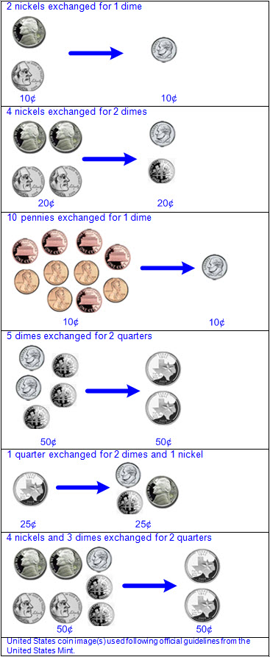  - Relationships between attributes  - Historically significant people on heads of all coins  - Non-proportional relationship between size and value of coin  Note(s):  - Grade Level(s):  - Kindergarten identified U.S. coins by name, including pennies, nickels, dimes, and quarters.  - Various mathematical process standards will be applied to this student expectation as appropriate.  - TxRCFP:  - Developing an understanding of place value  - TxCCRS:  - IX. Communication and Representation  - X. Connections
1.4B | Write a number with the cent symbol to describe the value of a coin.  Write a number with the cent symbol to describe the value of a coin.  Write  A NUMBER WITH THE CENT SYMBOL TO DESCRIBE THE VALUE OF A COIN  Including, but not limited to:  - Cent symbol (¢)  - Cent symbol written to the right of the numerical value  - Cent label read and written after numerical value  - Ex: Twenty-five cents is written 25¢ and read 25 cents.  - Value of a coin named with numbers and symbols  - Penny: 1¢  - Nickel: 5¢  - Dime: 10¢  - Quarter: 25¢  - Value of a coin named with numbers and words  - Penny: 1 cent  - Nickel: 5 cents  - Dime: 10 cents  - Quarter: 25 cents  Note(s):  - Grade Level(s):  - Grade 1 introduces the cent symbol to describe the value of a coin.  - Grade 2 will use the cent symbol, the dollar sign, and decimal point to name the value of a collection of coins.  - Various mathematical process standards will be applied to this student expectation as appropriate.  - TxRCFP:  - Developing an understanding of place value  - TxCCRS:  - IX. Communication and Representation  - X. Connections
1.4C | Use relationships to count by twos, fives, and tens to determine the value of a collection of pennies, nickels, and/or dimes.  Use relationships to count by twos, fives, and tens to determine the value of a collection of pennies, nickels, and/or dimes.  Use  RELATIONSHIPS TO COUNT BY TWOS, FIVES, AND TENS  Including, but not limited to:  - Whole numbers (0 – 120)  - Counting (natural) numbers – the set of positive numbers that begins at one and increases by increments of one each time {1, 2, 3, ..., n}  - Whole numbers – the set of counting (natural) numbers and zero {0, 1, 2, 3, ..., n}  - Skip counting – counting numbers in sequence forward or backward by a whole number other than 1  - Counting sequence can begin at any number.  - Ex:  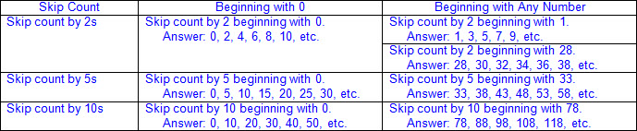  - Relationships in skip counting by twos  - When counting by twos, one number is skipped.  - When beginning with 0, all numbers counted have a 0, 2, 4, 6, or 8 in the ones place.  - Relationships when skip counting by fives  - When counting by fives, 4 numbers are skipped.  - When beginning with 0, all numbers counted alternate 0 or 5 in the ones place.  - Relationships when skip counting by tens  - When counting by tens, 9 numbers are skipped.  - When beginning with 0, all numbers counted have a 0 in the ones place.  - When beginning with any number, the digit in the ones place remains the same and the digit in the tens place increases by 1.  - When beginning with 0, all numbers counted by ten are also included in the count by twos and the count by fives.  - Relationships represented using concrete or pictorial models  - Hundreds chart, color tiles, number line, real-life objects, etc.  - Ex: Hundreds chart counting by twos  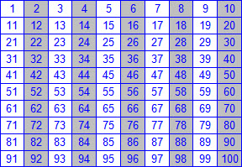  - Ex: Hundreds chart counting by fives  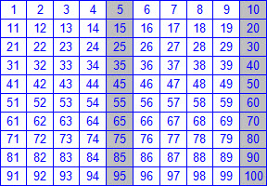  - Ex: Hundreds chart counting by tens  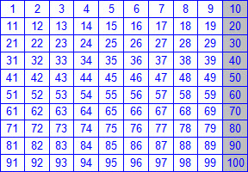  - Ex: Number line counting by twos, fives, and tens  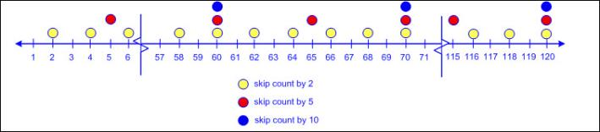  To Determine  THE VALUE OF A COLLECTION OF PENNIES, NICKELS, AND/OR DIMES  Including, but not limited to:  - Coins  - Penny: 1¢  - Nickel: 5¢  - Dime: 10¢  - Concrete and pictorial models  - Traditional and newly released designs  - Views of both sides of coins  - Collection of like coins up to 120 cents  - Collection of mixed coins up to 120 cents  - Skip counting  - Coins in like groups (e.g., dimes, nickels, pennies)  - By twos to determine the value of a collection of pennies  - 2¢, 4¢, 6¢, 8¢, …, 28¢, 30¢, 32¢, 34¢, etc.  - By fives to determine the value of a collection of nickels  - 5¢, 10¢, 15¢, 20¢, 25¢, 30¢, …, 95¢, 100¢, 105¢, 110¢, etc.  - By tens to determine the value of a collection of dimes  - 10¢, 20¢, 30¢, 40¢, 50¢, …, 80¢, 90¢, 100¢, 110¢, 120¢  - Compound counting to determine the value of a collection of mixed coins  - Separate coins into like groups prior to counting (e.g., dimes, nickels, pennies).  - Begin by counting the largest denomination of coins and then count on each denomination of coins in order from largest to smallest.  - Count dimes by tens, count on nickels by fives, count on pennies by twos or ones  - Ex:  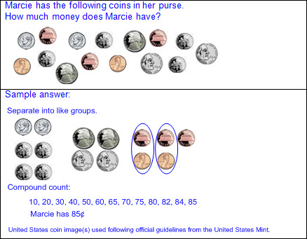  - Create a collection of coins for a given value.  - Comparison of the values of two collections of coins  - Number of coins may not be proportional to the value of the collection.  - Ex: 2 dimes have a greater value than 8 pennies, even though 2 dimes are fewer coins than 8 pennies.  - Multiple combinations of the same value  - Ex:  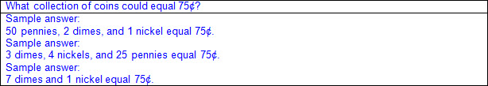  - Ex:  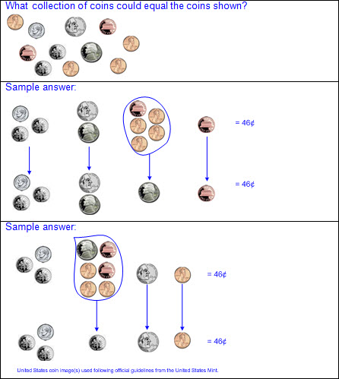  - Minimal set  - Least number of coins to equal a given value  - Ex:  Note(s):  - Grade Level(s):  - Grade 1 introduces using relationships to count by twos, fives, and tens to determine the value of a collection of pennies, nickels, and/or dimes.  - Grade 2 will determine the value of a collection of coins up to one dollar, including quarters and half-dollars.  - Various mathematical process standards will be applied to this student expectation as appropriate.  - TxRCFP:  - Developing an understanding of place value  - TxCCRS:  - IX. Communication and Representation  - X. Connections
1.5 | Algebraic reasoning. The student applies mathematical process standards to identify and apply number patterns within properties of numbers and operations in order to describe relationships. The student is expected to:
1.5A | Recite numbers forward and backward from any given number between 1 and 120.  Recite numbers forward and backward from any given number between 1 and 120.  Recite  NUMBERS FORWARD AND BACKWARD FROM ANY GIVEN NUMBER BETWEEN 1 AND 120  Including, but not limited to:  - Counting numbers (1 – 120)  - Counting (natural) numbers – the set of positive numbers that begins at one and increases by increments of one each time {1, 2, 3, ..., n}  - Number word sequence has a correct order.  - Recite – to verbalize from memory  - Development of automaticity  - Relationship to counting  - Cardinal number – a number that names the quantity of objects in a set  - Hierarchical inclusion – concept of nested numbers, meaning each prior number in the counting sequence is included in the set as the set increases (e.g., 58 is 57 increased by 1; 58 decreased by 1 is 57; etc.)  - Ex:  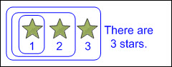  - Recite numbers forward from any given number between 1 and 120  - Orally by ones beginning with 1  - Orally by ones beginning with any given number  - Ex: Starting with 73, continue counting forward to 120 by ones.  - Orally by tens beginning with 10  - Orally by tens beginning with any given number  - Ex: Starting with 50, continue counting forward to 120 by tens.  - Ex: Starting with 58, continue counting forward to 118 by tens.  - Recite numbers backward from any given number between 1 and 120  - Orally by ones beginning with 120  - Orally by ones beginning with any given number between 1 and 120  - Ex: Starting with 73, continue counting backward to 43 by ones.  - Orally by tens beginning with 120  - Orally by tens beginning with any given number between 1 and 120  - Ex: Starting with 110, continue counting backward to 60 by tens.  - Ex: Starting with 73, continue counting backward to 33 by tens.  Note(s):  - Grade Level(s):  - Kindergarten recited numbers up to at least 100 by ones and tens beginning with any given number.  - Various mathematical process standards will be applied to this student expectation as appropriate.  - TxRCFP:  - Developing an understanding of place value  - TxCCRS:  - I. Numeric Reasoning  - IX. Communication and Representation
1.5B | Skip count by twos, fives, and tens to determine the total number of objects up to 120 in a set.  Skip count by twos, fives, and tens to determine the total number of objects up to 120 in a set.  Skip Count  BY TWOS, FIVES, AND TENS TO DETERMINE THE TOTAL NUMBER OF OBJECTS UP TO 120 IN A SET  Including, but not limited to:  - Whole numbers (0 – 120)  - Counting (natural) numbers – the set of positive numbers that begins at one and increases by increments of one each time {1, 2, 3, ..., n}  - Whole numbers – the set of counting (natural) numbers and zero {0, 1, 2, 3, ..., n}  - Skip counting – counting numbers in sequence forward or backward by a whole number other than 1  - Counting sequence can begin at any number.  - Ex:  - Determine the total number of objects in a set.  - Sets up to 120  - Skip counting by twos, fives, and tens  - More efficient than counting by ones  - Counting the same set of objects using different skip count increments results in the same total.  - Ex:  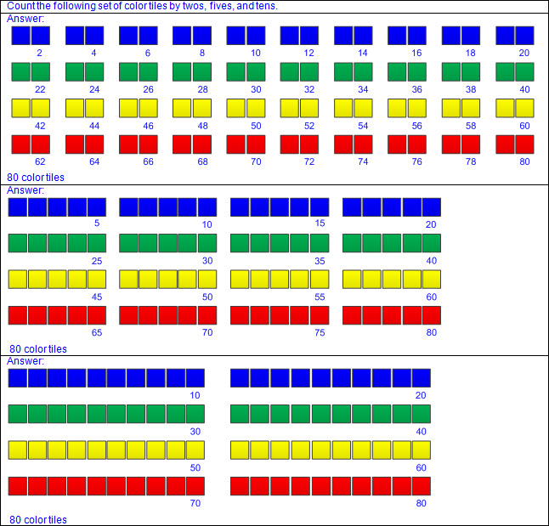  - Relationships in skip counting by twos  - When counting by twos, one number is skipped.  - When beginning with 0, all numbers counted have a 0, 2, 4, 6, or 8 in the ones place.  - Relationships when skip counting by fives  - When counting by fives, 4 numbers are skipped.  - When beginning with 0, all numbers counted alternate 0 or 5 in the ones place.  - Relationships when skip counting by tens  - When counting by tens, 9 numbers are skipped.  - When beginning with 0, all numbers counted have a 0 in the ones place.  - When beginning with any number, the digit in the ones place remains the same and the digit in the tens place increases by 1.  - When beginning with 0, all numbers counted by ten are also included in the count by twos and the count by fives.  - Relationships represented using concrete or pictorial models  - Hundreds chart, color tiles, number line, real-life objects, etc.  - Ex: Hundreds chart counting by twos  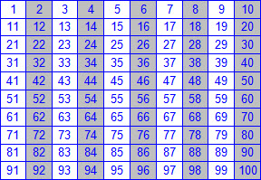  - Ex: Hundreds chart counting by fives  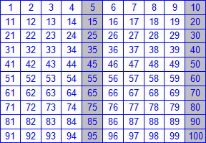  - Ex: Hundreds chart counting by tens  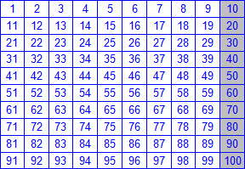  - Ex: Number line counting by twos, fives, and tens  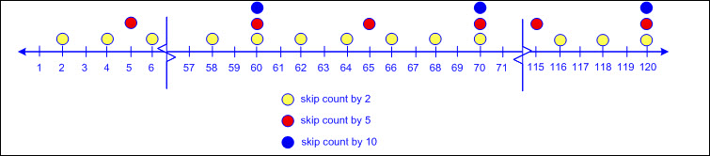  Note(s):  - Grade Level(s):  - Grade 1 introduces skip counting by twos, fives, and tens to determine the total number of objects up to 120 in a set.  - Grade 2 will determine whether a number up to 40 is even or odd using pairings of objects to represent the number.  - Various mathematical process standards will be applied to this student expectation as appropriate.  - TxRCFP:  - Developing an understanding of place value  - Solving problems involving addition and subtraction  - TxCCRS:  - I. Numeric Reasoning  - IX. Communication and Representation
1.5C | Use relationships to determine the number that is 10 more and 10 less than a given number up to 120.  Use relationships to determine the number that is 10 more and 10 less than a given number up to 120.  Use  RELATIONSHIPS TO DETERMINE THE NUMBER THAT IS 10 MORE AND 10 LESS THAN A GIVEN NUMBER UP TO 120  Including, but not limited to:  - Whole numbers (1 – 120)  - Counting (natural) numbers – the set of positive numbers that begins at one and increases by increments of one each time {1, 2, 3, ..., n}  - Whole numbers – the set of counting (natural) numbers and zero {0, 1, 2, 3, ..., n}  - Place value – the value of a digit as determined by its location in a number such as ones, tens, hundreds, etc.  - Hundreds place  - Tens place  - Ones place  - Comparative language  - Greater than, more than  - Less than, fewer than  - Relationships based on place value  - 10 more or 10 less  - Adding 1 in the tens place will generate a number that is 10 more than the original number.  - Ex:  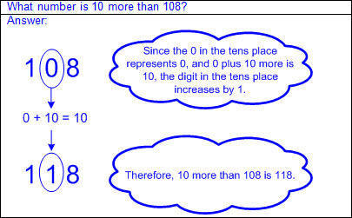  - Subtracting 1 in the tens place will generate a number that is 10 less than the original number.  - Ex:  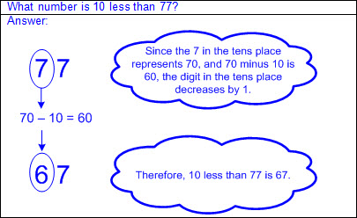  - Relationships based on patterns in concrete or pictorial models  - Hundreds chart  - Moving one row down will generate a number that is 10 more than the original number.  - Moving one row up will generate a number that is 10 less than the original number.  - Ex:  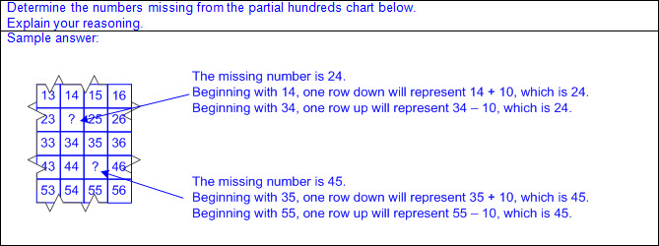  - Base-10 blocks  - Adding longs will increase a number by increments of 10.  - Removing longs will decrease a number by increments of 10.  - Ex:  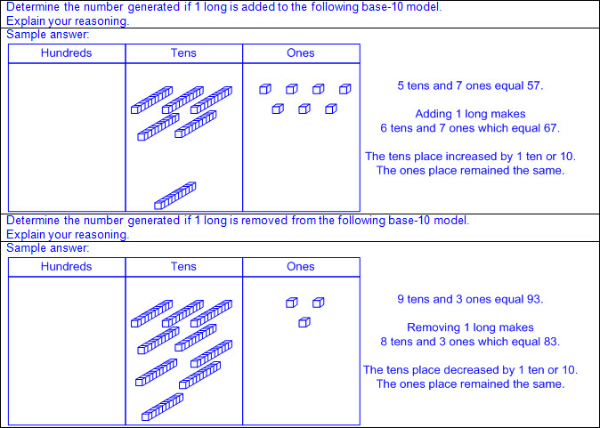  Note(s):  - Grade Level(s):  - Grade 1 introduces using relationships to determine the number that is 10 more and 10 less than a given number up to 120.  - Grade 2 will use an understanding of place value to determine the number that is 10 or 100 more or less than a given number up to 1,200.  - Various mathematical process standards will be applied to this student expectation as appropriate.  - TxRCFP:  - Developing an understanding of place value  - Solving problems involving addition and subtraction  - TxCCRS:  - I. Numeric Reasoning  - IX. Communication and Representation
1.5D | Represent word problems involving addition and subtraction of whole numbers up to 20 using concrete and pictorial models and number sentences.  Represent word problems involving addition and subtraction of whole numbers up to 20 using concrete and pictorial models and number sentences.  Represent  WORD PROBLEMS INVOLVING ADDITION OF WHOLE NUMBERS UP TO 20 USING CONCRETE AND PICTORIAL MODELS AND NUMBER SENTENCES  Including, but not limited to:  - Whole numbers  - Counting (natural) numbers – the set of positive numbers that begins at one and increases by increments of one each time {1, 2, 3, ..., n}  - Whole numbers – the set of counting (natural) numbers and zero {0, 1, 2, 3, ..., n}  - Addition  - Sum – the total when two or more addends are joined  - Addend – a number being added or joined together with another number(s)  - Addition of whole numbers within 20  - Represent mathematical and real world problem situations  - Concrete models  - Objects represent the quantities described in the problem situation.  - Base-10 blocks, linking cubes, counters, etc.  - Pictorial models  - Pictures drawn represent the quantities described in the problem situation.  - Base-10 pictorials, number lines, strip diagrams, etc.  - Solutions recorded with a number sentence  - Number sentence – a mathematical statement composed of numbers, and/or an unknown(s), and/or an operator(s), and an equality or inequality symbol  - Numbers represent the quantities described in the problem situation.  - Number sentences, or equations, with an equal sign at the beginning or end  - Ex: 10 = 6 + 4; 6 + 4 = 10  - Oral and written descriptions  - Explanation of relationship between objects, pictorials, and numbers and the information in the problem situation  - Ex:  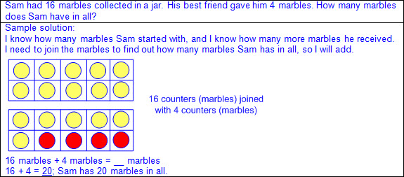  - Ex:  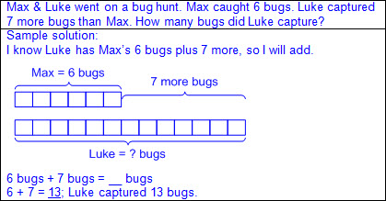  Represent  WORD PROBLEMS INVOLVING SUBTRACTION OF WHOLE NUMBERS UP TO 20 USING CONCRETE AND PICTORIAL MODELS AND NUMBER SENTENCES  Including, but not limited to:  - Whole numbers  - Counting (natural) numbers – the set of positive numbers that begins at one and increases by increments of one each time {1, 2, 3, ..., n}  - Whole numbers – the set of counting (natural) numbers and zero {0, 1, 2, 3, ..., n}  - Subtraction  - Difference – the remaining amount after the subtrahend has been subtracted from the minuend  - Minuend – a number from which another number will be subtracted  - Subtrahend – a number to be subtracted from a minuend  - Subtraction of whole numbers within 20  - Represent mathematical and real-world problem situations  - Concrete models  - Objects represent the quantities described in the problem situation.  - Base-10 blocks, linking cubes, counters, etc.  - Pictorial models  - Pictures drawn represent the quantities described in the problem situation.  - Base-10 pictorials, number lines, strip diagrams, etc.  - Solutions recorded with a number sentence  - Number sentence – a mathematical statement composed of numbers, and/or an unknown(s), and/or an operator(s), and an equality or inequality symbol  - Numbers represent the quantities described in the problem situation.  - Number sentences, or equations, with an equal sign at the beginning or end  - Ex: 6 = 10 – 4; 10 – 4 = 6  - Oral and written descriptions  - Explanation of relationship between objects, pictorials, and numbers and the information in the problem situation  - Ex:  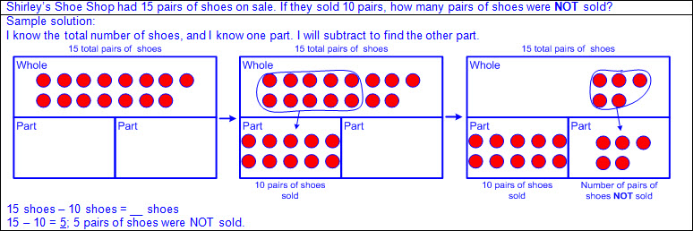  - Ex:  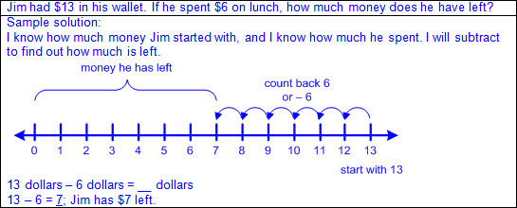  Note(s):  - Grade Level(s):  - Grade 1 introduces representing word problems involving addition and subtraction of whole numbers up to 20 using concrete and pictorial models and number sentences.  - Grade 2 will represent and solve addition and subtraction word problems where unknowns may be any one of the terms in the problem.  - Various mathematical process standards will be applied to this student expectation as appropriate.  - TxRCFP:  - Solving problems involving addition and subtraction  - TxCCRS:  - I. Numeric Reasoning  - II.D. Algebraic Reasoning – Representations  - VIII. Problem Solving and Reasoning  - IX. Communication and Representation  - X. Connections
1.5E | Understand that the equal sign represents a relationship where expressions on each side of the equal sign represent the same value(s).  Understand that the equal sign represents a relationship where expressions on each side of the equal sign represent the same value(s).  Understand  THE EQUAL SIGN REPRESENTS A RELATIONSHIP WHERE EXPRESSIONS ON EACH SIDE OF THE EQUAL SIGN REPRESENT THE SAME VALUE(S)  Including, but not limited to:  - Term – a number and/or an unknown in an expression separated by an operation symbol(s)  - Expression – a mathematical phrase, with no equal sign, that may contain a number(s), an unknown(s), and/or an operator(s)  - Equal sign – a mathematical symbol representing equivalence  - Equation – a mathematical statement composed of equivalent expressions separated by an equal sign  - Ex:  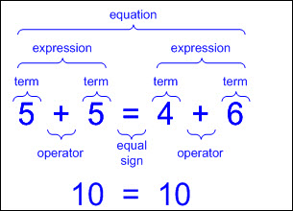  - Multi-step solutions represented with one number sentence, or equation, per step  - All expressions separated by equal signs must be equivalent.  - Ex: Joining 4, 3, and 2 would not be represented as 4 + 3 = 7 + 2 = 9 because all expressions and/or terms do not represent equivalent values.  Note(s):  - Grade Level(s):  - Grade 1 introduces an understanding that the equal sign represents a relationship where expressions on each side of the equal sign represent the same value(s).  - Grade 2 will represent and solve addition and subtraction word problems where unknowns may be any one of the terms in the problem.  - Various mathematical process standards will be applied to this student expectation as appropriate.  - TxRCFP:  - Solving problems involving addition and subtraction  - TxCCRS:  - II.D. Algebraic Reasoning – Representations  - IX. Communication and Representation
1.5F | Determine the unknown whole number in an addition or subtraction equation when the unknown may be any one of the three or four terms in the equation.  Determine the unknown whole number in an addition or subtraction equation when the unknown may be any one of the three or four terms in the equation.  Determine  THE UNKNOWN WHOLE NUMBER IN AN ADDITION OR SUBTRACTION EQUATION WHEN THE UNKNOWN MAY BE ANY ONE OF THE THREE OR FOUR TERMS IN THE EQUATION  Including, but not limited to:  - Whole numbers  - Counting (natural) numbers – the set of positive numbers that begins at one and increases by increments of one each time {1, 2, 3, ..., n}  - Whole numbers – the set of counting (natural) numbers and zero {0, 1, 2, 3, ..., n}  - Addition  - Sum – the total when two or more addends are joined  - Addend – a number being added or joined together with another number(s)  - Addition of whole numbers within 20  - Subtraction  - Difference – the remaining amount after the subtrahend has been subtracted from the minuend  - Minuend – a number from which another number will be subtracted  - Subtrahend – a number to be subtracted from a minuend  - Subtraction of whole numbers within 20  - Term – a number and/or an unknown in an expression separated by an operation symbol(s)  - Expression – a mathematical phrase, with no equal sign, that may contain a number(s), an unknown(s), and/or an operator(s)  - Equal sign – a mathematical symbol representing equivalence  - Equation – a mathematical statement composed of equivalent expressions separated by an equal sign  - Unknown as any one of the three terms in the equation  - a + b = __  - Join the addends (a + b) to determine the missing sum (c).  - a + __ = c  - Count on from the addend (a) to the sum (c) to determine the missing addend (b).  - Subtract the addend (a) from the sum (c) to determine the missing addend (b).  - Ex:  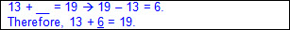  - __ + b = c  - Count on from the addend (b) to the sum (c) to determine the missing addend (a).  - Subtract the addend (b) from the sum (c) to determine the missing addend (a).  - Ex:  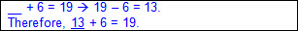  - a – b = __  - Subtract the subtrahend (b) from the minuend (a) to determine the missing difference (c).  - a – __ = c  - Count up from the difference (c) to the minuend (a) to determine the missing subtrahend (b).  - Subtract the difference (c) from the minuend (a) to determine the missing subtrahend (b).  - Ex:  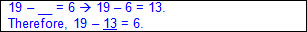  - __ – b = c  - Count up or join the subtrahend (b) and the difference (c) to determine the missing minuend (a).  - Ex:  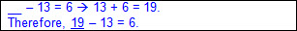  - Unknown as any one of the four terms in the equation  - __ + b = c + d  - Add the addends (c + d), and then subtract the addend (b) to determine the missing addend (a).  - Ex:  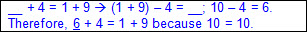  - a + __ = c + d  - Add the addends (c + d), and then subtract the addend (a) to determine the missing addend (b).  - Ex:  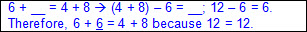  - a + b = __ + d  - Add the addends (a + b), and then subtract the addend (d) to determine the missing addend (c).  - Ex:  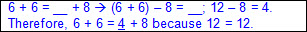  - a + b = c + __  - Add the addends (a + b), and then subtract the addend (c) to determine the missing addend (d).  - Ex:  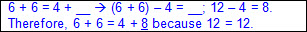  - __ – b = c – d  - Subtract to determine the difference of the minuend and subtrahend (c – d), and then add the subtrahend (b) to determine the missing minuend (a).  - Ex:  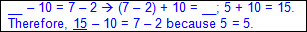  - a – __ = c – d  - Subtract to determine the difference of the minuend and subtrahend (c – d), and then subtract this difference from the minuend (a) to determine the missing subtrahend (b).  - Ex:  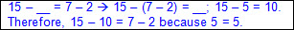  - a – b = __ – d  - Subtract to determine the difference of the minuend and subtrahend (a – b), and then add the subtrahend (d) to determine the missing minuend (c).  - Ex:  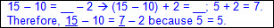  - a – b = c – __  - Subtract to determine the difference of the minuend and subtrahend (a – b), and then subtract this difference from the minuend (c) to determine the missing subtrahend (d).  - Ex:  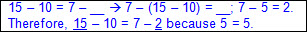  - a + b + c = __  - Join the first two addends (a + b), and then add the third addend (c) to determine the missing sum (d).  - Ex:  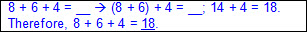  - Join the second two addends (b + c), and then add the first addend (a) to determine the missing sum (d).  - Ex:  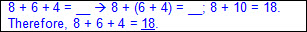  - a – b – c = __  - Subtract the first subtrahend (b) from the minuend (a), and then subtract the second subtrahend (c) from this difference to determine the missing difference (d).  - Ex:  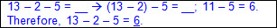  - Unknown as any one of the four terms in an equation with multiple operations  - a – b + c = __  - Subtract the second term (b) from the first term (a), and then add the third term (c) to this difference to determine the missing solution (d).  - Ex:  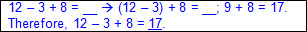  - a + b – c = __  - Add the first term (a) to the second term (b), and then subtract the third term (c) from this sum to determine the missing solution (d).  - Ex:  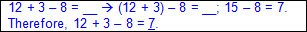  - __ + b = c – d  - Subtract the minuend and the subtrahend (c – d), and then subtract the addend (b) from this difference to determine the missing addend (a).  - Ex:  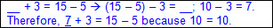  - a + __ = c – d  - Subtract the minuend and the subtrahend (c – d), and then subtract the addend (a) from this difference to determine the missing addend (b).  - Ex:  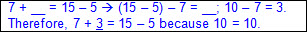  - a + b = __ – d  - Add the addends (a + b), and then add the subtrahend (d) to this sum to determine the missing minuend (c).  - Ex:  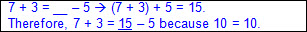  - a + b = c – __  - Add the addends (a + b), and then subtract this sum from the minuend (c) to determine the missing subtrahend (d).  - Ex:  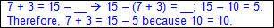  Note(s):  - Grade Level(s):  - Grade 1 introduces determining the unknown whole number in an addition or subtraction equation when the unknown may be any one of the three or four terms in the equation.  - Grade 2 will represent and solve addition and subtraction word problems where unknowns may be any one of the terms in the problem.  - Various mathematical process standards will be applied to this student expectation as appropriate.  - TxRCFP:  - Solving problems involving addition and subtraction  - TxCCRS:  - I. Numeric Reasoning  - II.D. Algebraic Reasoning – Representations  - VIII. Problem Solving and Reasoning  - IX. Communication and Representation
1.5G | Apply properties of operations to add and subtract two or three numbers.  Apply properties of operations to add and subtract two or three numbers.  Apply  PROPERTIES OF OPERATIONS TO ADD TWO OR THREE NUMBERS  Including, but not limited to:  - Whole numbers  - Counting (natural) numbers – the set of positive numbers that begins at one and increases by increments of one each time {1, 2, 3, ..., n}  - Whole numbers – the set of counting (natural) numbers and zero {0, 1, 2, 3, ..., n}  - Addition  - Sum – a number being added or joined together with another number(s)  - Addend – a number being added or joined together with another number(s)  - Addition of whole numbers within 20  - Commutative property of addition – if the order of the addends are changed, the sum will remain the same  - Two addends  - Ex:  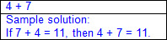  - Three addends  - Ex:  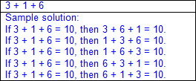  - Associative property of addition – if three or more addends are added, they can be grouped in any order, and the sum will remain the same  - Two addends  - Hidden tens  - Decompose an addend to form a tens fact.  - Ex:  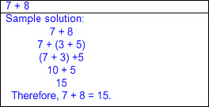  - Hidden doubles  - Decompose an addend to form a doubles fact.  - Ex:  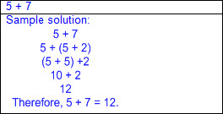  - Three addends  - Ex:  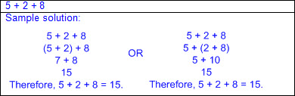  - Additive identity – the sum/difference is not affected when zero is added/subtracted to a number  - Ex: 1 + 0 = 1; 2 + 0 = 2; 3 + 0 = 3; etc.  Apply  PROPERTIES OF OPERATIONS TO SUBTRACT TWO NUMBERS  Including, but not limited to:  - Whole numbers  - Counting (natural) numbers – the set of positive numbers that begins at one and increases by increments of one each time {1, 2, 3, ..., n}  - Whole numbers – the set of counting (natural) numbers and zero {0, 1, 2, 3, ..., n}  - Subtraction  - Difference – the remaining amount after the subtrahend has been subtracted from the minuend  - Minuend – a number from which another number will be subtracted  - Subtrahend – a number to be subtracted from a minuend  - Subtraction of whole numbers within 20  - Recognition of addition and subtraction as inverse operations  - Fact families – related number sentences using the same set of numbers  - Ex:  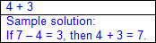  - Additive identity – the sum/difference is not affected when zero is added/subtracted to a number  - Ex: 9 – 0 = 9; 8 – 0 = 8; 7 – 0 = 7; etc.  - Subtraction is not commutative even though addition is commutative.  - Ex: 4 + 3 = 7; therefore, 3 + 4 = 7  7 – 3 = 4; however, 3 – 7 ≠ 4  Note(s):  - Grade Level(s):  - Grade 1 introduces applying properties of operations to add and subtract two or three numbers.  - Various mathematical process standards will be applied to this student expectation as appropriate.  - TxRCFP:  - Solving problems involving addition and subtraction  - TxCCRS:  - I. Numeric Reasoning  - IX. Communication and Representation
1.6 | Geometry and measurement. The student applies mathematical process standards to analyze attributes of two-dimensional shapes and three-dimensional solids to develop generalizations about their properties. The student is expected to:
1.6A | Classify and sort regular and irregular two-dimensional shapes based on attributes using informal geometric language.  Classify and sort regular and irregular two-dimensional shapes based on attributes using informal geometric language.  Classify, Sort  REGULAR AND IRREGULAR TWO-DIMENSIONAL SHAPES BASED ON ATTRIBUTES USING INFORMAL GEOMETRIC LANGUAGE  Including, but not limited to:  - Two-dimensional figure – a flat figure  - Sort – grouping objects or figures by a shared characteristic or attribute  - Classify – applying an attribute to categorize a sorted group  - Attributes of two-dimensional figures – characteristics that define a geometric figure (e.g., sides [outer edges], vertices [corners], etc.)  - Properties of two-dimensional figures – relationship of attributes within a geometric figure (e.g., a square has 4 sides [outer edges] that appear to be the same length and 4 square corners, etc.) and between a group of geometric figures (e.g., a square and a rectangle both have 4 sides [outer edges] and 4 square corners; however, a square has 4 sides [outer edges] that appear to be the same length but a rectangle has only opposite sides [outer edges] that appear to be the same length; etc.)  - Attributes of two-dimensional figures  - Side – a straight outer boundary between two vertices (line segment) of a two-dimensional figure  - Number of sides  - Length of sides  - Vertex (vertices) in a two-dimensional figure – the point (corner) where two sides (outer edges) of a two-dimensional figure meet  - Number of vertices  - Types of corners  - Square corners  - Square corners can be determined using the corner of a known square or rectangle (e.g., sticky note, sheet of paper, etc.).  - Ex:  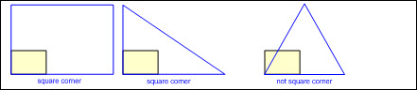  - May have a box in corner to represent square corner  - Ex:  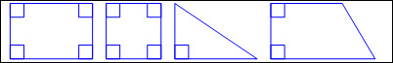  - Not square corners  - Opposite corners  - Attributes that do not identify a two-dimensional figure  - Orientation  - Size  - Color  - Texture  - Types of two-dimensional figures  - Circle  - A round, flat figure  - No straight sides (outer edges)  - No vertices (corners)  - Ex:  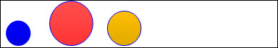  - Triangle  - 3 straight sides (outer edges)  - 3 vertices (corners)  - Regular triangle – a triangle with side (outer edge) lengths and corners that appear to be the same or equal  - Ex:  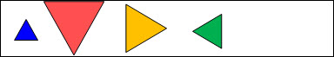  - Irregular triangle – a triangle with side (outer edge) lengths and/or corners that appear to be different or unequal  - Ex:  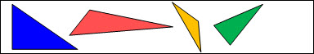  - Rectangle  - 4 straight sides (outer edges)  - 4 vertices (corners)  - Opposite sides equal in length  - 4 square corners  - Ex:  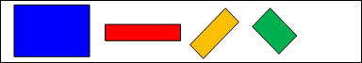  - Rhombus  - 4 straight sides (outer edges)  - 4 vertices (corners)  - All sides equal in length  - Opposite corners equal  - Ex:  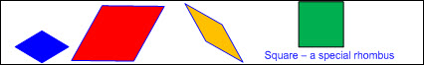  - Square (a special type of rectangle and a special type of rhombus)  - 4 straight sides (outer edges)  - 4 vertices (corners)  - All sides equal in length  - Opposite sides equal in length  - 4 square corners  - Opposite corners equal  - Ex:  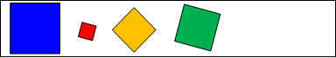  - Hexagon  - 6 straight sides (outer edges)  - 6 vertices (corners)  - Regular hexagon – a hexagon with side (outer edge) lengths and corners that appear to be the same or equal  - Ex:  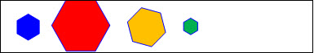  - Irregular hexagon – a hexagon with side (outer edge) lengths and/or corners that appear to be different or unequal  - Ex:  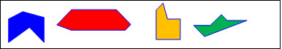  - Concrete models (e.g., wood or plastic figures, etc.) and pictorial models (e.g., drawings, images, etc.)  - Collection of two-dimensional figures  - Sort and justify  - Rule used for sorting expressed  - Attributes and properties of geometric figures expressed  - Existence (have) and absence (do not have) of attributes and properties expressed (e.g., figures that have “a common attribute” and figures that do not have “a common attribute”)  - Ex:  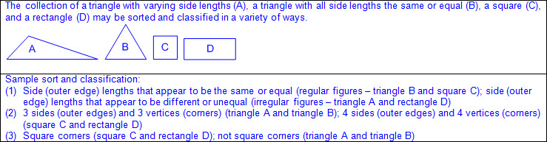  Note(s):  - Grade Level(s):  - Kindergarten classified and sorted a variety of regular and irregular two- and three-dimensional figures regardless of orientation or size.  - Grade 2 will classify and sort polygons with 12 or fewer sides according to attributes, including identifying the number of sides and number of vertices.  - Various mathematical process standards will be applied to this student expectation as appropriate.  - TxRCFP:  - Analyzing attributes of two-dimensional shapes and three-dimensional solids  - TxCCRS:  - III.A. Geometric Reasoning – Figures and their properties  - IX. Communication and Representation
1.6B | Distinguish between attributes that define a two-dimensional or three-dimensional figure and attributes that do not define the shape.  Distinguish between attributes that define a two-dimensional or three-dimensional figure and attributes that do not define the shape.  Distinguish  BETWEEN ATTRIBUTES THAT DEFINE A TWO-DIMENSIONAL FIGURE AND ATTRIBUTES THAT DO NOT DEFINE THE SHAPE  Including, but not limited to:  - Two-dimensional figure – a flat figure  - Attributes of two-dimensional figures – characteristics that define a geometric figure (e.g., sides [outer edges], vertices [corners], etc.)  - Properties of two-dimensional figures – relationship of attributes within a geometric figure (e.g., a square has 4 sides [outer edges] that appear to be the same length and 4 square corners, etc.) and between a group of geometric figures (e.g., a square and a rectangle both have 4 sides [outer edges] and 4 square corners; however, a square has 4 sides [outer edges] that appear to be the same length but a rectangle has only opposite sides [outer edges] that appear to be the same length; etc.)  - Attributes of two-dimensional figures  - Side – a straight outer boundary between two vertices (line segment) of a two-dimensional figure  - Number of sides  - Length of sides  - Vertex (vertices) in a two-dimensional figure – the point (corner) where two sides (outer edges) of a two-dimensional figure meet  - Number of vertices  - Types of corners  - Square corners  - Square corners can be determined using the corner of a known square or rectangle (e.g., sticky note, sheet of paper, etc.).  - Ex:  - May have a box in corner to represent square corner  - Ex:  - Not square corners  - Opposite corners  - Attributes that do not define a two-dimensional figure  - Orientation  - Size  - Color  - Texture  Distinguish  BETWEEN ATTRIBUTES THAT DEFINE A THREE-DIMENSIONAL FIGURE AND ATTRIBUTES THAT DO NOT DEFINE THE SHAPE  Including, but not limited to:  - Three-dimensional figure – a solid figure  - Attributes of three-dimensional figures – characteristics that define a geometric figure (e.g., faces [flat surfaces], curved surfaces, edges, vertices, etc.)  - Properties of three-dimensional figures – relationship of attributes within a geometric figure (e.g., a cylinder can roll on its curved surface and stand or slide on its face [flat surface], etc.) and between a group of geometric figures (e.g., a cylinder and a cube can both stand or slide on their faces [flat surfaces]; however, a cylinder can also roll on its curved surface; etc.)  - Attributes that define a three-dimensional figure  - Surfaces  - Curved surface  - Flat surface  - Face of a prism – a flat figure with straight sides that forms the surface of a prism  - Number of faces  - Shape of faces  - Edge – where the sides of two faces meet on a three-dimensional figure  - Number of edges  - Vertex (vertices) in a three-dimensional figure – the point (corner) where three or more edges of a three-dimensional figure meet  - Number of vertices  - Attributes that do not define a three-dimensional figure  - Orientation  - Size  - Color  - Texture  Note(s):  - Grade Level(s):  - Kindergarten identified two-dimensional components of three-dimensional objects.  - Various mathematical process standards will be applied to this student expectation as appropriate.  - TxRCFP:  - Analyzing attributes of two-dimensional shapes and three-dimensional solids  - TxCCRS:  - III.A. Geometric Reasoning – Figures and their properties  - IX. Communication and Representation
1.6C | Create two-dimensional figures, including circles, triangles, rectangles, and squares, as special rectangles, rhombuses, and hexagons.  Create two-dimensional figures, including circles, triangles, rectangles, and squares, as special rectangles, rhombuses, and hexagons.  Create  TWO-DIMENSIONAL FIGURES, INCLUDING CIRCLES, TRIANGLES, RECTANGLES, AND SQUARES, AS SPECIAL RECTANGLES, RHOMBUSES, AND HEXAGONS  Including, but not limited to:  - Variety of materials and drawings  - Computer programs  - Art materials  - Ex: crayons, chenille sticks, toothpicks, yarn, paint, geoboard, cutting paper, dot paper, grid paper, etc.  - Two-dimensional figure – a flat figure  - Spatial visualization – creation and manipulation of mental representations of shapes  - Attributes of two-dimensional figures  - Side – a straight outer boundary between two vertices (line segment) of a two-dimensional figure  - Number of sides  - Length of sides  - Vertex (vertices) in a two-dimensional figure – the point (corner) where two sides (outer edges) of a two-dimensional figure meet  - Number of vertices  - Types of corners  - Square corners  - Square corners can be determined using the corner of a known square or rectangle (e.g., sticky note, sheet of paper, etc.).  - Ex:  - May have a box in corner to represent square corner  - Ex:  - Not square corners  - Opposite corners  - Attributes that do not identify a two-dimensional figure  - Orientation  - Size  - Color  - Texture  - Create two-dimensional figures based on attributes  - Circle  - A round, flat figure  - No straight sides (outer edges)  - No vertices (corners)  - Ex:  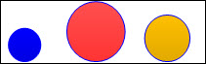  - Triangle  - 3 straight sides (outer edges)  - 3 vertices (corners)  - Regular triangle – a triangle with side (outer edge) lengths and corners that appear to be the same or equal  - Ex:  - Irregular triangle – a triangle with side (outer edge) lengths and/or corners that appear to be different or unequal  - Ex:  - Rectangle  - 4 straight sides (outer edges)  - 4 vertices (corners)  - Opposite sides equal in length  - 4 square corners  - Ex:  - Rhombus  - 4 straight sides (outer edges)  - 4 vertices (corners)  - All sides equal in length  - Opposite corners equal  - Ex:  - Square (a special type of rectangle and a special type of rhombus)  - 4 straight sides (outer edges)  - 4 vertices (corners)  - All sides equal in length  - Opposite sides equal in length  - 4 square corners  - Opposite corners equal  - Ex:  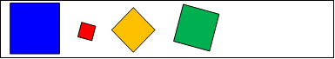  - Hexagon  - 6 straight sides (outer edges)  - 6 vertices (corners)  - Regular hexagon – a hexagon with side (outer edge) lengths and corners that appear to be the same or equal  - Ex:  - Irregular hexagon – a hexagon with side (outer edge) lengths and/or corners that appear to be different or unequal  - Ex:  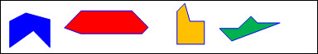  Note(s):  - Grade Level(s):  - Kindergarten identified two-dimensional shapes, including circles, triangles, rectangles, and squares as special rectangles.  - Kindergarten created two-dimensional shapes using a variety of materials and drawings.  - Grade 2 will create two-dimensional shapes based on given attributes, including number of sides and vertices.  - Various mathematical process standards will be applied to this student expectation as appropriate.  - TxRCFP:  - Analyzing attributes of two-dimensional shapes and three-dimensional solids  - TxCCRS:  - III.A. Geometric Reasoning – Figures and their properties  - IX. Communication and Representation
1.6D | Identify two-dimensional shapes, including circles, triangles, rectangles, and squares, as special rectangles, rhombuses, and hexagons and describe their attributes using formal geometric language.  Identify two-dimensional shapes, including circles, triangles, rectangles, and squares, as special rectangles, rhombuses, and hexagons and describe their attributes using formal geometric language.  Identify  TWO-DIMENSIONAL SHAPES, INCLUDING CIRCLES, TRIANGLES, RECTANGLES, AND SQUARES, AS SPECIAL RECTANGLES, RHOMBUSES, AND HEXAGONS  Including, but not limited to:  - Two-dimensional figure – a flat figure  - Names of two-dimensional shapes  - Circle  - Triangle  - Rectangle  - Rhombus  - Square (a special type of rectangle and a special type of rhombus)  - Hexagon  - Identify two-dimensional shapes in the real-world  - Circle  - Pizza, coin, etc.  - Triangle  - Pizza slice, yield sign, etc.  - Rectangle  - Door, TV screen, etc.  - Rhombus  - Kite, baseball diamond, etc.  - Square (a special type of rectangle and a special type of rhombus)  - Floor tiles, pizza box lid, etc.  - Hexagon  - Beehive hole, soccer ball pattern, etc.  Describe  ATTRIBUTES OF TWO-DIMENSIONAL SHAPES USING FORMAL GEOMETRIC LANGUAGE  Including, but not limited to:  - Two-dimensional figure – a flat figure  - Attributes of two-dimensional figures – characteristics that define a geometric figure (e.g., sides [outer edges], vertices [corners], etc.)  - Properties of two-dimensional figures – relationship of attributes within a geometric figure (e.g., a square has 4 sides [outer edges] that appear to be the same length and 4 square corners, etc.) and between a group of geometric figures (e.g., a square and a rectangle both have 4 sides [outer edges] and 4 square corners; however, a square has 4 sides [outer edges] that appear to be the same length but a rectangle has only opposite sides [outer edges] that appear to be the same length; etc.)  - Attributes of two-dimensional figures  - Side – a straight outer boundary between two vertices (line segment) of a two-dimensional figure  - Number of sides  - Length of sides  - Vertex (vertices) in a two-dimensional figure – the point (corner) where two sides (outer edges) of a two-dimensional figure meet  - Number of vertices  - Types of corners  - Square corners  - Square corners can be determined using the corner of a known square or rectangle (e.g., sticky note, sheet of paper, etc.).  - Ex:  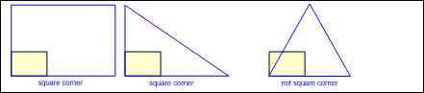  - May have a box in corner to represent square corner  - Ex:  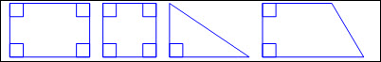  - Not square corners  - Opposite corners  - Attributes that do not identify a two-dimensional figure  - Orientation  - Size  - Color  - Texture  - Types of two-dimensional figures  - Circle  - A round, flat figure  - No straight sides (outer edges)  - No vertices (corners)  - Ex:  - Triangle  - 3 straight sides (outer edges)  - 3 vertices (corners)  - Regular triangle – a triangle with side (outer edge) lengths and corners that appear to be the same or equal  - Ex:  - Irregular triangle – a triangle with side (outer edge) lengths and/or corners that appear to be different or unequal  - Ex:  - Rectangle  - 4 straight sides (outer edges)  - 4 vertices (corners)  - Opposite sides equal in length  - 4 square corners  - Ex:  - Rhombus  - 4 straight sides (outer edges)  - 4 vertices (corners)  - All sides equal in length  - Opposite corners equal  - Ex:  - Square (a special type of rectangle and a special type of rhombus)  - 4 straight sides (outer edges)  - 4 vertices (corners)  - All sides equal in length  - Opposite sides equal in length  - 4 square corners  - Opposite corners equal  - Ex:  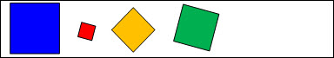  - Hexagon  - 6 straight sides (outer edges)  - 6 vertices (corners)  - Regular hexagon – a hexagon with side (outer edge) lengths and corners that appear to be the same or equal  - Ex:  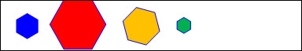  - Irregular hexagon – a hexagon with side (outer edge) lengths and/or corners that appear to be different or unequal  - Ex:  Note(s):  - Grade Level(s):  - Kindergarten identified attributes of two-dimensional shapes using informal and formal geometric language interchangeably.  - Grade 2 will create two-dimensional shapes based on given attributes, including number of sides and vertices.  - Various mathematical process standards will be applied to this student expectation as appropriate.  - TxRCFP:  - Analyzing attributes of two-dimensional shapes and three-dimensional solids  - TxCCRS:  - III.A. Geometric Reasoning – Figures and their properties  - IX. Communication and Representation
1.6E | Identify three-dimensional solids, including spheres, cones, cylinders, rectangular prisms (including cubes), and triangular prisms, and describe their attributes using formal geometric language.  Identify three-dimensional solids, including spheres, cones, cylinders, rectangular prisms (including cubes), and triangular prisms, and describe their attributes using formal geometric language.  Identify  THREE-DIMENSIONAL SOLIDS, INCLUDING SPHERES, CONES, CYLINDERS, RECTANGULAR PRISMS (INCLUDING CUBES), AND TRIANGULAR PRISMS  Including, but not limited to:  - Three-dimensional figure – a solid figure  - Names of three-dimensional figures  - Sphere  - Cone  - Cylinder  - Rectangular prism  - Cube (special rectangular prism)  - Triangular prism  - Identify three-dimensional shapes in the real-world  - Sphere  - Globe, ball, etc.  - Cone  - Party hat, ice cream cone, etc.  - Cylinder  - Can, paper towel roll, etc.  - Rectangular prism  - Tissue box, shoe box, etc.  - Cube (special rectangular prism)  - Alphabet block, die, etc.  - Triangular prism  - Tent, a Toblerone® candy box, etc.  Describe  ATTRIBUTES OF THREE-DIMENSIONAL SOLIDS USING FORMAL GEOMETRIC LANGUAGE  Including, but not limited to:  - Three-dimensional figure – a solid figure  - Attributes of three-dimensional figures – characteristics that define a geometric figure (e.g., faces [flat surfaces], curved surfaces, edges, vertices, etc.)  - Properties of three-dimensional figures – relationship of attributes within a geometric figure (e.g., a cylinder can roll on its curved surface and stand or slide on its face [flat surface], etc.) and between a group of geometric figures (e.g., a cylinder and a cube can both stand or slide on their faces [flat surfaces]; however, a cylinder can also roll on its curved surface; etc.)  - Attributes of three-dimensional figures using formal language  - Surfaces  - Curved surface  - Flat surface  - Face of a prism – a flat figure with straight sides that forms the surface of a prism  - Number of faces  - Shape of faces  - Edge – where the sides of two faces meet on a three-dimensional figure  - Number of edges  - Vertex (vertices) in a three-dimensional figure – the point (corner) where three or more edges of a three-dimensional figure meet  - Number of vertices  - Attributes that do not identify a three-dimensional figure  - Orientation  - Size  - Color  - Texture  - Types of three-dimensional figures  - Curved surface three-dimensional figures  - Sphere  - 1 curved surface forming a solid round figure  - Rolls  - Ex:  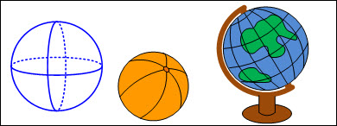  - Cone  - 1 flat surface shaped like a circle  - 1 curved surface  - 1 vertex  - Rolls, slides  - Ex:  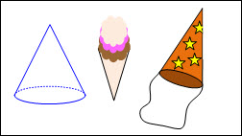  - Cylinder  - 2 equal, opposite, flat surfaces shaped like circles  - 1 curved surface  - Rolls, slides, stacks  - Ex:  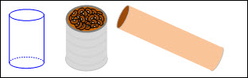  - Prisms  - Rectangular prism  - 6 rectangular faces  - 12 edges  - 8 vertices  - Slides, stacks  - Ex:  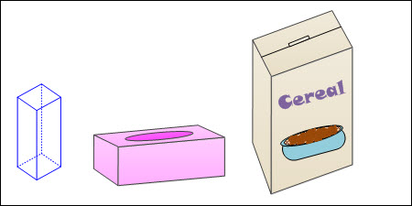  - Cube (special rectangular prism)  - 6 square faces  - 12 edges  - 8 vertices  - Slides, stacks  - Ex:  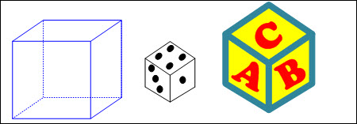  - Triangular prism  - 5 faces (2 triangular faces, 3 rectangular faces)  - 9 edges  - 6 vertices  - Slides, stacks  - Ex:  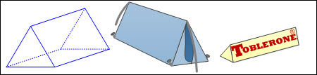  Note(s):  - Grade Level(s):  - Kindergarten identified three-dimensional solids, including cylinders, cones, spheres, and cubes, in the real world.  - Various mathematical process standards will be applied to this student expectation as appropriate.  - TxRCFP:  - Analyzing attributes of two-dimensional shapes and three-dimensional solids  - TxCCRS:  - III.A. Geometric Reasoning – Figures and their properties  - IX. Communication and Representation
1.6F | Compose two-dimensional shapes by joining two, three, or four figures to produce a target shape in more than one way if possible.  Compose two-dimensional shapes by joining two, three, or four figures to produce a target shape in more than one way if possible.  Compose  TWO-DIMENSIONAL SHAPES BY JOINING TWO, THREE, OR FOUR FIGURES TO PRODUCE A TARGET SHAPE IN MORE THAN ONE WAY IF POSSIBLE  Including, but not limited to:  - Two-dimensional figure – a flat figure  - Spatial visualization – creation and manipulation of mental representations of shapes  - Compose figures – to combine smaller geometric figures to form a larger geometric figure  - Compose two-dimensional shapes using a variety of concrete models.  - Ex: Color tiles, pattern blocks, tangrams, attribute shapes, etc.  - Compose regular and irregular figures to produce a target shape.  - Multiple compositions if possible  - Ex: Join three rhombuses to produce a hexagon.  - Ex: Join six squares to produce a rectangle.  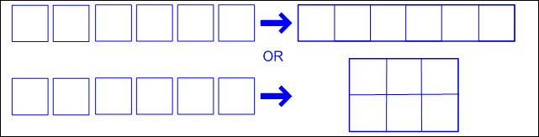  - Ex: Join four squares to produce a square.  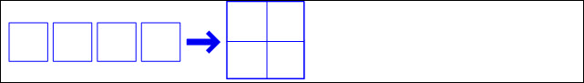  - Ex: Join a square and a rectangle to produce a hexagon.  - Ex: Join a square and two triangles to produce a hexagon.  - Ex: Join two triangles to produce a square.  Note(s):  - Grade Level(s):  - Kindergarten created two-dimensional shapes using a variety of materials and drawings.  - Grade 2 will compose two-dimensional shapes and three-dimensional solids with given properties or attributes.  - Various mathematical process standards will be applied to this student expectation as appropriate.  - TxRCFP:  - Analyzing attributes of two-dimensional shapes and three-dimensional solids  - TxCCRS:  - III.A. Geometric Reasoning – Figures and their properties  - IX. Communication and Representation
1.6G | Partition two-dimensional figures into two and four fair shares or equal parts and describe the parts using words.  Partition two-dimensional figures into two and four fair shares or equal parts and describe the parts using words.  Partition  TWO-DIMENSIONAL FIGURES INTO TWO AND FOUR FAIR SHARES OR EQUAL PARTS  Including, but not limited to:  - Two-dimensional figure – a flat figure  - Spatial visualization – creation and manipulation of mental representations of shapes  - Partition figures – to separate a geometric figure into two or more smaller geometric figures  - Partition two-dimensional shapes using a variety of concrete models and materials.  - Ex: Color tiles, pattern blocks, tangrams, attribute shapes, paper, scissors, etc.  - Two-dimensional figures partitioned into two and four fair shares or equal parts  - Resulting parts equal in size and shape  - Ex:  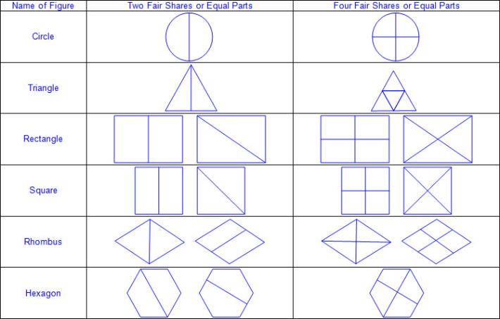  Describe  THE FAIR SHARES OR EQUAL PARTS OF TWO-DIMENSIONAL FIGURES USING WORDS  Including, but not limited to:  - Appropriate oral and written mathematical language  - Two equal parts or fair shares  - Halves  - Half of  - One out of two equal parts  - Ex:  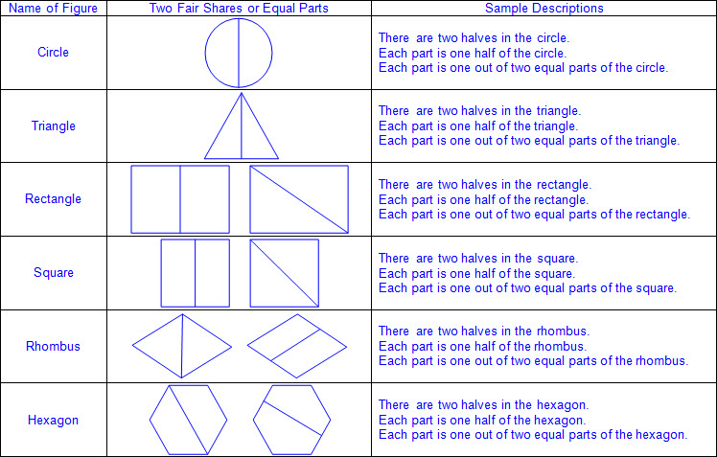  - Four equal parts or fair shares  - Fourths  - Fourth of  - Quarters  - Quarter of  - One out of four equal parts  - Ex:  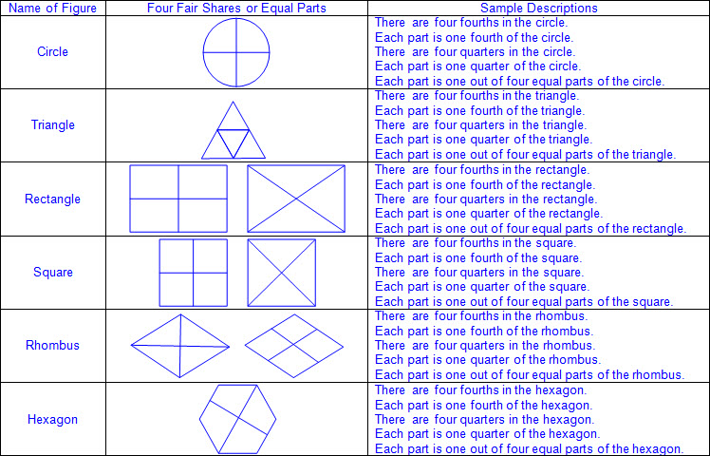  Note(s):  - Grade Level(s):  - Grade 1 introduces partitioning two-dimensional figures into two and four fair shares or equal parts and describing the parts using words.  - Grade 2 will partition objects into equal parts and name the parts, including halves, fourths, and eighths, using words.  - Various mathematical process standards will be applied to this student expectation as appropriate.  - TxRCFP:  - Analyzing attributes of two-dimensional shapes and three-dimensional solids  - TxCCRS:  - III.A. Geometric Reasoning – Figures and their properties  - IX. Communication and Representation
1.6H | Identify examples and non-examples of halves and fourths.  Identify examples and non-examples of halves and fourths.  Identify  EXAMPLES AND NON-EXAMPLES OF HALVES AND FOURTHS  Including, but not limited to:  - Halves – two equal parts of a partitioned figure  - Examples and non-examples of halves  - Ex:  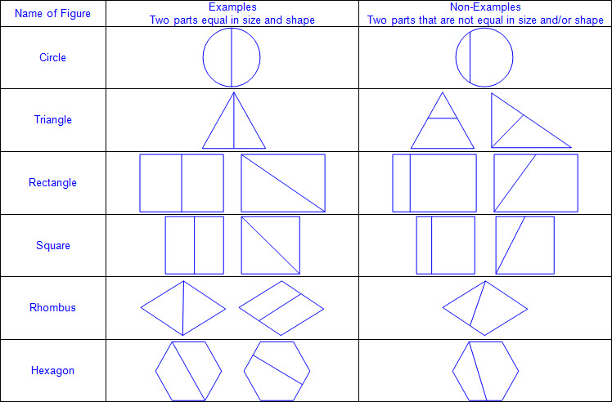  - Fourths – four equal parts of a partitioned figure  - Examples and non-examples of fourths  - Ex:  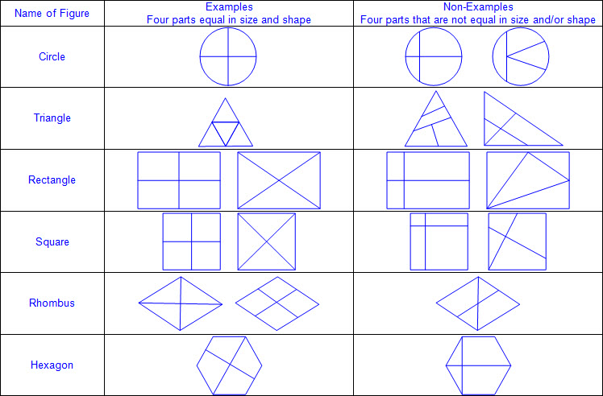  Note(s):  - Grade Level(s):  - Grade 1 introduces identifying examples and non-examples of halves and fourths.  - Various mathematical process standards will be applied to this student expectation as appropriate.  - TxRCFP:  - Grade Level Connections (reinforces previous learning and/or provides development for future learning)  - TxCCRS:  - III.A. Geometric Reasoning – Figures and their properties  - IX. Communication and Representation
1.7 | Geometry and measurement. The student applies mathematical process standards to select and use units to describe length and time. The student is expected to:
1.7A | Use measuring tools to measure the length of objects to reinforce the continuous nature of linear measurement.  Use measuring tools to measure the length of objects to reinforce the continuous nature of linear measurement.  Use  MEASURING TOOLS TO MEASURE THE LENGTH OF OBJECTS TO REINFORCE THE CONTINUOUS NATURE OF LINEAR MEASUREMENT  Including, but not limited to:  - Length – the measurement attribute that describes a continuous distance from end to end  - Linear measurement – the measurement of length along a continuous line or curve  - Starting point and ending point defined  - Continuous line may bend or curve, but not break  - Non-standard measuring tools to reinforce the continuous nature of linear measurement  - Ribbon, yarn, string, adding machine tape, etc.  - Ex:  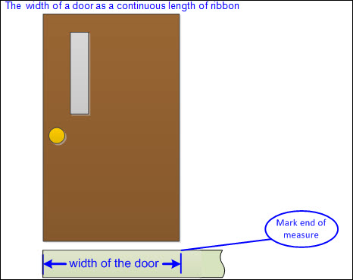  - Ex:  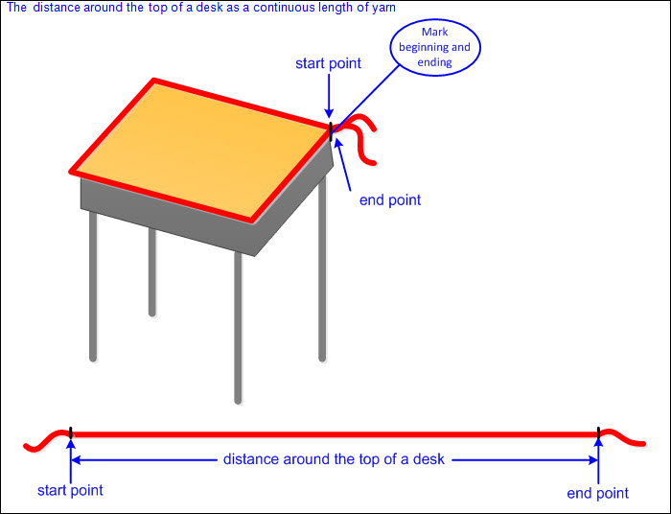  Note(s):  - Grade Level(s):  - Kindergarten gave an example of a measurable attribute of a given object, including length, capacity, and weight.  - Grade 2 will determine the length of an object to the nearest marked unit using rulers, yardsticks, meter sticks, or measuring tapes.  - Various mathematical process standards will be applied to this student expectation as appropriate.  - TxRCFP:  - Developing the understanding of length  - TxCCRS:  - IV.A. Measurement Reasoning – Measurement involving physical and natural attributes  - IX. Communication and Representation
1.7B | Illustrate that the length of an object is the number of same-size units of length that, when laid end-to-end with no gaps or overlaps, reach from one end of the object to the other.  Illustrate that the length of an object is the number of same-size units of length that, when laid end-to-end with no gaps or overlaps, reach from one end of the object to the other.  Illustrate  THAT THE LENGTH OF AN OBJECT IS THE NUMBER OF SAME-SIZE UNITS OF LENGTH THAT, WHEN LAID END-TO-END WITH NO GAPS OR OVERLAPS, REACH FROM ONE END OF THE OBJECT TO THE OTHER  Including, but not limited to:  - Length – the measurement attribute that describes a continuous distance from end to end  - Unit of length – the object or unit used to measure length  - Non-standard units of length  - Color tiles, linking cubes, paper clips, measuring rods, toothpicks, craft sticks, etc.  - Linear measurement – the measurement of length along a continuous line or curve  - Starting point and ending point defined  - Ex:  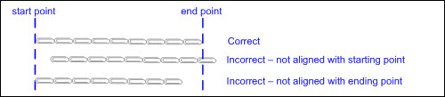  - Equal sized units of length placed end to end along the distance being measured  - Ex:  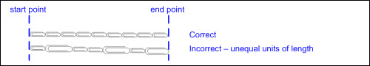  - Equal sized units of length iterated (repeated) with no gaps or overlays  - Ex:  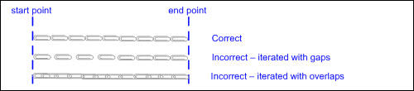  - Length measured using one-dimensional units of length (e.g., if measuring with a color tile, measure with the edge, not the area of the color tile; if measuring with a paper clip, measure with either the length or width of the paper clip, not a combination of lengths and widths; etc.)  - Ex:  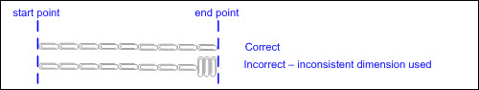  - Equal sized units of length counted to the nearest whole unit  - Last unit is not counted if the end point falls less than half-way along the unit.  - Last unit is counted if the end point falls half-way, or more than half-way, along the unit.  - Ex:  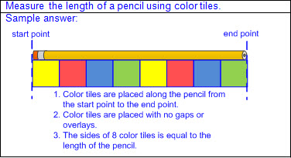  - Ex:  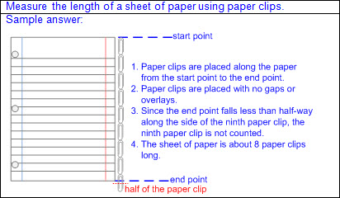  - Ex:  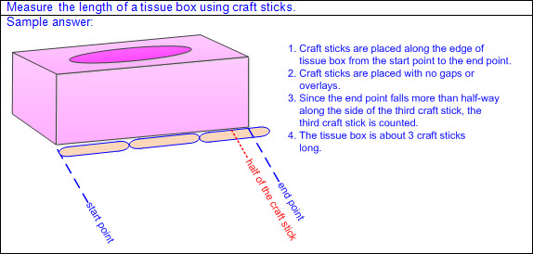  - Unit of length selected for efficiency  - Smaller unit of length to measure shorter objects or distances  - Ex:  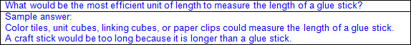  - Larger unit of length to measure longer objects or distances  - Ex:  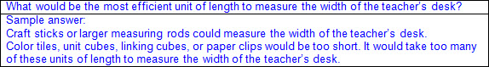  - Unit of length selected for precision  - Smaller unit of length results in a more precise measurement when measuring to the whole unit.  - Larger unit of length results in a less precise measurement when measuring to the whole unit.  Note(s):  - Grade Level(s):  - Grade 1 introduces illustrating that the length of an object is the number of same-size units of length that, when laid end-to-end with no gaps or overlaps, reach from one end of the object to the other.  - Grade 2 will find the length of objects using concrete models for standard units of length.  - Various mathematical process standards will be applied to this student expectation as appropriate.  - TxRCFP:  - Developing the understanding of length  - TxCCRS:  - IV.A. Measurement Reasoning – Measurement involving physical and natural attributes  - IX. Communication and Representation
1.7C | Measure the same object/distance with units of two different lengths and describe how and why the measurements differ.  Measure the same object/distance with units of two different lengths and describe how and why the measurements differ.  Measure  THE SAME OBJECT/DISTANCE WITH UNITS OF TWO DIFFERENT LENGTHS  Including, but not limited to:  - Length – the measurement attribute that describes a continuous distance from end to end  - Unit of length – the object or unit used to measure length  - Non-standard units of length  - Color tiles, linking cubes, paper clips, measuring rods, toothpicks, craft sticks, etc.  - Equal sized units of length counted to the nearest whole unit  - Last unit is not counted if the end point falls less than half-way along the unit.  - Last unit is counted if the end point falls half-way, or more than half-way, along the unit.  - Linear measurement – the measurement of length along a continuous line or curve  - Starting point and ending point defined  - Equal sized units of length placed end to end along the distance being measured  - Equal sized units of length iterated (repeated) with no gaps or overlays  - Length measured using one-dimensional units of length (e.g., if measuring with a color tile, measure with the edge, not the area of the color tile; if measuring with a paper clip, measure with either the length or width of the paper clip, not a combination of lengths and widths; etc.)  - Equal sized units of length counted to the nearest whole unit  - Last unit is not counted if the end point falls less than half-way along the unit.  - Last unit is counted if the end point falls half-way, or more than half-way, along the unit.  - Measure the same object with different sized units of length.  - Ex:  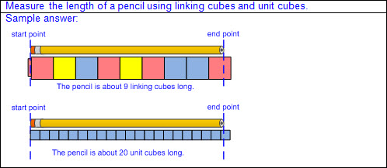  Describe  HOW AND WHY THE MEASUREMENTS OF THE SAME OBJECT/DISTANCE MEASURED WITH UNITS OF TWO DIFFERENT LENGTHS DIFFER  Including, but not limited to:  - Length – the measurement attribute that describes a continuous distance from end to end  - Unit of length – the object or unit used to measure length  - Non-standard units of length  - Color tiles, linking cubes, paper clips, measuring rods, toothpicks, craft sticks, etc.  - Compare the measurements of the same object with different sized units of length.  - Description of how the measurements differ  - Measurements described using a number and unit label  - Description of why the measurements differ  - The shorter the unit of length, the more units counted  - The longer the unit of length, the fewer units counted  - Ex:  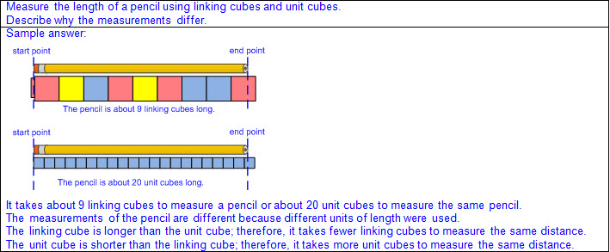  Note(s):  - Grade Level(s):  - Grade 1 introduces measuring the same object/distance with units of two different lengths and describing how and why the measurements differ.  - Grade 2 will describe the inverse relationship between the size of the unit and the number of units needed to equal the length of an object.  - Various mathematical process standards will be applied to this student expectation as appropriate.  - TxRCFP:  - Developing the understanding of length  - TxCCRS:  - IV.A. Measurement Reasoning – Measurement involving physical and natural attributes  - IX. Communication and Representation
1.7D | Describe a length to the nearest whole unit using a number and a unit.  Describe a length to the nearest whole unit using a number and a unit.  Describe  A LENGTH TO THE NEAREST WHOLE UNIT USING A NUMBER AND A UNIT  Including, but not limited to:  - Length – the measurement attribute that describes a continuous distance from end to end  - Unit of length – the object or unit used to measure length  - Non-standard units of length  - Color tiles, linking cubes, paper clips, measuring rods, toothpicks, craft sticks, etc.  - Measurement named using a number and a unit  - Equal sized units of length counted to the nearest whole unit  - Last unit is not counted if the end point falls less than half-way along the unit.  - Last unit is counted if the end point falls half-way, or more than half-way, along the unit.  - Ex:  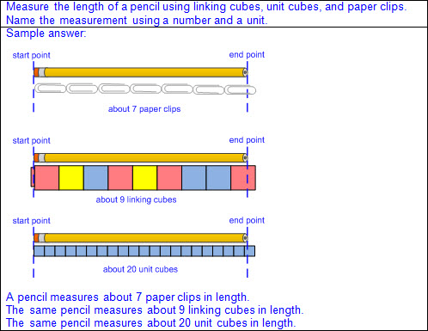  - Ex:  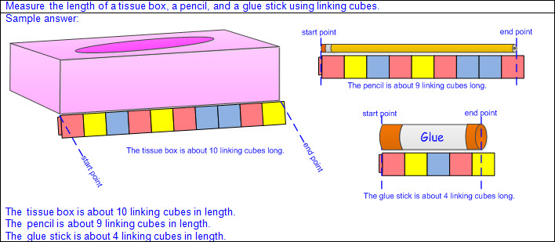  Note(s):  - Grade Level(s):  - Grade 2 will find the length of objects using concrete models for standard units of length.  - Various mathematical process standards will be applied to this student expectation as appropriate.  - TxRCFP:  - Developing the understanding of length  - TxCCRS:  - IV.A. Measurement Reasoning – Measurement involving physical and natural attributes  - IX. Communication and Representation
1.7E | Tell time to the hour and half hour using analog and digital clocks.  Tell time to the hour and half hour using analog and digital clocks.  Tell  TIME TO THE HOUR AND HALF HOUR USING ANALOG AND DIGITAL CLOCKS  Including, but not limited to:  - Clocks used to describe the measurement attribute of time  - Analog clock  - A circular number line representing 12 one-hour increments, labeled 1 – 12  - Numbers increase in a clockwise direction (from left to right when starting at the top) around the circle.  - Each one-hour increment also represents 5 one-minute increments that are not labeled with numbers.  - One full rotation of the face of the clock  - One full rotation of the hour hand represents 12 hours.  - One full rotation of the minute hand represents 60 minutes.  - Skip counting by 5 from the 12 all the way around to the 12 equals 60 minutes.  - Hour hand  - Shorter than the minute hand  - Moves slower than the minute hand  - One full rotation of the minute hand moves the hour hand to the next labeled hour.  - Hour is read as the labeled number when hour hand falls on a marked increment.  - Hour is read as the labeled number just passed when hour hand falls between marked increments, regardless of which increment it is closest to.  - Ex:  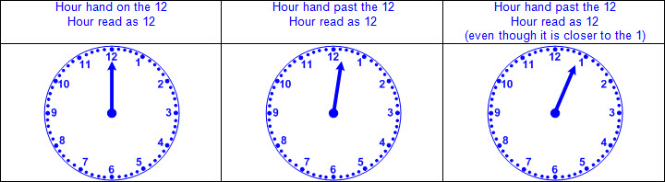  - Minute hand  - Longer than the hour hand  - Moves faster than the hour hand  - One full rotation of the minute hand moves the hour hand to the next labeled hour.  - Time to the hour  - Minute hand on the 12  - Hour hand names the hour  - Read, written, and stated in words as o’clock  - Read and written numerically as :00  - Ex:  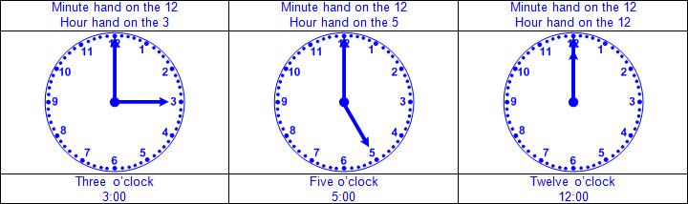  - Time to the half-hour  - Minute hand on the 6  - Hour hand names the hour  - Ex:  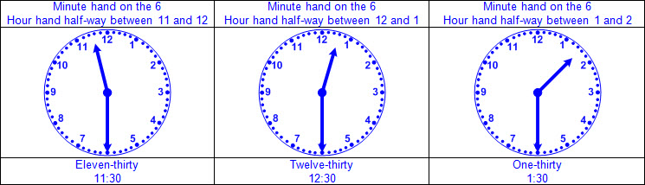  - Relationship between half of a circle and half of an hour on an analog clock  - Skip counting by 5 from the 12 to the 6 equals 30 minutes and from the 6 to the 12 equals 30 minutes.  - Ex:  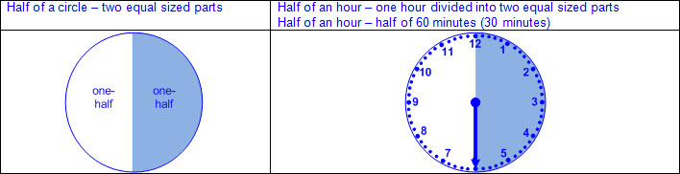  - Time to the half-hour approximated by the location of the minute hand  - Minute hand between the 12 and 3, time is read as closer to a full hour or o’clock.  - Minute hand between the 3 and 9, time is read as closer to a half-hour or 30 minutes.  - Minute hand between the 9 and 12, time is read as closer to the next full hour or o’clock.  - Ex:  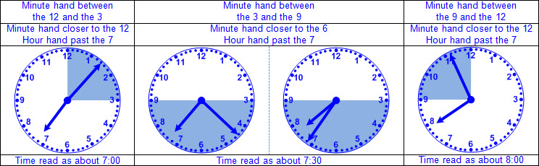  - Digital clock  - Colon used to separate the hour from the minutes  - Hour (1 – 12) displayed to the left of the colon  - Hour increases by 1 for every 60 minutes  - Minutes (00 – 59) displayed to the right of the colon  - One minute after 59 displayed as :00  - Time to the hour  - 00 minutes displayed  - Hour displayed names the hour  - Read, written, and stated in words as o’clock  - Read and written numerically as :00  - Ex:  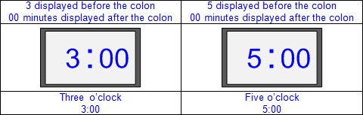  - Time to the half-hour  - 30 minutes displayed  - Hour displayed names the hour  - Ex:  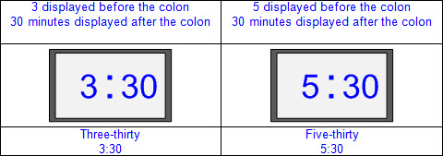  - Relationship between half of 60 in a number line and half of an hour on an digital clock  - Ex:  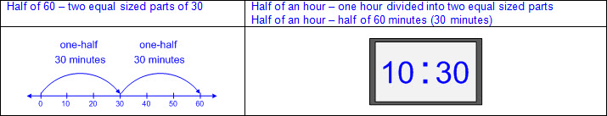  - Relationship between time on an analog clock and the same time on a digital clock  - Ex:  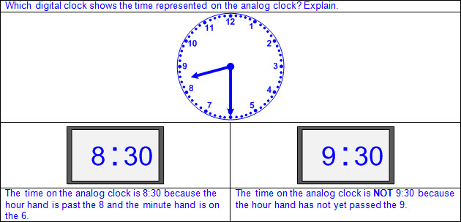  - Ex:  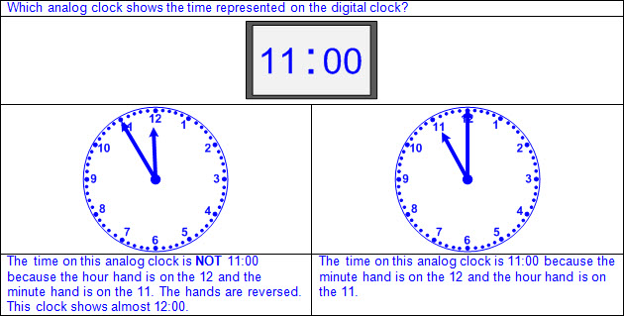  Note(s):  - Grade Level(s):  - Grade 1 introduces telling time to the hour and half hour using analog and digital clocks.  - Grade 1 introduces partitioning two-dimensional figures into two equal parts and identifying examples and non-examples of halves.  - Grade 2 will read and write time to the nearest one-minute increment using analog and digital clocks and distinguish between a.m. and p.m.  - Various mathematical process standards will be applied to this student expectation as appropriate.  - TxRCFP:  - Grade Level Connections (reinforces previous learning and/or provides development for future learning)  - TxCCRS:  - IV.A. Measurement Reasoning – Measurement involving physical and natural attributes  - IX. Communication and Representation  - X. Connections
1.8 | Data analysis. The student applies mathematical process standards to organize data to make it useful for interpreting information and solving problems. The student is expected to:
1.8A | Collect, sort, and organize data in up to three categories using models/representations such as tally marks or T-charts.  Collect, sort, and organize data in up to three categories using models/representations such as tally marks or T-charts.  Collect, Sort, Organize  DATA IN UP TO THREE CATEGORIES USING MODELS/REPRESENTATIONS  Including, but not limited to:  - Data – information that is collected about people, events, or objects  - Categorical data – data that represents the attributes of a group of people, events, or objects  - Ex: What is your favorite color? Represented on a graph with colors as category labels (e.g., red, yellow, and blue)  - Ex: Do you have a brother? Represented on a graph with yes and no as category labels  - Ex: Which sporting event do you prefer? Represented on a graph with names of sports as category labels (e.g., basketball, baseball, and football)  - Categorical data may represent numbers or ranges of numbers.  - Ex: How many pets do you have? Represented on a graph with numbers as category labels (e.g., 0 – 1, 2, and 3 or more)  - Ex: How many letters are in your name? Represented on a graph with ranges of numbers as category labels (e.g., 1 – 3, 4 – 6, 7 or more)  - Data collected in the form of responses to a question  - Survey – to ask a group of people a question in order to collect information about their opinions or answers  - Ex: What is your favorite food?  - Ex: What color are your eyes?  - Ex: What was the weather like each day in April?  - Ex: How many letters are in your name?  - Common characteristics in a collection of objects  - Ex: How many of each color are in a collection of different colored linking cubes?  - Ex: How many sides does each figure have in a collection of two-dimensional figures?  - Data sorted in up to three categories  - Data sorted in a variety of ways  - Ex: A collection of three-dimensional real-world objects sorted by number of faces, shape of faces, etc.  - Data organized and represented in a variety of ways  - Data organized using T-charts, sorting mats, etc.  - Data represented by real-world objects, pictures, drawings, or tally marks  - Each object, picture, drawing, or tally mark represents one unit of data.  - Ex:  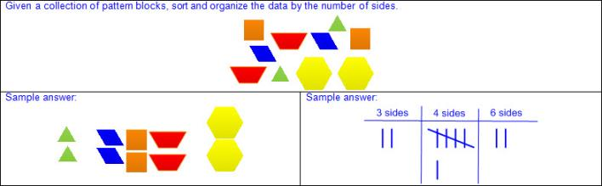  - Ex:  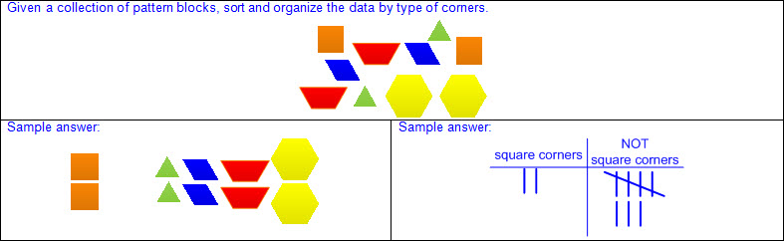  Note(s):  - Grade Level(s):  - Kindergarten collected, sorted, and organized data into two or three categories.  - Various mathematical process standards will be applied to this student expectation as appropriate.  - TxRCFP:  - Developing an understanding of place value  - TxCCRS:  - IX. Communication and Representation  - X. Connections
1.8B | Use data to create picture and bar-type graphs.  Use data to create picture and bar-type graphs.  Use  DATA  Including, but not limited to:  - Data – information that is collected about people, events, or objects  - Categorical data – data that represents the attributes of a group of people, events, or objects  - Ex: What is your favorite color? Represented on a graph with colors as category labels (e.g., red, yellow, and blue)  - Ex: Do you have a brother? Represented on a graph with yes and no as category labels  - Ex: Which sporting event do you prefer? Represented on a graph with names of sports as category labels (e.g., basketball, baseball, and football)  - Categorical data may represent numbers or ranges of numbers.  - Ex: How many pets do you have? Represented on a graph with numbers as category labels (e.g., 0 – 1, 2, and 3 or more)  - Ex: How many letters are in your name? Represented on a graph with ranges of numbers as category labels (e.g., 1 – 3, 4 – 6, 7 or more)  - Data collected in the form of responses to a question with up to three categories  - Survey – to ask a group of people a question in order to collect information about their opinions or answers  - Ex: What is your favorite food?  - Ex: What color are your eyes?  - Ex: What was the weather like each day in April?  - Ex: How many letters are in your name?  - Common characteristics in a collection of objects sorted into up to three categories  - Ex: How many of each color are in a collection of different colored linking cubes?  - Ex: How many sides does each figure have in a collection of two-dimensional figures?  To Create  PICTURE AND BAR-TYPE GRAPHS  Including, but not limited to:  - Graph – a visual representation of the relationships between data collected  - Organization of data used to interpret data, draw conclusions, and make comparisons  - Picture graphs and bar-type graphs with up to three categories  - Picture graph – a graphical representation to organize data that uses pictures or symbols evenly spaced or placed in individual cells, where each picture or symbol represents one unit of data, to show the frequency (number of times) that each category occurs  - Characteristics of a picture graph  - Pictures are placed in a linear arrangement to represent data.  - Horizontal or vertical linear arrangement  - Pictures spaced approximately equal distances apart  - Placement of pictures beginning at the bottom of vertical graph and progressing up  - Placement of pictures beginning at the left of horizontal graph and progressing to the right  - Each category may use a different picture that represents the category.  - Each picture represents one unit of data.  - Value of the data in each category is determined by the total number of pictures in that category.  - Each category may be represented with labels.  - Graph is represented with a title.  - Ex:  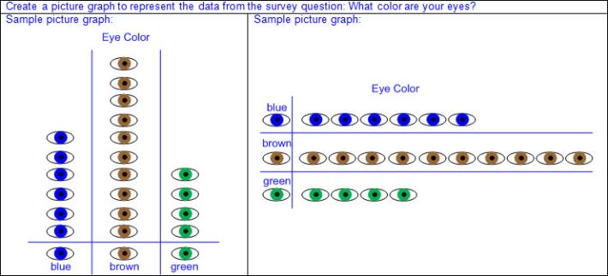  - Bar-type graph – a graphical representation to organize data that uses bars divided into individual cells to demonstrate one-to-one correspondence and to show the frequency (number of times) that each category occurs  - Characteristics of bar-type graphs  - Bars are placed in a linear arrangement to represent data.  - Horizontal or vertical linear arrangement  - Bars divided into equal-sized cells with no gaps between cells  - Placement of bars beginning at the bottom of vertical graph and progressing up  - Placement of bars beginning at the left of horizontal graph and progressing to the right  - Each category may use a different color that represents the category.  - Each shaded cell represents one unit of data.  - Value of the data in each category is determined by the total number of shaded cells in that category.  - Each category is represented with labels.  - Graph is represented with a title.  - Ex:  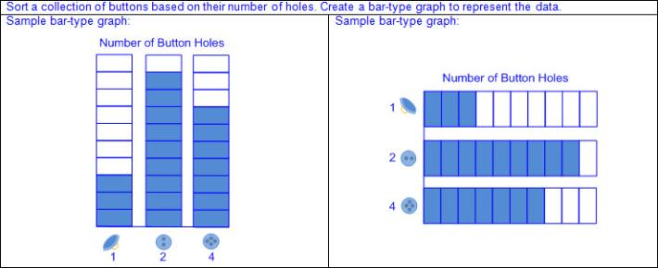  - Same data represented using a picture graph and a bar-type graph  - Ex:  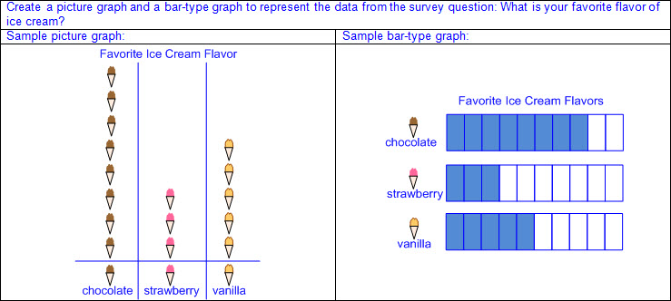  - Connection between picture graphs and bar-type graphs  - Replace each picture on a picture graph with a shaded cell to create a bar-type graph.  - Ex:  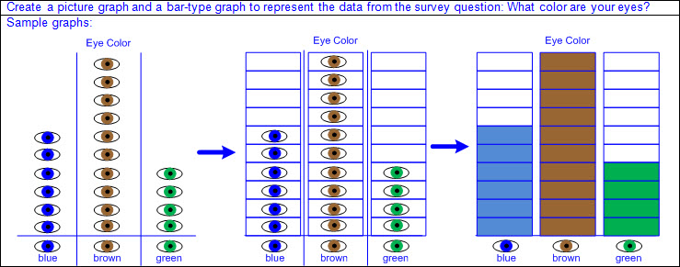  Note(s):  - Grade Level(s):  - Kindergarten used data to create real-object and picture graphs.  - Grade 2 will organize a collection of data with up to four categories using pictographs and bar graphs with intervals of one or more.  - Various mathematical process standards will be applied to this student expectation as appropriate.  - TxRCFP:  - Developing an understanding of place value  - TxCCRS:  - IX. Communication and Representation  - X. Connections
1.8C | Draw conclusions and generate and answer questions using information from picture and bar-type graphs.  Draw conclusions and generate and answer questions using information from picture and bar-type graphs.  Draw  CONCLUSIONS USING INFORMATION FROM PICTURE AND BAR-TYPE GRAPHS  Including, but not limited to:  - Graph – a visual representation of the relationships between data collected  - Organization of data used to interpret data, draw conclusions, and make comparisons  - Picture graph – a graphical representation to organize data that uses pictures or symbols evenly spaced or placed in individual cells, where each picture or symbol represents one unit of data, to show the frequency (number of times) that each category occurs  - Bar-type graph – a graphical representation to organize data that uses bars divided into individual cells to demonstrate one-to-one correspondence and to show the frequency (number of times) that each category occurs  - Data – information that is collected about people, events, or objects  - Categorical data – data that represents the attributes of a group of people, events, or objects  - Picture graphs  - Up to three categories  - Each picture or symbol represents one unit of data  - Bar-type graphs  - Up to three categories  - Each cell of the bars represents intervals of one  - Description of data represented  - Identification of title and category labels  - Explanation of what the graph represents  - Conclusions related to the question that led to the data collection  - Numerical conclusions in the data  - Data counts limited to addition or subtraction of categories within 20  - Quantities represented by the data  - Number in each category represented  - Number represented in a category(s) may be zero.  - Combined total represented  - Ex:  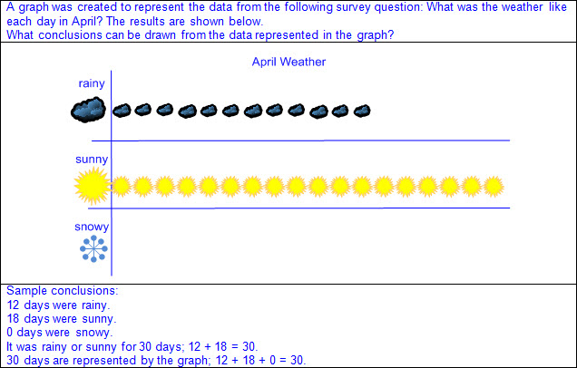  - Comparisons of data represented  - Comparative language used without numbers  - Ex: More than, less than, fewer than, the most, the least, the same as, equal to, etc.  - Comparative language used with numbers  - Ex: 10 more than, 5 greater than, 2 less than, 1 fewer than, etc.  - Ex:  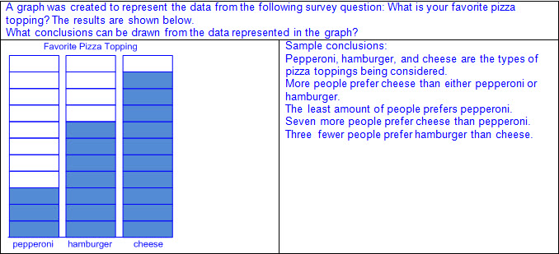  - Changes in orientation do not affect the data.  - Ex:  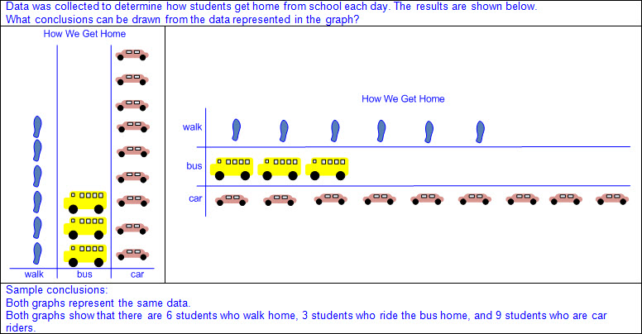  Generate, Answer  QUESTIONS USING INFORMATION FROM PICTURE AND BAR-TYPE GRAPHS  Including, but not limited to:  - Graph – a visual representation of the relationships between data collected  - Organization of data used to interpret data, draw conclusions, and make comparisons  - Picture graph – graphical representation to organize data that uses pictures or symbols evenly spaced or placed in individual cells, where each picture or symbol represents one unit of data, to show the frequency (number of times) that each category occurs  - Bar-type graph – a graphical representation to organize data that uses bars divided into individual cells to demonstrate one-to-one correspondence and to show the frequency (number of times) that each category occurs  - Data – information that is collected about people, events, or objects  - Categorical data – data that represents the attributes of a group of people, events, or objects  - Generate questions using data in graphs.  - Picture graphs  - Up to three categories  - Each picture or symbol represents one unit of data  - Bar-type graphs  - Up to three categories  - Each cell of the bars represents intervals of one  - Mathematical and real-world problem situations  - One-step problems  - Addition or subtraction of categories within 20  - Comparison of data represented  - Numerical conclusions from the data represented  - Ex:  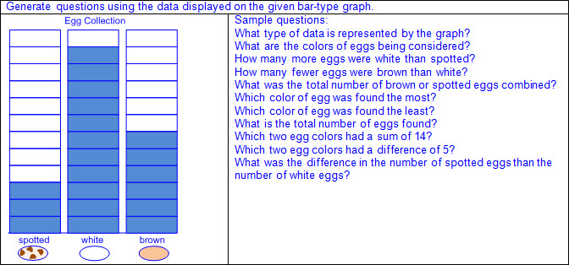  - Answer questions using data in graphs  - Picture graphs  - Up to three categories  - Each picture or symbol represents one unit of data  - Bar-type graphs  - Up to three categories  - Each cell of the bars represents intervals of one  - Mathematical and real-world problem situations  - One-step problems  - Addition or subtraction of categories within 20  - Comparison of data represented  - Numerical conclusions from the data represented  - Ex:  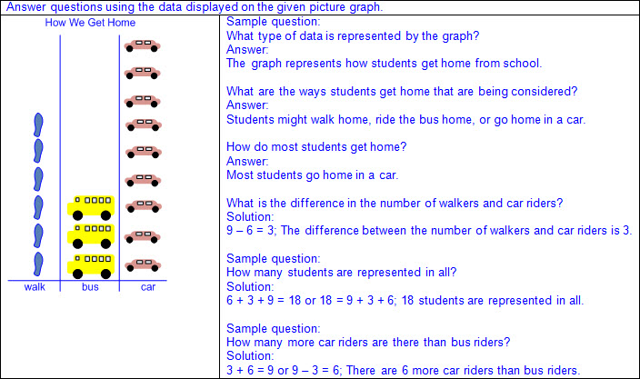  Note(s):  - Grade Level(s):  - Kindergarten drew conclusions from real-object and picture graphs.  - Grade 2 will draw conclusions and make predictions from information in a graph.  - Various mathematical process standards will be applied to this student expectation as appropriate.  - TxRCFP:  - Developing an understanding of place value  - TxCCRS:  - IX. Communication and Representation  - X. Connections
1.9 | Personal financial literacy. The student applies mathematical process standards to manage one's financial resources effectively for lifetime financial security. The student is expected to:
1.9A | Define money earned as income.  Define money earned as income.  Define  MONEY EARNED AS INCOME  Including, but not limited to:  - Income – money earned  - Ways to earn income  - Job – work performed to complete a task, usually for money  - Jobs are available in the home, school, and community.  - Jobs for adults  - Ex: Teacher, principal, custodian, nurse, bus driver, hair stylist, waiter, mechanic, doctor, lawyer, cashier, etc.  - Jobs for children  - Ex: Household chores, babysitting, mowing the lawn, washing the car, taking care of pets, etc.  - Sale of goods or property  - Ex: Garage sale, resale store, lemonade stand, cookie sale, etc.  Note(s):  - Grade Level(s):  - Kindergarten identified ways to earn income.  - Various mathematical process standards will be applied to this student expectation as appropriate.  - TxRCFP:  - Financial Literacy  - TxCCRS:  - IX. Communication and Representation  - X. Connections
1.9B | Identify income as a means of obtaining goods and services, oftentimes making choices between wants and needs.  Identify income as a means of obtaining goods and services, oftentimes making choices between wants and needs.  Identify  INCOME AS A MEANS OF OBTAINING GOODS AND SERVICES, OFTENTIMES MAKING CHOICES BETWEEN WANTS AND NEEDS  Including, but not limited to:  - Income – money earned  - Income may be used to obtain goods and services.  - Purchasing – to acquire goods or services through the payment of money  - Goods – physical products that can be touched and felt  - Ex: food, toys, computer, clothes, sink, cars, etc.  - Services – tasks or work provided by people for other people  - Ex: taking out the trash, walking the dog, setting the table, teaching, nursing, etc.  - Amount of income earned may require making choices between purchasing wants and needs.  - Wants – things you wish for but are not necessary for life  - Ex: toys, unnecessary food such as candy, expensive clothes, dance or music lessons, etc.  - Needs – things that are necessary for life  - Ex: food, water, shelter, clothing, etc.  - Choices are required when the costs of wants and needs are greater than income.  - Purchases of needs should be met first.  - Purchases of wants should be based on remaining extra income.  - Purchases of wants may need to wait until more income is earned.  Note(s):  - Grade Level(s):  - Kindergarten distinguished between wants and needs and identified income as a source to meet one's wants and needs.  - Various mathematical process standards will be applied to this student expectation as appropriate.  - TxRCFP:  - Financial Literacy  - TxCCRS:  - IX. Communication and Representation  - X. Connections
1.9C | Distinguish between spending and saving.  Distinguish between spending and saving.  Distinguish  BETWEEN SPENDING AND SAVING  Including, but not limited to:  - Money earned may be spent or saved.  - Spending – purchasing goods and services to satisfy wants and needs  - Spending results in a decrease in the amount of money you have.  - Saving – setting aside money earned or received for future use  - Saving results in no decrease in the amount of money you have.  - Saving may result in an increase in the amount of money you have.  - Money may be saved in a bank account, piggy bank, etc.  - Distinguish between spending and saving in real-world problem situations.  - Ex:  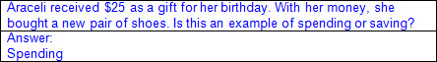  - Ex:  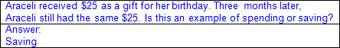  - Ex:  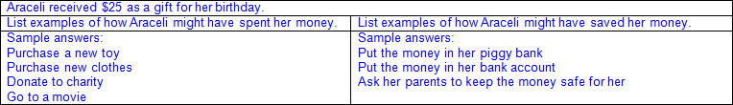  Note(s):  - Grade Level(s):  - Grade 1 introduces distinguishing between spending and saving.  - Grade 2 will calculate how money saved can accumulate into a larger amount over time.  - Various mathematical process standards will be applied to this student expectation as appropriate.  - TxRCFP:  - Financial Literacy  - TxCCRS:  - IX. Communication and Representation  - X. Connections
1.9D | Consider charitable giving.  Consider charitable giving.  Consider  CHARITABLE GIVING  Including, but not limited to:  - Money earned may be donated to charity.  - Charity – an organization that collects money, goods, or services for groups in need  - Charitable giving – donating to an organization that collects money, goods, or services to groups in need  - Donating – giving money, goods, or services to a charitable organization  - Donating money earned to charity  - Donating goods or property to charity without receiving money in exchange  - Ex: Purchase food to donate to a food bank, purchase toys to donate to a child in need, etc.  - Donating services or volunteering time to charity without receiving income in exchange  - Ex: Volunteering at the humane society, serving food to residents at a nursing home, delivering meals to the elderly, etc.  - Reasons for charitable giving  - Helping others who are not able to meet their needs  - Feeling good about oneself  Note(s):  - Grade Level(s):  - Grade 1 introduces considering charitable giving.  - Grade 3 will identify decisions involving income, spending, saving, credit, and charitable giving.  - Various mathematical process standards will be applied to this student expectation as appropriate.  - TxRCFP:  - Financial Literacy  - TxCCRS:  - IX. Communication and Representation  - X. Connections
Bibliography:
Texas Education Agency & Texas Higher Education Coordinating Board. (2009). Texas college and career readiness standards. Retrieved from http://www.thecb.state.tx.us/collegereadiness/crs.pdf

Texas Education Agency. (2013). Introduction to the revised mathematics TEKS – kindergarten-algebra I vertical alignment. Retrieved from
http://www.projectsharetexas.org/sites/default/files/resources/documents/K-AlgebraIVAChart.pdf

Texas Education Agency. (2013). Texas response to curriculum focal points for kindergarten through grade 8 mathematics. Retrieved from
http://projectsharetexas.org/resource/txrcfp-texas-response-curriculum-focal-points-k-8-mathematics-revised-2013
Bold black text in italics: Knowledge and Skills Statement (TEKS); Bold black text: Student Expectation (TEKS)
Blue text: Supporting information / Clarifications from TCMPC (Specificity)
Black text: Texas Education Agency (TEA); Texas College and Career Readiness Standards (TxCCRS)

