May 5, 2017

Dear Students and Parents,

In order to prepare incoming sophomores for the rigor of Advanced Placement World History, we are requiring all students who will be taking the class next year to read The World is Flat by author Thomas L. Friedman over the summer. This New York Times best selling book by multiple Pulitzer Prize winning author Thomas Friedman examines the interconnected nature of global relationships and the impact of increasing globalization. This topic is especially pertinent to this course in that A.P. World History is a global history course…not merely a western civilization course.

In order to enroll and be accepted into the A.P. World History course students must complete a summer reading assignment that each student needs to fill out while reading through the book. Students will need to print off the assignment which will be completed and turned in on the first day of class (Monday; August 21, 2017) for a test grade. Students will not be allowed to remain in AP World History if they do not have this assignment turned in on the first day of school. If the assignment is not completed on the first day of school the student will be sent directly to the counselor to change their schedule to an on-level World History course. The book will be used as a reference throughout the year. Please contact me via email if you have any questions about the assignment. Have a great summer.

The summer assignment can be accessed at my website at…

https://sites.google.com/a/kaufman-isd.net/templeofdoom/home

Click on the WHAP tab. Then click on the link at the bottom of the page labeled WHAP Summer Assignment 2017. Print off the assignment. You must write your answers, by hand, not typed on the printed assignment.

You can also find the assignment in the KHS counselor’s office during summer office hours and on the Kaufman High School Website.

Again, please contact me via email with any questions.

Sincerely,

David C. White
Department Chair
KHS History and Social Studies
dwhite@kaufman-isd.net

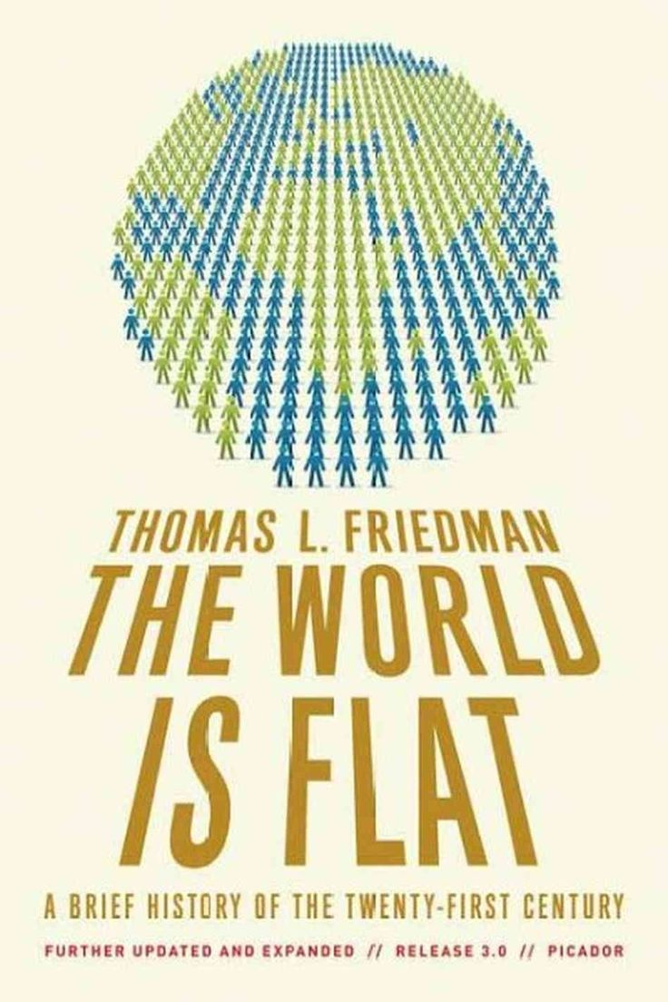
The World is Flat by Thomas l. Friedman can be found at most bookstores, used bookstores, online and libraries. Any edition (i.e. the first edition, the 3.0 edition, etc…) will be acceptable for this assignment. Call first to make sure bookstores have it stock. They can easily order this book if it is not currently in stock. The cheapest way to purchase this book new or used is online at sites like amazon.com or other online sources. Kindle, iPad or other E-Reader editions are also acceptable. You may also contact the Kaufman County Library to see if they have it available.
Remember the following…
1.) Answer the question fully in your own handwriting (not typed).
2.) Use complete sentences.
3.) Use quotations from the book to support your answers.
4.) Write your answers on this assignment.
5.) If you lose this assignment you may download it from my page on the KHS website at…
https://sites.google.com/a/kaufman-isd.net/templeofdoom/
This assignment will be due the FIRST day of school…No exceptions. You will not be allowed to enroll in the class if you do not have this assignment on the first day of school. If you do not have this assignment completed on the first day you will be sent to the counselor’s office to change your schedule to an on-level World History course. It will count as a test grade for the First Quarter. Although study groups are encouraged all answers must be in your own words. Any cheating will result in dismissal from the AP program.
1. What does Friedman mean when he says the “World is Flat?”

2. The first chapter in The World Is Flat recalls the voyage of Columbus, colonization, and industrialization. Are the motivations behind twenty-first-century globalization much different from the ones recorded throughout history?

3. Thomas L. Friedman discusses the many occupations that can now be outsourced or offshored, including his own job as a journalist. Could your desired future job be done by someone in another country? Could you do your future job better from home, as the JetBlue telephone agents do? Would you feel comfortable knowing that your taxes had been prepared by an overseas accountant, or your CAT scan read by an overseas radiologist? (Chapter One)

4. What were the ten forces that flattened the world?

5. The second chapter outlines "Ten Forces That Flattened the World," ranging from the fall of the Berlin Wall on November 9, 1989, to the open-source software movement. In what way did politics influence entrepreneurship in the 1990s? What psychological impact did November 9 have on the world, particularly when paired with new means for global communication?

6. What is your opinion of the open-source movement? Should there be any limit to the amount of freedom, including "freedom" from the demand to make a profit, in the technology marketplace? (Chapter Two)

7. What qualities enabled India to take center stage when the looming Y2K scenario generated unprecedented demand for programmers? What can other nations learn from India's success in this realm? What are India's greatest vulnerabilities? (Chapter Two)

8. Discuss the ruthless efficiency demanded by supply-chaining. In the long run, does it benefit consumers? Do you believe it enhances or reduces production quality? (Chapter Two)

9. Were you familiar with the concept of "insourcing" prior to reading The World Is Flat? Does it matter to you whether your computer is repaired by an employee of Toshiba or of UPS? Should it matter? (Chapter Two)

10. Friedman calls the tenth flattener "steroids." Are these crucial to success, or are they luxuries? Will the globe's nonsteroidal citizens be able to compete without them? (Chapter Two)

11. What is the Triple Convergence?

12. In what ways has the Triple Convergence affected your day-to-day life? (Chapter Three)

13. What is meant by the Great Sorting Out?

14. What would be the dangers inherent in our nation banning outsourcing and offshoring?

15. Discuss the "Indiana versus India" anecdote, recounted in the second section of Chapter Four. Which approach benefits Americans more: offshoring state projects and cutting taxpayer expenditures, or paying higher wages to maintain job security at home?

16. Chapter Six, "The Untouchables," features the story of Friedman's childhood friend Bill Greer. What does his story indicate about flattening in the creative fields? Will illustrators lose out to Illustrator? What would it take for you to become an untouchable?

17. What does Thomas Friedman mean by “The New Middle?”

18. Chapter Seven, "The Quiet Crisis," outlines three dirty secrets regarding American dominance: fewer young Americans pursuing careers in math and science, and the demise of both ambition and brainpower among American youth. What accounts for this? What would it take to restore academic rigor and the enthusiasm enjoyed during the "man on the moon" days?

19. What are the important abilities American youth must learn in order to compete in a “flat” world?

20. Which of the proposals in Chapter Eight, "This Is Not a Test," would you be able to implement?

21. What changes must take place in the American educational system to compete with a globalized world?

22. In Chapter Nine's third section, "I Can Only Get It for You Retail," Friedman offers a vivid portrait of the "neighborhoods" comprising various parts of the globe today. How will those neighborhoods look one hundred years from now? Will America still be a gated community, and Asia "the other side of the tracks"?

23. Friedman contemplates the cultural traits (such as motivated, educated workers and leaders who don't squander the nation's treasure) that drive a nation's success. He uses this to illustrate why Mexico, despite NAFTA, has become the tortoise while China has become the hare. Does America fit Friedman's cultural profile as a nation poised for prosperity? (Chapter Nine)

24. Is Kaufman High School implementing any of Friedman's coping strategies? Which of them would be the most controversial in your chosen industry? (Chapter Ten)

25. What rules should companies follow to cope with a globalized world?

26. What do you make of the approach taken by Bill Gates's foundation to combat disease? In your opinion, what are the roots of the public-health crisis in the Third World? (Chapter Eleven)

27. How did the book's images of India compare to your previous perceptions of it, from the country-club atmosphere described on the first page to the tragedy of the untouchables? (Chapters One and Eleven)

28. Do you have faith in Michael Dell's theory of conflict prevention? What can we do to ensure that the strategic optimists win? And when they do, what dreams do you have for the world they will create? (Chapter Twelve)

