Enhanced TEKS Clarification

Mathematics

Grade 7

2014 - 2015
Grade 7
§111.25. Implementation of Texas Essential Knowledge and Skills for Mathematics, Middle School, Adopted 2012.
Source: The provisions of this §111.25 adopted to be effective September 10, 2012, 37 TexReg 7109.
§111.27. Grade 7, Adopted 2012.
7.Intro.1 | The desire to achieve educational excellence is the driving force behind the Texas essential knowledge and skills for mathematics, guided by the college and career readiness standards. By embedding statistics, probability, and finance, while focusing on computational thinking, mathematical fluency, and solid understanding, Texas will lead the way in mathematics education and prepare all Texas students for the challenges they will face in the 21st century.

7.Intro.2 | The process standards describe ways in which students are expected to engage in the content. The placement of the process standards at the beginning of the knowledge and skills listed for each grade and course is intentional. The process standards weave the other knowledge and skills together so that students may be successful problem solvers and use mathematics efficiently and effectively in daily life. The process standards are integrated at every grade level and course. When possible, students will apply mathematics to problems arising in everyday life, society, and the workplace. Students will use a problem-solving model that incorporates analyzing given information, formulating a plan or strategy, determining a solution, justifying the solution, and evaluating the problem-solving process and the reasonableness of the solution. Students will select appropriate tools such as real objects, manipulatives, algorithms, paper and pencil, and technology and techniques such as mental math, estimation, number sense, and generalization and abstraction to solve problems. Students will effectively communicate mathematical ideas, reasoning, and their implications using multiple representations such as symbols, diagrams, graphs, computer programs, and language. Students will use mathematical relationships to generate solutions and make connections and predictions. Students will analyze mathematical relationships to connect and communicate mathematical ideas. Students will display, explain, or justify mathematical ideas and arguments using precise mathematical language in written or oral communication.

7.Intro.3 | The primary focal areas in Grade 7 are number and operations; proportionality; expressions, equations, and relationships; and measurement and data. Students use concepts, algorithms, and properties of rational numbers to explore mathematical relationships and to describe increasingly complex situations. Students use concepts of proportionality to explore, develop, and communicate mathematical relationships, including number, geometry and measurement, and statistics and probability. Students use algebraic thinking to describe how a change in one quantity in a relationship results in a change in the other. Students connect verbal, numeric, graphic, and symbolic representations of relationships, including equations and inequalities. Students use geometric properties and relationships, as well as spatial reasoning, to model and analyze situations and solve problems. Students communicate information about geometric figures or situations by quantifying attributes, generalize procedures from measurement experiences, and use the procedures to solve problems. Students use appropriate statistics, representations of data, and reasoning to draw conclusions, evaluate arguments, and make recommendations. While the use of all types of technology is important, the emphasis on algebra readiness skills necessitates the implementation of graphing technology.

7.Intro.4 | Statements that contain the word "including" reference content that must be mastered, while those containing the phrase "such as" are intended as possible illustrative examples.

7.1 | Mathematical process standards. The student uses mathematical processes to acquire and demonstrate mathematical understanding. The student is expected to:
7.1A | Apply mathematics to problems arising in everyday life, society, and the workplace.  Apply mathematics to problems arising in everyday life, society, and the workplace.  Apply  MATHEMATICS TO PROBLEMS ARISING IN EVERYDAY LIFE, SOCIETY, AND THE WORKPLACE  Note(s):  - The mathematical process standards may be applied to all content standards as appropriate.  - TxRCFP:  - Developing fluency with rational numbers and operations to solve problems in a variety of contexts  - Representing and applying proportional relationships  - Using expressions and equations to describe relationships in a variety of contexts, including geometric problems  - Comparing sets of data  - TxCCRS:  - X. Connections
7.1B | Use a problem-solving model that incorporates analyzing given information, formulating a plan or strategy, determining a solution, justifying the solution, and evaluating the problem-solving process and the reasonableness of the solution.  Use a problem-solving model that incorporates analyzing given information, formulating a plan or strategy, determining a solution, justifying the solution, and evaluating the problem-solving process and the reasonableness of the solution.  Use  A PROBLEM-SOLVING MODEL THAT INCORPORATES ANALYZING GIVEN INFORMATION, FORMULATING A PLAN OR STRATEGY, DETERMINING A SOLUTION, JUSTIFYING THE SOLUTION, AND EVALUATING THE PROBLEM-SOLVING PROCESS AND THE REASONABLENESS OF THE SOLUTION  Note(s):  - The mathematical process standards may be applied to all content standards as appropriate.  - TxRCFP:  - Developing fluency with rational numbers and operations to solve problems in a variety of contexts  - Representing and applying proportional relationships  - Using expressions and equations to describe relationships in a variety of contexts, including geometric problems  - Comparing sets of data  - TxCCRS:  - VIII. Problem Solving and Reasoning
7.1C | Select tools, including real objects, manipulatives, paper and pencil, and technology as appropriate, and techniques, including mental math, estimation, and number sense as appropriate, to solve problems.  Select tools, including real objects, manipulatives, paper and pencil, and technology as appropriate, and techniques, including mental math, estimation, and number sense as appropriate, to solve problems.  Select  TOOLS, INCLUDING REAL OBJECTS, MANIPULATIVES, PAPER AND PENCIL, AND TECHNOLOGY AS APPROPRIATE, TO SOLVE PROBLEMS  Select  TECHNIQUES, INCLUDING MENTAL MATH, ESTIMATION, AND NUMBER SENSE AS APPROPRIATE, TO SOLVE PROBLEMS  Note(s):  - The mathematical process standards may be applied to all content standards as appropriate.  - TxRCFP:  - Developing fluency with rational numbers and operations to solve problems in a variety of contexts  - Representing and applying proportional relationships  - Using expressions and equations to describe relationships in a variety of contexts, including geometric problems  - Comparing sets of data  - TxCCRS:  - VIII. Problem Solving and Reasoning
7.1D | Communicate mathematical ideas, reasoning, and their implications using multiple representations, including symbols, diagrams, graphs, and language as appropriate.  Communicate mathematical ideas, reasoning, and their implications using multiple representations, including symbols, diagrams, graphs, and language as appropriate.  Communicate  MATHEMATICAL IDEAS, REASONING, AND THEIR IMPLICATIONS USING MULTIPLE REPRESENTATIONS, INCLUDING SYMBOLS, DIAGRAMS, GRAPHS, AND LANGUAGE AS APPROPRIATE  Note(s):  - The mathematical process standards may be applied to all content standards as appropriate.  - TxRCFP:  - Developing fluency with rational numbers and operations to solve problems in a variety of contexts  - Representing and applying proportional relationships  - Using expressions and equations to describe relationships in a variety of contexts, including geometric problems  - Comparing sets of data  - TxCCRS:  - IX. Communication and Representation
7.1E | Create and use representations to organize, record, and communicate mathematical ideas.  Create and use representations to organize, record, and communicate mathematical ideas.  Create, Use  REPRESENTATIONS TO ORGANIZE, RECORD, AND COMMUNICATE MATHEMATICAL IDEAS  Note(s):  - The mathematical process standards may be applied to all content standards as appropriate.  - TxRCFP:  - Developing fluency with rational numbers and operations to solve problems in a variety of contexts  - Representing and applying proportional relationships  - Using expressions and equations to describe relationships in a variety of contexts, including geometric problems  - Comparing sets of data  - TxCCRS:  - IX. Communication and Representation
7.1F | Analyze mathematical relationships to connect and communicate mathematical ideas.  Analyze mathematical relationships to connect and communicate mathematical ideas.  Analyze  MATHEMATICAL RELATIONSHIPS TO CONNECT AND COMMUNICATE MATHEMATICAL IDEAS  Note(s):  - The mathematical process standards may be applied to all content standards as appropriate.  - TxRCFP:  - Developing fluency with rational numbers and operations to solve problems in a variety of contexts  - Representing and applying proportional relationships  - Using expressions and equations to describe relationships in a variety of contexts, including geometric problems  - Comparing sets of data  - TxCCRS:  - X. Connections
7.1G | Display, explain, and justify mathematical ideas and arguments using precise mathematical language in written or oral communication.  Display, explain, and justify mathematical ideas and arguments using precise mathematical language in written or oral communication.  Display, Explain, Justify  MATHEMATICAL IDEAS AND ARGUMENTS USING PRECISE MATHEMATICAL LANGUAGE IN WRITTEN OR ORAL COMMUNICATION  Note(s):  - The mathematical process standards may be applied to all content standards as appropriate.  - TxRCFP:  - Developing fluency with rational numbers and operations to solve problems in a variety of contexts  - Representing and applying proportional relationships  - Using expressions and equations to describe relationships in a variety of contexts, including geometric problems  - Comparing sets of data  - TxCCRS:  - IX. Communication and Representation
7.2 | Number and operations. The student applies mathematical process standards to represent and use rational numbers in a variety of forms. The student is expected to:
7.2A | Extend previous knowledge of sets and subsets using a visual representation to describe relationships between sets of rational numbers.  Supporting Standard  Extend previous knowledge of sets and subsets using a visual representation to describe relationships between sets of rational numbers.  Supporting Standard  Extend  PREVIOUS KNOWLEDGE OF SETS AND SUBSETS USING A VISUAL REPRESENTATION TO DESCRIBE RELATIONSHIPS BETWEEN SETS OF RATIONAL NUMBERS  Including, but not limited to:  - Counting (natural) numbers – the set of positive numbers that begins at one and increases by increments of one each time {1, 2, 3, ..., n}  - Whole numbers – the set of counting (natural) numbers and zero {0, 1, 2, 3, ..., n}  - Integers – the set of counting (natural numbers), their opposites, and zero {-n, …, -3, -2, -1, 0, 1, 2, 3, ..., n}. The set of integers is denoted by the symbol Z.  - Rational numbers – the set of numbers that can be expressed as a fraction , where a and b are integers and b ≠ 0, which includes the subsets of integers, whole numbers, and counting (natural) numbers (e.g., -3, 0, 2, 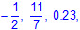 etc.). The set of rational numbers is denoted by the symbol Q.  - Visual representations of the relationships between sets and subsets of rational numbers  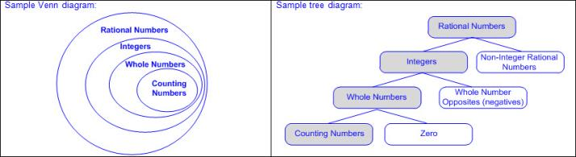  To Describe  RELATIONSHIPS BETWEEN SETS OF NUMBERS  Including, but not limited to:  - All counting (natural) numbers are a subset of whole numbers, integers, and rational numbers.  - Ex: Two is a counting (natural) number, whole number, integer, and rational number.  - All whole numbers are a subset of integers and rational numbers.  - Ex: Zero is a whole number, integer, and rational number, but not a counting (natural) number.  - All integers are a subset of rational numbers.  - Ex: Negative two is an integer and rational number, but neither a whole number nor counting (natural) number.  - All counting (natural) numbers, whole numbers, and integers are a subset of rational numbers.  - Ex: Four is a counting (natural) number, whole number, integer, and rational number.  - Not all rational numbers are an integer, whole number, or counting (natural) number.  - Ex: One-half is a rational number, but not an integer, whole number, or counting (natural) number.  - Terminating and repeating decimals are rational numbers but not integers, whole numbers, or counting (natural) numbers.  - Ex: is a repeating decimal; therefore, it is rational number.  Note(s):  - Grade Level(s):  - Grade 6 classified whole numbers, integers, and rational numbers using a visual representation such as a Venn diagram to describe relationships between sets of numbers.  - Grade 8 will extend previous knowledge of sets and subsets using a visual representation to describe relationships between sets of real numbers.  - Various mathematical process standards will be applied to this student expectation as appropriate.  - TxRCFP:  - Developing fluency with rational numbers and operations to solve problems in a variety of contexts  - TxCCRS:  - I. Numeric Reasoning  - IX. Communication and Representation
7.3 | Number and operations. The student applies mathematical process standards to add, subtract, multiply, and divide while solving problems and justifying solutions. The student is expected to:
7.3A | Add, subtract, multiply, and divide rational numbers fluently.  Supporting Standard  Add, subtract, multiply, and divide rational numbers fluently.  Supporting Standard  Add, Subtract, Multiply, and Divide  RATIONAL NUMBERS FLUENTLY  Including, but not limited to:  - Rational numbers – the set of numbers that can be expressed as a fraction , where a and b are integers and b ≠ 0, which includes the subsets of integers, whole numbers, and counting (natural) numbers (e.g., -3, 0, 2, etc.). The set of rational numbers is denoted by the symbol Q.  - Fluency – efficient application of procedures with accuracy  - Addition, subtraction, multiplication, and division involving various forms of positive and negative rational numbers  - Whole numbers  - Integers  - Decimals (less than or greater than one)  - Fractions (proper, improper, and mixed numbers)  - Percents converted to equivalent decimals or fractions for multiplying or dividing fluently  Note(s):  - Grade Level(s):  - Grade 5 estimated to determine solutions to mathematical and real-world problems involving addition, subtraction, multiplication, or division.  - Grade 5 added and subtracted positive rational numbers fluently.  - Grade 6 multiplied and divided positive rational numbers fluently.  - Various mathematical process standards will be applied to this student expectation as appropriate.  - TxRCFP:  - Developing fluency with rational numbers and operations to solve problems in a variety of contexts  - TxCCRS:  - I. Numeric Reasoning  - IX. Communication and Representation
7.3B | Apply and extend previous understandings of operations to solve problems using addition, subtraction, multiplication, and division of rational numbers.  Readiness Standard  Apply and extend previous understandings of operations to solve problems using addition, subtraction, multiplication, and division of rational numbers.  Readiness Standard  Apply, Extend  PREVIOUS UNDERSTANDINGS OF OPERATIONS TO SOLVE PROBLEMS USING ADDITION, SUBTRACTION, MULTIPLICATION, AND DIVISION OF RATIONAL NUMBERS  Including, but not limited to:  - Rational numbers – the set of numbers that can be expressed as a fraction , where a and b are integers and b ≠ 0, which includes the subsets of integers, whole numbers, and counting (natural) numbers (e.g., -3, 0, 2, etc.). The set of rational numbers is denoted by the symbol Q.  - Various forms of positive and negative rational numbers  - Whole numbers  - Integers  - Decimals (less than or greater than one)  - Fractions (proper, improper, and mixed numbers)  - Percents converted to equivalent decimals or fractions for multiplying or dividing  - Various forms of representing multiplying by a negative  - Ex: 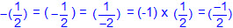  - Generalizations of integer operations  - Addition and subtraction  - If a pair of addends has the same sign, then the sum will have the sign of both addends.  - If a pair of addends has opposite signs, then the sum will have the sign of the addend with the greatest absolute value.  - A subtraction problem may be rewritten as an addition problem by adding the opposite of the integer following the subtraction symbol, and then applying the rules for addition.  - Multiplication and division  - If two rational numbers have the same sign, then the product or quotient is positive.  - If two rational numbers have opposite signs, then the product or quotient is negative.  - When multiplying or dividing two or more rational numbers, the product or quotient is positive if there are no negative signs or an even number of negative signs.  - When multiplying or dividing two or more rational numbers, the product or quotient is negative if there is one negative sign or an odd number of negative signs.  - Connections between generalizations for integer operations to rational number operations for addition and subtraction  - Ex:  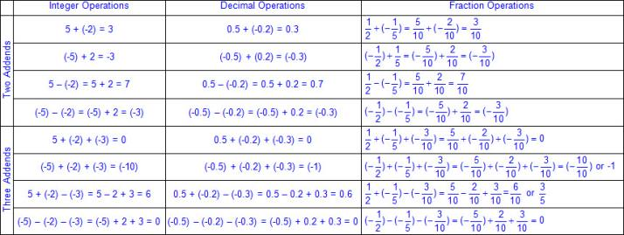  - Recognize that dividing by a rational number and multiplying by its reciprocal result in equivalent values.  - Connections between generalizations for integer operations to rational number operations for multiplication and division  - Ex:  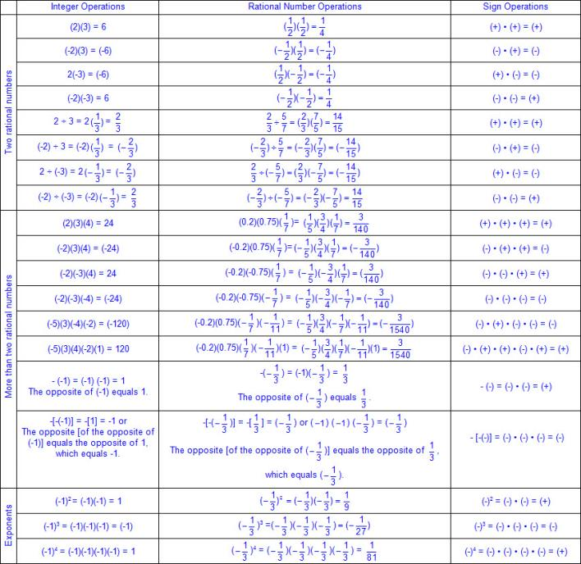  - Mathematical and real-world problem situations  - Multi-step problems  - Multiple operations  Note(s):  - Grade Level(s):  - Grade 6 multiplied and divided positive rational numbers fluently.  - Grade 6 determined, with and without computation, whether a quantity is increased or decreased when multiplied by a fraction, including values greater than or less than one.  - Various mathematical process standards will be applied to this student expectation as appropriate.  - TxRCFP:  - Developing fluency with rational numbers and operations to solve problems in a variety of contexts  - TxCCRS:  - I. Numeric Reasoning  - IX. Communication and Representation
7.4 | Proportionality. The student applies mathematical process standards to represent and solve problems involving proportional relationships. The student is expected to:
7.4A | Represent constant rates of change in mathematical and real-world problems given pictorial, tabular, verbal, numeric, graphical, and algebraic representations, including d = rt.  Readiness Standard  Represent constant rates of change in mathematical and real-world problems given pictorial, tabular, verbal, numeric, graphical, and algebraic representations, including d = rt.  Readiness Standard  Represent  CONSTANT RATES OF CHANGE IN MATHEMATICAL AND REAL-WORLD PROBLEMS GIVEN PICTORIAL, TABULAR, VERBAL, NUMERIC, GRAPHICAL, AND ALGEBRAIC REPRESENTATIONS, INCLUDING d = rt  Including, but not limited to:  - Rational numbers – the set of numbers that can be expressed as a fraction , where a and b are integers and b ≠ 0, which includes the subsets of integers, whole numbers, and counting (natural) numbers (e.g., -3, 0, 2, , etc.). The set of rational numbers is denoted by the symbol Q.  - Various forms of positive and negative rational numbers  - Whole numbers  - Integers  - Decimals (less than or greater than one)  - Fractions (proper, improper, and mixed numbers)  - Constant rate of change – a ratio when the dependent, y-value, changes at a constant rate for each independent, x-value  - Proportional mathematical and real-world problems  - Unit conversions within and between systems  - Customary  - Metric  - d = rt  - In d = rt, the d represents distance, the r represents rate, and the t represents time.  - Connections between constant rate of change r, in d = rt, to the constant of proportionality, k, in y = kx  - Various representations of constant rates of change  - Pictorial  - Ex:  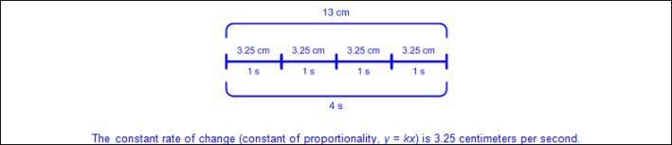  - Tabular (vertical/horizontal)  - Ex:  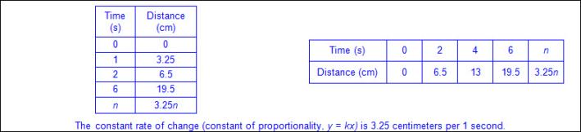  - Verbal  - Ex:  - Numeric  - Ex:  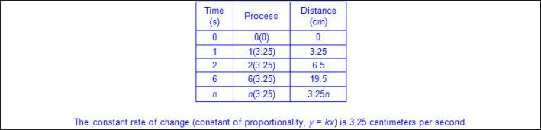  - Graphical  - Ex:  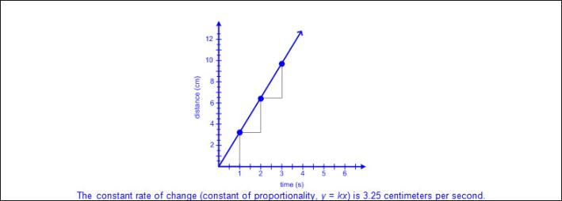  - Algebraic  - Ex:  Note(s):  - Grade Level(s):  - Grade 6 compared two rules verbally, numerically, graphically, and symbolically in the form of y = ax or y = x + a in order to differentiate between additive and multiplicative relationships.  - Grade 6 gave examples of rates as the comparison by division of two quantities having different attributes, including rates as quotients.  - Grade 6 represented mathematical and real-world problems involving ratios and rates using scale factors, tables, graphs, and proportions.  - Various mathematical process standards will be applied to this student expectation as appropriate.  - TxRCFP:  - Representing and applying proportional relationships  - TxCCRS:  - I. Numeric Reasoning  - II. Algebraic Reasoning  - VIII. Problem Solving and Reasoning  - IX. Communication and Representation  - X. Connections
7.4B | Calculate unit rates from rates in mathematical and real-world problems.  Supporting Standard  Calculate unit rates from rates in mathematical and real-world problems.  Supporting Standard  Calculate  UNIT RATES FROM RATES IN MATHEMATICAL AND REAL-WORLD PROBLEMS  Including, but not limited to:  - Rational numbers – the set of numbers that can be expressed as a fraction , where a and b are integers and b ≠ 0, which includes the subsets of integers, whole numbers, and counting (natural) numbers (e.g., -3, 0, 2, etc.). The set of rational numbers is denoted by the symbol Q.  - Various forms of positive and negative rational numbers  - Whole numbers  - Integers  - Decimals (less than or greater than one)  - Fractions (proper, improper, and mixed numbers)  - Unit rate – a ratio between two different units where one of the terms is 1  - Rate – a multiplicative comparison of two different quantities where the measuring unit is different for each quantity  - Ex: 120 heart beats per 2 minutes  - Various representations of rates  - Verbal (e.g., for every, per, for each, to, etc.)  - Symbolic (e.g., , 2 to 7, etc.)  - Multiplication/division to determine unit rate from mathematical and real-world problems  - Speed  - Ex:  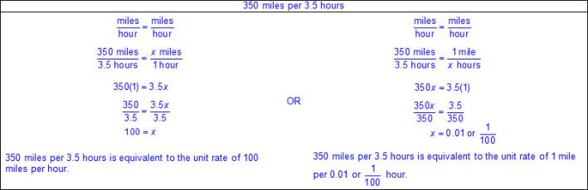  - Density ()  - Ex:  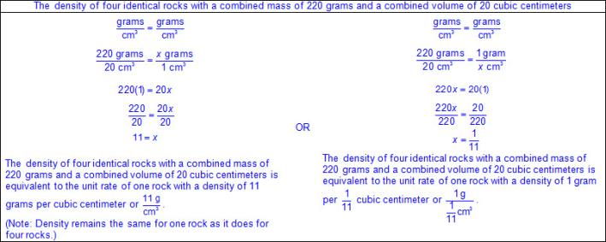  - Price  - Ex:  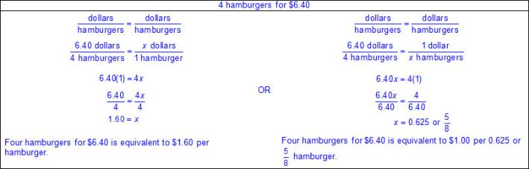  - Measurement in recipes  - Ex:  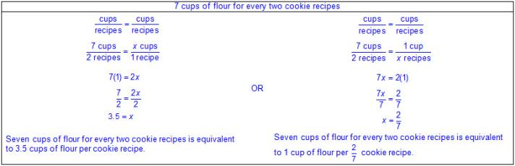  - Student–teacher ratios  - Ex:  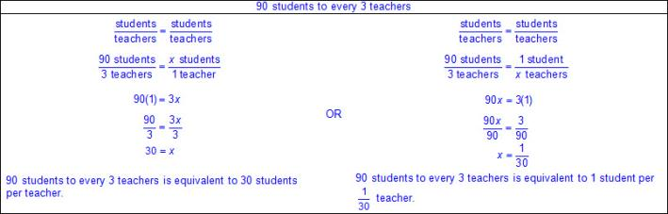  - Unit conversions within and between systems  - Customary  - Metric  - Ex:  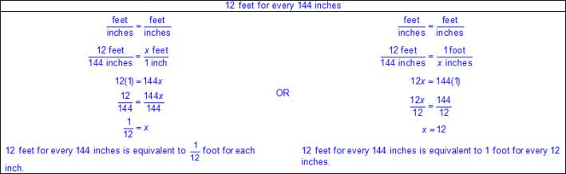  - Ex:  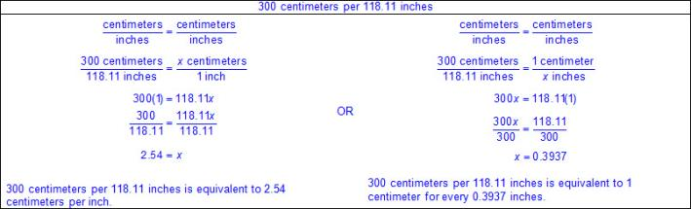  Note(s):  - Grade Level(s):  - Grade 6 calculated density (Science 6.6B).  - Grade 7 introduces calculating unit rates from rates in mathematical and real-world problems.  - Various mathematical process standards will be applied to this student expectation as appropriate.  - TxRCFP:  - Representing and applying proportional relationships  - TxCCRS:  - I. Numeric Reasoning  - VIII. Problem Solving and Reasoning  - IX. Communication and Representation  - X. Connections
7.4C | Determine the constant of proportionality (k = y/x) within mathematical and real-world problems.  Supporting Standard  Determine the constant of proportionality (k = y/x) within mathematical and real-world problems.  Supporting Standard  Determine  THE CONSTANT OF PROPORTIONALITY () WITHIN MATHEMATICAL AND REAL-WORLD PROBLEMS  Including, but not limited to:  - Rational numbers – the set of numbers that can be expressed as a fraction , where a and b are integers and b ≠ 0, which includes the subsets of integers, whole numbers, and counting (natural) numbers (e.g., -3, 0, 2, etc.). The set of rational numbers is denoted by the symbol Q.  - Various forms of positive and negative rational numbers  - Whole numbers  - Integers  - Decimals (less than or greater than one)  - Fractions (proper, improper, and mixed numbers)  - Constant rate of change – a ratio when the dependent, y-value, changes at a constant rate for each independent, x-value  - Constant of proportionality – a constant positive ratio between two proportional quantities denoted by the symbol k  - Characteristics of the constant of proportionality  - The constant of proportionality can never be zero.  - Unit rate – a ratio between two different units where one of the terms is 1  - Proportional mathematical and real-world problems  - Unit conversions within and between same system  - Customary  - Metric  - d = rt  - In d = rt, the d represents distance, the r represents rate, and the t represents time  - Connections between constant rate of change r, in d = rt, to the constant of proportionality, k, in y = kx  - Various representations of the constant of proportionality  - Tabular (vertical/horizontal)  - Ex:  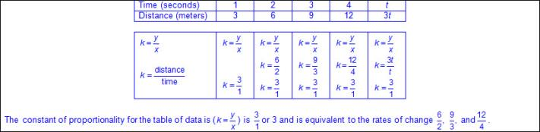  - Verbal  - Ex:  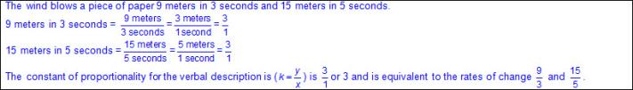  - Numeric  - Ex:  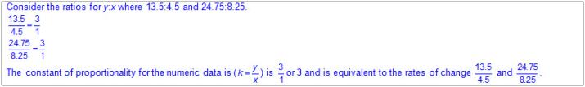  - Graphical  - Ex:  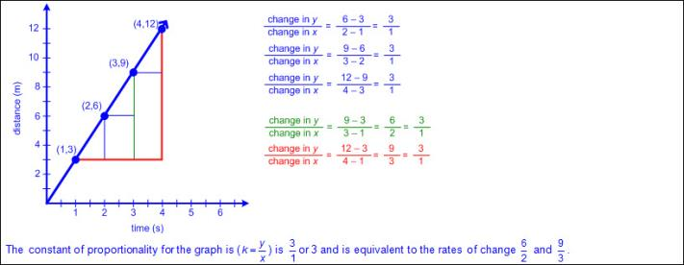  - Algebraic  - Ex:  Note(s):  - Grade Level(s):  - Grade 6 compared two rules verbally, numerically, graphically, and symbolically in the form of y = ax or y = x + a in order to differentiate between additive and multiplicative relationships.  - Grade 8 will solve problems involving direct variation.  - Various mathematical process standards will be applied to this student expectation as appropriate.  - TxRCFP:  - Representing and applying proportional relationships  - TxCCRS:  - I. Numeric Reasoning  - II. Algebraic Reasoning  - VIII. Problem Solving and Reasoning  - IX. Communication and Representation  - X. Connections
7.4D | Solve problems involving ratios, rates, and percents, including multi-step problems involving percent increase and percent decrease, and financial literacy problems.  Readiness Standard  Solve problems involving ratios, rates, and percents, including multi-step problems involving percent increase and percent decrease, and financial literacy problems.  Readiness Standard  Solve  PROBLEMS INVOLVING RATIOS, RATES, AND PERCENTS INCLUDING MULTI-STEP PROBLEMS INVOLVING PERCENT INCREASE AND PERCENT DECREASE, AND FINANCIAL LITERACY PROBLEMS  Including, but not limited to:  - Rational numbers – the set of numbers that can be expressed as a fraction , where a and b are integers and b ≠ 0, which includes the subsets of integers, whole numbers, and counting (natural) numbers (e.g., -3, 0, 2, etc.). The set of rational numbers is denoted by the symbol Q.  - Various forms of positive rational numbers  - Whole numbers  - Decimals (less than or greater than one)  - Fractions (proper, improper, and mixed numbers)  - Percents converted to equivalent decimals or fractions for multiplying or dividing  - Ratio – a multiplicative comparison of two quantities  - Symbolic representations of ratios  - a to b, a:b, or  - Verbal representations of ratios  - 12 to 3, 12 per 3, 12 parts to 3 parts, 12 for every 3, 12 out of every 3  - Units may or may not be included (e.g., 12 boys to 3 girls, 12 to 3, etc.)  - Rate – a multiplicative comparison of two different quantities where the measuring unit is different for each quantity  - Ex: 120 heart beats per 2 minutes  - Relationship between ratios and rates  - All ratios have associated rates  - Percent – a part of a whole expressed in hundredths  - Numeric forms  - Ex: 40%, 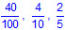, 0.4  - Algebraic notation as a decimal  - Ex: 40% of any given amount x can be represented as 0.4x  - Ex: 132% of any given amount x can be represented as 1.32x  - Multi-step problems  - Multiple methods for solving problems involving ratios, rates, and percents  - Models (e.g., percent bars, hundredths grid, etc.)  - Decimal method (algebraic)  - Dimensional analysis  - Proportion method  - Scale factors between ratios  - Equivalent representations of ratios, rates and percents  - Ex: 50% is equivalent to 0.50 because 0.50 is equal to or .  - Various representations of ratios, rates, percents  - Tabular (vertical/horizontal)  - Verbal  - Numeric  - Graphical  - Strip diagram  - Number line  - Percent graph  - Algebraic  - Situations involving ratios, rates, or percents  - Percent increase – a change in percentage where the value increases  - Ex:  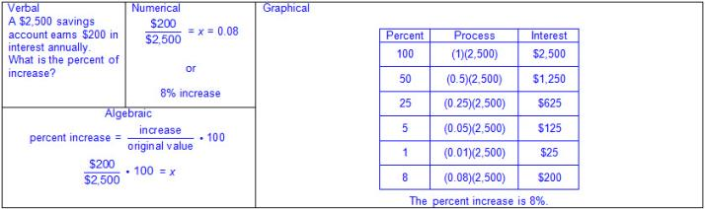  - Percent decrease – a change in percentage where the value decreases  - Ex:  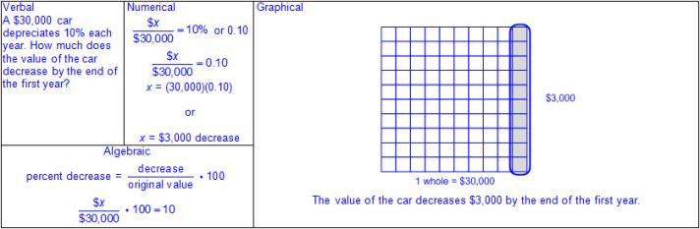  - Financial literacy problems  - Principal – the original amount invested or borrowed  - Simple interest – interest paid on the original principal in an account, disregarding any previously earned interest  - Formula for simple interest from STAAR Grade 7 Mathematics Reference Materials  - I = Prt, where I represents the interest, P represents the principal amount, r represents the interest rate in decimal form, and t represents the number of years the amount is deposited or borrowed  - Ex:  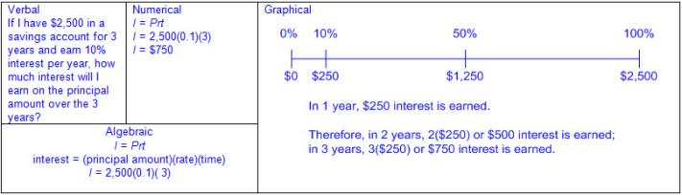  - Tax – a financial charge, usually a percentage applied to goods, property, sales, etc.  - Ex:  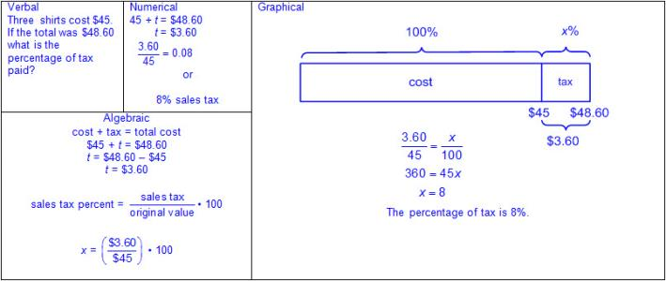  - Tip – an amount of money rendered for a service, gratuity  - Ex:  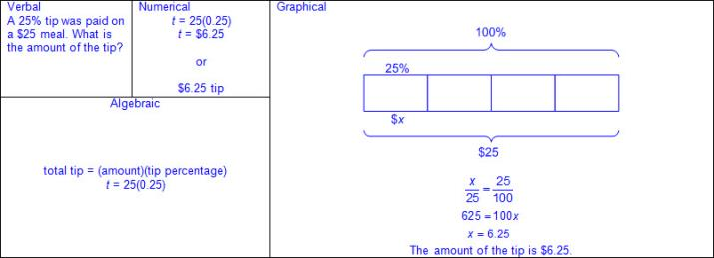  - Commission – pay based on a percentage of the sales or profit made by an employee or agent  - Ex:  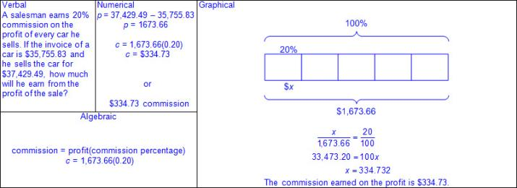  - Markup – the difference between the purchase price of an item and its sales price  - Ex:  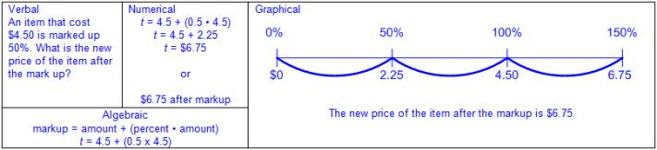  - Markdown – the difference between the original price of an item and its current price  - Ex:  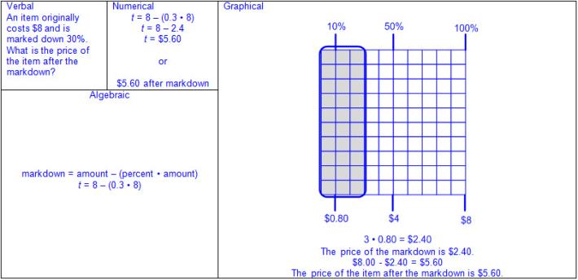  - Appreciation – the increase in value over time  - Ex:  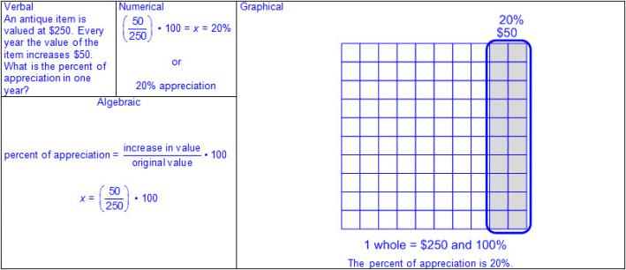  - Depreciation – the decrease in value over time  - Ex:  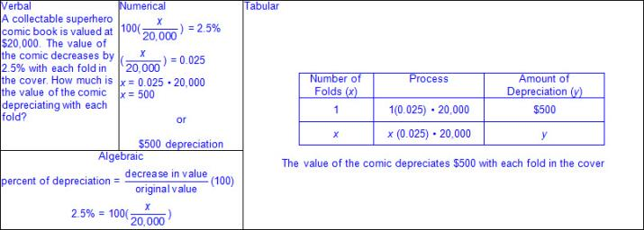  Note(s):  - Grade Level(s):  - Grade 6 represented ratios and percents with concrete models, fractions, and decimals.  - Grade 6 represented benchmark fractions and percents such as 1%, 10%, 25%, 33% and multiples of these values using 10 by 10 grids, strip diagrams, number lines, and numbers.  - Grade 6 generated equivalent forms of fractions, decimals, and percents using real-world problems, including problems that involve money.  - Grade 6 solved real-world problems to find the whole given a part and the percent, to find the part given the whole and the percent, and to find the percent given the part and the whole, including the use of concrete and pictorial models.  - Grade 6 used equivalent fractions, decimals, and percents to show equal parts of the same whole.  - Various mathematical process standards will be applied to this student expectation as appropriate.  - TxRCFP:  - Representing and applying proportional relationships  - TxCCRS:  - I. Numeric Reasoning  - II. Algebraic Reasoning  - VIII. Problem Solving and Reasoning  - IX. Communication and Representation  - X. Connections
7.4E | Convert between measurement systems, including the use of proportions and the use of unit rates.  Supporting Standard  Convert between measurement systems, including the use of proportions and the use of unit rates.  Supporting Standard  Convert  BETWEEN MEASUREMENT SYSTEMS, INCLUDING THE USE OF PROPORTIONS AND THE USE OF UNIT RATES  Including, but not limited to:  - Positive rational numbers – the set of numbers that can be expressed as a fraction , where a and b are whole numbers and b ≠ 0, which includes the subsets of whole numbers and counting (natural) numbers (e.g., 0, 2, 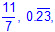 etc.).  - Various forms of positive rational numbers  - Whole numbers  - Decimals (less than or greater than one)  - Fractions (proper, improper, and mixed numbers)  - Convert units between measurement systems.  - Customary to metric  - Ex: inches to centimeters, yards to meters, pounds to kilograms, quarts to liters, etc.  - Metric to customary  - Ex: centimeters to inches, meters to yards, kilograms to pounds, liters to quarts, etc.  - Multiple solution strategies  - Dimensional analysis using unit rates  - Ex:  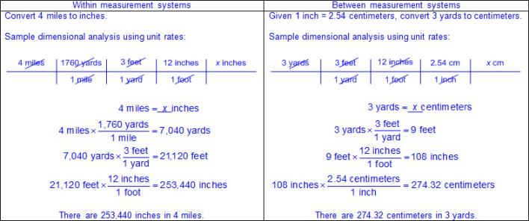  - Scale factor between ratios  - Ex:  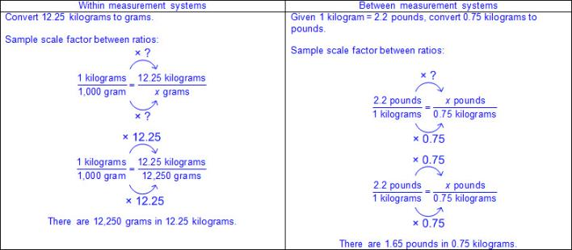  - Proportion method  - Ex:  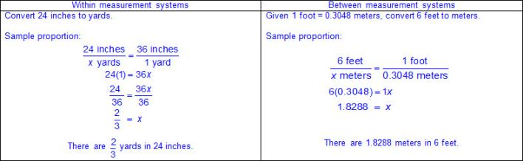  - Conversion graph  - Ex:  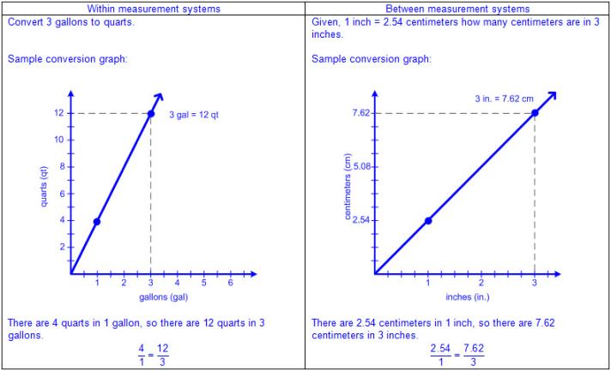  Note(s):  - Grade Level(s):  - Grade 6 converted units within a measurement system, including the use of proportions and unit rates.  - Various mathematical process standards will be applied to this student expectation as appropriate.  - TxRCFP:  - Representing and applying proportional relationships  - TxCCRS:  - I. Numeric Reasoning  - IV. Measurement Reasoning  - VIII. Problem Solving and Reasoning  - IX. Communication and Representation
7.5 | Proportionality. The student applies mathematical process standards to use geometry to describe or solve problems involving proportional relationships. The student is expected to:
7.5A | Generalize the critical attributes of similarity, including ratios within and between similar shapes.  Supporting Standard  Generalize the critical attributes of similarity, including ratios within and between similar shapes.  Supporting Standard  Generalize  THE CRITICAL ATTRIBUTES OF SIMILARITY, INCLUDING RATIOS WITHIN AND BETWEEN SIMILAR SHAPES  Including, but not limited to:  - Congruent – of equal measure, having exactly the same size and same shape  - Similar shapes – shapes whose angles are congruent and side lengths are proportional (equal scale factor)  - Notation for similar shapes  - Symbol for similarity (~) read as “similar to”  - Ex: ABCD ~ A’B’C’D’ is read as “ABCD is similar to A prime B prime C prime and D prime”  - The order of the letters determines corresponding side lengths and angles  - Attributes of similar shapes  - Corresponding sides are proportional.  - Corresponding angles are congruent.  - Ex:  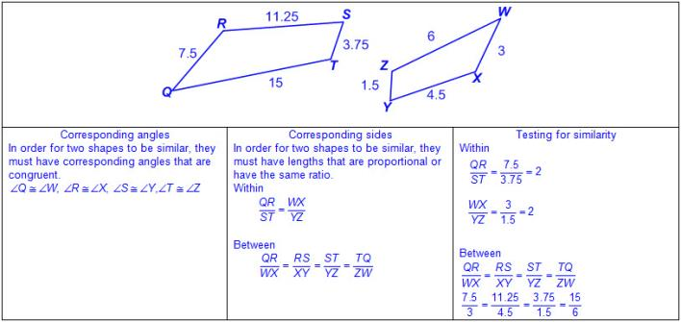  - Generalizations of similarity  - A scale factor  - A scale factor >1 increases the linear dimensions of the shape.  - Ratios comparing lengths within each shape or between shapes will determine if the shapes are similar.  - Shapes that are “the same shape, but a different size” are not always similar shapes.  - Corresponding sides are proportional, while corresponding angles are congruent.  - There is a multiplicative relationship between the lengths of corresponding sides.  Note(s):  - Grade Level(s):  - Grade 7 introduces generalizing the critical attributes of similarity, including ratios within and between similar shapes.  - Various mathematical process standards will be applied to this student expectation as appropriate.  - TxRCFP:  - Representing and applying proportional relationships  - TxCCRS:  - III.C. Geometric Reasoning – Connections between geometry and other mathematical content strands  - IV. Measurement Reasoning  - VIII. Problem Solving and Reasoning  - IX. Communication and Representation  - X. Connections
7.5B | Describe π as the ratio of the circumference of a circle to its diameter.  Supporting Standard  Describe π as the ratio of the circumference of a circle to its diameter.  Supporting Standard  Describe  π AS THE RATIO OF THE CIRCUMFERENCE OF A CIRCLE TO ITS DIAMETER  Including, but not limited to:  - Circle  - A figure formed by a closed curve with all points equal distance from the center  - No straight sides  - No vertices  - No parallel or, perpendicular sides  - Diameter – a line segment whose endpoints are on the circle and passes through the center of the circle  - Radius – a line segment drawn from the center of a circle to any point on the circle and is half the length of diameter of the circle  - Circumference – a linear measurement of the distance around a circle  - Pi (π) – the ratio of the circumference to the diameter of a circle  - π = or  - π ≈ 3.14 or  - Relationships between circumference and diameter  - Ex:  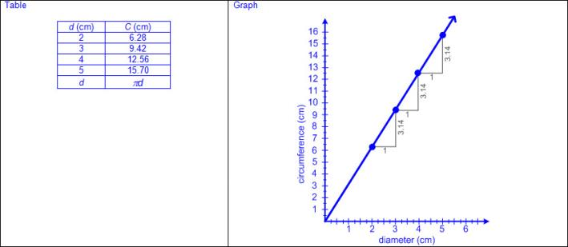  Note(s):  - Grade Level(s):  - Grade 7 introduces describing π as the ratio of the circumference of a circle to its diameter.  - Various mathematical process standards will be applied to this student expectation as appropriate.  - TxRCFP:  - Representing and applying proportional relationships  - TxCCRS:  - I. Numeric Reasoning  - III.C. Geometric Reasoning – Connections between geometry and other mathematical content strands  - IV. Measurement Reasoning  - IX. Communication and Representation  - X. Connections
7.5C | Solve mathematical and real-world problems involving similar shape and scale drawings.  Readiness Standard  Solve mathematical and real-world problems involving similar shape and scale drawings.  Readiness Standard  Solve  MATHEMATICAL AND REAL-WORLD PROBLEMS INVOLVING SIMILAR SHAPE AND SCALE DRAWINGS  Including, but not limited to:  - Positive rational numbers – the set of numbers that can be expressed as a fraction , where a and b are whole numbers and b ≠ 0, which includes the subsets of whole numbers and counting (natural) numbers (e.g., 0, 2, etc.).  - Various forms of positive rational numbers  - Whole numbers  - Decimals (less than or greater than one)  - Fractions (proper, improper, and mixed numbers)  - Percents converted to equivalent decimals or fractions for multiplying or dividing  - Similar shapes – shapes whose angles are congruent and side lengths are proportional (equal scale factor)  - Proportional relationship between scale factor and linear measures of similar figures and scale drawings in mathematical and real-world problem situations  - Linear measures  - Ex:  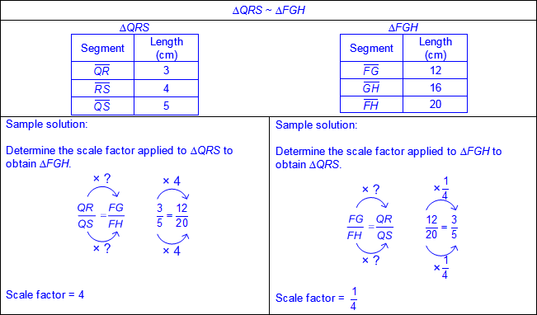  - Ex:  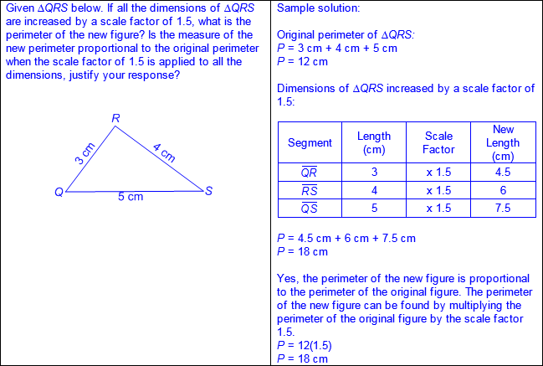  Note(s):  - Grade Level(s):  - Grade 7 introduces solving mathematical and real-world problems involving similar shape and scale drawings.  - Various mathematical process standards will be applied to this student expectation as appropriate.  - TxRCFP:  - Representing and applying proportional relationships  - TxCCRS:  - I. Numeric Reasoning  - III.C. Geometric Reasoning – Connections between geometry and other mathematical content strands  - IV. Measurement Reasoning  - VIII. Problem Solving and Reasoning  - IX. Communication and Representation  - X. Connections
7.6 | Proportionality. The student applies mathematical process standards to use probability and statistics to describe or solve problems involving proportional relationships. The student is expected to:
7.6A | Represent sample spaces for simple and compound events using lists and tree diagrams.  Supporting Standard  Represent sample spaces for simple and compound events using lists and tree diagrams.  Supporting Standard  Represent  SAMPLE SPACES FOR SIMPLE AND COMPOUND EVENTS USING LISTS AND TREE DIAGRAMS  Including, but not limited to:  - Event – a probable situation or condition  - Outcome – the result of an action or event  - Mutually exclusive events – events that cannot happen at the same time  - Ex:  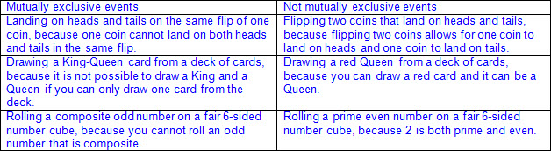  - Simple event – an event that consists of a single outcome  - Compound events – events that consists of two or more simple events and consists of more than one outcome  - Compound independent events – events with more than one outcome, and one event does not affect the outcome of the other  - Compound dependent events – events with more than one outcome, and the outcome of one event affects the outcome of the subsequent event or events  - Sample space – a set of all possible outcomes of one or more events  - Various representations of sample space for simple and compound events  - Lists  - Tree diagrams  - Tables  - Fundamental Counting Principle – if one event has a possible outcomes and a second independent event has b possible outcomes, then there are a • b total possible outcomes for the two events together  - Ex:  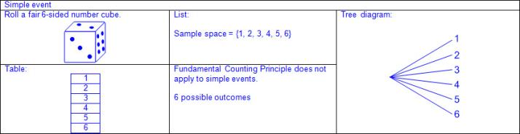  - Ex:  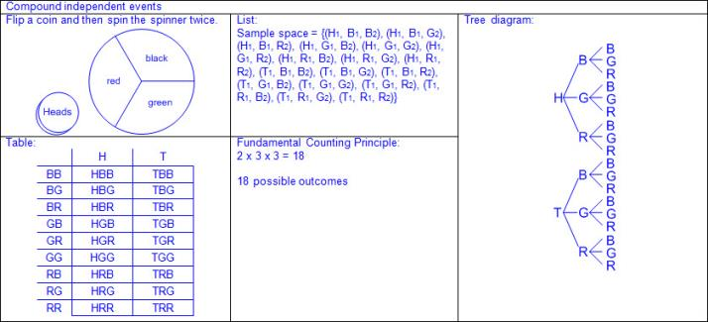  - Ex:  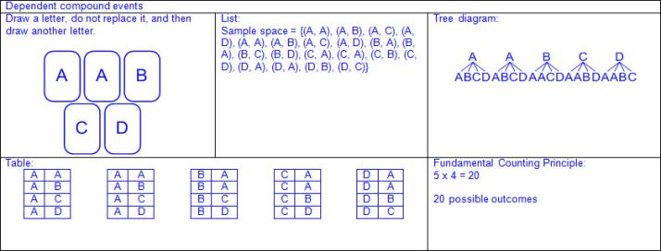  Note(s):  - Grade Level(s):  - Grade 7 introduces representing sample spaces for simple and compound events using lists and tree diagrams.  - Various mathematical process standards will be applied to this student expectation as appropriate.  - TxRCFP:  - Representing and applying proportional relationships  - TxCCRS:  - V. Probabilistic Reasoning  - IX. Communication and Representation
7.6B | Select and use different simulations to represent simple and compound events with and without technology.  Select and use different simulations to represent simple and compound events with and without technology.  Select, Use  DIFFERENT SIMULATIONS TO REPRESENT SIMPLE AND COMPOUND EVENTS WITH AND WITHOUT TECHNOLOGY  Including, but not limited to:  - Event – a probable situation or condition  - Outcome – the result of an action or event  - Simple event – an event that consists of a single outcome  - Compound events – events that consists of two or more simple events and consists of more than one outcome  - Compound independent events – events with more than one outcome, and one event does not affect the outcome of the other  - Compound dependent events – events with more than one outcome, and the outcome of one event affects the outcome of the subsequent event or events  - Sample space – a set of all possible outcomes of one or more events  - Simulation – an experiment or model used to test the outcomes of an event  - Developing a design for a simulation  - Appropriate methods to simulate simple and compound events  - With technology  - Calculator  - Computer model  - Random number generators  - Without technology  - Spinners (even and uneven sections)  - Color tiles  - Two-color counters  - Coins  - Deck of cards  - Marbles  - Number cubes  - Ex:  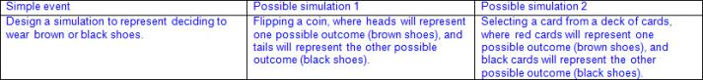  - Ex:  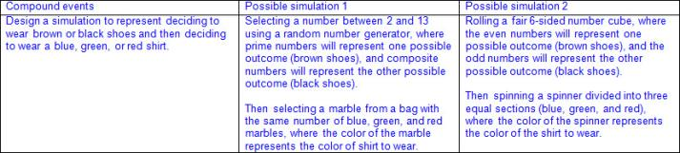  Note(s):  - Grade Level(s):  - Grade 7 introduces selecting and using different simulations to represent simple and compound events with and without technology.  - Various mathematical process standards will be applied to this student expectation as appropriate.  - TxRCFP:  - Representing and applying proportional relationships  - TxCCRS:  - V. Probabilistic Reasoning  - VIII. Problem Solving and Reasoning  - IX. Communication and Representation
7.6C | Make predictions and determine solutions using experimental data for simple and compound events.  Supporting Standard  Make predictions and determine solutions using experimental data for simple and compound events.  Supporting Standard  Predict, Determine  SOLUTIONS USING EXPERIMENTAL DATA FOR SIMPLE AND COMPOUND EVENTS  Including, but not limited to:  - Positive rational numbers – the set of numbers that can be expressed as a fraction , where a and b are whole numbers and b ≠ 0, which includes the subsets of whole numbers and counting (natural) numbers (e.g., 0, 2, etc.).  - Various forms of positive rational numbers  - Whole numbers  - Decimals (less than or equal to one)  - Fractions (proper or equal to one)  - Percents (less than or equal to 100%)  - Event – a probable situation or condition  - Outcome – the result of an action or event  - Mutually exclusive events – events that cannot happen at the same time  - Ex:  - Experimental data – the data collected or observed from the outcomes of an experiment  - Various types of experiments  - Ex: Coins, drawing objects out of box without looking, spinners with even and uneven sections, choosing a random card, marbles, number cubes, etc.  - Representation of experimental data as a fraction, decimal, or percent  - Ex: Three out of the ten throws were strikes: , 0.3, 30%  - Simple event – an event that consists of a single outcome  - Compound events – events that consists of two or more simple events and consists of more than one outcome  - Compound independent events – events with more than one outcome, and one event does not affect the outcome of the other  - Compound dependent events – events with more than one outcome, and the outcome of one event affects the outcome of the subsequent event or events  - Proportional reasoning to make predictions using experimental data  - Ex:  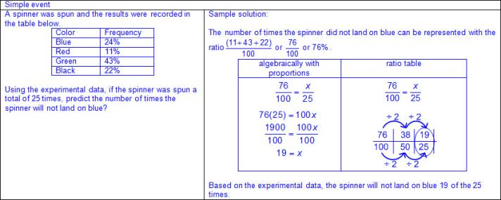  - Ex:  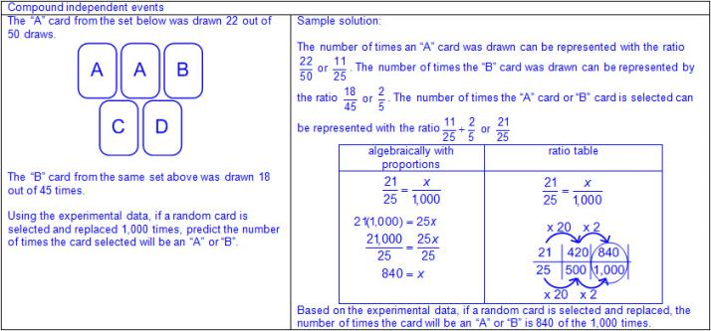  - Ex:  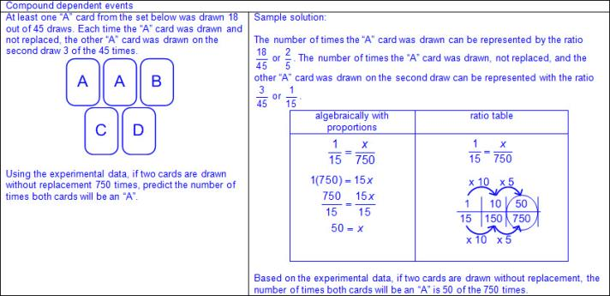  Note(s):  - Grade Level(s):  - Grade 7 introduces making predictions and determining solutions using experimental data for simple and compound events.  - Various mathematical process standards will be applied to this student expectation as appropriate.  - TxRCFP:  - Representing and applying proportional relationships  - TxCCRS:  - I. Numeric Reasoning  - V. Probabilistic Reasoning  - VI. Statistical Reasoning  - VIII. Problem Solving and Reasoning  - IX. Communication and Representation
7.6D | Make predictions and determine solutions using theoretical probability for simple and compound events.  Supporting Standard  Make predictions and determine solutions using theoretical probability for simple and compound events.  Supporting Standard  Predict, Determine  SOLUTIONS USING THEORETICAL PROBABILITY FOR SIMPLE AND COMPOUND EVENTS  Including, but not limited to:  - Positive rational numbers – the set of numbers that can be expressed as a fraction , where a and b are whole numbers and b ≠ 0, which includes the subsets of whole numbers and counting (natural) numbers (e.g., 0, 2, etc.).  - Various forms of positive rational numbers  - Whole numbers  - Decimals (less than or equal to one)  - Fractions (proper or equal to one)  - Percents (less than or equal to 100%)  - Event – a probable situation or condition  - Outcome – the result of an action or event  - Mutually exclusive events – events that cannot happen at the same time  - Ex:  - Sample space – a set of all possible outcomes of one or more events  - Probability – a ratio between the number of desired outcomes to the total possible outcomes, 0 ≤ p ≤1  - Probability = 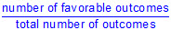  - Notation for probability  - P(event)  - The closer a probability of an outcome is to 1, the more likely the outcome will occur; whereas, the closer a probability of an outcome is to 0, the less likely the outcome will occur.  - Ex:  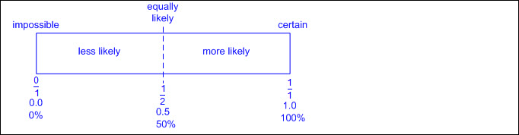  - Theoretical probability – the likelihood of an event occurring without conducting an experiment  - Various types of theoretical experiments  - Ex: Coins, drawing objects out of box without looking, spinners with even and uneven sections, choosing a random card, marbles, number cubes, etc.  - Representation of theoretical probability as a fraction, decimal, or percent  - Ex: Three out of the ten sections are blue: , 0.3, 30%  - Simple event – an event that consists of a single outcome  - Compound events – events that consists of two or more simple events and consists of more than one outcome  - Compound independent events – events with more than one outcome, and one event does not affect the outcome of the other  - Compound dependent events – events with more than one outcome, and the outcome of one event affects the outcome of the subsequent event or events  - Proportional reasoning to make predictions using theoretical probability  - Ex:  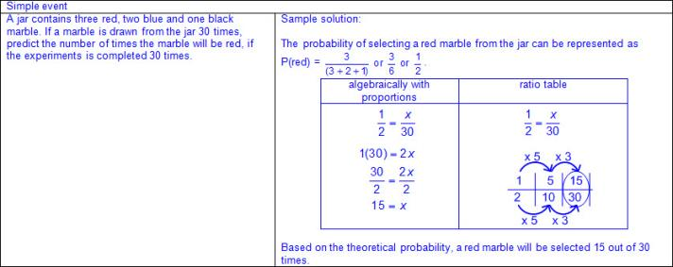  - Ex:  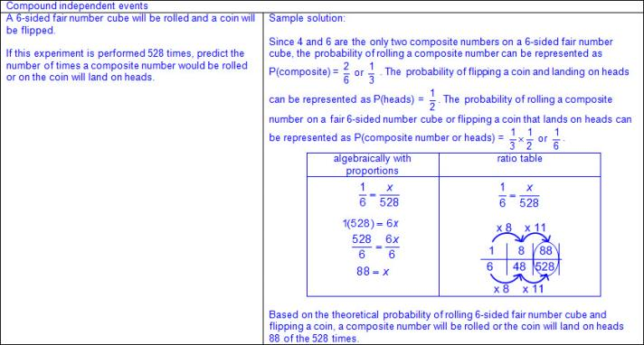  - Ex:  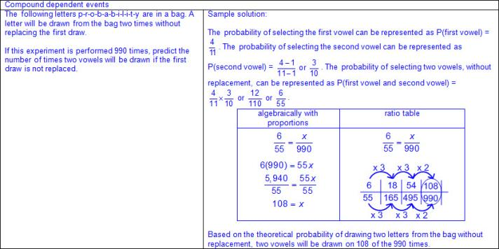  Note(s):  - Grade Level(s):  - Grade 7 introduces making predictions and determining solutions using theoretical probability for simple and compound events.  - Various mathematical process standards will be applied to this student expectation as appropriate.  - TxRCFP:  - Representing and applying proportional relationships  - TxCCRS:  - I. Numeric Reasoning  - V. Probabilistic Reasoning  - VI. Statistical Reasoning  - VIII. Problem Solving and Reasoning  - IX. Communication and Representation
7.6E | Find the probabilities of a simple event and its complement and describe the relationship between the two.  Supporting Standard  Find the probabilities of a simple event and its complement and describe the relationship between the two.  Supporting Standard  Find  THE PROBABILITIES OF A SIMPLE EVENT AND ITS COMPLEMENT AND DESCRIBE THE RELATIONSHIP BETWEEN THE TWO  Including, but not limited to:  - Positive rational numbers – the set of numbers that can be expressed as a fraction , where a and b are whole numbers and b ≠ 0, which includes the subsets of whole numbers and counting (natural) numbers (e.g., 0, 2, etc.).  - Various forms of positive rational numbers  - Whole numbers  - Decimals (less than or equal to one)  - Fractions (proper or equal to one)  - Percents (less than or equal to 100%)  - Event – a probable situation or condition  - Outcome – the result of an action or event  - Sample space – a set of all possible outcomes of one or more events  - Probability – a ratio between the number of desired outcomes to the total possible outcomes, 0 ≤ p ≤1  - Probability =  - Notation for probability  - P(event)  - The closer a probability of an outcome is to 1, the more likely the outcome will occur; whereas, the closer a probability of an outcome is to 0, the less likely the outcome will occur.  - Ex:  - Various types of simple experiments  - Ex: coins, drawing objects out of box without looking, spinners with even and uneven sections, choosing a random card, marbles, cubes, etc.  - Simple event – an event that consists of a single outcome  - Complement of an event – the probability of the non-occurrence of a desired outcome  - Ex: The probability of selecting a face card from a deck of cards is or . The complement of selecting a face card from a deck of cards is the probability of selecting any card but a face card from a deck of cards which is or .  - The outcomes of a simple event and its complement complete the sample space.  - Ex:  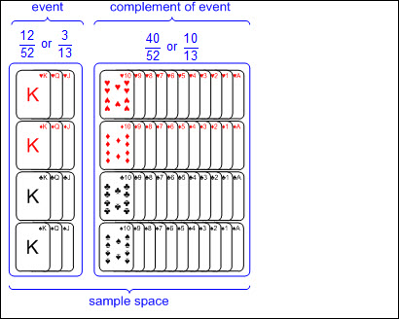  - Representation of probability and complements as a fraction, decimal, or percent  - Ex: The probability of not selecting a day of the week with a “u” in the name of the day: , 0.6, 60%  - Relationship between a simple event and its complement expressed as a ratio or numerical expression.  - The sum of the probability of a simple event and its complement will always be 1.  - Ex:  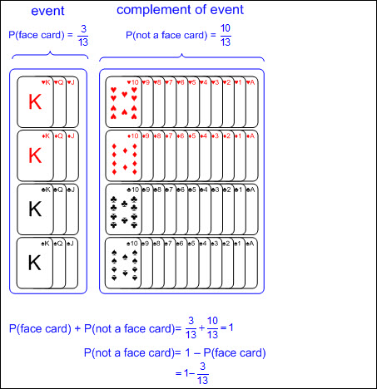  - Ex: If, P(A) = , then P(not A) = 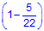 or . Therefore, P(A) + P(not A) = 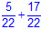 = 1  Note(s):  - Grade Level(s):  - Grade 7 introduces finding the probabilities of a simple event and its complement and describing the relationship between the two.  - Various mathematical process standards will be applied to this student expectation as appropriate.  - TxRCFP:  - Representing and applying proportional relationships  - TxCCRS:  - I. Numeric Reasoning  - V. Probabilistic Reasoning  - VIII. Problem Solving and Reasoning  - IX. Communication and Representation
7.6F | Use data from a random sample to make inferences about a population.  Use data from a random sample to make inferences about a population.  Use  DATA FROM A RANDOM SAMPLE TO MAKE INFERENCES ABOUT A POPULATION  Including, but not limited to:  - Positive rational numbers – the set of numbers that can be expressed as a fraction , where a and b are whole numbers and b ≠ 0, which includes the subsets of whole numbers and counting (natural) numbers (e.g., 0, 2, etc.).  - Various forms of positive rational numbers  - Whole numbers  - Decimals (less than or equal to one)  - Fractions (proper or equal to one)  - Percents (less than or equal to 100%)  - Data – information that is collected about people, events, or objects  - Inference – a conclusion or prediction based on data  - Population – total collection of persons, objects, or items of interest  - Sample – a subset of the population selected in order to make inferences about the entire population  - Ex:  - Ex:  - Random sample – a subset of the population selected without bias in order to make inferences about the entire population  - Random samples are more likely to contain data that can be used to make predictions about a whole population.  - Data from a random sample given or collected in various forms  - Verbal  - Ex:  - Tabular (vertical/horizontal)  - Ex:  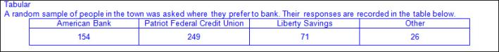  - Graphical  - Ex:  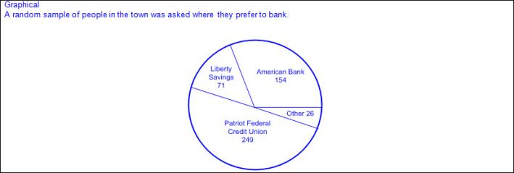  - Inferences based on random sample  - Qualitative – a broad subjective description (e.g., the probability of an event occurring is certain, more likely, not likely, equally likely, or impossible.)  - Quantitative – a narrowed objective description associated with a quantity (e.g., the probability of selecting a consonant from the word EXPERIMENT is 1.5 times as likely as selecting a vowel from the same word, etc.)  - Proportional reasoning from data in a random sample to make inferences about the population  - Ex:  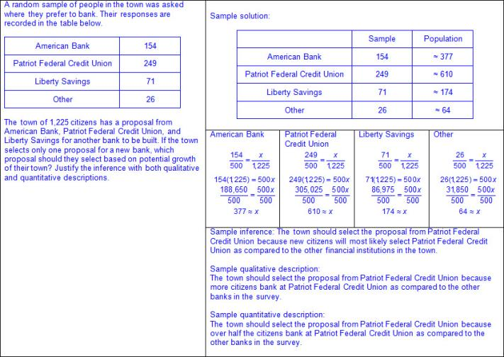  Note(s):  - Grade Level(s):  - Grade 7 introduces using data from random samples to make inferences about a population.  - Various mathematical process standards will be applied to this student expectation as appropriate.  - TxRCFP:  - Representing and applying proportional relationships  - TxCCRS:  - I. Numeric Reasoning  - IV. Measurement Reasoning  - VI. Statistical Reasoning  - VIII. Problem Solving and Reasoning  - IX. Communication and Representation
7.6G | Solve problems using data represented in bar graphs, dot plots, and circle graphs, including part-to-whole and part-to-part comparisons and equivalents.  Readiness Standard  Solve problems using data represented in bar graphs, dot plots, and circle graphs, including part-to-whole and part-to-part comparisons and equivalents.  Readiness Standard  Solve  PROBLEMS USING DATA REPRESENTED IN BAR GRAPHS, DOT PLOTS, AND CIRCLE GRAPHS, INCLUDING PART-TO-WHOLE AND PART-TO-PART COMPARISONS AND EQUIVALENTS  Including, but not limited to:  - Positive rational numbers – the set of numbers that can be expressed as a fraction , where a and b are whole numbers and b ≠ 0, which includes the subsets of whole numbers and counting (natural) numbers (e.g., 0, 2, etc.).  - Various forms of positive rational numbers  - Whole numbers  - Decimals (less than or greater than one)  - Fractions (proper, improper, and mixed numbers)  - Percents converted to equivalent decimals or fractions for multiplying or dividing  - Data – information that is collected about people, events, or objects  - Categorical data – data that represents the attributes of a group of people, events, or objects  - Ex: What is your favorite color? Represented on a graph with colors as category labels (e.g., red, yellow, blue, green, and purple).  - Ex: Do you have a brother? Represented on a graph with yes and no as category labels.  - Ex: Which sporting event do you prefer? Represented on a graph with names of sports as category labels (e.g., basketball, baseball, football, soccer, and hockey).  - Categorical data may represent numbers or ranges of numbers.  - Ex: How many pets do you have? Represented on a graph with numbers as category labels (e.g., 0, 1, 2, 3, and 4 or more).  - Ex: How many letters are in your name? Represented on a graph with ranges of numbers as category labels (e.g., 1 – 3, 4 – 6, 7 – 9, and 10 or more).  - Numerical data – data that represents values or observations that can be measured and placed in ascending or descending order  - Data can be counted (discrete) or measured (continuous).  - Ex: How many hours do you spend studying each night? Represented on a graph with a numerical axis.  - Ex: How old were you when you lost your first tooth? Represented on a graph with a numerical axis.  - Data representations  - Bar graph – a graphical representation to organize data that uses solid bars that do not touch each other to show the frequency (number of times) that each category occurs  - Characteristics of a bar graph  - Title clarifies the meaning of the data represented.  - Subtitles clarify the meaning of the data represented on each axis.  - Categorical data is represented with labels.  - Horizontal or vertical linear arrangement  - Bars are solid.  - Bars do not touch.  - Scale of the axis may be intervals of one or more, and scale intervals are proportionally displayed.  - The scale of the axis is a number line.  - Length of the bar represents the number of data points for a given category.  - Length the bar represents the distance from zero on the scale of the axis.  - Value of the data represented by the bar is determined by reading the number associated with its length (distance from zero) on the axis scale.  - Dot plot – a graphical representation to organize data that uses dots (or Xs) to show the frequency (number of times) that each number occurs  - Characteristics of a dot plot  - Title clarifies the meaning of the data represented.  - Numerical data is represented with labels and may be whole numbers, fractions, or decimals.  - Data represented may be numbers.  - Counts related to numbers represented by a number line.  - Dots (or Xs) recorded vertically above the line to represent the frequency of each number.  - Dots (or Xs) generally represent one count.  - Dots (or Xs) may represent multiple counts if indicated with a key.  - Density of dots relates to the frequency of distribution of the data.  - Circle graph – a circular graph with partitions (sections) that represent a part of the total  - Characteristics of a circle graph  - Title clarifies the meaning of the data represented.  - Categorical data is represented as partitions of the circle.  - Size of partition is proportional to the magnitude of the quantity and its relationship to the 360° of the circle.  - Partitions generally labeled as percents or fractions.  - When labeled as percents, the sum of the quantities of the partitions is 100%.  - When labeled as fractions, the sum of the quantities of the partitions is 1.  - Proportional relationships within data representations  - Part-to-whole comparisons  - Part-to-part comparisons  - Ex:  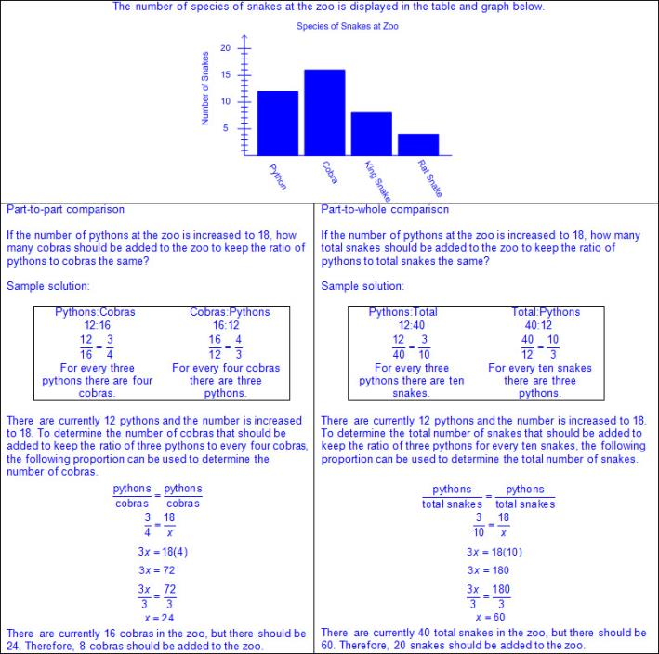  - Ex:  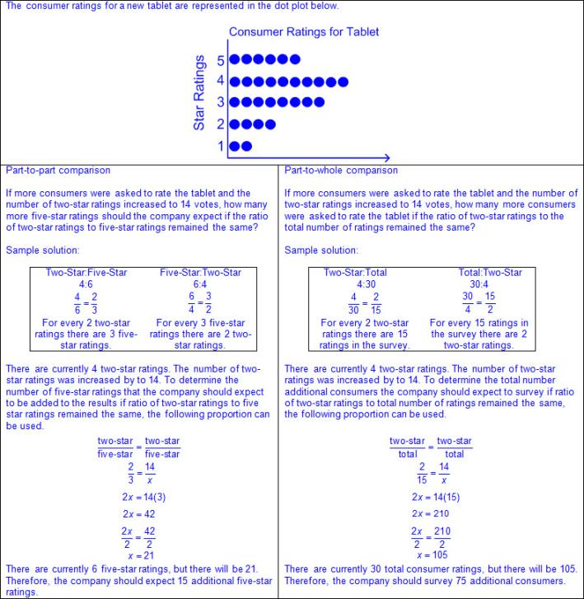  - Ex:  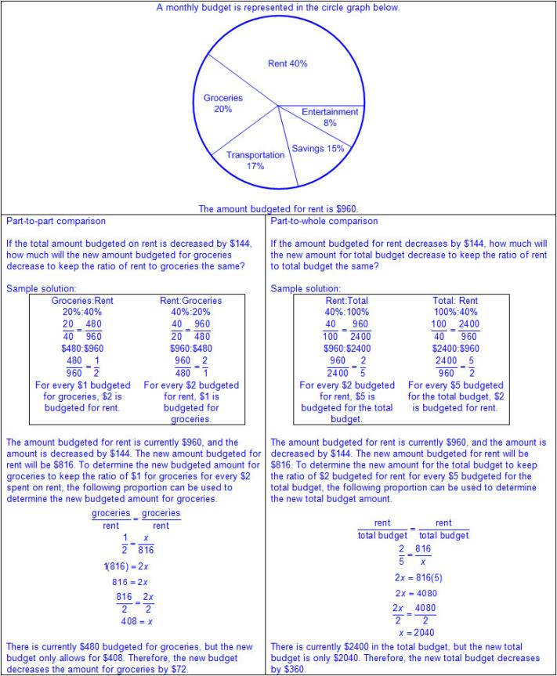  Note(s):  - Grade Level(s):  - In previous grades, students have represented data with pictographs, bar graphs, frequency tables, dot plots, stem-and-leaf plots scatterplots, histograms, box plots, relative frequency tables, and percent bar graphs.  - Grade 7 introduces solving problems using data represented in bar graphs, dot plots, and circle graphs, including part-to-whole and part-to-part comparisons and equivalents.  - Various mathematical process standards will be applied to this student expectation as appropriate.  - TxRCFP:  - Representing and applying proportional relationships  - TxCCRS:  - I. Numeric Reasoning  - VI. Statistical Reasoning  - VIII. Problem Solving and Reasoning  - IX. Communication and Representation
7.6H | Solve problems using qualitative and quantitative predictions and comparisons from simple experiments.  Readiness Standard  Solve problems using qualitative and quantitative predictions and comparisons from simple experiments.  Readiness Standard  Solve  PROBLEMS USING QUALITATIVE AND QUANTITATIVE PREDICTIONS AND COMPARISONS FROM SIMPLE EXPERIMENTS  Including, but not limited to:  - Positive rational numbers – the set of numbers that can be expressed as a fraction , where a and b are whole numbers and b ≠ 0, which includes the subsets of whole numbers and counting (natural) numbers (e.g., 0, 2, etc.).  - Various forms of positive rational numbers  - Whole numbers  - Decimals (less than or equal to one)  - Fractions (proper or equal to one)  - Percents (less than or equal to 100%)  - Event – a probable situation or condition  - Outcome – the result of an action or event  - Sample space – a set of all possible outcomes of one or more events  - Probability – a ratio between the number of desired outcomes to the total possible outcomes, 0 ≤ p≤1  - Probability =  - Notation for probability  - P(event)  - The closer a probability of an outcome is to 1, the more likely the outcome will occur; whereas, the closer a probability of an outcome is to 0, the less likely the outcome will occur.  - Ex:  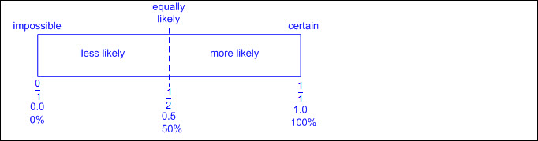  - Simple experiment – an experiment with one simple event  - Various types of simple experiments  - Ex: coins, drawing objects out of box without looking, spinners with even and uneven sections, choosing a random card, marbles, cubes, etc.  - Theoretical data – the possible outcomes of an event without conducting an experiment  - Experimental data – the data collected or observed from the outcomes of an experiment  - Predictions and comparisons  - Qualitative – a broad subjective description (e.g., the probability of an event occurring is certain, more likely, not likely, equally likely, or impossible.)  - Quantitative – a narrowed objective description associated with a quantity (e.g., the probability of selecting a consonant from the word EXPERIMENT is 1.5 times as likely as selecting a vowel from the same word, etc.)  - Proportional reasoning to make predictions and comparisons from simple experiments  - Ex:  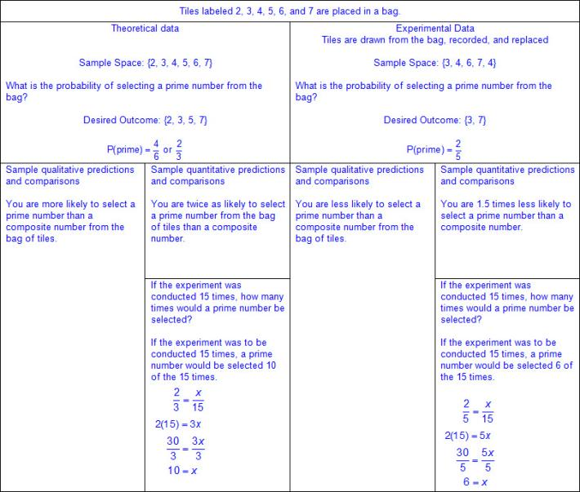  Note(s):  - Grade Level(s):  - Grade 7 introduces solving problems using qualitative and quantitative predictions and comparisons from simple experiments.  - Various mathematical process standards will be applied to this student expectation as appropriate.  - TxRCFP:  - Representing and applying proportional relationships  - TxCCRS:  - I. Numeric Reasoning  - IV. Measurement Reasoning  - V. Probabilistic Reasoning  - VI. Statistical Reasoning  - VIII. Problem Solving and Reasoning  - IX. Communication and Representation
7.6I | Determine experimental and theoretical probabilities related to simple and compound events using data and sample spaces.  Readiness Standard  Determine experimental and theoretical probabilities related to simple and compound events using data and sample spaces.  Readiness Standard  Determine  EXPERIMENTAL AND THEORETICAL PROBABILITIES RELATED TO SIMPLE AND COMPOUND EVENTS USING DATA AND SAMPLE SPACES  Including, but not limited to:  - Positive rational numbers – the set of numbers that can be expressed as a fraction , where a and b are whole numbers and b ≠ 0, which includes the subsets of whole numbers and counting (natural) numbers (e.g., 0, 2, etc.).  - Various forms of positive rational numbers  - Whole numbers  - Decimals (less than or equal to one)  - Fractions (proper or equal to one)  - Percents (less than or equal to 100%)  - Event – a probable situation or condition  - Outcome – the result of an action or event  - Mutually exclusive events – events that cannot happen at the same time  - Ex:  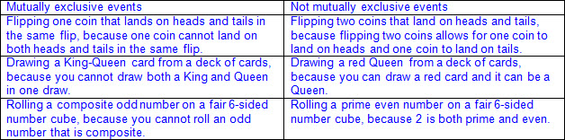  - Sample space – a set of all possible outcomes of one or more events  - Various representations of sample space  - Lists  - Tree diagrams  - Tables  - Fundamental Counting Principle – if one event has a possible outcomes and a second independent event has b possible outcomes, then there are a • b total possible outcomes for the two events together  - Probability – a ratio between the number of desired outcomes to the total possible outcomes, 0 ≤ p≤1  - Probability =  - Notation for probability  - P(event)  - The closer a probability of an outcome is to 1, the more likely the outcome will occur; whereas, the closer a probability of an outcome is to 0, the less likely the outcome will occur.  - Ex:  - Theoretical probability – the likelihood of an event occurring without conducting an experiment  - Experimental probability – the likelihood of an event occurring from the outcomes of an experiment  - Various types of experiments  - Ex: Coins, drawing objects out of box without looking, spinners with even and uneven sections, choosing a random card, marbles, number cubes, etc.  - Representation of probability as a fraction, decimal, or percent  - Ex: Three out of the ten sections are blue: , 0.3, 30%  - Complement of an event – the probability of the non-occurrence of a desired outcome  - Ex: The probability of selecting a face card from a deck of cards is or . The complement of selecting a face card from a deck of cards is the probability of selecting any card but a face card from a deck of cards which is or .  - The outcomes of an event and its complement complete the sample space.  - Relationship between an event and its complement expressed as a ratio or numerical expression  - The sum of the probability of an event and its complement will always be 1.  - Ex: If, P(A) = , then P(not A) = or . Therefore, P(A) + P(not A) = = 1  - Relationship between theoretical and experimental probability  - Law of large numbers – as the number of trials increases the difference between the experimental and theoretical probability will be closer to zero  - Simple event – an event that consists of a single outcome  - Ex:  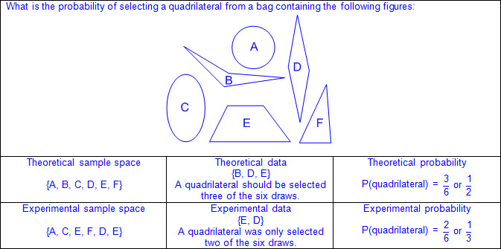  - Compound events – events that consists of two or more simple events and consists of more than one outcome  - Compound independent events – events with more than one outcome, and one event does not affect the outcome of the other  - Ex:  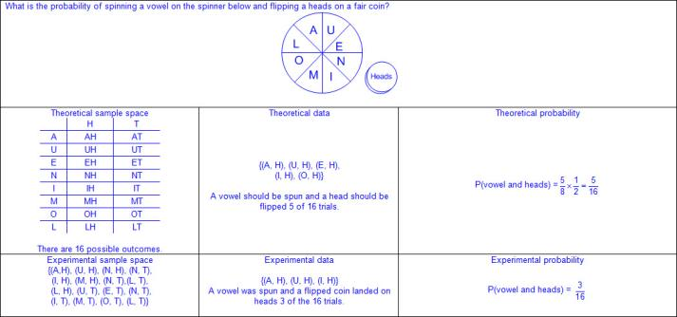  - Compound dependent events – events with more than one outcome, and the outcome of one event affects the outcome of the subsequent event or events  - Ex:  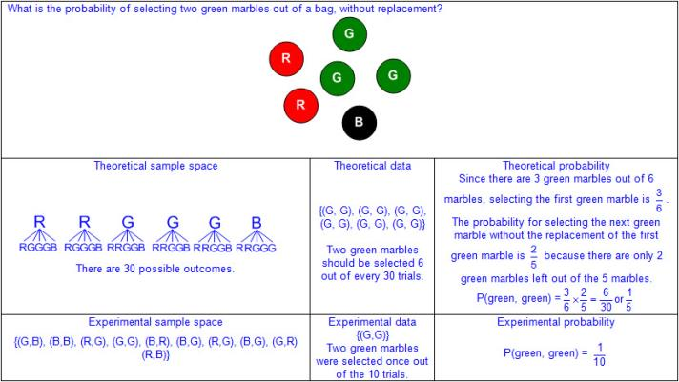  Note(s):  - Grade Level(s):  - Grade 7 introduces determining experimental and theoretical probabilities related to simple and compound events using data and sample spaces.  - Various mathematical process standards will be applied to this student expectation as appropriate.  - TxRCFP:  - Representing and applying proportional relationships  - TxCCRS:  - I. Numeric Reasoning  - IV. Measurement Reasoning  - V. Probabilistic Reasoning  - VIII. Problem Solving and Reasoning  - IX. Communication and Representation
7.7 | Expressions, equations, and relationships. The student applies mathematical process standards to represent linear relationships using multiple representations. The student is expected to:
7.7A | Represent linear relationships using verbal descriptions, tables, graphs, and equations that simplify to the form y = mx + b.  Readiness Standard  Represent linear relationships using verbal descriptions, tables, graphs, and equations that simplify to the form y = mx + b.  Readiness Standard  Represent  LINEAR RELATIONSHIPS USING VERBAL DESCRIPTIONS, TABLES, GRAPHS, AND EQUATIONS THAT SIMPLIFY TO THE FORM y = mx + b  Including, but not limited to:  - Rational numbers – the set of numbers that can be expressed as a fraction , where a and b are integers and b ≠ 0, which includes the subsets of integers, whole numbers, and counting (natural) numbers (e.g., -3, 0, 2, etc.). The set of rational numbers is denoted by the symbol Q.  - Various forms of positive and negative rational numbers as constants and coefficients  - Coefficient – a number that is multiplied by a variable(s)  - Constant – a fixed value that does not appear with a variable(s)  - Whole numbers  - Integers  - Decimals (less than or greater than one)  - Fractions (proper, improper, and mixed numbers)  - Constant rate of change – a ratio when the dependent, y-value, changes at a constant rate for each independent, x-value  - Linear relationship – a relationship with a constant rate of change represented by a graph that forms a straight line  - Linear proportional relationship  - Linear  - Represented by y = kx or y = mx + b (slope intercept form), where b = 0  - Constant of proportionality represented as  - Constant rate of change represented as m = or m = 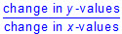  - Passes through the origin (0,0) meaning b = 0 in y = mx + b  - b represents the y-coordinate when the x-coordinate of the ordered pair is 0, (0,b)  - Linear non-proportional relationship  - Linear  - Represented by y = mx + b (slope intercept form), where b ≠ 0  - Constant rate of change represented as m = or m =  - Does not pass through the origin (0,0) meaning b ≠ 0 in y = mx + b  - b represents the y-coordinate of the ordered pair when 0 is the x-coordinate of the ordered pair, (0,b)  - Rate of change is either positive, negative, zero, or undefined  - Ex:  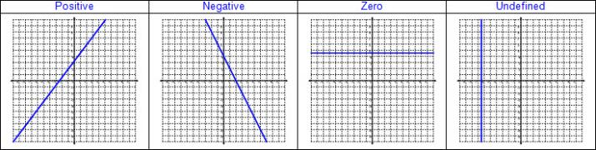  - Various representations to describe algebraic relationships  - Verbal descriptions  - Tables  - Graphs  - Equations  - In the form y = mx + b (slope intercept form)  - Ex:  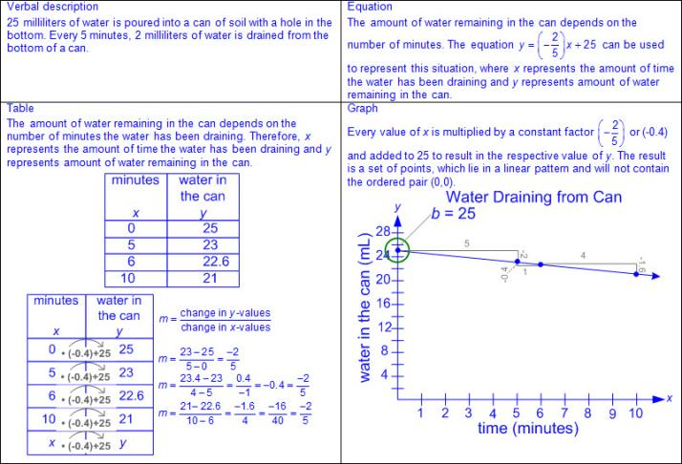  - Ex:  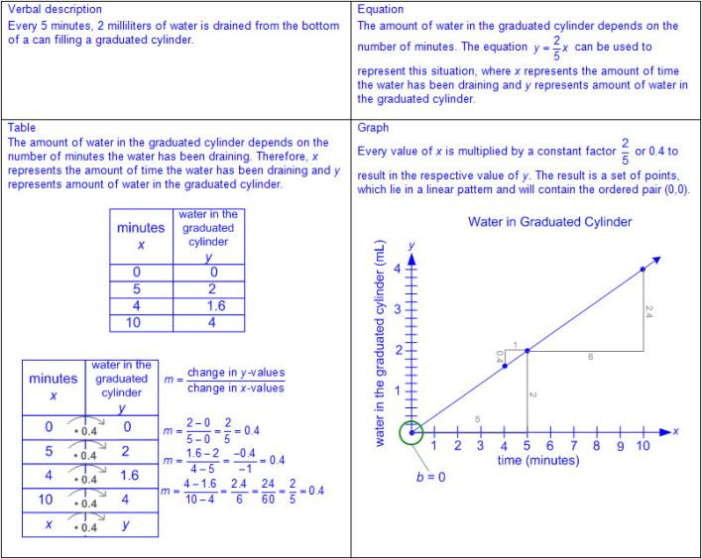  - Ex:  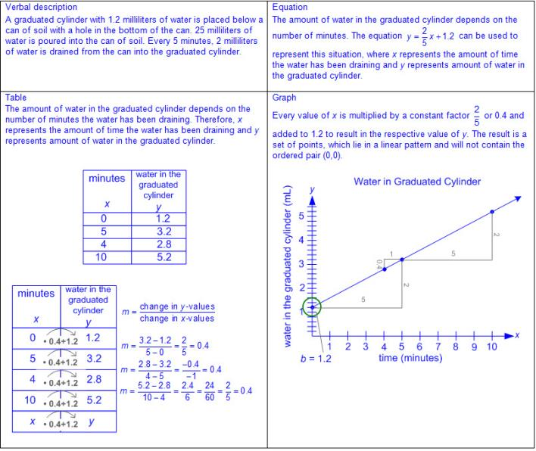  - Ex:  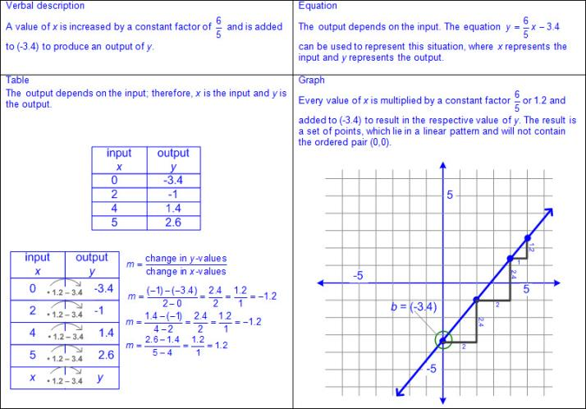  Note(s):  - Grade Level(s):  - Grade 6 identified independent and dependent quantities from tables and graphs.  - Grade 6 wrote an equation that represents the relationship between independent and dependent quantities from a table.  - Grade 6 represented a given situation using verbal descriptions, tables, graphs, and equations in the form y = kx or y = x + b.  - Grade 8 will represent linear non-proportional situations with tables, graphs, and equations in the form of y = mx + b, where b ≠ 0.  - Grade 8 will write an equation in the form y = mx + b to model a linear relationship between two quantities using verbal, numerical, tabular, and graphical representations.  - Grade 8 will distinguish between proportional and non-proportional situations using tables, graphs, and equations in the form y = kx or y = mx + b, where b ≠ 0.  - Various mathematical process standards will be applied to this student expectation as appropriate.  - TxRCFP:  - Using expressions and equations to describe relationships in a variety of contexts, including geometric problems  - TxCCRS:  - I. Numeric Reasoning  - II. Algebraic Reasoning  - VIII. Problem Solving and Reasoning  - IX. Communication and Representation
7.8 | Expressions, equations, and relationships. The student applies mathematical process standards to develop geometric relationships with volume. The student is expected to:
7.8A | Model the relationship between the volume of a rectangular prism and a rectangular pyramid having both congruent bases and heights and connect that relationship to the formulas.  Model the relationship between the volume of a rectangular prism and a rectangular pyramid having both congruent bases and heights and connect that relationship to the formulas.  Model  THE RELATIONSHIP BETWEEN THE VOLUME OF A RECTANGULAR PRISM AND A RECTANGULAR PYRAMID HAVING BOTH CONGRUENT BASES AND HEIGHTS AND CONNECT THAT RELATIONSHIP TO THE FORMULAS  Including, but not limited to:  - Three-dimensional figure – a figure that has measurements including length, width (depth), and height  - Attributes of rectangular prisms and pyramids  - Rectangular prism  - 6 rectangular faces (2 parallel rectangular faces [bases], 4 rectangular faces)  - 12 edges  - 8 vertices  - Face – a flat surface of a three-dimensional figure  - Base of a rectangular prism – any two congruent, opposite and parallel faces shaped like rectangles; possibly more than one set  - Height of a rectangular prism – the length of a side that is perpendicular to both bases  - Rectangular pyramid  - 5 faces (1 rectangular face [base], 4 triangular faces)  - 8 edges  - 5 vertices  - Base of a rectangular pyramid – a rectangle attached to triangular faces meeting at a point  - Height of a rectangular pyramid – the length of a perpendicular line segment from the vertex of the pyramid to the base  - Volume – the measurement attribute of the amount of space occupied by matter  - One way to measure volume is a three-dimensional cubic measure  - Congruent – of equal measure, having exactly the same size and same shape  - Various models to represent the relationship between the volume of a rectangular prism and a rectangular pyramid having both congruent bases and heights  - Filling the rectangular pyramid with a measurable unit (e.g., rice, sand, water, etc.) and emptying the contents into the rectangular prism until the rectangular prism is completely full  - The contents of the rectangular pyramid will need to be emptied three times in order to fill the rectangular prism completely.  - Creating a replica of the rectangular pyramid and rectangular prisms with clay and comparing their masses  - The mass of the rectangular prism will be three times the mass of the rectangular pyramid, whereas the mass of the rectangular pyramid is the mass of the rectangular prism.  - Generalizations from models used to represent the relationship between the volume of a rectangular prism and a rectangular pyramid having congruent bases and heights  - The volume of a rectangular prism is three times the volume of a rectangular pyramid.  - The volume of a rectangular pyramid is the volume of a rectangular prism.  - Connections between models to represent volume of a rectangular prism and rectangular pyramid having both congruent bases and heights to the formulas for volume  - Formulas for volume from STAAR Grade 7 Mathematics Reference Materials  - Prism  - V = Bh, where B represents the base area and h represents the height of the prism which is the number of times the base area is repeated or layered  - Rectangular prism  - The base of a rectangular prism is a rectangle whose area may be found with the formula, A = bh or A = lw, meaning the base area, B, may be found with the formula B = bh or B = lw; therefore, the volume of a rectangular prism may be found using V = Bh or V = (bh)h or V = (lw)h.  - Pyramid  - V = Bh, where B represents the base area and h represents the height of the pyramid  - Rectangular pyramid  - The base of a rectangular pyramid is a rectangle whose area may be found with the formula, A = bh or A = lw, meaning the base area, B, may be found with the formula B = bh or B = lw; therefore the volume of a rectangular pyramid may be found using V = Bh or V = (bh)h or V = (lw)h.  - Ex:  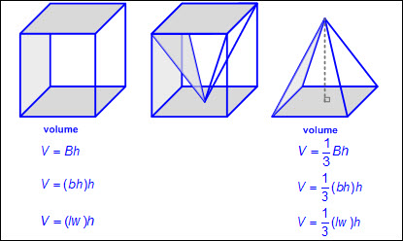  Note(s):  - Grade Level(s):  - Grade 6 modeled area formulas for parallelograms, trapezoids, and triangles by decomposing and rearranging parts of these shapes.  - Grade 8 will describe the volume formula V = Bh of a cylinder in terms of its base area and its height.  - Various mathematical process standards will be applied to this student expectation as appropriate.  - TxRCFP:  - Using expressions and equations to describe relationships in a variety of contexts, including geometric problems  - TxCCRS:  - IV. Measurement Reasoning  - VIII. Problem Solving and Reasoning  - IX. Communication and Representation
7.8B | Explain verbally and symbolically the relationship between the volume of a triangular prism and a triangular pyramid having both congruent bases and heights and connect that relationship to the formulas.  Explain verbally and symbolically the relationship between the volume of a triangular prism and a triangular pyramid having both congruent bases and heights and connect that relationship to the formulas.  Explain  VERBALLY AND SYMBOLICALLY THE RELATIONSHIP BETWEEN THE VOLUME OF A TRIANGULAR PRISM AND A TRIANGULAR PYRAMID HAVING BOTH CONGRUENT BASES AND HEIGHTS AND CONNECT THAT RELATIONSHIP TO THE FORMULAS  Including, but not limited to:  - Three-dimensional figure – a figure that has measurements including length, width (depth), and height  - Attributes of triangular prisms and pyramids  - Triangular prism  - 5 faces (2 triangular faces [bases], 3 rectangular faces)  - 9 edges  - 6 vertices  - Face – a flat surface of a three-dimensional figure  - Base of a triangular prism – the two congruent, opposite and parallel faces shaped like triangles  - Height of a triangular prism – the length of a side that is perpendicular to a base  - Triangular pyramid  - 4 faces (1 triangular face [base], 3 triangular faces)  - 6 edges  - 4 vertices  - Base of a triangular pyramid – a triangle attached to triangular faces meeting at a point  - Height of a triangular pyramid – the length of a perpendicular line segment from the vertex of the pyramid to the base  - Volume – the measurement attribute of the amount of space occupied by matter  - One way to measure volume is a three-dimensional cubic measure  - Congruent – of equal measure, having exactly the same size and same shape  - Generalizations of the relationship between the volume of a triangular prism and a triangular pyramid having congruent bases and heights  - The volume of a triangular prism is three times the volume of a triangular pyramid.  - The volume of a triangular pyramid is the volume of a triangular prism.  - Connections between models to represent volume of a triangular prism and triangular pyramid having both congruent bases and heights to the formulas for volume  - Formulas for volume from STAAR Grade 7 Mathematics Reference Materials  - Prism  - V = Bh, where B represents the base area and h represents the height of the prism which is the number of times the base area is repeated or layered)  - Triangular prism  - The base of a triangular prism is a triangle whose area may be found with the formula, A = bh, meaning the base area, B, may be found using B = bh; therefore, the volume of a triangular prism may be found using V = Bh or V = 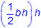.  - Pyramid  - V = Bh, where B represents the base area and h represents the height of the pyramid  - Triangular pyramid  - The base of a triangular pyramid is a triangle whose area may be found with the formula, A = bh, meaning the base area, B, may be found using B = bh; therefore, the volume of a triangular pyramid may be found using V = Bh or V = 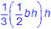 or V = 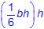.  - Ex:  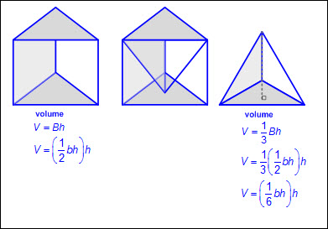  Note(s):  - Grade Level(s):  - Grade 7 introduces explaining verbally and symbolically the relationship between the volume of a triangular prism and a triangular pyramid having both congruent bases and heights and connecting that relationship to the formulas.  - Grade 8 will model the relationship between the volume of a cylinder and a cone having both congruent bases and heights and connect that relationship to the formulas.  - Various mathematical process standards will be applied to this student expectation as appropriate.  - TxRCFP:  - Using expressions and equations to describe relationships in a variety of contexts, including geometric problems  - TxCCRS:  - I. Numeric Reasoning  - IV. Measurement Reasoning  - VIII. Problem Solving and Reasoning  - IX. Communication and Representation
7.8C | Use models to determine the approximate formulas for the circumference and area of a circle and connect the models to the actual formulas.  Use models to determine the approximate formulas for the circumference and area of a circle and connect the models to the actual formulas.  Use  MODELS TO DETERMINE THE APPROXIMATE FORMULAS FOR THE CIRCUMFERENCE AND AREA OF A CIRCLE AND CONNECT THE MODELS TO THE ACTUAL FORMULAS  Including, but not limited to:  - Circle  - A figure formed by a closed curve with all points equal distance from the center  - No straight sides  - No vertices  - No parallel or, perpendicular sides  - Diameter – a line segment whose endpoints are on the circle and passes through the center of the circle  - Radius – a line segment drawn from the center of a circle to any point on the circle and is half the length of diameter of the circle  - Circumference – a linear measurement of the distance around a circle  - Pi (π) – the ratio of the circumference to the diameter of a circle  - Various models to approximate the formulas for the circumference of a circle  - Using a string to measure the length around a circle, and another piece of string to measure the length of the diameter of the circle  - The length of the string representing the circumference of the circle will be a little more than three times longer than the length of the string representing the diameter of the circle  - Using centimeter cubes to measure the length around a circle, and using centimeter cubes to measure the length of the radius of the circle  - The number of centimeter cubes needed to represent the radius of the circle is a little more than one-sixth of the number of centimeter cubes needed to represent the length of the circumference of the circle.  - Circumference using the diameter of a circle  - Ex:  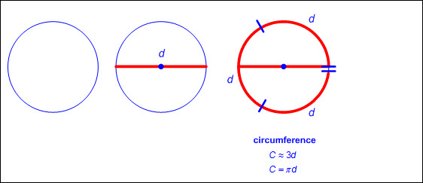  - Circumference using the radius of a circle  - Ex:  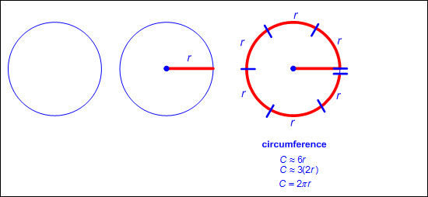  - Generalizations of models used to determine the approximate formulas for circumference of a circle  - The circumference of a circle is a little more than three times the length of the diameter of a circle.  - The circumference of a circle is a little more than three times twice the length of the radius of a circle or a little more than 6 times the radius.  - Connections between models to represent the circumference of a circle and formulas for circumference  - Formulas for circumference from STAAR Grade 7 Mathematics Reference Materials  - Circumference using the diameter of a circle  - C = πd, where C represents the circumference of the circle, d represents the diameter of the circle, and π represents the approximate number of times the diameter wraps the circumference of the circle.  - The ratio of the circumference to the diameter of the circle is a little more than 3 and denoted by π ≈ 3.14.  - Circumference using the radius of a circle  - C = 2πr, where C represents the circumference of the circle, r represents the radius of the circle, and π represents the approximate number of times the radius wraps the circumference of the circle.  - The ratio of the circumference to the radius of the circle is a little more than 6.  - The ratio of the circumference to the radius of the circle is twice as much as the ratio of the circumference to the diameter of the circle.  - The ratio of the circumference to the diameter of the circle is a little more than 3 and denoted by π ≈ 3.14.  - Area – the measurement attribute that describes the number of square units a figure or region covers  - Area is a two-dimensional square unit measure.  - Various models to approximate the formula for the area of a circle  - Cutting a circle into equally sized pieces from the center of the circle to the outside of the circle where the length of the non-curved side is the length of the radius of the circle, then laying the equally-sized pieces next to each other to create a figure similar to the shape of a rectangle  - The area of the rectangle (formed with pieces of the circle) is a little more than three times the length of the radius squared.  - Ex:  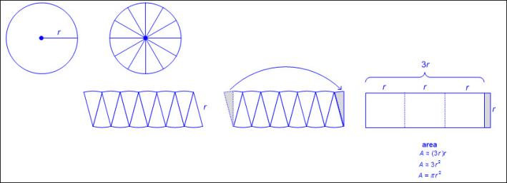  - Tracing a circle on centimeter grid paper, dividing the circle into four equally sized pieces from the center of the circle, forming squares with three of the four pieces of the divided circle using the radius of the circle as the side length of each square, and using the area of the square that extends beyond the circle to fill the last of the four equally sized pieces  - The number of square centimeters needed to represent the area of the entire circle is a little more than the area of three squares with the radius of the circle as one of the side lengths of the square.  - Ex:  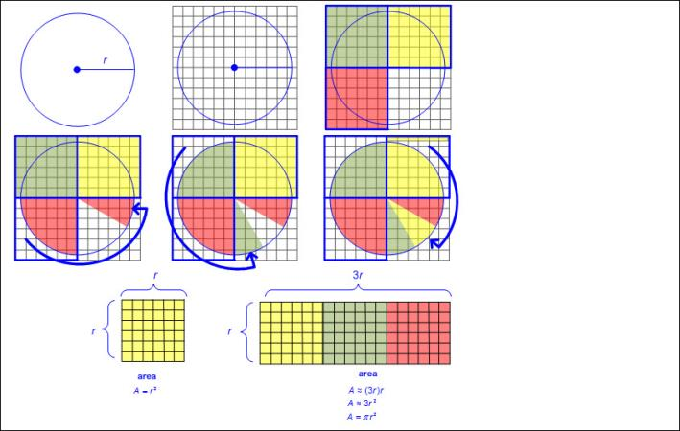  - Generalization of models used to determine the approximate formula for area of a circle  - The area of a circle is a little more than three times the length of the radius squared.  - Connections between models to represent the area of a circle and formulas for area of a circle  - Formula for area of a circle from STAAR Grade 7 Mathematics Reference Materials  - Area of a circle  - A = πr², where A represents the area of the circle, r represents the radius of the circle, and π represents the approximate number of squares, with a side length of r, needed to fill the area of the circle.  - The ratio of the area of the circle to the area of the radius squared is a little more than 3 and denoted by π ≈ 3.14.  Note(s):  - Grade Level(s):  - Grade 7 introduces using models to determine the approximate formulas for the circumference and area of a circle and connecting the models to the actual formulas.  - Grade 8 will use models and diagrams to explain the Pythagorean theorem.  - Various mathematical process standards will be applied to this student expectation as appropriate.  - TxRCFP:  - Using expressions and equations to describe relationships in a variety of contexts, including geometric problems  - TxCCRS:  - I. Numeric Reasoning  - IV. Measurement Reasoning  - VIII. Problem Solving and Reasoning  - IX. Communication and Representation
7.9 | Expressions, equations, and relationships. The student applies mathematical process standards to solve geometric problems. The student is expected to:
7.9A | Solve problems involving the volume of rectangular prisms, triangular prisms, rectangular pyramids, and triangular pyramids.  Readiness Standard  Solve problems involving the volume of rectangular prisms, triangular prisms, rectangular pyramids, and triangular pyramids.  Readiness Standard  Solve  PROBLEMS INVOLVING THE VOLUME OF RECTANGULAR PRISMS, TRIANGULAR PRISMS, RECTANGULAR PYRAMIDS, AND TRIANGULAR PYRAMIDS  Including, but not limited to:  - Positive rational numbers – the set of numbers that can be expressed as a fraction , where a and b are whole numbers and b ≠ 0, which includes the subsets of whole numbers and counting (natural) numbers (e.g., 0, 2, etc.).  - Various forms of positive rational numbers  - Whole numbers  - Decimals (less than or greater than one)  - Fractions (proper, improper, and mixed numbers)  - Three-dimensional figure – a figure that has measurements including length, width (depth), and height  - Attributes of prisms and pyramids  - Rectangular prism  - 6 rectangular faces (2 parallel rectangular faces [bases], 4 rectangular faces)  - 12 edges  - 8 vertices  - Face – a flat surface of a three-dimensional figure  - Base of a rectangular prism – any two congruent, opposite and parallel faces shaped like rectangles; possibly more than one set  - Height of a rectangular prism – the length of a side that is perpendicular to both bases  - Triangular prism  - 5 faces (2 triangular faces [bases], 3 rectangular faces)  - 9 edges  - 6 vertices  - Base of a triangular prism – the two congruent, opposite and parallel faces shaped like triangles  - Height of a triangular prism – the length of a side that is perpendicular to both bases  - Rectangular pyramid  - 5 faces (1 rectangular face [base], 4 triangular faces)  - 8 edges  - 5 vertices  - Base of a rectangular pyramid – a rectangle attached to triangular faces meeting at a point  - Height of a rectangular pyramid – the length of a perpendicular line segment from the vertex of the pyramid to the base  - Triangular pyramid  - 4 faces (1 triangular face [base], 3 triangular faces)  - 6 edges  - 4 vertices  - Base of a triangular pyramid – a triangle attached to triangular faces meeting at a point  - Height of a triangular pyramid – the length of a perpendicular line segment from the vertex of the pyramid to the base  - Volume – the measurement attribute of the amount of space occupied by matter  - One way to measure volume is a three-dimensional cubic measure  - Positive rational number side lengths  - Recognition of volume embedded in mathematical and real-world problem situations  - Ex: How much sand is needed to fill a sand box?  - Ex: How much water is needed to fill an aquarium?  - Formulas for volume from STAAR Grade 7 Mathematics Reference Materials  - Prism  - V = Bh, where B represents the base area and h represents the height of the prism which is the number of times the base area is repeated or layered)  - Rectangular prism  - The base of a rectangular prism is a rectangle whose area may be found with the formula, A = bh or A = lw, meaning the base area, B, may be found with the formula B = bh or B = lw; therefore, the volume of a rectangular prism may be found using V = Bh or V = (bh)h or V = (lw)h.  - Ex:  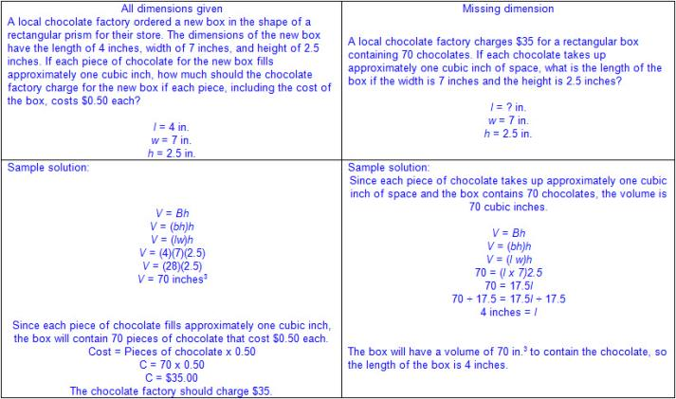  - Triangular prism  - The base of a triangular prism is a triangle whose area may be found with the formula, A = bh, meaning the base area, B, may be found using B = bh; therefore, the volume of a triangular prism may be found using V = Bh or V = .  - Ex:  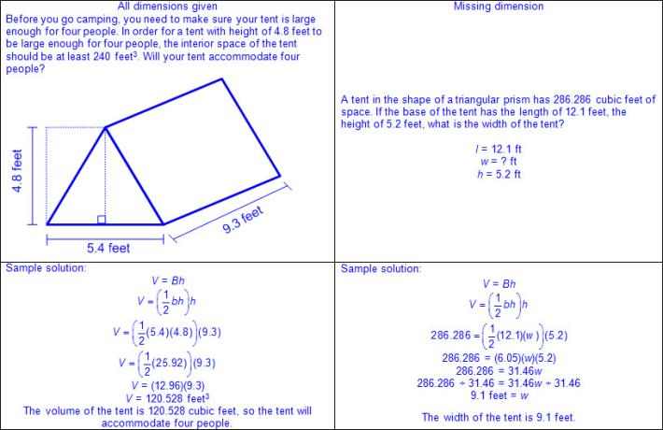  - Pyramid  - V = Bh, where B represents the base area and h represents the height of the pyramid  - Rectangular pyramid  - The base of a rectangular pyramid is a rectangle whose area may be found with the formula, A = bh or A = lw, meaning the base area, B, may be found with the formula B = bh or B = lw; therefore the volume of a rectangular pyramid may be found using V = Bh or V = (bh)h or V = (lw)h.  - Ex:  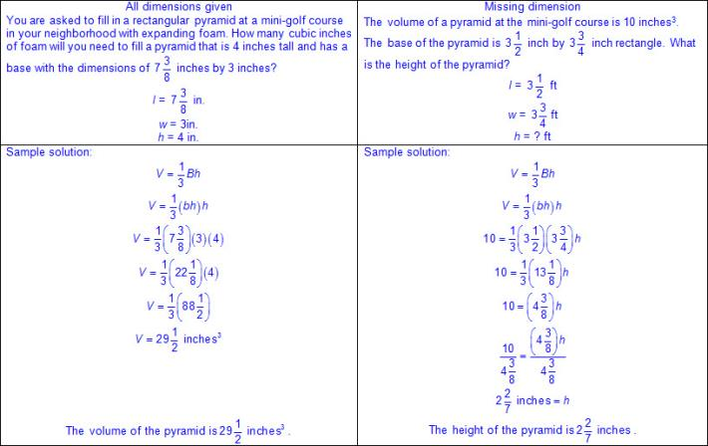  - Triangular pyramid  - The base of a triangular pyramid is a triangle whose area may be found with the formula, A = bh, meaning the base area, B, may be found using B = bh; therefore, the volume of a triangular pyramid may be found using V = Bh or V = or V = .  - Ex:  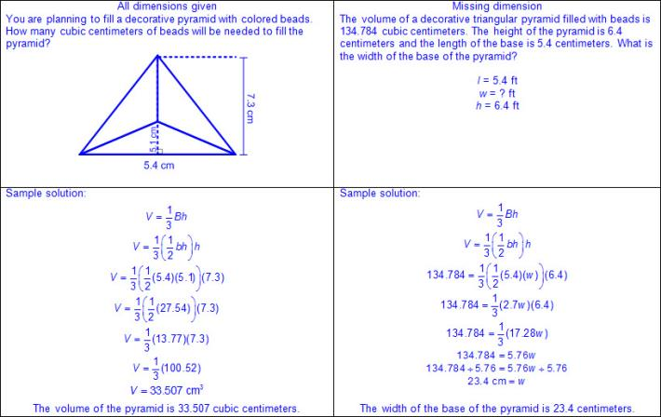  Note(s):  - Grade Level(s):  - Grade 6 determined solutions for problems involving the area of rectangles, parallelograms, trapezoids, and triangles and volume of right rectangular prisms where dimensions are positive rational numbers.  - Grade 8 will solve problems involving the volume of cylinders, cones, and spheres.  - Various mathematical process standards will be applied to this student expectation as appropriate.  - TxRCFP:  - Using expressions and equations to describe relationships in a variety of contexts, including geometric problems  - TxCCRS:  - I. Numeric Reasoning  - III.C. Geometric Reasoning – Connections between geometry and other mathematical content strands  - IV. Measurement Reasoning  - VIII. Problem Solving and Reasoning  - IX. Communication and Representation  - X. Connections
7.9B | Determine the circumference and area of circles.  Readiness Standard  Determine the circumference and area of circles.  Readiness Standard  Determine  THE CIRCUMFERENCE AND AREA OF CIRCLES  Including, but not limited to:  - Positive rational numbers – the set of numbers that can be expressed as a fraction , where a and b are whole numbers and b ≠ 0, which includes the subsets of whole numbers and counting (natural) numbers (e.g., 0, 2, etc.).  - Various forms of positive rational numbers  - Whole numbers  - Decimals (less than or greater than one)  - Fractions (proper, improper, and mixed numbers)  - Circle  - A figure formed by a closed curve with all points equal distance from the center  - No straight sides  - No vertices  - No parallel or, perpendicular sides  - Diameter – a line segment whose endpoints are on the circle and passes through the center of the circle  - Radius – a line segment drawn from the center of a circle to any point on the circle and is half the length of diameter of the circle  - Semicircle – half of a circle  - Quarter circle – one-fourth of a circle  - Circumference – a linear measurement of the distance around a circle  - Positive rational number dimensions  - Pi (π) – the ratio of the circumference to the diameter of a circle  - π ≈ 3.14 or  - Formulas for circumference from STAAR Grade 7 Mathematics Reference Materials  - Circumference using the radius of a circle  - C = 2πr, where C represents the circumference of the circle and r represents the radius of the circle, and π is approximately 3.14 or  - Ex:  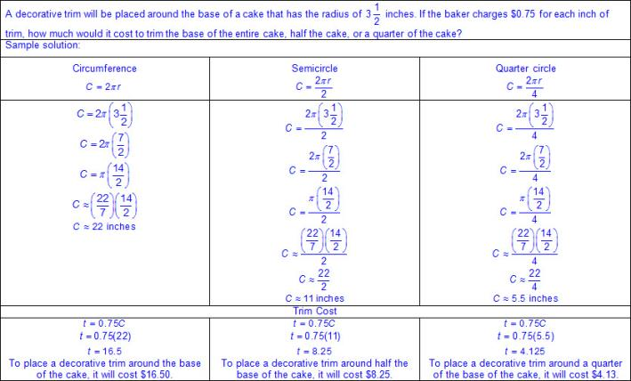  - Circumference using the diameter of a circle  - C = πd, where C represents the circumference of the circle, d represents the diameter of the circle, and π is approximately 3.14 or  - Ex:  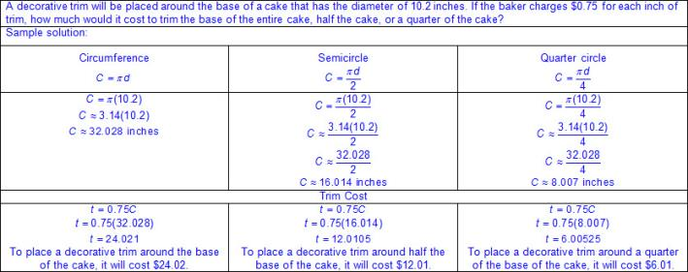  - Area – the measurement attribute that describes the number of square units a figure or region covers  - Area is a two-dimensional square unit measure.  - Positive rational number dimensions  - Formula for area of a circle from STAAR Grade 7 Mathematics Reference Materials  - Area  - A = πr², where A represents the area of the circle, r represents the radius of the circle, and π is approximately 3.14 or  - Ex:  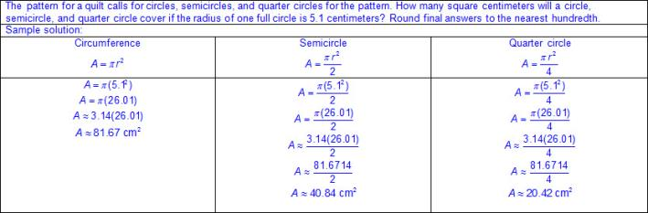  Note(s):  - Grade Level(s):  - Grade 6 determined solutions for problems involving the area of rectangles, parallelograms, trapezoids, and triangles and volume of right rectangular prisms where dimensions are positive rational numbers.  - Various mathematical process standards will be applied to this student expectation as appropriate.  - TxRCFP:  - Using expressions and equations to describe relationships in a variety of contexts, including geometric problems  - TxCCRS:  - I. Numeric Reasoning  - III.C. Geometric Reasoning – Connections between geometry and other mathematical content strands  - IV. Measurement Reasoning  - VIII. Problem Solving and Reasoning  - IX. Communication and Representation  - X. Connections
7.9C | Determine the area of composite figures containing combinations of rectangles, squares, parallelograms, trapezoids, triangles, semicircles, and quarter circles.  Readiness Standard  Determine the area of composite figures containing combinations of rectangles, squares, parallelograms, trapezoids, triangles, semicircles, and quarter circles.  Readiness Standard  Determine  THE AREA OF COMPOSITE FIGURES CONTAINING COMBINATIONS OF RECTANGLES, SQUARES, PARALLELOGRAMS, TRAPEZOIDS, TRIANGLES, SEMICIRCLES, AND QUARTER CIRCLES  Including, but not limited to:  - Positive rational numbers – the set of numbers that can be expressed as a fraction , where a and b are whole numbers and b ≠ 0, which includes the subsets of whole numbers and counting (natural) numbers (e.g., 0, 2, etc.).  - Various forms of positive rational numbers  - Whole numbers  - Decimals (less than or greater than one)  - Fractions (proper, improper, and mixed numbers)  - Two-dimensional figure – a figure with two basic units of measure, usually length and width  - Circle  - A figure formed by a closed curve with all points equal distance from the center  - No straight sides  - No vertices  - No parallel or, perpendicular sides  - Polygon – a closed figure with at least 3 sides, where all sides are straight (no curves)  - Types of polygons  - Triangle  - 3 sides  - 3 vertices  - No parallel sides  - Quadrilateral  - 4 sides  - 4 vertices  - Types of quadrilaterals  - Trapezoid  - 4 sides  - 4 vertices  - Exactly one pair of parallel sides  - Up to two possible pairs of perpendicular sides  - Parallelogram  - 4 sides  - 4 vertices  - Opposite sides congruent  - 2 pairs of parallel sides  - Opposite angles congruent  - Types of parallelograms  - Rectangle  - 4 sides  - 4 vertices  - Opposite sides congruent  - 2 pairs of parallel sides  - 2 pairs of perpendicular sides  - 4 right angles  - Rhombus  - 4 sides  - 4 vertices  - All sides congruent  - 2 pairs of parallel sides  - Opposite angles congruent  - Square (a special type of rectangle and a special type of rhombus)  - 4 sides  - 4 vertices  - All sides congruent  - 2 pairs of parallel sides  - 2 pairs of perpendicular sides  - 4 right angles  - Composite Figure – a figure that is composed of two or more two-dimensional figures  - Rectangles  - Squares  - Parallelograms  - Trapezoids  - Triangles  - Circles  - Semicircles  - Quarter circles  - Any combination of these figures  - Area – the measurement attribute that describes the number of square units a figure or region covers  - Area is a two-dimensional square unit measure.  - Positive rational number side lengths  - Formulas for area from STAAR Grade 7 Mathematics Reference Materials  - Triangle  - A = bh, where b represents the length of the base of the triangle and h represents the height of the triangle  - Rectangle or parallelogram  - A = bh, where b represents the length of the base of the rectangle or parallelogram and h represents the height of the rectangle or parallelogram  - Trapezoid  - A = (b₁ + b₂)h, where b₁ represents the length of one of the parallel bases, b₂ represents the length of the other parallel base, and h represents the height of the trapezoid  - Circle  - A = πr², where A represents the area of the circle, r represents the radius of the circle, and π is approximately 3.14 or  - Ex:  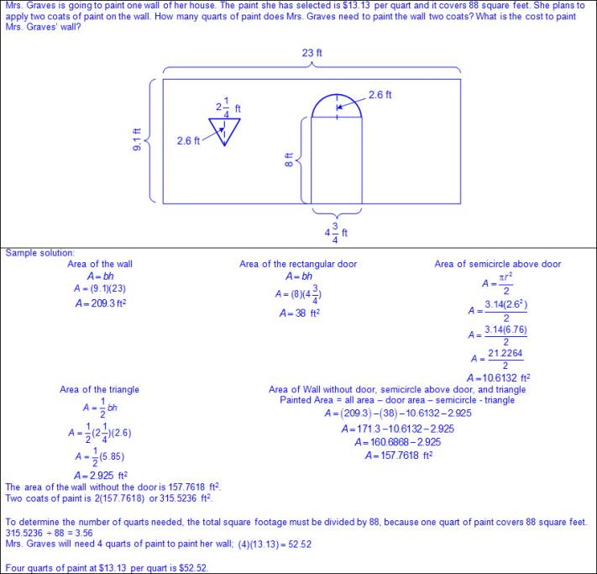  - Ex:  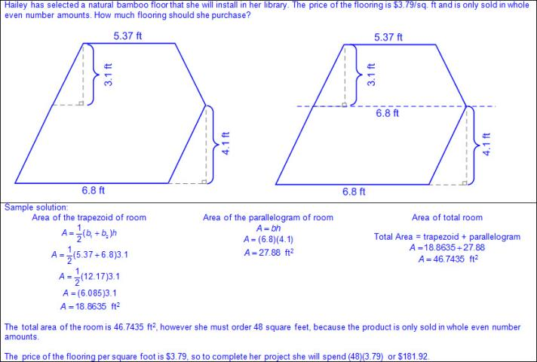  - Ex:  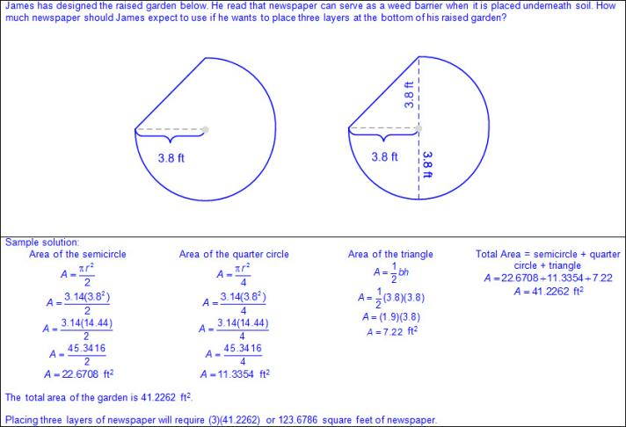  Note(s):  - Grade Level(s):  - Grade 6 determined solutions for problems involving the area of rectangles, parallelograms, trapezoids, and triangles and volume of right rectangular prisms where dimensions are positive rational numbers.  - Various mathematical process standards will be applied to this student expectation as appropriate.  - TxRCFP:  - Using expressions and equations to describe relationships in a variety of contexts, including geometric problems  - TxCCRS:  - I. Numeric Reasoning  - III.C. Geometric Reasoning – Connections between geometry and other mathematical content strands  - IV. Measurement Reasoning  - VIII. Problem Solving and Reasoning  - IX. Communication and Representation  - X. Connections
7.9D | Solve problems involving the lateral and total surface area of a rectangular prism, rectangular pyramid, triangular prism, and triangular pyramid by determining the area of the shape's net.  Supporting Standard  Solve problems involving the lateral and total surface area of a rectangular prism, rectangular pyramid, triangular prism, and triangular pyramid by determining the area of the shape's net.  Supporting Standard  Solve  PROBLEMS INVOLVING THE LATERAL AND TOTAL SURFACE AREA OF A RECTANGULAR PRISM, RECTANGULAR PYRAMID, TRIANGULAR PRISM, AND TRIANGULAR PYRAMID BY DETERMINING THE AREA OF THE SHAPE'S NET  Including, but not limited to:  - Positive rational numbers – the set of numbers that can be expressed as a fraction , where a and b are whole numbers and b ≠ 0, which includes the subsets of whole numbers and counting (natural) numbers (e.g., 0, 2, etc.).  - Various forms of positive rational numbers  - Whole numbers  - Decimals (less than or greater than one)  - Fractions (proper, improper, and mixed numbers)  - Three-dimensional figure – a figure that has measurements including length, width (depth), and height  - Attributes of prisms and pyramids  - Rectangular prism  - 6 rectangular faces (2 parallel rectangular faces [bases], 4 rectangular faces)  - 12 edges  - 8 vertices  - Face – a flat surface of a three-dimensional figure  - Base of a rectangular prism – any two congruent, opposite and parallel faces shaped like rectangles; possibly more than one set  - Height of a rectangular prism – the length of a side that is perpendicular to both bases  - Triangular prism  - 5 faces (2 triangular faces [bases], 3 rectangular faces)  - 9 edges  - 6 vertices  - Base of a triangular prism – the two congruent, opposite and parallel faces shaped like triangles  - Height of a triangular prism – the length of a side that is perpendicular to both bases  - Rectangular pyramid  - 5 faces (1 rectangular face [base], 4 triangular faces)  - 8 edges  - 5 vertices  - Base of a rectangular pyramid – a rectangle attached to triangular faces meeting at a point  - Height of a rectangular pyramid – the length of a perpendicular line segment from the vertex of the pyramid to the base  - Triangular pyramid  - 4 faces (1 triangular face [base], 3 triangular faces)  - 6 edges  - 4 vertices  - Base of a triangular pyramid – a triangle attached to triangular faces meeting at a point  - Height of a triangular pyramid – the length of a perpendicular line segment from the vertex of the pyramid to the base  - Area – the measurement attribute that describes the number of square units a figure or region covers  - Area is a two-dimensional square unit measure.  - Positive rational number side lengths  - Surface Area  - Lateral surface area – the number of square units needed to cover the lateral view (area excluding the base(s) of a three-dimensional figure)  - Total surface area – the number of square units needed to cover all of the surfaces (bases and lateral area)  - Net – a two-dimensional model or drawing that can be folded into a three-dimensional solid  - Ex:  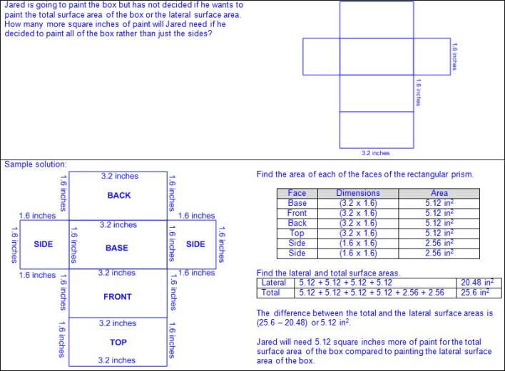  - Ex:  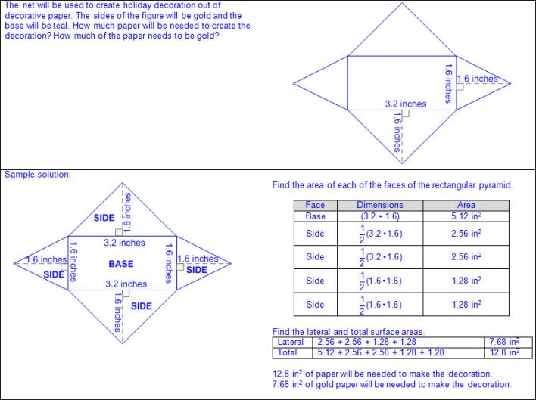  - Ex:  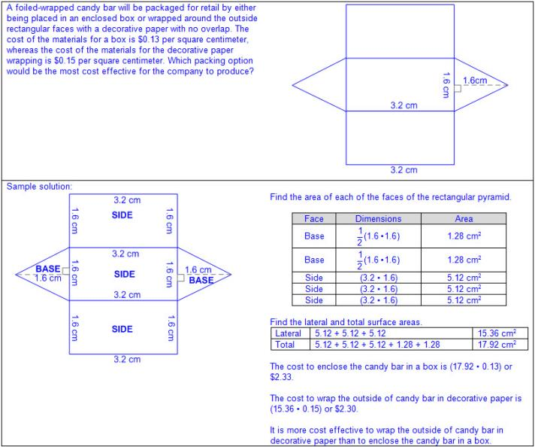  - Ex:  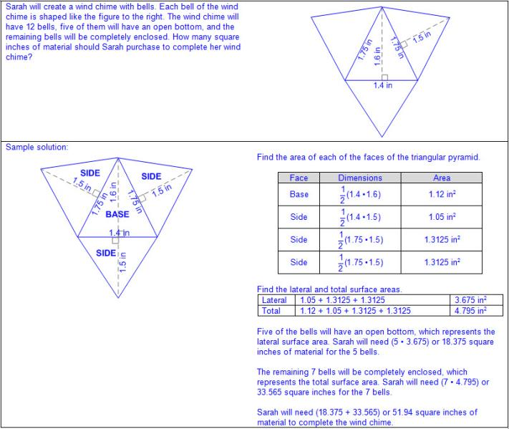  Note(s):  - Grade Level(s):  - Grade 6 determined solutions for problems involving the area of rectangles, parallelograms, trapezoids, and triangles and volume of right rectangular prisms where dimensions are positive rational numbers.  - Grade 8 will use previous knowledge of surface area to make connections to the formulas for lateral and total surface area and determine solutions for problems involving rectangular prisms, triangular prisms, and cylinders.  - Various mathematical process standards will be applied to this student expectation as appropriate.  - TxRCFP:  - Using expressions and equations to describe relationships in a variety of contexts, including geometric problems  - TxCCRS:  - I. Numeric Reasoning  - III.C. Geometric Reasoning – Connections between geometry and other mathematical content strands  - IV. Measurement Reasoning  - VIII. Problem Solving and Reasoning  - IX. Communication and Representation  - X. Connections
7.10 | Expressions, equations, and relationships. The student applies mathematical process standards to use one-variable equations and inequalities to represent situations. The student is expected to:
7.10A | Write one-variable, two-step equations and inequalities to represent constraints or conditions within problems.  Supporting Standard  Write one-variable, two-step equations and inequalities to represent constraints or conditions within problems.  Supporting Standard  Write  ONE-VARIABLE, TWO-STEP EQUATIONS AND INEQUALITIES TO REPRESENT CONSTRAINTS OR CONDITIONS WITHIN PROBLEMS  Including, but not limited to:  - Equation – a mathematical statement composed of algebraic and/or numeric expressions set equal to each other  - Inequality – a mathematical statement composed of algebraic and/or numeric expressions set apart by an inequality symbol  - Variable – a letter or symbol that represents a number  - One variable on one side of the equation or inequality  - Ex:  - Coefficient – a number that is multiplied by a variable(s)  - Whole numbers  - Integers  - Decimals (less than or greater than one)  - Fractions (proper, improper, and mixed numbers)  - Ex:  - Constant – a fixed value that does not appear with a variable(s)  - Whole numbers  - Integers  - Decimals (less than or greater than one)  - Fractions (proper, improper, and mixed numbers)  - Ex:  - Solution set – a set of all values of the variable(s) that satisfy the equation or inequality  - Constraints or conditions  - Ex: Minimum, maximum, up to, no more than, no less than, etc.  - Distinguishing between equations and inequalities  - Characteristics of equations  - Equates two expressions  - Equality of the variable  - One solution  - Characteristics of inequalities  - Shows the relationship between two expressions in terms of >,≥, ≤,or ≠  - Inequality of the variable  - One or more solutions  - Equality and inequality words and symbols  - Equal to, =  - Ex: x is 4, x = 4  - Greater than, >  - Ex: x is greater than 4, x > 4  - Greater than or equal to, ≥  - Ex: x is greater than or equal to 4, x ≥ 4  - Less than, <  - Ex: x is less than 4, x < 4  - Less than or equal to, ≤  - Ex: x is less than or equal to 4, x ≤ 4  - Not equal to, ≠  - Ex: x is not equal to 4, x ≠ 4  - Relationship of order of operations within an equation or inequality  - Order of operations – the rules of which calculations are performed first when simplifying an expression  - Parentheses/brackets: simplify expressions inside parentheses or brackets in order from left to right  - Exponents: rewrite in standard numerical form and simplify from left to right  - Limited to positive whole numer exponents  - Multiplication/division: simplify expressions involving multiplication and/or division in order from left to right  - Addition/subtraction: simplify expressions involving addition and/or subtraction in order from left to right  - One-variable, two-step equations from a problem  - Ex:  - Ex:  - Ex:  - One-variable, two-step inequalities from a problem  - Ex:  - Ex:  - Ex:  Note(s):  - Grade Level(s):  - Grade 6 wrote one-variable, one-step equations and inequalities to represent constraints or conditions within problems.  - Grade 8 will write one-variable equations or inequalities with variables on both sides that represent problems using rational number coefficients and constants.  - Various mathematical process standards will be applied to this student expectation as appropriate.  - TxRCFP:  - Using expressions and equations to describe relationships in a variety of contexts, including geometric problems  - TxCCRS:  - II. Algebraic Reasoning  - VIII. Problem Solving and Reasoning  - IX. Communication and Representation  - X. Connections
7.10B | Represent solutions for one-variable, two-step equations and inequalities on number lines.  Supporting Standard  Represent solutions for one-variable, two-step equations and inequalities on number lines.  Supporting Standard  Represent  SOLUTIONS FOR ONE-VARIABLE, TWO-STEP EQUATIONS AND INEQUALITIES ON NUMBER LINES  Including, but not limited to:  - Equation – a mathematical statement composed of algebraic and/or numeric expressions set equal to each other  - Inequality – a mathematical statement composed of algebraic and/or numeric expressions set apart by an inequality symbol  - Variable – a letter or symbol that represents a number  - One variable on one side of the equation or inequality  - Ex:  - Coefficient – a number that is multiplied by a variable(s)  - Whole numbers  - Integers  - Decimals (less than or greater than one)  - Fractions (proper, improper, and mixed numbers)  - Ex:  - Constant – a fixed value that does not appear with a variable(s)  - Whole numbers  - Integers  - Decimals (less than or greater than one)  - Fractions (proper, improper, and mixed numbers)  - Ex:  - Solution set – a set of all values of the variable(s) that satisfy the equation or inequality  - Constraints or conditions  - Ex: Minimum, maximum, up to, no more than, no less than, etc.  - Distinguishing between equations and inequalities  - Characteristics of equations  - Equates two expressions  - Equality of the variable  - One solution  - Characteristics of inequalities  - Shows the relationship between two expressions in terms of >,≥, ≤,or ≠  - Inequality of the variable  - One or more solutions  - Equality and inequality words and symbols  - Equal to, =  - Ex: x is 4, x = 4  - Greater than, >  - Ex: x is greater than 4, x > 4  - Greater than or equal to, ≥  - Ex: x is greater than or equal to 4, x ≥ 4  - Less than, <  - Ex: x is less than 4, x < 4  - Less than or equal to, ≤  - Ex: x is less than or equal to 4, x ≤ 4  - Not equal to, ≠  - Ex: x is not equal to 4, x ≠ 4  - Representations of solutions to equations and inequalities on a number line  - Closed circle  - Equal to, =  - Ex:  - Greater than or equal to, ≥  - Ex:  - Less than or equal to, ≤  - Ex:  - Open circle  - Greater than, >  - Ex:  - Less than, <  - Ex:  - Not equal to, ≠  - Ex:  - Ex:  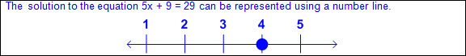  - Ex:  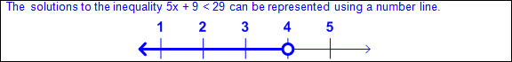  - Ex:  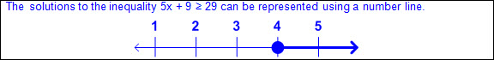  Note(s):  - Grade Level(s):  - Grade 6 represented solutions for one-variable, one-step equations and inequalities on number lines.  - Various mathematical process standards will be applied to this student expectation as appropriate.  - TxRCFP:  - Using expressions and equations to describe relationships in a variety of contexts, including geometric problems  - TxCCRS:  - II. Algebraic Reasoning  - IX. Communication and Representation
7.10C | Write a corresponding real-world problem given a one-variable, two-step equation or inequality.  Supporting Standard  Write a corresponding real-world problem given a one-variable, two-step equation or inequality.  Supporting Standard  Write  A CORRESPONDING REAL-WORLD PROBLEM GIVEN A ONE-VARIABLE, TWO-STEP EQUATION OR INEQUALITY  Including, but not limited to:  - Equation – a mathematical statement composed of algebraic and/or numeric expressions set equal to each other  - Inequality – a mathematical statement composed of algebraic and/or numeric expressions set apart by an inequality symbol  - Variable – a letter or symbol that represents a number  - One variable on one side of the equation or inequality  - Ex:  - Coefficient – a number that is multiplied by a variable(s)  - Whole numbers  - Integers  - Decimals (less than or greater than one)  - Fractions (proper, improper, and mixed numbers)  - Ex:  - Constant – a fixed value that does not appear with a variable(s)  - Whole numbers  - Integers  - Decimals (less than or greater than one)  - Fractions (proper, improper, and mixed numbers)  - Ex:  - Solution set – a set of all values of the variable(s) that satisfy the equation or inequality  - Constraints or conditions  - Ex: Minimum, maximum, up to, no more than, no less than, etc.  - Distinguishing between equations and inequalities  - Characteristics of equations  - Equates two expressions  - Equality of the variable  - One solution  - Characteristics of inequalities  - Shows the relationship between two expressions in terms of >,≥, ≤,or ≠  - Inequality of the variable  - One or more solutions  - Equality and inequality words and symbols  - Equal to, =  - Ex: x is 4, x = 4  - Greater than, >  - Ex: x is greater than 4, x > 4  - Greater than or equal to, ≥  - Ex: x is greater than or equal to 4, x ≥ 4  - Less than, <  - Ex: x is less than 4, x < 4  - Less than or equal to, ≤  - Ex: x is less than or equal to 4, x ≤ 4  - Not equal to, ≠  - Ex: x is not equal to 4, x ≠ 4  - Relationship of order of operations within an equation or inequality  - Order of operations – the rules of which calculations are performed first when simplifying an expression  - Parentheses/brackets: simplify expressions inside parentheses or brackets in order from left to right  - Exponents: rewrite in standard numerical form and simplify from left to right  - Limited to positive whole numer exponents  - Multiplication/division: simplify expressions involving multiplication and/or division in order from left to right  - Addition/subtraction: simplify expressions involving addition and/or subtraction in order from left to right  - Corresponding real-world problem from a one-variable, two-step equation  - Ex:  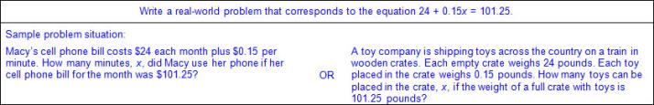  - Corresponding real-world problem from a one-variable, two-step inequality  - Ex:  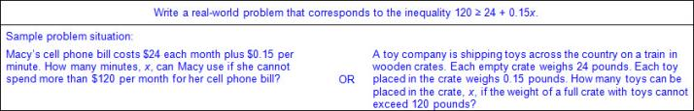  Note(s):  - Grade Level(s):  - Grade 6 wrote corresponding real-world problems given one-variable, one-step equations or inequalities.  - Grade 8 will write a corresponding real-world problem when given a one-variable equation or inequality with variables on both sides of the equal sign using rational number coefficients and constants.  - Various mathematical process standards will be applied to this student expectation as appropriate.  - TxRCFP:  - Using expressions and equations to describe relationships in a variety of contexts, including geometric problems  - TxCCRS:  - II. Algebraic Reasoning  - VIII. Problem Solving and Reasoning  - IX. Communication and Representation  - X. Connections
7.11 | Expressions, equations, and relationships. The student applies mathematical process standards to solve one-variable equations and inequalities. The student is expected to:
7.11A | Model and solve one-variable, two-step equations and inequalities.  Readiness Standard  Model and solve one-variable, two-step equations and inequalities.  Readiness Standard  Model, Solve  ONE-VARIABLE, TWO-STEP EQUATIONS AND INEQUALITIES  Including, but not limited to:  - Equation – a mathematical statement composed of algebraic and/or numeric expressions set equal to each other  - Inequality – a mathematical statement composed of algebraic and/or numeric expressions set apart by an inequality symbol  - Variable – a letter or symbol that represents a number  - One variable on one side of the equation or inequality  - Ex:  - Coefficient – a number that is multiplied by a variable(s)  - Whole numbers  - Integers  - Decimals (less than or greater than one)  - Fractions (proper, improper, and mixed numbers)  - Ex:  - Constant – a fixed value that does not appear with a variable(s)  - Whole numbers  - Integers  - Decimals (less than or greater than one)  - Fractions (proper, improper, and mixed numbers)  - Ex:  - Solution set – a set of all values of the variable(s) that satisfy the equation or inequality  - Constraints or conditions  - Ex: Minimum, maximum, up to, no more than, no less than, etc.  - Distinguishing between equations and inequalities  - Characteristics of equations  - Equates two expressions  - Equality of the variable  - One solution  - Characteristics of inequalities  - Shows the relationship between two expressions in terms of >,≥, ≤,or ≠  - Inequality of the variable  - One or more solutions  - Equality and inequality words and symbols  - Equal to, =  - Ex: x is 4, x = 4  - Greater than, >  - Ex: x is greater than 4, x > 4  - Greater than or equal to, ≥  - Ex: x is greater than or equal to 4, x ≥ 4  - Less than, <  - Ex: x is less than 4, x < 4  - Less than or equal to, ≤  - Ex: x is less than or equal to 4, x ≤ 4  - Not equal to, ≠  - Ex: x is not equal to 4, x ≠ 4  - Relationship of order of operations within an equation or inequality  - Order of operations – the rules of which calculations are performed first when simplifying an expression  - Parentheses/brackets: simplify expressions inside parentheses or brackets in order from left to right  - Exponents: rewrite in standard numerical form and simplify from left to right  - Limited to positive whole numer exponents  - Multiplication/division: simplify expressions involving multiplication and/or division in order from left to right  - Addition/subtraction: simplify expressions involving addition and/or subtraction in order from left to right  - Models to solve one-variable, two-step equations (concrete, pictorial, algebraic)  - Ex:  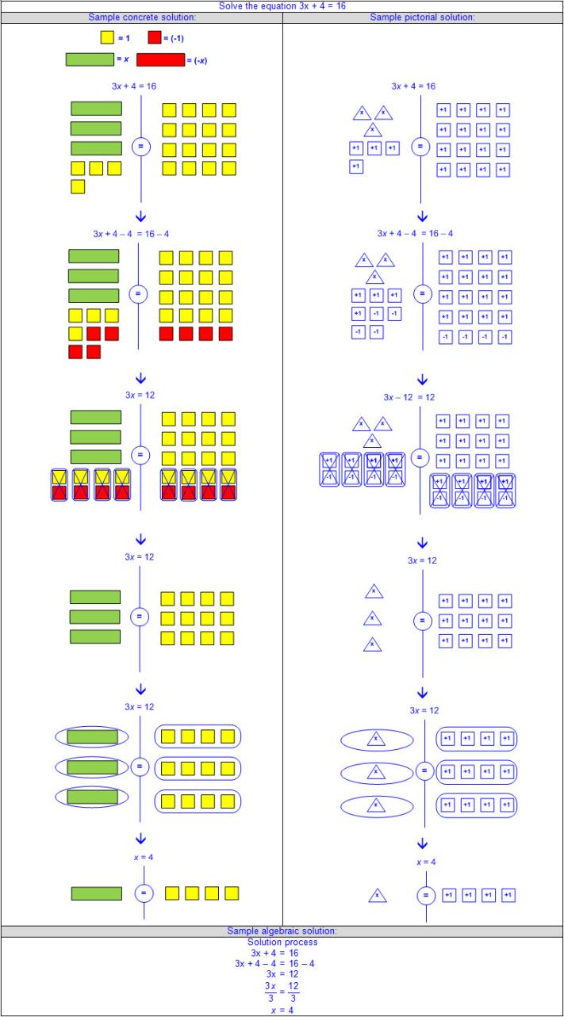  - Ex:  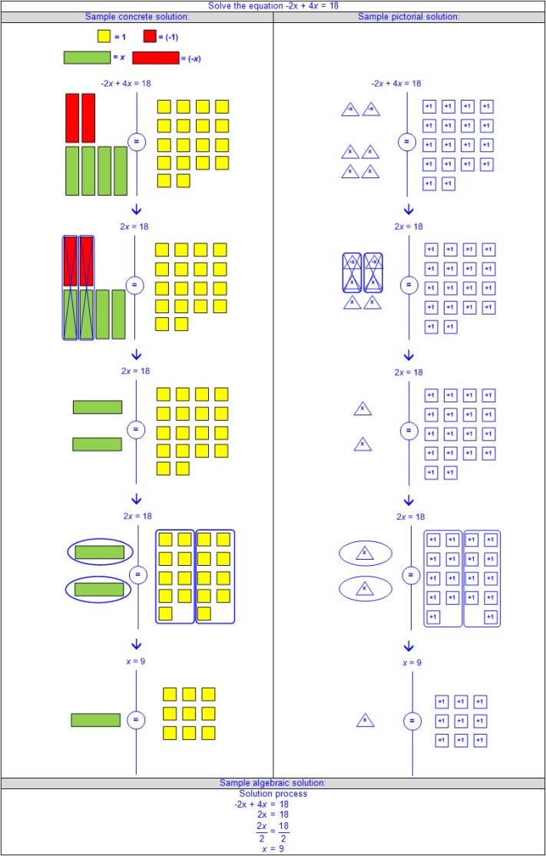  - Models to solve one-variable, two-step inequalities (concrete, pictorial, algebraic)  - Ex:  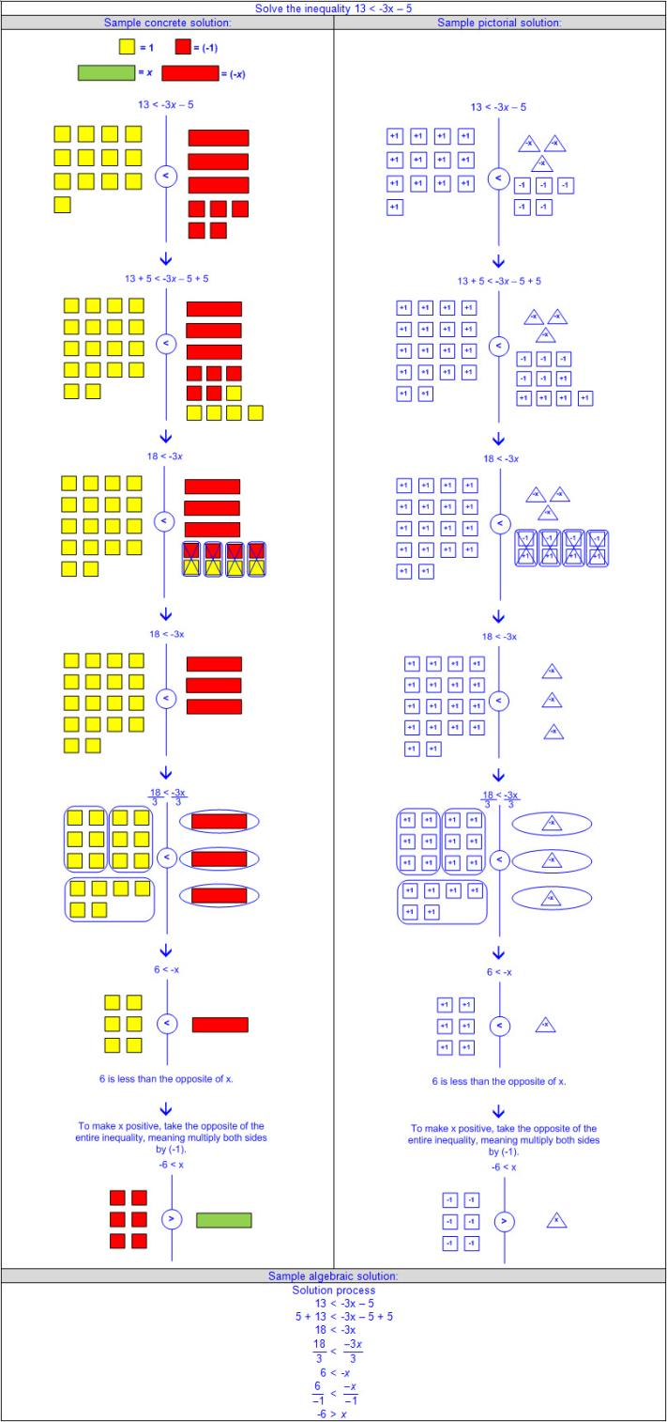  - Ex:  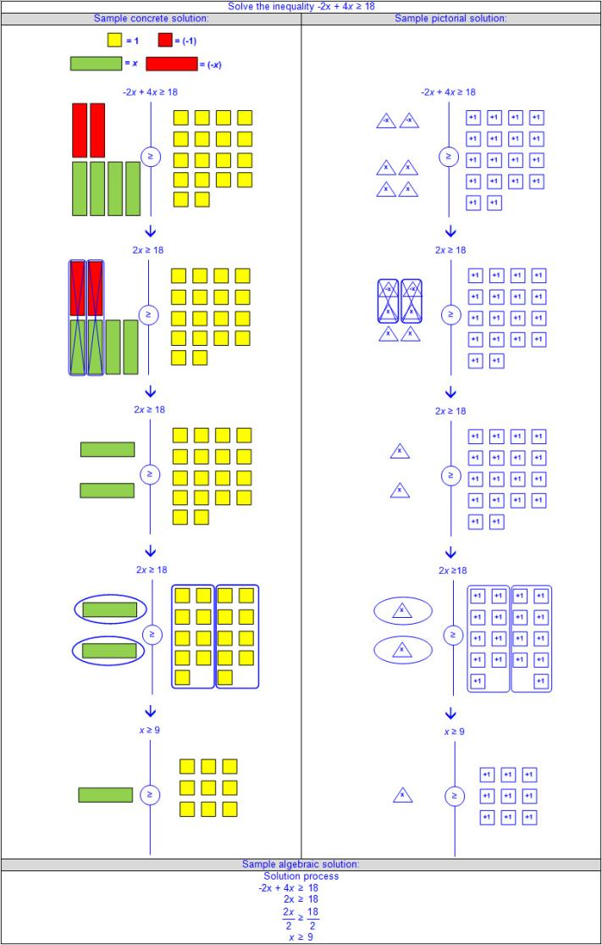  - Solutions to one-variable, two-step equations from a problem situation  - Ex:  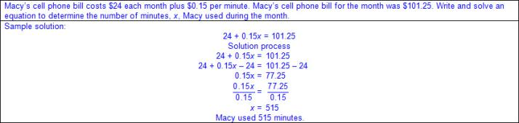  - Ex:  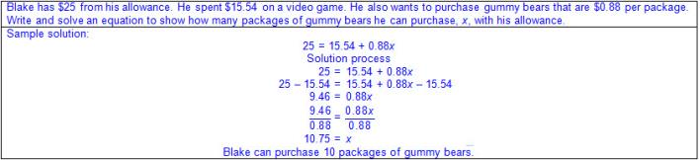  - Ex:  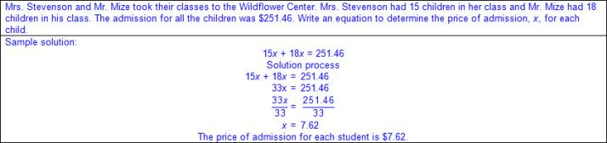  - Solutions to one-variable, two-step inequalities from a problem situation  - Ex:  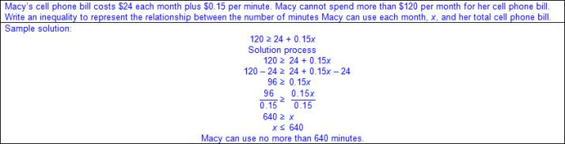  - Ex:  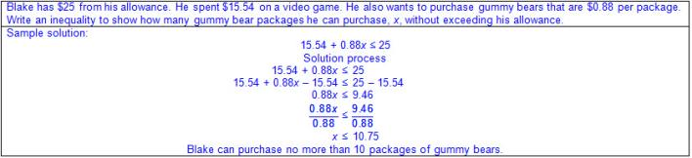  - Ex:  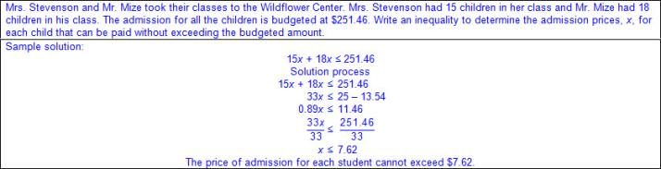  Note(s):  - Grade Level(s):  - Grade 6 modeled and solved one-variable, one-step equations and inequalities that represented problems, including geometric concepts.  - Grade 8 will model and solve one-variable equations with variables on both sides of the equal sign that represent mathematical and real-world problems using rational number coefficients and constants.  - Various mathematical process standards will be applied to this student expectation as appropriate.  - TxRCFP:  - Using expressions and equations to describe relationships in a variety of contexts, including geometric problems  - TxCCRS:  - I. Numeric Reasoning  - II. Algebraic Reasoning  - VIII. Problem Solving and Reasoning  - IX. Communication and Representation  - X. Connections
7.11B | Determine if the given value(s) make(s) one-variable, two-step equations and inequalities true.  Supporting Standard  Determine if the given value(s) make(s) one-variable, two-step equations and inequalities true.  Supporting Standard  Determine  IF THE GIVEN VALUE(S) MAKE(S) ONE-VARIABLE, TWO-STEP EQUATIONS AND INEQUALITIES TRUE  Including, but not limited to:  - Equation – a mathematical statement composed of algebraic and/or numeric expressions set equal to each other  - Inequality – a mathematical statement composed of algebraic and/or numeric expressions set apart by an inequality symbol  - Variable – a letter or symbol that represents a number  - One variable on one side of the equation or inequality  - Ex:  - Coefficient – a number that is multiplied by a variable(s)  - Whole numbers  - Integers  - Decimals (less than or greater than one)  - Fractions (proper, improper, and mixed numbers)  - Ex:  - Constant – a fixed value that does not appear with a variable(s)  - Whole numbers  - Integers  - Decimals (less than or greater than one)  - Fractions (proper, improper, and mixed numbers)  - Ex:  - Solution set – a set of all values of the variable(s) that satisfy the equation or inequality  - Constraints or conditions  - Ex: Minimum, maximum, up to, no more than, no less than, etc.  - Distinguishing between equations and inequalities  - Characteristics of equations  - Equates two expressions  - Equality of the variable  - One solution  - Characteristics of inequalities  - Shows the relationship between two expressions in terms of >,≥, ≤,or ≠  - Inequality of the variable  - One or more solutions  - Equality and inequality words and symbols  - Equal to, =  - Ex: x is 4, x = 4  - Greater than, >  - Ex: x is greater than 4, x > 4  - Greater than or equal to, ≥  - Ex: x is greater than or equal to 4, x ≥ 4  - Less than, <  - Ex: x is less than 4, x < 4  - Less than or equal to, ≤  - Ex: x is less than or equal to 4, x ≤ 4  - Not equal to, ≠  - Ex: x is not equal to 4, x ≠ 4  - Relationship of order of operations within an equation or inequality  - Order of operations – the rules of which calculations are performed first when simplifying an expression  - Parentheses/brackets: simplify expressions inside parentheses or brackets in order from left to right  - Exponents: rewrite in standard numerical form and simplify from left to right  - Limited to positive whole numer exponents  - Multiplication/division: simplify expressions involving multiplication and/or division in order from left to right  - Addition/subtraction: simplify expressions involving addition and/or subtraction in order from left to right  - Evaluation of given value(s) as possible solutions of one-variable, two-step equations  - Ex:  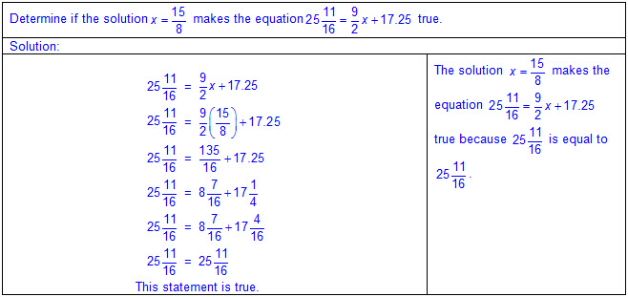  - Ex:  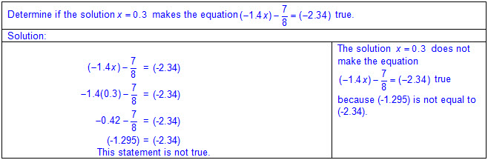  - Evaluation of given value(s) as possible solutions of one-variable, two-step inequalities  - Ex:  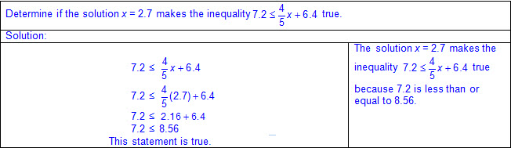  - Ex:  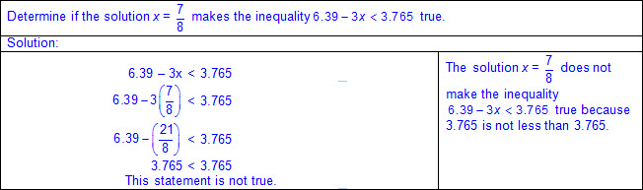  Note(s):  - Grade Level(s):  - Grade 6 determined if the given value(s) make(s) one-variable, one-step equations or inequalities true.  - Grade 8 identify and verify the values of x and y that simultaneously satisfy two linear equations in the form y = mx + b from the intersections of the graphed equations.  - Various mathematical process standards will be applied to this student expectation as appropriate.  - TxRCFP:  - Using expressions and equations to describe relationships in a variety of contexts, including geometric problems  - TxCCRS:  - I. Numeric Reasoning  - II. Algebraic Reasoning  - VIII. Problem Solving and Reasoning  - IX. Communication and Representation
7.11C | Write and solve equations using geometry concepts, including the sum of the angles in a triangle, and angle relationships.  Supporting Standard  Write and solve equations using geometry concepts, including the sum of the angles in a triangle, and angle relationships.  Supporting Standard  Write, Solve  EQUATIONS USING GEOMETRY CONCEPTS, INCLUDING THE SUM OF THE ANGLES IN A TRIANGLE, AND ANGLE RELATIONSHIPS  Including, but not limited to:  - Equation – a mathematical statement composed of algebraic and/or numeric expressions set equal to each other  - Variable – a letter or symbol that represents a number  - One variable on one side of the equation  - Ex:  - Coefficient – a number that is multiplied by a variable(s)  - Whole numbers  - Integers  - Decimals (less than or greater than one)  - Fractions (proper, improper, and mixed numbers)  - Ex:  - Constant – a fixed value that does not appear with a variable(s)  - Whole numbers  - Integers  - Decimals (less than or greater than one)  - Fractions (proper, improper, and mixed numbers)  - Ex:  - Solution set – a set of all values of the variable(s) that satisfy the equation or inequality  - Equations from geometry concepts  - Angle measures as numeric and/or algebraic expressions  - Sum of the angles in a triangle  - Ex:  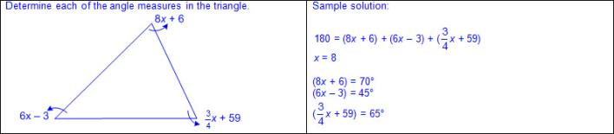  - Other angle relationships  - Complementary angles – two angles whose sum of angle measures equals 90 degrees  - Supplementary angles – two angles whose sum of angle measures equals 180 degrees  - Ex:  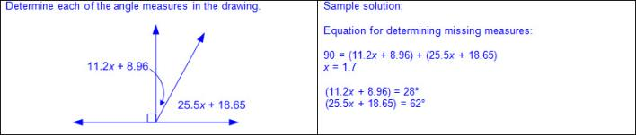  Note(s):  - Grade Level(s):  - Grade 6 extended previous knowledge of triangles and their properties to include the sum of angles of a triangle, the relationship between the lengths of sides and measures of angles in a triangle, and determining when three lengths form a triangle.  - Grade 8 will use informal arguments to establish facts about the angle sum and exterior angle of triangles, the angles created when parallel lines are cut by a transversal, and the angle-angle criterion for similarity of triangles.  - Various mathematical process standards will be applied to this student expectation as appropriate.  - TxRCFP:  - Using expressions and equations to describe relationships in a variety of contexts, including geometric problems  - TxCCRS:  - I. Numeric Reasoning  - II. Algebraic Reasoning  - III.C. Geometric Reasoning – Connections between geometry and other mathematical content strands  - VIII. Problem Solving and Reasoning  - IX. Communication and Representation  - X. Connections
7.12 | Measurement and data. The student applies mathematical process standards to use statistical representations to analyze data. The student is expected to:
7.12A | Compare two groups of numeric data using comparative dot plots or box plots by comparing their shapes, centers, and spreads.  Readiness Standard  Compare two groups of numeric data using comparative dot plots or box plots by comparing their shapes, centers, and spreads.  Readiness Standard  Compare  TWO GROUPS OF NUMERIC DATA USING COMPARATIVE DOT PLOTS OR BOX PLOTS BY COMPARING THEIR SHAPES, CENTERS, AND SPREADS  Including, but not limited to:  - Positive rational numbers – the set of numbers that can be expressed as a fraction , where a and b are whole numbers and b ≠ 0, which includes the subsets of whole numbers and counting (natural) numbers (e.g., 0, 2, etc.).  - Various forms of positive rational numbers  - Whole numbers  - Decimals (less than or greater than one)  - Fractions (proper, improper, and mixed numbers)  - Data – information that is collected about people, events, or objects  - Numerical data – data that represents values or observations that can be measured and placed in ascending or descending order  - Data can be counted (discrete) or measured (continuous).  - Ex: How many hours do you spend studying each night? Represented on a graph with a numerical axis.  - Ex: How old were you when you lost your first tooth? Represented on a graph with a numerical axis.  - Data representations  - Dot plot – a graphical representation to organize data that uses dots (or Xs) to show the frequency (number of times) that each number occurs  - Characteristics of a dot plot  - Title clarifies the meaning of the data represented.  - Numerical data is represented with labels and may be whole numbers, fractions, or decimals.  - Data represented may be numbers.  - Counts related to numbers represented by a number line.  - Dots (or Xs) recorded vertically above the line to represent the frequency of each number.  - Dots (or Xs) generally represent one count.  - Dots (or Xs) may represent multiple counts if indicated with a key.  - Density of dots relates to the frequency of distribution of the data.  - Ex:  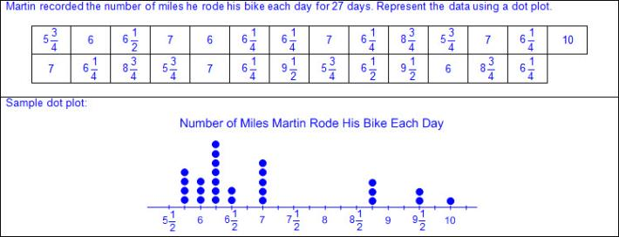  - Comparative dot plots – a graphical representation that consists of at least two related dot plots  - Ex:  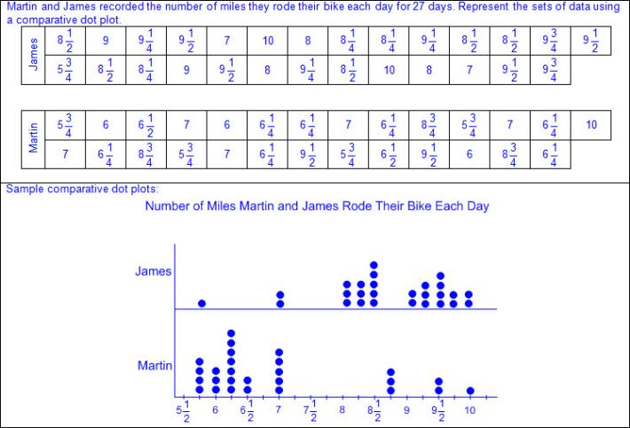  - Box plot (box and whisker plot) – a graphical representation that displays the centers and range of the data distribution on a number line  - Characteristics of a box plot  - Title clarifies the meaning of the data represented.  - Numerical data is represented with labels and may be whole numbers, fractions, or decimals.  - Aligned to a vertical or horizontal number line  - Data is divided into quartiles using the five-number summary.  - Minimum  - Quartile 1 (Q1): median of lower 50% of the data  - Median  - Quartile 3 (Q3): median of the upper 50% of the data  - Maximum  - Interquartile range represented by the difference between Q3 and Q1 (IQR = Q3 – Q1)  - Ex:  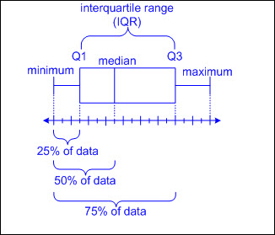  - Outliers may or may not exist.  - Outliers calculated as any data point that falls outside of range of 1.5 times the IQR (Outliers = 1.5(IQR)) from Q1 and Q3  - From the lower quartile: Q1 – 1.5(IQR)  - From the upper quartile: Q3 + 1.5(IQR)  - Density of quartiles represents the frequency of distribution of the data.  - Ex:  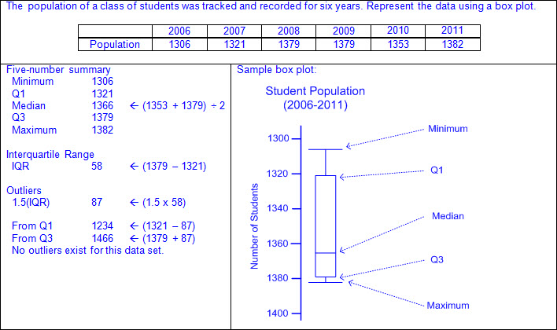  - Comparative box plots – a graphical representation that consists of at least two related box plots  - Ex:  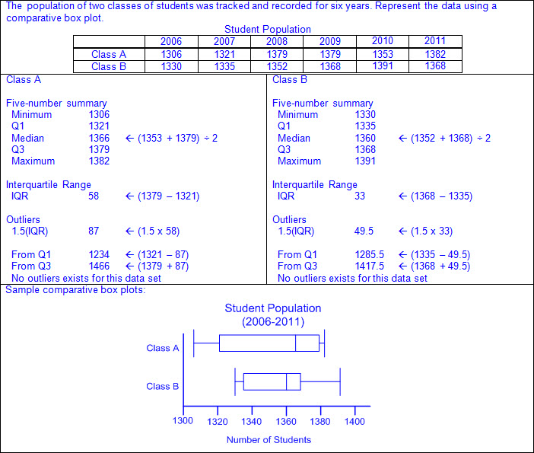  - Measures of center of a data distribution  - Mean – average of a set of data found by finding the sum of a set of data and dividing the sum by the number of pieces of data in the set  - Median – the middle number of a set of data that has been arranged in order from greatest to least or least to greatest  - Mode of numeric data – most frequent value in a set of data  - Measures of shape of a data distribution  - Range – the difference between the greatest number and least number in a set of data  - Interquartile range  - Shape of the data distribution  - Skewed right  - Usually the mean is greater than the median, and the median is greater than the mode.  - Shape of data when graphed has a tail to the right  - Ex:  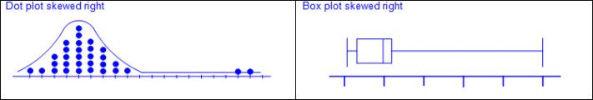  - Symmetric  - Usually the mean, median, and mode are approximately the same.  - Shape of data when graphed resembles a bell curve  - Ex:  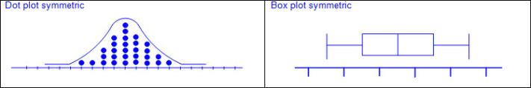  - Skewed left  - Usually the mean is less than the median, and the median is less than the mode.  - Shape of data when graphed has a tail to the left  - Ex:  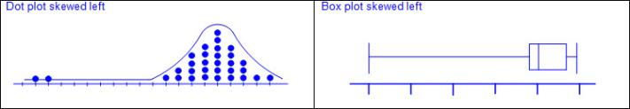  - Comparisons of shapes, centers, and spreads  - Comparative dot plots  - Ex:  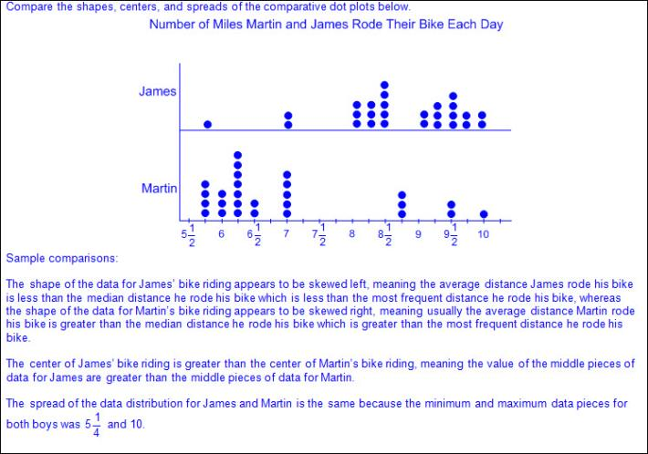  - Comparative box plots  - Ex:  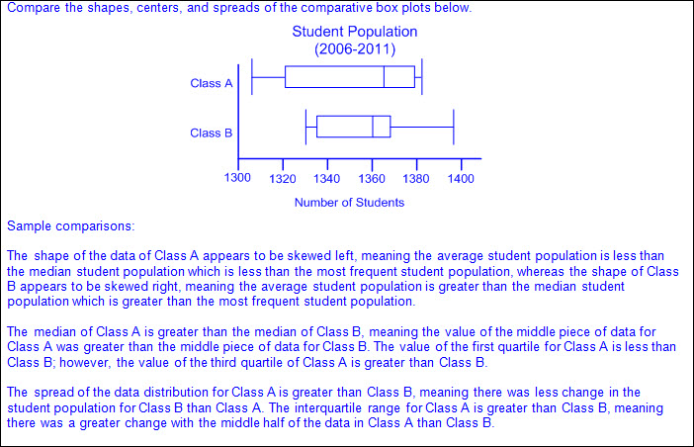  Note(s):  - Grade Level(s):  - Grade 6 used the graphical representation of numeric data to describe the center, spread, and shape of the data distribution.  - Grade 6 summarized numeric data with numerical summaries, including the mean and median (measures of center) and the range and interquartile range (IQR) (measures of spread), and used these summaries to describe the center, spread, and shape of the data distribution.  - Grade 6 summarized categorical data with numerical and graphical summaries, including the mode, the percent of values in each category (relative frequency table), and the percent bar graph, and used these summaries to describe the data distribution.  - Grade 8 will determine the mean absolute deviation and use this quantity as a measure of the average distance data are from the mean using a data set of no more than 10 data points.  - Various mathematical process standards will be applied to this student expectation as appropriate.  - TxRCFP:  - Comparing sets of data  - TxCCRS:  - I. Numeric Reasoning  - VI. Statistical Reasoning  - VIII. Problem Solving and Reasoning  - IX. Communication and Representation
7.12B | Use data from a random sample to make inferences about a population.  Supporting Standard  Use data from a random sample to make inferences about a population.  Supporting Standard  Use  DATA FROM A RANDOM SAMPLE TO MAKE INFERENCES ABOUT A POPULATION  Including, but not limited to:  - Positive rational numbers – the set of numbers that can be expressed as a fraction , where a and b are whole numbers and b ≠ 0, which includes the subsets of whole numbers and counting (natural) numbers (e.g., 0, 2, etc.).  - Various forms of positive rational numbers  - Whole numbers  - Decimals (less than or greater than one)  - Fractions (proper, improper, and mixed numbers)  - Data – information that is collected about people, events, or objects  - Inference – a conclusion or prediction based on data  - Population – total collection of persons, objects, or items of interest  - Sample – a subset of the population selected in order to make inferences about the entire population  - Ex:  - Ex:  - Random sample – a subset of the population selected without bias in order to make inferences about the entire population  - Random samples are more likely to contain data that can be used to make predictions about a whole population.  - Data from a random sample given or collected in various forms  - Verbal  - Tabular (vertical/horizontal)  - Graphical  - Inferences based on random sample  - Qualitative – a broad subjective description (e.g., the probability of an event occurring is certain, more likely, not likely, equally likely, or impossible.)  - Quantitative – a narrowed objective description associated with a quantity (e.g., the probability of selecting a consonant from the word EXPERIMENT is 1.5 times as likely as selecting a vowel from the same word, etc.)  - Statistical analysis of data in a random sample to make inferences about a population  - Ex:  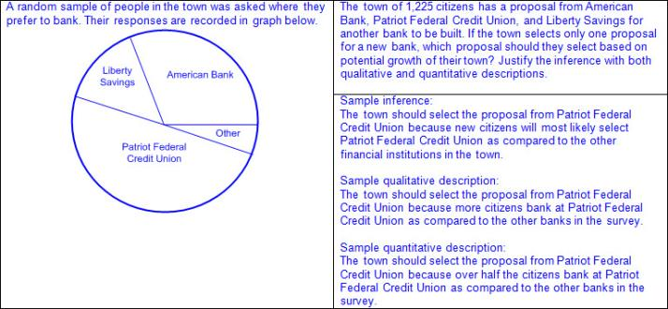  - Ex:  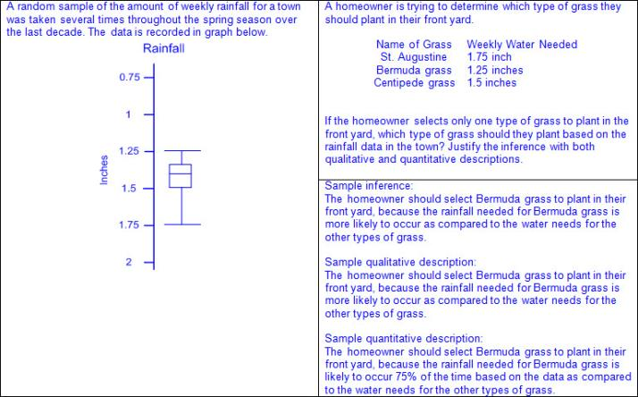  Note(s):  - Grade Level(s):  - Grade 7 introduces using data from random samples to make inferences about a population.  - Various mathematical process standards will be applied to this student expectation as appropriate.  - TxRCFP:  - Comparing sets of data  - TxCCRS:  - I. Numeric Reasoning  - IV. Measurement Reasoning  - VI. Statistical Reasoning  - VIII. Problem Solving and Reasoning  - IX. Communication and Representation
7.12C | Compare two populations based on data in random samples from these populations, including informal comparative inferences about differences between the two populations.  Supporting Standard  Compare two populations based on data in random samples from these populations, including informal comparative inferences about differences between the two populations.  Supporting Standard  Compare  TWO POPULATIONS BASED ON DATA IN RANDOM SAMPLES FROM THESE POPULATIONS, INCLUDING INFORMAL COMPARATIVE INFERENCES ABOUT DIFFERENCES BETWEEN THE TWO POPULATIONS  Including, but not limited to:  - Positive rational numbers – the set of numbers that can be expressed as a fraction , where a and b are whole numbers and b ≠ 0, which includes the subsets of whole numbers and counting (natural) numbers (e.g., 0, 2, etc.).  - Various forms of positive rational numbers  - Whole numbers  - Decimals (less than or greater than one)  - Fractions (proper, improper, and mixed numbers)  - Data – information that is collected about people, events, or objects  - Inference – a conclusion or prediction based on data  - Population – total collection of persons, objects, or items of interest  - Sample – a subset of the population selected in order to make inferences about the entire population  - Ex:  - Ex:  - Random sample – a subset of the population selected without bias in order to make inferences about the entire population  - Random samples are more likely to contain data that can be used to make predictions about a whole population.  - Data from a random sample given or collected in various forms  - Verbal  - Tabular (vertical/horizontal)  - Graphical  - Informal comparative inferences based on random samples from two populations  - Qualitative – a broad subjective description (e.g., the probability of an event occurring is certain, more likely, not likely, equally likely, or impossible.)  - Quantitative – a narrowed objective description associated with a quantity (e.g., the probability of selecting a consonant from the word EXPERIMENT is 1.5 times as likely as selecting a vowel from the same word, etc.)  - Statistical analysis of data from random sample to make inferences about two populations  - Ex:  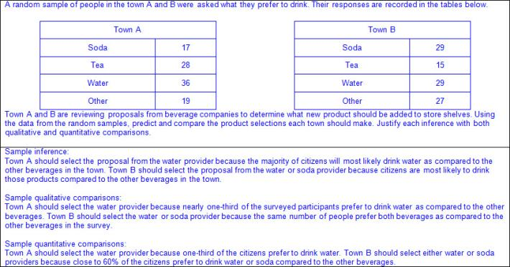  - Ex:  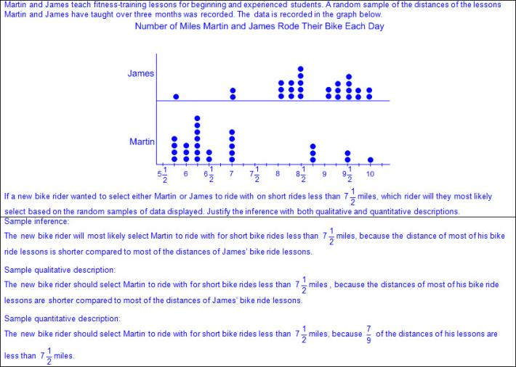  Note(s):  - Grade Level(s):  - Grade 7 introduces comparing two populations based on data in random samples from these populations, including informal comparative inferences about differences between the two populations.  - Grade 8 will simulate generating random samples of the same size from a population with known characteristics to develop the notion of a random sample being representative of the population from which it was selected.  - Various mathematical process standards will be applied to this student expectation as appropriate.  - TxRCFP:  - Comparing sets of data  - TxCCRS:  - I. Numeric Reasoning  - VI. Statistical Reasoning  - VIII. Problem Solving and Reasoning  - IX. Communication and Representation
7.13 | Personal financial literacy. The student applies mathematical process standards to develop an economic way of thinking and problem solving useful in one's life as a knowledgeable consumer and investor. The student is expected to:
7.13A | Calculate the sales tax for a given purchase and calculate income tax for earned wages.  Supporting Standard  Calculate the sales tax for a given purchase and calculate income tax for earned wages.  Supporting Standard  Calculate  THE SALES TAX FOR A GIVEN PURCHASE AND CALCULATE INCOME TAX FOR EARNED WAGES  Including, but not limited to:  - Positive rational numbers – the set of numbers that can be expressed as a fraction , where a and b are whole numbers and b ≠ 0, which includes the subsets of whole numbers and counting (natural) numbers (e.g., 0, 2, etc.).  - Various forms of positive rational numbers  - Whole numbers  - Decimals (less than or greater than one)  - Percents converted to equivalent decimals or fractions for multiplying or dividing  - Sales tax – a percentage of money collected by a store (retailer), in addition to a good or service that was purchased, for the local government as required by law  - Sales tax is set by the local government (city, county, and state) and the money stays within those local systems  - Ex:  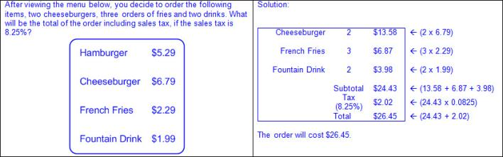  - Earned wages – the amount an individual earns over given period of time  - Income tax – a percentage of money paid on the earned wages of an individual or business for the federal and/or state governments as required by law  - Determined by a fixed rate on different brackets (levels) of taxable income and an individual’s income tax filing status of single, married joint, or head of household  - Income tax filing status  - Single can be claimed by any individual filing an income tax return.  - Married-joint can be claimed by married couples or individuals who have been widowed within the last two years.  - Head of household can be claimed individuals who pay for more than half of the household expenses and have at least one dependent (usually a child) that lives with them.  - Income tax brackets and rates are published by the state and/or federal government annually  - Income tax goes directly to federal government; the state of Texas does not collect income tax.  - Income tax rates fluctuate from year to year due to inflation and other federal and/or state government budgets.  - Earned income is rounded to the nearest whole dollar for purposes of tax brackets.  - Income tax is rounded to the nearest whole dollar.  - Ex:  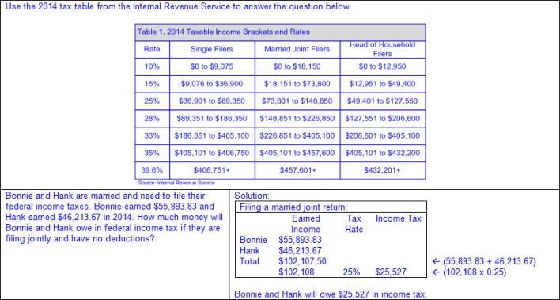  Note(s):  - Grade Level(s):  - Grade 5 defined income tax, payroll tax, sales tax, and property tax.  - Various mathematical process standards will be applied to this student expectation as appropriate.  - TxRCFP:  - Financial Literacy  - TxCCRS:  - I. Numeric Reasoning  - VIII. Problem Solving and Reasoning  - IX. Communication and Representation  - X. Connections
7.13B | Identify the components of a personal budget, including income; planned savings for college, retirement, and emergencies; taxes; and fixed and variable expenses, and calculate what percentage each category comprises of the total budget.  Supporting Standard  Identify the components of a personal budget, including income; planned savings for college, retirement, and emergencies; taxes; and fixed and variable expenses, and calculate what percentage each category comprises of the total budget.  Supporting Standard  Identify  THE COMPONENTS OF A PERSONAL BUDGET, INCLUDING INCOME; PLANNED SAVINGS FOR COLLEGE, RETIREMENT, AND EMERGENCIES; TAXES; AND FIXED AND VARIABLE EXPENSES  Including, but not limited to:  - Budget – a monthly or yearly spending and savings plan for an individual, family, business, or organization  - Budgets based on financial records help people plan and make choices about how to spend and save their money  - Components of a personal budget  - Income – money earned or received  - Savings for college – money saved for continuing education beyond high school  - Savings for retirement – money saved over the period of time an individual is employed to be spent once the individual retires from their occupation  - Savings for emergencies – money save for unexpected expenses (e.g., car repairs, emergency healthcare, etc.)  - Taxes – money paid to local, state, and federal governments to pay for things the government provides to its citizens  - Ex: Federal taxes pay for social security, national defense, healthcare, etc.  - Ex: Local taxes pay for schools, roads, healthcare, fire departments, police, etc.  - Various types of taxes  - Income tax – a percentage of money paid on the earned wages of an individual or business for the federal and/or state governments as required by law  - Payroll tax – a percentage of money that a company withholds from its employees for the federal government as required by law  - Sales tax – a percentage of money collected by a store (retailer), in addition to a good or service that was purchased, for the local government as required by law  - Property tax – a percentage of money collected on the value of a property for the local government as required by law  - Expense – payment for goods and services  - Fixed expenses – expenses that occur regularly and do not vary month to month  - Variable expenses – expenses that occur regularly but vary month to month and can usually be controlled by an individual  Calculate  WHAT PERCENTAGE EACH CATEGORY OF A PERSONAL BUDGET COMPRISES OF THE TOTAL BUDGET  Including, but not limited to:  - Positive rational numbers – the set of numbers that can be expressed as a fraction , where a and b are whole numbers and b ≠ 0, which includes the subsets of whole numbers and counting (natural) numbers (e.g., 0, 2, etc.).  - Various forms of positive rational numbers  - Whole numbers  - Decimals (less than or greater than one)  - Percents (less than or equal to 100%)  - Ex:  - Proportional reasoning to determine percentages within a budget  - Ex:  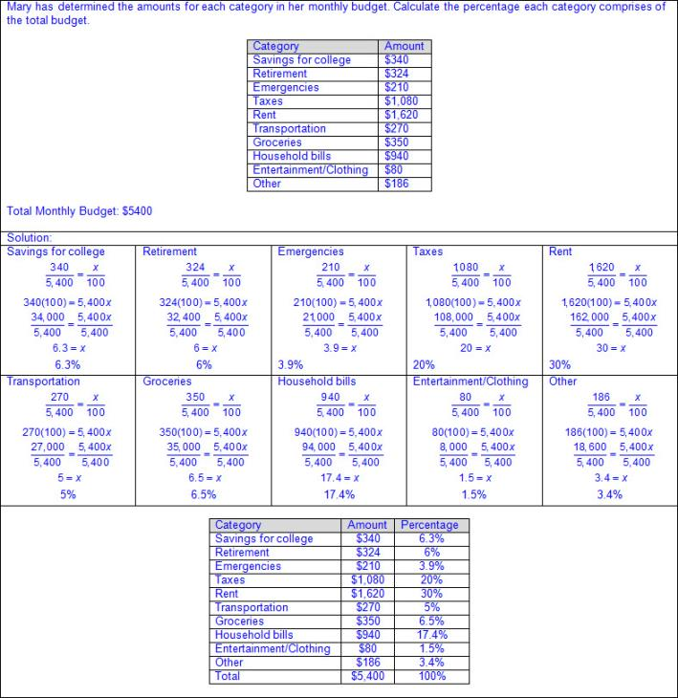  Note(s):  - Grade Level(s):  - Grade 5 balanced a simple budget.  - Various mathematical process standards will be applied to this student expectation as appropriate.  - TxRCFP:  - Financial Literacy  - TxCCRS:  - I. Numeric Reasoning  - VIII. Problem Solving and Reasoning  - IX. Communication and Representation  - X. Connections
7.13C | Create and organize a financial assets and liabilities record and construct a net worth statement.  Supporting Standard  Create and organize a financial assets and liabilities record and construct a net worth statement.  Supporting Standard  Create, Organize  A FINANCIAL ASSETS AND LIABILITIES RECORD  Including, but not limited to:  - Financial asset – an object or item of value that one owns  - Financial liability – an unpaid or outstanding debt  - Financial assets and liabilities records may fluctuate each month depending on payments made towards liabilities, whether additional liabilities are taken on, or if the value of an asset changes due to appreciation or depreciation.  - Ex:  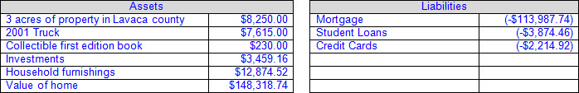  Construct  A NET WORTH STATEMENT  Including, but not limited to:  - Net worth – the total assets of an individual after their liabilities have been settled  - An individual’s net worth may be positive or negative depending on the amount of their assets and liabilities.  - Process of constructing a net worth statement  - Calculate the value of an individual’s assets.  - Ex:  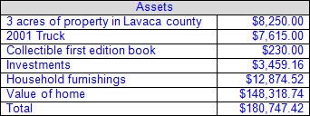  - Calculate the value on an individual’s liabilities.  - Ex:  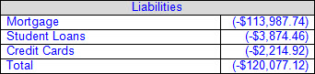  - Calculate the difference between an individual’s assets and liabilities.  - Ex:  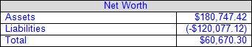  Note(s):  - Grade Level(s):  - Grade 7 introduces creating and organizing a financial assets and liabilities record and constructing a net worth statement.  - Various mathematical process standards will be applied to this student expectation as appropriate.  - TxRCFP:  - Financial Literacy  - TxCCRS:  - I. Numeric Reasoning  - VIII. Problem Solving and Reasoning  - IX. Communication and Representation  - X. Connections
7.13D | Use a family budget estimator to determine the minimum household budget and average hourly wage needed for a family to meet its basic needs in the student's city or another large city nearby.  Supporting Standard  Use a family budget estimator to determine the minimum household budget and average hourly wage needed for a family to meet its basic needs in the student's city or another large city nearby.  Supporting Standard  Use  A FAMILY BUDGET ESTIMATOR  Including, but not limited to:  - Budget – a monthly or yearly spending and savings plan for an individual, family, business, or organization  - Family budget estimator – determines the monthly or annual base income that is needed for a family  - Ex:  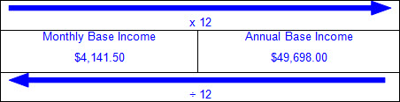  - Components of a family budget estimator  - Location of family  - Number of parents/guardians in the household  - Number of children in the household  - Basic needs  - Housing  - Food  - Medical Insurance  - Medial out-of-pocket expenses  - Transportation  - Child care  - Other family needs  - Savings (e.g., emergencies, retirement, college, etc.)  - Federal taxes  - Payroll tax  - Income tax  - Earned income credit  - Child tax credit  - Budget components are usually rounded to the nearest whole dollar amount.  - Values of budget components vary depending on location within a country, state, city, or county.  - Data from multiple sources is used to create a family budget estimator.  To Determine  THE MINIMUM HOUSEHOLD BUDGET AND AVERAGE HOURLY WAGE NEEDED FOR A FAMILY TO MEET ITS BASIC NEEDS IN THE STUDENT'S CITY OR ANOTHER LARGE CITY NEARBY  Including, but not limited to:  - Wage – the amount usually earned per hour or over a given period of time  - Basic needs – minimum necessities  - Minimum household budget is usually a monthly budget and is determined by finding the difference between the sum of the cost of basic needs, savings, and taxes and the total household income  - Average hourly wage is calculated by dividing the minimum household budget by the number of hours worked each month by each working adult in the household  - A typical workweek is considered 40 hours or 8 hours per day.  - The number of hours worked per month varies depending on the number of working days in the month, but can be usually considered as 20 working days per month.  - Ex:  - Average hourly wage needed in the student’s city  - Average hourly wage needed in nearby larger city  Note(s):  - Grade Level(s):  - Grade 7 introduces using a family budget estimator to determine the minimum household budget and average hourly wage needed for a family to meet its basic needs in the student's city or another large city nearby.  - Various mathematical process standards will be applied to this student expectation as appropriate.  - TxRCFP:  - Financial Literacy  - TxCCRS:  - I. Numeric Reasoning  - VIII. Problem Solving and Reasoning  - IX. Communication and Representation  - X. Connections
7.13E | Calculate and compare simple interest and compound interest earnings.  Supporting Standard  Calculate and compare simple interest and compound interest earnings.  Supporting Standard  Calculate, Compare  SIMPLE INTEREST AND COMPOUND INTEREST EARNINGS  Including, but not limited to:  - Positive rational numbers – the set of numbers that can be expressed as a fraction , where a and b are whole numbers and b ≠ 0, which includes the subsets of whole numbers and counting (natural) numbers (e.g., 0, 2, etc.).  - Various forms of positive rational numbers  - Whole numbers  - Decimals (less than or greater than one)  - Principal – the original amount invested or borrowed  - Simple interest – interest paid on the original principal in an account, disregarding any previously earned interest  - Compound interest – interest that is computed on the latest balance, including any previously earned interest that has been added to the original principal  - Formulas for interest from STAAR Grade 7 Mathematics Reference Materials  - Simple interest  - I = Prt, where I represents the interest, P represents the principal amount , r represents the interest rate in decimal form, and t represents the number of years the amount is deposited or borrowed  - Ex:  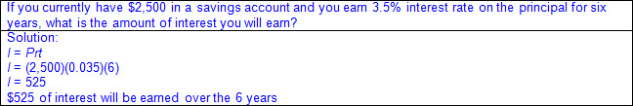  - Compound interest  - A = P(1+r)^{t} , where A represents the total amount of money deposited or borrowed, including interested, P represents the principal amount, r represents the interest rate in decimal form, and t represents the number of years the amount is deposited or borrowed  - Ex:  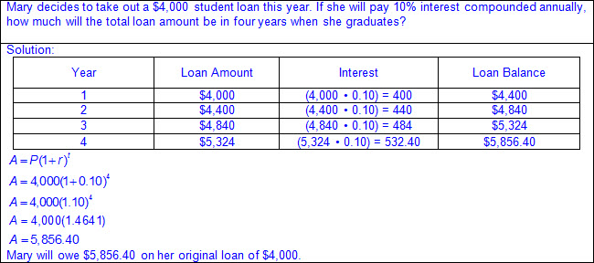  - Comparing simple and compound interest earnings  - Ex:  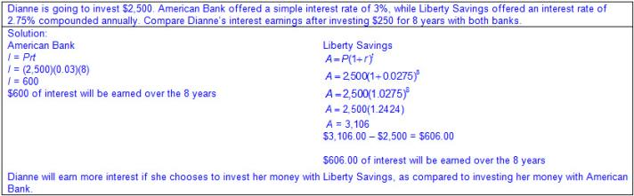  Note(s):  - Grade Level(s):  - Grade 4 compared the advantages and disadvantages of various savings options.  - Grade 8 will calculate and compare simple interest and compound interest earnings.  - Various mathematical process standards will be applied to this student expectation as appropriate.  - TxRCFP:  - Financial Literacy  - TxCCRS:  - I. Numeric Reasoning  - VIII. Problem Solving and Reasoning  - IX. Communication and Representation  - X. Connections
7.13F | Analyze and compare monetary incentives, including sales, rebates, and coupons.  Supporting Standard  Analyze and compare monetary incentives, including sales, rebates, and coupons.  Supporting Standard  Analyze, Compare  MONETARY INCENTIVES, INCLUDING SALES, REBATES, AND COUPONS  Including, but not limited to:  - Monetary incentives  - Sale – a reduced amount or price of an item  - May be offered by a store or manufacturer depending on the location of the purchase  - Ex: 30% off, buy one get one free, etc.  - Rebate – an amount returned or refunded for purchasing an item or items  - May be offered by the store or manufacturer  - May be instant or require a rebate form with proof of purchase to be mailed in  - Ex: Five dollars back with the purchase of four items, $50 rebate when you purchase a qualifying cell phone, etc.  - Coupon – an amount deducted from the total cost of an item  - May be offered by manufacturers or by retailers  - Some retailers may allow coupons to be stacked by accepting both a store coupon and a manufacturer’s coupon.  - Ex: $0.50 with the purchase of two, $1.00 off, etc.  - Ex:  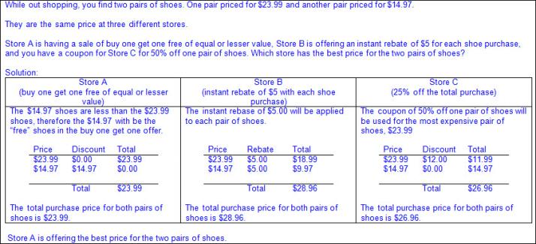  Note(s):  - Grade Level(s):  - Grade 3 identified the costs and benefits of planned and unplanned spending decisions.  - Grade 8 will explain how small amounts of money invested regularly, including money saved for college and retirement, grow over time.  - Various mathematical process standards will be applied to this student expectation as appropriate.  - TxRCFP:  - Financial Literacy  - TxCCRS:  - I. Numeric Reasoning  - VIII. Problem Solving and Reasoning  - IX. Communication and Representation  - X. Connections
Bibliography:
Texas Education Agency & Texas Higher Education Coordinating Board. (2009). Texas college and career readiness standards. Retrieved from http://www.thecb.state.tx.us/collegereadiness/crs.pdf

Texas Education Agency. (2013). Introduction to the revised mathematics TEKS – kindergarten-algebra I vertical alignment. Retrieved from
http://www.projectsharetexas.org/sites/default/files/resources/documents/K-AlgebraIVAChart.pdf

Texas Education Agency. (2013). Texas response to curriculum focal points for kindergarten through grade 8 mathematics. Retrieved from
http://projectsharetexas.org/resource/txrcfp-texas-response-curriculum-focal-points-k-8-mathematics-revised-2013
Bold black text in italics: Knowledge and Skills Statement (TEKS); Bold black text: Student Expectation (TEKS)
Bold red text in italics: Student Expectation identified by TEA as a Readiness Standard for STAAR
Bold green text in italics: Student Expectation identified by TEA as a Supporting Standard for STAAR
Blue text: Supporting information / Clarifications from TCMPC (Specificity)
Black text: Texas Education Agency (TEA); Texas College and Career Readiness Standards (TxCCRS)

