Enhanced TEKS Clarification

Mathematics

Grade 5

2014 - 2015
Grade 5
§111.1. Implementation of Texas Essential Knowledge and Skills for Mathematics, Elementary, Adopted 2012.
Source: The provisions of this §111.1 adopted to be effective September 10, 2012, 37 TexReg 7109.
§111.7. Grade 5, Adopted 2012.
5.Intro.1 | The desire to achieve educational excellence is the driving force behind the Texas essential knowledge and skills for mathematics, guided by the college and career readiness standards. By embedding statistics, probability, and finance, while focusing on computational thinking, mathematical fluency, and solid understanding, Texas will lead the way in mathematics education and prepare all Texas students for the challenges they will face in the 21st century.

5.Intro.2 | The process standards describe ways in which students are expected to engage in the content. The placement of the process standards at the beginning of the knowledge and skills listed for each grade and course is intentional. The process standards weave the other knowledge and skills together so that students may be successful problem solvers and use mathematics efficiently and effectively in daily life. The process standards are integrated at every grade level and course. When possible, students will apply mathematics to problems arising in everyday life, society, and the workplace. Students will use a problem-solving model that incorporates analyzing given information, formulating a plan or strategy, determining a solution, justifying the solution, and evaluating the problem-solving process and the reasonableness of the solution. Students will select appropriate tools such as real objects, manipulatives, algorithms, paper and pencil, and technology and techniques such as mental math, estimation, number sense, and generalization and abstraction to solve problems. Students will effectively communicate mathematical ideas, reasoning, and their implications using multiple representations such as symbols, diagrams, graphs, computer programs, and language. Students will use mathematical relationships to generate solutions and make connections and predictions. Students will analyze mathematical relationships to connect and communicate mathematical ideas. Students will display, explain, or justify mathematical ideas and arguments using precise mathematical language in written or oral communication.

5.Intro.3 | For students to become fluent in mathematics, students must develop a robust sense of number. The National Research Council's report, "Adding It Up," defines procedural fluency as "skill in carrying out procedures flexibly, accurately, efficiently, and appropriately." As students develop procedural fluency, they must also realize that true problem solving may take time, effort, and perseverance. Students in Grade 5 are expected to perform their work without the use of calculators.

5.Intro.4 | The primary focal areas in Grade 5 are solving problems involving all four operations with positive rational numbers, determining and generating formulas and solutions to expressions, and extending measurement to area and volume. These focal areas are supported throughout the mathematical strands of number and operations, algebraic reasoning, geometry and measurement, and data analysis. In Grades 3-5, the number set is limited to positive rational numbers. In number and operations, students will apply place value and identify part-to-whole relationships and equivalence. In algebraic reasoning, students will represent and solve problems with expressions and equations, build foundations of functions through patterning, identify prime and composite numbers, and use the order of operations. In geometry and measurement, students will classify two-dimensional figures, connect geometric attributes to the measures of three-dimensional figures, use units of measure, and represent location using a coordinate plane. In data analysis, students will represent and interpret data.

5.Intro.5 | Statements that contain the word "including" reference content that must be mastered, while those containing the phrase "such as" are intended as possible illustrative examples.

5.1 | Mathematical process standards. The student uses mathematical processes to acquire and demonstrate mathematical understanding. The student is expected to:
5.1A | Apply mathematics to problems arising in everyday life, society, and the workplace.  Apply mathematics to problems arising in everyday life, society, and the workplace.  Apply  MATHEMATICS TO PROBLEMS ARISING IN EVERYDAY LIFE, SOCIETY, AND THE WORKPLACE  Note(s):  - The mathematical process standards may be applied to all content standards as appropriate.  - TxRCFP:  - Developing an understanding of and fluency with addition, subtraction, multiplication, and division of fractions and decimals  - Understanding and generating expressions and equations to solve problems  - Representing and solving problems with perimeter, area, and volume  - Organizing, representing, and interpreting sets of data  - TxCCRS:  - X. Connections
5.1B | Use a problem-solving model that incorporates analyzing given information, formulating a plan or strategy, determining a solution, justifying the solution, and evaluating the problem-solving process and the reasonableness of the solution.  Use a problem-solving model that incorporates analyzing given information, formulating a plan or strategy, determining a solution, justifying the solution, and evaluating the problem-solving process and the reasonableness of the solution.  Use  A PROBLEM-SOLVING MODEL THAT INCORPORATES ANALYZING GIVEN INFORMATION, FORMULATING A PLAN OR STRATEGY, DETERMINING A SOLUTION, JUSTIFYING THE SOLUTION, AND EVALUATING THE PROBLEM-SOLVING PROCESS AND THE REASONABLENESS OF THE SOLUTION  Note(s):  - The mathematical process standards may be applied to all content standards as appropriate.  - TxRCFP:  - Developing an understanding of and fluency with addition, subtraction, multiplication, and division of fractions and decimals  - Understanding and generating expressions and equations to solve problems  - Representing and solving problems with perimeter, area, and volume  - Organizing, representing, and interpreting sets of data  - TxCCRS:  - VIII. Problem Solving and Reasoning
5.1C | Select tools, including real objects, manipulatives, paper and pencil, and technology as appropriate, and techniques, including mental math, estimation, and number sense as appropriate, to solve problems.  Select tools, including real objects, manipulatives, paper and pencil, and technology as appropriate, and techniques, including mental math, estimation, and number sense as appropriate, to solve problems.  Select  TOOLS, INCLUDING REAL OBJECTS, MANIPULATIVES, PAPER AND PENCIL, AND TECHNOLOGY AS APPROPRIATE, TO SOLVE PROBLEMS  Select  TECHNIQUES, INCLUDING MENTAL MATH, ESTIMATION, AND NUMBER SENSE AS APPROPRIATE, TO SOLVE PROBLEMS  Note(s):  - The mathematical process standards may be applied to all content standards as appropriate.  - TxRCFP:  - Developing an understanding of and fluency with addition, subtraction, multiplication, and division of fractions and decimals  - Understanding and generating expressions and equations to solve problems  - Representing and solving problems with perimeter, area, and volume  - Organizing, representing, and interpreting sets of data  - TxCCRS:  - VIII. Problem Solving and Reasoning
5.1D | Communicate mathematical ideas, reasoning, and their implications using multiple representations, including symbols, diagrams, graphs, and language as appropriate.  Communicate mathematical ideas, reasoning, and their implications using multiple representations, including symbols, diagrams, graphs, and language as appropriate.  Communicate  MATHEMATICAL IDEAS, REASONING, AND THEIR IMPLICATIONS USING MULTIPLE REPRESENTATIONS, INCLUDING SYMBOLS, DIAGRAMS, GRAPHS, AND LANGUAGE AS APPROPRIATE  Note(s):  - The mathematical process standards may be applied to all content standards as appropriate.  - TxRCFP:  - Developing an understanding of and fluency with addition, subtraction, multiplication, and division of fractions and decimals  - Understanding and generating expressions and equations to solve problems  - Representing and solving problems with perimeter, area, and volume  - Organizing, representing, and interpreting sets of data  - TxCCRS:  - IX. Communication and Representation
5.1E | Create and use representations to organize, record, and communicate mathematical ideas.  Create and use representations to organize, record, and communicate mathematical ideas.  Create, Use  REPRESENTATIONS TO ORGANIZE, RECORD, AND COMMUNICATE MATHEMATICAL IDEAS  Note(s):  - The mathematical process standards may be applied to all content standards as appropriate.  - TxRCFP:  - Developing an understanding of and fluency with addition, subtraction, multiplication, and division of fractions and decimals  - Understanding and generating expressions and equations to solve problems  - Representing and solving problems with perimeter, area, and volume  - Organizing, representing, and interpreting sets of data  - TxCCRS:  - IX. Communication and Representation
5.1F | Analyze mathematical relationships to connect and communicate mathematical ideas.  Analyze mathematical relationships to connect and communicate mathematical ideas.  Analyze  MATHEMATICAL RELATIONSHIPS TO CONNECT AND COMMUNICATE MATHEMATICAL IDEAS  Note(s):  - The mathematical process standards may be applied to all content standards as appropriate.  - TxRCFP:  - Developing an understanding of and fluency with addition, subtraction, multiplication, and division of fractions and decimals  - Understanding and generating expressions and equations to solve problems  - Representing and solving problems with perimeter, area, and volume  - Organizing, representing, and interpreting sets of data  - TxCCRS:  - X. Connections
5.1G | Display, explain, and justify mathematical ideas and arguments using precise mathematical language in written or oral communication.  Display, explain, and justify mathematical ideas and arguments using precise mathematical language in written or oral communication.  Display, Explain, Justify  MATHEMATICAL IDEAS AND ARGUMENTS USING PRECISE MATHEMATICAL LANGUAGE IN WRITTEN OR ORAL COMMUNICATION  Note(s):  - The mathematical process standards may be applied to all content standards as appropriate.  - TxRCFP:  - Developing an understanding of and fluency with addition, subtraction, multiplication, and division of fractions and decimals  - Understanding and generating expressions and equations to solve problems  - Representing and solving problems with perimeter, area, and volume  - Organizing, representing, and interpreting sets of data  - TxCCRS:  - IX. Communication and Representation
5.2 | Number and operations. The student applies mathematical process standards to represent, compare, and order positive rational numbers and understand relationships as related to place value. The student is expected to:
5.2A | Represent the value of the digit in decimals through the thousandths using expanded notation and numerals.  Supporting Standard  Represent the value of the digit in decimals through the thousandths using expanded notation and numerals.  Supporting Standard  Represent  THE VALUE OF THE DIGIT IN DECIMALS THROUGH THE THOUSANDTHS USING EXPANDED NOTATION AND NUMERALS  Including, but not limited to:  - Whole numbers  - Counting (natural) numbers – the set of positive numbers that begins at one and increases by increments of one each time {1, 2, 3, ..., n}  - Whole numbers – the set of counting (natural) numbers and zero {0, 1, 2, 3, ..., n}  - Decimals (less than and greater than one to the tenths, hundredths, and thousandths)  - Decimal number – a number in the base-10 place value system used to represent a quantity that may include part of a whole and is recorded with a decimal point separating the whole from the part  - Numeral – a symbol used to name a number  - Digit – any numeral from 0 – 9  - Place value – the value of a digit as determined by its location in a number, such as ones, tens, hundreds, one thousands, ten thousands, etc.  - One billions place  - Hundred millions place  - Ten millions place  - One millions place  - Hundred thousands place  - Ten thousands place  - One thousands place  - Hundreds place  - Tens place  - Ones place  - Tenths place  - Hundredths place  - Thousandths place  - Base-10 place value system  - A number system using ten digits 0 – 9  - Relationships between places are based on multiples of 10.  - Moving left across the places, the values are 10 times the position to the right.  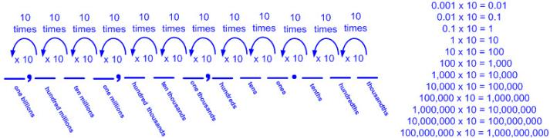  - Moving right across the places, the values are one-tenth the value of the place to the left.  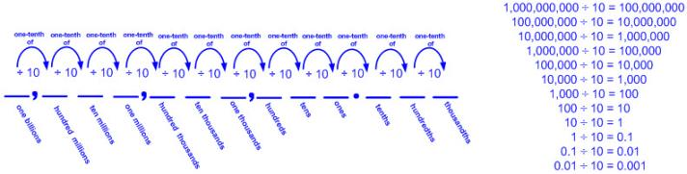  - Multiplying a number by 10 increases the place value of each digit.  - Ex: 10 x [4(100) + 8(10) + 9 + 3 () + 2 ()] = 4(1000) +8(100) + 9(10) + 3 + 2()  - Ex: 489.32 x 10 = 4893.2 x 1  - Dividing a number by 10 decreases the place value of each digit.  - Ex: [4(100) + 8(10) + 9 + 3 () + 2 ()] ÷ 10 = 4(10) +8 + 9() + 3() + 2()  - Ex: 489.32 ÷ 10 = 48.932 ÷ 1  - The magnitude (relative size) of decimal places through the thousandths  - The magnitude of one-tenth  - 0.1 can be represented as 1 tenth.  - 0.1 can be represented as 10 hundredths.  - 0.1 can be represented as 100 thousandths  - The magnitude of one-hundredth  - 0.01 can be represented as 1 hundredth.  - 0.01 can be represented as 10 thousandths.  - The magnitude of one-thousandth  - 0.001 can be represented as 1 thousandth.  - Expanded form – the representation of a number as a sum of place values (e.g., 985,156,789.782 as 900,000,000 + 80,000,000 + 5,000,000 + 100,000 + 50,000 + 6,000 + 700 + 80 + 9 + 0.7 + 0.08 + 0.002 or as 900,000,000 + 80,000,000 + 5,000,000 + 100,000 + 50,000 + 6,000 + 700 + 80 + 9 + + + 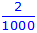)  - Zero may or may not be written as an addend to represent the digit 0 in a number (e.g., 905,150,089.087 as 900,000,000 + 0 + 5,000,000 + 100,000 + 50,000 + 0 + 0 + 80 + 9 + 0.1 + 0.08+ 0.007or as 900,000,000 + 5,000,000 + 100,000 + 50,000 + 80 + 9 + 0.08 + 0.007).  - Expanded notation – the representation of a number as a sum of place values where each term is shown as a digit(s) times its place value (e.g., 985,156,789.782 as (9 x 100,000,000) + (8 x 10,000,000) + (5 x 1,000,000) + (1 x 100,000) + (5 x 10,000) + (6 x 1,000) + (7 x 100) + (8 x 10) + (9 x 1) + (7 x 0.1) + (8 x 0.01) + (2 x 0.001) or as 9(100,000,000) + 8(10,000,000) + 5(1,000,000) + 1(100,000) + 5(10,000) + 6(1,000) + 7(100) + 8(10) + 9(1) + 7(0.1) + 8(0.01) + 2 (0.001) or as 9(100,000,000) + 8(10,000,000) + 5(1,000,000) + 1(100,000) + 5(10,000) +6(1,000) + 7(100) + 8(10) + 9(1) + 7() + 8() + 2 ())  - Zero may or may not be written as an addend to represent the digit 0 in a number (e.g., 905,150,089.087 as (9 x 100,000,000) + (0 x 10,000,000) + (5 x 1,000,000) + (1 x 100,000) + (5 x 10,000) + (0 x 1,000) + (0 x 100) + (8 x 10) + (9 x 1) + (0 x 0.1) + (8 x 0.01) + (7 x 0.001) or as (9 x 100,000,000) + (5 x 1,000,000) + (1 x 100,000) + (5 x 10,000) + (8 x 10) + (9 x 1) + (8 x 0.01) + (7 x 0.001)).  - Standard form – the representation of a number using digits (e.g., 985,156,789.782)  - The whole part of a decimal number is recorded to the left of the decimal point when written and stated as a whole number.  - The decimal point is recorded to separate the whole part of a decimal number from the fractional part of a decimal number when written and is stated as “and” when read.  - The fractional part of a decimal number is recorded to the right of the decimal point when written.  - The fractional part of a decimal number is stated as a whole number with the label of the smallest decimal place value when read (e.g., 0.5 is read as 5 tenths; 0.25 is read as 25 hundredths; 0.625 is read as 625 thousandths; etc.).  - The “-ths” ending denotes the fractional part of a decimal number.  - Zeros are used as place holders between the digits of a decimal number as needed, whole part and fractional part, to maintain the value of each digit (e.g., 400.005).  - Leading zeros in a decimal number are not commonly used in standard form, but are not incorrect and do not change the value of the decimal number (e.g., 0,037,564,215.558 equals 37,564,215.558)  - Trailing zeros after a fractional part of a decimal number may or may not be used and do not change the value of the decimal number (e.g., 400.500 equals 400.5).  - Word form – the representation of a number using written words (e.g., 985,156,789.782 as nine hundred eighty-five million, one hundred fifty-six thousand, seven hundred eighty-nine and seven hundred eighty-two thousandths)  - The whole part of a decimal number is recorded the same as a whole number with all appropriate unit labels prior to recording the fractional part of a decimal number.  - The decimal point is recorded as the word “and” to separate the whole part of a decimal number from the fractional part of a decimal number when written and is stated as “and” when read.  - The fractional part of a decimal number followed by the label of the smallest decimal place value is recorded when written and stated when read.  - The “-ths” ending denotes the fractional part of a decimal number.  - The zeros in a decimal number are not stated when read and are not recorded when written (e.g., 854,091,005.026 in standard form is read and written as eight hundred fifty-four million, ninety-one thousand, five and twenty-six thousandths in word form.).  - Equivalent relationships between place value of decimals through the thousandths  - Multiple representations  - Ex:  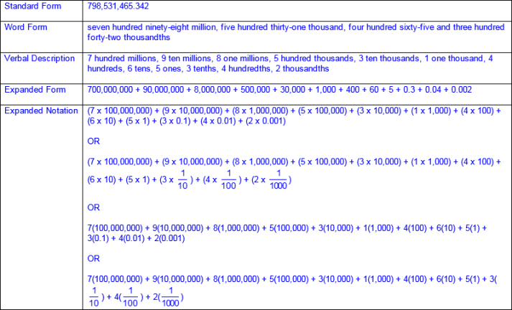  - Place values presented out of order  - Ex:  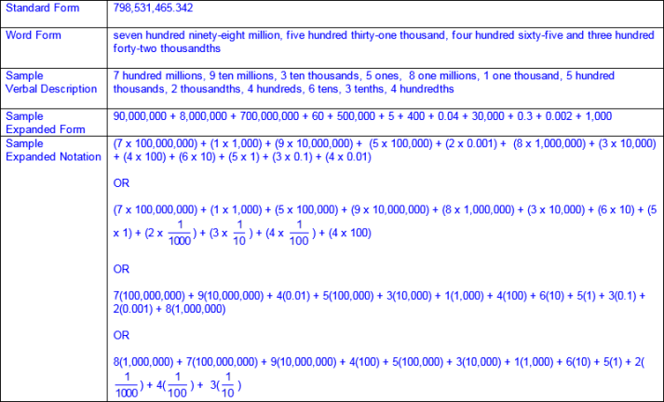  - Equivalent compositions/decompositions of numbers with the same value  - Ex:  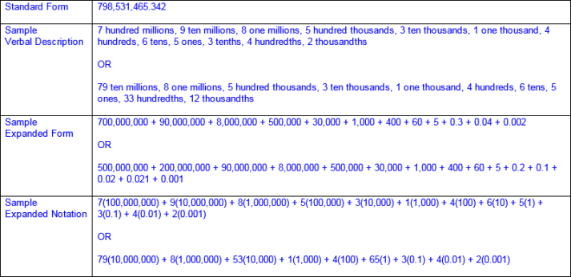  Note(s):  - Grade Level(s):  - Grade 4 represented the value of the digit in whole numbers through 1,000,000,000 and decimals to the hundredths using expanded notation and numerals.  - Grade 4 interpreted the value of each place-value position as 10 times the position to the right and as one-tenth of the value of the place to its left.  - Grade 4 represented decimals, including tenths and hundredths, using concrete and visual models and money.  - Grade 5 introduces the value of a digit in decimals through the thousandths place.  - Various mathematical process standards will be applied to this student expectation as appropriate.  - TxRCFP:  - Grade Level Connections (reinforces previous learning and/or provides development for future learning)  - TxCCRS:  - I. Numeric Reasoning  - IX. Communication and Representation
5.2B | Compare and order two decimals to thousandths and represent comparisons using the symbols >, <, or =.  Readiness Standard  Compare and order two decimals to thousandths and represent comparisons using the symbols >, <, or =.  Readiness Standard  Compare, Order  TWO DECIMALS TO THOUSANDTHS  Including, but not limited to:  - Decimals (less than and greater than one to the tenths, hundredths, and thousandths)  - Decimal number – a number in the base-10 place value system used to represent a quantity that may include part of a whole and is recorded with a decimal point separating the whole from the part  - Place value – the value of a digit as determined by its location in a number such as ones, tens, hundreds, one thousands, ten thousands, etc.  - Compare numbers – to consider the value of two numbers to determine which number is greater or less or if the numbers are equal in value  - Relative magnitude of a number describes the size of a number and its relationship to another number.  - Ex: 1.2 is closer to 0 on a number line than 1.5, so 1.2 < 1.5 and 1.5 > 1.2  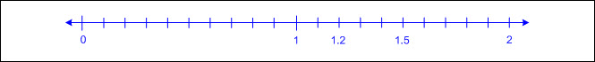  - Ex: 2.73 is further from 0 on a number line than 2.37, so 2.73 > 2.37 and 2.37 < 2.73  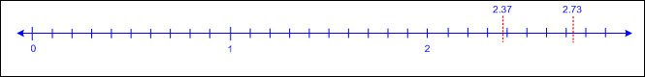  - Ex: 23.38 is further from 0 on a number line than 23.308, so 23.38 > 23.308 and 23.308 < 23.38  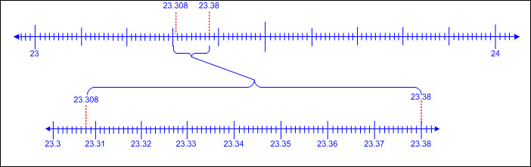  - Compare two decimals using place value charts.  - Compare digits in the same place value position beginning with the greatest place value.  - If these digits are the same, continue to the next smallest place until the digits are different.  - Ex:  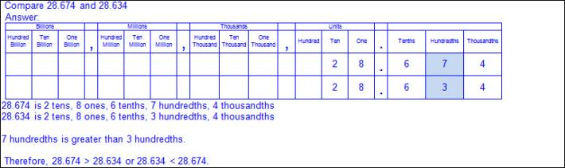  - Numbers that have common digits but are not equal in value (different place values)  - Ex:  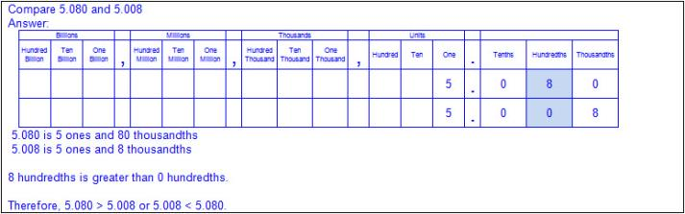  - Numbers that have a different number of digits  - Ex:  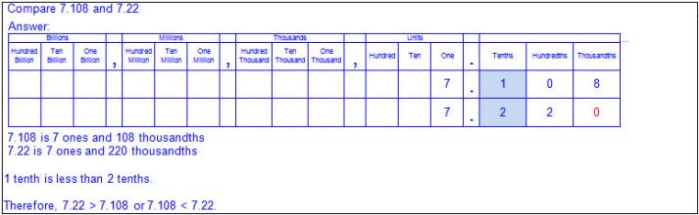  - Compare two decimals using a number line.  - Number lines (horizontal/vertical)  - Proportionally scaled number lines (pre-determined intervals with at least two labeled numbers)  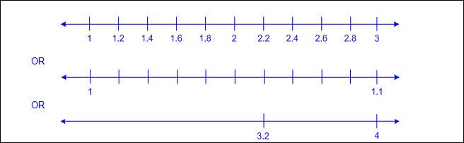  - Open number lines (no marked intervals)  - Ex:  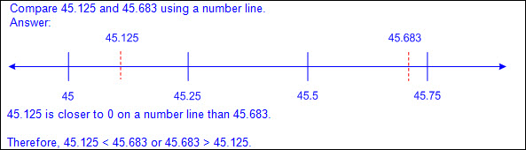  - Order numbers – to arrange a set of numbers based on their numerical value  - Numbers increase from left to right on a horizontal number line and from bottom to top on a vertical number line.  - Points to the left of a specified point on a horizontal number line are less than points to the right.  - Points to the right of a specified point on a horizontal number line are greater than points to the left.  - Points below a specified point on a vertical number line are less than points above.  - Points above a specified point on a vertical number line are greater than points below.  - Order two decimals on a number line.  - Ex:  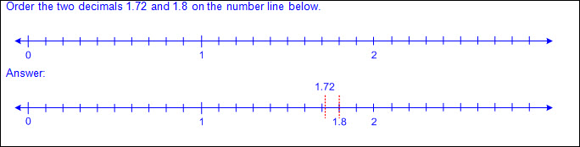  - Order two decimals on an open number line.  - Ex:  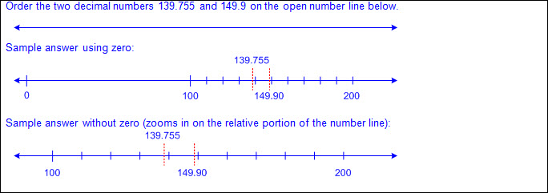  - Quantifying descriptors (e.g., between two given numbers, greatest/least, ascending/descending, tallest/shortest, warmest/coldest, fastest/slowest, longest/shortest, heaviest/lightest, closest/farthest, oldest/youngest, etc.)  - Ex:  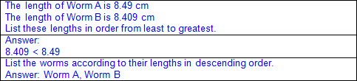  - Ex:  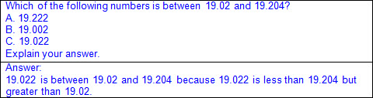  Represent  COMPARISONS OF TWO DECIMALS TO THOUSANDTHS USING THE SYMBOLS >, <, or =  Including, but not limited to:  - Decimals (less than and greater than one to the tenths, hundredths, and thousandths)  - Decimal number – a number in the base-10 place value system used to represent a quantity that may include part of a whole and is recorded with a decimal point separating the whole from the part  - Comparative language and symbols  - Inequality words and symbols  - Greater than (>)  - Less than (  - Ex:  - Equality words and symbol  - Equal to (=)  - Ex:  Note(s):  - Grade Level(s):  - Grade 4 compared and ordered whole numbers to 1,000,000,000 and represented comparisons using the symbols >, <, or =.  - Grade 4 compared and ordered decimals using concrete and visual models to the hundredths.  - Grade 5 introduces comparing and ordering two decimals to the thousandths place.  - Grade 6 will order a set of rational numbers arising from mathematical and real-world contexts.  - Various mathematical process standards will be applied to this student expectation as appropriate.  - TxRCFP  - Grade Level Connections (reinforces previous learning and/or provides development for future learning)  - TxCCRS:  - I. Numeric Reasoning  - IX. Communication and Representation
5.2C | Round decimals to tenths or hundredths.  Supporting Standard  Round decimals to tenths or hundredths.  Supporting Standard  Round  DECIMALS TO TENTHS OR HUNDREDTHS  Including, but not limited to:  - Decimals (less than and greater than one to the tenths, hundredths, and thousandths)  - Decimal number – a number in the base-10 place value system used to represent a quantity that may include part of a whole and is recorded with a decimal point separating the whole from the part  - Rounding – a type of estimation with specific rules for determining the closest value  - Nearest tenth or hundredth  - Number lines  - Proportionally scaled number lines (pre-determined intervals)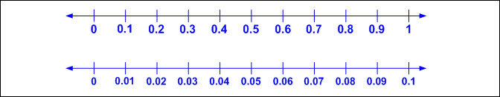  - Open number line (no marked intervals)  - Trailing zeros – a sequence of zeros in the decimal part of a number that follow the last non-zero digit, and whether recorded or deleted, does not change the value of the number  - Relative magnitude of a number describes the size of a number and its relationship to another number.  - Ex:  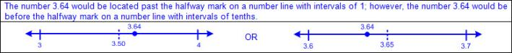  - Connections between rounding whole numbers on number line to rounding decimals on a number line  - Rounding to the nearest tenth on a number line  - Determine the two consecutive tenths that the number being rounded falls between.  - Begin with the value of the original tenths place within the number and then identify the next highest value in the tenths place.  - Determine the halfway point between the consecutive tenths.  - Locate the position of the number being rounded on the number line.  - Determine if the number being rounded is before, past, or on the halfway point between the consecutive tenths on the number line.  - If the number being rounded is before the halfway point on the number line, round to the value of the original tenths place.  - If the number being rounded is past the halfway point on the number line, round to the value of the next highest tenths place.  - If the number being rounded is on the halfway point on the number line, round to the value of the next highest tenths place.  - Rounding to the nearest hundredth on a number line  - Determine the two consecutive hundredths that the number being rounded falls between.  - Begin with the value of the original hundredths place within the number and then identify the next highest value in the hundredths place.  - Determine the halfway point between the consecutive hundredths.  - Locate the position of the number being rounded on the number line.  - Determine if the number being rounded is before, past, or on the halfway point between the consecutive hundredths on the number line.  - If the number being rounded is before the halfway point on the number line, round to the value of the original hundredths place.  - If the number being rounded is past the halfway point on the number line, round to the value of the next highest hundredths place.  - If the number being rounded is on the halfway point on the number line, round to the value of the next highest hundredths place.  - Round a given decimal to the closest tenth or hundredth on a number line.  - Ex:  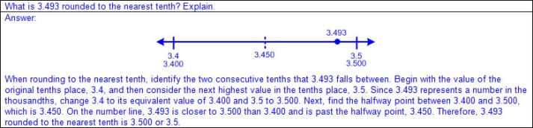  - Ex:  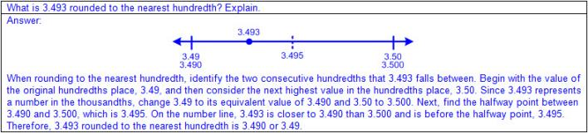  - Round a given decimal to the greater tenth or hundredth if it falls exactly halfway between the consecutive tenths or hundredths on a number line.  - Ex:  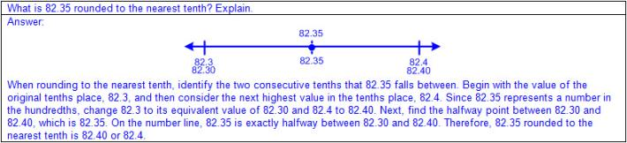  - Ex:  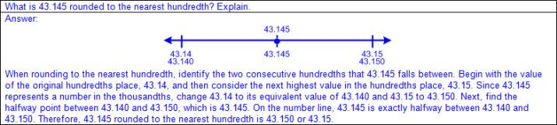  - Money (tenths, hundredths)  - Relationship between tenths and $0.10 or a dime  - Ex: 18.46 can be thought of as $18.46. Rounding $18.46 to the nearest dime ($0.10) is $18.50. Therefore, rounding 18.46 to the nearest tenth (0.1) is 18.5.  - Relationship between hundredths and $0.01 or a penny  - Ex: 0.793 can be thought of as $0.79 and of the next penny or hundredth. Rounding $0.79 and of the next hundredth to the nearest penny ($0.01) is $0.79. Therefore, rounding 0.793 to the nearest hundredth (0.01) is 0.79.  - Rounding numerically based on place value  - Find the place to which you are rounding.  Look at the digit of the next lowest place value, the digit to the right of which you are rounding.  If the digit in that place is less than 5, then the digit in the rounding place remains the same.  If the digit in that place is greater than or equal to 5, then the digit in the rounding place increases by 1.  The digit(s) to the right of the place of which you are rounding is replaced with “0”. Trailing zeros are not necessary to record in the decimal part of the number.  - Ex:  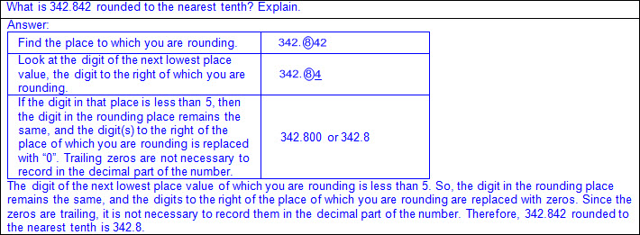  - Ex:  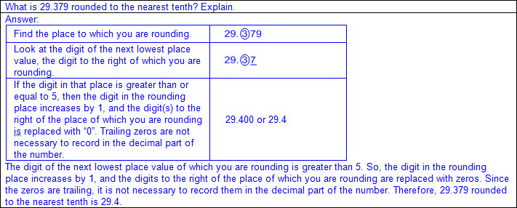  - Ex:  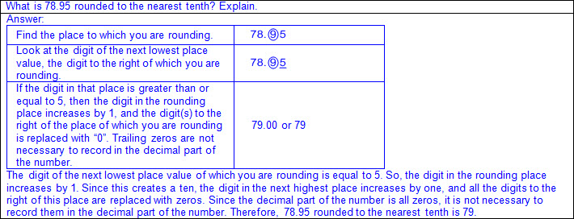  - Ex:  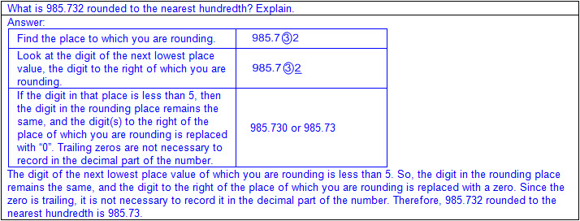  - Ex:  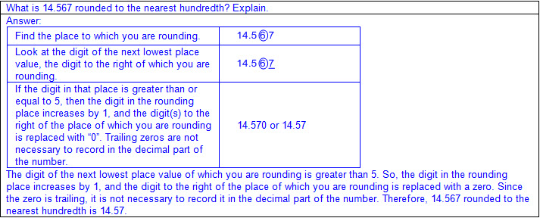  Note(s):  - Grade Level(s):  - Grade 4 rounded whole numbers to a given place through the hundred thousands place.  - Grade 4 rounded to the nearest 10, 100, or 1,000 or used compatible numbers to estimate solutions involving whole numbers.  - Grade 5 introduces rounding decimals to the tenths or hundredths.  - Various mathematical process standards will be applied to this student expectation as appropriate.  - TxRCFP  - Grade Level Connections (reinforces previous learning and/or provides development for future learning)  - TxCCRS:  - I. Numeric Reasoning  - IX. Communication and Representation
5.3 | Number and operations. The student applies mathematical process standards to develop and use strategies and methods for positive rational number computations in order to solve problems with efficiency and accuracy. The student is expected to:
5.3A | Estimate to determine solutions to mathematical and real-world problems involving addition, subtraction, multiplication, or division.  Supporting Standard  Estimate to determine solutions to mathematical and real-world problems involving addition, subtraction, multiplication, or division.  Supporting Standard  Estimate To Determine  SOLUTIONS TO MATHEMATICAL AND REAL-WORLD PROBLEMS INVOLVING ADDITION, SUBTRACTION, MULTIPLICATION, OR DIVISION  Including, but not limited to:  - Whole numbers  - Counting (natural) numbers – the set of positive numbers that begins at one and increases by increments of one each time {1, 2, 3, ..., n}  - Whole numbers – the set of counting (natural) numbers and zero {0, 1, 2, 3, ..., n}  - Decimals (less than and greater than one to the tenths, hundredths, and thousandths)  - Decimal number – a number in the base-10 place value system used to represent a quantity that may include part of a whole and is recorded with a decimal point separating the whole from the part  - Fractions (proper, improper, or mixed numbers with equal or unequal denominators)  - Fraction – a number in the form where a and b are whole numbers and b is not equal to zero. A fraction can be used to name part of an object, part of a set of objects, to compare two quantities, or to represent division.  - Proper fraction – a number in the form where a and b are whole numbers and a < b where b is not equal to zero  - Improper fraction – a number in the form where a and b are whole numbers and a > b where b is not equal to zero  - Mixed number – a number that is composed of a whole number and a fraction  - Unit fraction – a fraction in the form representing the quantity formed by one part of a whole that has been partitioned into b equal parts where b is a non-zero whole number  - Addition  - Sums of whole numbers  - Sums of decimals up to the thousandths  - Sums of fractions with equal and unequal denominators  - Subtraction  - Differences of whole numbers  - Differences of decimals with values limited to the thousandths  - Differences of fractions with equal and unequal denominators  - Multiplication  - Product – the total when two or more factors are multiplied  - Factor – a number multiplied by another number to find a product  - Products of whole numbers up to three-digit factors by two-digit factors  - Products of decimals limited to three-digit factors by two-digit factors with products to the hundredths  - Multiply tenths by tenths (e.g., 0.3 x 0.7 = 0.21, 1.2 x 1.2 = 1.44, 14.3 x 1.3 = 18.59, etc.)  - Multiply tenths by hundredths or vice versa (e.g., 0.5 x 0.12 = 0.06, 1.4 x 0.15 = 0.21, 21.4 x 0.45 = 9.63, etc.)  - Multiply tenths by thousandths or vice versa (e.g., 0.4 x 0.125 = 0.05, 0.125 x 8.4 = 1.05, etc.)  - Multiply whole numbers by tenths, hundredths, and thousandths or vice versa (e.g., 3 x 1.3 = 3.9, 42 x 7.45 = 312.9, 7.02 x 78 = 547.56, 6 x 0.125 = 0.75, etc.)  - Products of fractions where factors are limited to a fraction and a whole number  - Division  - Quotient – the size or measure of each group or the number of groups when the dividend is divided by the divisor  - Dividend – the number that is being divided  - Divisor – the number the dividend is being divided by  - Whole numbers with quotients up to four-digit dividends and two-digit divisors  - Quotients of decimals limited to four-digit dividends and two-digit whole number divisors, with quotients to the hundredths  - Dividend to the tenths and whole number divisor (e.g., 1.2 ÷ 24 = 0.05, 358.8 ÷ 23 = 15.6, 721.7 ÷ 14 = 51.55, etc.)  - Dividend to the hundredths and whole number divisor (e.g., 8.68 ÷ 4 = 2.17, 8.25 ÷ 15 = 0.55, 62.76 ÷ 12 = 5.23, etc.)  - Whole number dividends and whole number divisors (e.g., 3 ÷ 4 = 0.75, 10 ÷ 8 = 1.25, 1000 ÷ 16 = 62.5, etc.)  - Quotients of fractions where dividend and divisors are limited to whole numbers by unit fractions and unit fractions by whole numbers  - Estimation strategies for solving mathematical and real-world problem situations  - Estimation – reasoning to determine an approximate value  - Vocabulary indicating estimation situations (e.g., about, approximately, estimate, etc.)  - Vocabulary descriptors of the effects of the adjustment on the estimation compared to the actual solution (e.g., about, close, little more/little less, around, approximately, estimated, etc.)  - Variation of the estimate from the actual solution is dependent upon the magnitude of the adjustment(s) of the actual numbers.  - Front-end method – a type of estimation focusing first on the largest place value in each of the numbers to be computed and then determining if the next smallest place value(s) when grouped should be considered or ignored (compensation)  - Ex:  - Ex:  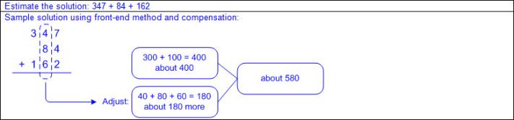  - Ex:  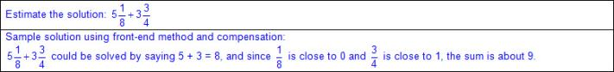  - Ex:  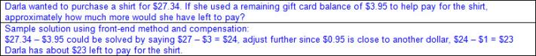  - Rounding – a type of estimation with specific rules for determining the closest value  - Round numbers to a common place then computer  - Ex: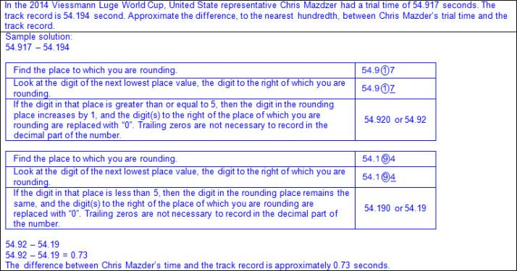  - Ex:  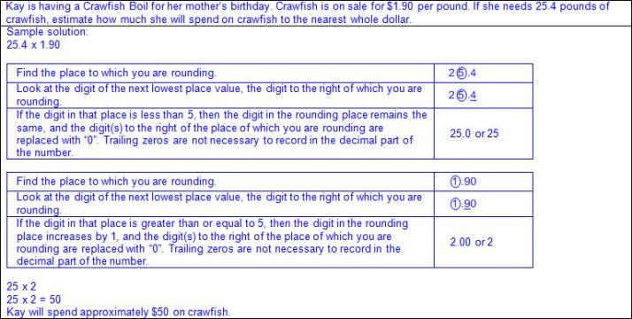  - Ex:  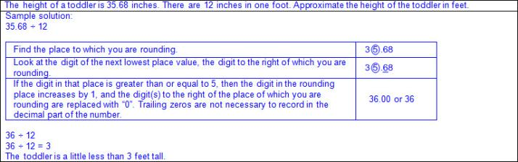  - Keep one value the same and round the other value to estimate solutions.  - Ex: 5,869 + 2,890 can be thought of as 5,869 + 3,000. Therefore, the estimated sum of 5,869 and 2,890 is about 8,869.  - Ex: 58.69 – 29.90 can be thought of as 58.69 – 30. Therefore, the estimated difference between 58.69 and 29.90 is about 28.69.  - Ex: 5.15 x 24 can be thought of as 5.15 x 20. Therefore, the estimated product of 5.15 and 24 is about 103.  - Ex: 90.5 ÷ 9 can be thought of as 90.5 ÷ 10. Therefore, the estimated quotient of 90.5 and 9 is about 9.05.  - Compatible numbers – numbers that are slightly adjusted to create groups of numbers that are easy to compute mentally  - Ex:  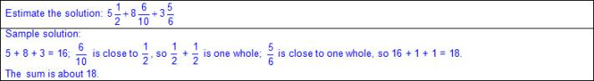  - Ex:  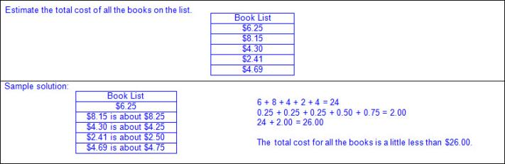  - Ex:  - Ex:  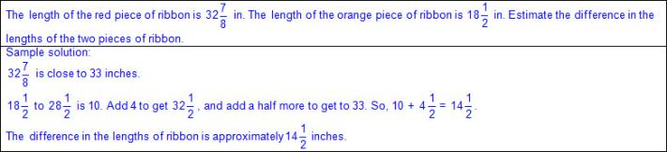  - Ex:  - Ex:  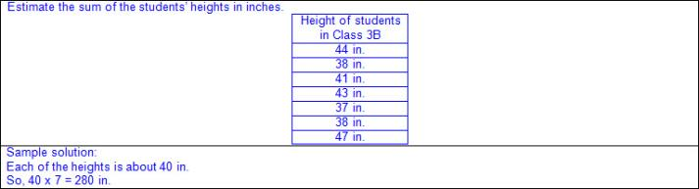  - Ex:  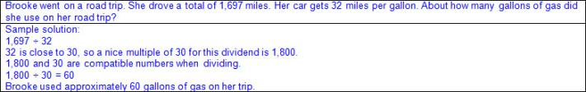  - Ex:  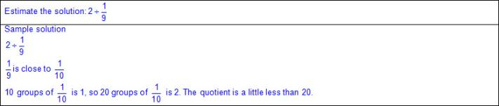  - Ex:  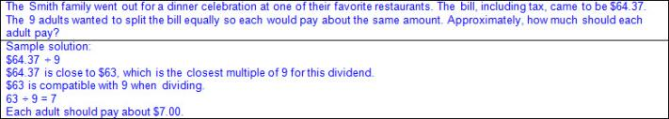  - Multiple operations with various forms of numbers  - Ex:  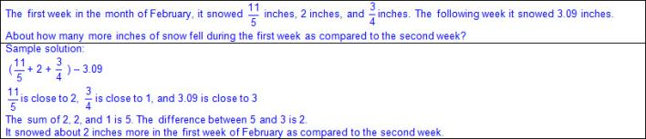  Note(s):  - Grade Level(s):  - Grade 4 added and subtracted whole numbers and decimals to the hundredths place using the standard algorithm.  - Grade 5 estimates solutions with whole numbers, fractions, and decimals.  - Various mathematical process standards will be applied to this student expectation as appropriate.  - TxRCFP:  - Developing an understanding of and fluency with addition, subtraction, multiplication, and division of fractions and decimals  - TxCCRS:  - I. Numeric Reasoning  - VIII. Problem Solving and Reasoning  - IX. Communication and Representation
5.3B | Multiply with fluency a three-digit number by a two-digit number using the standard algorithm.  Supporting Standard  Multiply with fluency a three-digit number by a two-digit number using the standard algorithm.  Supporting Standard  Multiply  WITH FLUENCY A THREE-DIGIT NUMBER BY A TWO-DIGIT NUMBER USING THE STANDARD ALGORITHM  Including, but not limited to:  - Whole numbers  - Counting (natural) numbers – the set of positive numbers that begins at one and increases by increments of one each time {1, 2, 3, ..., n}  - Whole numbers – the set of counting (natural) numbers and zero {0, 1, 2, 3, ..., n}  - Fluency – efficient application of procedures with accuracy  - Multiplication  - Product – the total when two or more factors are multiplied  - Factor – a number multiplied by another number to find a product  - Products of whole numbers up to three-digit factors by two-digit factors  - Recognition of multiplication in mathematical and real-world problem situations  - Automatic recall of basic facts  - Standard algorithm  - Ex:  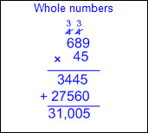  Note(s):  - Grade Level(s):  - Grade 4 determined products of a number and 10 or 100 using properties of operations and place value understandings.  - Grade 4 represented the product of 2 two-digit numbers using arrays, area models, or equations, including perfect squares through 15 by 15.  - Grade 4 used strategies and algorithms, including the standard algorithm, to multiply up to a four-digit number by a one-digit number and to multiply a two-digit number by a two-digit number. Strategies may have included mental math, partial products, and the commutative, associative, and distributive properties.  - Grade 4 solved with fluency one- and two-step problems involving multiplication and division, including interpreting remainders.  - Grade 6 will multiply and divide positive rational numbers fluently.  - Various mathematical process standards will be applied to this student expectation as appropriate  - TxRCFP:  - Developing an understanding of and fluency with addition, subtraction, multiplication, and division of fractions and decimals  - TxCCRS:  - I. Numeric Reasoning  - IX. Communication and Representation
5.3C | Solve with proficiency for quotients of up to a four-digit dividend by a two-digit divisor using strategies and the standard algorithm.  Supporting Standard  Solve with proficiency for quotients of up to a four-digit dividend by a two-digit divisor using strategies and the standard algorithm.  Supporting Standard  Solve  WITH PROFICIENCY FOR QUOTIENTS OF UP TO A FOUR-DIGIT DIVIDEND BY A TWO-DIGIT DIVISOR USING STRATEGIES AND THE STANDARD ALGORITHM  Including, but not limited to:  - Whole numbers  - Counting (natural) numbers – the set of positive numbers that begins at one and increases by increments of one each time {1, 2, 3, ..., n}  - Whole numbers – the set of counting (natural) numbers and zero {0, 1, 2, 3, ..., n}  - Proficiency – the mathematical ability to reason, apply, understand, compute, and engage in meaningful mathematics  - Division  - Quotient – the size or measure of each group or the number of groups when the dividend is divided by the divisor  - Dividend – the number that is being divided  - Divisor – the number the dividend is being divided by  - Quotients of whole numbers up to four-digit dividends and two-digit divisors  - Recognition of division in mathematical and real-world problem situations  - Automatic recall of basic facts  - Relationships between multiplication and division to help in solution process  - a ÷ b = c, so b x c = a  - Ex: 9,756 ÷ 12 = 813, so 12 x 813 = 9,756  - Division structures  - Partitive division  - Total amount known  - Number of groups known  - Size or measure of each group unknown  - Ex:  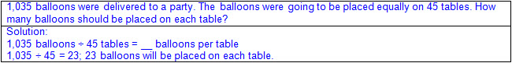  - Quotative division (also known as Measurement division)  - Total amount known  - Size or measure of each group known  - Number of groups unknown  - Ex:  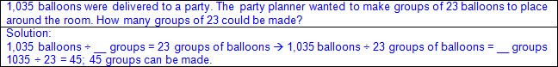  - Relationships between division and multiples of 10  - When the value of the dividend increases by a multiple of 10 and the value of the divisor remains the same, then the value of the quotient is multiplied by the same multiple of 10.  - Ex:  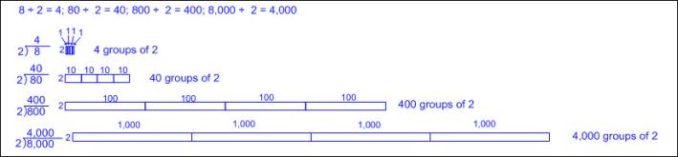  - When the value of the dividend remains the same and the value of the divisor is multiplied by a multiple of 10, then the value of the quotient is divided by the same multiple of 10.  - Ex:  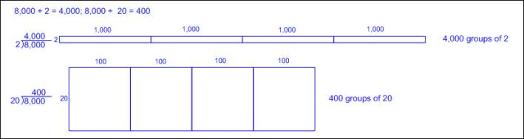  - When the value of both the dividend and the divisor are multiplied by the same multiple of 10, the quotient remains the same.  - Ex:  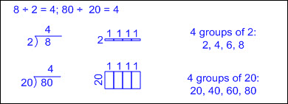  - Decomposing division problems into partial quotients  - Ex:  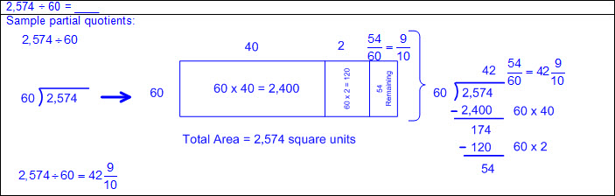  - Ratio tables  - Ex:  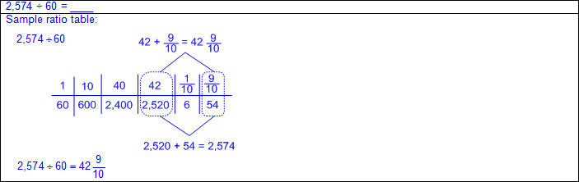  - Strip diagrams  - Strip diagram – a linear model used to illustrate number relationships  - Ex:  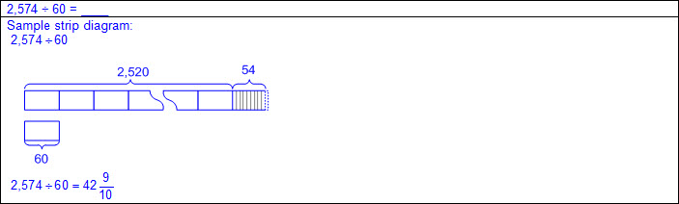  - Standard algorithm using the distributive method  - Record steps that relate to the algorithm used including distributing the value in the quotient according to place value.  - Ex:  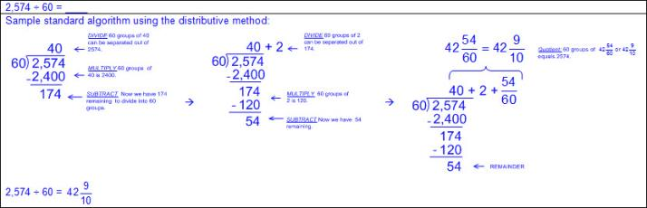  - Standard algorithm  - Ex:  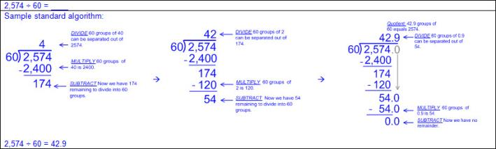  - Remainder dependent upon the mathematical and real-world problem situation  - Various ways to record remainder  - Ignore the remainder  - Ex:  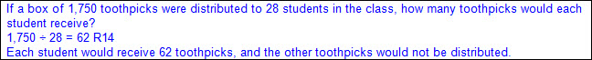  - Add one to the quotient  - Ex:  - Remainder is written as a fraction or decimal  - Ex:  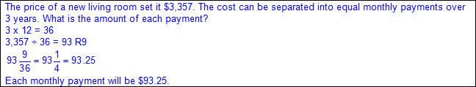  - Remainder is the answer  - Ex:  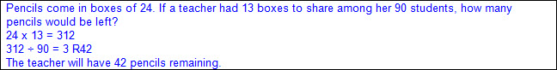  - Conversion of remainder into smaller units  - Ex:  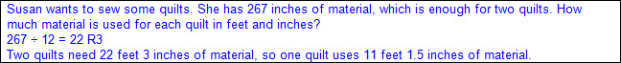  - Equation(s) to reflect solution process  Note(s):  - Grade Level(s):  - Grade 4 represented the quotient of up to a four-digit whole number divided by a one-digit whole number using arrays, area models, or equations.  - Grade 4 used strategies, including the standard algorithm, to divide a four-digit whole number dividend by a one-digit whole number divisor.  - Grade 4 solved with fluency one- and two-step problems involving multiplication and division, including interpreting remainders.  - Grade 6 will multiply and divide positive rational numbers fluently.  - Various mathematical process standards will be applied to this student expectation as appropriate.  - TxRCFP:  - Developing an understanding of and fluency with addition, subtraction, multiplication, and division of fractions and decimals  - TxCCRS:  - I. Numeric Reasoning  - VIII. Problem Solving and Reasoning  - IX. Communication and Representation
5.3D | Represent multiplication of decimals with products to the hundredths using objects and pictorial models, including area models.  Supporting Standard  Represent multiplication of decimals with products to the hundredths using objects and pictorial models, including area models.  Supporting Standard  Represent  MULTIPLICATION OF DECIMALS WITH PRODUCTS TO THE HUNDREDTHS USING OBJECTS AND PICTORIAL MODELS, INCLUDING AREA MODELS  Including, but not limited to:  - Decimals (less than and greater than one to the tenths, hundredths, and thousandths)  - Decimal number – a number in the base-10 place value system used to represent a quantity that may include part of a whole and is recorded with a decimal point separating the whole from the part  - Multiplication  - Product – the total when two or more factors are multiplied  - Factor – a number multiplied by another number to find a product  - Products of decimals limited to three-digit factors by two-digit factors with products to the hundredths  - Multiply tenths by tenths (e.g., 0.3 x 0.7 = 0.21, 1.2 x 1.2 = 1.44, 14.3 x 1.3 = 18.59, etc.)  - Multiply tenths by hundredths or vice versa (e.g., 0.5 x 0.12 = 0.06, 1.4 x 0.15 = 0.21, 21.4 x 0.45 = 9.63, etc.)  - Multiply tenths by thousandths or vice versa (e.g., 0.4 x 0.125 = 0.05, 0.125 x 8.4 = 1.05, etc.)  - Multiply whole numbers by tenths, hundredths, and thousandths or vice versa (e.g., 3 x 1.3 = 3.9, 42 x 7.45 = 312.9, 7.02 x 78 = 547.56, 6 x 0.125 = 0.75, etc.)  - Multiplying by a lesser factor results in lesser products.  - Ex:  - Connections between whole number multiplication and decimal multiplication  - Ex:  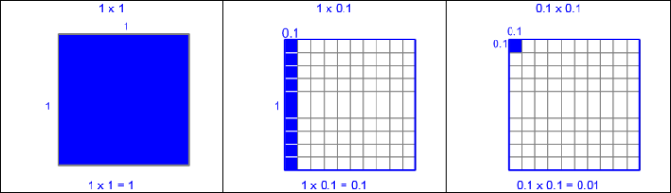  - Ex:  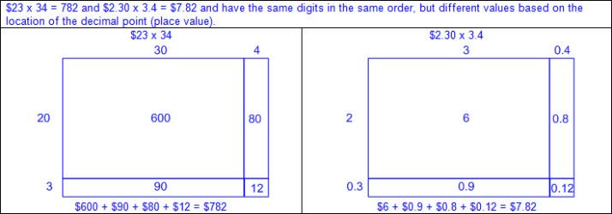  - Base-10 place value system  - A number system using ten digits 0 – 9  - Relationships between places are based on multiples of 10.  - Moving left across the places, the values are 10 times the position to the right.  - Moving right across the places, the values are one-tenth the value of the place to the left.  - Place value relationships to determine products  - Ex:  - Objects and pictorial models  - Area models  - Ex:  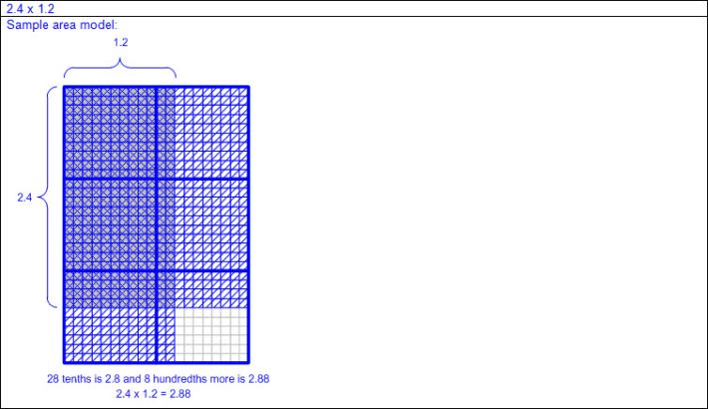  - Ex:  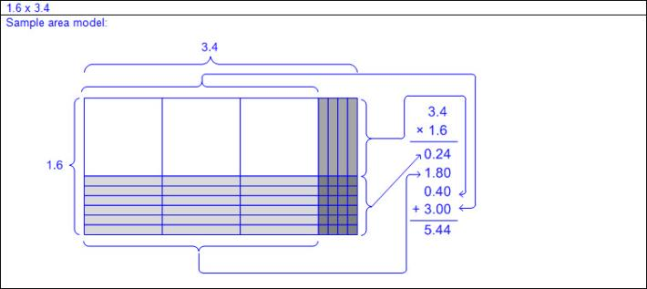  - Decimal grids  - Ex:  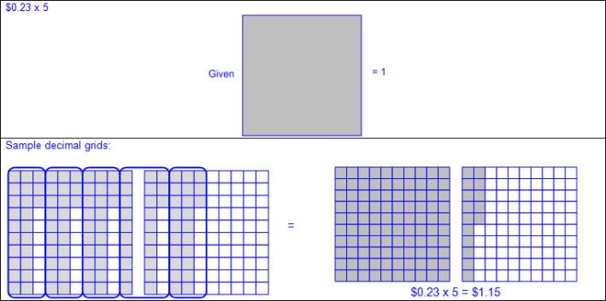  - Number lines  - Ex:  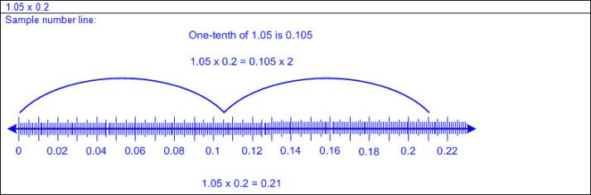  - Ratio tables  - Ex:  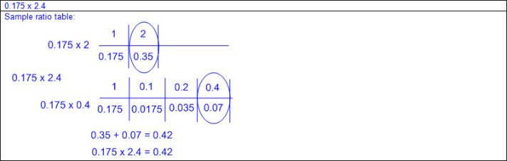  Note(s):  - Grade Level(s):  - Grade 5 introduces representing multiplication of decimals with products to the hundredths using objects and pictorial models, including area models.  - Grade 6 will multiply and divide positive rational numbers fluently.  - Various mathematical process standards will be applied to this student expectation as appropriate.  - TxRCFP:  - Developing an understanding of and fluency with addition, subtraction, multiplication, and division of fractions and decimals  - TxCCRS:  - I. Numeric Reasoning  - IX. Communication and Representation
5.3E | Solve for products of decimals to the hundredths, including situations involving money, using strategies based on place-value understandings, properties of operations, and the relationship to the multiplication of whole numbers.  Readiness Standard  Solve for products of decimals to the hundredths, including situations involving money, using strategies based on place-value understandings, properties of operations, and the relationship to the multiplication of whole numbers.  Readiness Standard  Solve  FOR PRODUCTS OF DECIMALS TO THE HUNDREDTHS, INCLUDING SITUATIONS INVOLVING MONEY, USING STRATEGIES BASED ON PLACE-VALUE UNDERSTANDINGS, PROPERTIES OF OPERATIONS, AND THE RELATIONSHIP TO THE MULTIPLICATION OF WHOLE NUMBERS  Including, but not limited to:  - Decimals (less than and greater than one to the tenths, hundredths, and thousandths)  - Decimal number – a number in the base-10 place value system used to represent a quantity that may include part of a whole and is recorded with a decimal point separating the whole from the part  - Multiplication  - Product – the total when two or more factors are multiplied  - Factor – a number multiplied by another number to find a product  - Products of decimals limited to three-digit factors by two-digit factors with products to the hundredths  - Multiply tenths by tenths (e.g., 0.3 x 0.7 = 0.21, 1.2 x 1.2 = 1.44, 14.3 x 1.3 = 18.59, etc.)  - Multiply tenths by hundredths or vice versa (e.g., 0.5 x 0.12 = 0.06, 1.4 x 0.15 = 0.21, 21.4 x 0.45 = 9.63, etc.)  - Multiply tenths by thousandths or vice versa (e.g., 0.4 x 0.125 = 0.05, 0.125 x 8.4 = 1.05, etc.)  - Multiply whole numbers by tenths, hundredths, and thousandths or vice versa (e.g., 3 x 1.3 = 3.9, 42 x 7.45 = 312.9, 7.02 x 78 = 547.56, 6 x 0.125 = 0.75, etc.)  - Multiplying by a lesser factor results in lesser products.  - Ex:  - Connections between whole number multiplication and decimal multiplication  - Ex:  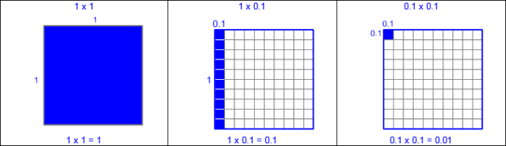  - Ex:  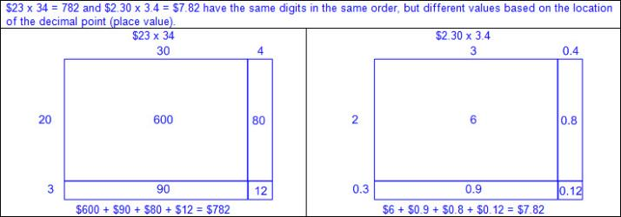  - Base-10 place value system  - A number system using ten digits 0 – 9  - Relationships between places are based on multiples of 10.  - Moving left across the places, the values are 10 times the position to the right.  - Moving right across the places, the values are one-tenth the value of the place to the left.  - Place value relationships to determine products  - Ex:  - Properties of operations  - Commutative property of multiplication – if the order of the factors are changed, the product will remain the same  - a x b = c; therefore, b x a = c  - Ex: 2.5 x 1.1 = 2.75 and 1.1 x 2.5 = 2.75  Therefore, 2.5 x 1.1 = 1.1 x 2.5  - Associative property of multiplication – if three or more factors are multiplied, they can be grouped in any order, and the product will remain the same  - a x b x c = (a × b) × c = a × (b × c)  - Ex: 2.5 x 1.1 x 3  (2.5 x 1.1) x 3 = 2.75 x 3 = 8.25 or 2.5 x (1.1 x 3) = 2.5 x 3.3 = 8.25  Therefore, 2.5 x 1.1 x 3 = (2.5 x 1.1) x 3 = 2.5 x (1.1 x 3)  - Distributive property of multiplication – if multiplying a number by a sum of numbers, the product will be the same as multiplying the number by each addend and then adding the products together  - a x (b + c) = (a x b) + (a x c)  - Ex: 2.5 x 1.1 = 2.5 x (1.0 + 0.1) = (2.5 x 1.0) + (2.5 x 0.1) = 2.5 + 0.25 = 2.75  - Ex: 2.7 x 2.5 = (2.5 + 0.2) x 2.5 = (2.5 x 2.5) + (0.2 x 2.5) = 6.25 + 0.50 = 6.75  - Strategies for multiplication  - Distributive property for partial products  - Ex:  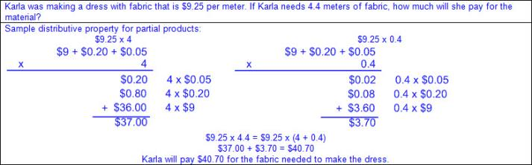  - Doubling and halving  - Ex:  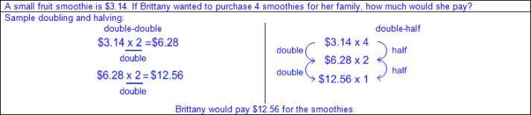  - Relate multiplication (associative property) to numerical notation  - Ex:  - Ratio tables  - Ex:  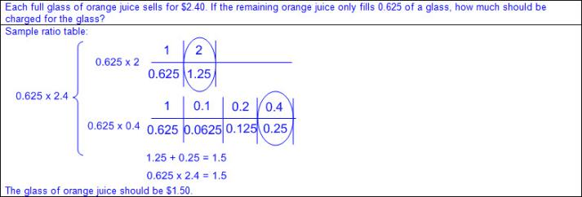  - Equation(s) to reflect solution process  Note(s):  - Grade Level(s):  - Grade 5 introduces solving for products of decimals to the hundredths, including situations involving money, using strategies based on place-value understandings, properties of operations, and the relationship to the multiplication of whole numbers.  - Grade 6 will multiply and divide positive rational numbers fluently.  - Various mathematical process standards will be applied to this student expectation as appropriate.  - TxRCFP:  - Developing an understanding of and fluency with addition, subtraction, multiplication, and division of fractions and decimals  - TxCCRS:  - I. Numeric Reasoning  - VIII. Problem Solving and Reasoning  - IX. Communication and Representation  - X. Connections
5.3F | Represent quotients of decimals to the hundredths, up to four-digit dividends and two-digit whole number divisors, using objects and pictorial models, including area models.  Supporting Standard  Represent quotients of decimals to the hundredths, up to four-digit dividends and two-digit whole number divisors, using objects and pictorial models, including area models.  Supporting Standard  Represent  QUOTIENTS OF DECIMALS TO THE HUNDREDTHS, UP TO FOUR-DIGIT DIVIDENDS AND TWO-DIGIT WHOLE NUMBER DIVISORS, USING OBJECTS AND PICTORIAL MODELS, INCLUDING AREA MODELS  Including, but not limited to:  - Whole numbers  - Counting (natural) numbers – the set of positive numbers that begins at one and increases by increments of one each time {1, 2, 3, ..., n}  - Whole numbers – the set of counting (natural) numbers and zero {0, 1, 2, 3, ..., n}  - Decimals (less than and greater than one to the tenths and hundredths)  - Decimal number – a number in the base-10 place value system used to represent a quantity that may include part of a whole and is recorded with a decimal point separating the whole from the part  - Division  - Quotient – the size or measure of each group or the number of groups when the dividend is divided by the divisor  - Dividend – the number that is being divided  - Divisor – the number the dividend is being divided by  - Quotients of decimals limited to four-digit dividends and two-digit whole number divisors, with quotients to the hundredths  - Dividend to the tenths and whole number divisor (e.g., 1.2 ÷ 24 = 0.05, 358.8 ÷ 23 = 15.6, 721.7 ÷ 14 = 51.55, etc.)  - Dividend to the hundredths and whole number divisor (e.g., 8.68 ÷ 4 = 2.17, 8.25 ÷ 15 = 0.55, 62.76 ÷ 12 = 5.23, etc.)  - Whole number dividends and whole number divisors (e.g., 3 ÷ 4 = 0.75, 10 ÷ 8 = 1.25, 1000 ÷ 16 = 62.5, etc.)  - Relationships between multiplication and division to help in solution process  - a ÷ b = c, so b x c = a  - Ex: 62.76 ÷ 12 = 5.23, so 12 x 5.23 = 62.76  - Connections between division of whole numbers and division with decimals  - Decimal quotients will have the same digits as whole number quotients when the number of digits in the dividend and number of digits in the divisor of both the decimal problem and whole number problem are the same.  - Ex: 8.25 ÷ 15 = 0.55 and 825 ÷ 15 = 55 have the same digits in the same order, but different values based on the location of the decimal point (place value).  - Base-10 place value system  - A number system using ten digits 0 – 9  - Relationships between places are based on multiples of 10.  - Moving left across the places, the values are 10 times the position to the right.  - Moving right across the places, the values are one-tenth the value of the place to the left.  - Place value relationships to determine quotients  - Ex:  - Objects and pictorial models  - Base-10 blocks  - Ex:  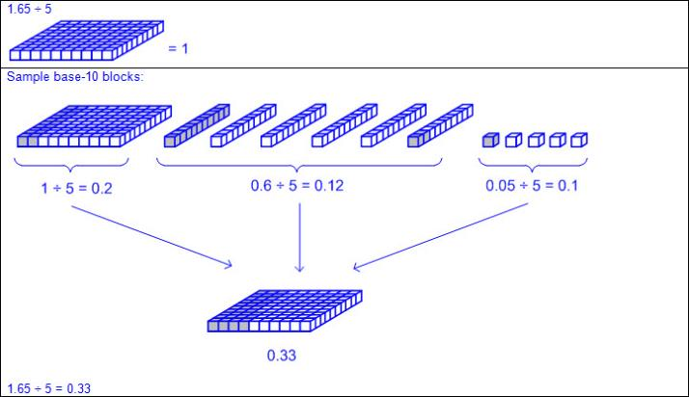  - Area models  - Ex:  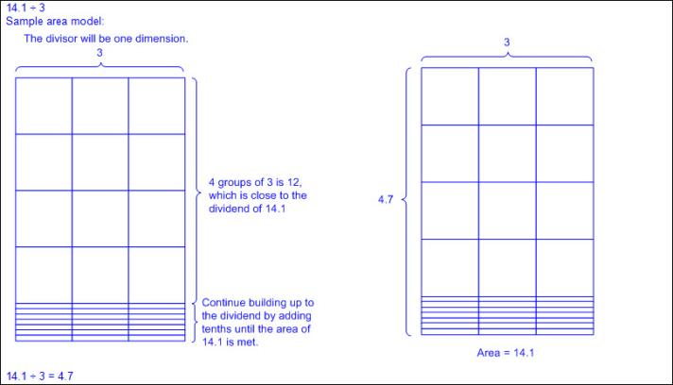  - Decimal grids  - Ex:  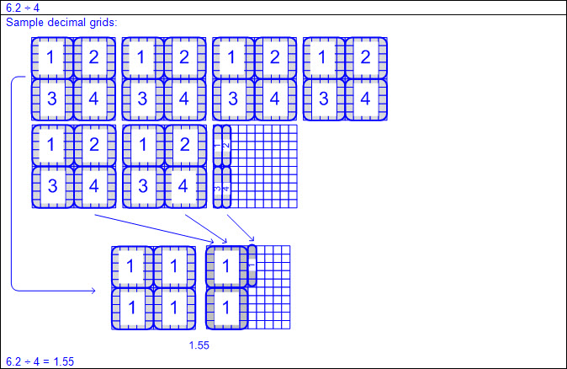  - Ex:  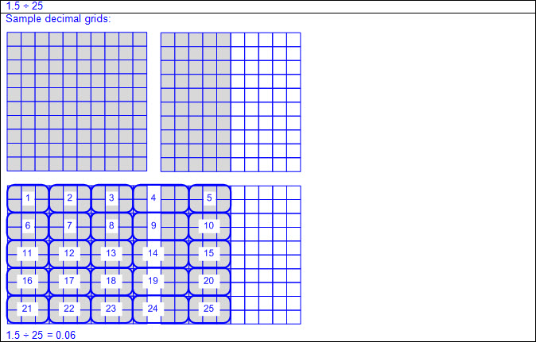  - Number lines  - Ex:  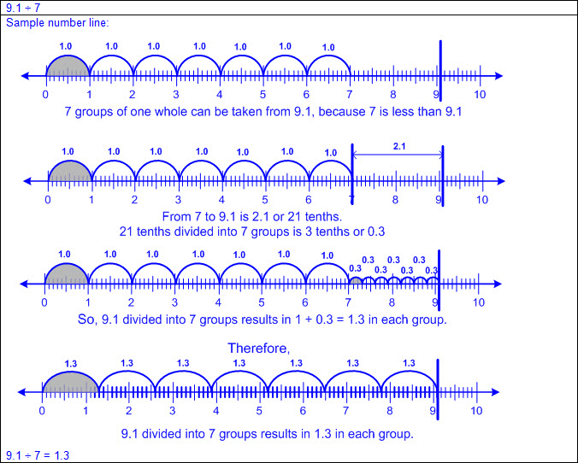  - Ratio tables  - Ex:  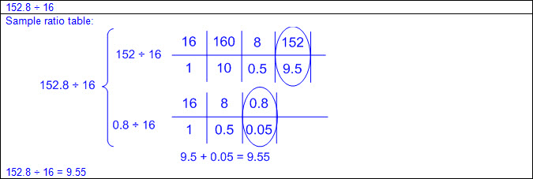  - Equation(s) to reflect solution process  Note(s):  - Grade Level(s):  - Grade 5 introduces representing quotients of decimals to the hundredths, up to four-digit dividends and two-digit whole number divisors, using objects and pictorial models, including area models.  - Grade 6 will multiply and divide positive rational numbers fluently.  - Various mathematical process standards will be applied to this student expectation as appropriate.  - TxRCFP:  - Developing an understanding of and fluency with addition, subtraction, multiplication, and division of fractions and decimals  - TxCCRS:  - I. Numeric Reasoning  - IX. Communication and Representation
5.3G | Solve for quotients of decimals to the hundredths, up to four-digit dividends and two-digit whole number divisors, using strategies and algorithms, including the standard algorithm.  Readiness Standard  Solve for quotients of decimals to the hundredths, up to four-digit dividends and two-digit whole number divisors, using strategies and algorithms, including the standard algorithm.  Readiness Standard  Solve  FOR QUOTIENTS OF DECIMALS TO THE HUNDREDTHS, UP TO FOUR-DIGIT DIVIDENDS AND TWO-DIGIT WHOLE NUMBER DIVISORS, USING STRATEGIES AND ALGORITHMS, INCLUDING THE STANDARD ALGORITHM  Including, but not limited to:  - Whole numbers  - Counting (natural) numbers – the set of positive numbers that begins at one and increases by increments of one each time {1, 2, 3, ..., n}  - Whole numbers – the set of counting (natural) numbers and zero {0, 1, 2, 3, ..., n}  - Decimals (less than and greater than one to the tenths and hundredths)  - Decimal number – a number in the base-10 place value system used to represent a quantity that may include part of a whole and is recorded with a decimal point separating the whole from the part  - Division  - Quotient – the size or measure of each group or the number of groups when the dividend is divided by the divisor  - Dividend – the number that is being divided  - Divisor – the number the dividend is being divided by  - Quotients of decimals limited to four-digit dividends and two-digit whole number divisors, with quotients to the hundredths  - Dividend to the tenths and whole number divisor (e.g., 1.2 ÷ 24 = 0.05, 358.8 ÷ 23 = 15.6, 721.7 ÷ 14 = 51.55, etc.)  - Dividend to the hundredths and whole number divisor (e.g., 8.68 ÷ 4 = 2.17, 8.25 ÷ 15 = 0.55, 62.76 ÷ 12 = 5.23, etc.)  - Whole number dividends and whole number divisors (e.g., 3 ÷ 4 = 0.75, 10 ÷ 8 = 1.25, 1000 ÷ 16 = 62.5, etc.)  - Relationships between multiplication and division to help in solution process  - a ÷ b = c, so b x c = a  - Ex: 62.76 ÷ 12 = 5.23, so 12 x 5.23 = 62.76  - Connections between division of whole numbers and division with decimals  - Decimal quotients will have the same digits as whole number quotients when the number of digits in the dividend and number of digits in the divisor of both the decimal problem and whole number problem are the same.  - Ex: 8.25 ÷ 15 = 0.55 and 825 ÷ 15 = 55 have the same digits in the same order, but different values based on the location of the decimal point (place value).  - Base-10 place value system  - A number system using ten digits 0 – 9  - Relationships between places are based on multiples of 10.  - Moving left across the places, the values are 10 times the position to the right.  - Moving right across the places, the values are one-tenth the value of the place to the left.  - Place value relationships to determine quotients  - Ex:  - Division structures  - Partitive division  - Total amount known  - Number of groups known  - Size or measure of each group unknown  - Ex:  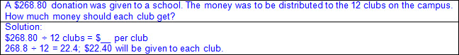  - Quotative division (also known as Measurement division)  - Total amount known  - Size or measure of each group known  - Number of groups unknown  - Ex:  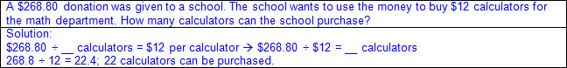  - Decomposing division problems into partial quotients  - Ex:  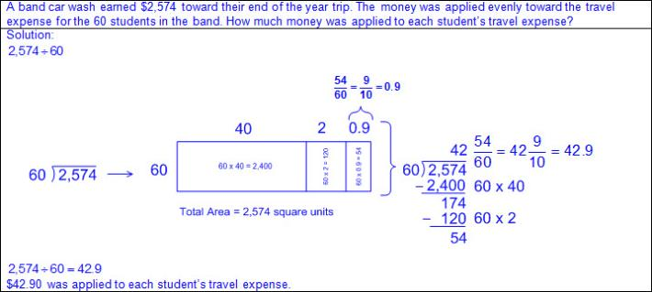  - Ex:  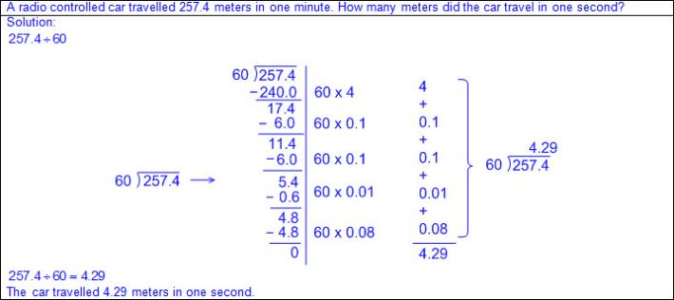  - Standard algorithm using the distributive method  - Record steps that relate to the algorithm used including distributing the value in the quotient according to place value.  - Ex:  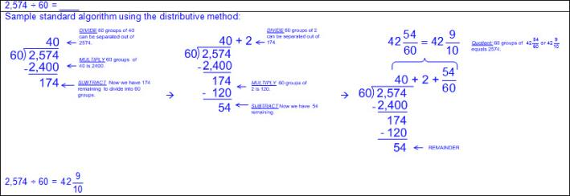  - Standard algorithm  - Ex:  - Remainder dependent upon the mathematical and real-world problem situation  - Various ways to record remainder  - Ignore the remainder  - Ex:  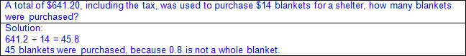  - Add one to the quotient  - Ex:  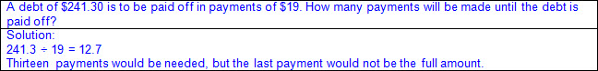  - Remainder is written as a decimal  - Ex:  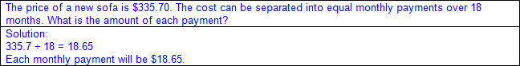  - Remainder is the answer  - Ex:  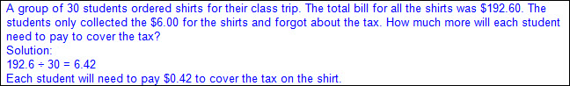  - Conversion of remainder into smaller units  - Ex:  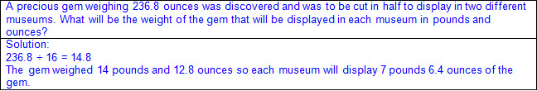  - Equation(s) to reflect solution process  Note(s):  - Grade Level(s):  - Grade 5 introduces solving for quotients of decimals to the hundredths, up to four-digit dividends and two-digit whole number divisors, using strategies and algorithms, including the standard algorithm.  - Grade 6 will multiply and divide decimals fluently.  - Various mathematical process standards will be applied to this student expectation as appropriate.  - TxRCFP:  - Developing an understanding of and fluency with addition, subtraction, multiplication, and division of fractions and decimals  - TxCCRS:  - I. Numeric Reasoning  - VIII. Problem Solving and Reasoning  - IX. Communication and Representation
5.3H | Represent and solve addition and subtraction of fractions with unequal denominators referring to the same whole using objects and pictorial models and properties of operations.  Supporting Standard  Represent and solve addition and subtraction of fractions with unequal denominators referring to the same whole using objects and pictorial models and properties of operations.  Supporting Standard  Represent, Solve  ADDITION AND SUBTRACTION OF FRACTIONS WITH UNEQUAL DENOMINATORS REFERRING TO THE SAME WHOLE USING OBJECTS AND PICTORIAL MODELS AND PROPERTIES OF OPERATIONS  Including, but not limited to:  - Fractions (proper, improper, or mixed numbers)  - Fraction – a number in the form where a and b are whole numbers and b is not equal to zero. A fraction can be used to name part of an object, part of a set of objects, to compare two quantities, or to represent division  - Proper fraction – a number in the form where a and b are whole numbers and a < b where b is not equal to zero  - Improper fraction – a number in the form where a and b are whole numbers and a > b where b is not equal to zero  - Mixed number – a number that is composed of a whole number and a fraction  - Addition  - Sums of fractions with equal or unequal denominators referring to the same whole  - Subtraction  - Differences of fractions with equal or unequal denominators referring to the same whole  - Fraction relationships  - Relationship between the whole and the part  - Numerator – the part of a fraction written above the fraction bar that tells the number of fractional parts specified or being considered  - Denominator – the part of a fraction written below the fraction bar that tells the total number of equal parts in a whole or set  - Referring to the same whole  - Fractions are relationships, and the size or the amount of the whole matters.  - Common whole is needed when adding or subtracting fractions  - Least common denominator (LCD) – the least common multiple of the denominators of two or more fractions  - Common denominator determined prior to adding or subtracting fractions  - Concrete objects and pictorial models  - Pattern blocks and other shapes (circles, squares, rectangles, etc.)  - Ex:  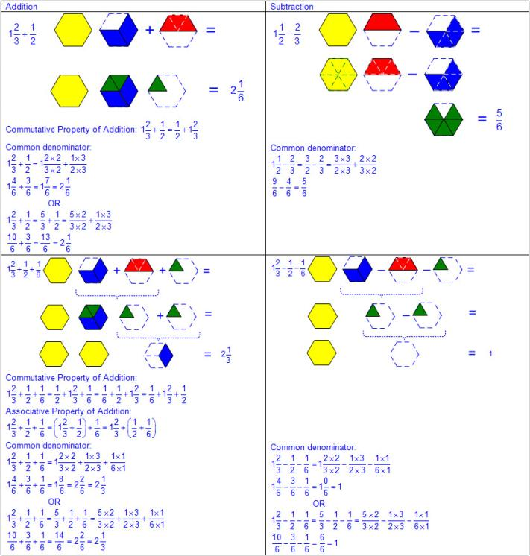  - Fraction strips and other strip models  - Ex:  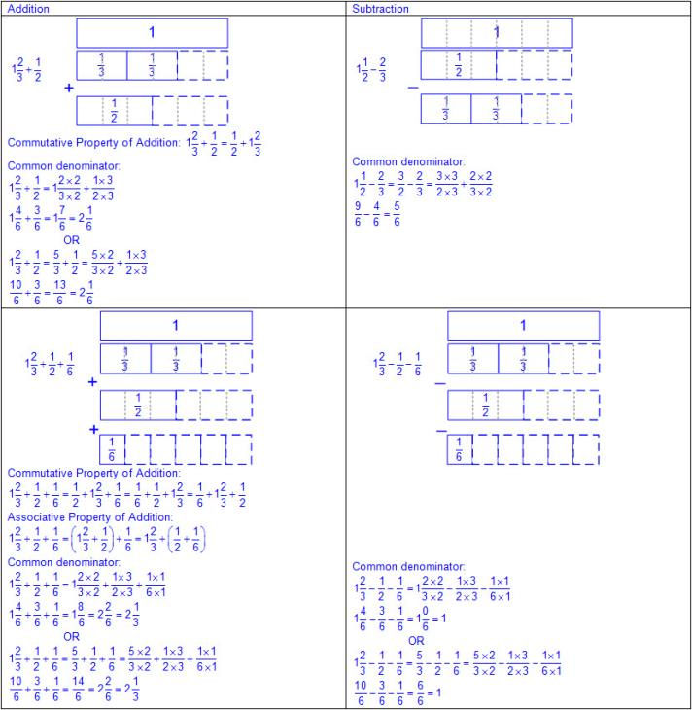  - Number lines  - Ex:  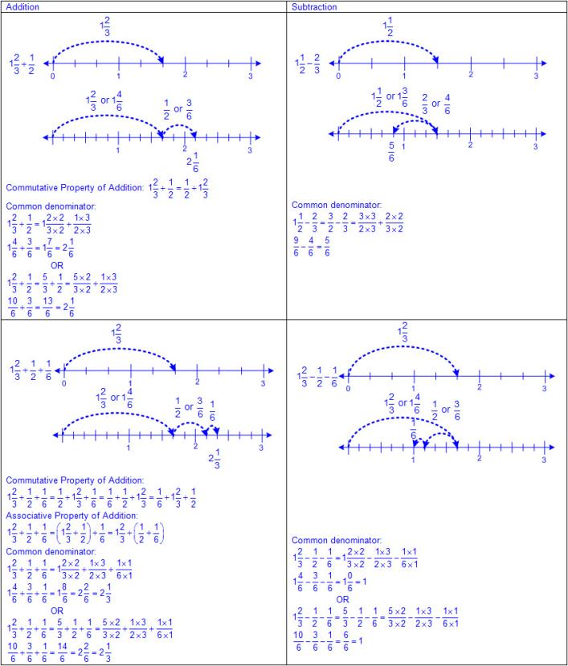  - Clocks  - Ex:  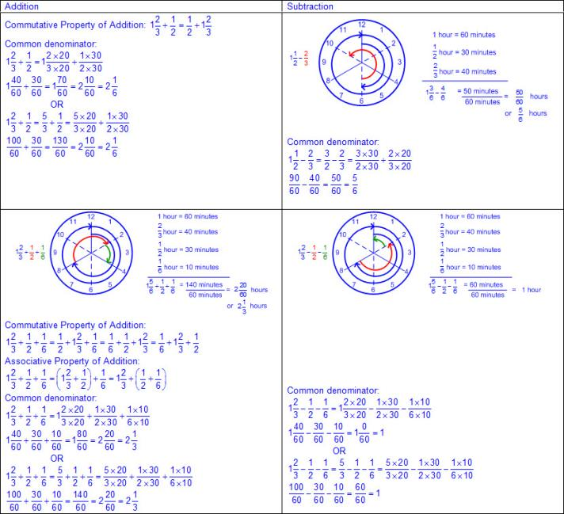  - Ratio tables  - Ex:  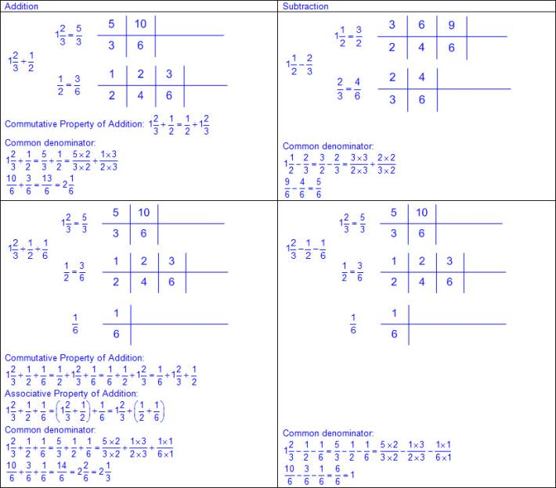  - Sets of objects  - Ex:  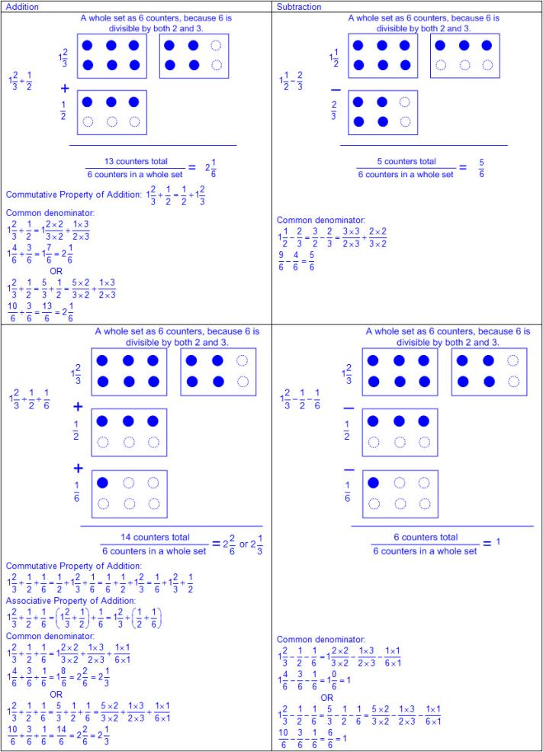  - Properties of operations  - Commutative property of addition – if the order of the addends are changed, the sum will remain the same  - a + b = c; therefore, b + a = c  - Ex: 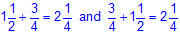  Therefore, 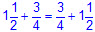  - Associative property of addition – if three or more addends are added, they can be grouped in any order, and the sum will remain the same  - a + b + c = (a + b) + c = a + (b + c)  - Ex: 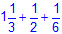  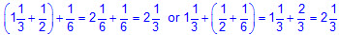  Therefore, 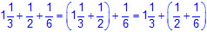  - Equation(s) to reflect solution process  Note(s):  - Grade Level(s):  - Grade 4 represented and solved addition and subtraction of fractions with equal denominators using objects and pictorial models that build to the number line and properties of operations.  - Grade 5 introduces representing and solving addition and subtraction of fractions with unequal denominators.  - Various mathematical process standards will be applied to this student expectation as appropriate.  - TxRCFP:  - Developing an understanding of and fluency with addition, subtraction, multiplication, and division of fractions and decimals  - TxCCRS:  - I. Numeric Reasoning  - IX. Communication and Representation
5.3I | Represent and solve multiplication of a whole number and a fraction that refers to the same whole using objects and pictorial models, including area models.  Supporting Standard  Represent and solve multiplication of a whole number and a fraction that refers to the same whole using objects and pictorial models, including area models.  Supporting Standard  Represent, Solve  MULTIPLICATION OF A WHOLE NUMBER AND A FRACTION THAT REFERS TO THE SAME WHOLE USING OBJECTS AND PICTORIAL MODELS, INCLUDING AREA MODELS  Including, but not limited to:  - Whole numbers  - Counting (natural) numbers – the set of positive numbers that begins at one and increases by increments of one each time {1, 2, 3, ..., n}  - Whole numbers – the set of counting (natural) numbers and zero {0, 1, 2, 3, ..., n}  - Fractions (proper, improper, or mixed numbers)  - Fraction – a number in the form where a and b are whole numbers and b is not equal to zero. A fraction can be used to name part of an object, part of a set of objects, to compare two quantities, or to represent division  - Proper fraction – a number in the form where a and b are whole numbers and a < b where b is not equal to zero  - Improper fraction – a number in the form where a and b are whole numbers and a > b where b is not equal to zero  - Mixed number – a number that is composed of a whole number and a fraction  - Multiplication  - Product – the total when two or more factors are multiplied  - Factor – a number multiplied by another number to find a product  - Products limited to a whole number and a fraction that refers to the same whole  - Fraction relationships  - Relationship between the whole and the part  - Numerator – the part of a fraction written above the fraction bar that tells the number of fractional parts specified or being considered  - Denominator – the part of a fraction written below the fraction bar that tells the total number of equal parts in a whole or set  - Referring to the same whole  - Fractions are relationships, and the size or the amount of the whole matters.  - Concrete objects and pictorial models  - Pattern blocks and other shapes  - Ex:  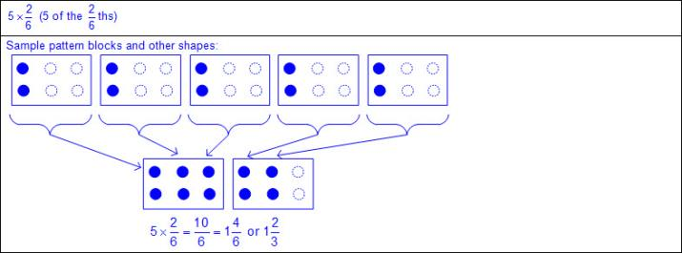  - Skip counting  - Ex:  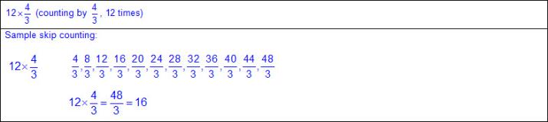  - Fraction bars  - Ex:  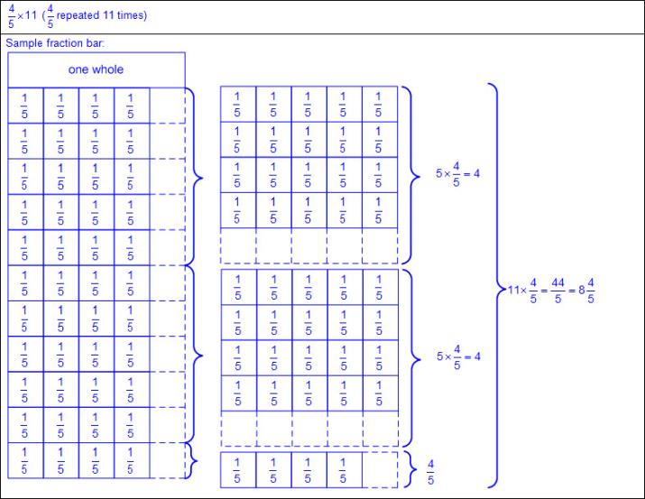  - Number lines  - Ex:  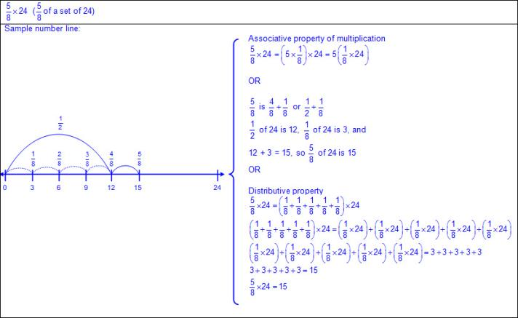  - Area models  - Ex:  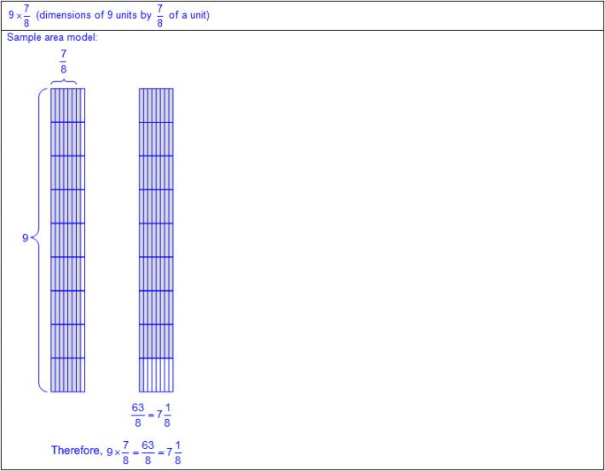  - Strip diagrams  - Strip diagram – a linear model used to illustrate number relationships  - Ex:  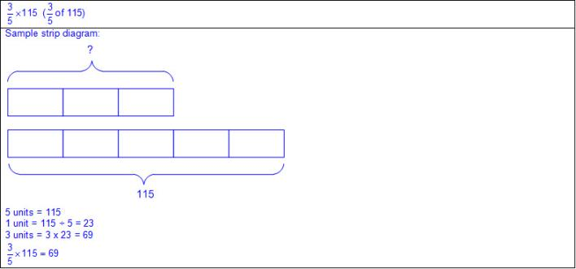  - Equation(s) to reflect solution process  Note(s):  - Grade Level(s):  - Grade 5 introduces representing and solving multiplication of a whole number and a fraction that refers to the same whole using objects and pictorial models, including area models.  - Grade 6 will multiply and divide positive rational numbers fluently.  - Various mathematical process standards will be applied to this student expectation as appropriate.  - TxRCFP:  - Developing an understanding of and fluency with addition, subtraction, multiplication, and division of fractions and decimals  - TxCCRS:  - I. Numeric Reasoning  - IX. Communication and Representation
5.3J | Represent division of a unit fraction by a whole number and the division of a whole number by a unit fraction such as 1/3 ÷ 7 and 7 ÷ 1/3 using objects and pictorial models, including area models.  Supporting Standard  Represent division of a unit fraction by a whole number and the division of a whole number by a unit fraction such as 1/3 ÷ 7 and 7 ÷ 1/3 using objects and pictorial models, including area models.  Supporting Standard  Represent  DIVISION OF A UNIT FRACTION BY A WHOLE NUMBER AND THE DIVISION OF A WHOLE NUMBER BY A UNIT FRACTION USING OBJECTS AND PICTORIAL MODELS, INCLUDING AREA MODELS  Including, but not limited to:  - Whole numbers  - Counting (natural) numbers – the set of positive numbers that begins at one and increases by increments of one each time {1, 2, 3, ..., n}  - Whole numbers – the set of counting (natural) numbers and zero {0, 1, 2, 3, ..., n}  - Fractions (unit fractions)  - Fraction – a number in the form where a and b are whole numbers and b is not equal to zero. A fraction can be used to name part of an object, part of a set of objects, to compare two quantities, or to represent division  - Unit fraction – a fraction in the form representing the quantity formed by one part of a whole that has been partitioned into b equal parts where b is a non-zero whole number  - Division  - Quotient – the size or measure of each group or the number of groups when the dividend is divided by the divisor  - Dividend – the number that is being divided  - Divisor – the number the dividend is being divided by  - Quotients limited to a unit fraction by whole number and a whole number by a unit fraction  - Fraction relationships  - Relationship between the whole and the part  - Numerator – the part of a fraction written above the fraction bar that tells the number of fractional parts specified or being considered  - Denominator – the part of a fraction written below the fraction bar that tells the total number of equal parts in a whole or set  - Referring to the same whole  - Fractions are relationships, and the size or the amount of the whole matters.  - Division structures  - Partitive division  - Total amount known  - Number of groups known  - Size or measure of each group unknown  - Ex:  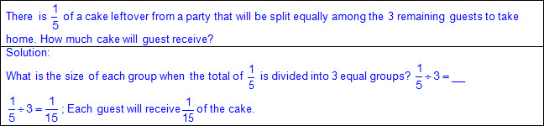  - Quotative division (also known as Measurement division)  - Total amount known  - Size or measure of each group known  - Number of groups unknown  - Ex:  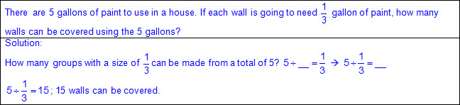  - Concrete objects and pictorial models  - Strip diagrams  - Strip diagram – a linear model used to illustrate number relationships  - Ex:  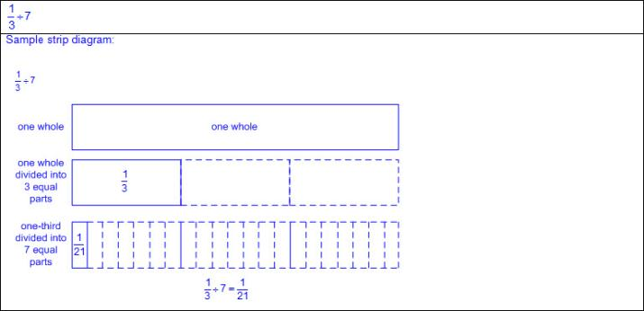  - Ex:  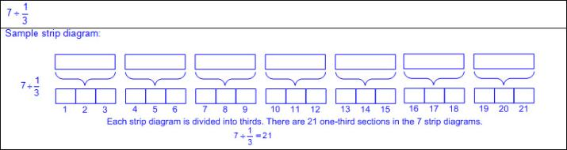  - Clocks  - Ex:  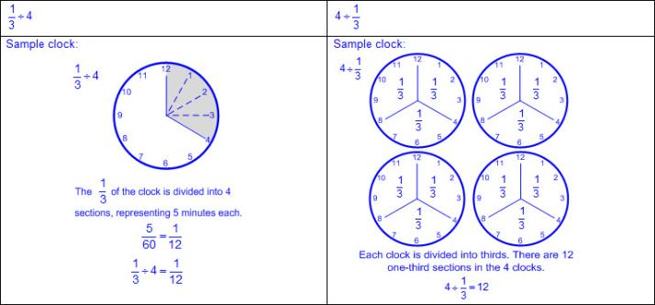  - Number lines  - Ex:  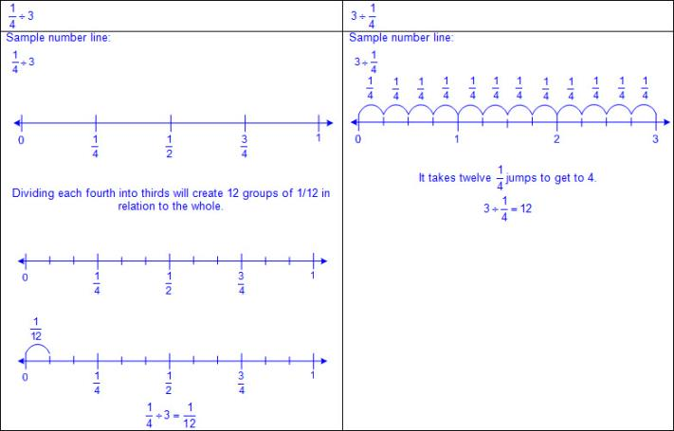  - Adapted area models (e.g., brownie pan method)  - Ex:  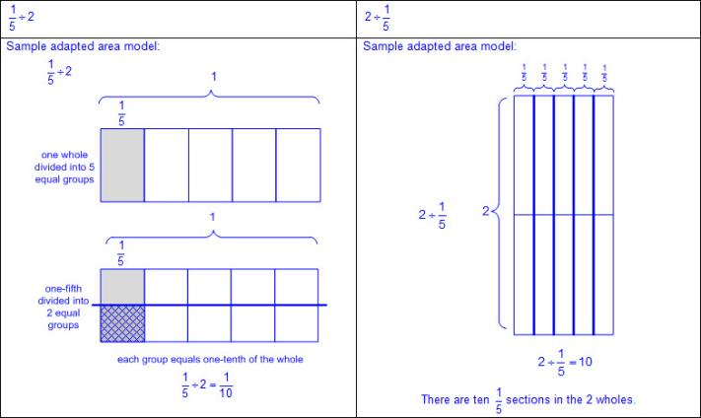  Note(s):  - Grade Level(s):  - Grade 5 introduces representing division of a unit fraction by a whole number and the division of a whole number by a unit fraction such as ÷ 7 and 7 ÷ using objects and pictorial models, including area models.  - Grade 6 will multiply and divide positive rational numbers fluently.  - Various mathematical process standards will be applied to this student expectation as appropriate.  - TxRCFP:  - Developing an understanding of and fluency with addition, subtraction, multiplication, and division of fractions and decimals  - TxCCRS:  - I. Numeric Reasoning  - IX. Communication and Representation
5.3K | Add and subtract positive rational numbers fluently.  Readiness Standard  Add and subtract positive rational numbers fluently.  Readiness Standard  Add, Subtract  POSITIVE RATIONAL NUMBERS FLUENTLY  Including, but not limited to:  - Whole numbers  - Counting (natural) numbers – the set of positive numbers that begins at one and increases by increments of one each time {1, 2, 3, ..., n}  - Whole numbers – the set of counting (natural) numbers and zero {0, 1, 2, 3, ..., n}  - Decimals (less than and greater than one to the tenths, hundredths, and thousandths)  - Decimal number – a number in the base-10 place value system used to represent a quantity that may include part of a whole and is recorded with a decimal point separating the whole from the part  - Fractions (proper, improper, or mixed numbers with equal or unequal denominators)  - Fraction – a number in the form where a and b are whole numbers and b is not equal to zero. A fraction can be used to name part of an object, part of a set of objects, to compare two quantities, or to represent division.  - Proper fraction – a number in the form where a and b are whole numbers and a < b where b is not equal to zero  - Improper fraction – a number in the form where a and b are whole numbers and a > b where b is not equal to zero  - Mixed number – a number that is composed of a whole number and a fraction  - Unit fraction – a fraction in the form representing the quantity formed by one part of a whole that has been partitioned into b equal parts where b is a non-zero whole number  - Positive rational numbers – the set of numbers that can be expressed as a fraction , where a and b are whole numbers, and b ≠ 0 which includes the subset of whole numbers and counting (natural) numbers (e.g., 0, 2, 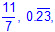 etc.)  - Fluency – efficient application of procedures with accuracy  - Addition  - Sums of whole numbers  - Sums of decimals up to the thousandths  - Sums of fractions with equal and unequal denominators  - Subtraction  - Differences of whole numbers  - Differences of decimals with values limited to the thousandths  - Differences of fractions with equal and unequal denominators  - Least common denominator (LCD) – the least common multiple of the denominators of two or more fractions  - Common denominator determined prior to adding or subtracting fractions  - Recognition of addition or subtraction in mathematical and real-world problem situations  - Ex:  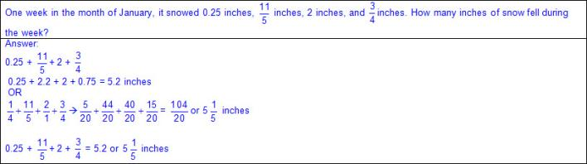  - Ex:  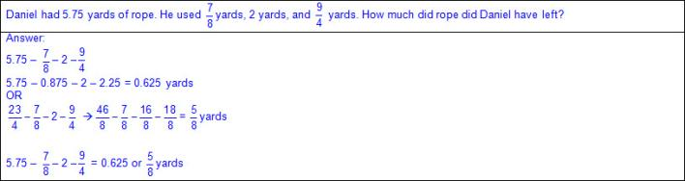  - Addition and subtraction with various forms of numbers  - Ex:  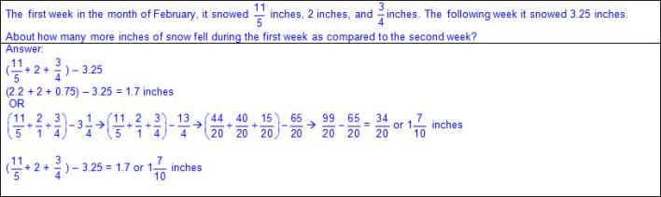  Note(s):  - Grade Level(s):  - Grade 4 evaluated the reasonableness of sums and differences of fractions using benchmark fractions 0, 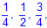 and 1 referring to the same whole.  - Various mathematical process standards will be applied to this student expectation as appropriate.  - TxRCFP:  - Developing an understanding of and fluency with addition, subtraction, multiplication, and division of fractions and decimals  - TxCCRS:  - I. Numeric Reasoning  - X. Communication and Representation
5.3L | Divide whole numbers by unit fractions and unit fractions by whole numbers.  Readiness Standard  Divide whole numbers by unit fractions and unit fractions by whole numbers.  Readiness Standard  Divide  WHOLE NUMBERS BY UNIT FRACTIONS AND UNIT FRACTIONS BY WHOLE NUMBERS  Including, but not limited to:  - Whole numbers  - Counting (natural) numbers – the set of positive numbers that begins at one and increases by increments of one each time {1, 2, 3, ..., n}  - Whole numbers – the set of counting (natural) numbers and zero {0, 1, 2, 3, ..., n}  - Fractions (unit fractions)  - Fraction – a number in the form where a and b are whole numbers and b is not equal to zero. A fraction can be used to name part of an object, part of a set of objects, to compare two quantities, or to represent division.  - Unit fraction – a fraction in the form representing the quantity formed by one part of a whole that has been partitioned into b equal parts where b is a non-zero whole number  - Division  - Quotient – the size or measure of each group or the number of groups when the dividend is divided by the divisor  - Dividend – the number that is being divided  - Divisor – the number the dividend is being divided by  - Quotients of fractions where dividend and divisors are limited to whole numbers by unit fractions and unit fractions by whole numbers  - Fraction relationships  - Relationship between the whole and the part  - Numerator – the part of a fraction written above the fraction bar that tells the number of fractional parts specified or being considered  - Denominator – the part of a fraction written below the fraction bar that tells the total number of equal parts in a whole or set  - Referring to the same whole  - Fractions are relationships, and the size or the amount of the whole matters.  - Division structures  - Partitive division  - Total amount known  - Number of groups known  - Size or measure of each group unknown  - Ex:  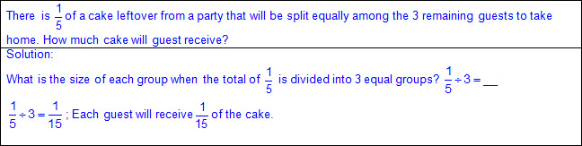  - Quotative division (also known as Measurement division)  - Total amount known  - Size or measure of each group known  - Number of groups unknown  - Ex:  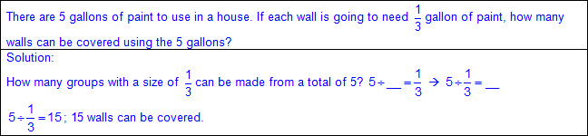  - Division strategies  - Partitive  - Ex:  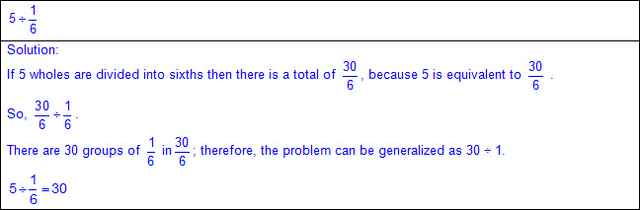  - Ratio tables  - Ex:  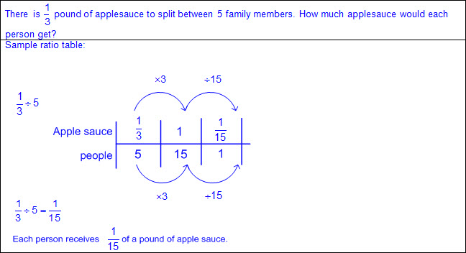  Note(s):  - Grade Level(s):  - Grade 5 introduces dividing whole numbers by unit fractions and unit fractions by whole numbers.  - Grade 6 will multiply and divide positive rational numbers fluently  - Various mathematical process standards will be applied to this student expectation as appropriate.  - TxRCFP:  - Developing an understanding of and fluency with addition, subtraction, multiplication, and division of fractions and decimals  - TxCCRS:  - I. Numeric Reasoning  - IX. Communication and Representation
5.4 | Algebraic reasoning. The student applies mathematical process standards to develop concepts of expressions and equations. The student is expected to:
5.4A | Identify prime and composite numbers.  Supporting Standard  Identify prime and composite numbers.  Supporting Standard  Identify  PRIME AND COMPOSITE NUMBERS  Including, but not limited to:  - Whole numbers  - Counting (natural) numbers – the set of positive numbers that begins at one and increases by increments of one each time {1, 2, 3, ..., n}  - Whole numbers – the set of counting (natural) numbers and zero {0, 1, 2, 3, ..., n}  - Prime number – a whole number with exactly two factors, 1 and the number itself  - Composite number – a whole number with more than two factors  - Special numbers  - 2 is the only even prime number.  - 1 is the only common factor in all of the factor pairs of prime numbers.  - Ex: (1, 3), (1, 2), (1, 13), etc.  - 1 is neither prime nor composite.  - 0 is neither prime nor composite.  - 0 cannot be expressed as a product of primes.  - 0 x 0 and/or 0 x any number yields an infinite number of factor pairs that have the product 0.  - Various representations to identify prime and composite numbers  - Arrays  - Ex: Tile arrangements  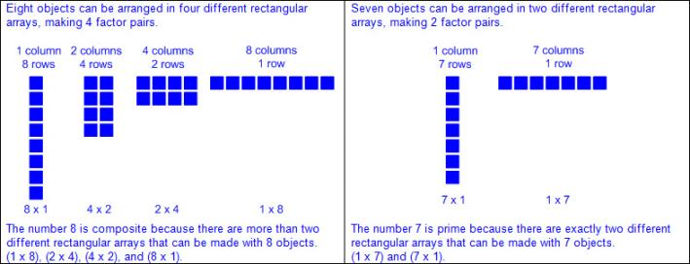  - Generalizations from arrays used to determine if a number is prime or composite  - Composite numbers have more than two different rectangular arrays that can be made.  - Prime numbers have exactly two different rectangular arrays that can be made.  - Organizational factor lists  - Ex: 35  - Ex: 13  - Generalizations from organizational factor lists used to determine if a number is prime or composite  - Composite numbers have more than two factors.  - Prime numbers have exactly two factors.  Note(s):  - Grade Level(s):  - Grade 5 introduces identifying prime and composite numbers.  - Various mathematical process standards will be applied to this student expectation as appropriate.  - TxRCFP:  - Grade Level Connections (reinforces previous learning and/or provides development for future learning)  - TxCCRS:  - IX. Communication and Representation
5.4B | Represent and solve multi-step problems involving the four operations with whole numbers using equations with a letter standing for the unknown quantity.  Readiness Standard  Represent and solve multi-step problems involving the four operations with whole numbers using equations with a letter standing for the unknown quantity.  Readiness Standard  Represent, Solve  MULTI-STEP PROBLEMS INVOLVING THE FOUR OPERATIONS WITH WHOLE NUMBERS USING EQUATIONS WITH A LETTER STANDING FOR THE UNKNOWN QUANTITY  Including, but not limited to:  - Whole numbers  - Counting (natural) numbers – the set of positive numbers that begins at one and increases by increments of one each time {1, 2, 3, ..., n}  - Whole numbers – the set of counting (natural) numbers and zero {0, 1, 2, 3, ..., n}  - Addition  - Sums of whole numbers  - Subtraction  - Differences of whole numbers  - Multiplication  - Product – the total when two or more factors are multiplied  - Factor – a number multiplied by another number to find a product  - Products of whole numbers up to three-digit factors by two-digit factors  - Division  - Quotient – the size or measure of each group or the number of groups when the dividend is divided by the divisor  - Dividend – the number that is being divided  - Divisor – the number the dividend is being divided by  - Whole numbers with quotients up to four-digit dividends and two-digit divisors  - Representations of an unknown quantity in an equation  - Equation – a mathematical statement composed of algebraic and/or numeric expressions set equal to each other  - Any single letter to represent the unknown quantity (e.g., 24 – 8 = y, etc.)  - Equal sign at beginning or end and unknown in any position  - Ex: g = 6 + 4; 6 + 4 = g  - Ex: x = 10 – 4; 10 – 4 = x  - Ex: 10 = x + 4; x + 4 = 10  - Ex: r = 6 x 4; 6 x 4 = r  - Ex: p = 24 ÷ 4; 24 ÷ 4 = p  - Ex: 24 = 6 • z; z • 6 = 24  - Recognition of addition, subtraction, multiplication, and/or division in mathematical and real-world problem situations  - Representation of problem situations with equations  - Relationship between quantities represented and problem situation  - Addition and subtraction problem structures  - Join problems  - Start unknown  - Ex:  - Change unknown  - Ex:  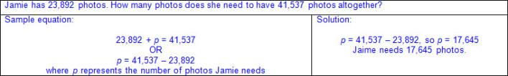  - Result unknown  - Ex:  - Separate problems  - Start unknown  - Ex:  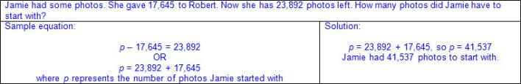  - Change unknown  - Ex:  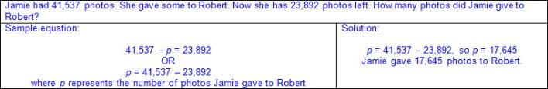  - Result unknown  - Ex:  - Part-part-whole problems  - Part unknown  - Ex:  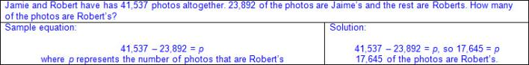  - Whole unknown  - Ex:  - Compare problems  - Difference unknown  - Ex:  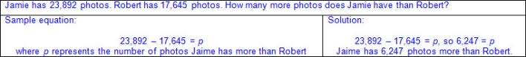  - Larger part unknown  - Ex:  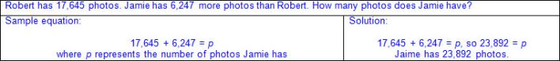  - Smaller part unknown  - Ex:  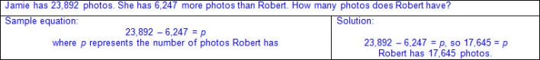  - Multiplicative structures  - Product unknown  - Ex:  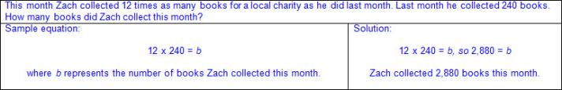  - Factor unknown  - Ex:  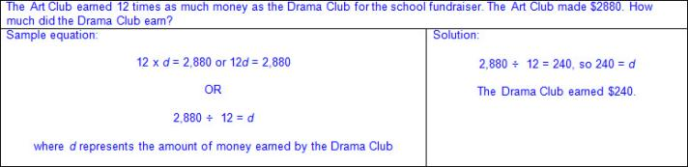  - Division structures  - Partitive division  - Total amount known  - Number of groups known  - Size or measure of each group unknown  - Ex:  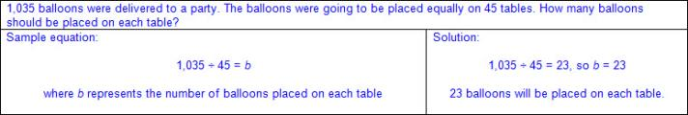  - Quotative division (also known as Measurement division)  - Total amount known  - Size or measure of each group known  - Number of groups unknown  - Ex:  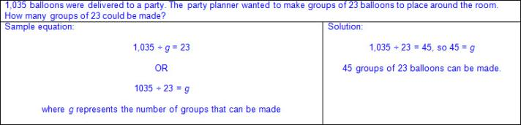  - Multi-step problem situations  - Ex:  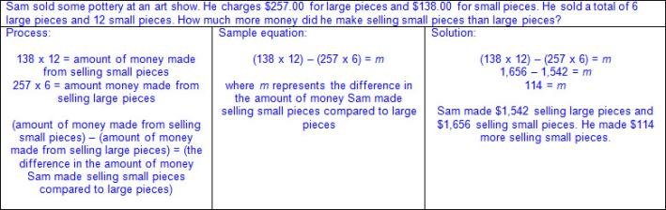  - Ex:  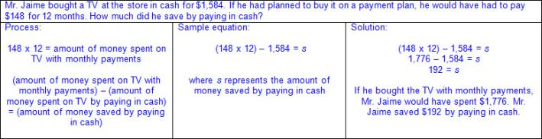  - Ex:  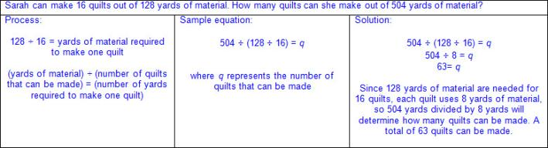  - Ex:  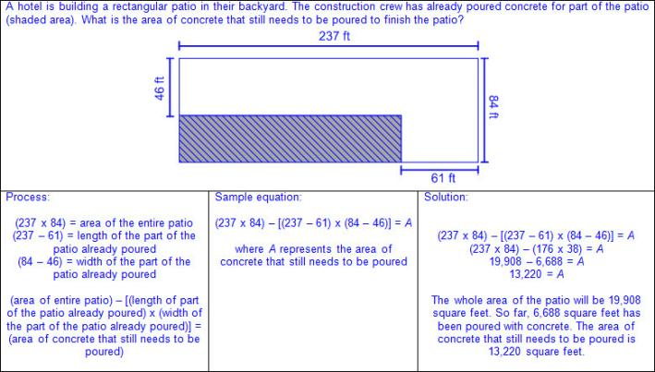  - Ex:  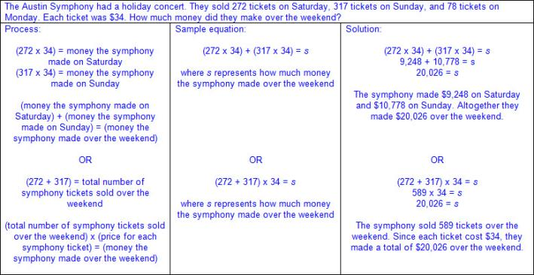  - Ex:  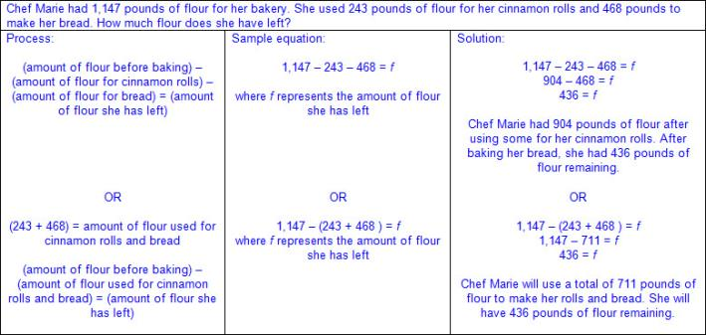  - Ex:  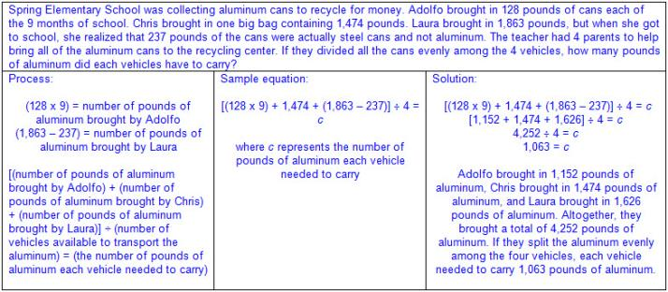  Note(s):  - Grade Level(s):  - Grade 4 represented multi-step problems involving the four operations with whole numbers, using strip diagrams and equations with a letter standing for the unknown quantity.  - Grade 6 will distinguish between expressions and equations verbally, numerically, and algebraically.  - Various mathematical process standards will be applied to this student expectation as appropriate.  - TxRCFP:  - Understanding and generating expressions and equations to solve problems  - TxCCRS:  - I. Numeric Reasoning  - VIII. Problem Solving and Reasoning  - IX. Communication and Representation
5.4C | Generate a numerical pattern when given a rule in the form y = ax or y = x + a and graph.  Readiness Standard  Generate a numerical pattern when given a rule in the form y = ax or y = x + a and graph.  Readiness Standard  Generate  A NUMERICAL PATTERN WHEN GIVEN A RULE IN THE FORM y = ax OR y = x + a AND GRAPH  Including, but not limited to:  - Whole numbers  - Counting (natural) numbers – the set of positive numbers that begins at one and increases by increments of one each time {1, 2, 3, ..., n}  - Whole numbers – the set of counting (natural) numbers and zero {0, 1, 2, 3, ..., n}  - Decimals (less than and greater than one to the tenths, hundredths, and thousandths)  - Decimal number – a number in the base-10 place value system used to represent a quantity that may include part of a whole and is recorded with a decimal point separating the whole from the part  - Fractions (proper, improper, or mixed numbers with equal or unequal denominators)  - Fraction – a number in the form where a and b are whole numbers and b is not equal to zero. A fraction can be used to name part of an object, part of a set of objects, to compare two quantities, or to represent division.  - Proper fraction – a number in the form where a and b are whole numbers and a < b where b is not equal to zero  - Improper fraction – a number in the form where a and b are whole numbers and a > b where b is not equal to zero  - Mixed number – a number that is composed of a whole number and a fraction  - Addition  - Sums of whole numbers  - Sums of decimals up to the thousandths  - Sums of fractions with equal and unequal denominators  - Multiplication  - Product – the total when two or more factors are multiplied  - Factor – a number multiplied by another number to find a product  - Products of whole numbers up to three-digit factors by two-digit factors  - Products of decimals limited to three-digit factors by two-digit factors with products to the hundredths  - Multiply tenths by tenths (e.g., 0.3 x 0.7 = 0.21, 1.2 x 1.2 = 1.44, 14.3 x 1.3 = 18.59, etc.)  - Multiply tenths by hundredths or vice versa (e.g., 0.5 x 0.12 = 0.06, 1.4 x 0.15 = 0.21, 21.4 x 0.45 = 9.63, etc.)  - Multiply tenths by thousandths or vice versa (e.g., 0.4 x 0.125 = 0.05, 0.125 x 8.4 = 1.05, etc.)  - Multiply whole numbers by tenths, hundredths, and thousandths or vice versa (e.g., 3 x 1.3 = 3.9, 42 x 7.45 = 312.9, 7.02 x 78 = 547.56, 6 x 0.125 = 0.75, etc.)  - Products of fractions where factors are limited to a fraction and a whole number  - Input-output table – a table which represents how the application of a rule on a value, input, results in a different value, output  - Relationship between input-output tables and numerical patterns  - Input represented as x  - Output represented as y  - Numerical patterns from rules  - Replace the input (x) with a set of numbers to generate an related output (y).  - Input values must be sequential.  - List of output values creates numerical pattern  - Multiplicative rule in the form y = ax  - Ex:  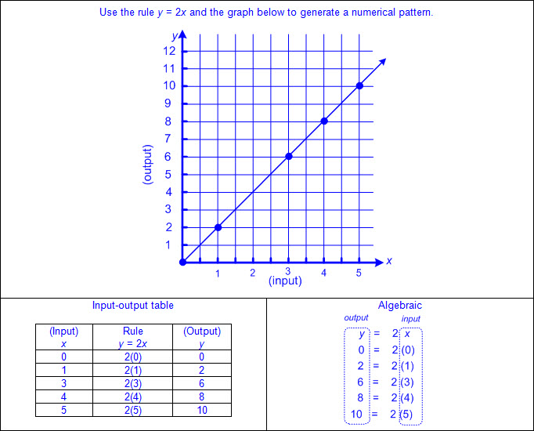  - Ex:  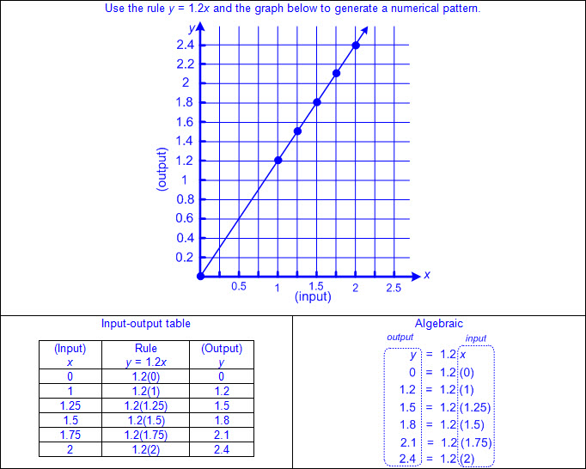  - Additive rule y = x + a  - Ex:  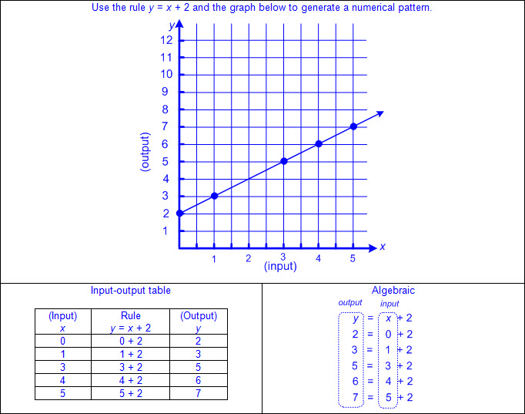  - Ex:  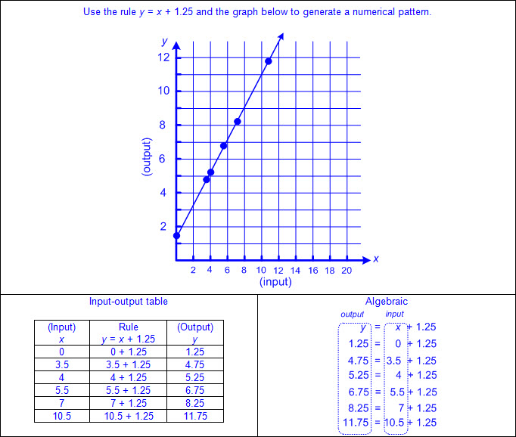  Graph  A NUMERICAL PATTERN WHEN GIVEN A RULE IN THE FORM y = ax OR y = x + a  Including, but not limited to:  - Whole numbers  - Counting (natural) numbers – the set of positive numbers that begins at one and increases by increments of one each time {1, 2, 3, ..., n}  - Whole numbers – the set of counting (natural) numbers and zero {0, 1, 2, 3, ..., n}  - Decimals (less than and greater than one to the tenths, hundredths, and thousandths)  - Decimal number – a number in the base-10 place value system used to represent a quantity that may include part of a whole and is recorded with a decimal point separating the whole from the part  - Fractions (proper, improper, or mixed numbers with equal or unequal denominators)  - Fraction – a number in the form where a and b are whole numbers and b is not equal to zero. A fraction can be used to name part of an object, part of a set of objects, to compare two quantities, or to represent division.  - Proper fraction – a number in the form where a and b are whole numbers and a < b where b is not equal to zero  - Improper fraction – a number in the form where a and b are whole numbers and a > b where b is not equal to zero  - Mixed number – a number that is composed of a whole number and a fraction  - Addition  - Sums of whole numbers  - Sums of decimals up to the thousandths  - Sums of fractions with equal and unequal denominators  - Multiplication  - Product – the total when two or more factors are multiplied  - Factor – a number multiplied by another number to find a product  - Products of whole numbers up to three-digit factors by two-digit factors  - Products of decimals limited to three-digit factors by two-digit factors with products to the hundredths  - Multiply tenths by tenths (e.g., 0.3 x 0.7 = 0.21, 1.2 x 1.2 = 1.44, 14.3 x 1.3 = 18.59, etc.)  - Multiply tenths by hundredths or vice versa (e.g., 0.5 x 0.12 = 0.06, 1.4 x 0.15 = 0.21, 21.4 x 0.45 = 9.63; etc.)  - Multiply tenths by thousandths or vice versa (e.g., 0.4 x 0.125 = 0.05, 0.125 x 8.4 = 1.05, etc.)  - Multiply whole numbers by tenths, hundredths, and thousandths or vice versa (e.g., 3 x 1.3 = 3.9, 42 x 7.45 = 312.9, 7.02 x 78 = 547.56, 6 x 0.125 = 0.75, etc.)  - Products of fractions where factors are limited to a fraction and a whole number  - Graphs of numerical patterns  - Limited to Quadrant I of the coordinate plane  - Horizontal axis represents an input (x)  - Vertical axis represents the related output (y)  - Ordered pairs written in the form (x, y) where x represents the input (x-coordinate) and y represents the output (y-coordinate)  - Ex:  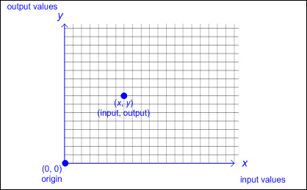  - Numerical patterns from the rule y = ax create a graph of points that lie in a straight line and pass through the origin (0,0).  - Numerical patterns from the rule y = x + a create a graph of points that lie in a straight line and do not pass through the origin (0,0).  - Generating a set of ordered pairs from a rule using an input-output table  - Substitute values of x in the rule as the input to produce a related value of y as the output to create an ordered pair (x,y), including when x = 0.  - Multiplicative rule in the form y = ax  - Ex:  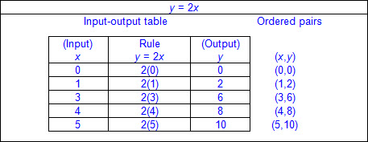  - Ex:  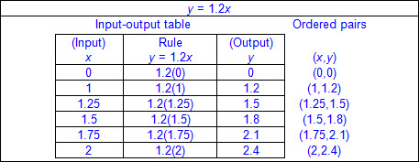  - Additive rule in the form y = x + a  - Ex:  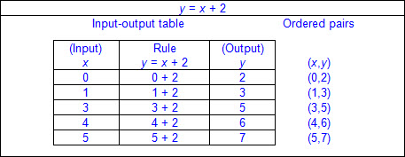  - Ex:  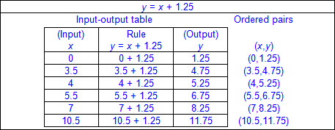  - Process for graphing ordered pairs of numbers in the first quadrant  - To locate the x-coordinate, begin at the origin and move to the right along the x-axis the appropriate number of units according to the x-coordinate in the ordered pair.  - To locate the y-coordinate, begin at the origin and move up along the y-axis the appropriate number of units according to the y-coordinate in the ordered pair.  - The point of intersection of both the parallel movements on the x-axis and the y-axis is the location of the ordered pair.  - Graphing ordered pairs from a numerical rule on a coordinate plane  - Multiplicative rule in the form y = ax  - Ex:  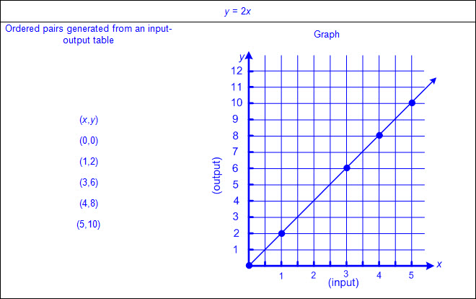  - Ex:  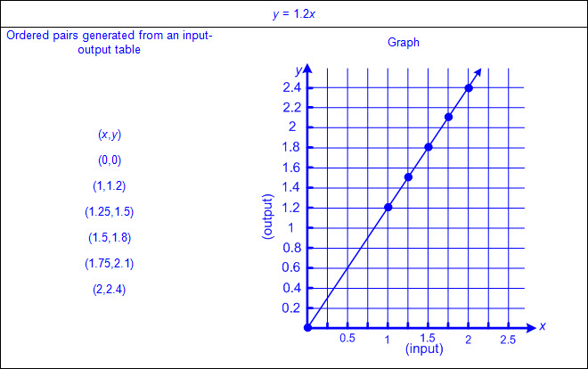  - Additive rule in the form y = x + a  - Ex:  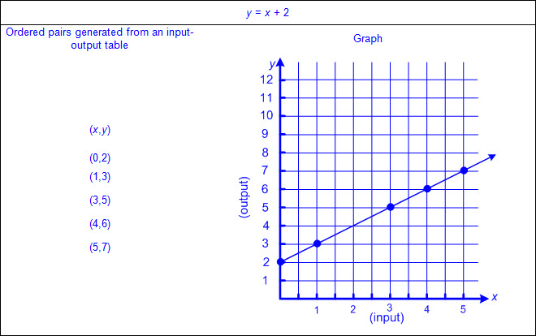  - Ex:  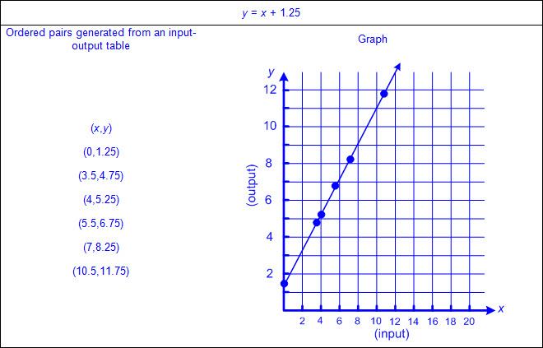  Note(s):  - Grade Level(s):  - Grade 4 represented problems using an input-output table and numerical expressions to generate a number pattern that follows a given rule representing the relationship of the values in the resulting sequence and their position in the sequence.  - Grade 6 will compare the two rules verbally, numerically, graphically, symbolically in the form y = ax or y = a +x in order to differentiate between additive and multiplicative relationships.  - Various mathematical process standards will be applied to this student expectation as appropriate.  - TxRCFP:  - Understanding and generating expressions and equations to solve problems  - TxCCRS:  - I. Numeric Reasoning  - II.D. Algebraic Reasoning – Representations  - VIII. Problem Solving and Reasoning  - IX. Communication and Representation
5.4D | Recognize the difference between additive and multiplicative numerical patterns given in a table or graph.  Supporting Standard  Recognize the difference between additive and multiplicative numerical patterns given in a table or graph.  Supporting Standard  Recognize  THE DIFFERENCE BETWEEN ADDITIVE AND MULTIPLICATIVE NUMERICAL PATTERNS GIVEN IN A TABLE OR GRAPH  Including, but not limited to:  - Whole numbers  - Counting (natural) numbers – the set of positive numbers that begins at one and increases by increments of one each time {1, 2, 3, ..., n}  - Whole numbers – the set of counting (natural) numbers and zero {0, 1, 2, 3, ..., n}  - Decimals (less than and greater than one to the tenths, hundredths, and thousandths)  - Decimal number – a number in the base-10 place value system used to represent a quantity that may include part of a whole and is recorded with a decimal point separating the whole from the part  - Fractions (proper, improper, or mixed numbers with equal or unequal denominators)  - Fraction – a number in the form where a and b are whole numbers and b is not equal to zero. A fraction can be used to name part of an object, part of a set of objects, to compare two quantities, or to represent division.  - Proper fraction – a number in the form where a and b are whole numbers and a < b where b is not equal to zero  - Improper fraction – a number in the form where a and b are whole numbers and a > b where b is not equal to zero  - Mixed number – a number that is composed of a whole number and a fraction  - Addition  - Sums of whole numbers  - Sums of decimals up to the thousandths  - Sums of fractions with equal and unequal denominators  - Multiplication  - Product – the total when two or more factors are multiplied  - Factor – a number multiplied by another number to find a product  - Products of whole numbers up to three-digit factors by two-digit factors  - Products of decimals limited to three-digit factors by two-digit factors with products to the hundredths  - Multiply tenths by tenths (e.g., 0.3 x 0.7 = 0.21, 1.2 x 1.2 = 1.44, 14.3 x 1.3 = 18.59, etc.)  - Multiply tenths by hundredths or vice versa (e.g., 0.5 x 0.12 = 0.06, 1.4 x 0.15 = 0.21, 21.4 x 0.45 = 9.63, etc.)  - Multiply tenths by thousandths or vice versa (e.g., 0.4 x 0.125 = 0.05, 0.125 x 8.4 = 1.05, etc.)  - Multiply whole numbers by tenths, hundredths, and thousandths or vice versa (e.g., 3 x 1.3 = 3.9, 42 x 7.45 = 312.9, 7.02 x 78 = 547.56, 6 x 0.125 = 0.75, etc.)  - Products of fractions where factors are limited to a fraction and a whole number  - Additive numerical pattern – a pattern that occurs when a constant non-zero value is added to an input value to determine the output value (y = x + a)  - Multiplicative numerical pattern – a pattern that occurs when a constant non-zero value is multiplied by an input value to determine the output value (y = ax)  - Input-output table – a table which represents how the application of a rule on a value, input, results in a different value, output  - Relationship between input-output tables and tables of numerical patterns  - x is the input.  - y is the output.  - Additive numerical patterns exist in a table when a constant non-zero value is added to each input value to result in a respective output value.  - Multiplicative numerical patterns exist in a table when a constant non-zero value is multiplied by each input value to result in a respective output value.  - Ex:  - Graphs of numerical patterns  - Limited to Quadrant I of the coordinate plane  - Horizontal axis represents an input (x)  - Vertical axis represents the related output (y)  - Ordered pairs written in the form (x, y) where x represents the input (x-coordinate) and y represents the output (y-coordinate)  - Ex:  - Additive numerical patterns exist in a graph when the points lie in a straight line that does not pass through the origin (0,0).  - Multiplicative numerical patterns exist in a graph when the points lie in a straight line that passes through the origin (0,0).  - Ex:  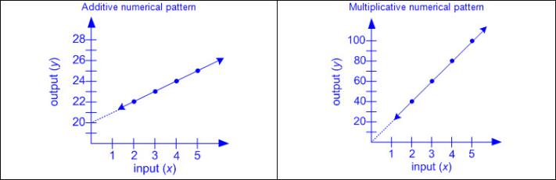  - Relationship between numerical patterns in tables and graphs  - An additive numerical pattern exists when each value of x is added to a constant non-zero value of a to result in a set of respective values of y and will result in a set of ordered pairs which, when graphed, lie on a straight line that does not pass through the origin (0,0).  - A multiplicative numerical pattern exists when each value of x is multiplied by a constant non-zero value of a to result in a set of respective values of y and will result in a set of ordered pairs which, when graphed, lie on a straight line that passes through the origin (0,0).  - Ex:  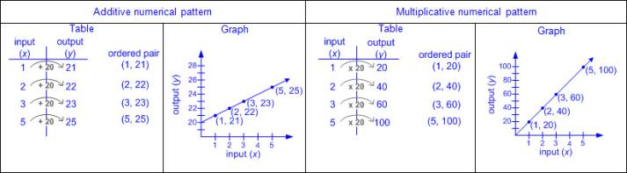  Note(s):  - Grade Level(s):  - Grade 4 represented problems using an input-output table and numerical expressions to generate a number pattern that follows a given rule representing the relationship of the values in the resulting sequence and their position in the sequence.  - Grade 6 will compare two rules verbally, numerically, graphically, and symbolically in the form of y = ax or y = x + a in order to differentiate between additive and multiplicative relationships.  - Various mathematical process standards will be applied to this student expectation as appropriate.  - TxRCFP:  - Understanding and generating expressions and equations to solve problems  - TxCCRS:  - I. Numeric Reasoning  - II.D. Algebraic Reasoning – Representations  - IX. Communication and Representation
5.4E | Describe the meaning of parentheses and brackets in a numeric expression.  Supporting Standard  Describe the meaning of parentheses and brackets in a numeric expression.  Supporting Standard  Describe  THE MEANING OF PARENTHESES AND BRACKETS IN A NUMERIC EXPRESSION  Including, but not limited to:  - Expression – a mathematical phrase, with no equal sign, that may contain a number(s), a unknown(s), and/or an operator(s)  - Parentheses and brackets – symbols to show a group of terms and/or expressions within a mathematical expression  - Up to two levels of grouping  - Parentheses and brackets  - Ex: 3 × [7 + 2 - (8 - 4) ÷ 3] + 2  - Double parentheses  - Ex: 3 × (7 + 2 - (8 - 4) ÷ 3) + 2  - Division bar  - Ex: 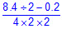  - Generalization about grouping symbols within a numerical expression  - When both parentheses and brackets or a double set of parentheses is used within a numerical expression, the inner most grouping should be evaluated first.  - Ex:  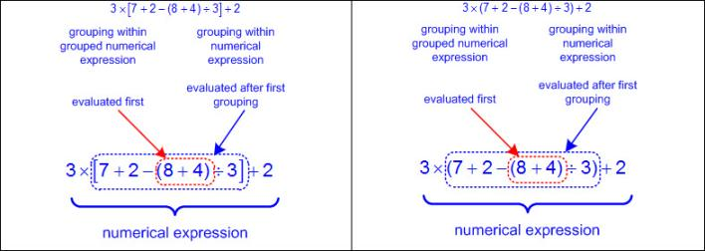  - Parentheses without an operation symbol may be used to represent multiplication.  - Various symbols to represent multiplication include x, •, parentheses, or brackets.  - Ex: 5 x 15, 5 • 15, 5(15), (5)(15), 5[15], [5][15]  - Relationship between numbers and operators separated by parentheses and/or brackets  - Ex: 5(15 + 2) is 5 times larger than (15 + 2)  - Ex: [4 x (2 + 5) – 3] ÷ 3 is the quotient of the difference between a value 4 times larger than (2 + 5) and 3, divided by 3  Note(s):  - Grade Level(s):  - Grade 5 introduces describing the meaning of parentheses and brackets in a numeric expression.  - Grade 6 will generate equivalent numerical expressions using order of operations, including whole number exponents and prime factorization.  - Various mathematical process standards will be applied to this student expectation as appropriate.  - TxRCFP:  - Understanding and generating expressions and equations to solve problems  - TxCCRS:  - IX. Communication and Representation
5.4F | Simplify numerical expressions that do not involve exponents, including up to two levels of grouping.  Readiness Standard  Simplify numerical expressions that do not involve exponents, including up to two levels of grouping.  Readiness Standard  Simplify  NUMERICAL EXPRESSIONS THAT DO NOT INVOLVE EXPONENTS, INCLUDING UP TO TWO LEVELS OF GROUPING  Including, but not limited to:  - Whole numbers  - Counting (natural) numbers – the set of positive numbers that begins at one and increases by increments of one each time {1, 2, 3, ..., n}  - Whole numbers – the set of counting (natural) numbers and zero {0, 1, 2, 3, ..., n}  - Decimals (less than and greater than one to the tenths, hundredths, and thousandths)  - Decimal number – a number in the base-10 place value system used to represent a quantity that may include part of a whole and is recorded with a decimal point separating the whole from the part  - Fractions (proper, improper, or mixed numbers with equal or unequal denominators)  - Fraction – a number in the form where a and b are whole numbers and b is not equal to zero. A fraction can be used to name part of an object, part of a set of objects, to compare two quantities, or to represent division.  - Proper fraction – a number in the form where a and b are whole numbers and a < b where b is not equal to zero  - Improper fraction – a number in the form where a and b are whole numbers and a > b where b is not equal to zero  - Mixed number – a number that is composed of a whole number and a fraction  - Unit fraction – a fraction in the form representing the quantity formed by one part of a whole that has been partitioned into b equal parts where b is a non-zero whole number  - Addition  - Sums of whole numbers  - Sums of decimals up to the thousandths  - Sums of fractions with equal and unequal denominators  - Subtraction  - Differences of whole numbers  - Differences of decimals with values limited to the thousandths  - Differences of fractions with equal and unequal denominators  - Multiplication  - Product – the total when two or more factors are multiplied  - Factor – a number multiplied by another number to find a product  - Products of whole numbers up to three-digit factors by two-digit factors  - Products of decimals limited to three-digit factors by two-digit factors with products to the hundredths  - Multiply tenths by tenths (e.g., 0.3 x 0.7 = 0.21, 1.2 x 1.2 = 1.44, 14.3 x 1.3 = 18.59, etc.)  - Multiply tenths by hundredths or vice versa (e.g., 0.5 x 0.12 = 0.06, 1.4 x 0.15 = 0.21, 21.4 x 0.45 = 9.63, etc.)  - Multiply tenths by thousandths or vice versa (e.g., 0.4 x 0.125 = 0.05, 0.125 x 8.4 = 1.05, etc.)  - Multiply whole numbers by tenths, hundredths, and thousandths or vice versa (e.g., 3 x 1.3 = 3.9, 42 x 7.45 = 312.9, 7.02 x 78 = 547.56, 6 x 0.125 = 0.75, etc.)  - Products of fractions where factors are limited to a fraction and a whole number  - Division  - Quotient – the size or measure of each group or the number of groups when the dividend is divided by the divisor  - Dividend – the number that is being divided  - Divisor – the number the dividend is being divided by  - Whole numbers with quotients up to four-digit dividends and two-digit divisors  - Quotients of decimals limited to four-digit dividends and two-digit whole number divisors, with quotients to the hundredths  - Dividend to the tenths and whole number divisor (e.g., 1.2 ÷ 24 = 0.05, 358.8 ÷ 23 = 15.6, 721.7 ÷ 14 = 51.55, etc.)  - Dividend to the hundredths and whole number divisor (e.g., 8.68 ÷ 4 = 2.17, 8.25 ÷ 15 = 0.55, 62.76 ÷ 12 = 5.23, etc.)  - Whole number dividends and whole number divisors (e.g., 3 ÷ 4 =.0.75, 10 ÷ 8 = 1.25, 1000 ÷ 16 = 62.5, etc.)  - Quotients of fractions where dividend and divisors are limited to whole numbers by unit fractions and unit fractions by whole numbers  - Expression – a mathematical phrase, with no equal sign, that may contain a number(s), a unknown(s), and/or an operator(s)  - Numerical expressions without exponents  - Parentheses and brackets – symbols to show a group of terms and/or expressions within a mathematical expression  - Up to two levels of grouping  - Parentheses and brackets  - Ex: 3 × [7 + 2 - (8 - 4) ÷ 3] + 2  - Double parentheses  - Ex: 3 × (7 + 2 - (8 - 4) ÷ 3) + 2  - Division bar  - Ex:  - Order of operations – the rules of which calculations are performed first when simplifying an expression  - Parentheses/brackets: simplify expressions inside parentheses or brackets in order from left to right  - Multiplication/division: simplify expressions involving multiplication and/or division in order from left to right  - Various symbols to represent multiplication include x, •, parentheses, or brackets.  - Ex: 5 x 15, 5 • 15, 5(15), (5)(15), 5[15], [5][15]  - Addition/subtraction: simplify expressions involving addition and/or subtraction in order from left to right  - Ex:  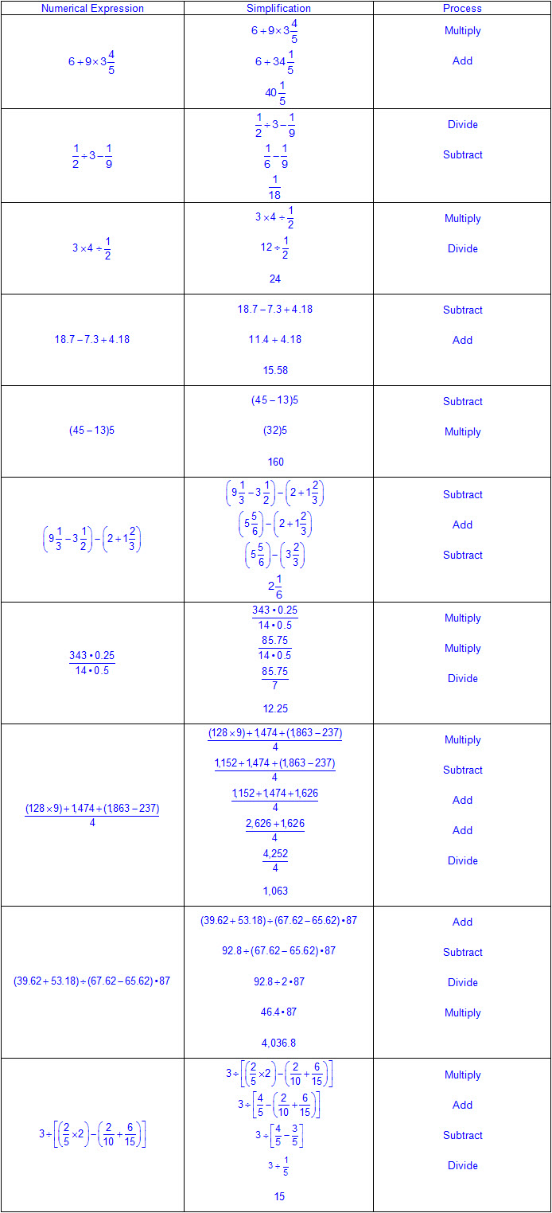  Note(s):  - Grade Level(s):  - Grade 5 introduces simplifying numerical expressions that do not involve exponents, including up to two levels of grouping.  - Grade 6 will generate equivalent numerical expressions using order of operations, including whole number exponents and prime factorization.  - Various mathematical process standards will be applied to this student expectation as appropriate.  - TxRCFP:  - Understanding and generating expressions and equations to solve problems  - TxCCRS:  - I. Numeric Reasoning  - IX. Communication and Representation
5.4G | Use concrete objects and pictorial models to develop the formulas for the volume of a rectangular prism, including the special form for a cube (V = l x w x h, V = s x s x s, and V = Bh).  Use concrete objects and pictorial models to develop the formulas for the volume of a rectangular prism, including the special form for a cube (V = l x w x h, V = s x s x s, and V = Bh).  Use  CONCRETE OBJECTS AND PICTORIAL MODELS TO DEVELOP THE FORMULAS FOR THE VOLUME OF A RECTANGULAR PRISM, INCLUDING THE SPECIAL FORM FOR A CUBE (V = l x w x h, V = s x s x s, AND V = Bh)  Including, but not limited to:  - Volume – the measurement attribute of the amount of space occupied by matter  - One way to measure volume is a three-dimensional cubic measure.  - Attributes of rectangular prisms and cubes to model volume  - Rectangular prism  - 6 rectangular faces (2 parallel rectangular faces [bases], 4 rectangular faces)  - 12 edges  - 8 vertices  - Cube (special form of a rectangular prism)  - 6 square faces (2 parallel square faces [bases], 4 square faces)  - 12 edges  - 8 vertices  - Concrete objects and pictorial models to develop formulas for volume  - Rectangular prism  - V = l x w x h or V = Bh, where B represents the area of the base and h represents the height of the prism  - Ex:  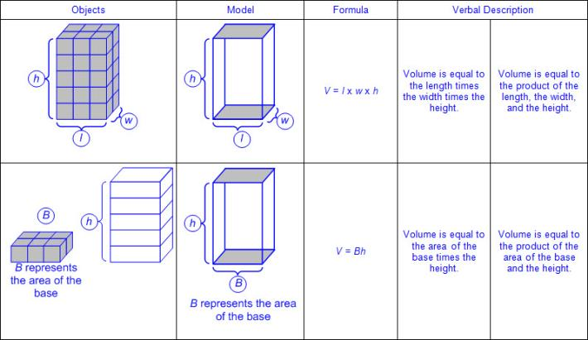  - Cube  - V = s x s x s or V = Bh, where B represents the area of the base and h represents the height of the prism  - Ex:  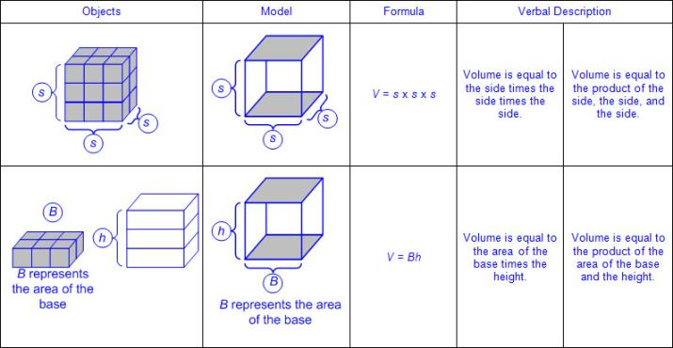  Note(s):  - Grade Level(s):  - Grade 4 used models to determine the formulas for the perimeter of a rectangle (l + w + l + w or 2l + 2w), including the special form for perimeter of a square (4s) and the area of a rectangle (l x w).  - Grade 6 will model area formulas for parallelograms, trapezoids, and triangles by decomposing and rearranging parts of these shapes.  - Various mathematical process standards will be applied to this student expectation as appropriate.  - TxRCFP:  - Understanding and generating expressions and equations to solve problems  - Representing and solving problems with perimeter, area, and volume  - TxCCRS:  - VIII. Problem Solving and Reasoning  - IX. Communication and Representation
5.4H | Represent and solve problems related to perimeter and/or area and related to volume.  Readiness Standard  Represent and solve problems related to perimeter and/or area and related to volume.  Readiness Standard  Represent, Solve  PROBLEMS RELATED TO PERIMETER AND/OR AREA  Including, but not limited to:  - Perimeter – a linear measurement of the distance around the outer edge of a figure  - Perimeter is a one-dimensional linear measure.  - Whole number, decimal, or fractional side lengths  - Recognition of perimeter embedded in mathematical and real-world problem situations  - Ex: How much lace is needed to go around the edge of the rectangular tablecloth?  - Ex: How much fencing is needed to enclose a garden?  - Formulas for perimeter from STAAR Grade 5 Mathematics Reference Materials  - Square  - P = 4s, where s represents the side length of the square  - Rectangle  - P = 2l + 2w, where l represents the length of the rectangle and w represents the width of the rectangle  - Determine perimeter when given side lengths with and without models  - Ex:  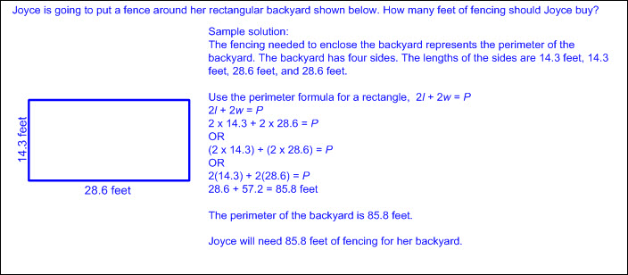  - Ex:  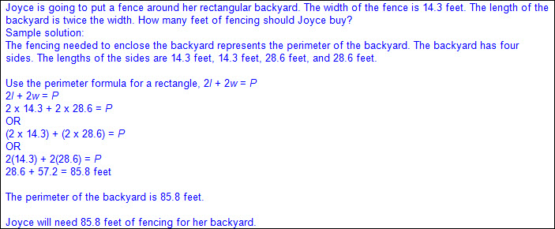  - Determine perimeter by measuring to determine side lengths  - Ruler, STAAR Grade 5 Mathematics Reference Materials ruler, yardstick, meter stick, measuring tape, etc.  - Ex:  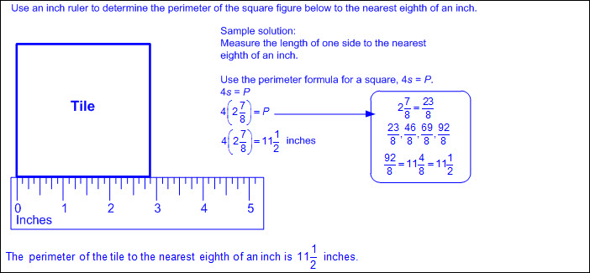  - Determine missing side length when given perimeter and remaining side lengths  - Ex:  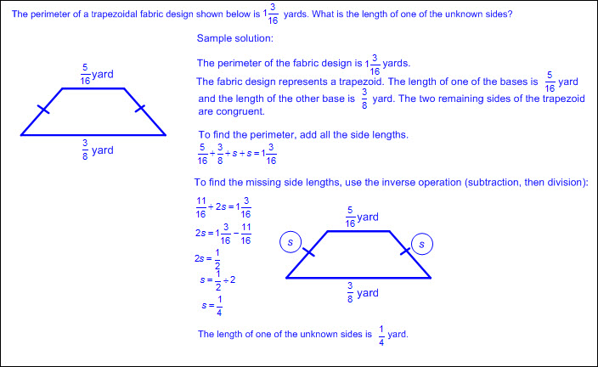  - Perimeter of composite figures  - Ex:  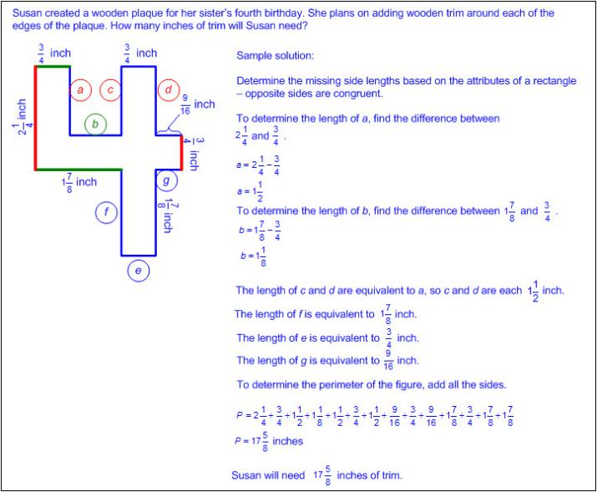  - Area – the measurement attribute that describes the number of square units a figure or region covers  - Area is a two-dimensional square unit measure.  - Whole number, decimal, or fractional side lengths  - Recognition of area embedded in mathematical and real-world problem situations  - Ex: How much fabric is needed to cover a bulletin board?  - Ex: How much carpet is needed to cover the living room floor?  - Formulas for area from STAAR Grade 5 Mathematics Reference Materials  - Square  - A = s x s, where s represents the side length of the square  - Rectangle  - A = l x w, where l represents the length of the rectangle and w represents the width of the rectangle  - A = bh, where b represents the base of the rectangle and h represents the height of the rectangle  - Determine area when given side lengths with and without models  - Ex:  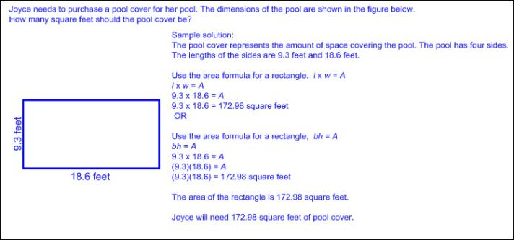  - Ex:  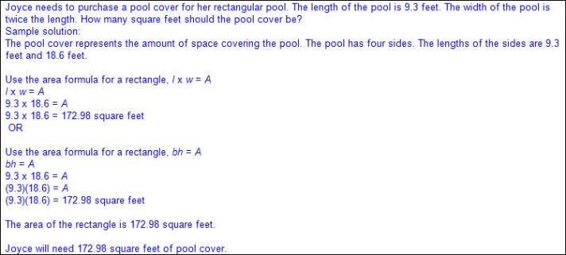  - Determine area by measuring to determine side lengths  - Ruler, STAAR Grade 5 Mathematics Reference Materials ruler, yardstick, meter stick, measuring tape, etc.  - Ex:  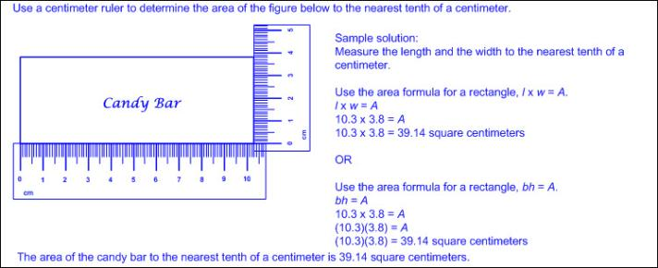  - Determine missing side length when given area and remaining side length  - Ex:  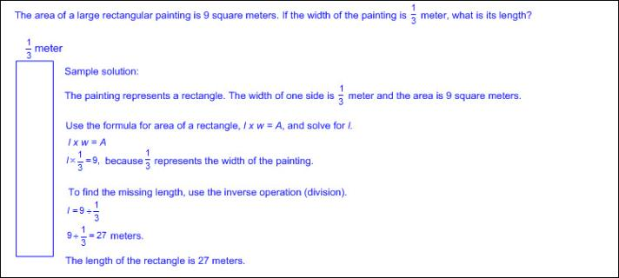  - Area of composite figures  - Ex:  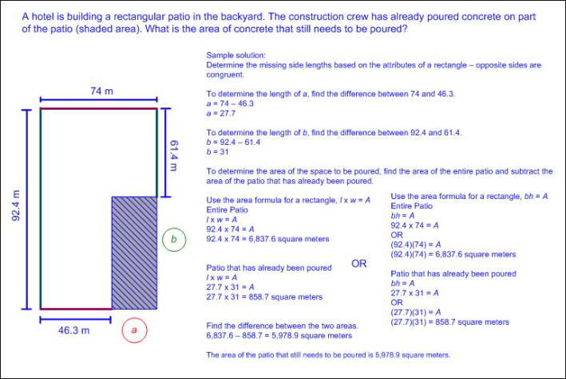  Represent, Solve  PROBLEMS RELATED TO VOLUME  Including, but not limited to:  - Volume – the measurement attribute of the amount of space occupied by matter  - One way to measure volume is a three-dimensional cubic measure.  - Whole number, decimal, or fractional side lengths  - Recognition of volume embedded in mathematical and real-world problem situations  - Ex: How much sand is needed to fill a sand box?  - Ex: How much water is needed to fill an aquarium?  - Formulas for volume for Grade 5 STAAR Mathematics Reference Materials  - Rectangular prism  - V = l x w x h, where l represents the length of the rectangular prism, w represents the width of the rectangular prism, and h represents the height of the rectangular prism  - V = Bh, where B represents the area of the base and hrepresents the height of the rectangular prism, which is the number of times the base area is repeated or layered  - The base of a rectangular prism is a rectangle whose area may be found with the formula, A = bh or A = l x w, meaning the area of the base, B, may be found with the formula B = bh or B = l x w; therefore, the volume of a rectangular prism may be found using V = Bh or V = (bh)h or V = l x w x h.  - Cube  - V = s x s x s, where s represents the length of one side of the cube  - Determine volume when given side lengths with and without models  - Ex:  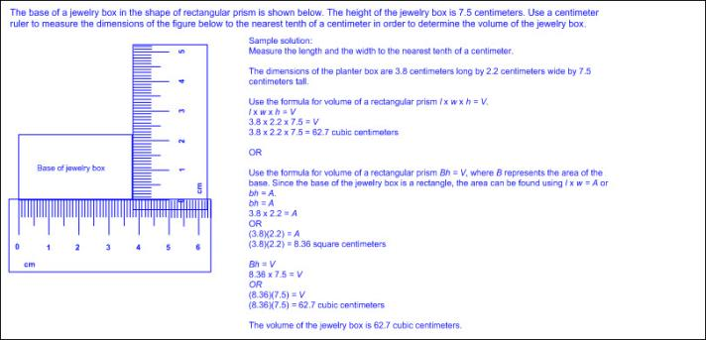  - Ex:  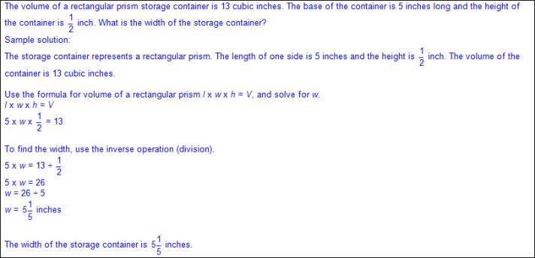  - Determine volume by measuring to determine side lengths  - Ruler, STAAR Grade 5 Mathematics Reference Materials ruler, yardstick, meter stick, measuring tape, etc.  - Ex:  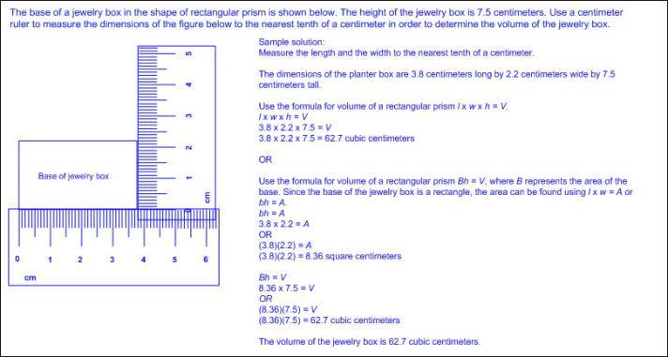  - Determine missing side length when given volume and remaining side lengths  - Ex:  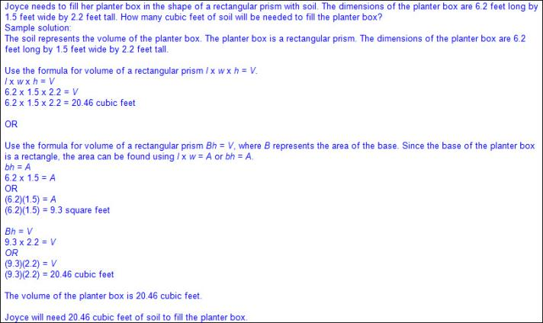  - Volume of composite figures  - Ex:  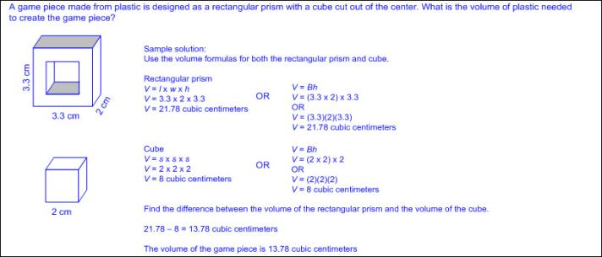  Note(s):  - Grade Level(s):  - Grade 4 solved problems related to perimeter and area of rectangles where dimensions are whole numbers,  - Grade 6 will write equations that represent problems related to the area of rectangles, parallelograms, trapezoids, and triangles and volume of right rectangular prisms where dimensions are positive rational numbers.  - Grade 6 will determine solutions for problems involving the area of rectangles, parallelograms, trapezoids, and triangles and volume of right rectangular prisms where dimensions are positive rational numbers.  - Various mathematical process standards will be applied to this student expectation as appropriate.  - TxRCFP:  - Understanding and generating expressions and equations to solve problems  - Representing and solving problems with perimeter, area, and volume  - TxCCRS:  - I. Numeric Reasoning  - III.A. Geometric Reasoning – Figures and their properties  - III.C. Geometric Reasoning – Connections between geometry and other mathematical content strands  - IV.C. Measurement Reasoning – Measurement involving geometry and algebra  - VIII. Problem Solving and Reasoning  - IX. Communication and Representation
5.5 | Geometry and measurement. The student applies mathematical process standards to classify two-dimensional figures by attributes and properties. The student is expected to
5.5A | Classify two-dimensional figures in a hierarchy of sets and subsets using graphic organizers based on their attributes and properties.  Readiness Standard  Classify two-dimensional figures in a hierarchy of sets and subsets using graphic organizers based on their attributes and properties.  Readiness Standard  Classify  TWO-DIMENSIONAL FIGURES IN A HIERARCHY OF SETS AND SUBSETS USING GRAPHIC ORGANIZERS BASED ON THEIR ATTRIBUTES AND PROPERTIES  Including, but not limited to:  - Two-dimensional figure – a figure with two basic units of measure, usually length and width  - Classify – applying an attribute to categorize a sorted group  - Attributes of two-dimensional figures – characteristics that define a geometric figure (e.g., sides, vertices, etc.)  - Properties of two-dimensional figures – relationship of attributes within a geometric figure (e.g., a square has 4 congruent sides and 4 right angles, etc.) and between a group of geometric figures (e.g., a square and a rectangle both have 4 sides and 4 right angles; however, a square has 4 congruent sides but a rectangle has only opposite sides congruent; etc.)  - Regular figure – a polygon with all side lengths and angles congruent  - Irregular figure – a polygon with side lengths and/or angles that are not all congruent  - Attributes of two-dimensional figures  - Side – a line segment that forms the boundary of a two-dimensional figure  - Number of sides  - Length of sides  - Vertex (vertices) in a two-dimensional figure – the point (corner) where two sides of a two-dimensional figure meet  - Number of vertices  - Angle – two rays with a common endpoint (the vertex)  - Types of angles  - Acute – an angle that measures less than 90°  - Right – an angle (formed by perpendicular lines) that measures exactly 90°  - Notation is given as a box in the angle corner to represent a 90° angle.  - Obtuse – an angle that measures greater than 90° but less than 180°  - Congruent – of equal measure, having exactly the same size and same shape  - Angle congruency marks – angle marks indicating angles of the same measure  - Ex:  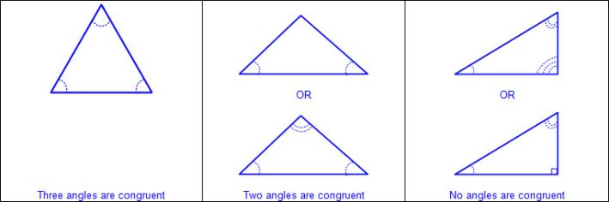  - Side congruency marks – side marks indicating side lengths of the same measure  - Ex:  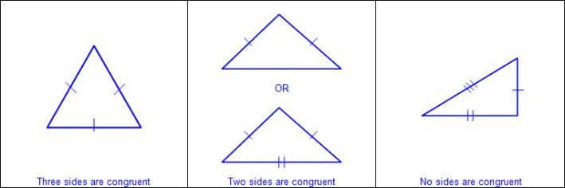  - Types of two-dimensional figures  - Circle  - A figure formed by a closed curve with all points equal distance from the center  - No straight sides  - No vertices  - No parallel or perpendicular sides  - Ex:  - Polygon – a closed figure with at least 3 sides, where all sides are straight (no curves)  - Ex:  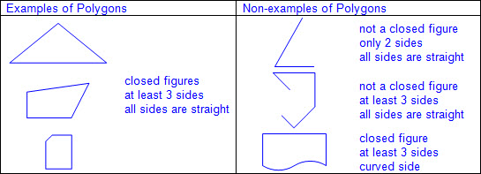  - Types of polygons  - Triangle  - 3 sides  - 3 vertices  - No parallel sides  - Types of triangles  - Scalene triangle  - 3 sides  - 3 vertices  - No congruent sides  - No parallel sides  - Up to one possible pair of perpendicular sides  - Right triangle with two sides that are perpendicular to form a right angle and three different side lengths  - Ex:  - No congruent angles  - Right triangle with one 90° angle and two other angles each of different measures  - Ex:  - Isosceles triangle  - 3 sides  - 3 vertices  - At least 2 congruent sides  - No parallel sides  - Up to one possible pair of perpendicular sides  - Right triangle with two sides that are perpendicular to form a right angle and are each of the same length  - Ex:  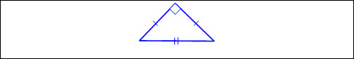  - At least 2 congruent angles  - Right triangle with one 90° angle and two other angles each of the same measure  - Ex:  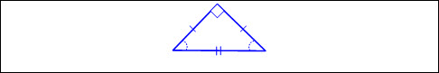  - Obtuse triangle with two angles of the same measure and one angle greater than 90°  - Ex:  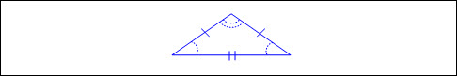  - Acute triangle with all angles measuring less than 90° and at least two of the angles of the same measure  - Ex:  - Equilateral triangle  - 3 sides  - 3 vertices  - All sides congruent  - No parallel or perpendicular sides  - All angles congruent  - Acute triangle with all angles measuring 60°  - Ex:  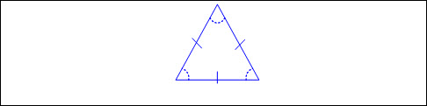  - Quadrilateral  - 4 sides  - 4 vertices  - Types of quadrilaterals  - Trapezoid  - 4 sides  - 4 vertices  - Exactly one pair of parallel sides  - Up to two possible pairs of perpendicular sides  - Ex:  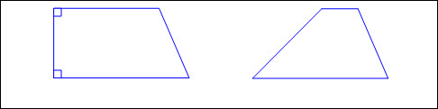  - Parallelogram  - 4 sides  - 4 vertices  - Opposite sides congruent  - 2 pairs of parallel sides  - Opposite angles congruent  - Ex:  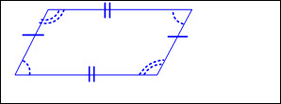  - Types of parallelograms  - Rectangle  - 4 sides  - 4 vertices  - Opposite sides congruent  - 2 pairs of parallel sides  - 2 pairs of perpendicular sides  - 4 right angles  - Ex:  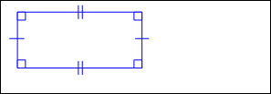  - Rhombus  - 4 sides  - 4 vertices  - All sides congruent  - 2 pairs of parallel sides  - Opposite angles congruent  - Ex:  - Square (a special type of rectangle and a special type of rhombus)  - 4 sides  - 4 vertices  - All sides congruent  - 2 pairs of parallel sides  - 2 pairs of perpendicular sides  - 4 right angles  - Ex:  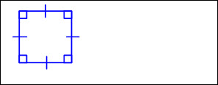  - Pentagon  - 5 sides  - 5 vertices  - Possible parallel and/or perpendicular sides  - Possible acute, obtuse, and/or right angles  - Ex:  - Hexagon  - 6 sides  - 6 vertices  - Possible parallel and/or perpendicular sides  - Possible acute, obtuse, and/or right angles  - Ex:  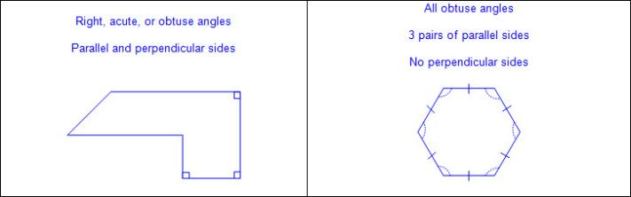  - Heptagon or septagon  - 7 sides  - 7 vertices  - Possible parallel and/or perpendicular sides  - Possible acute, obtuse, and/or right angles  - Ex:  - Octagon  - 8 sides  - 8 vertices  - Possible parallel and/or perpendicular sides  - Possible acute, obtuse, and/or right angles  - Ex:  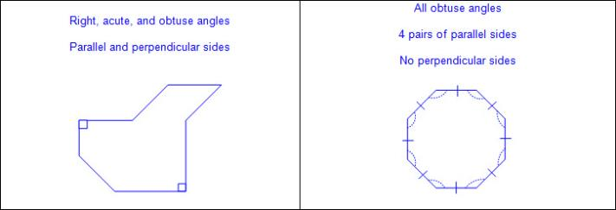  - Nonagon or enneagon  - 9 sides  - 9 vertices  - Possible parallel and/or perpendicular sides  - Possible acute, obtuse, and/or right angles  - Ex:  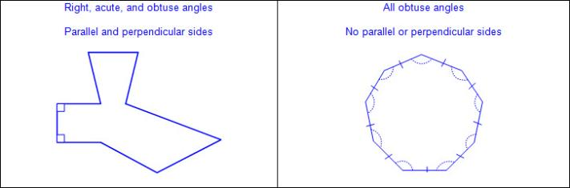  - Decagon  - 10 sides  - 10 vertices  - Possible parallel and/or perpendicular sides  - Possible acute, obtuse, and/or right angles  - Ex:  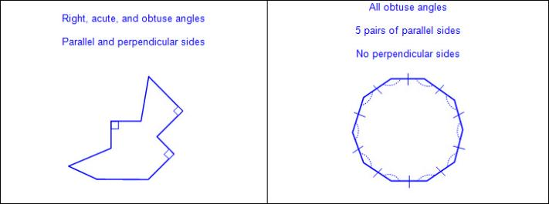  - Undecagon or hendecagon  - 11 sides  - 11 vertices  - Possible parallel and/or perpendicular sides  - Possible acute, obtuse, and/or right angles  - Ex:  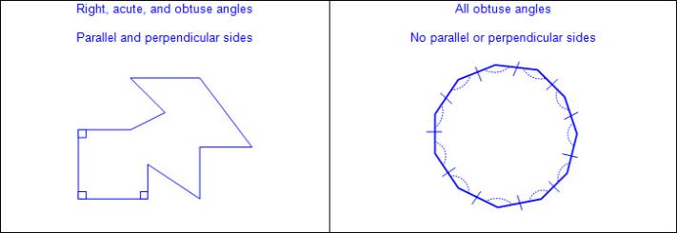  - Dodecagon  - 12 sides  - 12 vertices  - Possible parallel and/or perpendicular sides  - Possible acute, obtuse, and/or right angles  - Ex  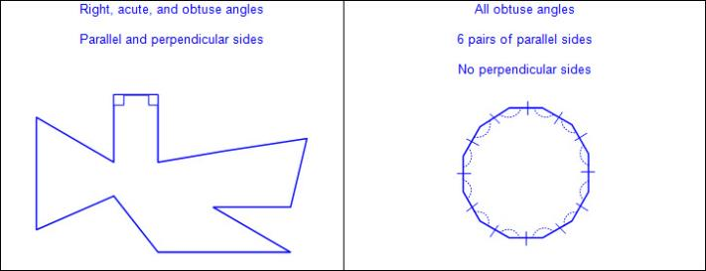  - Graphic organizer to represent hierarchy of sets and subsets of two-dimensional figures  - Ex:  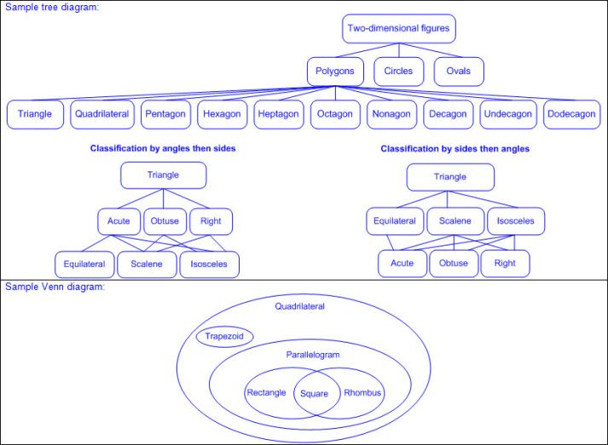  - Sample generalizations about sets and subsets of two-dimensional figures  - All two-dimensional figures have attributes and properties and can be classified.  - Some two-dimensional figures can be classified into more than one set or subset.  - All polygons can be classified by their angles and/or sides.  - All two-dimensional figures are polygons or circles.  - All triangles are acute, obtuse, or right triangles.  - All triangles are isosceles, equilateral, or scalene triangles.  - All acute triangles are isosceles, equilateral, or scalene triangles.  - All obtuse triangles are isosceles or scalene triangles.  - All right triangles are isosceles or scalene triangles.  - All isosceles and scalene triangles are acute, obtuse, or right triangles.  - All equilateral triangles are acute triangles.  - All equilateral triangles are isosceles triangles.  - All squares are rectangles and rhombuses.  - Some rectangles are rhombuses.  - Some rhombuses are rectangles.  - Some rectangles are squares.  - Some rhombuses are squares.  - All squares, rectangles, and rhombuses are parallelograms.  - All squares, rectangles, rhombuses, parallelograms, and trapezoids are quadrilaterals.  Note(s):  - Grade Level(s):  - Grade 4 classified two-dimensional figures based on the presence or absence of parallel or perpendicular lines or the presence or absence of angles of a specified size.  - Various mathematical process standards will be applied to this student expectation as appropriate.  - TxRCFP:  - Grade Level Connections (reinforces previous learning and/or provides development for future learning)  - TxCCRS:  - III.A. Geometric Reasoning – Figures and their properties  - VIII. Problem Solving and Reasoning  - IX. Communication and Representation
5.6 | Geometry and measurement. The student applies mathematical process standards to understand, recognize, and quantify volume. The student is expected to:
5.6A | Recognize a cube with side length of one unit as a unit cube having one cubic unit of volume and the volume of a three-dimensional figure as the number of unit cubes (n cubic units) needed to fill it with no gaps or overlaps if possible.  Supporting Standard  Recognize a cube with side length of one unit as a unit cube having one cubic unit of volume and the volume of a three-dimensional figure as the number of unit cubes (n cubic units) needed to fill it with no gaps or overlaps if possible.  Supporting Standard  Recognize  A CUBE WITH SIDE LENGTH OF ONE UNIT AS A UNIT CUBE HAVING ONE CUBIC UNIT OF VOLUME AND THE VOLUME OF A THREE-DIMENSIONAL FIGURE AS THE NUMBER OF UNIT CUBES (n CUBIC UNITS) NEEDED TO FILL IT WITH NO GAPS OR OVERLAPS IF POSSIBLE  Including, but not limited to:  - Three-dimensional figure – a figure that has measurements including length, width (depth), and height  - Attributes of cubes  - Cube (special form of a rectangular prism)  - 6 square faces (2 parallel square faces [bases], 4 square faces)  - 12 edges  - 8 vertices  - Relationships between units used to measure one-, two-, and three-dimensional figures  - One-dimensional figures are measured using linear units.  - Two-dimensional figures are measured using square units.  - Three-dimensional figures are measured using cubic units.  - Ex:  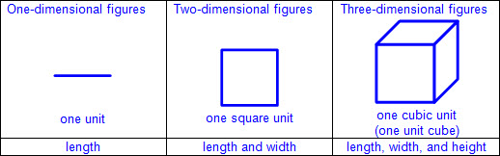  - Volume – the measurement attribute of the amount of space occupied by matter  - One way to measure volume is a three-dimensional cubic measure.  - Volume is measured by counting the number of unit cubes that fill the space with no gaps or overlaps.  - Ex:  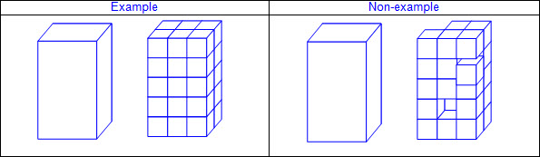  Note(s):  - Grade Level(s):  - Grade 2 used concrete models of square units to find the area of a rectangle by covering it with no gaps or overlaps, counting to find the total number of square units, and describing the measurement using a number and the unit.  - Various mathematical process standards will be applied to this student expectation as appropriate.  - TxRCFP:  - Representing and solving problems with perimeter, area, and volume  - TxCCRS:  - III.A. Geometric Reasoning – Figures and their properties  - IX. Communication and Representation
5.6B | Determine the volume of a rectangular prism with whole number side lengths in problems related to the number of layers times the number of unit cubes in the area of the base.  Supporting Standard  Determine the volume of a rectangular prism with whole number side lengths in problems related to the number of layers times the number of unit cubes in the area of the base.  Supporting Standard  Determine  THE VOLUME OF A RECTANGULAR PRISM WITH WHOLE NUMBER SIDE LENGTHS IN PROBLEMS RELATED TO THE NUMBER OF LAYERS TIMES THE NUMBER OF UNIT CUBES IN THE AREA OF THE BASE  Including, but not limited to:  - Three-dimensional figure – a figure that has measurements including length, width (depth), and height  - Attributes of rectangular prisms and cubes  - Rectangular prism  - 6 rectangular faces (2 parallel rectangular faces [bases], 4 rectangular faces)  - 12 edges  - 8 vertices  - Cube (special form of a rectangular prism)  - 6 square faces (2 parallel square faces [bases], 4 square faces)  - 12 edges  - 8 vertices  - Volume – the measurement attribute of the amount of space occupied by matter  - One way to measure volume is a three-dimensional cubic measure.  - Whole number side lengths  - Products of whole numbers up to three-digit factors by two-digit factors  - Whole numbers with quotients up to four-digit dividends and two-digit divisors  - Volume is measured by counting the number of unit cubes that fill the space with no gaps or overlaps.  - Formulas for volume for Grade 5 STAAR Mathematics Reference Materials  - Rectangular prism  - V = l x w x h, where l represents the length of the rectangular prism, w represents the width of the rectangular prism, and h represents the height of the rectangular prism  - V = Bh, where B represents the area of the base and hrepresents the height of the rectangular prism, which is the number of times the base area is repeated or layered  - The base of a rectangular prism is a rectangle whose area may be found with the formula, A = bh or A = l x w, meaning the area of the base, B, may be found with the formula B = bh or B = l x w; therefore, the volume of a rectangular prism may be found using V = Bh or V = (bh)h or V = l x w x h.  - Ex:  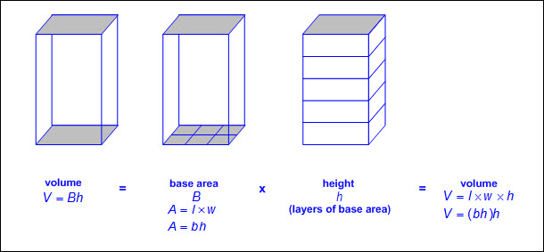  - Relationship between volume of a rectangular prism, its base area, and height (the number of layers)  - The volume of a rectangular prism is the product of its base area and its height. (V = Bh)  - The base area of a rectangular prism is the quotient of its volume and its height. (B = V ÷ h)  - The height of a rectangular prism is the quotient of its volume and its base area. (h = V ÷ B)  - Problem situations related to the number of layers times the number of unit cubes in the area of the base  - Ex:  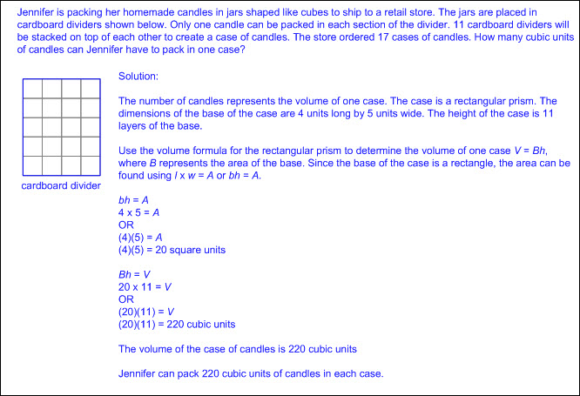  Note(s):  - Grade Level(s):  - Grade 3 determined the area of rectangles with whole number side lengths in problems using multiplication related to the number of rows times the number of unit squares in each row.  - Various mathematical process standards will be applied to this student expectation as appropriate.  - TxRCFP:  - Representing and solving problems with perimeter, area, and volume  - TxCCRS:  - I. Numeric Reasoning  - III.A. Geometric Reasoning – Figures and their properties  - III.C. Geometric Reasoning – Connections between geometry and other mathematical content strands  - IV.C. Measurement Reasoning – Measurement involving geometry and algebra  - VIII. Problem Solving and Reasoning  - IX. Communication and Representation
5.7 | Geometry and measurement. The student applies mathematical process standards to select appropriate units, strategies, and tools to solve problems involving measurement. The student is expected to
5.7A | Solve problems by calculating conversions within a measurement system, customary or metric.  Supporting Standard  Solve problems by calculating conversions within a measurement system, customary or metric.  Supporting Standard  Solve  PROBLEMS BY CALCULATING CONVERSIONS WITHIN A MEASUREMENT SYSTEM, CUSTOMARY OR METRIC  Including, but not limited to:  - Whole numbers  - Decimals (less than and greater than one to the tenths, hundredths, and thousandths)  - Fractions (proper, improper, or mixed numbers with equal or unequal denominators)  - Multiplication  - Products of whole numbers up to three-digit factors by two-digit factors  - Products of decimals limited to three-digit factors by two-digit factors with products to the hundredths  - Multiply tenths by tenths (e.g., 0.3 x 0.7 = 0.21, 1.2 x 1.2 = 1.44, 14.3 x 1.3 = 18.59, etc.)  - Multiply tenths by hundredths or vice versa (e.g., 0.5 x 0.12 = 0.06, 1.4 x 0.15 = 0.21, 21.4 x 0.45 = 9.63, etc.)  - Multiply tenths by thousandths or vice versa (e.g., 0.4 x 0.125 = 0.05, 0.125 x 8.4 = 1.05, etc.)  - Multiply whole numbers by tenths, hundredths, and thousandths or vice versa (e.g., 3 x 1.3 = 3.9, 42 x 7.45 = 312.9, 7.02 x 78 = 547.56, 6 x 0.125 = 0.75, etc.)  - Products of fractions where factors are limited to a fraction and a whole number  - Division  - Whole numbers with quotients up to four-digit dividends and two-digit divisors  - Quotients of decimals limited to four-digit dividends and two-digit whole number divisors, with quotients to the hundredths  - Dividend to the tenths and whole number divisor (e.g., 1.2 ÷ 24 = 0.05, 358.8 ÷ 23 = 15.6, 721.7 ÷ 14 = 51.55, etc.)  - Dividend to the hundredths and whole number divisor (e.g., 8.68 ÷ 4 = 2.17, 8.25 ÷ 15 = 0.55, 62.76 ÷ 12 = 5.23, etc.)  - Whole number dividends and whole number divisors (e.g., 3 ÷ 4 = 0.75, 10 ÷ 8 = 1.25, 1000 ÷ 16 = 62.5, etc.)  - Quotients of fractions where dividend and divisors are limited to whole numbers by unit fractions and unit fractions by whole numbers  - Conversion – change from one unit to another unit  - Typically used customary and metric units  - Customary  - Length: miles, yards, feet, inches  - Volume (liquid volume) and capacity: gallons, quarts, pints, cups, fluid ounces  - Weight: tons, pounds, ounces  - Metric  - Length: kilometers, meters, centimeters, millimeters  - Volume (liquid volume) and capacity: kiloliters, liters, milliliters  - Mass: kilograms, grams, milligrams  - Based on prefixes attached to base unit  - Base units include meter for length, liter for volume and capacity, and gram for weight and mass.  - Kilo: one thousand base units  - Deci: one-tenth of a base unit  - Centi: one-hundredth of a base unit  - Milli: one-thousandth of a base unit  - Relationship between converting units  - Converting within the same measurement system, customary or metric  - Multiplication converts larger units to smaller units.  - Division converts smaller units to larger units.  - Ex: Length  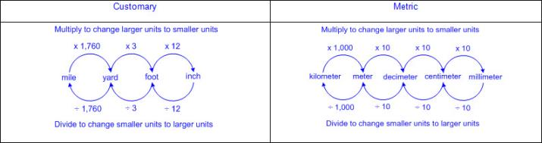  - Ex: Volume (liquid volume) and capacity  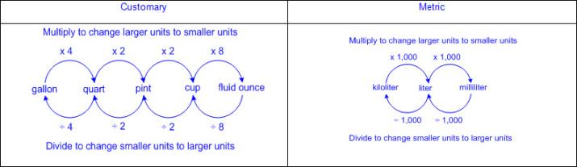  - Ex: Weight and mass  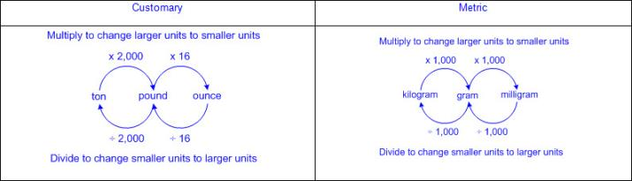  - Appropriate units based on the information considered in the mathematical and real-world problem situations  - Length  - Ex:  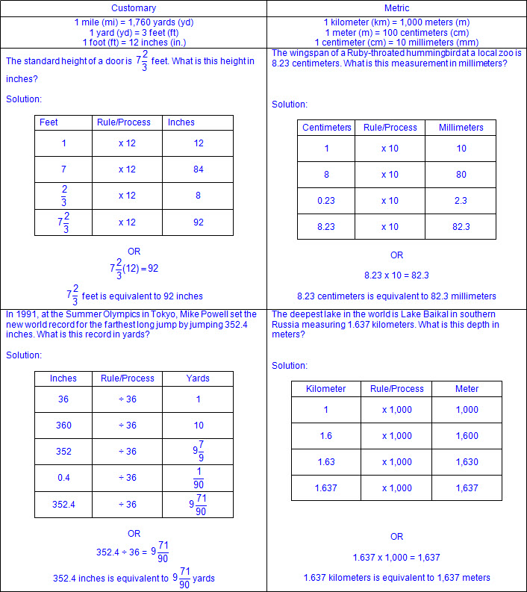  - Volume (liquid volume) and capacity  - Ex:  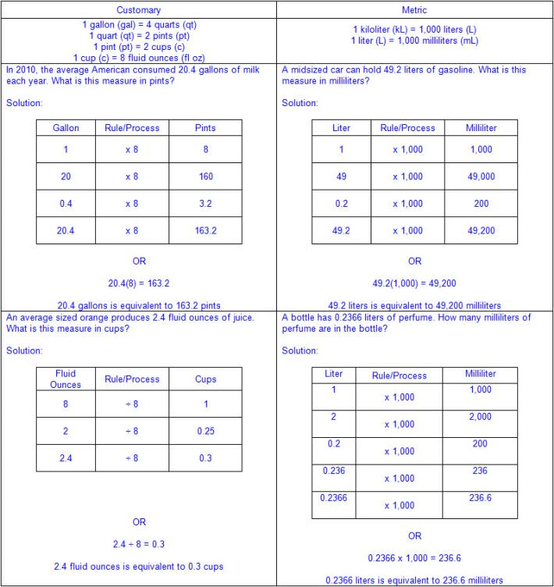  - Weight and mass  - Ex:  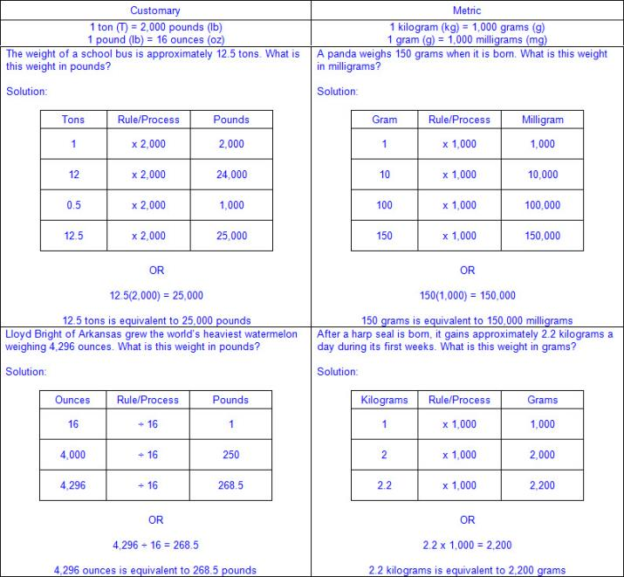  Note(s):  - Grade Level(s):  - Grade 4 identified relative sizes of measurement units within the customary and metric systems.  - Grade 4 converted measurements within the same measurement system, customary or metric, from a smaller unit into a larger unit or a larger unit into a smaller unit when given other equivalent measures represented in a table.  - Grade 4 solved problems that deal with measurements of length, intervals of time, liquid volumes, mass, and money using addition, subtraction, multiplication, or division as appropriate.  - Grade 6 will convert units within a measurement system, including the use of proportions and unit rates.  - Various mathematical process standards will be applied to this student expectation as appropriate.  - TxRCFP:  - Developing an understanding of and fluency with addition, subtraction, multiplication, and division of fractions and decimals  - Understanding and generating expressions and equations to solve problems  - Representing and solving problems with perimeter, area, and volume  - TxCCRS:  - I. Numeric Reasoning  - VIII. Problem Solving and Reasoning  - IX. Communication and Representation
5.8 | Geometry and measurement. The student applies mathematical process standards to identify locations on a coordinate plane. The student is expected to:
5.8A | Describe the key attributes of the coordinate plane, including perpendicular number lines (axes) where the intersection (origin) of the two lines coincides with zero on each number line and the given point (0, 0); the x-coordinate, the first number in an ordered pair, indicates movement parallel to the x-axis starting at the origin; and the y-coordinate, the second number, indicates movement parallel to the y-axis starting at the origin.  Supporting Standard  Describe the key attributes of the coordinate plane, including perpendicular number lines (axes) where the intersection (origin) of the two lines coincides with zero on each number line and the given point (0, 0); the x-coordinate, the first number in an ordered pair, indicates movement parallel to the x-axis starting at the origin; and the y-coordinate, the second number, indicates movement parallel to the y-axis starting at the origin.  Supporting Standard  Describe  THE KEY ATTRIBUTES OF THE COORDINATE PLANE, INCLUDING PERPENDICULAR NUMBER LINES (AXES) WHERE THE INTERSECTION (ORIGIN) OF THE TWO LINES COINCIDES WITH ZERO ON EACH NUMBER LINE AND THE GIVEN POINT (0, 0); THE X-COORDINATE, THE FIRST NUMBER IN AN ORDERED PAIR, INDICATES MOVEMENT PARALLEL TO THE X-AXIS STARTING AT THE ORIGIN; AND THE Y-COORDINATE, THE SECOND NUMBER, INDICATES MOVEMENT PARALLEL TO THE Y-AXIS STARTING AT THE ORIGIN  Including, but not limited to:  - Coordinate plane – a two-dimensional plane on which to plot points, lines, and curves  - Perpendicular lines – lines that intersect at right angles to each other to form square corners  - Axes – the vertical and horizontal lines that act as a reference when plotting points on a coordinate plane  - Intersecting lines – lines that meet or cross at a point  - Origin – the starting point in locating points on a coordinate plane  - Quadrants – any of the four areas created by dividing a plane with an x-axis and y-axis  - Attributes of the coordinate plane  - Two number lines intersect perpendicularly to form the axes, which are used to locate points on the plane.  - The horizontal number line is called the x-axis.  - The vertical number line is called the y-axis.  - The x-axis and the y-axis cross at 0 on both number lines and that intersection is called the origin.  - The ordered pair of numbers corresponding to the origin is (0, 0).  - Four quadrants are formed by the intersection of the x- and y-axes and are labeled counterclockwise with Roman numerals.  - Ex:  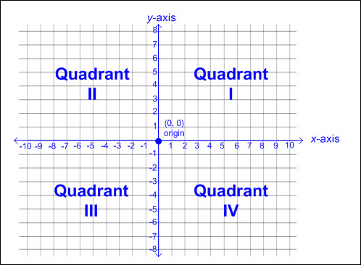  - The first quadrant plots positive rational numbers.  - Positive numbers on the x-axis are located to the right of the origin.  - Positive numbers on the y-axis are located above the origin.  - Iterated units are labeled and shown on both axes to show scale.  - Intervals may or may not be increments of one.  - Ex:  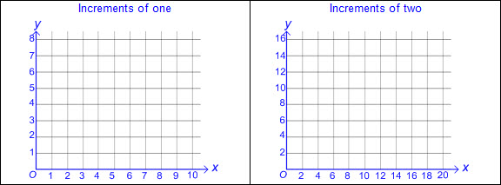  - Intervals may or may not include decimal or fractional amounts.  - Ex:  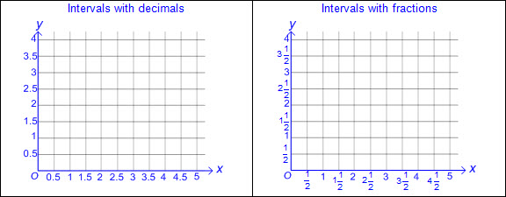  - Relationship between ordered pairs and attributes of the coordinate plane  - A pair of ordered numbers names the location of a point on a coordinate plane.  - Ordered pairs of numbers are indicated within parentheses and separated by a comma (x, y).  - When graphing in Quadrant I, the first number in the ordered pair represents the parallel movement on the x-axis, starting at the origin and moving right.  - When graphing in Quadrant I, the second number in the ordered pair represents the parallel movement on the y-axis, starting at the origin and moving up.  Note(s):  - Grade Level(s):  - Grade 3 represented fractions of halves, fourths, and eighths as distances from zero on a number line.  - Grade 6 will graph points in all four quadrants using ordered pairs of rational numbers.  - Various mathematical process standards will be applied to this student expectation as appropriate.  - TxRCFP:  - Organizing, representing, and interpreting sets of data  - TxCCRS:  - IX. Communication and Representation
5.8B | Describe the process for graphing ordered pairs of numbers in the first quadrant of the coordinate plane.  Supporting Standard  Describe the process for graphing ordered pairs of numbers in the first quadrant of the coordinate plane.  Supporting Standard  Describe  THE PROCESS FOR GRAPHING ORDERED PAIRS OF NUMBERS IN THE FIRST QUADRANT OF THE COORDINATE PLANE  Including, but not limited to:  - Coordinate plane – a two-dimensional plane on which to plot points, lines, and curves  - Axes – the vertical and horizontal lines that act as a reference when plotting points on a coordinate plane  - Intersecting lines – lines that meet or cross at a point  - Origin – the starting point in locating points on a coordinate plane  - Quadrants – any of the four areas created by dividing a plane with an x-axis and y-axis  - Attributes of the coordinate plane  - Two number lines intersect perpendicularly to form the axes, which are used to locate points on the plane.  - The horizontal number line is called the x-axis.  - The vertical number line is called the y-axis.  - The x-axis and the y-axis cross at 0 on both number lines and that intersection is called the origin.  - The ordered pair of numbers corresponding to the origin is (0, 0).  - Relationship between ordered pairs and attributes of the coordinate plane  - A pair of ordered numbers names the location of a point on a coordinate plane.  - Ordered pairs of numbers are indicated within parentheses and separated by a comma (x, y).  - When graphing in Quadrant I, the first number in the ordered pair represents the parallel movement on the x-axis, starting at the origin and moving right.  - When graphing in Quadrant I, the second number in the ordered pair represents the parallel movement on the y-axis, starting at the origin and moving up.  - Limited to the first quadrant for graphing ordered pairs of positive rational numbers  - Various forms of positive rational numbers as ordered pairs  - Whole numbers  - Decimals (less than and greater than one to the tenths, hundredths, and thousandths)  - Fractions (proper, improper, or mixed numbers with equal or unequal denominators)  - Process for graphing ordered pairs of numbers in the first quadrant  - To locate the x-coordinate, begin at the origin and move to the right along the x-axis the appropriate number of units according to the x-coordinate in the ordered pair.  - To locate the y-coordinate, begin at the origin and move up along the y-axis the appropriate number of units according to the y-coordinate in the ordered pair.  - The point of intersection of both the parallel movements on the x-axis and the y-axis is the location of the ordered pair.  - Ex:  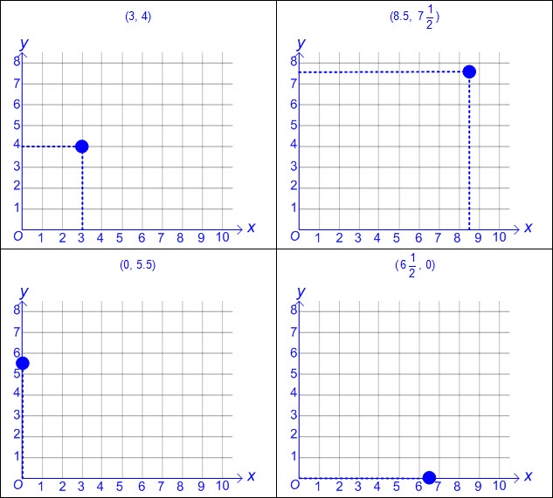  - Multiple ordered pairs may be graphed on the same coordinate plane.  - Ex:  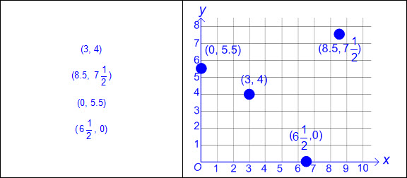  Note(s):  - Grade Level(s):  - Grade 3 represented fractions of halves, fourths, and eighths as distances from zero on a number line.  - Grade 6 will graph points in all four quadrants using ordered pairs of rational numbers.  - Various mathematical process standards will be applied to this student expectation as appropriate.  - TxRCFP:  - Organizing, representing, and interpreting sets of data  - TxCCRS:  - IX. Communication and Representation
5.8C | Graph in the first quadrant of the coordinate plane ordered pairs of numbers arising from mathematical and real-world problems, including those generated by number patterns or found in an input-output table.  Readiness Standard  Graph in the first quadrant of the coordinate plane ordered pairs of numbers arising from mathematical and real-world problems, including those generated by number patterns or found in an input-output table.  Readiness Standard  Graph  IN THE FIRST QUADRANT OF THE COORDINATE PLANE ORDERED PAIRS OF NUMBERS ARISING FROM MATHEMATICAL AND REAL-WORLD PROBLEMS, INCLUDING THOSE GENERATED BY NUMBER PATTERNS OR FOUND IN AN INPUT-OUTPUT TABLE  Including, but not limited to:  - Coordinate plane – a two-dimensional plane on which to plot points, lines, and curves  - Axes – the vertical and horizontal lines that act as a reference when plotting points on a coordinate plane  - Intersecting lines – lines that meet or cross at a point  - Origin – the starting point in locating points on a coordinate plane  - Quadrants – any of the four areas created by dividing a plane with an x-axis and y-axis  - Attributes of the coordinate plane  - Two number lines intersect perpendicularly to form the axes, which are used to locate points on the plane.  - The horizontal number line is called the x-axis.  - The vertical number line is called the y-axis.  - The x-axis and the y-axis cross at 0 on both number lines and that intersection is called the origin.  - The coordinate pair of numbers corresponding to the origin is (0, 0).  - Relationship between ordered pairs and attributes of the coordinate plane  - A pair of ordered numbers names the location of a point on a coordinate plane.  - Ordered pairs of numbers are indicated within parentheses and separated by a comma (x, y).  - When graphing in Quadrant I, the first number in the ordered pair represents the parallel movement on the x-axis, starting at the origin and moving right.  - When graphing in Quadrant I, the second number in the ordered pair represents the parallel movement on the y-axis, starting at the origin and moving up.  - Limited to the first quadrant for graphing ordered pairs of positive rational numbers  - Various forms of positive rational numbers as ordered pairs  - Whole numbers  - Decimals (less than and greater than one to the tenths, hundredths, and thousandths)  - Fractions (proper, improper, or mixed numbers with equal or unequal denominators)  - Process for graphing ordered pairs of numbers in the first quadrant  - To locate the x-coordinate, begin at the origin and move to the right along the x-axis the appropriate number of units according to the x-coordinate in the ordered pair.  - To locate the y-coordinate, begin at the origin and move up along the y-axis the appropriate number of units according to the y-coordinate in the ordered pair.  - The point of intersection of both the parallel movements on the x-axis and the y-axis is the location of the ordered pair.  - Multiple ordered pairs may be graphed on the same coordinate plane.  - Ordered pairs in mathematical and real-world problem situations  - Ex:  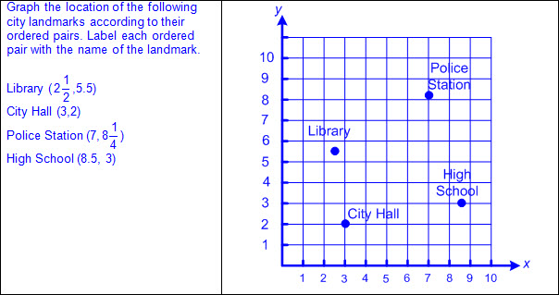  - Ex:  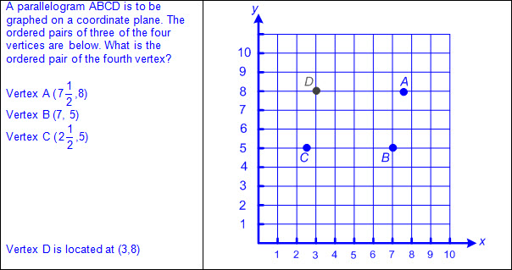  - Ordered pairs generated from number patterns or those found in an input-output table  - Ex:  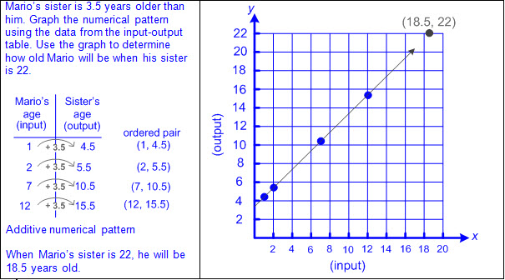  - Ex:  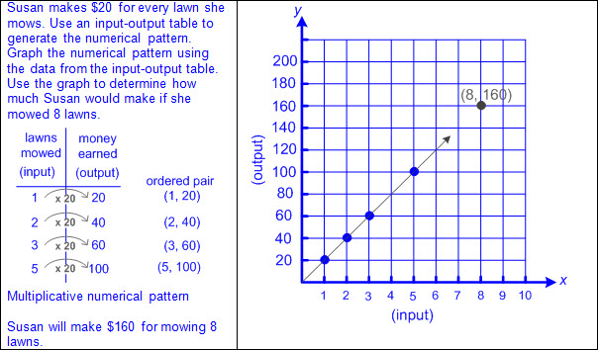  Note(s):  - Grade Level(s):  - Grade 3 represented fractions of halves, fourths, and eighths as distances from zero on a number line.  - Grade 6 will graph points in all four quadrants using ordered pairs of rational numbers.  - Various mathematical process standards will be applied to this student expectation as appropriate.  - TxRCFP:  - Organizing, representing, and interpreting sets of data  - TxCCRS:  - IX. Communication and Representation
5.9 | Data analysis. The student applies mathematical process standards to solve problems by collecting, organizing, displaying, and interpreting data. The student is expected to:
5.9A | Represent categorical data with bar graphs or frequency tables and numerical data, including data sets of measurements in fractions or decimals, with dot plots or stem-and-leaf plots.  Supporting Standard  Represent categorical data with bar graphs or frequency tables and numerical data, including data sets of measurements in fractions or decimals, with dot plots or stem-and-leaf plots.  Supporting Standard  Represent  CATEGORICAL DATA WITH BAR GRAPHS OR FREQUENCY TABLES  Including, but not limited to:  - Whole numbers  - Data – information that is collected about people, events, or objects  - Categorical data – data that represents the attributes of a group of people, events, or objects  - Ex: What is your favorite color? Represented on a graph with colors as category labels (e.g., red, yellow, blue, green, and purple).  - Ex. Do you have a brother? Represented on a graph with yes and no as category labels.  - Ex: Which sporting event do you prefer? Represented on a graph with names of sports as category labels (e.g., basketball, baseball, football, soccer, and hockey).  - Categorical data may represent numbers or ranges of numbers.  - Ex: How many pets do you have? Represented on a graph with numbers as category labels (e.g., 0, 1, 2, 3, and 4 or more).  - Ex: How many letters are in your name? Represented on a graph with ranges of numbers as category labels (e.g., 1 – 3, 4 – 6, 7 – 9, and 10 or more).  - Data representations  - Bar graph – a graphical representation to organize data that uses solid bars that do not touch each other to show the frequency (number of times) that each category occurs  - Characteristics of a bar graph  - Title clarifies the meaning of the data represented.  - Subtitles clarify the meaning of the data represented on each axis.  - Categorical data is represented with labels.  - Horizontal or vertical linear arrangement  - Bars are solid.  - Bars do not touch.  - Scale of the axis may be intervals of one or more, and scale intervals are proportionally displayed.  - The scale of the axis is a number line.  - Length of the bar represents the number of data points for a given category.  - Length the bar represents the distance from zero on the scale of the axis.  - Value of the data represented by the bar is determined by reading the number associated with its length (distance from zero) on the axis scale.  - Ex:  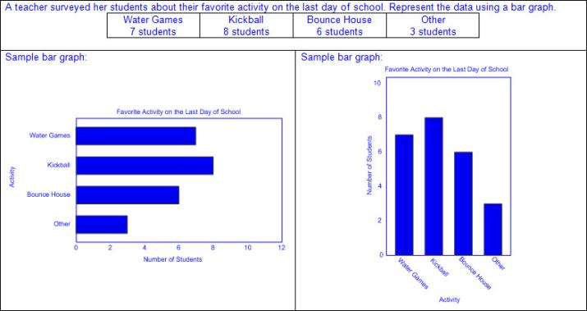  - Frequency table – a table to organize data that lists categories and the frequency (number of times) that each category occurs  - Characteristics of a frequency table  - Title clarifies the meaning of the data represented.  - Categorical data is represented with labels.  - Data represented may be objects, events, numbers, or a range of numbers.  - Tally marks are used to record frequencies.  - Numbers are used to represent the count of tally marks in each category.  - Count of tally marks represents the frequency of how often a category occurs.  - Ex:  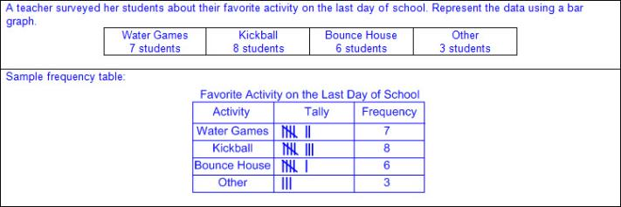  Represent  NUMERICAL DATA, INCLUDING DATA SETS OF MEASUREMENTS IN FRACTIONS OR DECIMALS, WITH DOT PLOTS OR STEM-AND-LEAF PLOTS  Including, but not limited to:  - Whole numbers  - Decimals (less than and greater than one to the tenths, hundredths, and thousandths)  - Fractions (proper, improper, and mixed numbers)  - Data – information that is collected about people, events, or objects  - Numerical data – data that represents values or observations that can be measured and placed in ascending or descending order  - Data can be counted (discrete) or measured (continuous).  - Ex: How many hours do you spend studying each night? Represented on a graph with a numerical axis  - Ex: How old were you when you lost your first tooth? Represented on a graph with a numerical axis  - Data representations  - Dot plot – a graphical representation to organize data that uses dots (or Xs) to show the frequency (number of times) that each number occurs  - Characteristics of a dot plot  - Title clarifies the meaning of the data represented.  - Numerical data is represented with labels and may be whole numbers, fractions, or decimals.  - Data represented may be numbers.  - Counts related to numbers represented by a number line.  - Dots (or Xs) recorded vertically above the line to represent the frequency of each number.  - Dots (or Xs) generally represent one count.  - Dots (or Xs) may represent multiple counts if indicated with a key.  - Density of dots relates to the frequency of distribution of the data.  - Ex:  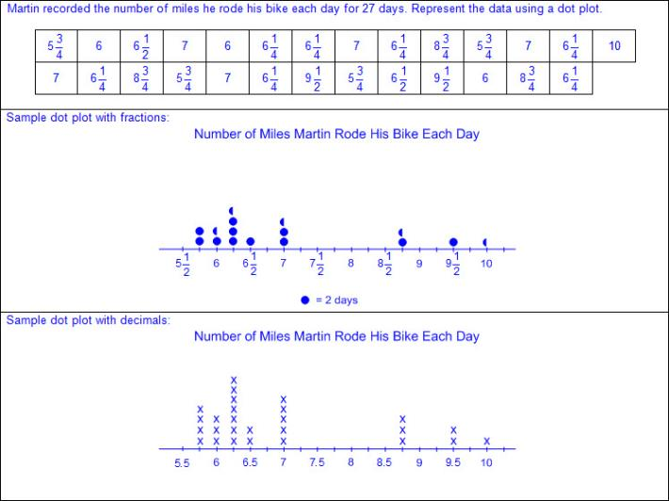  - Stem-and-leaf plot – a graphical representation used to analyze and compare groups or clusters of numerical data by separating one place value from another place value of a data set. The larger of the two place values is called the stem and the smaller of the two place values is called the leaf.  - Characteristics of a stem-and-leaf plot  - Title clarifies the meaning of the data represented.  - Numerical data is represented with labels and may be whole numbers, fractions, or decimals.  - The place value of the stem and leaf is dependent upon the values of data in the set.  - For decimals and fractions, usually the whole number is the stem and decimal or fractional values are the leaves.  - For sets of data close in value, usually the stem is represented by the place value of a number before the last digit and the leaves are represented by the last digit in the number.  - The stem represents one or more piece of data in the set.  - The leaf represents one piece of data in the set.  - Density of leaves relates to the frequency of distribution of the data.  - Ex:  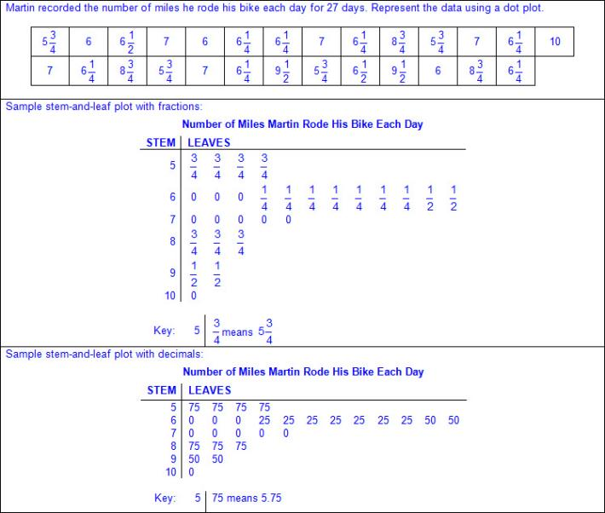  Note(s):  - Grade Level(s):  - Grade 4 represented data on a frequency table, dot plot, or stem-and-leaf plot marked with whole numbers and fractions.  - Grade 6 will represent numeric data graphically, including dot plots, stem-and-leaf plots, histograms, and box plots.  - Various mathematical process standards will be applied to this student expectation as appropriate.  - TxRCFP:  - Organizing, representing, and interpreting sets of data  - TxCCRS:  - VI.A. Statistical Reasoning – Describe Data  - VIII. Problem Solving and Reasoning  - IX. Communication and Representation
5.9B | Represent discrete paired data on a scatterplot.  Supporting Standard  Represent discrete paired data on a scatterplot.  Supporting Standard  Represent  DISCRETE PAIRED DATA ON A SCATTERPLOT  Including, but not limited to:  - Data – information that is collected about people, events, or objects  - Discrete data – data with finite and distinct values, not inclusive of in-between values  - Scatterplot – a graphical representation used to display the relationship between discrete data pairs  - Characteristics of a scatterplot  - Title clarifies the meaning of the data represented.  - Subtitles clarify the meaning of data represented on each axis.  - Numerical data represented with labels may be whole numbers, fractions, or decimals.  - Points are not connected by a line.  - Scales of the axes may be intervals of one or more, and scale intervals are proportionally displayed.  - The scales of the axes are number lines.  - Data pairs are analyzed to find possible relationships between the two sets of data.  - A pair of numbers is collected to determine if a relationship exists between the two sets of data.  - Ex: Distance from basket and number of baskets made  - Ex: Time spent reading and score on reading test  - Various forms of positive rational numbers within related data pairs  - Whole numbers  - Decimals (less than and greater than one to the tenths, hundredths, and thousandths)  - Fractions (proper, improper, and mixed numbers)  - Relationship between related data pairs and ordered pairs graphed in the first quadrant of the coordinate plane  - Scatterplots consist of an x- and y-axis and a series of points (ordered pairs) to represent data from an observation.  - Pairs of data are used to form ordered pairs that can be graphed.  - Attributes of the coordinate plane  - Two number lines intersect perpendicularly to form the axes, which are used to locate points on the plane.  - The horizontal number line is called the x-axis.  - The vertical number line is called the y-axis.  - The x-axis and the y-axis cross at 0 on both number lines and that intersection is called the origin.  - The coordinate pair of numbers corresponding to the origin is (0, 0).  - Relationship between ordered pairs and attributes of the coordinate plane  - A pair of ordered numbers names the location of a point on a coordinate plane.  - Ordered pairs of numbers are indicated within parentheses and separated by a comma (x, y).  - When graphing in Quadrant I, the first number in the ordered pair represents the parallel movement on the x-axis, starting at the origin and moving right.  - When graphing in Quadrant I, the second number in the ordered pair represents the parallel movement on the y-axis, starting at the origin and moving up.  - Ex:  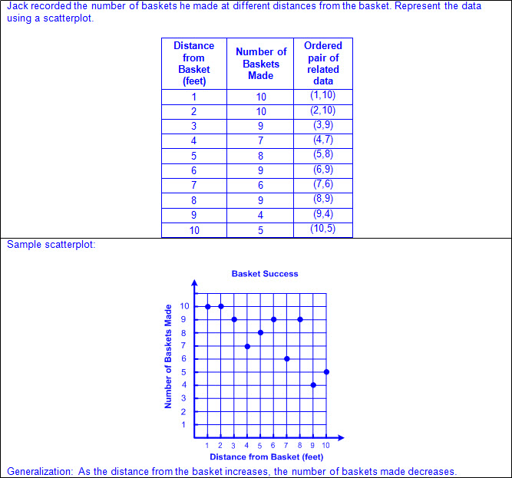  Note(s):  - Grade Level(s):  - Grade 5 introduces representing discrete paired data on a scatterplot.  - Grade 8 will construct a scatterplot and describe the observed data to address questions of association such as linear, non-linear, and no association between bivariate data.  - Various mathematical process standards will be applied to this student expectation as appropriate.  - TxRCFP:  - Organizing, representing, and interpreting sets of data  - TxCCRS:  - VI.A. Statistical Reasoning – Describe Data  - VIII. Problem Solving and Reasoning  - IX. Communication and Representation
5.9C | Solve one- and two-step problems using data from a frequency table, dot plot, bar graph, stem-and-leaf plot, or scatterplot.  Readiness Standard  Solve one- and two-step problems using data from a frequency table, dot plot, bar graph, stem-and-leaf plot, or scatterplot.  Readiness Standard  Solve  ONE- AND TWO-STEP PROBLEMS USING DATA FROM A FREQUENCY TABLE, DOT PLOT, BAR GRAPH, STEM-AND-LEAF PLOT, OR SCATTERPLOT  Including, but not limited to:  - Whole numbers  - Decimals (less than and greater than one to the tenths, hundredths, and thousandths)  - Fractions (proper, improper, or mixed numbers with equal or unequal denominators)  - Addition  - Sums of whole numbers  - Sums of decimals up to the thousandths  - Sums of fractions with equal and unequal denominators  - Subtraction  - Differences of whole numbers  - Differences of decimals with values limited to the thousandths  - Differences of fractions with equal and unequal denominators  - Multiplication  - Products of whole numbers up to three-digit factors by two-digit factors  - Products of decimals limited to three-digit factors by two-digit factors with products to the hundredths  - Multiply tenths by tenths (e.g., 0.3 x 0.7 = 0.21, 1.2 x 1.2 = 1.44, 14.3 x 1.3 = 18.59, etc.)  - Multiply tenths by hundredths or vice versa (e.g., 0.5 x 0.12 = 0.06, 1.4 x 0.15 = 0.21, 21.4 x 0.45 = 9.63, etc.)  - Multiply tenths by thousandths or vice versa (e.g., 0.4 x 0.125 = 0.05, 0.125 x 8.4 = 1.05, etc.)  - Multiply whole numbers by tenths, hundredths, and thousandths or vice versa (e.g., 3 x 1.3 = 3.9, 42 x 7.45 = 312.9, 7.02 x 78 = 547.56, 6 x 0.125 = 0.75, etc.)  - Products of fractions where factors are limited to a fraction and a whole number  - Division  - Whole numbers with quotients up to four-digit dividends and two-digit divisors  - Quotients of decimals limited to four-digit dividends and two-digit whole number divisors, with quotients to the hundredths  - Dividend to the tenths and whole number divisor (e.g., 1.2 ÷ 24 = 0.05, 358.8 ÷ 23 = 15.6, 721.7 ÷ 14 = 51.55, etc.)  - Dividend to the hundredths and whole number divisor (e.g., 8.68 ÷ 4 = 2.17, 8.25 ÷ 15 = 0.55, 62.76 ÷ 12 = 5.23, etc.)  - Whole number dividends and whole number divisors (e.g., 3 ÷ 4 = 0.75, 10 ÷ 8 = 1.25, 1000 ÷ 16 = 62.5, etc.)  - Quotients of fractions where dividend and divisors are limited to whole numbers by unit fractions and unit fractions by whole numbers  - Data – information that is collected about people, events, or objects  - Categorical data – data that represents the attributes of a group of people, events, or objects  - Ex: What is your favorite color? Represented on a graph with colors as category labels (e.g., red, yellow, blue, green, and purple).  - Ex. Do you have a brother? Represented on a graph with yes and no as category labels.  - Ex: Which sporting event do you prefer? Represented on a graph with names of sports as category labels (e.g., basketball, baseball, football, soccer, and hockey).  - Categorical data may represent numbers or ranges of numbers.  - Ex: How many pets do you have? Represented on a graph with numbers as category labels (e.g., 0, 1, 2, 3, and 4 or more).  - Ex: How many letters are in your name? Represented on a graph with ranges of numbers as category labels (e.g., 1 – 3, 4 – 6, 7 – 9, and 10 or more).  - Numerical data – data that represents values or observations that can be measured and placed in ascending or descending order  - Data can be counted (discrete) or measured (continuous)  - Ex: How many hours do you spend studying each night? Represented on a graph with a numerical axis  - Ex: How old were you when you lost your first tooth? Represented on a graph with a numerical axis  - Discrete data – data with finite and distinct values, not inclusive of in-between values  - Data representations  - Frequency table – a table to organize data that lists categories and the frequency (number of times) that each category occurs  - Bar graph – a graphical representation to organize data that uses solid bars that do not touch each other to show the frequency (number of times) that each category occurs  - Dot plot – a graphical representation to organize data that uses dots (or Xs) to show the frequency (number of times) that each number occurs  - Stem-and-leaf plot – a graphical representation used to analyze and compare groups or clusters of numerical data by separating one place value from another place value of a data set. The larger of the two place values is called the stem and the smaller of the two place values is called the leaf.  - Scatterplot – a graphical representation used to display the relationship between discrete data pairs  - One- and two-step problem situations using graphical representations  - Ex:  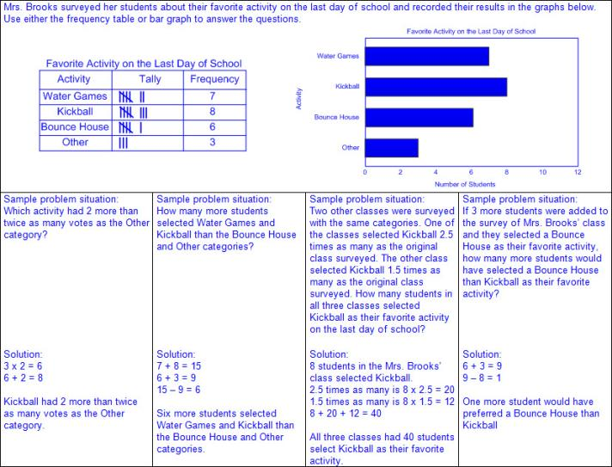  - Ex:  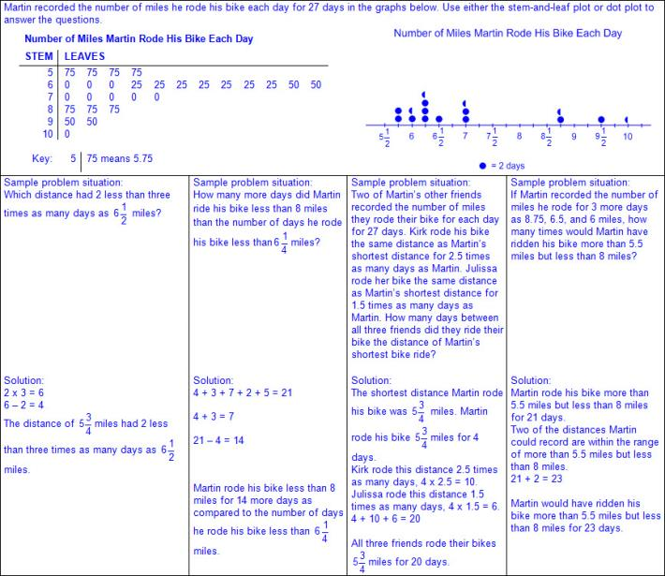  - Ex:  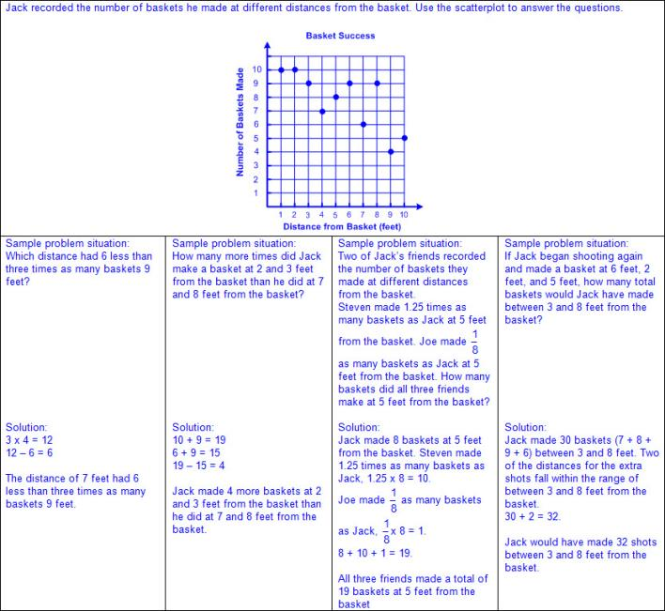  Note(s):  - Grade Level(s):  - Grade 4 solved solve one- and two-step problems using data in whole number, decimal, and fraction form in a frequency table, dot plot, or stem-and-leaf plot.  - Grade 6 will interpret numeric data summarized in dot plots, stem-and-leaf plots, histograms, and box plots.  - Various mathematical process standards will be applied to this student expectation as appropriate.  - TxRCFP:  - Organizing, representing, and interpreting sets of data  - TxCCRS:  - VI.A. Statistical Reasoning – Describe Data  - VIII. Problem Solving and Reasoning  - IX. Communication and Representation
5.10 | Personal financial literacy. The student applies mathematical process standards to manage one's financial resources effectively for lifetime financial security. The student is expected to:
5.10A | Define income tax, payroll tax, sales tax, and property tax.  Supporting Standard  Define income tax, payroll tax, sales tax, and property tax.  Supporting Standard  Define  INCOME TAX, PAYROLL TAX, SALES TAX, AND PROPERTY TAX  Including, but not limited to:  - Income tax – money paid to federal and/or state governments based on an individual's income as required by law  - Income – money earned or received  - Income tax goes directly to federal government; the state of Texas does not collect income tax.  - Payroll tax – the amount of money that a company withholds from its employees for the federal government as required by law  - A portion of the wages of each employee is given directly to the federal government.  - Sales tax – the amount of money collected by a store (retailer), in addition to a good or service that was purchased, for the local government as required by law  - Sales tax is set by the local government (city, county, and state) and the money stays within those local systems.  - Property tax – the amount of money collected on the value of a property for the local government as required by law  - A portion of the value of the property is given to different levels of local government (city and county).  - Taxes help pay for things the government provides to its citizens.  - Ex: Federal taxes pay for social security, national defense, healthcare, etc.  - Ex: Local taxes pay for schools, roads, healthcare, fire departments, police, etc.  Note(s):  - Grade Level(s):  - Grade 4 distinguished between fixed and variable incomes.  - Grade 7 will calculate the sales tax for a given purchase and calculate income tax for earned wages.  - Various mathematical process standards will be applied to this student expectation as appropriate.  - TxRCFP:  - Financial Literacy  - TxCCRS:  - IX. Communication and Representation  - X. Connections
5.10B | Explain the difference between gross income and net income.  Supporting Standard  Explain the difference between gross income and net income.  Supporting Standard  Explain  THE DIFFERENCE BETWEEN GROSS INCOME AND NET INCOME  Including, but not limited to:  - Income – money earned or received  - Gross income – the total amount of personal income prior to taxes and deductions  - Individuals pay income tax on their gross income.  - Net income – the income that remains after taxes and other deductions are taken from an individual’s gross income  - Payroll deductions may include federal and state taxes, health insurance, retirement, etc.  - Calculated by subtracting deductions from gross income  - Businesses and self-employed persons pay income tax on their net income.  - Refers to the ending amount a person should expect “take-home” to use for budgeting for other expenses and savings.  - Ex:  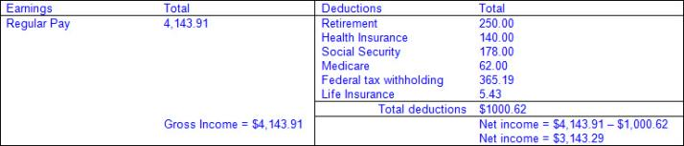  Note(s):  - Grade Level(s):  - Grade 6 will compare the annual salary of several occupations requiring various levels of post-secondary education or vocational training and calculate the effects of the different annual salaries on lifetime income.  - Various mathematical process standards will be applied to this student expectation as appropriate.  - TxRCFP:  - Financial Literacy  - TxCCRS:  - IX. Communication and Representation  - X. Connections
5.10C | Identify the advantages and disadvantages of different methods of payment, including check, credit card, debit card, and electronic payments.  Identify the advantages and disadvantages of different methods of payment, including check, credit card, debit card, and electronic payments.  Identify  THE ADVANTAGES AND DISADVANTAGES OF DIFFERENT METHODS OF PAYMENT, INCLUDING CHECK, CREDIT CARD, DEBIT CARD, AND ELECTRONIC PAYMENTS  Including, but not limited to:  - Check – a written document telling the financial institution to pay a specific amount of money from your account to a specific person or organization  - Must include date, name of payee (person or organization whom to pay), amount, and a signature from the account holder.  - Advantages of checks  - Financial institutions can trace a check to prove your payment was or was not paid.  - Physical copy of transaction may be obtained if duplicate (carbon copy) checks are used or if electronic scanning from a financial institution is available.  - Immediate tracking of payments may help to stay within a budget.  - Payment form for those who do not accept other forms of payment such as credit cards, debit cards, or electronic payments  - Funds may be received without having a bank account.  - Funds may be mailed.  - Disadvantages of checks  - Checks usually must be purchased.  - Timing of withdrawals from bank account depends on when the check is cashed by the payee, which may take days or weeks.  - Fees may be assessed by a financial institution and payee if the value of the check exceeds the available funds in the account and there is not an overdraft protection.  - Bounced check  - Not all retailers accept checks as a form of payment.  - Postage may be required if mailing a check as a form of payment.  - Credit card – a card that can be used to borrow money from financial institutions, stores, or other businesses in order to buy products and services on credit  - Lending company allows an individual to borrow money and pay it back over time  - Advantages of credit cards  - Convenience of not carrying cash, counting change, or writing in a check book  - Quick form of payment by swiping the card and signing for the purchase  - Repayment may occur in one payment or over time.  - Accepted most places as a form of payment  - Incentives may be offered by the lender (e.g., cash back, frequent flier miles, other reward programs, etc.).  - Information from credit card use and payments is linked to an individual’s credit score to determine future lending.  - Theft protection may be available if the card is used without authorization from the cardholder.  - Disadvantages of credit cards  - Fees may be assessed for using a credit card (e.g., annual membership fees, interest rates on unpaid balances, overdraft, etc.).  - Spending may be more difficult to track  - Limits on the amount of money from the lender as available credit may limit purchases  - Failure to repay the entire amount borrowed may result in a decrease an individual’s credit score to determine future lending and/or legal actions from the lender.  - Application required for each credit card obtained  - Not all brands of credit cards are accepted at every location (e.g., American Express, Visa, a store specific credit card, etc.).  - May not be accepted as a form of payment for certain purchases (e.g., school lunches, bus fair, etc.)  - Banking information may be compromised if lost or stolen  - Debit card – a card that is linked to your checking account so that a person can withdraw money, make deposits, or make purchases at a store  - Advantages of debit cards  - Convenience of not carrying cash, counting change, or writing in a checkbook  - Quick form of payment by swiping the card and signing for the purchase or entering a personalized identification code (PIN)  - Money is withdrawn from account within hours of the purchase  - Accepted most places  - No application required  - Incentives may be offered by the financial institution (e.g., cash back, etc.).  - Purchases are usually accepted only for amounts of the available balance in the account  - Disadvantages of debit cards  - Fees may be assessed for withdrawing money from an automated teller machine (ATM).  - Information is not linked to an individual’s credit score.  - Limits may be set by a financial institution regarding the amount of purchases that can be made within a specific time period (e.g., $700 within a 24-hour period).  - Banking information may be compromised if lost or stolen  - Electronic payment (e-payment) – payments using security features on the Internet  - Various types of electronic payments  - One-time customer to vendor payment  - Ex: Online shopping purchase  - Recurring customer-to-vendor payments  - Ex: Payment for monthly bill (e.g., mortgage, phone service, etc.)  - Automatic bank-to-vendor payment  - Ex: Payments initiated at time of purchase (e.g., car payments, life insurance, etc.)  - Advantages of electronic payments  - Convenience of not carrying cash, counting change, or writing in a check book  - Quick form of payment by entering banking information  - No postage needed to mail payment  - May be set up as reoccurring payment  - Disadvantages of electronic payments  - Bank information may be compromised if an unsecure website is used to make a purchase  Note(s):  - Grade Level(s):  - Grade 4 described the basic purpose of financial institutions, including keeping money safe, borrowing money, and lending.  - Grade 6 will distinguish between debit cards and credit cards.  - Various mathematical process standards will be applied to this student expectation as appropriate.  - TxRCFP:  - Financial Literacy  - TxCCRS:  - IX. Communication and Representation  - X. Connections
5.10D | Develop a system for keeping and using financial records.  Develop a system for keeping and using financial records.  Develop  A SYSTEM FOR KEEPING AND USING FINANCIAL RECORDS  Including, but not limited to:  - Financial records – a formal record of the transactions made by a person, business, or other organization  - May includes deposits, receipts, bills, invoices, bank statements, etc.  - Retains all accurate and necessary information of a bank account  - Income – money earned or received  - Register – a small table to track deposits added to account, expenses withdrawn from account, and current available balance  - Manual paper registers are available for maintaining a physical copy of an individual’s financial records.  - Electronic registers and software are available for maintaining an individual’s financial records electronically.  - Available balance – the amount available in an account for a person, business, or organization to spend  - Transaction – a specific time or instance when money changes hands  - Record income and expenses in a register  - Individuals have finite resources (money) and people have to pay for things using their finite amount of money.  - Registers organize and track the income and expenses within a particular account.  - Information in a financial record includes the date of purchase or deposit, description of purchase or deposit, amount of deposit or withdrawal, and a running record of available balance.  - Ex:  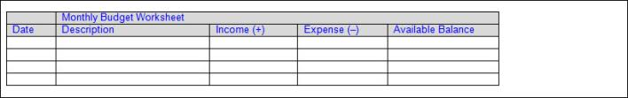  - Process of recording income and expenses in a register  - Record an initial available balance and the date.  - Ex:  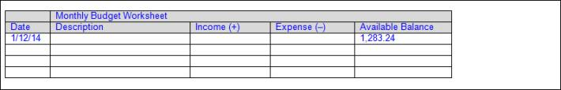  - Log each transaction on a separate row of the register with the date, a description of the payee or deposit, and exact amount of the transaction in either the “income” column or the “expense” column.  - Ex:  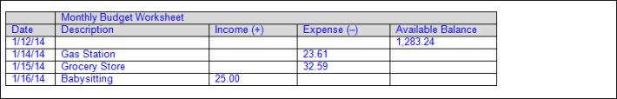  - Calculate the new available balance for each transaction.  - For expense transactions, subtract the amount of the expense from the available balance, making a new available balance less each time.  - For income transactions, add the amount of income to the available balance, making a new available balance more each time.  - Ex:  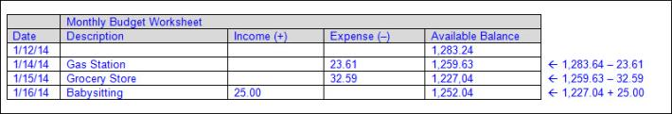  - After all income and expense items have been logged and calculated, the last balance at the bottom of the register is the new available balance to be considered for future spending and saving.  - Ex:  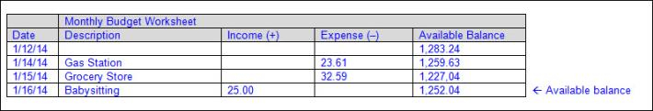  - Budgets based on financial records help people plan and make choices about how to spend and save their money.  - Transactions can be tracked to determine which products and services are wants and which are needs.  - Monthly bank statements allow individuals to reconcile their financial records be verifying their recorded transactions and balances with the bank’s record of transactions and balances.  Note(s):  - Grade Level(s):  - Grade 4 described how to allocate a weekly allowance among spending; saving, including for college; and sharing.  - Grade 6 will compare the features and costs of a checking account and a debit card offered by different local financial institutions.  - Various mathematical process standards will be applied to this student expectation as appropriate.  - TxRCFP:  - Financial Literacy  - TxCCRS:  - IX. Communication and Representation  - X. Connections
5.10E | Describe actions that might be taken to balance a budget when expenses exceed income.  Supporting Standard  Describe actions that might be taken to balance a budget when expenses exceed income.  Supporting Standard  Describe  ACTIONS THAT MIGHT BE TAKEN TO BALANCE A BUDGET WHEN EXPENSES EXCEED INCOME  Including, but not limited to:  - Balance – to reconcile your budget or account statement with your check register to make sure the records match and are accurate  - Available balance – the amount available in an account for a person, business, or organization to spend  - Budget – a monthly or yearly spending and savings plan for an individual, family, business, or organization  - Income – money earned or received  - Expense – payment for goods and services  - Transaction – a specific time or instance when money changes hands  - Register – a small table to track deposits added to account, expenses withdrawn from account, and current available balance  - Individuals have finite resources (money) and people have to pay for things using their finite amount of money.  - Budgets based on financial records help people plan and make choices about how to spend and save their money.  - Transactions can be tracked to determine which products and services are wants and which are needs.  - Actions to balance a budget  - Increase the available balance by depositing additional funds into the account.  - Ex: Working an additional job to increase the income for the budget or borrowing money from a lender.  - Remove or reduce expenses from the budget that may not be necessary.  - Ex: Remove a purchase that may be considered a want and not a need.  - Ex: Reduce the amount of money spent on eating out.  - Budget planning should be adhered to closely and include funds allotted for unexpected expenses to provide less opportunity for expenses to exceed income.  - Unexpected expenses include car repairs, emergency healthcare, etc.  Note(s):  - Grade Level(s):  - Grade 5 introduces describing actions that might be taken to balance a budget when expenses exceed income.  - Various mathematical process standards will be applied to this student expectation as appropriate.  - TxRCFP:  - Financial Literacy  - TxCCRS:  - IX. Communication and Representation  - X. Connections
5.10F | Balance a simple budget.  Supporting Standard  Balance a simple budget.  Supporting Standard  Balance  A SIMPLE BUDGET  Including, but not limited to:  - Balance – to reconcile your budget or account statement with your check register to make sure the records match and are accurate  - Available balance – the amount available in an account for a person, business, or organization to spend  - Budget – a monthly or yearly spending and savings plan for an individual, family, business, or organization.  - Various categories for a budget may include income, savings, emergencies, household expenses, automobile expenses, etc.  - A determined amount must be set for each expense category as a limit.  - Income amounts are expected for the budget and do not have a limit.  - Transaction – a specific time or instance when money changes hands  - Transactions should be recorded with an assigned category to track spending within a budget.  - The sum of the transactions for a category subtracted from the budgeted amount for the category should be greater than or equal to zero.  - Ex:  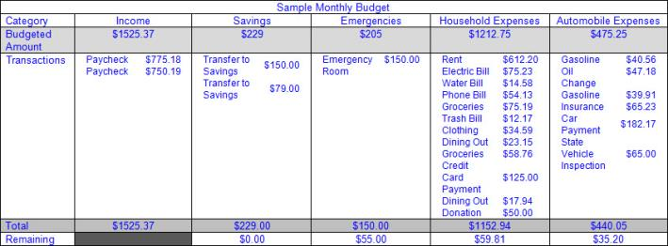  - Money remaining in a budget expense category may be rolled over into a savings account or used for other expenditures that are wanted and not necessarily needed.  Note(s):  - Grade Level(s):  - Grade 5 introduces balancing a simple budget.  - Grade 7 will identify the components of a personal budget, including income, planned savings for college, retirement, and emergencies, taxes, fixed and variable expenses, and calculate what percentage each category comprises of the total budget.  - Various mathematical process standards will be applied to this student expectation as appropriate.  - TxRCFP:  - Financial Literacy  - TxCCRS:  - I. Numeric Reasoning  - VIII. Problem Solving and Reasoning  - IX. Communication and Representation  - X. Connections
Bibliography:
Texas Education Agency & Texas Higher Education Coordinating Board. (2009). Texas college and career readiness standards. Retrieved from http://www.thecb.state.tx.us/collegereadiness/crs.pdf

Texas Education Agency. (2013). Introduction to the revised mathematics TEKS – kindergarten-algebra I vertical alignment. Retrieved from
http://www.projectsharetexas.org/sites/default/files/resources/documents/K-AlgebraIVAChart.pdf

Texas Education Agency. (2013). Texas response to curriculum focal points for kindergarten through grade 8 mathematics. Retrieved from
http://projectsharetexas.org/resource/txrcfp-texas-response-curriculum-focal-points-k-8-mathematics-revised-2013
Bold black text in italics: Knowledge and Skills Statement (TEKS); Bold black text: Student Expectation (TEKS)
Bold red text in italics: Student Expectation identified by TEA as a Readiness Standard for STAAR
Bold green text in italics: Student Expectation identified by TEA as a Supporting Standard for STAAR
Blue text: Supporting information / Clarifications from TCMPC (Specificity)

