Enhanced TEKS Clarification

Mathematics

Grade 3

2014 - 2015
Grade 3
§111.1. Implementation of Texas Essential Knowledge and Skills for Mathematics, Elementary, Adopted 2012.
Source: The provisions of this §111.1 adopted to be effective September 10, 2012, 37 TexReg 7109.
§111.5. Grade 3, Adopted 2012.
3.Intro.1 | The desire to achieve educational excellence is the driving force behind the Texas essential knowledge and skills for mathematics, guided by the college and career readiness standards. By embedding statistics, probability, and finance, while focusing on computational thinking, mathematical fluency, and solid understanding, Texas will lead the way in mathematics education and prepare all Texas students for the challenges they will face in the 21st century.

3.Intro.2 | The process standards describe ways in which students are expected to engage in the content. The placement of the process standards at the beginning of the knowledge and skills listed for each grade and course is intentional. The process standards weave the other knowledge and skills together so that students may be successful problem solvers and use mathematics efficiently and effectively in daily life. The process standards are integrated at every grade level and course. When possible, students will apply mathematics to problems arising in everyday life, society, and the workplace. Students will use a problem-solving model that incorporates analyzing given information, formulating a plan or strategy, determining a solution, justifying the solution, and evaluating the problem-solving process and the reasonableness of the solution. Students will select appropriate tools such as real objects, manipulatives, algorithms, paper and pencil, and technology and techniques such as mental math, estimation, number sense, and generalization and abstraction to solve problems. Students will effectively communicate mathematical ideas, reasoning, and their implications using multiple representations such as symbols, diagrams, graphs, computer programs, and language. Students will use mathematical relationships to generate solutions and make connections and predictions. Students will analyze mathematical relationships to connect and communicate mathematical ideas. Students will display, explain, or justify mathematical ideas and arguments using precise mathematical language in written or oral communication.

3.Intro.3 | For students to become fluent in mathematics, students must develop a robust sense of number. The National Research Council's report, "Adding It Up," defines procedural fluency as "skill in carrying out procedures flexibly, accurately, efficiently, and appropriately." As students develop procedural fluency, they must also realize that true problem solving may take time, effort, and perseverance. Students in Grade 3 are expected to perform their work without the use of calculators.

3.Intro.4 | The primary focal areas in Grade 3 are place value, operations of whole numbers, and understanding fractional units. These focal areas are supported throughout the mathematical strands of number and operations, algebraic reasoning, geometry and measurement, and data analysis. In Grades 3-5, the number set is limited to positive rational numbers. In number and operations, students will focus on applying place value, comparing and ordering whole numbers, connecting multiplication and division, and understanding and representing fractions as numbers and equivalent fractions. In algebraic reasoning, students will use multiple representations of problem situations, determine missing values in number sentences, and represent real-world relationships using number pairs in a table and verbal descriptions. In geometry and measurement, students will identify and classify two-dimensional figures according to common attributes, decompose composite figures formed by rectangles to determine area, determine the perimeter of polygons, solve problems involving time, and measure liquid volume (capacity) or weight. In data analysis, students will represent and interpret data.

3.Intro.5 | Statements that contain the word "including" reference content that must be mastered, while those containing the phrase "such as" are intended as possible illustrative examples.

3.1 | Mathematical process standards. The student uses mathematical processes to acquire and demonstrate mathematical understanding. The student is expected to:
3.1A | Apply mathematics to problems arising in everyday life, society, and the workplace.  Apply mathematics to problems arising in everyday life, society, and the workplace.  Apply  MATHEMATICS TO PROBLEMS ARISING IN EVERYDAY LIFE, SOCIETY, AND THE WORKPLACE  Note(s):  - The mathematical process standards may be applied to all content standards as appropriate.  - TxRCFP:  - Understanding and applying place value and properties of operations to solve problems involving addition and subtraction of whole numbers within 1,000  - Solving problems with multiplication and division within 100  - Understanding fractions as numbers and representing equivalent fractions  - Describing characteristics of two-dimensional and three-dimensional geometric figures, including measurable attributes  - TxCCRS:  - X. Connections
3.1B | Use a problem-solving model that incorporates analyzing given information, formulating a plan or strategy, determining a solution, justifying the solution, and evaluating the problem-solving process and the reasonableness of the solution.  Use a problem-solving model that incorporates analyzing given information, formulating a plan or strategy, determining a solution, justifying the solution, and evaluating the problem-solving process and the reasonableness of the solution.  Use  A PROBLEM-SOLVING MODEL THAT INCORPORATES ANALYZING GIVEN INFORMATION, FORMULATING A PLAN OR STRATEGY, DETERMINING A SOLUTION, JUSTIFYING THE SOLUTION, AND EVALUATING THE PROBLEM-SOLVING PROCESS AND THE REASONABLENESS OF THE SOLUTION  Note(s):  - The mathematical process standards may be applied to all content standards as appropriate.  - TxRCFP:  - Understanding and applying place value and properties of operations to solve problems involving addition and subtraction of whole numbers within 1,000  - Solving problems with multiplication and division within 100  - Understanding fractions as numbers and representing equivalent fractions  - Describing characteristics of two-dimensional and three-dimensional geometric figures, including measurable attributes  - TxCCRS:  - VIII. Problem Solving and Reasoning
3.1C | Select tools, including real objects, manipulatives, paper and pencil, and technology as appropriate, and techniques, including mental math, estimation, and number sense as appropriate, to solve problems.  Select tools, including real objects, manipulatives, paper and pencil, and technology as appropriate, and techniques, including mental math, estimation, and number sense as appropriate, to solve problems.  Select  TOOLS, INCLUDING REAL OBJECTS, MANIPULATIVES, PAPER AND PENCIL, AND TECHNOLOGY AS APPROPRIATE, TO SOLVE PROBLEMS  Select  TECHNIQUES, INCLUDING MENTAL MATH, ESTIMATION, AND NUMBER SENSE AS APPROPRIATE, TO SOLVE PROBLEMS  Note(s):  - The mathematical process standards may be applied to all content standards as appropriate.  - TxRCFP:  - Understanding and applying place value and properties of operations to solve problems involving addition and subtraction of whole numbers within 1,000  - Solving problems with multiplication and division within 100  - Understanding fractions as numbers and representing equivalent fractions  - Describing characteristics of two-dimensional and three-dimensional geometric figures, including measurable attributes  - TxCCRS:  - VIII. Problem Solving and Reasoning
3.1D | Communicate mathematical ideas, reasoning, and their implications using multiple representations, including symbols, diagrams, graphs, and language as appropriate.  Communicate mathematical ideas, reasoning, and their implications using multiple representations, including symbols, diagrams, graphs, and language as appropriate.  Communicate  MATHEMATICAL IDEAS, REASONING, AND THEIR IMPLICATIONS USING MULTIPLE REPRESENTATIONS, INCLUDING SYMBOLS, DIAGRAMS, GRAPHS, AND LANGUAGE AS APPROPRIATE  Note(s):  - The mathematical process standards may be applied to all content standards as appropriate.  - TxRCFP:  - Understanding and applying place value and properties of operations to solve problems involving addition and subtraction of whole numbers within 1,000  - Solving problems with multiplication and division within 100  - Understanding fractions as numbers and representing equivalent fractions  - Describing characteristics of two-dimensional and three-dimensional geometric figures, including measurable attributes  - TxCCRS:  - IX. Communication and Representation
3.1E | Create and use representations to organize, record, and communicate mathematical ideas.  Create and use representations to organize, record, and communicate mathematical ideas.  Create, Use  REPRESENTATIONS TO ORGANIZE, RECORD, AND COMMUNICATE MATHEMATICAL IDEAS  Note(s):  - The mathematical process standards may be applied to all content standards as appropriate.  - TxRCFP:  - Understanding and applying place value and properties of operations to solve problems involving addition and subtraction of whole numbers within 1,000  - Solving problems with multiplication and division within 100  - Understanding fractions as numbers and representing equivalent fractions  - Describing characteristics of two-dimensional and three-dimensional geometric figures, including measurable attributes  - TxCCRS:  - IX. Communication and Representation
3.1F | Analyze mathematical relationships to connect and communicate mathematical ideas.  Analyze mathematical relationships to connect and communicate mathematical ideas.  Analyze  MATHEMATICAL RELATIONSHIPS TO CONNECT AND COMMUNICATE MATHEMATICAL IDEAS  Note(s):  - The mathematical process standards may be applied to all content standards as appropriate.  - TxRCFP:  - Understanding and applying place value and properties of operations to solve problems involving addition and subtraction of whole numbers within 1,000  - Solving problems with multiplication and division within 100  - Understanding fractions as numbers and representing equivalent fractions  - Describing characteristics of two-dimensional and three-dimensional geometric figures, including measurable attributes  - TxCCRS:  - X. Connections
3.1G | Display, explain, and justify mathematical ideas and arguments using precise mathematical language in written or oral communication.  Display, explain, and justify mathematical ideas and arguments using precise mathematical language in written or oral communication.  Display, Explain, Justify  MATHEMATICAL IDEAS AND ARGUMENTS USING PRECISE MATHEMATICAL LANGUAGE IN WRITTEN OR ORAL COMMUNICATION  Note(s):  - The mathematical process standards may be applied to all content standards as appropriate.  - TxRCFP:  - Understanding and applying place value and properties of operations to solve problems involving addition and subtraction of whole numbers within 1,000  - Solving problems with multiplication and division within 100  - Understanding fractions as numbers and representing equivalent fractions  - Describing characteristics of two-dimensional and three-dimensional geometric figures, including measurable attributes  - TxCCRS:  - IX. Communication and Representation
3.2 | Number and operations. The student applies mathematical process standards to represent and compare whole numbers and understand relationships related to place value. The student is expected to:
3.2A | Compose and decompose numbers up to 100,000 as a sum of so many ten thousands, so many thousands, so many hundreds, so many tens, and so many ones using objects, pictorial models, and numbers, including expanded notation as appropriate.  Readiness Standard  Compose and decompose numbers up to 100,000 as a sum of so many ten thousands, so many thousands, so many hundreds, so many tens, and so many ones using objects, pictorial models, and numbers, including expanded notation as appropriate.  Readiness Standard  Compose, Decompose  NUMBERS UP TO 100,000 AS A SUM OF SO MANY TEN THOUSANDS, SO MANY THOUSANDS, SO MANY HUNDREDS, SO MANY TENS, AND SO MANY ONES USING OBJECTS, PICTORIAL MODELS, AND NUMBERS, INCLUDING EXPANDED NOTATION AS APPROPRIATE  Including, but not limited to:  - Whole numbers (0 – 100,000)  - Counting (natural) numbers – the set of positive numbers that begins at one and increases by increments of one each time {1, 2, 3, ..., n}  - Whole numbers – the set of counting (natural) numbers and zero {0, 1, 2, 3, ..., n}  - Numeral – a symbol used to name a number  - Digit – any numeral from 0 – 9  - Place value – the value of a digit as determined by its location in a number such as ones, tens, hundreds, one thousands, ten thousands, etc.  - Hundred thousands place  - Ten thousands place  - One thousands place  - Hundreds place  - Tens place  - Ones place  - Base-10 place value system  - A number system using ten digits 0 – 9  - Relationships between places are based on multiples of 10.  - Moving left across the places, the values 10 times the position to the right.  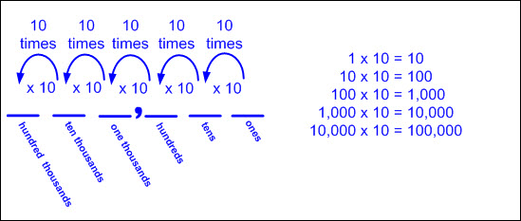  - The magnitude (relative size) of one hundred thousand  - Ex: 100,000 can be represented as 10 ten thousands.  - Ex: 100,000 can be represented as 100 one thousands.  - Ex: 100,000 can be represented as 1,000 hundreds.  - Compose numbers – to combine parts or smaller values to form a number  - Decompose numbers – to break a number into parts or smaller values  - Objects  - Proportional models – a visual representation that demonstrates the relative size of each place value using models with proportional dimensions, meaning the model of each place value is exactly 10 times larger than the place value model to the right (e.g., the base-10 long is exactly 10 times as big as the unit showing that one 10 is equal to ten ones)  - Base-10 blocks for values up to 9,999 (proportional representation of the magnitude of a number with a 1-to-10 relationship)  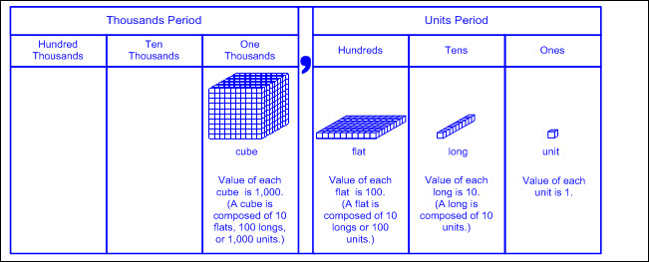  - Non-proportional models – a visual representation that does not maintain the proportional relationship of size, meaning the size of each place value model is not 10 times larger than the place value model to the right (e.g., the value of each place value disk is indicated by the numerical label and color but does not change in size)  - Base-10 blocks for values over 9,999 (repetition of ones, tens, hundreds in each period)  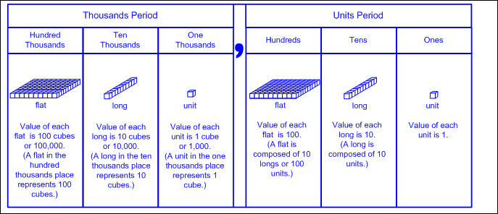  - Place value disks (non-proportional representation with a 1-to-10 relationship)  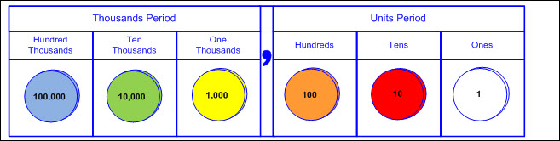  - Pictorial models  - Base-10 block representations for values up to 9,999 (ones, tens, hundreds, one thousands)  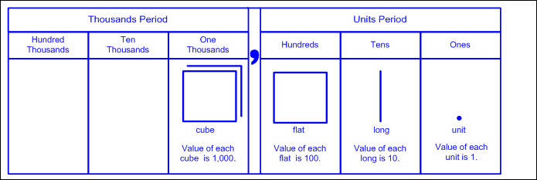  - Base-10 block representations for values over 9,999 (repetition of ones, tens, hundreds in each period)  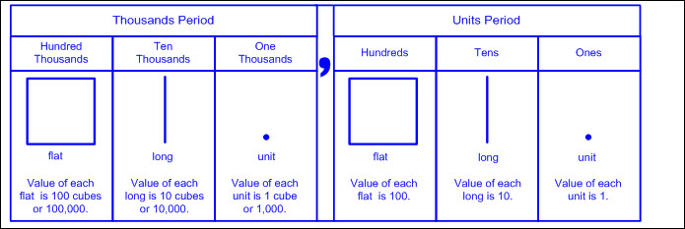  - Place value disk representations  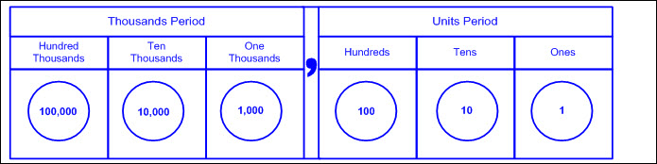  - Open number line – an empty number line where tick marks are added to represent landmarks of numbers, often indicated with arcs above the number line (referred to as jumps) demonstrating approximate proportional distances  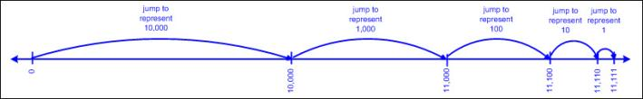  - Multiple concrete and pictorial representations  - Compositions and decompositions as a sum of so many ten thousands, so many thousands, so many hundreds, so many tens, and so many ones  - Ex: Proportional base-10 blocks and the pictorial representation  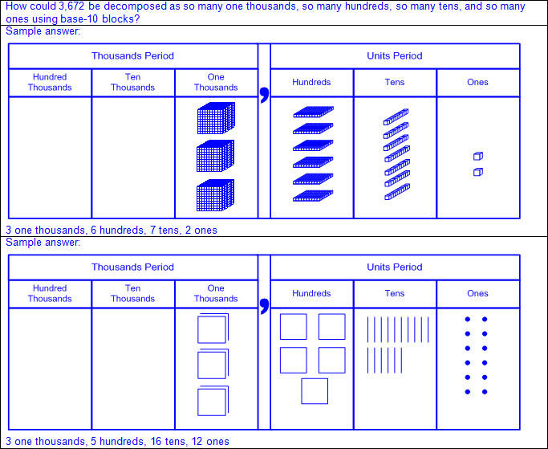  - Ex: Proportional base-10 blocks and the pictorial representation  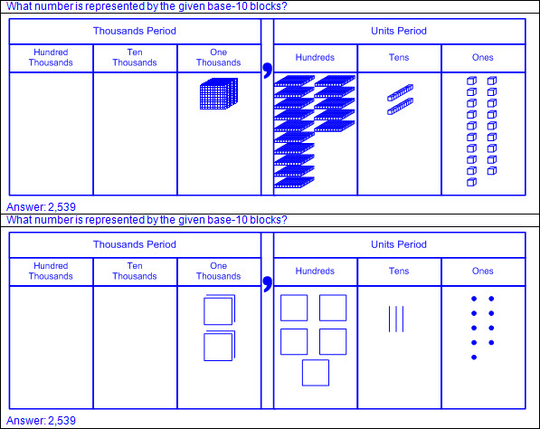  - Ex: Non-proportional base-10 blocks and the pictorial representation  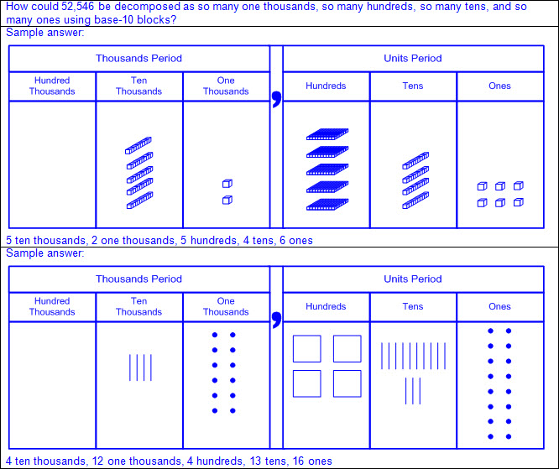  - Ex: Non-proportional base-10 blocks and the pictorial representation  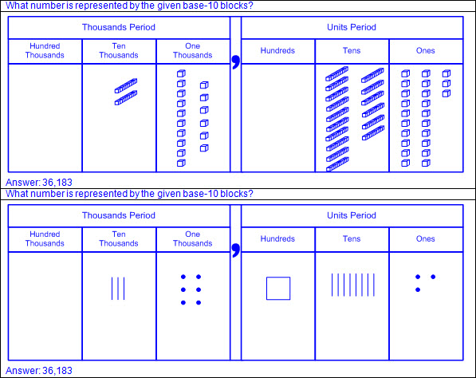  - Ex: Place value disks and the pictorial representation  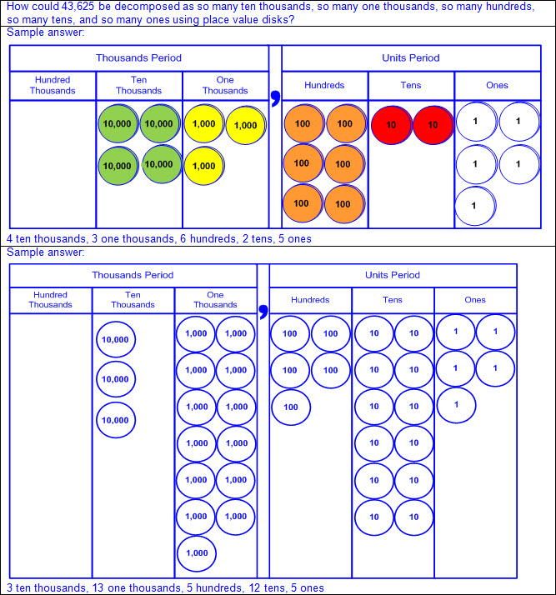  - Ex: Place value disks and the pictorial representation  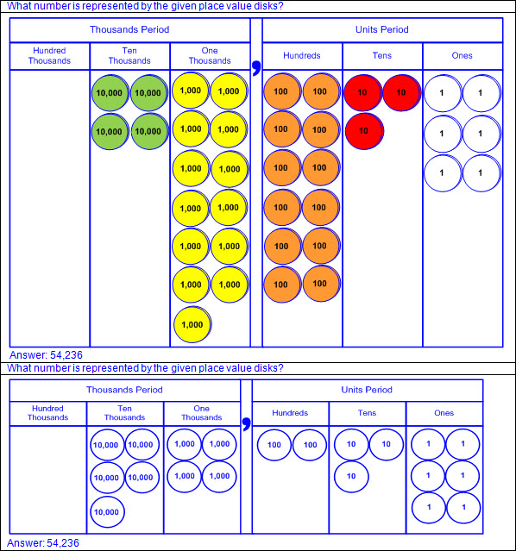  - Ex: Open number lines  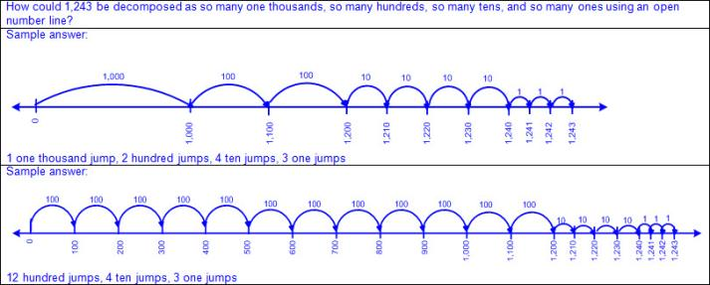  - Ex: Open umber lines  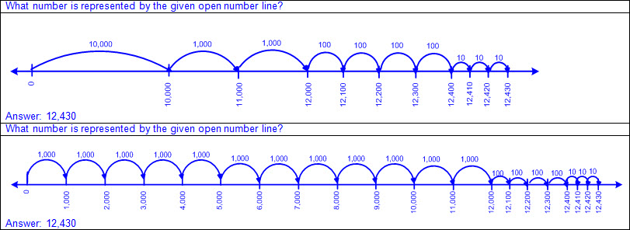  - Expanded form – the representation of a number as a sum of place values (e.g., 56,789 as 50,000 + 6,000 + 700 + 80 + 9)  - Zero may or may not be written as an addend to represent the digit 0 in a number (e.g., 98,075 as 90,000 + 8,000 + 0 + 70 + 5 or as 90,000 + 8,000 + 70 + 5).  - Expanded notation – the representation of a number as a sum of place values where each term is shown as a digit(s) times its place value (e.g., 56,789 as (5 x 10,000) + (6 x 1,000) + (7 x 100) + (8 x 10) + (9 x 1))  - Zero may or may not be written as an addend to represent the digit 0 in a number (e.g., 98,075 as (9 x 10,000) + (8 x 1,000) + (0 x 100) + (7 x 10) + (5 x 1) or as (9 x 10,000) + (8 x 1,000) + (7 x 10) + (5 x 1)).  - Standard form – the representation of a number using digits (e.g., 56,789)  - Period – a three-digit grouping of whole numbers where each grouping is composed of a ones place, a tens place, and a hundreds place, and each grouping is separated by a comma  - Thousands period is composed of the one thousands place, ten thousands place, and hundred thousands place.  - Units period is composed of the ones place, tens place, and hundreds place.  - The word “thousand” after the numerical value of the thousands period is stated when read.  - A comma between the thousands period and the units period is recorded when written but not stated when read.  - The word “unit” after the numerical value of the units period is not stated when read.  - The word “hundred” in each period is stated when read.  - The words “ten” and “one” in each period are not stated when read.  - The tens place digit and ones place digit in each period are stated as a two-digit number when read.  - Zeros are used as place holders between digits as needed to maintain the value of each digit (e.g., 91,075).  - Leading zeros in a whole number are not commonly used in standard form, but are not incorrect and do not change the value of the number (e.g., 037, 564 equals 37,564).  - Ex:  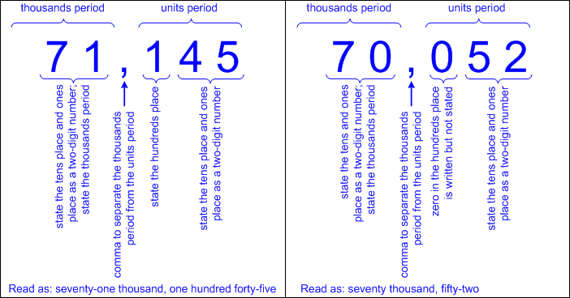  - Word form – the representation of a number using written words (e.g., 56,789 as fifty-six thousand, seven hundred eighty-nine)  - The word “thousand” after the numerical value of the thousands period is stated when read and recorded when written.  - A comma between the thousands period and the units period is not stated when read but is recorded when written.  - The word “unit” after the numerical value of the units period is not stated when read and not recorded when written.  - The word “hundred” in each period is stated when read and recorded when written.  - The words “ten” and “one” in each period are not stated when read and not recorded when written.  - The tens place digit and ones place digit in each period are stated as a two-digit number when read and recorded using a hyphen, where appropriate, when written (e.g., twenty-three, thirteen, etc.).  - The zeros in a whole number are not stated when read and are not recorded when written (e.g., 91,005 in standard form is read and written as ninety-one thousand, five in written form).  - Ex:  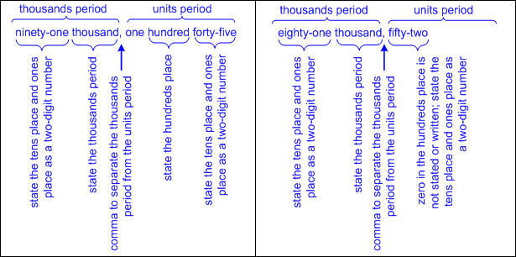  - Multiple numerical representations  - Ex:  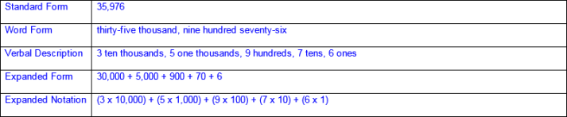  - Place values presented out of order  - Ex:  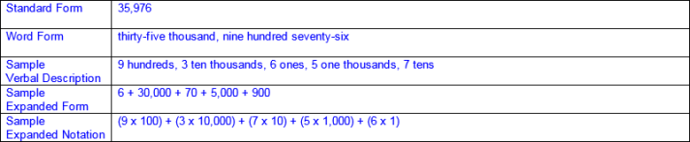  - Equivalent compositions/decompositions of numbers with the same value  - Ex:  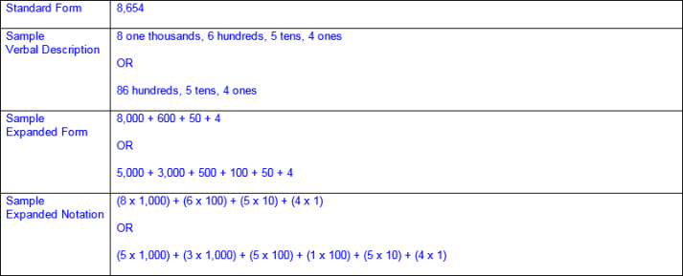  Note(s):  - Grade Level(s):  - Grade 2 used concrete and pictorial models to compose and decompose numbers up to 1,200 in more than one way as a sum of so many one thousands, hundreds, tens, and ones.  - Grade 2 used standard, word, and expanded forms to represent numbers up to 1,200.  - Grade 4 will represent the value of the digit in whole numbers through 1,000,000,000 and decimals to the hundredths using expanded notation and numerals.  - Various mathematical process standards will be applied to this student expectation as appropriate.  - TxRCFP:  - Understanding and applying place value and properties of operations to solve problems involving addition and subtraction of whole numbers within 1,000  - TxCCRS:  - I. Numeric Reasoning  - IX. Communication and Representation
3.2B | Describe the mathematical relationships found in the base-10 place value system through the hundred thousands place.  Supporting Standard  Describe the mathematical relationships found in the base-10 place value system through the hundred thousands place.  Supporting Standard  Describe  THE MATHEMATICAL RELATIONSHIPS FOUND IN THE BASE-10 PLACE VALUE SYSTEM THROUGH THE HUNDRED THOUSANDS PLACE  Including, but not limited to:  - Place value – the value of a digit as determined by its location in a number, such as ones, tens, hundreds, one thousands, ten thousands, etc.  - Hundred thousands place  - Ten thousands place  - One thousands place  - Hundreds place  - Tens place  - Ones place  - Base-10 place value system  - A number system using ten digits 0 – 9  - Relationships between places are based on multiples of 10.  - Moving left across the places, the values are 10 times the position to the right.  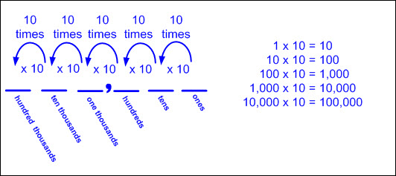  Note(s):  - Grade Level(s):  - Grade 4 will interpret the value of each place-value position as 10 times the position to the right and as one-tenth of the value of the place to its left.  - Various mathematical process standards will be applied to this student expectation as appropriate.  - TxRCFP:  - Understanding and applying place value and properties of operations to solve problems involving addition and subtraction of whole numbers within 1,000  - TxCCRS:  - I. Numeric Reasoning  - IX. Communication and Representation
3.2C | Represent a number on a number line as being between two consecutive multiples of 10; 100; 1,000; or 10,000 and use words to describe relative size of numbers in order to round whole numbers.  Supporting Standard  Represent a number on a number line as being between two consecutive multiples of 10; 100; 1,000; or 10,000 and use words to describe relative size of numbers in order to round whole numbers.  Supporting Standard  Represent  A NUMBER ON A NUMBER LINE AS BEING BETWEEN TWO CONSECUTIVE MULTIPLES OF 10; 100; 1,000; OR 10,000  Including, but not limited to:  - Whole numbers (0 – 100,000)  - Counting (natural) numbers – the set of positive numbers that begins at one and increases by increments of one each time {1, 2, 3, ..., n}  - Whole numbers – the set of counting (natural) numbers and zero {0, 1, 2, 3, ..., n}  - Characteristics of a number line  - A number line begins as a line with predetermined intervals (or tick marks) with positions/numbers labeled.  - A minimum of two positions/numbers should be labeled.  - Numbers on a number line represent the distance from zero.  - The distance between the tick marks is counted rather than the tick marks themselves.  - The placement of the labeled positions/numbers on a number line determines the scale of the number line.  - Intervals between position/numbers are proportional.  - When reasoning on a number line, the position of zero may or may not be placed.  - When working with larger numbers, a number line without the constraint of distance from zero allows the ability to “zoom-in” on the relevant section of the number line.  - Number lines extend infinitely in both directions (arrows indicate the number line continues infinitely).  - Numbers increase from left to right on a horizontal number line and from bottom to top on a vertical number line.  - Points to the left of a specified point on a horizontal number line are less than points to the right.  - Points to the right of a specified point on a horizontal number line are greater than points to the left.  - Points below a specified point on a vertical number line are less than points above.  - Points above a specified point on a vertical number line are greater than points below.  - Characteristics of an open number line  - An open number line begins as a line with no intervals (or tick marks) and no positions/numbers labeled.  - Numbers/positions are placed on the empty number line only as they are needed.  - When reasoning on an open number line, the position of zero is often not placed.  - When working with larger numbers, an open number line without the constraint of distance from zero allows the ability to “zoom-in” on the relevant section of the number line.  - The placement of the first two numbers on an open number line determines the scale of the number line.  - Once the scale of the number line has been established by the placement of the first two numbers, intervals between additional numbers placed are approximately proportional.  - The differences between numbers are approximated by the distance between the positions on the number line.  - Open number lines extend infinitely in both directions (arrows indicate the number line continues infinitely).  - Numbers increase from left to right on a horizontal number line and from bottom to top on a vertical number line.  - Points to the left of a specified point on a horizontal number line are less than points to the right.  - Points to the right of a specified point on a horizontal number line are greater than points to the left.  - Points below a specified point on a vertical number line are less than points above.  - Points above a specified point on a vertical number line are greater than points below.  - Landmark (or anchor) numbers may be placed on the open number line to help locate other numbers.  - Consecutive – a pattern or sequence of numbers in order without interruption  - Number lines representing multiples of 10  - Ex:  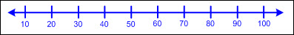  - Number lines representing multiples of 100  - Ex:  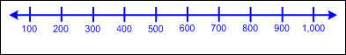  - Number lines representing multiples of 1,000  - Ex:  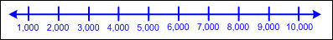  - Number lines representing multiples of 10,000  - Ex:  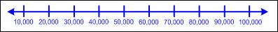  - Numbers between two consecutive multiples of 10 on a number line  - Begin with the original tens place value within the number and then consider the next highest value in the tens place to determine the next consecutive multiple of 10.  - Ex:  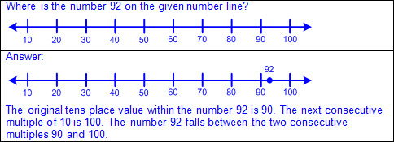  - Ex:  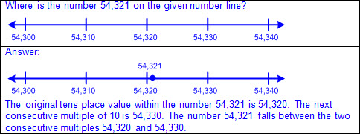  - Numbers between two consecutive multiples of 100 on a number line  - Begin with the original hundreds place value within the number and then consider the next highest value in the hundreds place to determine the next consecutive multiple of 100.  - Ex:  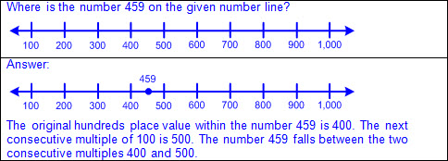  - Ex:  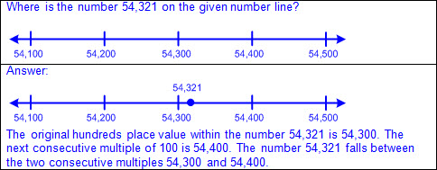  - Numbers between two consecutive multiples of 1,000 on a number line  - Begin with the original thousands place value within the number and then consider the next highest value in the thousands place to determine the next consecutive multiple of 1,000.  - Ex:  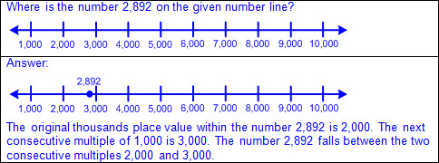  - Ex:  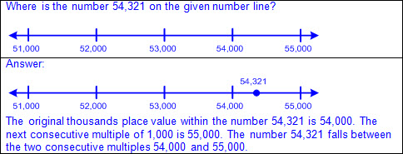  - Numbers between two consecutive multiples of 10,000 on a number line  - Begin with the original ten thousands place value within the number and then consider the next highest value in the ten thousands place to determine the next consecutive multiple of 10,000.  - Ex:  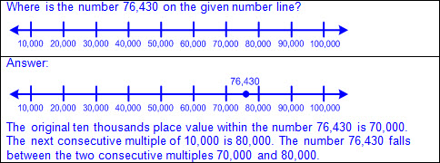  - Numbers between two consecutive multiples of 10 on an open number line  - Begin with the original tens place value within the number and then consider the next highest value in the tens place to determine the next consecutive multiple of 10.  - Ex:  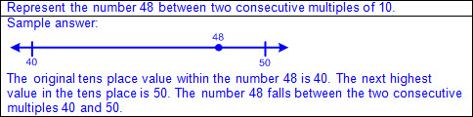  - Ex:  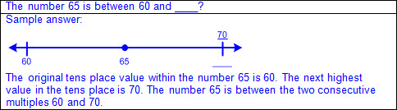  - Ex:  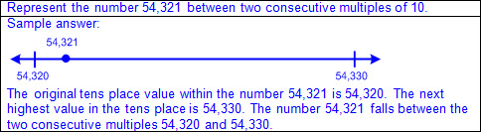  - Numbers between two consecutive multiples of 100 on an open number line  - Begin with the original hundreds place value within the number and then consider the next highest value in the hundreds place to determine the next consecutive multiple of 100.  - Ex:  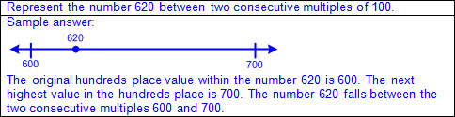  - Ex:  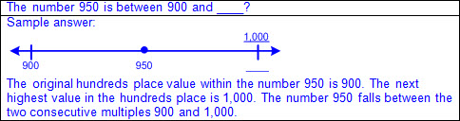  - Ex:  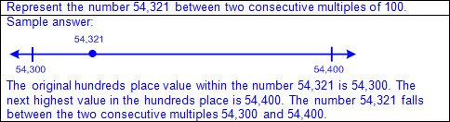  - Numbers between two consecutive multiples of 1,000 on an open number line  - Begin with the original thousands place value within the number and then consider the next highest value in the thousands place to determine the next consecutive multiple of 1,000.  - Ex:  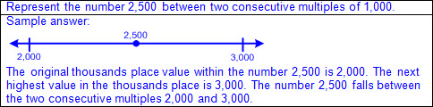  - Ex:  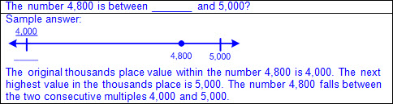  - Ex:  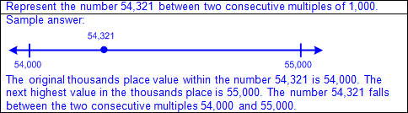  - Numbers between two consecutive multiples of 10,000 on an open number line  - Begin with the original ten thousands place value within the number and then consider the next highest value in the ten thousands place to determine the next consecutive multiple of 10,000.  - Ex:  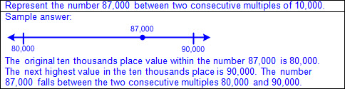  - Ex:  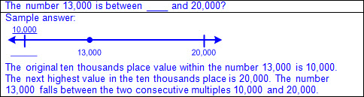  Use  WORDS TO DESCRIBE RELATIVE SIZE OF NUMBERS IN ORDER TO ROUND WHOLE NUMBERS  Including, but not limited to:  - Whole numbers (0 – 100,000)  - Counting (natural) numbers – the set of positive numbers that begins at one and increases by increments of one each time {1, 2, 3, ..., n}  - Whole numbers – the set of counting (natural) numbers and zero {0, 1, 2, 3, ..., n}  - Language to describe relative size of numbers on a number line between two consecutive multiples of 10; 100; 1,000; or 10,000 (e.g., closer to, less than halfway between, more than halfway between, halfway between, nearly, about, etc.)  - Ex: Is closer to ___ than ___.  - Ex: Is less than halfway between ___ and ___.  - Ex: Is more than halfway between ___ and ___.  - Ex: Is halfway between ___ and ___.  - Ex: Is nearly ___.  - Ex: Is about ___.  - Rounding – a type of estimation with specific rules for determining the closest value  - Rounding to the nearest 10 on a number line  - Determine the two consecutive multiples of 10 that the number being rounded falls between.  - Begin with the value of the original tens place within the number and then identify the next highest value in the tens place.  - Determine the halfway point between the consecutive multiples of 10.  - Locate the position of the number being rounded on the number line.  - Determine if the number being rounded is before, past, or on the halfway point between the consecutive multiples of 10 on the number line.  - If the number being rounded is before the halfway point on the number line, round to the value of the original tens place.  - If the number being rounded is past the halfway point on the number line, round to the value of the next highest tens place.  - If the number being rounded is on the halfway point on the number line, round to the value of the next highest tens place.  - Rounding to the nearest 100 on a number line  - Determine the two consecutive multiples of 100 that the number being rounded falls between.  - Begin with the value of the original hundreds place within the number and then identify the next highest value in the hundreds place.  - Determine the halfway point between the consecutive multiples of 100.  - Locate the position of the number being rounded on the number line.  - Determine if the number being rounded is before, past, or on the halfway point between the consecutive multiples of 100 on the number line.  - If the number being rounded is before the halfway point on the number line, round to the value of the original hundreds place.  - If the number being rounded is past the halfway point on the number line, round to the value of the next highest hundreds place.  - If the number being rounded is on the halfway point on the number line, round to the value of the next highest hundreds place.  - Rounding to the nearest 1,000 on a number line  - Determine the two consecutive multiples of 1,000 that the number being rounded falls between.  - Begin with the value of the original thousands place within the number and then identify the next highest value in the thousands place.  - Determine the halfway point between the consecutive multiples of 1,000.  - Locate the position of the number being rounded on the number line.  - Determine if the number being rounded is before, past, or on the halfway point between the consecutive multiples of 1,000 on the number line.  - If the number being rounded is before the halfway point on the number line, round to the value of the original thousands place.  - If the number being rounded is past the halfway point on the number line, round to the value of the next highest thousands place.  - If the number being rounded is on the halfway point on the number line, round to the value of the next highest thousands place.  - Rounding to the nearest 10,000 on a number line  - Determine the two consecutive multiples of 10,000 that the number being rounded falls between.  - Begin with the value of the original ten thousands place within the number and then identify the next highest value in the ten thousands place.  - Determine the halfway point between the consecutive multiples of 10,000.  - Locate the position of the number being rounded on the number line.  - Determine if the number being rounded is before, past, or on the halfway point between the consecutive multiples of 10,000 on the number line.  - If the number being rounded is before the halfway point on the number line, round to the value of the original ten thousands place.  - If the number being rounded is past the halfway point on the number line, round to the value of the next highest ten thousands place.  - If the number being rounded is on the halfway point on the number line, round to the value of the next highest ten thousands place.  - Round a given number to the closest multiple of 10; 100; 1,000; or 10,000 on a number line.  - Ex:  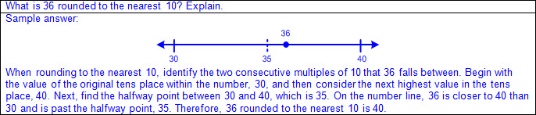  - Ex:  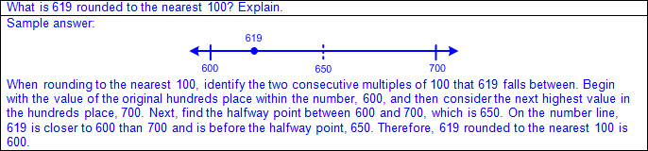  - Ex:  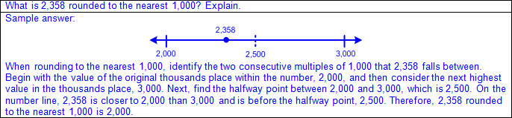  - Ex:  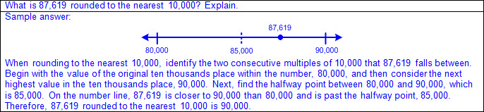  - Ex:  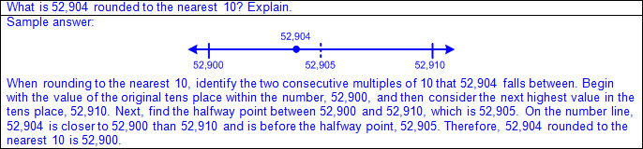  - Ex:  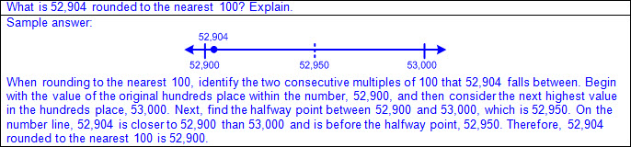  - Ex:  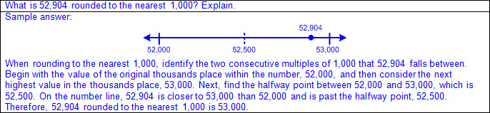  - Ex:  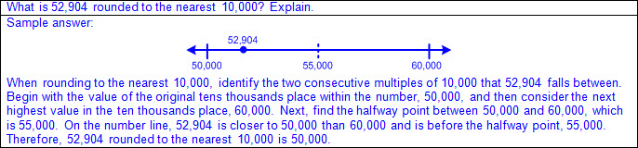  - Round a given number to the greater multiple of 10; 100; 1,000; or 10,000 if it falls exactly halfway between the multiples on a number line.  - Ex:  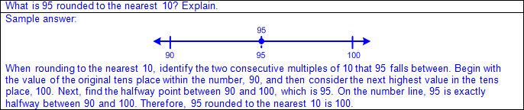  - Ex:  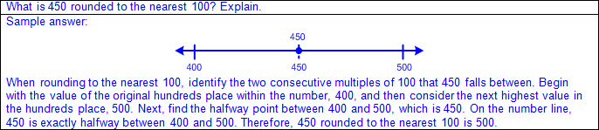  - Ex:  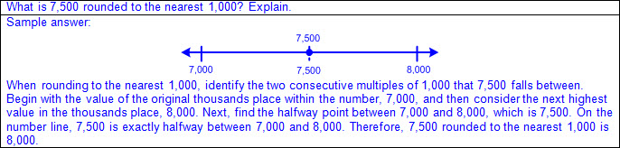  - Ex:  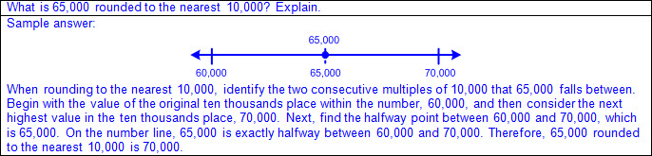  - Ex:  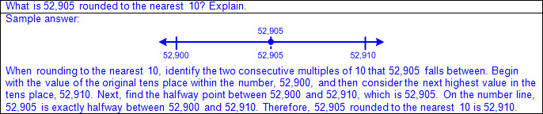  - Ex:  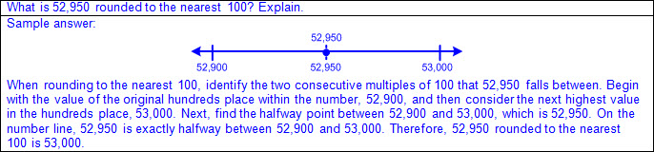  - Ex:  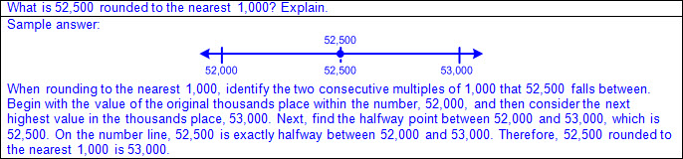  - Ex:  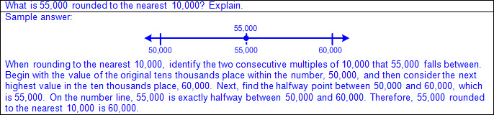  Note(s):  - Grade Level(s):  - Grade 1 introduced open number lines.  - Grade 3 introduces rounding.  - Grade 4 will determine the corresponding decimal to the tenths or hundreds place of a specified point on a number line.  - Various mathematical process standards will be applied to this student expectation as appropriate.  - TxRCFP:  - Understanding and applying place value and properties of operations to solve problems involving addition and subtraction of whole numbers within 1,000  - TxCCRS:  - I. Numeric Reasoning  - IX. Communication and Representation
3.2D | Compare and order whole numbers up to 100,000 and represent comparisons using the symbols >, <, or =.  Readiness Standard  Compare and order whole numbers up to 100,000 and represent comparisons using the symbols >, <, or =.  Readiness Standard  Compare, Order  WHOLE NUMBERS UP TO 100,000  Including, but not limited to:  - Whole numbers (0 – 100,000)  - Counting (natural) numbers – the set of positive numbers that begins at one and increases by increments of one each time {1, 2, 3, ..., n}  - Whole numbers – the set of counting (natural) numbers and zero {0, 1, 2, 3, ..., n}  - Place value – the value of a digit as determined by its location in a number such as ones, tens, hundreds, one thousands, ten thousands, etc.  - Compare numbers – to consider the value of two numbers to determine which number is greater or less or if the numbers are equal in value  - Relative magnitude of a number describes the size of a number and its relationship to another number.  - Ex: 85,000 is closer to 0 on a number line than 95,000, so 85,000 < 95,000 and 95,000 > 85,000.  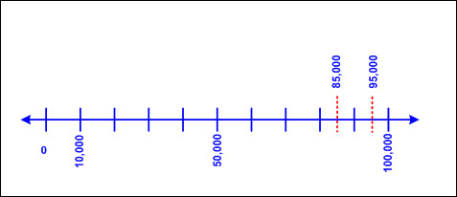  - Ex: 99,750 is further from 0 on a number line than 99,175, so 99,750 > 99,175 and 99,175 < 99,750.  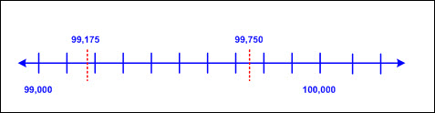  - Compare two numbers using place value charts.  - Compare digits in the same place value position beginning with the greatest place value.  - If these digits are the same, continue to the next smallest place until the digits are different.  - Ex:  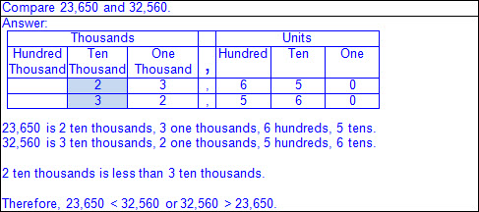  - Numbers that have common digits but are not equal in value (different place values)  - Ex:  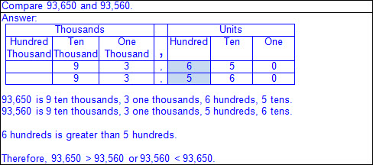  - Numbers that have a different number of digits  - Ex:  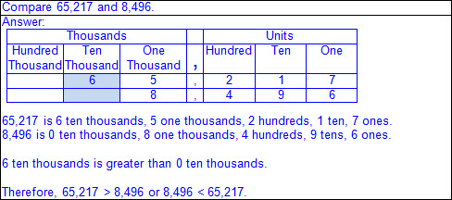  - Compare two numbers using a number line.  - Number lines (horizontal/vertical)  - Proportionally scaled number lines (pre-determined intervals with at least two labeled numbers)  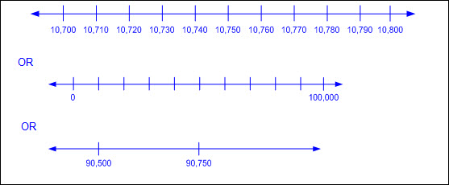  - Open number lines (no marked intervals)  - Ex:  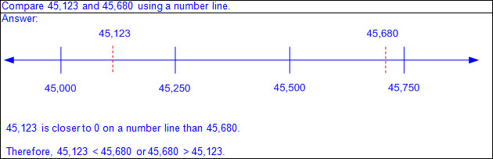  - Order numbers – to arrange a set of numbers based on their numerical value  - Numbers increase from left to right on a horizontal number line and from bottom to top on a vertical number line.  - Points to the left of a specified point on a horizontal number line are less than points to the right.  - Points to the right of a specified point on a horizontal number line are greater than points to the left.  - Points below a specified point on a vertical number line are less than points above.  - Points above a specified point on a vertical number line are greater than points below.  - Order a set of numbers on a number line.  - Ex:  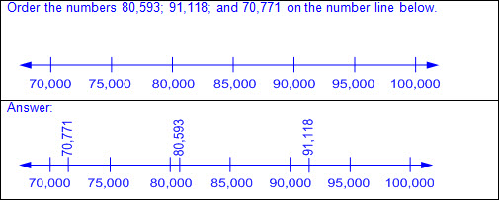  - Order a set of numbers on an open number line.  - Ex:  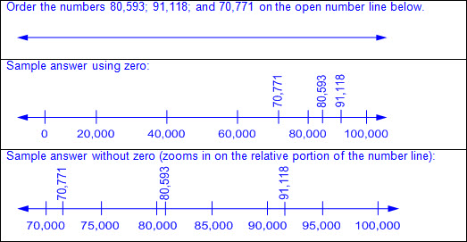  - Quantifying descriptors (e.g., between two given numbers, greatest/least, ascending/descending, tallest/shortest, warmest/coldest, fastest/slowest, longest/shortest, heaviest/lightest, closest/farthest, oldest/youngest, etc.)  - Ex:  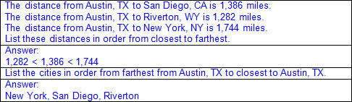  - Ex:  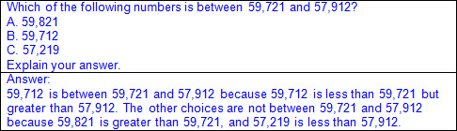  Represent  COMPARISONS OF WHOLE NUMBERS UP TO 100,000 USING THE SYMBOLS >,  Including, but not limited to:  - Whole numbers (0 – 100,000)  - Counting (natural) numbers – the set of positive numbers that begins at one and increases by increments of one each time {1, 2, 3, ..., n}  - Whole numbers – the set of counting (natural) numbers and zero {0, 1, 2, 3, ..., n}  - Comparative language and symbols  - Inequality words and symbols  - Greater than (>)  - Less than (<)  - Ex:  - Equality words and symbol  - Equal to (=)  - Ex:  Note(s):  - Grade Level(s):  - Grade 1 represented the comparison of two numbers to 100 using the symbols >, <, or =.  - Grade 2 used place value to compare and order whole numbers up to 1,200 using comparative language, numbers and the symbols >, <, or =.  - Grade 4 will compare and order whole numbers to 1,000,000,000 and represent comparisons using the symbols >, <, or =.  - Various mathematical process standards will be applied to this student expectation as appropriate.  - TxRCFP:  - Understanding and applying place value and properties of operations to solve problems involving addition and subtraction of whole numbers within 1,000  - TxCCRS:  - I. Numeric Reasoning  - IX. Communication and Representation
3.3 | Number and operations. The student applies mathematical process standards to represent and explain fractional units. The student is expected to:
3.3A | Represent fractions greater than zero and less than or equal to one with denominators of 2, 3, 4, 6, and 8 using concrete objects and pictorial models, including strip diagrams and number lines.  Supporting Standard  Represent fractions greater than zero and less than or equal to one with denominators of 2, 3, 4, 6, and 8 using concrete objects and pictorial models, including strip diagrams and number lines.  Supporting Standard  Represent  FRACTIONS GREATER THAN ZERO AND LESS THAN OR EQUAL TO ONE WITH DENOMINATORS OF 2, 3, 4, 6, AND 8 USING CONCRETE OBJECTS AND PICTORIAL MODELS, INCLUDING STRIP DIAGRAMS AND NUMBER LINES  Including, but not limited to:  - Fractions greater than zero and less than or equal to one  - Fraction – a number in the form where a and b are whole numbers and b is not equal to zero. A fraction can be used to name part of an object or part of a set of objects.  - Relationship between the whole and the part  - Numerator – the part of a fraction written above the fraction bar that tells the number of fractional parts specified or being considered  - Denominator – the part of a fraction written below the fraction bar that tells the total number of equal parts in a whole or set  - Whole number denominators of 2, 3, 4, 6, and 8  - Determination of the whole  - One object or shape defined as the whole  - Multiple connected shapes or objects defined as the whole  - A set of separate objects defined as the whole  - Concrete models of whole objects  - Linear models  - Cuisenaire rods, fraction bars, customary rulers, linking cube trains, folded paper strips, etc.  - Ex: Cuisenaire rods  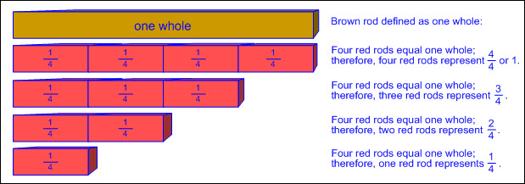  - Ex: Fraction bars  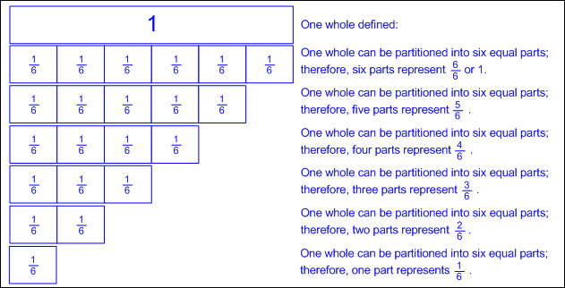  - Ex: Customary ruler  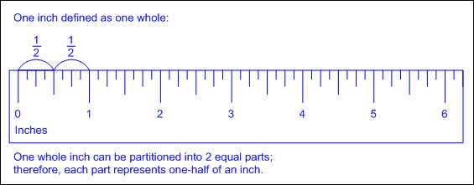  - Ex: Linking cube trains  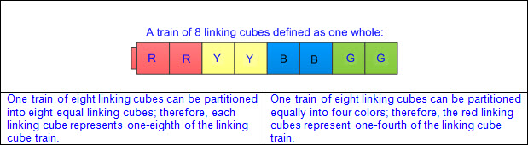  - Ex: Folded paper strip  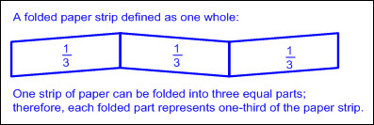  - Area models  - Fraction circles or squares, pattern blocks, geoboards, etc.  - Ex: Fraction circles or squares  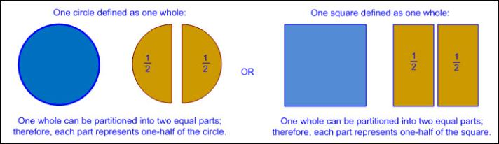  - Ex: Pattern blocks  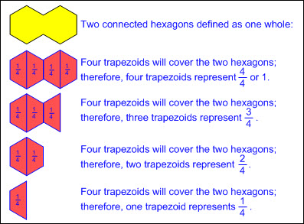  - Ex: Geoboards  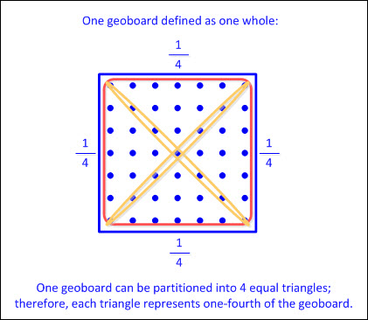  - Concrete models of a set of objects  - Pattern blocks, color tiles, counters, etc.  - Ex: Pattern blocks  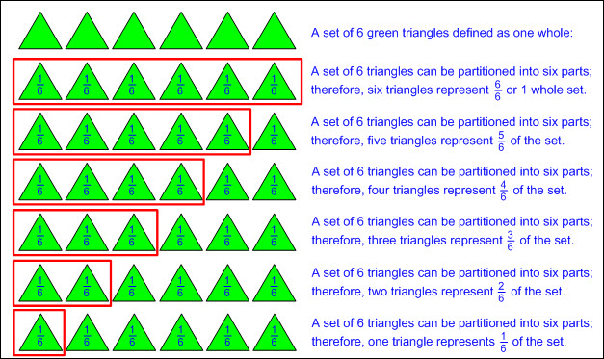  - Ex: Color tiles  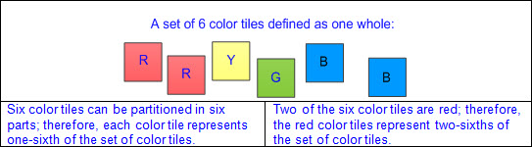  - Ex: Counters  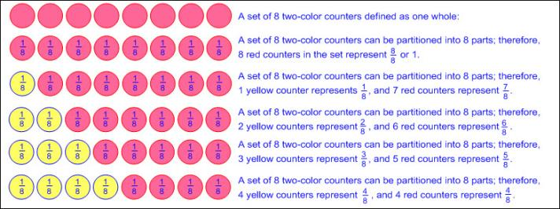  - Pictorial models  - Strip diagram – a linear model used to illustrate number relationships  - Ex: Fraction strips, fraction bar models, etc.  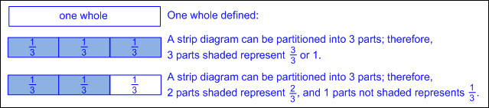  - Number lines  - Ex: Number lines, open number lines, etc.  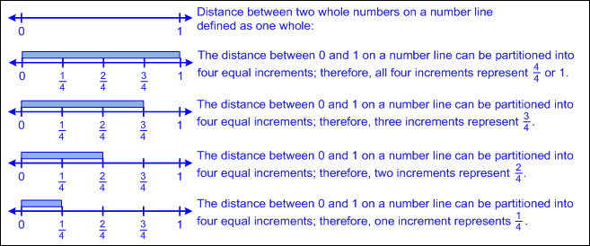  Note(s):  - Grade Level(s):  - Grade 2 used concrete models, pictorials, and words to represent and name fractional parts (e.g., halves, one-half, fourths, one-fourth, etc.).  - Grade 3 introduces the fraction symbol.  - Various mathematical process standards will be applied to this student expectation as appropriate.  - TxRCFP:  - Understanding fractions as numbers and representing equivalent fractions  - TxCCRS:  - I. Numeric Reasoning  - IX. Communication and Representation
3.3B | Determine the corresponding fraction greater than zero and less than or equal to one with denominators of 2, 3, 4, 6, and 8 given a specified point on a number line.  Supporting Standard  Determine the corresponding fraction greater than zero and less than or equal to one with denominators of 2, 3, 4, 6, and 8 given a specified point on a number line.  Supporting Standard  Determine  THE CORRESPONDING FRACTION GREATER THAN ZERO AND LESS THAN OR EQUAL TO ONE WITH DENOMINATORS OF 2, 3, 4, 6, AND 8 GIVEN A SPECIFIED POINT ON A NUMBER LINE  Including, but not limited to:  - Fractions greater than zero and less than or equal to one  - Fraction – a number in the form where a and b are whole numbers and b is not equal to zero. A fraction can be used to name part of an object or part of a set of objects.  - Relationship between the whole and the part  - Numerator – the part of a fraction written above the fraction bar that tells the number of fractional parts specified or being considered  - Denominator – the part of a fraction written below the fraction bar that tells the total number of equal parts in a whole or set  - Characteristics of a number line  - A number line begins as a line with predetermined intervals (or tick marks) with positions/numbers labeled.  - A minimum of two positions/numbers should be labeled.  - Numbers on a number line represent the distance from zero.  - The distance between the tick marks is counted rather than the tick marks themselves.  - The placement of the labeled positions/numbers on a number line determines the scale of the number line.  - Intervals between position/numbers are proportional.  - When reasoning on a number line, the position of zero may or may not be placed.  - When working with larger numbers, a number line without the constraint of distance from zero allows the ability to “zoom-in” on the relevant section of the number line.  - Number lines extend infinitely in both directions (arrows indicate the number line continues infinitely).  - Numbers increase from left to right on a horizontal number line and from bottom to top on a vertical number line.  - Points to the left of a specified point on a horizontal number line are less than points to the right.  - Points to the right of a specified point on a horizontal number line are greater than points to the left.  - Points below a specified point on a vertical number line are less than points above.  - Points above a specified point on a vertical number line are greater than points below.  - Number line from zero to one  - Whole number denominators of 2, 4, and 8  - Multiples of on a number line  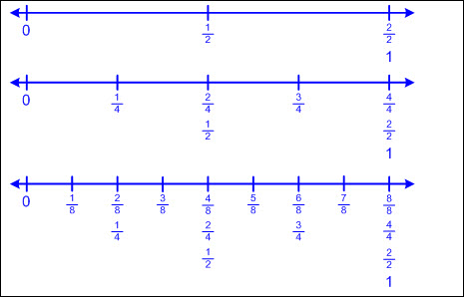  - Whole number denominators of 3 and 6  - Multiples of on a number line  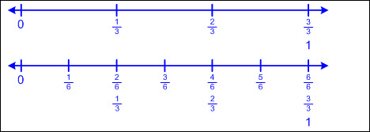  - Determine the corresponding fraction to a specified point on a number line with intervals and partial labels given.  - Ex:  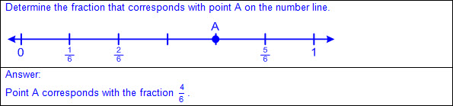  - Ex:  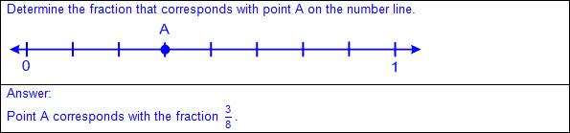  - Ex:  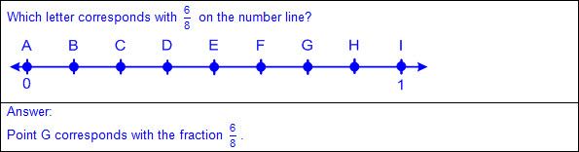  - Determine the corresponding fraction to a specified point on a number line with partial intervals and labels given.  - Ex:  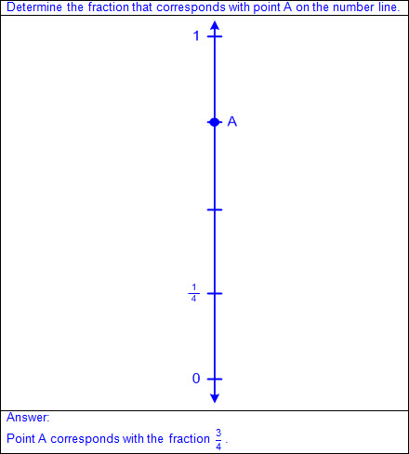  Note(s):  - Grade Level(s):  - Grade 2 used concrete models, pictorials, and words to represent and name fractional parts (e.g., halves, one-half, fourths, one-fourth, etc.).  - Grade 2 named the whole number that corresponds to a specific point on a number line.  - Grade 3 introduces the fraction symbol.  - Various mathematical process standards will be applied to this student expectation as appropriate.  - TxRCFP:  - Understanding fractions as numbers and representing equivalent fractions  - TxCCRS:  - I. Numeric Reasoning  - IX. Communication and Representation
3.3C | Explain that the unit fraction 1/b represents the quantity formed by one part of a whole that has been partitioned into b equal parts where b is a non-zero whole number.  Supporting Standard  Explain that the unit fraction 1/b represents the quantity formed by one part of a whole that has been partitioned into b equal parts where b is a non-zero whole number.  Supporting Standard  Explain  THAT THE UNIT FRACTION REPRESENTS THE QUANTITY FORMED BY ONE PART OF A WHOLE THAT HAS BEEN PARTITIONED INTO b EQUAL PARTS WHERE b IS A NON-ZERO WHOLE NUMBER  Including, but not limited to:  - Fractions greater than zero and less than or equal to one  - Fraction – a number in the form where a and b are whole numbers and b is not equal to zero. A fraction can be used to name part of an object or part of a set of objects.  - Unit fraction – a fraction in the form representing the quantity formed by one part of a whole that has been partitioned into b equal parts where bis a non-zero whole number  - Numerator (a) of 1 written above the fraction bar represents 1 equal part being specified or considered.  - Denominator (b) written below the fraction bar tells the total number of equal parts in the whole or set.  - Whole number denominators of 2, 3, 4, 6, and 8  - The same whole can be partitioned into different unit fractions dependent on the number of equal parts.  - If the same whole is partitioned into 2 equal parts, then each part is represented by the unit fraction .  - If the same whole is partitioned into 3 equal parts, then each part is represented by the unit fraction .  - If the same whole is partitioned into 4 equal parts, then each part is represented by the unit fraction .  - If the same whole is partitioned into 6 equal parts, then each part is represented by the unit fraction .  - If the same whole is partitioned into 8 equal parts, then each part is represented by the unit fraction .  - Ex:  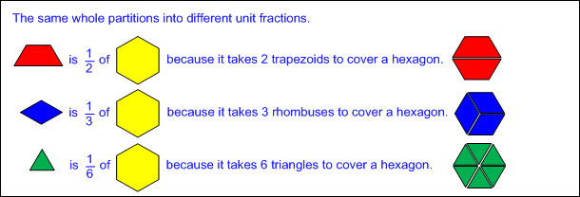  - The same sized part can represent different unit fractions dependent on the defined whole.  - The same size part represents the unit fraction if 2 of the parts equal the defined whole.  - The same size part represents the unit fraction if 3 of the parts equal the defined whole.  - The same size part represents the unit fraction if 4 of the parts equal the defined whole.  - The same size part represents the unit fraction if 6 of the parts equal the defined whole.  - The same size part represents the unit fraction if 8 of the parts equal the defined whole.  - Ex:  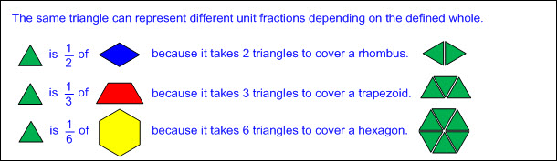  Note(s):  - Grade Level(s):  - Grade 2 explained that the more fractional parts used to make a whole, the smaller the part; and the fewer the fractional parts, the larger the part.  - Grade 3 introduces the fraction symbol.  - Various mathematical process standards will be applied to this student expectation as appropriate.  - TxRCFP:  - Understanding fractions as numbers and representing equivalent fractions  - TxCCRS:  - I. Numeric Reasoning  - IX. Communication and Representation
3.3D | Compose and decompose a fraction a/b with a numerator greater than zero and less than or equal to b as a sum of parts 1/b.  Supporting Standard  Compose and decompose a fraction a/b with a numerator greater than zero and less than or equal to b as a sum of parts 1/b.  Supporting Standard  Compose, Decompose  A FRACTION WITH A NUMERATOR GREATER THAN ZERO AND LESS THAN OR EQUAL TO b AS A SUM OF PARTS  Including, but not limited to:  - Fractions greater than zero and less than or equal to one  - Fraction – a number in the form where a and b are whole numbers and b is not equal to zero. A fraction can be used to name part of an object or part of a set of objects.  - Unit fraction – a fraction in the form representing the quantity formed by one part of a whole that has been partitioned into b equal parts where b is a non-zero whole number  - Numerator (a) of 1 written above the fraction bar represents 1 equal part being specified or considered.  - Denominator (b) written below the fraction bar tells the total number of equal parts in the whole or set.  - Whole number denominators of 2, 3, 4, 6, and 8  - Composition/decomposition of a fraction or a whole using a sum of unit fractions  - Concrete models of whole objects  - Linear models  - Cuisenaire rods, fraction bars, customary rulers, linking cube trains, folded paper strips, etc.  - Ex: Cuisenaire rods  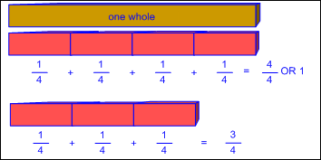  - Ex: Fraction bars  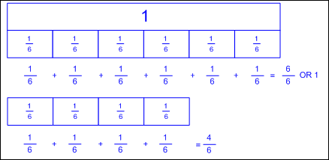  - Ex: Customary rulers  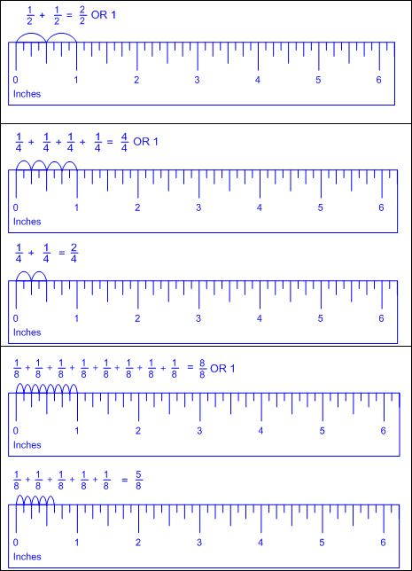  - Ex: Linking cube trains  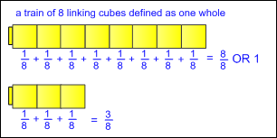  - Ex: Folded paper strip  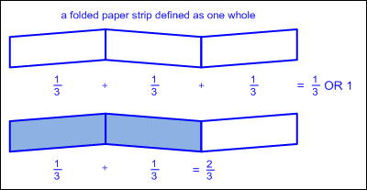  - Area models  - Fraction circles or squares, pattern blocks, geoboards, etc.  - Ex: Fraction circles or squares  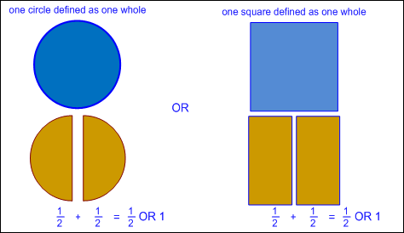  - Ex: Pattern blocks  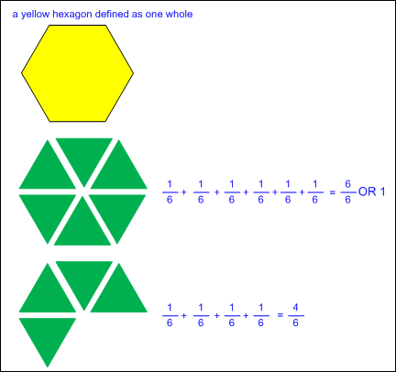  - Ex: Geoboards  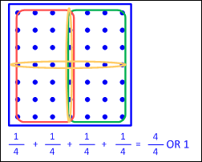  - Concrete models of a set of objects  - Pattern blocks, color tiles, counters, etc.  - Ex: Pattern blocks  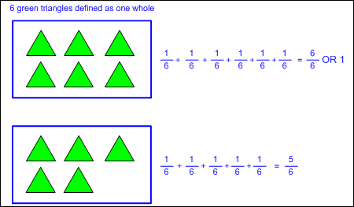  - Ex: Color tiles  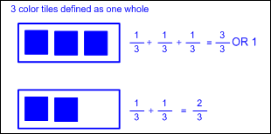  - Ex: Counters  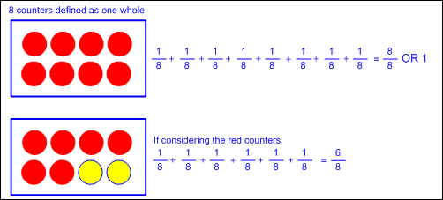  - Pictorial models  - Fraction strips, fraction bar models, number lines, etc.  - Ex:  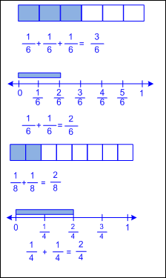  Note(s):  - Grade Level(s):  - Grade 2 used concrete models, pictorials, and words to represent and name fractional parts (e.g., halves, one-half, fourths, one-fourth, etc.).  - Grade 3 introduces the fraction symbol.  - Grade 4 will represent a fraction as a sum of fractions , where a and b are whole numbers and b > 0, including when a > b.  - Grade 4 will decompose a fraction in more than one way into a sum of fractions with the same denominator using concrete and pictorial models and record results with symbolic representations.  - Various mathematical process standards will be applied to this student expectation as appropriate.  - TxRCFP:  - Understanding fractions as numbers and representing equivalent fractions  - TxCCRS:  - I. Numeric Reasoning  - IX. Communication and Representation
3.3E | Solve problems involving partitioning an object or a set of objects among two or more recipients using pictorial representations of fractions with denominators of 2, 3, 4, 6, and 8.  Supporting Standard  Solve problems involving partitioning an object or a set of objects among two or more recipients using pictorial representations of fractions with denominators of 2, 3, 4, 6, and 8.  Supporting Standard  Solve  PROBLEMS INVOLVING PARTITIONING AN OBJECT OR A SET OF OBJECTS AMONG TWO OR MORE RECIPIENTS USING PICTORIAL REPRESENTATIONS OF FRACTIONS WITH DENOMINATORS OF 2, 3, 4, 6, AND 8  Including, but not limited to:  - Fractions greater than zero and less than or equal to one  - Fraction – a number in the form where a and b are whole numbers and b is not equal to zero. A fraction can be used to name part of an object or part of a set of objects.  - Relationship between the whole and the part  - Numerator – the part of a fraction written above the fraction bar that tells the number of fractional parts specified or being considered  - Denominator – the part of a fraction written below the fraction bar that tells the total number of equal parts in a whole or set  - Whole number denominators of 2, 3, 4, 6, and 8  - Pictorial representations  - Strip diagrams, fraction strips, fraction bar models, number lines, etc.  - Partitioning an object in mathematical and real-world problem situations  - Ex:  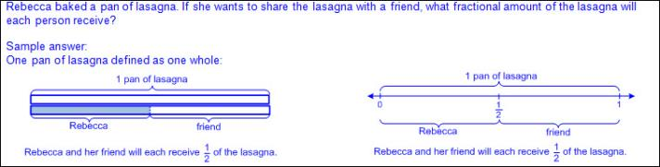  - Ex:  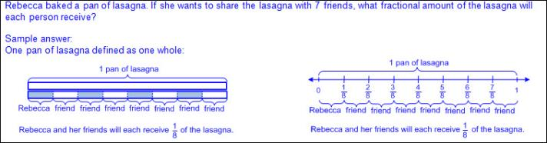  - Partitioning a set of objects in mathematical and real-world problem situations  - Ex:  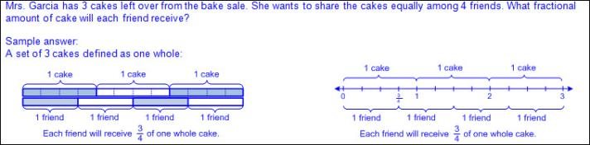  - Ex:  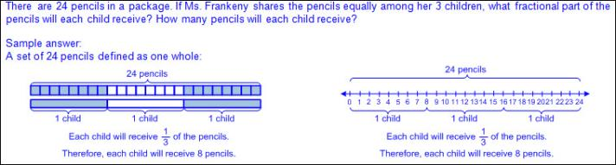  - Ex:  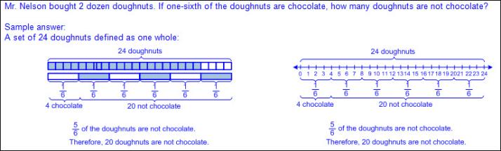  Note(s):  - Grade Level(s):  - Grade 2 used concrete models to count fractional parts beyond one whole using words and recognized how many parts it takes to equal one whole.  - Grade 3 introduces the fraction symbol.  - Various mathematical process standards will be applied to this student expectation as appropriate.  - TxRCFP:  - Understanding fractions as numbers and representing equivalent fractions  - TxCCRS:  - I. Numeric Reasoning  - VIII. Problem Solving and Reasoning  - IX. Communication and Representation
3.3F | Represent equivalent fractions with denominators of 2, 3, 4, 6, and 8 using a variety of objects and pictorial models, including number lines.  Readiness Standard  Represent equivalent fractions with denominators of 2, 3, 4, 6, and 8 using a variety of objects and pictorial models, including number lines.  Readiness Standard  Represent  EQUIVALENT FRACTIONS WITH DENOMINATORS OF 2, 3, 4, 6, AND 8 USING A VARIETY OF OBJECTS AND PICTORIAL MODELS, INCLUDING NUMBER LINES  Including, but not limited to:  - Fractions greater than zero and less than or equal to one  - Fraction – a number in the form where a and b are whole numbers and b is not equal to zero. A fraction can be used to name part of an object or part of a set of objects.  - Equivalent fractions – fractions that have the same value  - Whole number denominators of 2, 3, 4, 6, and 8  - Ex: etc.  - The number 1 as a fraction  - Ex: etc.  - Comparisons of fractions are only valid when referring to the same size whole.  - Relationship between the whole and the part  - Numerator – the part of a fraction written above the fraction bar that tells the number of fractional parts specified or being considere  - Denominator – the part of a fraction written below the fraction bar that tells the total number of equal parts in a whole or set  - Concrete models of whole objects  - Linear models  - Cuisenaire rods, fraction bars, customary rulers, linking cube trains, folded paper strips, etc.  - Ex: Cuisenaire rods  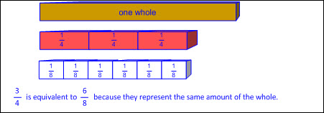  - Ex: Fraction bars  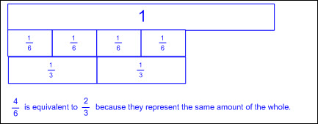  - Ex: Customary ruler  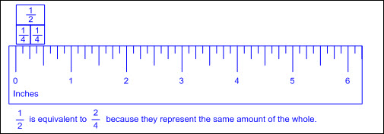  - Ex: Linking cube trains  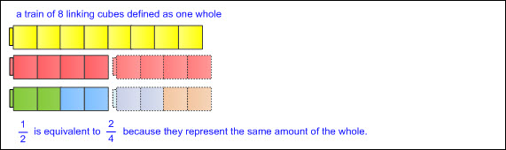  - Ex: Folded paper strip  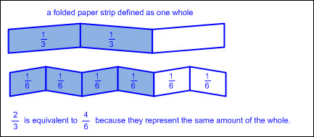  - Area models  - Fraction circles or squares, pattern blocks, geoboards, etc.  - Ex: Fraction circles or squares  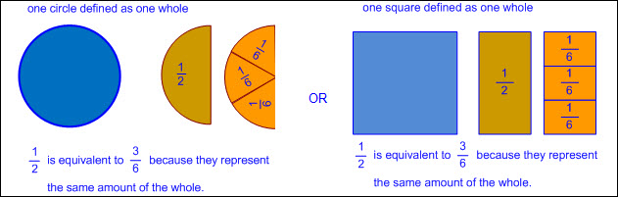  - Ex: Pattern blocks  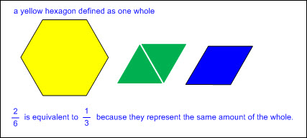  - Ex: Geoboards  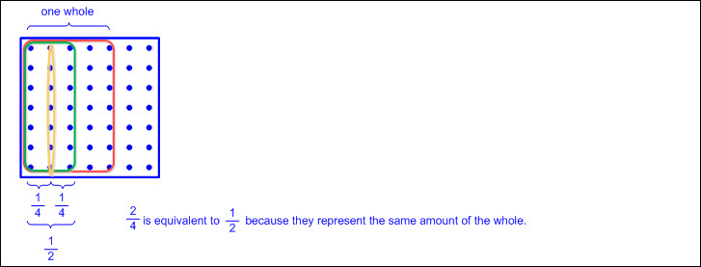  - Concrete models of a set of objects  - Pattern blocks, color tiles, counters, etc.  - Ex: Pattern blocks  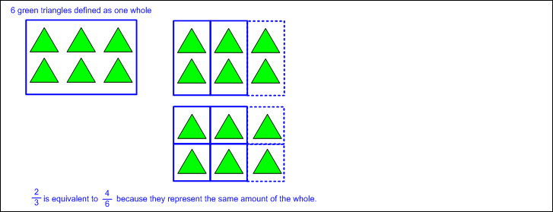  - Ex: Color tiles  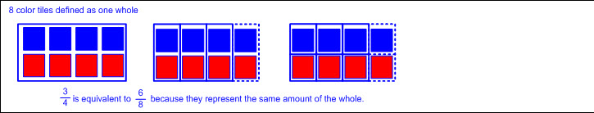  - Ex: Counters  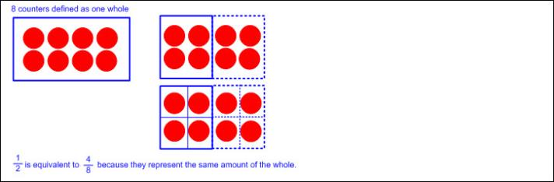  - Pictorial models  - Fraction strips, fraction bar models, number lines, etc.  - Ex:  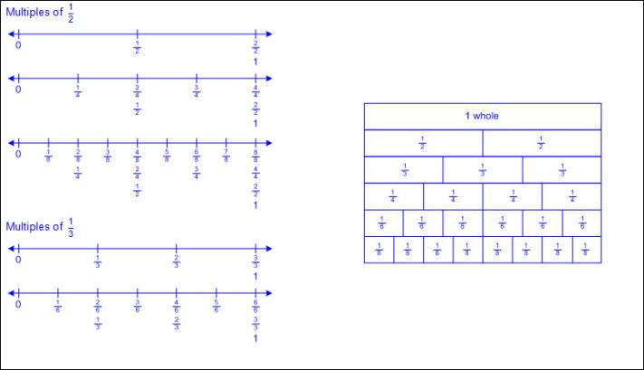  Note(s):  - Grade Level(s):  - Grade 2 used concrete models, pictorials, and words to represent and name fractional parts (e.g., halves, one-half, fourths, one-fourth, etc.).  - Grade 3 introduces the fraction symbol.  - Various mathematical process standards will be applied to this student expectation as appropriate.  - TxRCFP:  - Understanding fractions as numbers and representing equivalent fractions  - TxCCRS:  - I. Numeric Reasoning  - IX. Communication and Representation
3.3G | Explain that two fractions are equivalent if and only if they are both represented by the same point on the number line or represent the same portion of a same size whole for an area model.  Supporting Standard  Explain that two fractions are equivalent if and only if they are both represented by the same point on the number line or represent the same portion of a same size whole for an area model.  Supporting Standard  Explain  THAT TWO FRACTIONS ARE EQUIVALENT IF AND ONLY IF THEY ARE BOTH REPRESENTED BY THE SAME POINT ON THE NUMBER LINE OR REPRESENT THE SAME PORTION OF A SAME SIZE WHOLE FOR AN AREA MODEL  Including, but not limited to:  - Fractions greater than zero and less than or equal to one  - Fraction – a number in the form where a and b are whole numbers and b is not equal to zero. A fraction can be used to name part of an object or part of a set of objects.  - Equivalent fractions – fractions that have the same value  - Comparisons of fractions are only valid when referring to the same size whole.  - Equivalency using a number line  - Ex:  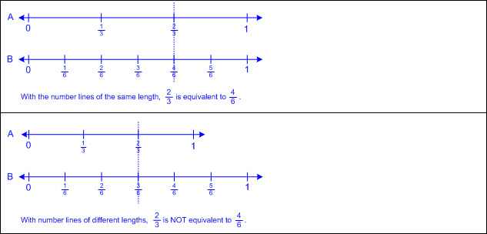  - Equivalency using an area model  - Ex:  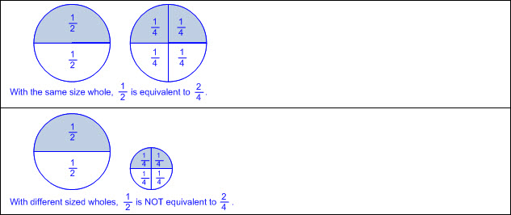  Note(s):  - Grade Level(s):  - Grade 2 used concrete models, pictorials, and words to represent and name fractional parts (e.g., halves, one-half, fourths, one-fourth, etc.).  - Grade 3 introduces the fraction symbol.  - Grade 4 will determine if two given fractions are equivalent using a variety of methods.  - Various mathematical process standards will be applied to this student expectation as appropriate.  - TxRCFP:  - Understanding fractions as numbers and representing equivalent fractions  - TxCCRS:  - I. Numeric Reasoning  - IX. Communication and Representation
3.3H | Compare two fractions having the same numerator or denominator in problems by reasoning about their sizes and justifying the conclusion using symbols, words, objects, and pictorial models.  Readiness Standard  Compare two fractions having the same numerator or denominator in problems by reasoning about their sizes and justifying the conclusion using symbols, words, objects, and pictorial models.  Readiness Standard  Compare  TWO FRACTIONS HAVING THE SAME NUMERATOR OR DENOMINATOR IN PROBLEMS BY REASONING ABOUT THEIR SIZES AND JUSTIFYING THE CONCLUSION USING SYMBOLS, WORDS, OBJECTS, AND PICTORIAL MODELS  Including, but not limited to:  - Fractions greater than zero and less than or equal to one  - Fraction – a number in the form where a and b are whole numbers and b is not equal to zero. A fraction can be used to name part of an object or part of a set of objects.  - Relationship between the whole and the part  - Numerator – the part of a fraction written above the fraction bar that tells the number of fractional parts specified or being considered  - Denominator – the part of a fraction written below the fraction bar that tells the total number of equal parts in a whole or set  - Whole number denominators of 2, 3, 4, 6, and 8  - Comparisons of fractions are only valid when referring to the same size whole.  - Comparison of two fractions with the same numerator  - Common numerators standardize the number of pieces; therefore, compare the size of each piece (denominator).  - Reason about the sizes of fractions with the same numerator.  - Larger denominator → smaller fractional piece → smaller fraction  - Smaller denominator → larger fractional piece → larger fraction  - Comparison of two fractions with the same denominator  - Common denominators standardize the size of the pieces; therefore, compare the number of pieces (numerator).  - Reason about the sizes of fractions with the same denominator.  - Larger numerator → more equal-size fractional pieces → larger fraction  - Smaller numerator → fewer equal-size fractional pieces → smaller fraction  - Justification of comparison  - Symbols  - Inequality words and symbols  - Greater than (>)  - Less than (  - Equality words and symbol  - Equal to (=)  - Words  - Reasoning related to the size of the parts and/or the number of parts  - Objects  - Cuisenaire rods, fraction bars, customary rulers, linking cube trains, folded paper strips, fraction circles or squares, geoboards, pattern blocks, color tiles, counters, etc.  - Pictorial models  - Fraction strips, fraction bar models, number lines, etc.  - Ex:  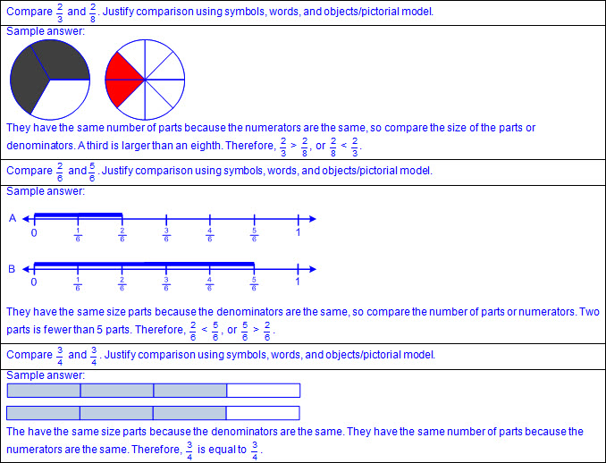  - Comparison of two fractions in mathematical and real-world problem situations  - Ex:  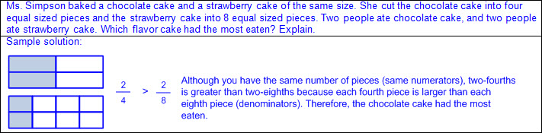  Note(s):  - Grade Level(s):  - Grade 2 used concrete models, pictorials, and words to represent and name fractional parts (e.g., halves, one-half, fourths, one-fourth, etc.).  - Grade 3 introduces the fraction symbol.  - Grade 4 will compare two fractions with different numerators and different denominators and represent the comparison using the symbols  >, =, or <.  - Various mathematical process standards will be applied to this student expectation as appropriate.  - TxRCFP:  - Understanding fractions as numbers and representing equivalent fractions  - TxCCRS:  - I. Numeric Reasoning  - IX. Communication and Representation
3.4 | Number and operations. The student applies mathematical process standards to develop and use strategies and methods for whole number computations in order to solve problems with efficiency and accuracy. The student is expected to:
3.4A | Solve with fluency one-step and two-step problems involving addition and subtraction within 1,000 using strategies based on place value, properties of operations, and the relationship between addition and subtraction.  Readiness Standard  Solve with fluency one-step and two-step problems involving addition and subtraction within 1,000 using strategies based on place value, properties of operations, and the relationship between addition and subtraction.  Readiness Standard  Solve With Fluency  ONE-STEP AND TWO-STEP PROBLEMS INVOLVING ADDITION AND SUBTRACTION WITHIN 1,000 USING STRATEGIES BASED ON PLACE VALUE, PROPERTIES OF OPERATIONS, AND THE RELATIONSHIP BETWEEN ADDITION AND SUBTRACTION  Including, but not limited to:  - Whole numbers  - Counting (natural) numbers – the set of positive numbers that begins at one and increases by increments of one each time {1, 2, 3, ..., n}  - Whole numbers – the set of counting (natural) numbers and zero {0, 1, 2, 3, ..., n}  - Fluency – efficient application of procedures with accuracy  - Addition  - Sum – the total when two or more addends are joined  - Addend – a number being added or joined together with another number(s)  - Addition of whole numbers within 1,000  - Subtraction  - Difference – the remaining amount after the subtrahend has been subtracted from the minuend  - Minuend – a number from which another number will be subtracted  - Subtrahend – a number to be subtracted from a minuend  - Subtraction of whole numbers within 1,000  - Recognition of addition and subtraction in mathematical and real-world problem situations  - One-step and two-step problems  - Addition strategies based on place value  - Ex:  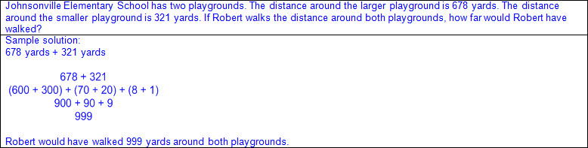  - Addition strategies based on properties of operations  - Ex:  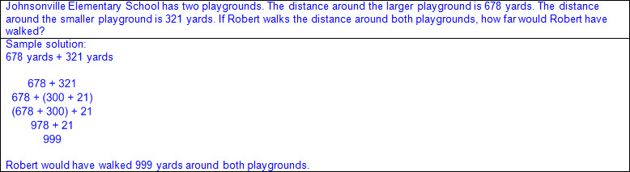  - Addition strategies based on the relationship between addition and subtraction  - Ex:  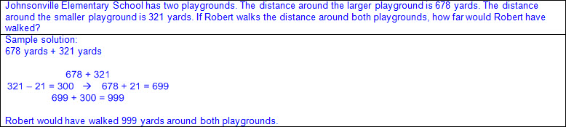  - Subtraction strategies based on place value  - Ex:  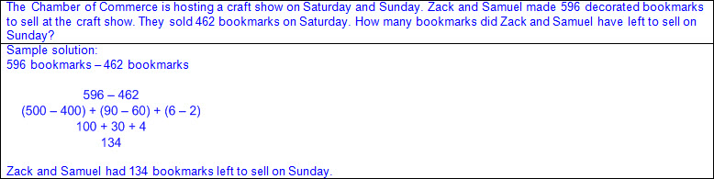  - Subtraction strategies based on properties of operations  - Ex:  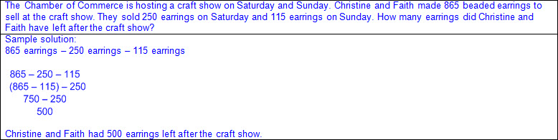  - Subtraction strategies based on the relationship between addition and subtraction  - Ex:  - Mathematical and real-world problem situations with multiple operations  - One-step and two-step problems  - Ex:  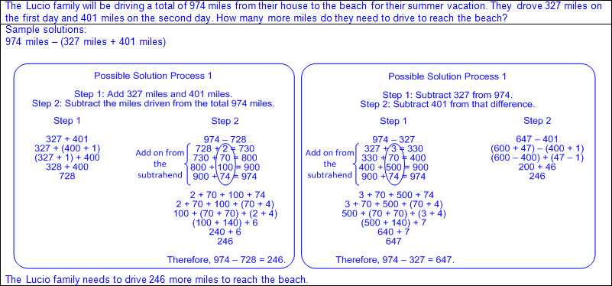  - Equation(s) to reflect solution process  Note(s):  - Grade Level(s):  - Grade 2 solved one-step and multi-step word problems involving addition and subtraction within 1,000 using a variety of strategies based on place value, including algorithms with and without regrouping.  - Grade 4 will add and subtract whole numbers and decimals to the hundredths place using the standard algorithm.  - Various mathematical process standards will be applied to this student expectation as appropriate.  - TxRCFP:  - Understanding and applying place value and properties of operations to solve problems involving addition and subtraction of whole numbers within 1,000  - TxCCRS:  - I. Numeric Reasoning  - VIII. Problem Solving and Reasoning  - IX. Communication and Representation  - X. Connections
3.4B | Round to the nearest 10 or 100 or use compatible numbers to estimate solutions to addition and subtraction problems.  Supporting Standard  Round to the nearest 10 or 100 or use compatible numbers to estimate solutions to addition and subtraction problems.  Supporting Standard  Round  TO THE NEAREST 10 OR 100 TO ESTIMATE SOLUTIONS TO ADDITION AND SUBTRACTION PROBLEMS  Including, but not limited to:  - Whole numbers  - Counting (natural) numbers – the set of positive numbers that begins at one and increases by increments of one each time {1, 2, 3, ..., n}  - Whole numbers – the set of counting (natural) numbers and zero {0, 1, 2, 3, ..., n}  - Addition  - Sum – the total when two or more addends are joined  - Addend – a number being added or joined together with another number(s)  - Addition of whole numbers within 1,000  - Subtraction  - Difference – the remaining amount after the subtrahend has been subtracted from the minuend  - Minuend – a number from which another number will be subtracted  - Subtrahend – a number to be subtracted from a minuend  - Subtraction of whole numbers within 1,000  - Recognition of addition and/or subtraction in mathematical and real-world problem situations  - One-step and two-step problems  - Estimation – reasoning to determine an approximate value  - Rounding – a type of estimation with specific rules for determining the closest value  - To the nearest 10 or 100  - Number lines  - Proportionally scaled number lines (pre-determined intervals)  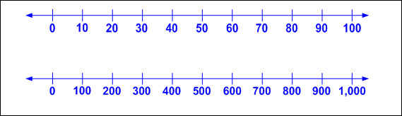  - Open number lines (no marked intervals)  - Relative magnitude of a number describes the size of a number and its relationship to another number.  - Ex:  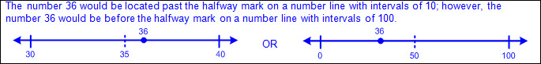  - Rounding to the nearest 10 on a number line  - Determine the two consecutive multiples of 10 that the number being rounded falls between.  - Begin with the value of the original tens place within the number and then identify the next highest value in the tens place.  - Determine the halfway point between the consecutive multiples of 10.  - Locate the position of the number being rounded on the number line.  - Determine if the number being rounded is before, past, or on the halfway point between the consecutive multiples of 10 on the number line.  - If the number being rounded is before the halfway point on the number line, round to the value of the original tens place.  - If the number being rounded is past the halfway point on the number line, round to the value of the next highest tens place.  - If the number being rounded is on the halfway point on the number line, round to the value of the next highest tens place.  - Rounding to the nearest 100 on a number line  - Determine the two consecutive multiples of 100 that the number being rounded falls between.  - Begin with the value of the original hundreds place within the number and then identify the next highest value in the hundreds place.  - Determine the halfway point between the consecutive multiples of 100.  - Locate the position of the number being rounded on the number line.  - Determine if the number being rounded is before, past, or on the halfway point between the consecutive multiples of 100 on the number line.  - If the number being rounded is before the halfway point on the number line, round to the value of the original hundreds place.  - If the number being rounded is past the halfway point on the number line, round to the value of the next highest hundreds place.  - If the number being rounded is on the halfway point on the number line, round to the value of the next highest hundreds place.  - Round a given number to the closest multiple of 10 or 100 on a number line.  - Ex:  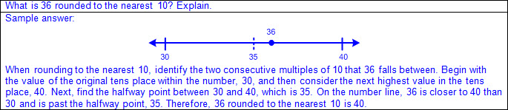  - Ex:  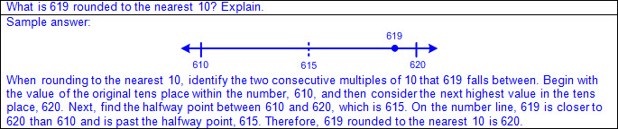  - Ex:  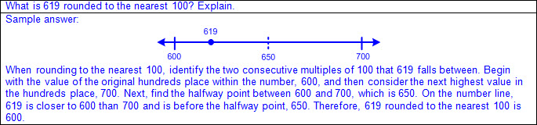  - Round a given number to the higher multiple of 10 or 100 if it falls exactly halfway between the consecutive multiples on a number line.  - Ex:  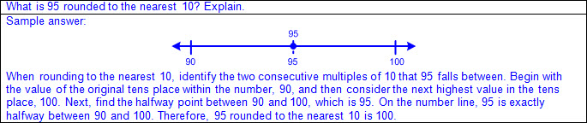  - Ex:  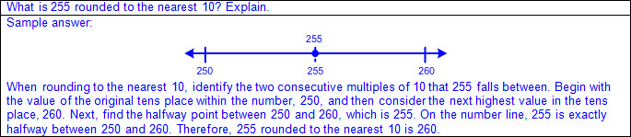  - Ex:  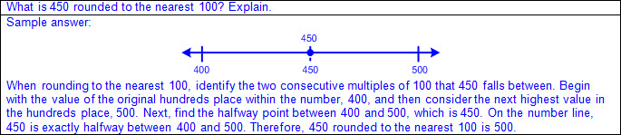  - Round numbers to a common place then compute.  - If not designated, find the greatest common place value of all numbers in the problem to determine the place value to which you are rounding (e.g., round to the nearest 10 if only two-digit numbers are being considered in the problem; round to the nearest 100 if only three-digit numbers are being considered in the problem; round to the nearest 10 if both two-digit and three-digit numbers are being considered in the problem; etc.).  - Vocabulary indicating estimation in mathematical and real-world problem situations (e.g., about, approximately, estimate, etc.)  - Vocabulary descriptors of the effects of the adjustment on the estimation compared to the actual solution (e.g., about, close, little more/little less, around, approximately, estimated, etc.)  - Variation of the estimate from the actual solution is dependent upon the magnitude of the adjustment(s) of the actual numbers.  - Ex:  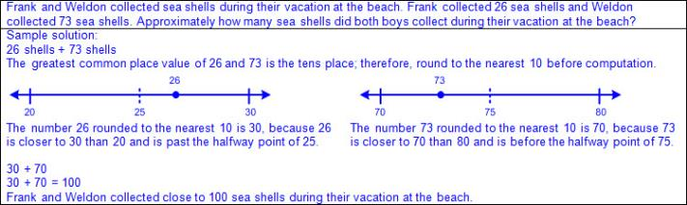  - Ex:  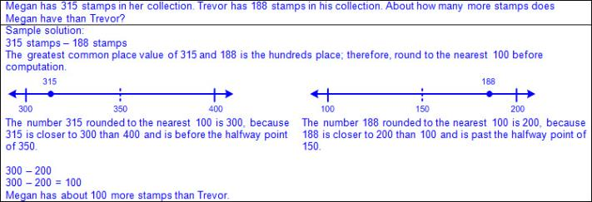  - Ex:  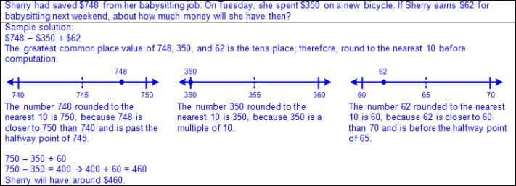  - Rounding numerically based on place value  - Find the place to which you are rounding.  Look at the digit of the next lowest place value, the digit to the right of which you are rounding.  If the digit in that place is less than 5, then the digit in the rounding place remains the same.  If the digit in that place is greater than or equal to 5, then the digit in the rounding place increases by 1.  The digit(s) to the right of the place of which you are rounding is replaced with “0”.  - Ex:  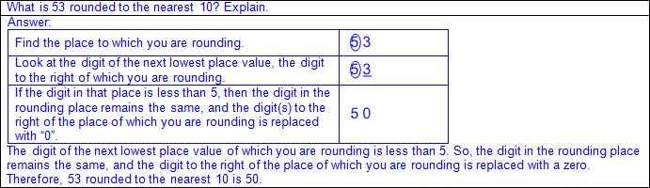  - Ex:  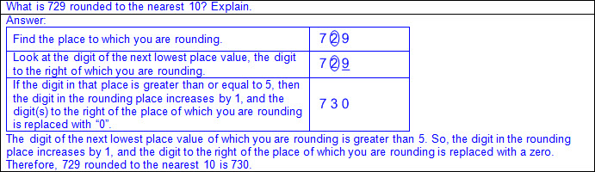  - Ex:  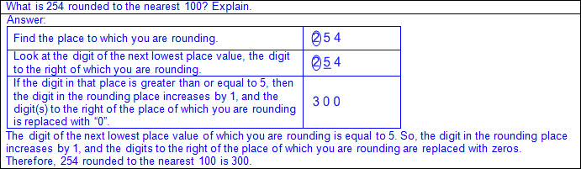  - Round numbers to a common place then compute.  - If not designated, find the greatest common place value of all numbers in the problem to determine the place value to which you are rounding (e.g., round to the nearest 10 if only two-digit numbers are being considered in the problem; round to the nearest 100 if only three-digit numbers are being considered in the problem; round to the nearest 10 if both two-digit and three-digit numbers are being considered in the problem; etc.).  - Vocabulary indicating estimation in mathematical and real-world problem situations (e.g., about, approximately, estimate, etc.)  - Vocabulary descriptors of the effects of the adjustment on the estimation compared to the actual solution (e.g., about, close, little more/little less, around, approximately, estimated, etc.)  - Variation of the estimate from the actual solution is dependent upon the magnitude of the adjustment(s) of the actual numbers.  - Ex:  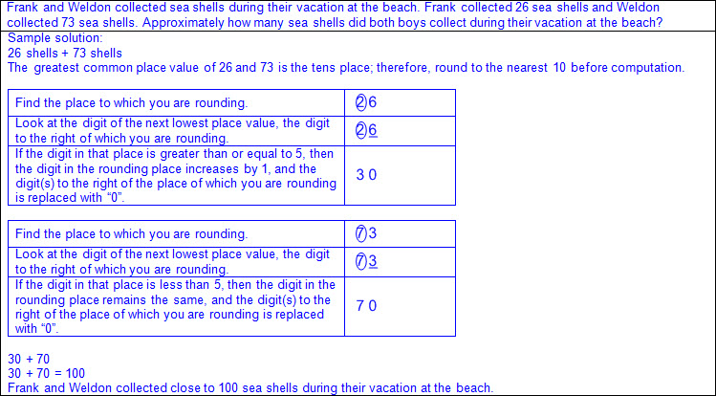  - Ex:  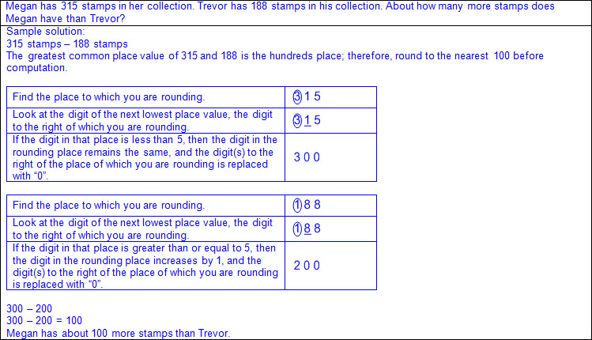  - Ex:  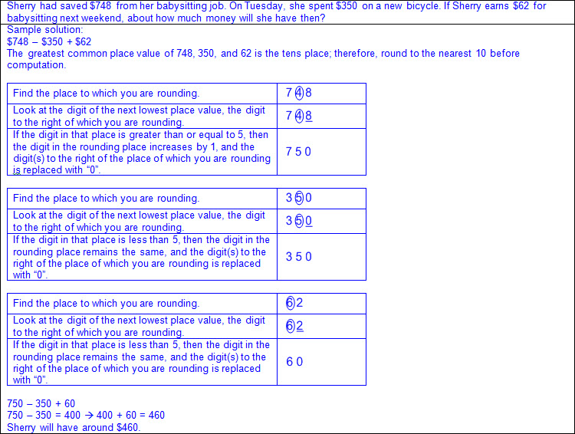  Use  COMPATIBLE NUMBERS TO ESTIMATE SOLUTIONS TO ADDITION AND SUBTRACTION PROBLEMS  Including, but not limited to:  - Whole numbers  - Counting (natural) numbers – the set of positive numbers that begins at one and increases by increments of one each time {1, 2, 3, ..., n}  - Whole numbers – the set of counting (natural) numbers and zero {0, 1, 2, 3, ..., n}  - Addition  - Sum – the total when two or more addends are joined  - Addend – a number being added or joined together with another number(s)  - Addition of whole numbers within 1,000  - Subtraction  - Difference – the remaining amount after the subtrahend has been subtracted from the minuend  - Minuend – a number from which another number will be subtracted  - Subtrahend – a number to be subtracted from a minuend  - Subtraction of whole numbers within 1,000  - Recognition of addition and/or subtraction in mathematical and real-world problem situations  - One-step and two-step problems  - Estimation – reasoning to determine an approximate value  - Compatible numbers – numbers that are slightly adjusted to create groups of numbers that are easy to compute mentally  - Determine compatible numbers then compute.  - Vocabulary indicating estimation in mathematical and real-world problem situations (e.g., about, approximately, estimate, etc.)  - Vocabulary descriptors of the effects of the adjustment on the estimation compared to the actual solution (e.g., about, close, little more/little less, around, approximately, estimated, etc.)  - Variation of the estimate from the actual solution is dependent upon the magnitude of the adjustment(s) of the actual numbers.  - Ex:  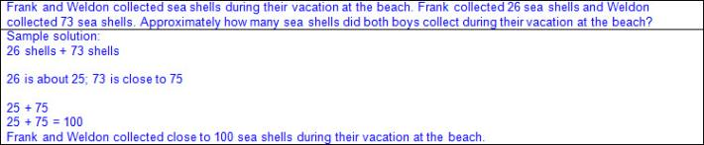  - Ex:  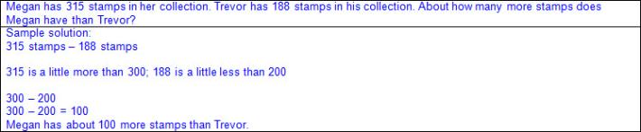  - Ex:  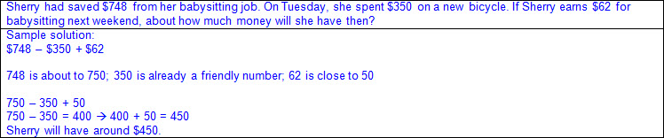  Note(s):  - Grade Level(s):  - Grade 3 introduces rounding and the term compatible numbers.  - Grade 4 will round to the nearest 10, 100, or 1,000 or use compatible numbers to estimate solutions involving whole numbers.  - Various mathematical process standards will be applied to this student expectation as appropriate.  - TxRCFP:  - Understanding and applying place value and properties of operations to solve problems involving addition and subtraction of whole numbers within 1,000  - TxCCRS:  - I. Numeric Reasoning  - VIII. Problem Solving and Reasoning  - IX. Communication and Representation  - X. Connections
3.4C | Determine the value of a collection of coins and bills.  Supporting Standard  Determine the value of a collection of coins and bills.  Supporting Standard  Determine  THE VALUE OF A COLLECTION OF COINS AND BILLS  Including, but not limited to:  - Coins and bills  - Concrete and pictorial models  - Traditional and newly released designs  - Views of both sides of coins and bills  - Skip counting  - Coins and bills in like groups (e.g., half-dollars, quarters, dimes, nickels, pennies, one dollar bills, five dollar bills, ten dollar bills, twenty dollar bills, etc.)  - By ones or twos to determine the value of a collection of pennies or one dollar bills  - By fives to determine the value of a collection of nickels or five dollar bills  - By tens to determine the value of a collection of dimes or ten dollar bills  - By twenties to determine the value of a collection of twenty dollar bills  - By twenty-fives to determine the value of a collection of quarters  - By fifties to determine the value of a collection of half-dollars  - Compound counting to determine the value of a collection of coins and bills  - Separate coins into like groups prior to counting (e.g., five dollars, ten dollars, quarters, dimes, etc.).  - Begin by counting the largest denomination of bills or coins and then count on each denomination of bills or coins in order from largest to smallest.  - Count twenty dollar bills by twenties, count on ten dollar bills by tens, count on five dollar bills by fives, count on one dollar bills by twos or ones, count on half-dollars by fifties, count on quarters by twenty-fives, count on dimes by tens, count on nickels by fives, count on pennies by twos or ones.  - Ex:  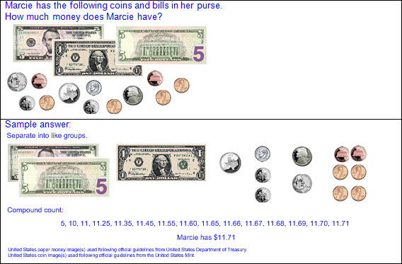  - Whole number computation  - Determine the total value of the collection of coins in cents.  - Determine the total value of the collection of bills in dollars.  - Determine the value of the collection of coins and bills combined.  - Ex:  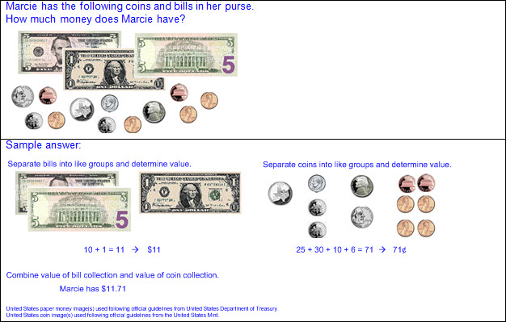  - Exchange of coins to other denominations based on relationships between values  - Ex: 2 dimes and 1 nickel can be exchanged for 1 quarter.  - Ex: 5 dimes can be exchanged for 2 quarters.  - Exchange of coins to equal one dollar based on relationships between values  - Ex:  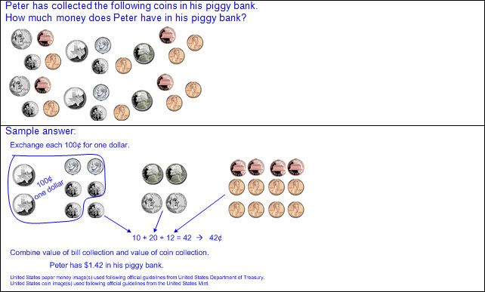  - Exchange of bills to other denominations based on relationships between values  - Ex: 5 one dollar bills can be exchanged for 1 five dollar bill.  - Ex: 5 one dollar bills and 1 five dollar bill can be exchanged for 1 ten dollar bill.  - Create a collection of coins and bills for a given value.  - Comparison of the values of two collections of coins and bills  - Number of coins or bills may not be proportional to the value of the collection.  - Ex: 2 quarters have a greater value than 5 nickels, even though 2 quarters are fewer coins than 5 nickels.  - Multiple combinations of the same value  - Ex:  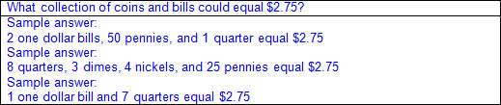  - Ex:  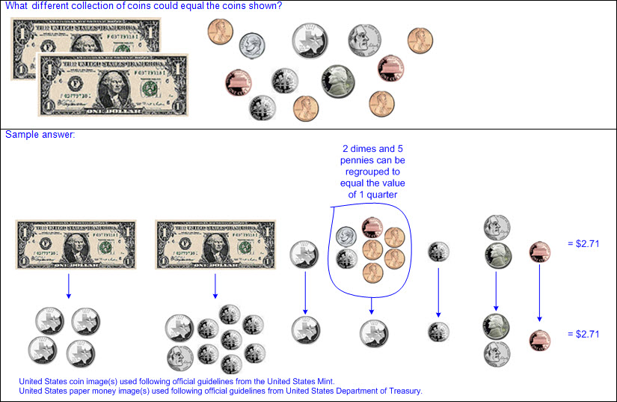  - Minimal set  - Least number of coins or bills to equal a given value  - Ex:  - Value of a collection of coins and bills named with numbers and symbols  - Cent symbol not used in conjunction with dollar symbol and decimal  - Cent symbol (¢)  - Cent symbol written to the right of the numerical value  - Cent label read and written after numerical value  - Ex: Fifty-two cents is written 52¢ and read 52 cents.  - Values equal to or greater than 100 written with cent symbol not customary, but acceptable  - Ex: 100¢, 153¢, etc.  - Dollar symbol ($) and decimal  - Dollar symbol written to the left of the dollar amount  - Decimal separates whole dollar amount from cent amount, or part of a dollar amount  - Dollar label read after dollar amount  - Decimal read as “and”  - Cent label read after cent amount even though the cent symbol is not written  - Ex: $15.29 is read fifteen dollars and twenty-nine cents.  - Zero written for the dollar amount, but not read, if value is less than one dollar  - Ex: $0.79 is read seventy-nine cents.  - Multiple representations of the same value  - Ex: $0.94, 94¢, 94 cents, ninety-four cents  - Ex: $3.43, 343¢, 3 dollars and 43 cents, 343 cents, three dollars and forty-three cents, three hundred forty-three cents  Note(s):  - Grade Level(s):  - Grade 2 determined the value of a collection of coins up to one dollar.  - Grade 2 used the cent symbol, dollar sign, and the decimal point to name the value of a collection of coins.  - Grade 4 will solve problems that involve operations with money.  - Various mathematical process standards will be applied to this student expectation as appropriate.  - TxRCFP:  - Understanding and applying place value and properties of operations to solve problems involving addition and subtraction of whole numbers within 1,000  - TxCCRS:  - I. Numeric Reasoning  - IX. Communication and Representation  - X. Connections
3.4D | Determine the total number of objects when equally-sized groups of objects are combined or arranged in arrays up to 10 by 10.  Supporting Standard  Determine the total number of objects when equally-sized groups of objects are combined or arranged in arrays up to 10 by 10.  Supporting Standard  Determine  THE TOTAL NUMBER OF OBJECTS WHEN EQUALLY-SIZED GROUPS OF OBJECTS ARE COMBINED OR ARRANGED IN ARRAYS UP TO 10 BY 10  Including, but not limited to:  - Variety of concrete models and objects  - Array – a set of objects arranged in rows and columns  - Arrays up to 10 x 10  - Arranged as a rectangle or square  - Equally-sized groups arranged horizontally in rows or vertically in columns  - Generally read rows x columns  - Orientation of the array does not change the quantity of objects  - Related turn-around facts (e.g., 4 x 3 and 3 x 4 are equivalent due to the commutative property of multiplication)  - Ex:  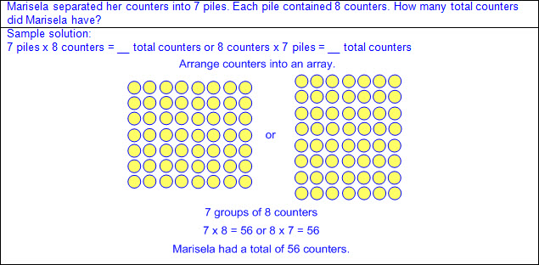  - Development of basic multiplication facts  - Relationship between the number of rows and columns in the array to the factors of a multiplication equation  - Product – the total when two or more factors are multiplied  - Factor – a number multiplied by another number to find a product  - Combination of equally-sized groups recorded as multiplication or repeated addition  - Ex: 7 rows/groups of 8 can be recorded as 7 x 8 = 56 or 8 + 8 + 8 + 8 + 8 + 8 + 8 = 56  - Connection between skip counting and counting multiples of a number  - Equation(s) to reflect solution process  Note(s):  - Grade Level(s):  - Grade 2 introduced multiplication by modeling, creating, and describing contextual multiplication situations in which equivalent sets of concrete objects were joined.  - Grade 3 introduces symbolic representations for multiplication.  - Various mathematical process standards will be applied to this student expectation as appropriate.  - TxRCFP:  - Solving problems with multiplication and division within 100  - TxCCRS:  - I. Numeric Reasoning  - IX. Communication and Representation
3.4E | Represent multiplication facts by using a variety of approaches such as repeated addition, equal-sized groups, arrays, area models, equal jumps on a number line, and skip counting.  Supporting Standard  Represent multiplication facts by using a variety of approaches such as repeated addition, equal-sized groups, arrays, area models, equal jumps on a number line, and skip counting.  Supporting Standard  Represent  MULTIPLICATION FACTS BY USING A VARIETY OF APPROACHES  Including, but not limited to:  - Whole numbers  - Counting (natural) numbers – the set of positive numbers that begins at one and increases by increments of one each time {1, 2, 3, ..., n}  - Whole numbers – the set of counting (natural) numbers and zero {0, 1, 2, 3, ..., n}  - Multiplication  - Product – the total when two or more factors are multiplied  - Factor – a number multiplied by another number to find a product  - Multiplication facts through 10 x 10  - Related turn-around facts (e.g., 4 x 3 and 3 x 4 are equivalent due to the commutative property of multiplication)  - Various approaches to multiplication  - Repeated addition  - Ex:  - Equal-sized groups  - Ex:  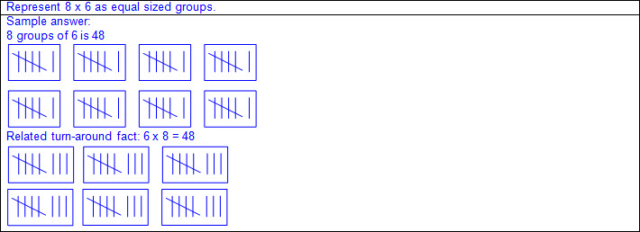  - Array – a set of objects arranged in rows and columns  - Ex:  - Area model – arrangement of squares/rectangles in a grid format  - Ex:  - Equal jumps on a number line  - Ex:  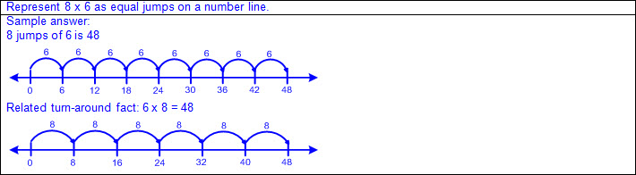  - Skip counting  - Ex:  Note(s):  - Grade Level(s):  - Grade 2 introduced multiplication by modeling, creating, and describing multiplication situations in which equivalent sets of concrete objects are joined.  - Grade 3 introduces symbolic representations for multiplication.  - Grade 4 will determine products of a number and 10 or 100 using properties of operations and place value understandings.  - Various mathematical process standards will be applied to this student expectation as appropriate.  - TxRCFP:  - Solving problems with multiplication and division within 100  - TxCCRS:  - I. Numeric Reasoning  - II.D. Algebraic Reasoning – Representations  - IX. Communication and Representation
3.4F | Recall facts to multiply up to 10 by 10 with automaticity and recall the corresponding division facts.  Supporting Standard  Recall facts to multiply up to 10 by 10 with automaticity and recall the corresponding division facts.  Supporting Standard  Recall With Automaticity  FACTS TO MULTIPLY UP TO 10 BY 10  Including, but not limited to:  - Automaticity – executing the fact with little or no conscious effort  - Multiplication  - Product – the total when two or more factors are multiplied  - Factor – a number multiplied by another number to find a product  - Multiplication facts up to 10 x 10  - Related turn-around facts (e.g., 4 x 3 and 3 x 4 are equivalent due to the commutative property of multiplication)  Recall  THE CORRESPONDING DIVISION FACTS UP TO 10 BY 10  Including, but not limited to:  - Division  - Quotient – the size or measure of each group or the number of groups when the dividend is divided by the divisor  - Dividend – the number that is being divided  - Divisor – the number the dividend is being divided by  - Division facts up to 100 ÷ 10  - Inverse relationship between multiplication and division  - a ÷ b can be determined by b x __ = a or __ x b = a  - Fact families – related number sentences using the same set of numbers  a x b = c c + a = b  b x a = c c + b = a  Note(s):  - Grade Level(s):  - Grade 3 introduces multiplication and division facts.  - Grade 3 is accountable for recalling multiplication facts with automaticity.  - Grade 4 will determine products of a number and 10 or 100 using properties of operations and place value understandings.  - Various mathematical process standards will be applied to this student expectation as appropriate.  - TxRCFP:  - Solving problems with multiplication and division within 100  - TxCCRS:  - I. Numeric Reasoning  - IX. Communication and Representation
3.4G | Use strategies and algorithms, including the standard algorithm, to multiply a two-digit number by a one-digit number. Strategies may include mental math, partial products, and the commutative, associative, and distributive properties.  Supporting Standard  Use strategies and algorithms, including the standard algorithm, to multiply a two-digit number by a one-digit number. Strategies may include mental math, partial products, and the commutative, associative, and distributive properties.  Supporting Standard  Use  STRATEGIES AND ALGORITHMS, INCLUDING THE STANDARD ALGORITHM, TO MULTIPLY A TWO-DIGIT NUMBER BY A ONE-DIGIT NUMBER. STRATEGIES MAY INCLUDE MENTAL MATH, PARTIAL PRODUCTS, AND THE COMMUTATIVE, ASSOCIATIVE, AND DISTRIBUTIVE PROPERTIES  Including, but not limited to:  - Whole NUmbers  - Counting (natural) numbers – the set of positive numbers that begins at one and increases by increments of one each time {1, 2, 3, ..., n}  - Whole numbers – the set of counting (natural) numbers and zero {0, 1, 2, 3, ..., n}  - Multiplication  - Product – the total when two or more factors are multiplied  - Factor – a number multiplied by another number to find a product  - Products of two-digit factors by one-digit factors  - Strategies and algorithms for multiplication  - Basic facts  - Multiplication facts up to 10 x 10  - Mental math  - Accurate computation without the aid of paper, pencil, or other tools  - Ex:  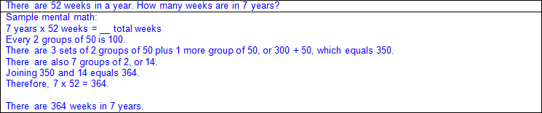  - Partial products  - Decomposing the factor(s) into smaller parts, multiplying the parts, and combining the intermittent products  - Ex:  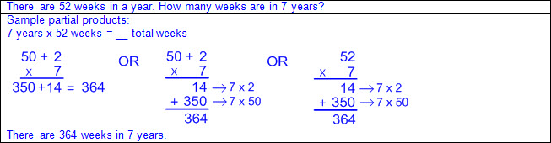  - Ex:  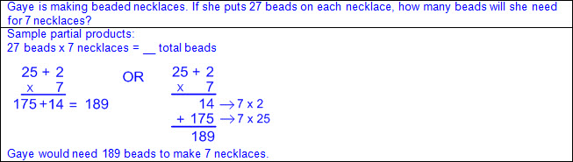  - Properties of operations  - Commutative property of multiplication – if the order of the factors are changed, the product will remain the same  - a x b = c; therefore, b x a = c  - Ex:  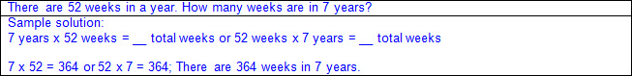  - Associative property of multiplication – if three or more factors are multiplied, they can be grouped in any order, and the product will remain the same  - a x b x c = (a × b) × c = a × (b × c)  - Ex:  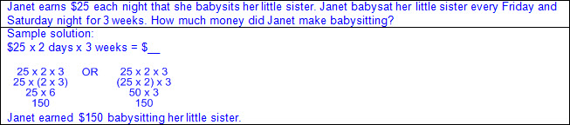  - Distributive property of multiplication – if multiplying a number by a sum of numbers, the product will be the same as multiplying the number by each addend and then adding the products together  - a x (b + c) = (a x b) + (a x c)  - Ex:  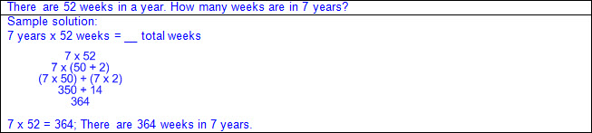  - Ex:  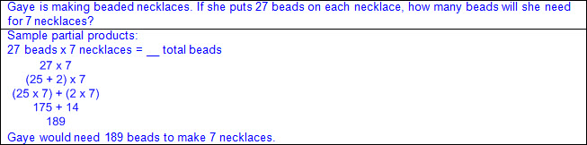  - Standard algorithm  - Standardized steps or routines used in computation  - With and without regrouping  - Ex:  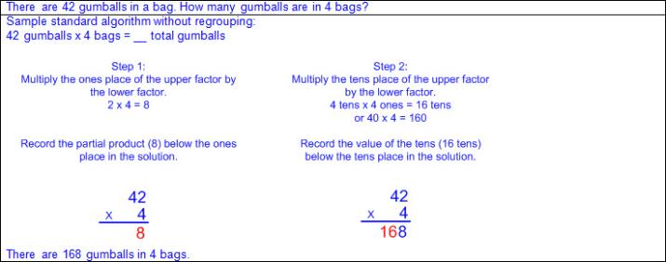  - Ex:  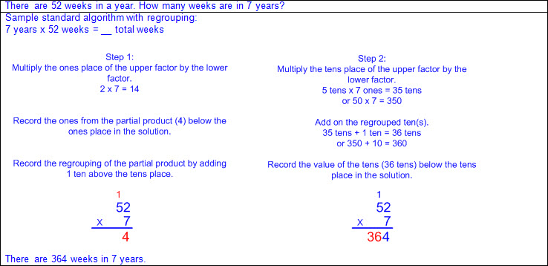  - Connections between strategies and operations  - Ex:  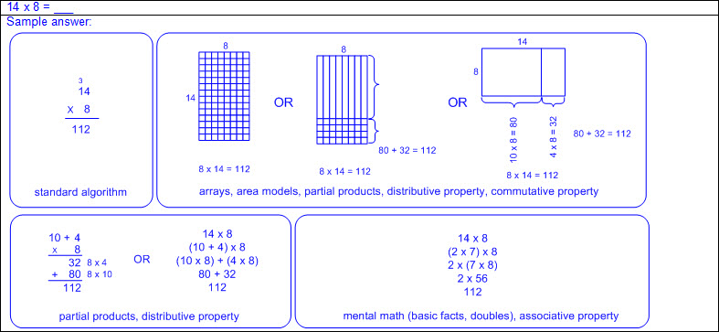  - Equation(s) to reflect solution process  Note(s):  - Grade Level(s):  - Grade 3 introduces the standard multiplication algorithm.  - Grade 4 will represent the product of 2 two-digit numbers using arrays, area models, or equations, including perfect squares through 15 by 15.  - Grade 4 will use strategies and algorithms, including the standard algorithm, to multiply up to a four-digit number by a one-digit number and to multiply a two-digit number by a two-digit number. Strategies may include mental math, partial products, and the commutative, associative, and distributive properties.  - Various mathematical process standards will be applied to this student expectation as appropriate.  - TxRCFP:  - Solving problems with multiplication and division within 100  - TxCCRS:  - I. Numeric Reasoning  - VIII. Problem Solving and Reasoning  - IX. Communication and Representation
3.4H | Determine the number of objects in each group when a set of objects is partitioned into equal shares or a set of objects is shared equally.  Supporting Standard  Determine the number of objects in each group when a set of objects is partitioned into equal shares or a set of objects is shared equally.  Supporting Standard  Determine  THE NUMBER OF OBJECTS IN EACH GROUP WHEN A SET OF OBJECTS IS PARTITIONED INTO EQUAL SHARES OR A SET OF OBJECTS IS SHARED EQUALLY  Including, but not limited to:  - Variety of concrete models and objects  - Division problem types  - Partitive division  - Total amount known  - Number of groups known  - Size or measure of each group unknown  - Set of objects (given total amount) partitioned into equal shares (given number of groups) to determine the size or measure of each group (unknown number of objects in each group)  - Ex:  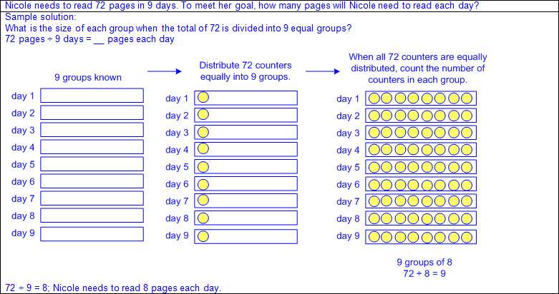  - Quotative division (also known as Measurement division)  - Total amount known  - Size or measure of each group known  - Number of groups unknown  - Set of objects (given total amount) shared in equal sized groups (given number in each group) to determine the number of groups (unknown number of groups)  - Ex:  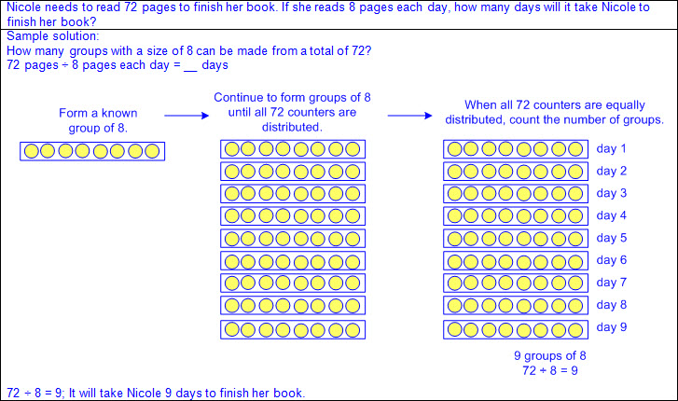  - Equation(s) to reflect solution process  Note(s):  - Grade Level(s):  - Grade 2 introduces multiplication by modeling, creating, and describing contextual division situations in which a set of concrete objects is separated into equivalent sets.  - Grade 3 introduces symbolic representations for division.  - Various mathematical process standards will be applied to this student expectation as appropriate.  - TxRCFP:  - Solving problems with multiplication and division within 100  - TxCCRS:  - I. Numeric Reasoning  - IX. Communication and Representation
3.4I | Determine if a number is even or odd using divisibility rules.  Supporting Standard  Determine if a number is even or odd using divisibility rules.  Supporting Standard  Determine  IF A NUMBER IS EVEN OR ODD USING DIVISIBILITY RULES  Including, but not limited to:  - Whole numbers (0 – 100,000)  - Counting (natural) numbers – the set of positive numbers that begins at one and increases by increments of one each time {1, 2, 3, ..., n}  - Whole numbers – the set of counting (natural) numbers and zero {0, 1, 2, 3, ..., n}  - Even number – a number divisible by 2  - If the digit in the ones place is divisible by 2, then the whole number is divisible by 2 and therefore even.  - 2, 4, 6, and 8 are divisible by 2.  - All numbers ending in 0 are multiples of 10, which are divisible by 2, and therefore even.  - The number zero is not considered odd or even.  - Odd number – a number not divisible by 2  - If the digit in the ones place is not divisible by 2, then the whole number is not divisible by 2 and therefore odd.  - 1, 3, 5, 7, and 9 are not divisible by 2.  Note(s):  - Grade Level(s):  - Grade 2 determined whether a number up to 40 was even or odd using pairings of objects to represent the number.  - Various mathematical process standards will be applied to this student expectation as appropriate.  - TxRCFP:  - Solving problems with multiplication and division within 100  - TxCCRS:  - I. Numeric Reasoning  - IX. Communication and Representation
3.4J | Determine a quotient using the relationship between multiplication and division.  Supporting Standard  Determine a quotient using the relationship between multiplication and division.  Supporting Standard  Determine  A QUOTIENT USING THE RELATIONSHIP BETWEEN MULTIPLICATION AND DIVISION  Including, but not limited to:  - Whole numbers  - Counting (natural) numbers – the set of positive numbers that begins at one and increases by increments of one each time {1, 2, 3, ..., n}  - Whole numbers – the set of counting (natural) numbers and zero {0, 1, 2, 3, ..., n}  - Multiplication  - Product – the total when two or more factors are multiplied  - Factor – a number multiplied by another number to find a product  - Division  - Quotient – the size or measure of each group or the number of groups when the dividend is divided by the divisor  - Dividend – the number that is being divided  - Divisor – the number the dividend is being divided by  - Relationship between division and an unknown factor problem  - Inverse relationship between multiplication and division  - a ÷ b can be determined by b x __ = a or __ x b = a  - Fact families – related number sentences using the same set of numbers  a x b = c c + a = b  b x a = c c + b = a  - Division problem types  - Partitive division  - Total amount known  - Number of groups known  - Size or measure of each group known  - Ex:  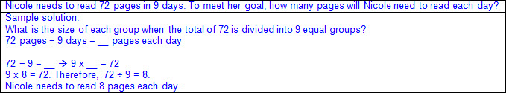  - Quotative division (also known as Measurement division)  - Total amount known  - Size or measure of each group known  - Number of groups unknown  - Ex:  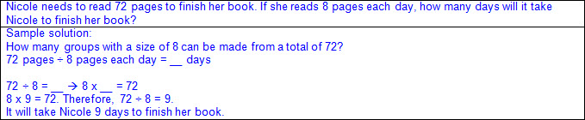  - Division involving 0  - Zero divided by any number equals 0.  - Relationship between multiplication and division applies.  - 0 ÷ a = 0 because 0 x a = 0  - Ex:  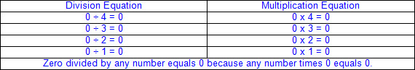  - Any number divided by 0 is undefined.  - Relationship between multiplication and division does not apply when dividing by 0.  - a ÷ 0 = ? (no possible quotient) because ? x 0 ≠ a  - Ex:  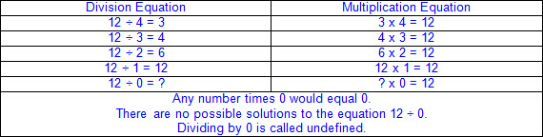  Note(s):  - Grade Level(s):  - Various mathematical process standards will be applied to this student expectation as appropriate.  - TxRCFP:  - Solving problems with multiplication and division within 100  - TxCCRS:  - I. Numeric Reasoning  - II.D. Algebraic Reasoning – Representations  - IX. Communication and Representation  - X. Connections
3.4K | Solve one-step and two-step problems involving multiplication and division within 100 using strategies based on objects; pictorial models, including arrays, area models, and equal groups; properties of operations; or recall of facts.  Readiness Standard  Solve one-step and two-step problems involving multiplication and division within 100 using strategies based on objects; pictorial models, including arrays, area models, and equal groups; properties of operations; or recall of facts.  Readiness Standard  Solve  ONE-STEP AND TWO-STEP PROBLEMS INVOLVING MULTIPLICATION AND DIVISION WITHIN 100 USING STRATEGIES BASED ON OBJECTS; PICTORIAL MODELS, INCLUDING ARRAYS, AREA MODELS, AND EQUAL GROUPS; PROPERTIES OF OPERATIONS; OR RECALL OF FACTS  Including, but not limited to:  - Whole numbers  - Counting (natural) numbers – the set of positive numbers that begins at one and increases by increments of one each time {1, 2, 3, ..., n}  - Whole numbers – the set of counting (natural) numbers and zero {0, 1, 2, 3, ..., n}  - Multiplication  - Product – the total when two or more factors are multiplied  - Factor – a number multiplied by another number to find a product  - Multiplication of whole numbers within 100  - Products of up to a two-digit factor by a one-digit factor  - Division  - Quotient – the size or measure of each group or the number of groups when the dividend is divided by the divisor  - Dividend – the number that is being divided  - Divisor – the number the dividend is being divided by  - Division of whole numbers within 100  - Quotients of up to a two-digit dividend by a one-digit divisor  - Recognition of multiplication and/or division in mathematical and real-world problem situations  - One-step and two-step problems  - Multiplication problem types  - Product unknown  - a x b = __  - Ex:  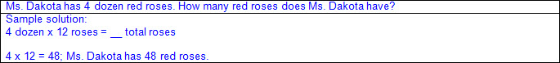  - Factor unknown  - b x __ = a or __ x b = a  - Can be solved as a ÷ b = __  - Ex:  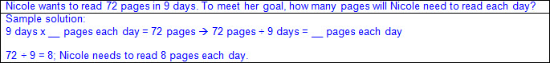  - Division problem types  - Partitive division  - Total amount known  - Number of groups known  - Size or measure of each group unknown  - Ex:  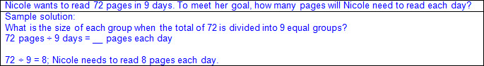  - Quotative division (also known as Measurement division)  - Total amount known  - Size or measure of each group known  - Number of groups unknown  - Ex:  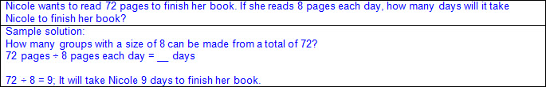  - Concrete objects  - Base-10 blocks, counters, color tiles, etc.  - Ex:  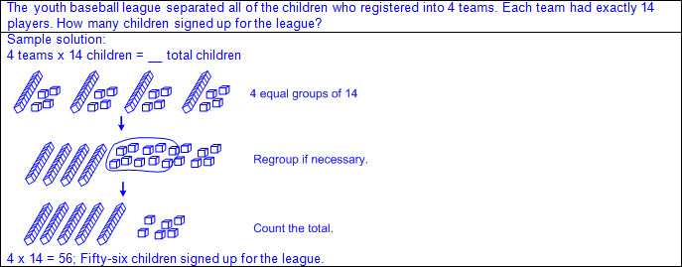  - Ex:  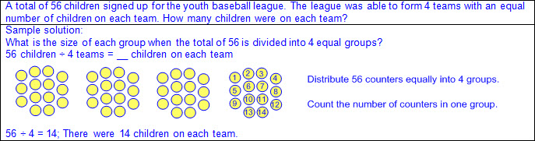  - Pictorial models  - Array  - Arrangement of a set of objects in rows and columns  - Ex:  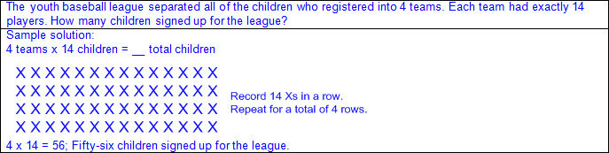  - Area model  - Arrangement of squares/rectangles in a grid format  - Ex:  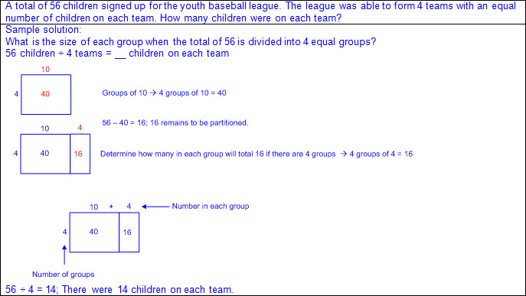  - Equal groups  - Ex:  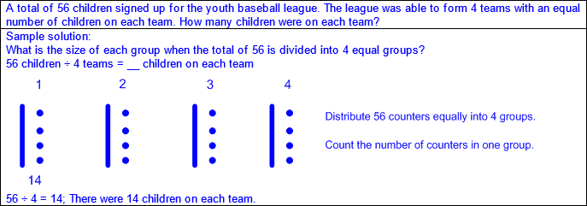  - Properties of operations  - Commutative property of multiplication – if the order of the factors are changed, the product will remain the same  - a x b = c; therefore, b x a = c  - Ex:  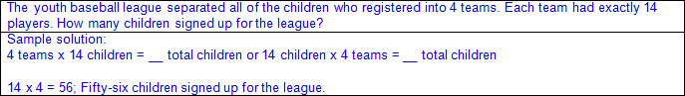  - Associative property of multiplication – if three or more factors are multiplied, they can be grouped in any order, and the product will remain the same  - a x b x c = (a × b) × c = a × (b × c)  - Ex:  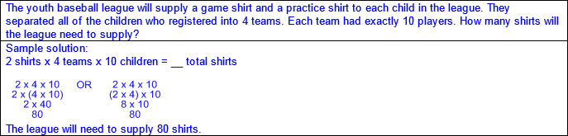  - Distributive property of multiplication – if multiplying a number by a sum of numbers, the product will be the same as multiplying the number by each addend and then adding the products together  - a x (b + c) = (a x b) + (a x c)  - Ex:  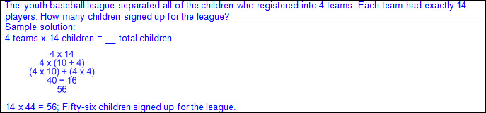  - Ex:  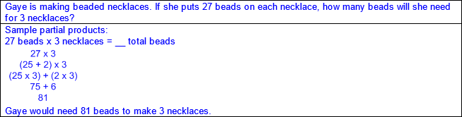  - Recall of facts  - Multiplication facts up to 10 x 10  - Division facts up to 100 ÷ 10  - Mathematical and real-world problem situations with multiple operations  - One-step and two-step problems  - Ex:  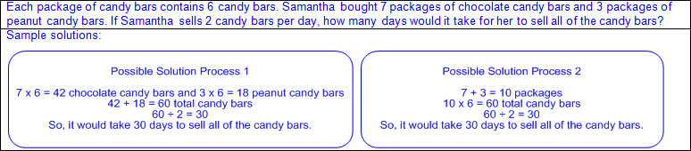  - Equation(s) to reflect solution process  Note(s):  - Grade Level(s):  - Grade 4 will represent the quotient of up to a four-digit whole number divided by a one-digit whole number using arrays, area models, or equations.  - Grade 4 will introduce the standard algorithm for division.  - Grade 4 will introduce interpreting remainders.  - Various mathematical process standards will be applied to this student expectation as appropriate.  - TxRCFP:  - Solving problems with multiplication and division within 100  - TxCCRS:  - I. Numeric Reasoning  - VIII. Problem Solving and Reasoning  - IX. Communication and Representation  - X. Connections
3.5 | Algebraic reasoning. The student applies mathematical process standards to analyze and create patterns and relationships. The student is expected to:
3.5A | Represent one- and two-step problems involving addition and subtraction of whole numbers to 1,000 using pictorial models, number lines, and equations.  Readiness Standard  Represent one- and two-step problems involving addition and subtraction of whole numbers to 1,000 using pictorial models, number lines, and equations.  Readiness Standard  Represent  ONE- AND TWO-STEP PROBLEMS INVOLVING ADDITION AND SUBTRACTION OF WHOLE NUMBERS TO 1,000 USING PICTORIAL MODELS, NUMBER LINES, AND EQUATIONS  Including, but not limited to:  - Whole numbers  - Counting (natural) numbers – the set of positive numbers that begins at one and increases by increments of one each time {1, 2, 3, ..., n}  - Whole numbers – the set of counting (natural) numbers and zero {0, 1, 2, 3, ..., n}  - Addition  - Sum – the total when two or more addends are joined  - Addend – a number being added or joined together with another number(s)  - Addition of whole numbers within 1,000  - Subtraction  - Difference – the remaining amount after the subtrahend has been subtracted from the minuend  - Minuend – a number from which another number will be subtracted  - Subtrahend – a number to be subtracted from a minuend  - Subtraction of whole numbers within 1,000  - Representations using equations  - Equation – a mathematical statement composed of equivalent expressions separated by an equal sign  - Expression – a mathematical phrase, with no equal sign, that may contain a number(s), an unknown(s), and/or an operator(s)  - Relationship between quantities represented and problem situation  - Equal sign at beginning or end  - Ex: 10 = 6 + 4; 6 + 4 = 10  - Ex: 6 = 10 – 4; 10 – 4 = 6  - Unknown in any position  - Ex: a + b = __; a + __ = c; __ + b = c; a – b = __; a – __= c; __ – b = c  - Proper equality representation for multi-step problems  - Multi-step solutions represented with one number sentence, or equation, per step  - All expressions separated by equal signs must be equivalent.  - Ex:  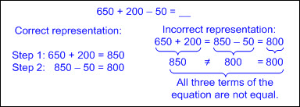  - Recognition of addition or subtraction in mathematical and real-world problem situations  - One-step problems  - Representations using pictorial models  - Relationship between quantities represented and problem situation  - Base-10 models  - Ex:  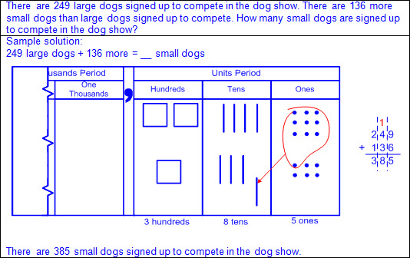  - Ex:  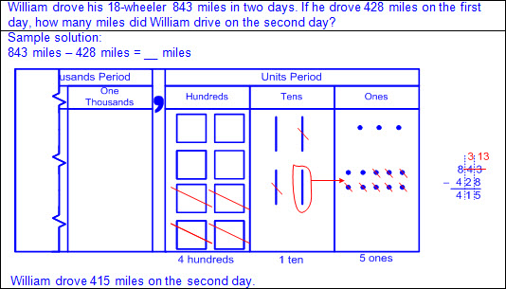  - Strip diagrams  - Ex:  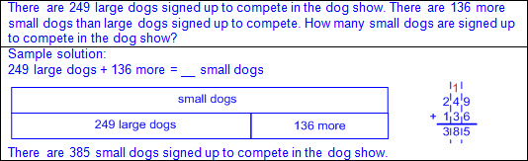  - Ex:  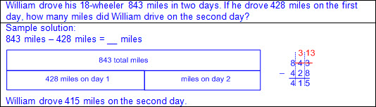  - Representations using number lines  - Relationship between quantities represented and problem situation  - Various solution methods  - Ex:  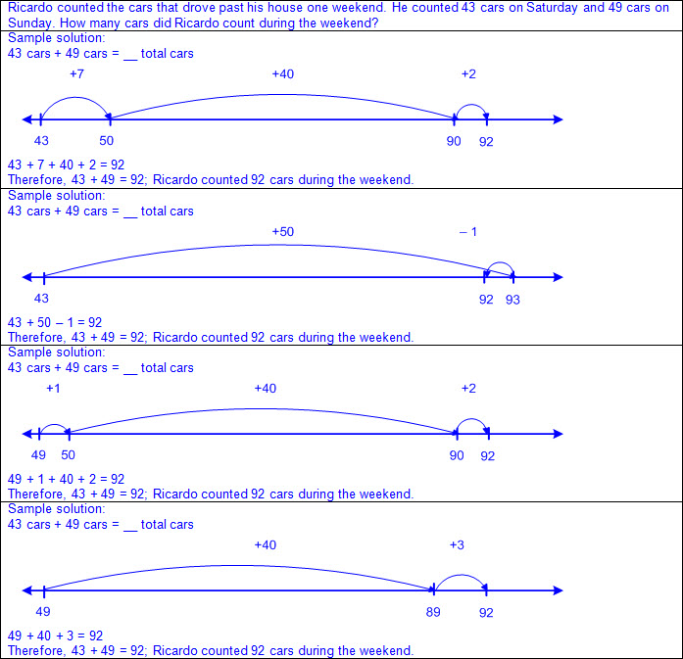  - Ex:  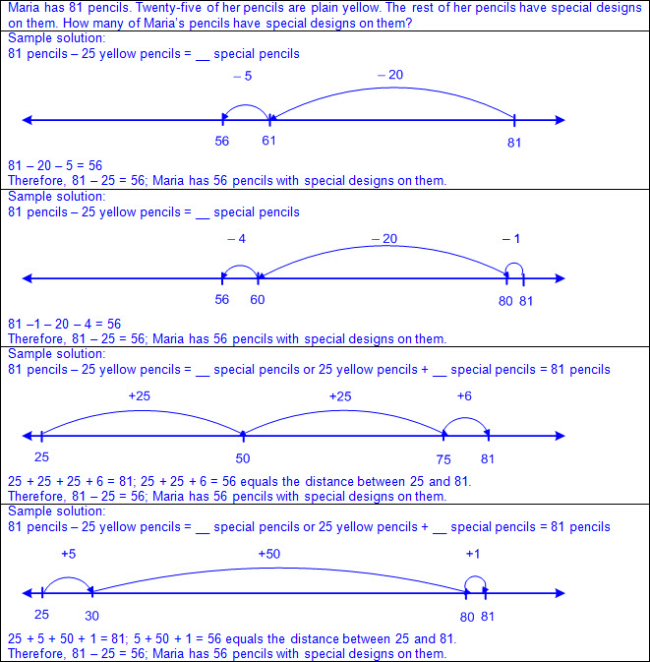  - Recognition of addition and/or subtraction in mathematical and real-world problem situations  - Two-step problems  - Multiple operations  - Ex:  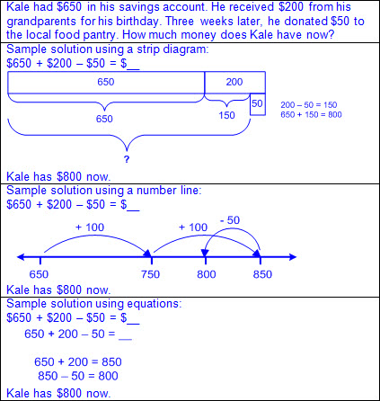  Note(s):  - Grade Level(s):  - Grade 2 represented and solved addition and subtraction word problems where unknowns may have been any one of the terms in the problem.  - Grade 4 will represent multi-step problems involving the four operations with whole numbers using strip diagrams and equations with a letter standing for the unknown quantity.  - Various mathematical process standards will be applied to this student expectation as appropriate.  - TxRCFP:  - Understanding and applying place value and properties of operations to solve problems involving addition and subtraction of whole numbers within 1,000  - TxCCRS:  - I. Numeric Reasoning  - II.D. Algebraic Reasoning – Representations  - VIII. Problem Solving and Reasoning  - IX. Communication and Representation  - X. Connections
3.5B | Represent and solve one- and two-step multiplication and division problems within 100 using arrays, strip diagrams, and equations.  Readiness Standard  Represent and solve one- and two-step multiplication and division problems within 100 using arrays, strip diagrams, and equations.  Readiness Standard  Represent, Solve  ONE- AND TWO-STEP MULTIPLICATION AND DIVISION PROBLEMS WITHIN 100 USING ARRAYS, STRIP DIAGRAMS, AND EQUATIONS  Including, but not limited to:  - Whole numbers  - Counting (natural) numbers – the set of positive numbers that begins at one and increases by increments of one each time {1, 2, 3, ..., n}  - Whole numbers – the set of counting (natural) numbers and zero {0, 1, 2, 3, ..., n}  - Multiplication  - Product – the total when two or more factors are multiplied  - Factor – a number multiplied by another number to find a product  - Multiplication of whole numbers within 100  - Products of up to a two-digit factor by a one-digit factor  - Division  - Quotient – the size or measure of each group or the number of groups when the dividend is divided by the divisor  - Dividend – the number that is being divided  - Divisor – the number the dividend is being divided by  - Division of whole numbers within 100  - Quotients of up to a two-digit dividend by a one-digit divisor  - Representations using equations  - Equation – a mathematical statement composed of equivalent expressions separated by an equal sign  - Expression – a mathematical phrase, with no equal sign, that may contain a number(s), an unknown(s), and/or an operator(s)  - Relationship between quantities represented and problem situation  - Equal sign at beginning or end  - Ex: 24 = 6 x 4; 6 x 4 = 24  - Ex: 6 = 24 ÷ 4; 24 ÷ 4 = 6  - Unknown in any position  - Ex: a x b = __; a x __ = c; __ x b = c; a ÷ b = __; a ÷ __ = c; __ ÷ b = c  - Proper equality representation  - Multi-step solutions represented with one number sentence, or equation, per step  - All expressions separated by equal signs must be equivalent.  - Ex:  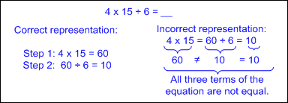  - Recognition of multiplication or division in mathematical and real-world problem situations  - One-step problems  - Representations using arrays  - Relationship between quantities represented and problem situation  - Arrangement of a set of objects in rows and columns  - Ex:  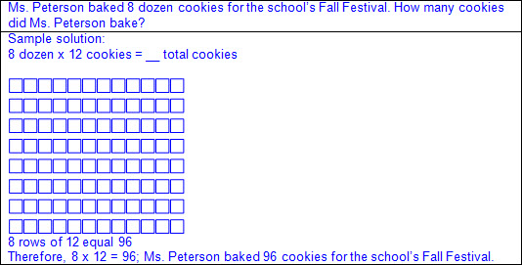  - Ex:  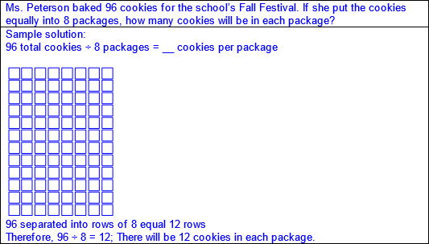  - Representations using strip diagrams  - Relationship between quantities represented and problem situation  - Linear arrangement used to illustrate number relationships  - Ex:  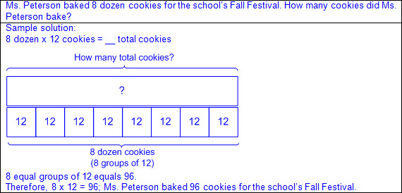  - Ex:  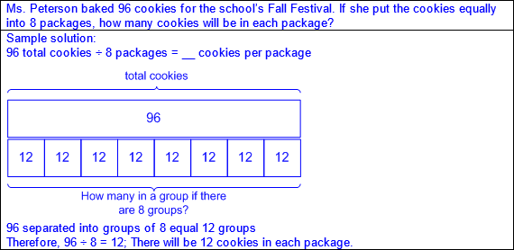  - Recognition of multiplication and/or division in mathematical and real-world problem situations  - Two-step problems  - Multiple operations  - Ex:  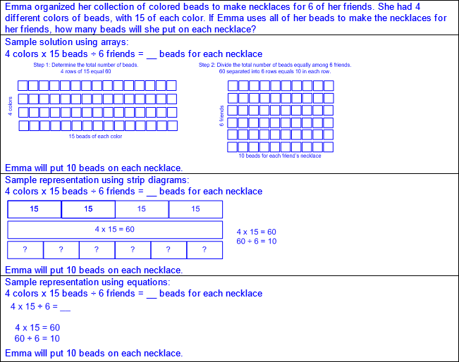  Note(s):  - Grade Level(s):  - Grade 4 will represent multi-step problems involving the four operations with whole numbers using strip diagrams and equations with a letter standing for the unknown quantity.  - Various mathematical process standards will be applied to this student expectation as appropriate.  - TxRCFP:  - Solving problems with multiplication and division within 100  - TxCCRS:  - I. Numeric Reasoning  - II.D. Algebraic Reasoning – Representations  - VIII. Problem Solving and Reasoning  - IX. Communication and Representation  - X. Connections
3.5C | Describe a multiplication expression as a comparison such as 3 x 24 represents 3 times as much as 24.  Supporting Standard  Describe a multiplication expression as a comparison such as 3 x 24 represents 3 times as much as 24.  Supporting Standard  Describe  A MULTIPLICATION EXPRESSION AS A COMPARISON  Including, but not limited to:  - Expression – a mathematical phrase, with no equal sign, that may contain a number(s), an unknown(s), and/or an operator(s)  - Factor – a number multiplied by another number to find a product  - Multiplication expressions up to a two-digit factor by a one-digit factor  - Language to describe a multiplication expression as a comparison (e.g., twice as much as, three times as much as, four times more than, five times greater than, etc.)  - Ex: 2 x 50 represents twice as much as 50  - Ex: 3 x 24 represents 3 times as much as 24  Note(s):  - Grade Level(s):  - Various mathematical process standards will be applied to this student expectation as appropriate.  - TxRCFP:  - Solving problems with multiplication and division within 100  - TxCCRS:  - II.D. Algebraic Reasoning – Representations  - IX. Communication and Representation
3.5D | Determine the unknown whole number in a multiplication or division equation relating three whole numbers when the unknown is either a missing factor or product.  Supporting Standard  Determine the unknown whole number in a multiplication or division equation relating three whole numbers when the unknown is either a missing factor or product.  Supporting Standard  Determine  THE UNKNOWN WHOLE NUMBER IN A MULTIPLICATION OR DIVISION EQUATION RELATING THREE WHOLE NUMBERS WHEN THE UNKNOWN IS EITHER A MISSING FACTOR OR PRODUCT  Including, but not limited to:  - Whole numbers  - Counting (natural) numbers – the set of positive numbers that begins at one and increases by increments of one each time {1, 2, 3, ..., n}  - Whole numbers – the set of counting (natural) numbers and zero {0, 1, 2, 3, ..., n}  - Multiplication  - Product – the total when two or more factors are multiplied  - Factor – a number multiplied by another number to find a product  - Products of up to a two-digit factor by a one-digit factor  - Division  - Quotient – the size or measure of each group or the number of groups when the dividend is divided by the divisor  - Dividend – the number that is being divided  - Divisor – the number the dividend is being divided by  - Quotients of up to a two-digit dividend by a one-digit divisor  - Multiplication and division as inverse operations  - Fact families – related number sentences using the same set of numbers  a x b = c c + a = b  b x a = c c + b = a  - Equation – a mathematical statement composed of equivalent expressions separated by an equal sign  - Expression – a mathematical phrase, with no equal sign, that may contain a number(s), an unknown(s), and/or an operator(s)  - Relationship between the terms of a division equation and a multiplication equation  - Quotient → factor  - Divisor → factor  - Dividend → product  - Ex:  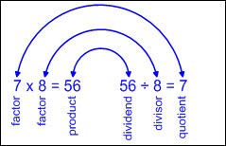  - Multiplication with the product unknown  - a x b = __  - Multiply the known factors to determine the unknown product.  - Multiplication with a factor unknown  - a x __ = c or __ x b = c  - Apply knowledge of basic facts to determine what multiple of the known factor equals the known product.  - Ex: 4 x __ = 24 or __ x 4 = 24 → 4 x 6 = 24 or 6 x 4 = 24  - Divide the known product by the known factor to determine the unknown factor.  - Ex: 4 x __ = 24 or __ x 4 = 24 → 24 ÷ 4 = 6; therefore, 4 x 6 = 24 or 6 x 4 = 24.  - Division with the quotient unknown  - c ÷ a = __  - Divide the known dividend by the known divisor to determine the unknown quotient.  - Division with the divisor unknown  - c ÷ __ = b  - Apply knowledge of basic facts to determine what multiple of the known quotient equals the known dividend.  - Ex: 63 ÷ __ = 7 → 7 x 9 = 63; therefore, 63 ÷ 9 = 7.  - Divide the known dividend by the known quotient to determine the unknown divisor.  - Ex: 63 ÷ __ = 7 → 63 ÷ 7 = 9; therefore, 63 ÷ 9 = 7.  - Division with the dividend unknown  - c ÷ a = __  - Multiply the known quotient by the known divisor to determine the unknown dividend.  - Ex: __ ÷ 10 = 5 → 5 x 10 = 50; therefore, 50 ÷ 10 = 5.  Note(s):  - Grade Level(s):  - Grade 4 will represent multi-step problems involving the four operations with whole numbers using strip diagrams and equations with a letter standing for the unknown quantity.  - Various mathematical process standards will be applied to this student expectation as appropriate.  - TxRCFP:  - Solving problems with multiplication and division within 100  - TxCCRS:  - I. Numeric Reasoning  - II.D. Algebraic Reasoning – Representations  - IX. Communication and Representation
3.5E | Represent real-world relationships using number pairs in a table and verbal descriptions.  Readiness Standard  Represent real-world relationships using number pairs in a table and verbal descriptions.  Readiness Standard  Represent  REAL-WORLD RELATIONSHIPS USING NUMBER PAIRS IN A TABLE AND VERBAL DESCRIPTIONS  Including, but not limited to:  - Whole numbers  - Counting (natural) numbers – the set of positive numbers that begins at one and increases by increments of one each time {1, 2, 3, ..., n}  - Whole numbers – the set of counting (natural) numbers and zero {0, 1, 2, 3, ..., n}  - Paired numbers in mathematical and real-world problem situations  - Data sets of whole numbers  - Sets may or may not begin with 1.  - Sets may or may not be listed in sequential order.  - Input-output table – a table which represents how the application of a rule on a value, input, results in a different value, output  - Relationships between values in a pair of numbers  - Additive numerical pattern – a pattern that occurs when a constant non-zero value is added to an input value to determine the output value  - Multiplicative numerical pattern – a pattern that occurs when a constant non-zero value is multiplied by an input value to determine the output value  - Tables (horizontal or vertical)  - With and without a process column  - Ex:  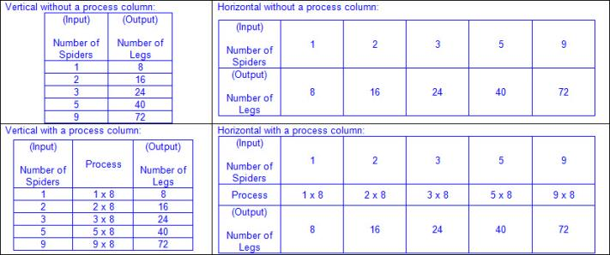  - Missing data that may be at the beginning, middle, or end within a table  - Ex:  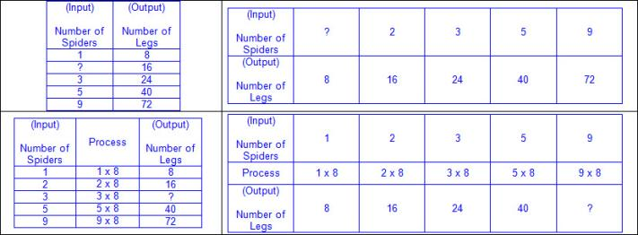  - Verbal descriptions  - Words, numbers, and/or symbols  - Appropriate labels used to describe relationships of number pairs  - Ex:  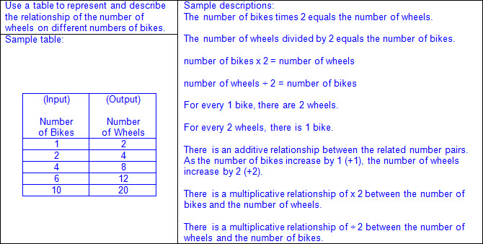  - Relationships used to extend the pattern  - Ex:  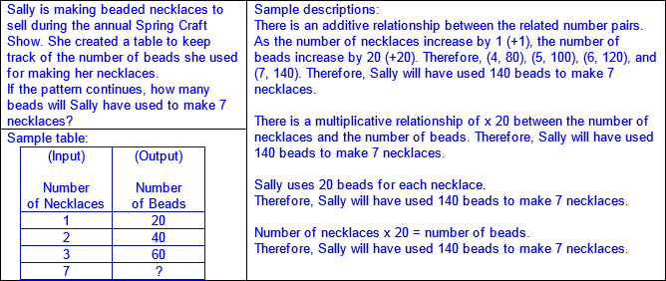  - Ex:  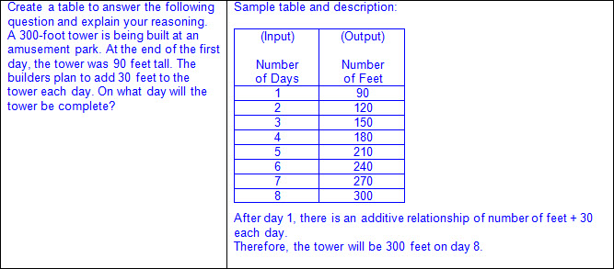  Note(s):  - Grade Level(s):  - Grade 4 will represent problems using an input-output table and numerical expressions to generate a number pattern that follows a given rule representing the relationship of the values in the resulting sequence and their position in the sequence.  - Various mathematical process standards will be applied to this student expectation as appropriate.  - TxRCFP:  - Grade Level Connections (reinforces previous learning and/or provides development for future learning)  - TxCCRS:  - II.D. Algebraic Reasoning – Representations  - IX. Communication and Representation
3.6 | Geometry and measurement. The student applies mathematical process standards to analyze attributes of two-dimensional geometric figures to develop generalizations about their properties. The student is expected to:
3.6A | Classify and sort two- and three-dimensional figures, including cones, cylinders, spheres, triangular and rectangular prisms, and cubes, based on attributes using formal geometric language.  Readiness Standard  Classify and sort two- and three-dimensional figures, including cones, cylinders, spheres, triangular and rectangular prisms, and cubes, based on attributes using formal geometric language.  Readiness Standard  Classify, Sort  TWO-DIMENSIONAL FIGURES BASED ON ATTRIBUTES USING FORMAL GEOMETRIC LANGUAGE  Including, but not limited to:  - Two-dimensional figure – a figure with two basic units of measure, usually length and width  - Sort – grouping objects or figures by a shared characteristic or attribute  - Classify – applying an attribute to categorize a sorted group  - Attributes of two-dimensional figures – characteristics that define a geometric figure (e.g., sides, vertices, etc.)  - Properties of two-dimensional figures – relationship of attributes within a geometric figure (e.g., a square has 4 congruent sides and 4 square corners, etc.) and between a group of geometric figures (e.g., a square and a rectangle both have 4 sides and 4 square corners; however, a square has 4 congruent sides but a rectangle has only opposite sides congruent; etc.)  - Regular figure – a polygon with all side lengths and corners congruent  - Irregular figure – a polygon with side lengths and/or corners that are not all congruent  - Attributes of two-dimensional figures  - Side – a straight outer boundary between two vertices (line segment) of a two-dimensional figure  - Number of sides  - Length of sides  - Vertex (vertices) in a two-dimensional figure – the point (corner) where two sides of a two-dimensional figure meet  - Number of vertices  - Types of corners  - Square corners  - Square corners can be determined using the corner of a known square or rectangle (e.g., sticky note, sheet of paper, etc.).  - Ex:  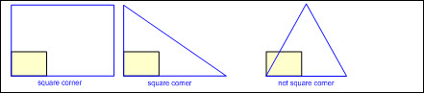  - May have a box in corner to represent square corner  - Ex:  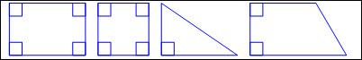  - Not square corners  - Opposite corners  - Congruent – of equal measure  - Types of two-dimensional figures  - Circle  - A figure formed by a closed curve with all points equal distance from the center  - No straight sides  - No vertices  - Ex:  - Polygon – a closed figure with at least 3 sides, where all sides are straight (no curves)  - Ex:  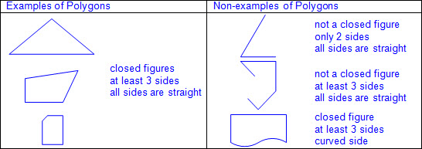  - Types of polygons  - Triangle  - 3 sides  - 3 vertices  - Types of triangles  - Scalene triangle  - 3 sides  - 3 vertices  - No congruent sides  - No congruent corners  - Ex:  - Isosceles triangle  - 3 sides  - 3 vertices  - At least 2 congruent sides  - At least 2 congruent corners  - Ex:  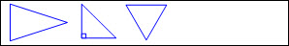  - Equilateral triangle  - 3 sides  - 3 vertices  - All sides congruent  - All corners congruent  - Ex:  - Quadrilateral  - 4 sides  - 4 vertices  - Types of quadrilaterals  - Trapezoid  - 4 sides  - 4 vertices  - Exactly one pair of sides equal distance apart  - Ex:  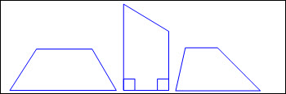  - Parallelogram  - 4 sides  - 4 vertices  - Opposite sides congruent  - Opposite sides equal distance apart  - Opposite corners congruent  - Ex:  - Types of parallelograms  - Rectangle  - 4 sides  - 4 vertices  - Opposite sides congruent  - Opposite sides equal distance apart  - 4 square corners  - Ex:  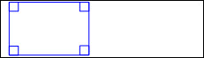  - Rhombus  - 4 sides  - 4 vertices  - All sides congruent  - Opposite sides equal distance apart  - Opposite corners congruent  - Ex:  - Square (a special type of rectangle and a special type of rhombus)  - 4 sides  - 4 vertices  - All sides congruent  - Opposite sides congruent  - Opposite sides equal distance apart  - 4 square corners  - Opposite corners congruent  - Ex:  - Pentagon  - 5 sides  - 5 vertices  - Ex:  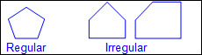  - Hexagon  - 6 sides  - 6 vertices  - Ex:  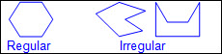  - Heptagon or septagon  - 7 sides  - 7 vertices  - Ex:  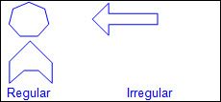  - Octagon  - 8 sides  - 8 vertices  - Ex:  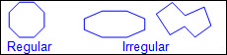  - Nonagon or enneagon  - 9 sides  - 9 vertices  - Ex:  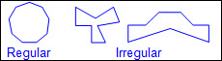  - Decagon  - 10 sides  - 10 vertices  - Ex:  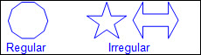  - Undecagon or hendecagon  - 11 sides  - 11 vertices  - Ex:  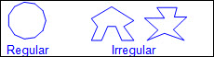  - Dodecagon  - 12 sides  - 12 vertices  - Ex:  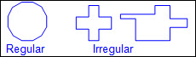  - Concrete models (e.g., wood or plastic figures, etc.) and pictorial models (e.g., drawings, images, etc.)  - Collection of two-dimensional figures  - Sort and justify  - Rule used for sorting expressed  - Attributes and properties of geometric figures expressed  - Existence (have) and absence (do not have) of attributes and properties expressed (e.g., figures that have “a common attribute” and figures that do not have “a common attribute”)  - Ex:  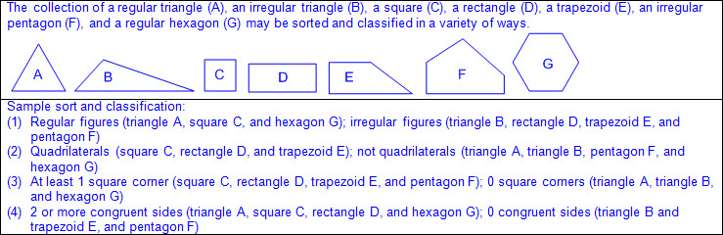  Classify, Sort  THREE-DIMENSIONAL FIGURES, INCLUDING CONES, CYLINDERS, SPHERES, TRIANGULAR AND RECTANGULAR PRISMS, AND CUBES, BASED ON ATTRIBUTES USING FORMAL GEOMETRIC LANGUAGE  Including, but not limited to:  - Three-dimensional figure – a figure that has measurements including length, width (depth), and height  - Sort – grouping objects or figures by a shared characteristic or attribute  - Classify – applying an attribute to categorize a sorted group  - Attributes of three-dimensional figures – characteristics that define a geometric figure (e.g., edges, vertices, faces [bases], etc.)  - Properties of three-dimensional figures – relationship of attributes within a geometric figure (e.g., a rectangular prism has 6 faces and each pair of opposite faces [bases] are congruent, etc.) and between a group of geometric figures (e.g., a cube and a rectangular prism both have 6 faces with opposite faces [bases] congruent; however, a cube has only square faces but a rectangular prism can have square or rectangular faces; etc.)  - Attributes of three-dimensional figures  - Surfaces  - Curved surface  - Flat surface  - Face of a prism – a polygon that forms a surface of a prism  - Number of faces  - Shape of faces  - Bases of a prism – the two unique, equal faces that are opposite each other  - Bases of a cylinder – the two congruent, opposite flat surfaces shaped like circles  - Base of a cone – the flat surface shaped like a circle  - Edge – where the sides of two faces meet on a three-dimensional figure  - Number of edges  - Vertex (vertices) in a three-dimensional figure – the point (corner) where three or more edges of a three-dimensional figure meet  - Number of vertices  - Congruent – of equal measure  - Three-dimensional figures  - Curved surface three-dimensional figures  - Cone  - 1 flat surface shaped like a circle (base)  - 1 curved surface  - 1 vertex  - Ex:  - Cylinder  - 2 congruent, opposite, flat surfaces shaped like circles (bases)  - 1 curved surface  - Ex:  - Sphere  - 1 curved surface with all points on the surface equal distance from the center  - Ex:  - Prisms  - Triangular prism  - 5 faces (2 triangular faces [bases], 3 rectangular faces)  - 9 edges  - 6 vertices  - Ex:  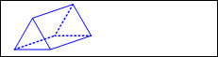  - Rectangular prism  - 6 rectangular faces (2 rectangular faces [bases], 4 rectangular faces)  - 12 edges  - 8 vertices  - Ex:  - Cube (special rectangular prism)  - 6 square faces (2 square faces [bases], 4 square faces)  - 12 edges  - 8 vertices  - Ex:  - Concrete models (e.g., wood or plastic figures, etc.), real-world objects (e.g., a cereal box, can of beans, etc.), and pictorial models (e.g., drawings, images, etc.)  - Collection of three-dimensional figures  - Sort and justify  - Rule used for sorting expressed  - Attributes and properties of geometric figures expressed  - Existence (have) and absence (do not have) of attributes and properties expressed (e.g., figures that have “a common attribute” and figures that do not have “a common attribute”)  - Ex:  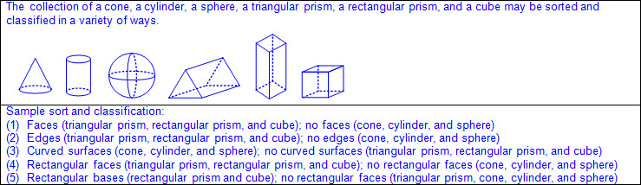  Note(s):  - Grade Level(s):  - Grade 1 classified and sorted three-dimensional solids, including spheres, cones, cylinders, rectangular prisms (including cubes as special rectangular prisms), and triangular prisms, based on attributes using formal geometric language.  - Grade 2 classified and sorted polygons with 12 or fewer sides according to attributes, including identifying the number of sides and number of vertices.  - Grade 4 will classify two-dimensional figures based on the presence or absence of parallel or perpendicular lines or the presence or absence of angles of a specified size.  - Grade 7 will introduce pyramids.  - Various mathematical process standards will be applied to this student expectation as appropriate.  - TxRCFP:  - Describing characteristics of two-dimensional and three-dimensional geometric figures, including measurable attributes  - TxCCRS:  - III.A. Geometric Reasoning – Figures and their properties  - IX. Communication and Representation
3.6B | Use attributes to recognize rhombuses, parallelograms, trapezoids, rectangles, and squares as examples of quadrilaterals and draw examples of quadrilaterals that do not belong to any of these subcategories.  Supporting Standard  Use attributes to recognize rhombuses, parallelograms, trapezoids, rectangles, and squares as examples of quadrilaterals and draw examples of quadrilaterals that do not belong to any of these subcategories.  Supporting Standard  Use  ATTRIBUTES TO RECOGNIZE RHOMBUSES, PARALLELOGRAMS, TRAPEZOIDS, RECTANGLES, AND SQUARES AS EXAMPLES OF QUADRILATERALS  Including, but not limited to:  - Attributes of two-dimensional figures – characteristics that define a geometric figure (e.g., sides, vertices, etc.)  - Properties of two-dimensional figures – relationship of attributes within a geometric figure (e.g., a square has 4 congruent sides and 4 square corners, etc.) and between a group of geometric figures (e.g., a square and a rectangle both have 4 sides and 4 square corners; however, a square has 4 congruent sides but a rectangle has only opposite sides congruent; etc.)  - Attributes of two-dimensional figures  - Side – a straight outer boundary between two vertices (line segment) of a two-dimensional figure  - Number of sides  - Length of sides  - Vertex (vertices) in a two-dimensional figure – the point (corner) where two sides of a two-dimensional figure meet  - Number of vertices  - Types of corners  - Square corners  - Square corners can be determined using the corner of a known square or rectangle (e.g., sticky note, sheet of paper, etc.).  - Ex:  - May have a box in corner to represent square corner  - Ex:  - Not square corners  - Opposite corners  - Congruent – of equal measure  - Polygon – a closed figure with at least 3 sides, where all sides are straight (no curves)  - Ex:  - Quadrilateral – a polygon with 4 sides and 4 vertices  - Subcategories of quadrilaterals  - Types of quadrilaterals  - Trapezoid  - 4 sides  - 4 vertices  - Exactly one pair of sides equal distance apart  - Ex:  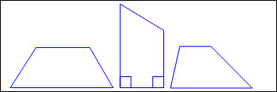  - Parallelogram  - 4 sides  - 4 vertices  - Opposite sides congruent  - Opposite sides equal distance apart  - Opposite corners congruent  - Ex:  - Types of parallelograms  - Rectangle  - 4 sides  - 4 vertices  - Opposite sides congruent  - Opposite sides equal distance apart  - 4 square corners  - Ex:  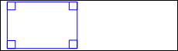  - Rhombus  - 4 sides  - 4 vertices  - All sides congruent  - Opposite sides equal distance apart  - Opposite corners congruent  - Ex:  - Square (a special type of rectangle and a special type of rhombus)  - 4 sides  - 4 vertices  - All sides congruent  - Opposite sides congruent  - Opposite sides equal distance apart  - 4 square corners  - Opposite corners congruent  - Ex:  Draw  EXAMPLES OF QUADRILATERALS THAT DO NOT BELONG TO ANY OF THE SUBCATEGORIES OF QUADRILATERALS  Including, but not limited to:  - Quadrilateral – a polygon with 4 sides and 4 vertices  - Attributes of quadrilaterals that do not belong to any of the subcategories of quadrilaterals  - 4 sides  - 4 vertices  - All or opposite sides not congruent  - All or opposite sides not equal distance apart  - All or opposite corners not congruent  - Ex:  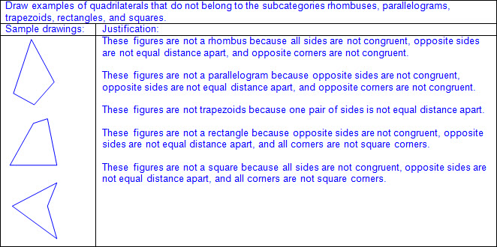  Note(s):  - Grade Level(s):  - Grade 2 created two-dimensional shapes based on given attributes, including number of sides and vertices.  - Grade 4 will identify points, lines, line segments, rays, angles, and perpendicular and parallel lines.  - Grade 4 will identify and draw one or more lines of symmetry, if they exist, for a two-dimensional figure.  - Grade 4 will apply knowledge of right angles to identify acute, right, and obtuse triangles.  - Various mathematical process standards will be applied to this student expectation as appropriate.  - TxRCFP:  - Describing characteristics of two-dimensional and three-dimensional geometric figures, including measurable attributes  - TxCCRS:  - III.A. Geometric Reasoning – Figures and their properties  - IX. Communication and Representation
3.6C | Determine the area of rectangles with whole number side lengths in problems using multiplication related to the number of rows times the number of unit squares in each row.  Readiness Standard  Determine the area of rectangles with whole number side lengths in problems using multiplication related to the number of rows times the number of unit squares in each row.  Readiness Standard  Determine  THE AREA OF RECTANGLES WITH WHOLE NUMBER SIDE LENGTHS IN PROBLEMS USING MULTIPLICATION RELATED TO THE NUMBER OF ROWS TIMES THE NUMBER OF UNIT SQUARES IN EACH ROW  Including, but not limited to:  - Area of rectangles  - Area – the measurement attribute that describes the number of unit squares (or square units) a figure or region covers  - Squares as a special type of rectangle  - Products of up to a two-digit factor by a one-digit factor  - Recognition of area embedded in mathematical and real-world problem situations  - Area determined by multiplying the number of rows times the number of unit squares in each row  - Ex:  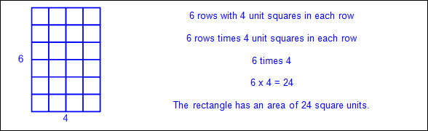  - Concrete models to represent the number of rows and the number of units in each row  - Concrete models  - Color tiles to measure square inches  - Centimeter cubes to measure square centimeters  - Area determined when given a rectangle  - Whole unit side lengths  - Ex:  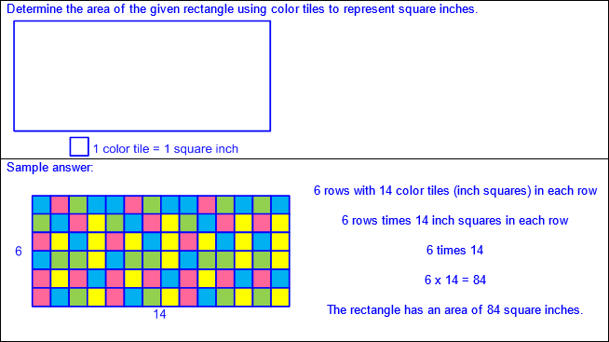  - Area determined when given the side lengths of a rectangle related to number of rows and number of unit squares in each row  - Whole unit side lengths  - Ex:  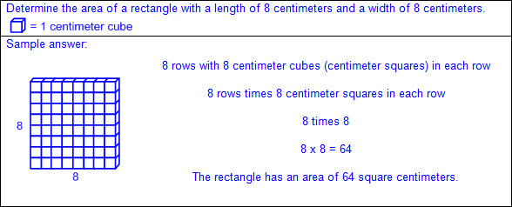  - Pictorial models to represent the number of rows and the number of units in each row  - Pictorial models  - Inch grid paper to measure square inches  - Centimeter grid paper to measure square centimeters  - Pictorial representations with grid lines to represent customary or metric square units  - Area determined when given a rectangle with grid lines  - Whole unit side lengths  - Ex:  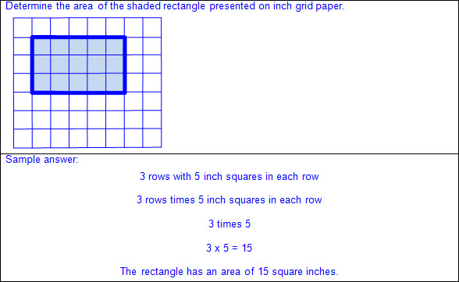  - Area determined when given the side lengths of a rectangle related to number of rows and number of unit squares in each row  - Whole unit side lengths  - Ex:  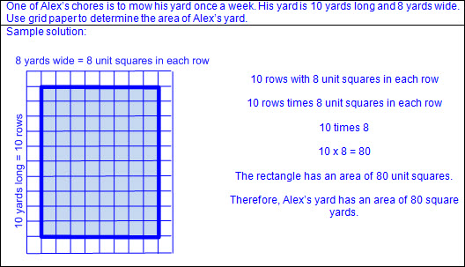  - Relationship to area models in multiplication  - Appropriate labels in standard units  - Square units of standard measure in word form only, not to include exponents  - Typically used customary units  - Square inches, square feet, square yards, square miles  - Typically used metric units  - Square millimeters, square centimeters, square decimeters, square meters, square kilometers  Note(s):  - Grade Level(s):  - Grade 4 will use models to determine the formulas for the perimeter of a rectangle (l + w + l + w or 2l + 2w), including the special form for perimeter of a square (4s) and the area of a rectangle (l x w).  - Various mathematical process standards will be applied to this student expectation as appropriate.  - TxRCFP:  - Describing characteristics of two-dimensional and three-dimensional geometric figures, including measurable attributes  - TxCCRS:  - IV.C. Measurement Reasoning – Measurement involving geometry and algebra  - IX. Communication and Representation  - X. Connections
3.6D | Decompose composite figures formed by rectangles into non-overlapping rectangles to determine the area of the original figure using the additive property of area.  Supporting Standard  Decompose composite figures formed by rectangles into non-overlapping rectangles to determine the area of the original figure using the additive property of area.  Supporting Standard  Decompose  COMPOSITE FIGURES FORMED BY RECTANGLES INTO NON-OVERLAPPING RECTANGLES  Including, but not limited to:  - Composite figure – a figure that is composed of two or more two-dimensional figures  - Decompose figures – to break a geometric figure into two or more smaller geometric figures  - Composite figures decomposed in multiple ways  - Limited to no more than three rectangles, including squares as a special type of rectangle  - Non-overlapping rectangles  - Ex:  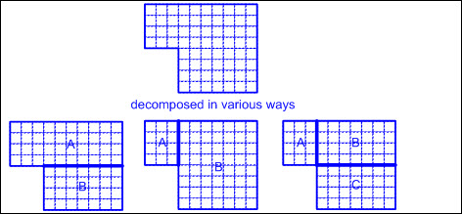  To Determine  THE AREA OF THE ORIGINAL COMPOSITE FIGURE USING THE ADDITIVE PROPERTY OF AREA  Including, but not limited to:  - Area – the measurement attribute that describes the number of unit squares (or square units) a figure or region covers  - Appropriate labels in standard units  - Square units of standard measure in word form only, not to include exponents  - Typically used customary units  - Square inches, square feet, square yards, square miles  - Typically used metric units  - Square millimeters, square centimeters, square decimeters, square meters, square kilometers  - Composite figure – a figure that is composed of two or more two-dimensional figures  - Additive property of area – the sum of the areas of each non-overlapping region of a composite figure equals the area of the original figure  - Determine the area of each decomposed part of the original composite figure.  - Add the areas of all decomposed part to determine the total area of the original composite figure.  - Ex:  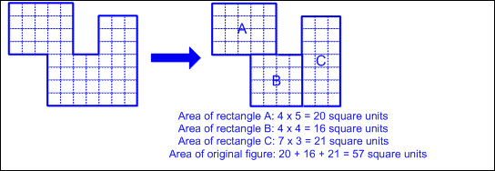  Note(s):  - Grade Level(s):  - Various mathematical process standards will be applied to this student expectation as appropriate.  - TxRCFP:  - Describing characteristics of two-dimensional and three-dimensional geometric figures, including measurable attributes  - TxCCRS:  - IV.C. Measurement Reasoning – Measurement involving geometry and algebra  - IX. Communication and Representation  - X. Connections
3.6E | Decompose two congruent two-dimensional figures into parts with equal areas and express the area of each part as a unit fraction of the whole and recognize that equal shares of identical wholes need not have the same shape.  Supporting Standard  Decompose two congruent two-dimensional figures into parts with equal areas and express the area of each part as a unit fraction of the whole and recognize that equal shares of identical wholes need not have the same shape.  Supporting Standard  Decompose  TWO CONGRUENT TWO-DIMENSIONAL FIGURES INTO PARTS WITH EQUAL AREAS  Including, but not limited to:  - Two-dimensional figure – a figure with two basic units of measure, usually length and width  - Congruent figures – figures that are the same size and same shape  - Decompose figures into equal parts.  - Decompose figures – to break a geometric figure into two or more smaller geometric figures  - Equal sized parts of congruent wholes have equal areas.  - Area – the measurement attribute that describes the number of unit squares (or square units) a figure or region covers  - Ex:  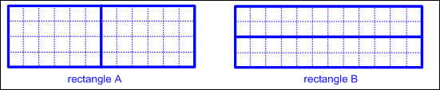  - Ex:  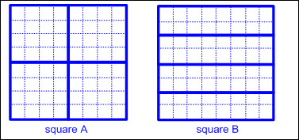  - Ex:  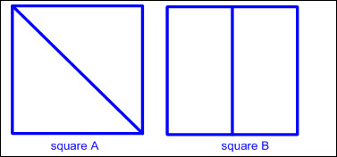  Express  THE AREA OF EACH PART OF A TWO-DIMENSIONAL FIGURE DECOMPOSED INTO EQUAL PARTS AS A UNIT FRACTION OF THE WHOLE  Including, but not limited to:  - Area – the measurement attribute that describes the number of unit squares (or square units) a figure or region covers  - Two-dimensional figure – a figure with two basic units of measure, usually length and width  - Express equal sized parts as unit fractions of the whole.  - Unit fraction – a fraction in the form representing the quantity formed by one part of a whole that has been partitioned into b equal parts where bis a non-zero whole number  - Numerator of 1 written above the fraction bar represents 1 equal part being specified or considered.  - Denominator (b) written below the fraction bar tells the total number of equal parts in the whole or set.  - Whole number denominators of 2, 3, 4, 6, and 8  - Ex:  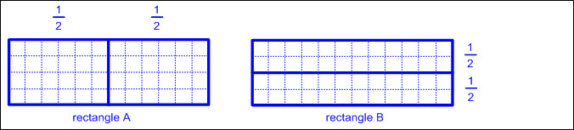  - Ex:  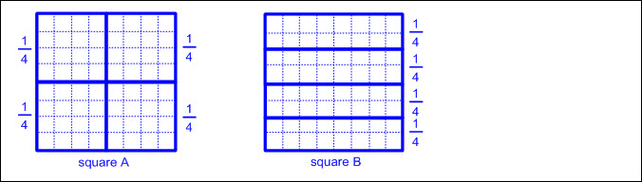  - Ex:  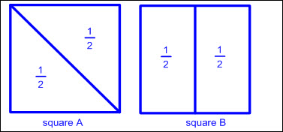  Recognize  THAT EQUAL SHARES OF IDENTICAL WHOLES NEED NOT HAVE THE SAME SHAPE  Including, but not limited to:  - Equal sized parts of congruent wholes have equal area.  - Area – the measurement attribute that describes the number of unit squares (or square units) a figure or region covers  - Congruent figures – figures that are the same size and same shape  - Equal sized parts of congruent wholes need not have the same shape.  - Ex:  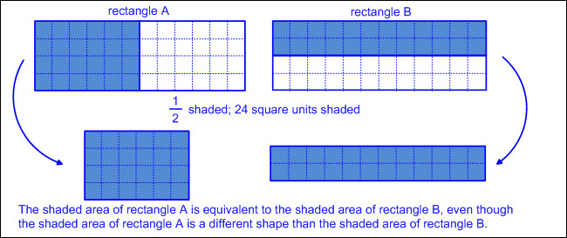  - Ex:  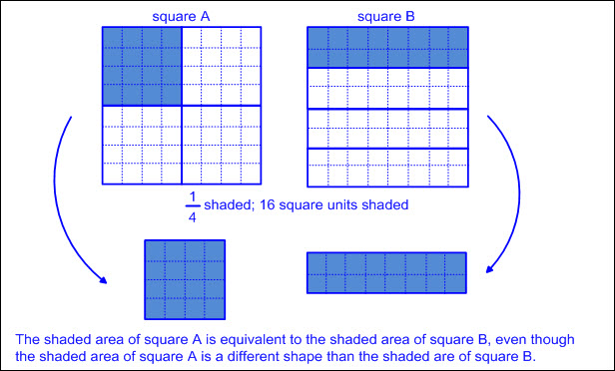  - Ex:  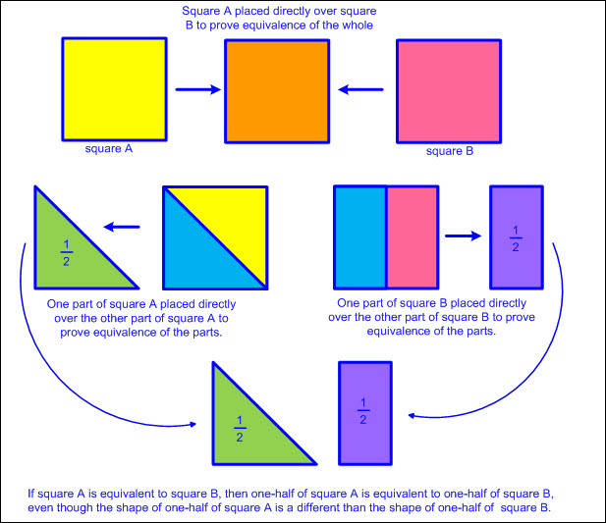  Note(s):  - Grade Level(s):  - Grade 1 partitioned two-dimensional figures into two and four fair shares or equal parts and described the parts using words.  - Various mathematical process standards will be applied to this student expectation as appropriate.  - TxRCFP:  - Understanding fractions as numbers and representing equivalent fractions  - TxCCRS:  - IV.C. Measurement Reasoning – Measurement involving geometry and algebra  - IX. Communication and Representation  - X. Connections
3.7 | Geometry and measurement. The student applies mathematical process standards to select appropriate units, strategies, and tools to solve problems involving customary and metric measurement. The student is expected to:
3.7A | Represent fractions of halves, fourths, and eighths as distances from zero on a number line.  Supporting Standard  Represent fractions of halves, fourths, and eighths as distances from zero on a number line.  Supporting Standard  Represent  FRACTIONS OF HALVES, FOURTHS, AND EIGHTHS AS DISTANCES FROM ZERO ON A NUMBER LINE  Including, but not limited to:  - Fraction – a number in the form where a and b are whole numbers and b is not equal to zero. A fraction can be used to name part of an object or part of a set of objects.  - Characteristics of a number line  - A number line begins as a line with predetermined intervals (or tick marks) with positions/numbers labeled.  - A minimum of two positions/numbers should be labeled.  - Numbers on a number line represent the distance from zero.  - The distance between the tick marks is counted rather than the tick marks themselves.  - The placement of the labeled positions/numbers on a number line determines the scale of the number line.  - Intervals between position/numbers are proportional.  - When reasoning on a number line, the position of zero may or may not be placed.  - When working with larger numbers, a number line without the constraint of distance from zero allows the ability to “zoom-in” on the relevant section of the number line.  - Number lines extend infinitely in both directions (arrows indicate the number line continues infinitely).  - Numbers increase from left to right on a horizontal number line and from bottom to top on a vertical number line.  - Points to the left of a specified point on a horizontal number line are less than points to the right.  - Points to the right of a specified point on a horizontal number line are greater than points to the left.  - Points below a specified point on a vertical number line are less than points above.  - Points above a specified point on a vertical number line are greater than points below.  - Fractions represented as distances from zero on a number line  - Whole number denominators of 2, 4, and 8  - Relationship between a fraction represented using a strip diagram to a fraction represented on a number line  - Strip diagram – a linear model used to illustrate number relationships  - Ex:  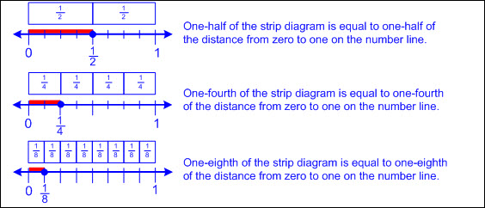  - Fractions represented as distances from zero on a number line greater than 1  - Point on a number line read as the number of whole units from zero and the fractional amount of the next whole unit  - Ex:  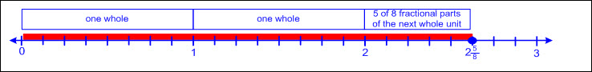  - Number lines beginning with a number other than zero  - Distance from zero to first marked increment is assumed even when not visible on the number line.  - Ex:  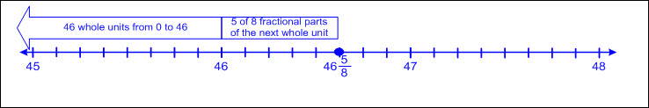  - Relationship between fractions as distances from zero on a number line to fractional measurements as distances from zero on a customary ruler, yardstick, or measuring tape  - Ex:  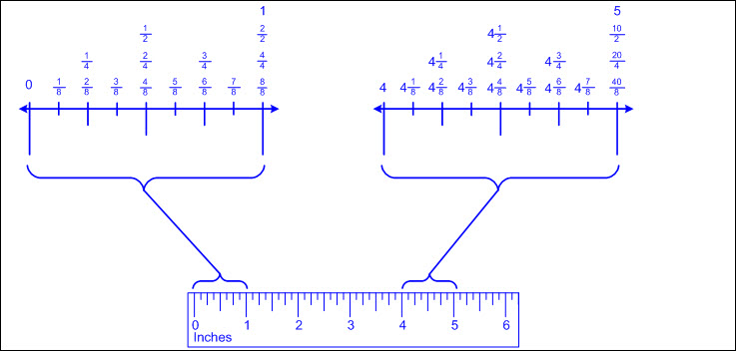  - Measuring a specific length using a starting point other than zero on a ruler, yardstick, or measuring tape  - Distance from zero to first marked increment not counted  - Length determined by number of whole units and the fractional amount of the next whole unit  - Ex:  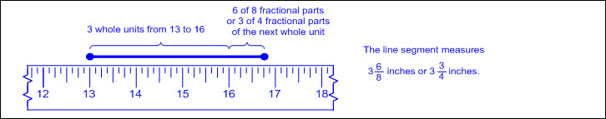  - Relationship between distances from zero on a number line, distances from zero on the scale of a bar graph, and heights of the bars within the graph  - Bar graph – a graphical representation to organize data that uses solid bars that do not touch each other to show the frequency (number of times) that each category occurs  - Ex:  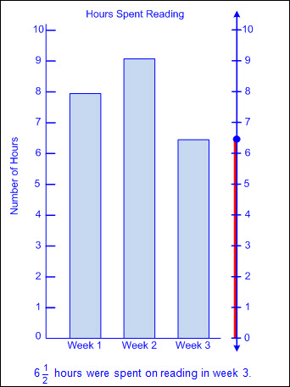  Note(s):  - Grade Level(s):  - Grade 2 represented whole numbers as distances from any given location on a number line.  - Grade 4 will represent fractions and decimals to the tenths or hundredths as distances from zero on a number line.  - Various mathematical process standards will be applied to this student expectation as appropriate.  - TxRCFP:  - Understanding fractions as numbers and representing equivalent fractions  - TxCCRS:  - I. Numeric Reasoning  - IX. Communication and Representation
3.7B | Determine the perimeter of a polygon or a missing length when given perimeter and remaining side lengths in problems.  Readiness Standard  Determine the perimeter of a polygon or a missing length when given perimeter and remaining side lengths in problems.  Readiness Standard  Determine  THE PERIMETER OF A POLYGON  Including, but not limited to:  - Perimeter – a linear measurement of the distance around the outer edge of a figure  - Recognition of perimeter embedded in mathematical and real-world problem situations  - Ex: How much lace is needed to go around the edge of the rectangular tablecloth?  - Ex: How much fencing is needed to enclose a garden?  - Polygon – a closed figure with at least 3 sides, where all sides are straight (no curves)  - Regular and irregular polygons  - Ex:  - Determine perimeter when given side lengths.  - Whole number side lengths  - Polygons (regular or irregular)  - Add all side lengths in any order to determine perimeter.  - Ex:  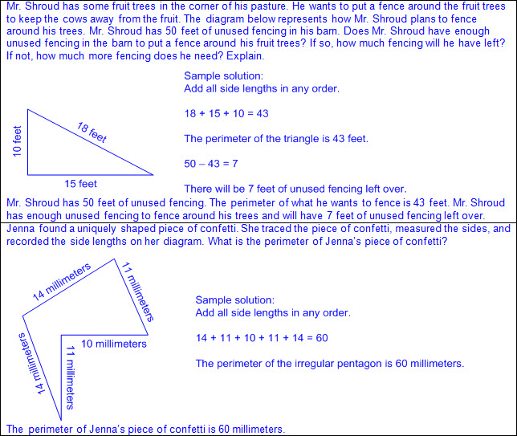  - Rectangles  - Apply attributes of geometric figures to determine unmarked side lengths.  - Opposite sides equal in length  - Add all side lengths in any order to determine perimeter.  - Ex:  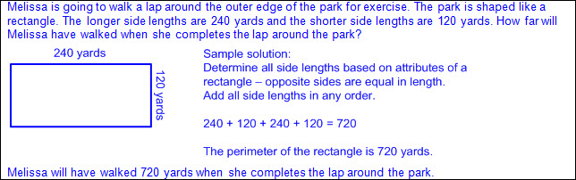  - Regular polygons  - Apply attributes of geometric figures to determine unmarked side lengths.  - All sides equal in length  - Add all side lengths in any order to determine perimeter.  - Ex:  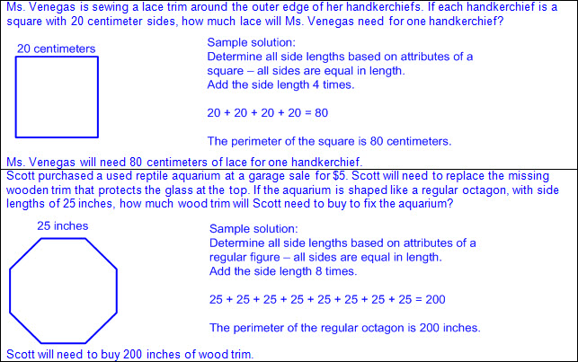  - Determine perimeter by measuring to determine side lengths.  - Ruler, STAAR Grade 3 Mathematics Reference Materials ruler, yardstick, meter stick, measuring tape, etc.  - Whole number side lengths  - Typically used units of measure in words and abbreviations  - Customary  - Inch (in.)  - Foot (ft)  - Yard (yd)  - Mile (mi)  - Metric  - Millimeter (mm)  - Meter (m)  - Centimeter (cm)  - Kilometer (km)  - Add all side lengths in any order to determine perimeter.  - Ex:  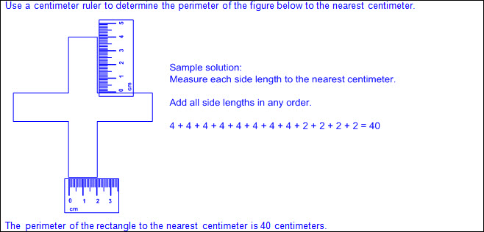  Determine  A MISSING LENGTH WHEN GIVEN PERIMETER AND REMAINING SIDE LENGTHS IN PROBLEMS  Including, but not limited to:  - Perimeter – a linear measurement of the distance around the outer edge of a figure  - Polygon – a closed figure with at least 3 sides, where all sides are straight (no curves)  - Ex:  - Determine missing side length when given perimeter and remaining side lengths.  - Whole number side lengths  - Polygons  - Limited to one missing side length in irregular polygons.  - Add all known side lengths and subtract from perimeter to determine the missing side length.  - Ex:  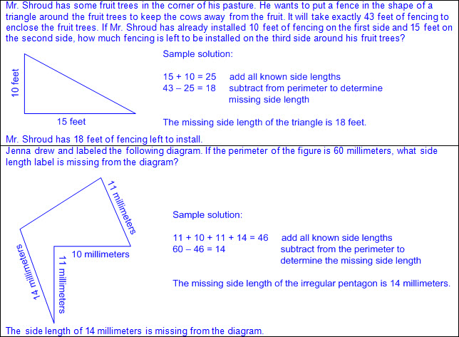  - Rectangles  - Apply attributes of geometric figures to determine unmarked side lengths.  - Opposite sides equal in length  - Add known side lengths of two opposite sides and subtract from perimeter to determine length of remaining sides combined.  - Divide length of remaining sides by 2 to determine each missing side length.  - Ex:  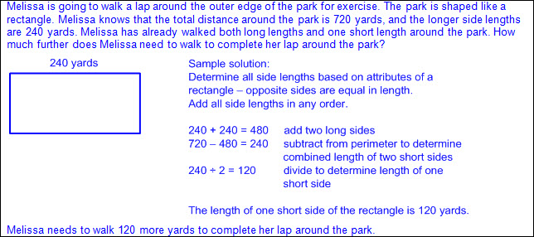  - Composite figures  - Rectangles and/or squares  - Apply attributes of geometric figures to determine unmarked side lengths when appropriate.  - Opposites sides equal in length for rectangles  - All sides equal in length for squares  - Add all known side lengths and subtract from perimeter to determine the length of remaining unknown sides combined.  - Apply attributes of rectangles and/or squares along with appropriate operations to determine each remaining missing side length.  - Ex:  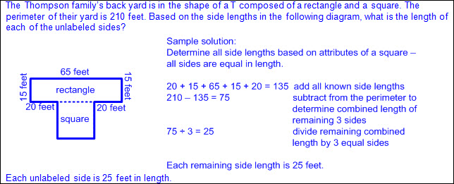  - Regular polygons  - Apply attributes of geometric figures to determine unmarked side lengths.  - All sides equal in length  - Divide given perimeter by the number of sides to determine the missing side length of all sides.  - Ex:  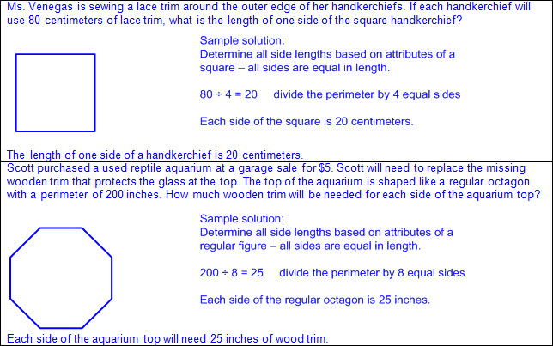  Note(s):  - Grade Level(s):  - Grade 2 determined a solution to a problem involving length, including estimating lengths.  - Grade 4 will use models to determine the formulas for the perimeter of a rectangle (l + w + l + w or 2l + 2w), including the special form for perimeter of a square (4s).  - Grade 4 will solve problems that deal with measurements of length using addition, subtraction, multiplication, or division as appropriate.  - Various mathematical process standards will be applied to this student expectation as appropriate.  - TxRCFP:  - Describing characteristics of two-dimensional and three-dimensional geometric figures, including measurable attributes  - TxCCRS:  - IV.C. Measurement Reasoning – Measurement involving geometry and algebra  - IX. Communication and Representation
3.7C | Determine the solutions to problems involving addition and subtraction of time intervals in minutes using pictorial models or tools such as a 15-minute event plus a 30-minute event equals 45 minutes.  Supporting Standard  Determine the solutions to problems involving addition and subtraction of time intervals in minutes using pictorial models or tools such as a 15-minute event plus a 30-minute event equals 45 minutes.  Supporting Standard  Determine  THE SOLUTIONS TO PROBLEMS INVOLVING ADDITION AND SUBTRACTION OF TIME INTERVALS IN MINUTES USING PICTORIAL MODELS OR TOOLS  Including, but not limited to:  - Addition and subtraction of time intervals in minutes  - Such as a 15-minute event plus a 30-minute event equals 45 minutes  - Time intervals given  - Conversion of 60 minutes to one hour and one hour to 60 minutes  - Pictorial models and tools  - Analog clock with gears, digital clock, number line, etc.  - Recognition of operations with time embedded in mathematical and real-world problem situations  - One-step and two-step problems  - Ex:  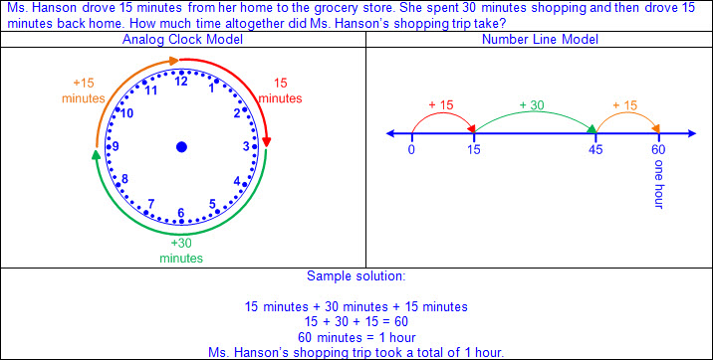  - Ex:  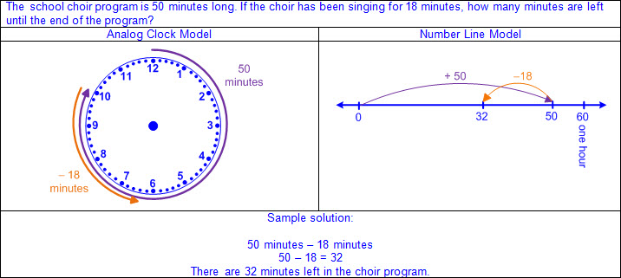  - Ex:  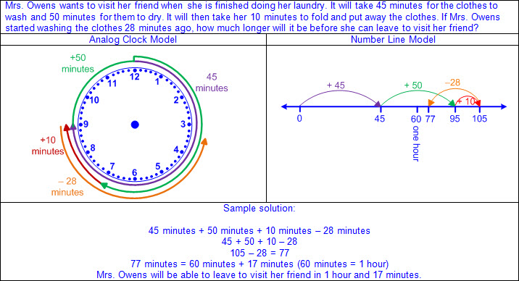  Note(s):  - Grade Level(s):  - Grade 2 read and wrote time to the nearest one-minute increment using analog and digital clocks and distinguished between a.m. and p.m.  - Grade 4 will solve problems that deal with intervals of time, including elapsed time, using addition, subtraction, multiplication, or division as appropriate.  - Various mathematical process standards will be applied to this student expectation as appropriate.  - TxRCFP:  - Understanding and applying place value and properties of operations to solve problems involving addition and subtraction of whole numbers within 1,000  - TxCCRS:  - VIII. Problem Solving and Reasoning  - IX. Communication and Representation  - X. Connections
3.7D | Determine when it is appropriate to use measurements of liquid volume (capacity) or weight.  Supporting Standard  Determine when it is appropriate to use measurements of liquid volume (capacity) or weight.  Supporting Standard  Determine  WHEN IT IS APPROPRIATE TO USE MEASUREMENTS OF LIQUID VOLUME (CAPACITY) OR WEIGHT  Including, but not limited to:  - Liquid volume – the measurement attribute that describes the amount of space that a liquid or dry, pourable material takes up, typically measured using standard units of capacity  - Capacity – the measurement attribute that describes the maximum amount a container will hold  - Typically used units of measure in words and abbreviations  - Customary  - Fluid ounce (fl oz)  - Cup (c)  - Pint (pt)  - Quart (qt)  - Gallon (gal)  - Metric  - Milliliter (ml or mL)  - Liter (l or L)  - Kiloliter (kl or kL)  - Recognition of liquid volume (capacity) concepts in mathematical and real-world problem situations  - Situations involving filling a container to its maximum, the amount of material in a container, etc.  - Ex: How much rice is needed to fill the box?  - Ex: How much rice is in the box?  - Situations involving liquid volume (capacity) units of measure  - Ex: How many pints of milk does the pitcher hold?  - Ex: How many liters of milk are in the pitcher?  - Weight – the measurement attribute that describes how heavy an object is, determined by the pull of gravity on the object  - Typically used units of measure in words and abbreviations  - Customary  - Ounce (oz)  - Pound (lb)  - Ton (T)  - Recognition of weight concepts in mathematical and real-world problem situations  - Situations involving how heavy objects are, how much something weighs, etc.  - Ex: How heavy is the dpg?  - Situations involving weight units of measure  - Ex: How many pounds does the dog weigh?  - Distinction between liquid ounces and ounces that measure weight  - Fluid ounces are associated with liquid volume (capacity) and ounces are associated with weight.  - Fluid ounces often named as simply ounces  - Distinction between ounces in mathematical and real-world problem situations  - Ex: The pitcher contains 20 ounces of fruit juice. (capacity; 20 fluid ounces inferred)  - Ex: The pitcher of fruit juice weighs 20 ounces. (weight)  Note(s):  - Grade Level(s):  - Kindergarten gave an example of a measurable attribute of a given object, including length, capacity, and weight.  - Grade 4 will solve problems that deal with measurements of liquid volumes and mass, including conversion, using addition, subtraction, multiplication, or division as appropriate.  - Various mathematical process standards will be applied to this student expectation as appropriate.  - TxRCFP:  - Describing characteristics of two-dimensional and three-dimensional geometric figures, including measurable attributes  - TxCCRS:  - IV.A. Measurement Reasoning – Measurement involving physical and natural attributes  - IX. Communication and Representation
3.7E | Determine liquid volume (capacity) or weight using appropriate units and tools.  Supporting Standard  Determine liquid volume (capacity) or weight using appropriate units and tools.  Supporting Standard  Determine  LIQUID VOLUME (CAPACITY) OR WEIGHT USING APPROPRIATE UNITS AND TOOLS  Including, but not limited to:  - Liquid volume – the measurement attribute that describes the amount of space that a liquid or dry, pourable material takes up, typically measured using standard units of capacity  - Capacity – the measurement attribute that describes the maximum amount a container will hold  - Typically used units of measure in words and abbreviations  - Customary  - Fluid ounce (fl oz)  - Cup (c)  - Pint (pt)  - Quart (qt)  - Gallon (gal)  - Metric  - Milliliter (ml or mL)  - Liter (l or L)  - Kiloliter (kl or kL)  - Measurement tools typically used for liquid volume (capacity)  - Measuring cups, measuring containers or jars, eye droppers, beakers, graduated cylinders, etc.  - Pourable material leveled at the top of the measuring tool or container when measuring to whole units  - Ex:  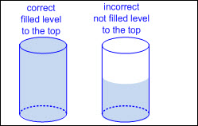  - Measure to determine liquid volume (capacity) in the customary and metric systems  - Measurement determined using equal sized units of liquid volume (capacity) counted to the nearest whole unit  - Last unit is not counted if the amount of pourable material fills less than half of the measuring tool.  - Last unit is counted if the amount of pourable material fills half, or more than half of the measuring tool.  - Ex:  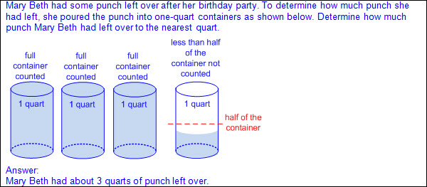  - Ex:  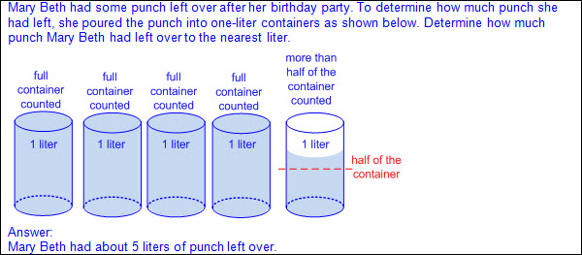  - Measurement determined using scaled measuring tools  - Relationship between reading a scaled measuring tool and a number line  - Ex:  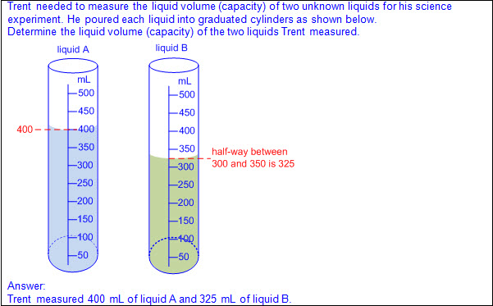  - Appropriate measuring tool selected  - Measuring tool selected for efficiency  - Smaller tool to measure the liquid volume (capacity) of smaller containers  - Larger tool to measure the liquid volume (capacity) of larger containers  - Appropriate unit of liquid volume (capacity) selected  - Unit of liquid volume (capacity) selected for efficiency  - Smaller unit of liquid volume (capacity) to measure the liquid volume (capacity) of smaller containers  - Larger unit of liquid volume (capacity) to measure the liquid volume (capacity) of larger containers  - Unit of liquid volume (capacity) selected for precision  - Smaller unit of liquid volume (capacity) results in a more precise measurement when measuring to the whole unit  - Larger unit of liquid volume (capacity) results in a less precise measurement when measuring to the whole unit  - Weight – the measurement attribute that describes how heavy an object is, determined by the pull of gravity on the object  - Typically used units of measure in words and abbreviations  - Customary  - Ounce (oz)  - Pound (lb)  - Ton (T)  - Measurement tools typically used for weight  - Spring scales, kitchen scales, bathroom scales, etc.  - Measure to determine weight in the in the customary system  - Measurement determined using scaled measuring tools  - Prior to measuring, the needle of the scale should point directly on zero.  - Ex:  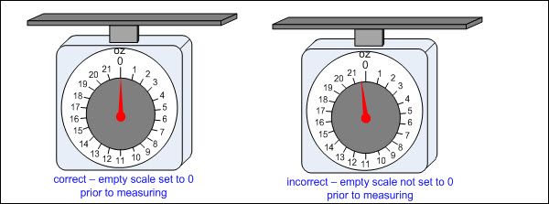  - Relationship between reading a scaled measuring tool and a number line  - Ex:  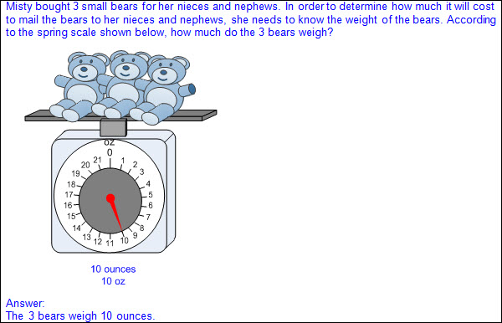  - Appropriate unit of weight selected  - Unit of weight selected for precision  - Smaller unit of weight results in a more precise measurement when measuring to the whole unit  - Larger unit of weight results in a less precise measurement when measuring to the whole unit  Note(s):  - Grade Level(s):  - Kindergarten compared two objects with a common measurable attribute to see which object has more of/less of the attribute and described the difference.  - Grade 4 will solve problems that deal with measurements liquid volumes and mass using addition, subtraction, multiplication, or division as appropriate.  - Various mathematical process standards will be applied to this student expectation as appropriate.  - TxRCFP:  - Describing characteristics of two-dimensional and three-dimensional geometric figures, including measurable attributes  - TxCCRS:  - IV.A. Measurement Reasoning – Measurement involving physical and natural attributes  - IX. Communication and Representation
3.8 | Data analysis. The student applies mathematical process standards to solve problems by collecting, organizing, displaying, and interpreting data. The student is expected to:
3.8A | Summarize a data set with multiple categories using a frequency table, dot plot, pictograph, or bar graph with scaled intervals.  Readiness Standard  Summarize a data set with multiple categories using a frequency table, dot plot, pictograph, or bar graph with scaled intervals.  Readiness Standard  Summarize  A DATA SET WITH MULTIPLE CATEGORIES USING A FREQUENCY TABLE, DOT PLOT, PICTOGRAPH, OR BAR GRAPH WITH SCALED INTERVALS  Including, but not limited to:  - Whole numbers  - Data – information that is collected about people, events, or objects  - Categorical data – data that represents the attributes of a group of people, events, or objects  - Ex: What is your favorite color? Represented on a graph with colors as category labels (e.g., red, yellow, blue, green, and purple)  - Ex: Do you have a brother? Represented on a graph with yes and no as category labels  - Ex: Which sporting event do you prefer? Represented on a graph with names of sports as category labels (e.g., basketball, baseball, football, soccer, and hockey)  - Categorical data may represent numbers or ranges of numbers.  - Ex: How many pets do you have? Represented on a graph with numbers as category labels (e.g., 0, 1, 2, 3, and 4 or more)  - Ex: How many letters are in your name? Represented on a graph with ranges of numbers as category labels (e.g., 1 – 3, 4 – 6, 7 – 9, and 10 or more)  - Data organized into multiple categories  - Data representations  - Frequency table – a table to organize data that lists categories and the frequency (number of times) that each category occurs  - Characteristics of a frequency table  - Title clarifies the meaning of the data represented.  - Categorical data is represented with labels.  - Data represented may be objects, events, numbers, or a range of numbers.  - Tally marks are used to record frequencies.  - Numbers are used to represent the count of tally marks in each category.  - Count of tally marks represents the frequency of how often a category occurs.  - Ex:  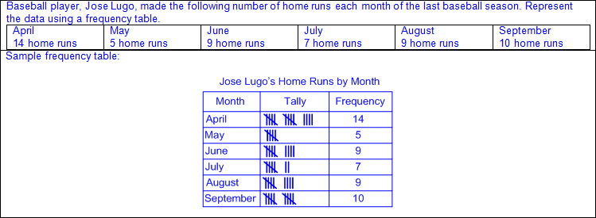  - Dot plot – a graphical representation to organize data that uses dots (or Xs) to show the frequency (number of times) that each category occurs  - Characteristics of a dot plot  - Title clarifies the meaning of the data represented.  - Categorical data is represented with labels.  - When categorical data is used it is orderly and not arbitrary.  - Data represented may be objects, events, numbers, or a range of numbers.  - Categories are represented by a line, or number line, labeled with categories.  - Dots (or Xs) are recorded vertically above the line to represent the frequency of each category or number.  - Dots (or Xs) generally represent one count.  - Ex:  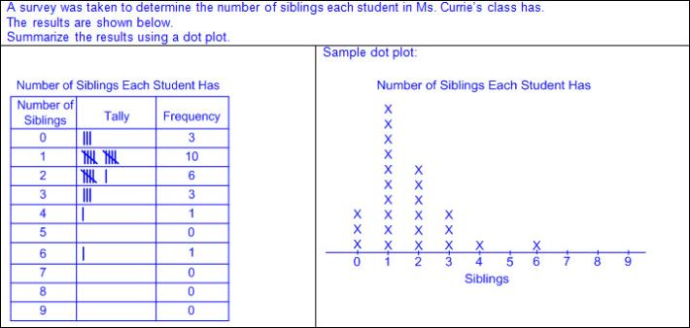  - Dots (or Xs) may represent multiple counts if indicated with a key.  - Ex:  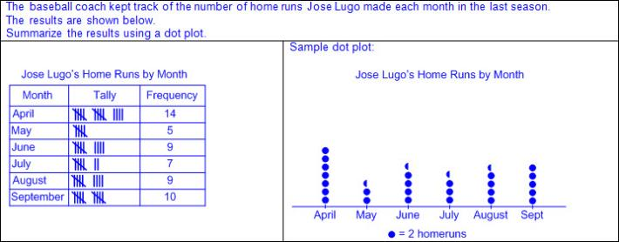  - Value of the category is determined by the number of dots (or Xs) drawn.  - Ex:  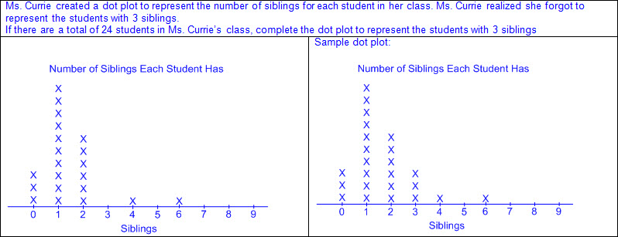  - Pictograph – a graphical representation to organize data that uses a picture or symbol, where each picture or symbol may represent one or more than one unit of data, to show the frequency (number of times) that each category occurs  - Characteristics of a pictograph  - Title clarifies the meaning of the data represented.  - Categorical data is represented with labels.  - Horizontal or vertical linear arrangement  - One picture or symbol is used to represent all categories.  - A key is used to identify the value of each picture or symbol.  - Number of pictures and partial-pictures or symbols represents the number of data points for a given category.  - Ex:  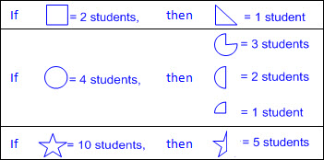  - Ex:  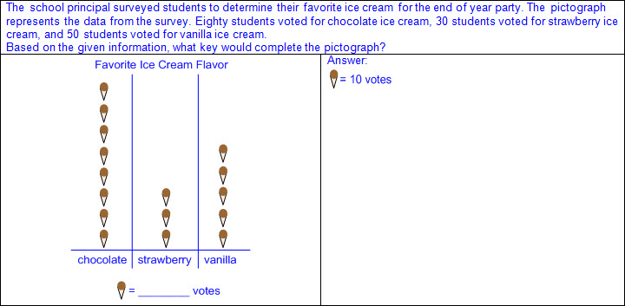  - Value of the data in each category is determined by the total value of the pictures or symbols in that category.  - Ex:  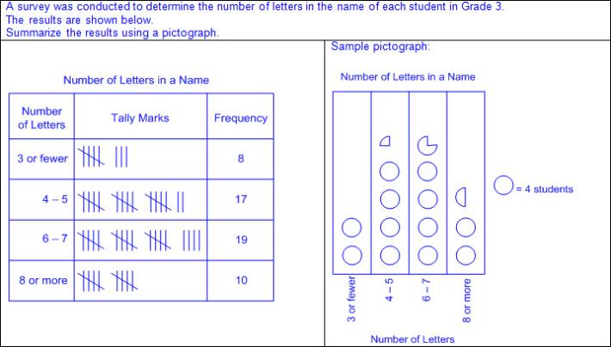  - Ex:  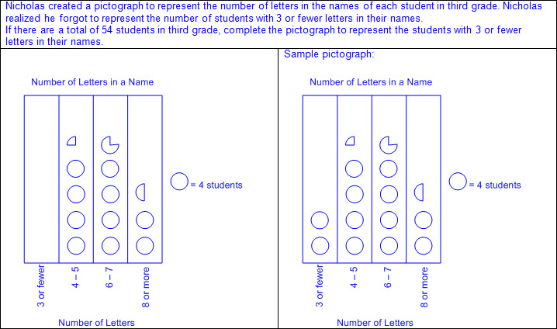  - Bar graph – a graphical representation to organize data that uses solid bars that do not touch each other to show the frequency (number of times) that each category occurs  - Characteristics of a bar graph  - Title clarifies the meaning of the data represented.  - Subtitles clarify the meaning of the data represented on each axis.  - Categorical data is represented with labels.  - Horizontal or vertical linear arrangement  - Bars are solid.  - Bars do not touch.  - Scale of the axis may be intervals of one or more, and scale intervals are proportionally displayed.  - The scale of the axis is a number line.  - Length of the bar represents the number of data points for a given category.  - Length the bar represents the distance from zero on the scale of the axis.  - Value of the data represented by the bar is determined by reading the number associated with its length (distance from zero) on the axis scale.  - Ex:  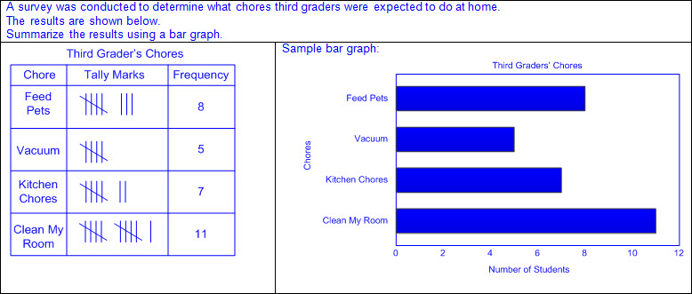  - Ex:  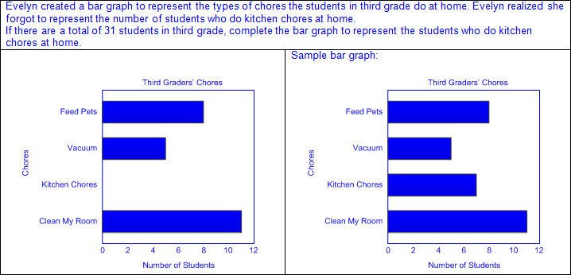  Note(s):  - Grade Level(s):  - Grade 2 organized a collection of data with up to four categories using pictographs and bar graphs with intervals of one or more.  - Grade 3 introduces frequency tables and dot plots.  - Grade 4 will represent data on a frequency table, dot plot, or stem-and-leaf plot marked with whole numbers and fractions.  - Various mathematical process standards will be applied to this student expectation as appropriate.  - TxRCFP:  - Understanding and applying place value and properties of operations to solve problems involving addition and subtraction of whole numbers within 1,000  - TxCCRS:  - VI.B. Statistical Reasoning – Describe data  - IX. Communication and Representation  - X. Connections
3.8B | Solve one- and two-step problems using categorical data represented with a frequency table, dot plot, pictograph, or bar graph with scaled intervals.  Supporting Standard  Solve one- and two-step problems using categorical data represented with a frequency table, dot plot, pictograph, or bar graph with scaled intervals.  Supporting Standard  Solve  ONE- AND TWO-STEP PROBLEMS USING CATEGORICAL DATA REPRESENTED WITH A FREQUENCY TABLE, DOT PLOT, PICTOGRAPH, OR BAR GRAPH WITH SCALED INTERVALS  Including, but not limited to:  - Whole numbers  - Addition  - Addition of whole numbers within 1,000  - Subtraction  - Subtraction of whole numbers within 1,000  - Multiplication  - Products of up to a two-digit factor by a one-digit factor  - Division  - Quotients of up to a two-digit dividend by a one-digit divisor  - Data – information that is collected about people, events, or objects  - Categorical data – data that represents the attributes of a group of people, events, or objects  - Ex: What is your favorite color? Represented on a graph with colors as category labels (e.g., red, yellow, blue, green, and purple)  - Ex: Do you have a brother? Represented on a graph with yes and no as category labels  - Ex: Which sporting event do you prefer? Represented on a graph with names of sports as category labels (e.g., basketball, baseball, football, soccer, and hockey)  - Categorical data may represent numbers or ranges of numbers.  - Ex: How many pets do you have? Represented on a graph with numbers as category labels (e.g., 0, 1, 2, 3, and 4 or more)  - Ex: How many letters are in your name? Represented on a graph with ranges of numbers as category labels (e.g., 1 – 3, 4 – 6, 7 – 9, and 10 or more)  - Data representations  - Frequency table – a table to organize data that lists categories and the frequency (number of times) that each category occurs  - Dot plot – a graphical representation to organize data that uses dots or Xs to show the frequency (number of times) that each category occurs  - Pictograph – a graphical representation to organize data that uses a picture or symbol, where each picture or symbol may represent one or more than one unit of data, to show the frequency (number of times) that each category occurs  - Bar graph – a graphical representation to organize data that uses solid bars that do not touch each other to show the frequency (number of times) that each category occurs  - Mathematical and real-world problem situations using data represented with frequency tables, dot plots, pictographs, and bar graphs  - One- or two-step problems  - Ex:  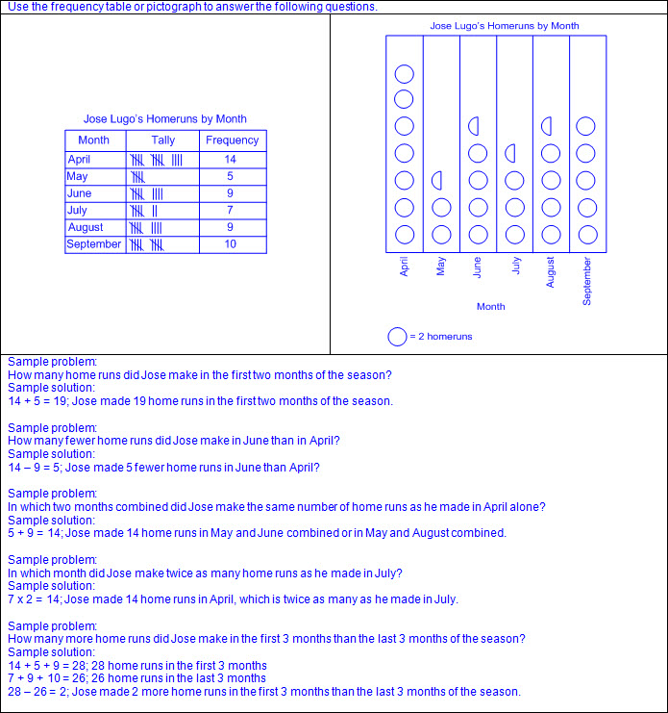  - Ex:  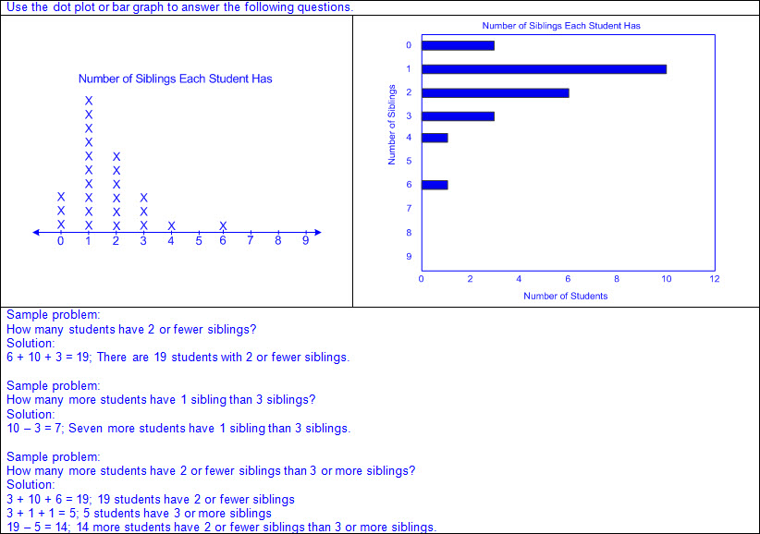  Note(s):  - Grade Level(s):  - Grade 2 wrote and solved one-step word problems involving addition or subtraction using data represented within pictographs and bar graphs with intervals of one.  - Grade 4 will solve one- and two-step problems using data in whole number, decimal, and fraction form in a frequency table, dot plot, or stem-and-leaf plot.  - Various mathematical process standards will be applied to this student expectation as appropriate.  - TxRCFP:  - Understanding and applying place value and properties of operations to solve problems involving addition and subtraction of whole numbers within 1,000  - TxCCRS:  - VI.B. Statistical Reasoning – Describe data  - VIII. Problem Solving and Reasoning  - IX. Communication and Representation  - X. Connections
3.9 | Personal financial literacy. The student applies mathematical process standards to manage one's financial resources effectively for lifetime financial security. The student is expected to:
3.9A | Explain the connection between human capital/labor and income.  Supporting Standard  Explain the connection between human capital/labor and income.  Supporting Standard  Explain  THE CONNECTION BETWEEN HUMAN CAPITAL/LABOR AND INCOME  Including, but not limited to:  - Income – money earned for working and money received for the sale of goods or property  - Human capital/labor – abilities, skills, and education that helps to make a worker more valuable  - Connection between human capital/labor and income  - Some jobs require specific abilities, skills, or education.  - Ex: A teacher must earn a college degree; an artist must have artistic talent; etc.  - Increased abilities, skills, and education may increase job opportunities.  - Ex: A person with a college degree may qualify for more types of jobs than a person without a college degree; a person with strong computer skills may be able to work in a wider variety of jobs than a person without computer skills; etc.  - Increased abilities, skills, and education may lead to higher income.  - Ex: A person with a college degree may earn more money than a person without a college degree; an employer may be willing to pay a higher income to a person with greater abilities, skills, and education; etc.  Note(s):  - Grade Level(s):  - Grade 1 defined money earned as income.  - Grade 4 will distinguish between fixed and variable expenses.  - Various mathematical process standards will be applied to this student expectation as appropriate.  - TxRCFP:  - Financial Literacy  - TxCCRS:  - IX. Communication and Representation  - X. Connections
3.9B | Describe the relationship between the availability or scarcity of resources and how that impacts cost.  Describe the relationship between the availability or scarcity of resources and how that impacts cost.  Describe  THE RELATIONSHIP BETWEEN THE AVAILABILITY OR SCARCITY OF RESOURCES AND HOW THAT IMPACTS COST  Including, but not limited to:  - Resources – natural or man-made materials or items needed to satisfy wants and needs  - Scarcity – when human wants for goods and services are greater than the quantity of goods and services that can be produced using all available resources  - Costs of production  - Materials and resources  - Human capital/labor  - Energy and natural resources  - Relationship between availability or scarcity of resources and cost of production  - Increased availability of resources may lower cost of production.  - Suppliers may lower prices in order to sell extra resources quickly.  - Buyers may have more choices of suppliers and may seek the lowest price.  - Scarcity of resources may increase cost of production.  - Suppliers may raise prices because there is a limited supply of the resource.  - Buyers may have fewer choices of suppliers and may be willing to pay more to obtain the resource.  - Relationship between cost of production and price of goods and services  - Increased cost of production may increase the price of goods and services.  - Decreased cost of production may decrease the price of goods and services.  Note(s):  - Grade Level(s):  - Grade 2 differentiated between producers and consumers and calculated the cost to produce a simple item.  - Grade 4 will calculate profit in a given situation.  - Various mathematical process standards will be applied to this student expectation as appropriate.  - TxRCFP:  - Financial Literacy  - TxCCRS:  - IX. Communication and Representation  - X. Connections
3.9C | Identify the costs and benefits of planned and unplanned spending decisions.  Identify the costs and benefits of planned and unplanned spending decisions.  Identify  THE COSTS AND BENEFITS OF PLANNED AND UNPLANNED SPENDING DECISIONS  Including, but not limited to:  - Costs of planned spending decisions  - Satisfaction of wants or needs may be delayed.  - Goods or services may not be available in the future.  - Benefits of planned spending decisions  - Ability to be sure income will be enough to cover costs of goods or services  - Time allowed for comparison shopping for best price or quality  - Costs of unplanned spending decisions  - May not have enough money left for future needs  - No time for comparison shopping for lower price  - Another option may be available in the near future.  - Benefits of unplanned spending decisions  - Goods and services may be on sale for a reduced price.  - Immediate satisfaction of wants or needs  Note(s):  - Grade Level(s):  - Grade 2 explained that saving is an alternative to spending.  - Various mathematical process standards will be applied to this student expectation as appropriate.  - TxRCFP:  - Financial Literacy  - TxCCRS:  - IX. Communication and Representation  - X. Connections
3.9D | Explain that credit is used when wants or needs exceed the ability to pay and that it is the borrower's responsibility to pay it back to the lender, usually with interest.  Supporting Standard  Explain that credit is used when wants or needs exceed the ability to pay and that it is the borrower's responsibility to pay it back to the lender, usually with interest.  Supporting Standard  Explain  THAT CREDIT IS USED WHEN WANTS OR NEEDS EXCEED THE ABILITY TO PAY AND THAT IT IS THE BORROWER'S RESPONSIBILITY TO PAY IT BACK TO THE LENDER, USUALLY WITH INTEREST  Including, but not limited to:  - Credit – buying or obtaining goods or services now with an agreement to pay in the future  - Reasons to use credit  - Current wants or needs exceed current income.  - Buyer does not have money with them at the time of purchase.  - Credit cards or loans used to make a purchase must be repaid within a given time period.  - Interest may be charged to purchase on credit.  - Interest paid – money paid for borrowing money or making purchases on credit  - Additional fees may be charged for failure to repay.  - Credit is a privilege not a guarantee.  - Responsible borrowers may be granted more credit or may be charged lower interest and fees.  - Irresponsible borrowers may not be granted credit or may be charged higher interest and fees.  Note(s):  - Grade Level(s):  - Grade 2 identified examples of borrowing and distinguished between responsible and irresponsible borrowing.  - Grade 4 will describe the basic purpose of financial institutions, including keeping money safe, borrowing money, and lending.  - Various mathematical process standards will be applied to this student expectation as appropriate.  - TxRCFP:  - Financial Literacy  - TxCCRS:  - IX. Communication and Representation  - X. Connections
3.9E | List reasons to save and explain the benefit of a savings plan, including for college.  Supporting Standard  List reasons to save and explain the benefit of a savings plan, including for college.  Supporting Standard  List  REASONS TO SAVE, INCLUDING FOR COLLEGE  Including, but not limited to:  - Saving – setting aside money earned or received for future use  - Reasons to save  - To pay for college  - To purchase future wants and needs  - To cover unexpected future expenses  - To earn interest  Explain  THE BENEFIT OF A SAVINGS PLAN, INCLUDING FOR COLLEGE  Including, but not limited to:  - Savings plan – a plan to set money aside for future use  - Benefits of a savings plan  - Specific goals set are more likely to be met.  - Savings plan may be designed to meet individual wants and needs.  - More money saved may result in higher interest amounts earned.  - Money placed in savings is less accessible for unplanned spending.  - Some government supported college savings plans may reduce the cost of attending college through lower fixed tuition rates.  Note(s):  - Grade Level(s):  - Grade 2 calculated how money saved can accumulate into a larger amount over time.  - Grade 4 will compare the advantages and disadvantages of various savings options.  - Various mathematical process standards will be applied to this student expectation as appropriate.  - TxRCFP:  - Financial Literacy  - TxCCRS:  - IX. Communication and Representation  - X. Connections
3.9F | Identify decisions involving income, spending, saving, credit, and charitable giving.  Identify decisions involving income, spending, saving, credit, and charitable giving.  Identify  DECISIONS INVOLVING INCOME, SPENDING, SAVING, CREDIT, AND CHARITABLE GIVING  Including, but not limited to:  - Decisions involving income  - Income – money earned for working and money received for the sale of goods or property  - Ex: How will income be earned?  - Ex: Will increasing ability, skills, or education increase income?  - Ex: Should income be saved or spent?  - Decisions involving spending  - Spending – purchasing goods and services to satisfy wants and needs  - Ex: Is this spending for a want or a need?  - Ex: Is the cost of goods or services the most reasonable cost?  - Ex: Will money spent now be needed in the future?  - Decisions involving saving  - Saving – setting aside money earned or received for future use  - Ex: What are my saving goals?  - Ex: How much money should be saved?  - Ex: How long should money be saved?  - Ex: How much interest will be earned with different savings plans?  - Ex: Should savings be held in a bank or at home?  - Decisions involving credit  - Credit – buying or obtaining goods or services now with an agreement to pay in the future  - Ex: How much interest and fees will be charged for using credit?  - Ex: Will credit be able to be repaid in the given time period?  - Decisions involving charitable giving  - Charity – an organization that collects money, goods, or services for groups in need  - Charitable giving – donating to an organization that collects money, goods, or services to groups in need  - Ex: How much money, goods, or services is needed by the charity?  - Ex: Will income remaining after a donation be enough to satisfy personal wants and needs?  - Ex: Who will benefit from donations to charity?  - Ex: Which charities should be selected?  Note(s):  - Grade Level(s):  - Grade 1 considered charitable giving.  - Various mathematical process standards will be applied to this student expectation as appropriate.  - TxRCFP:  - Financial Literacy  - TxCCRS:  - IX. Communication and Representation  - X. Connections
Bibliography:
Texas Education Agency & Texas Higher Education Coordinating Board. (2009). Texas college and career readiness standards. Retrieved from http://www.thecb.state.tx.us/collegereadiness/crs.pdf

Texas Education Agency. (2013). Introduction to the revised mathematics TEKS – kindergarten-algebra I vertical alignment. Retrieved from
http://www.projectsharetexas.org/sites/default/files/resources/documents/K-AlgebraIVAChart.pdf

Texas Education Agency. (2013). Texas response to curriculum focal points for kindergarten through grade 8 mathematics. Retrieved from
http://projectsharetexas.org/resource/txrcfp-texas-response-curriculum-focal-points-k-8-mathematics-revised-2013
Bold black text in italics: Knowledge and Skills Statement (TEKS); Bold black text: Student Expectation (TEKS)
Bold red text in italics: Student Expectation identified by TEA as a Readiness Standard for STAAR
Bold green text in italics: Student Expectation identified by TEA as a Supporting Standard for STAAR
Blue text: Supporting information / Clarifications from TCMPC (Specificity)
Black text: Texas Education Agency (TEA); Texas College and Career Readiness Standards (TxCCRS)

