Enhanced TEKS Clarification

Mathematics

Grade 2

2014 - 2015
Grade 2
§111.1. Implementation of Texas Essential Knowledge and Skills for Mathematics, Elementary, Adopted 2012.
Source: The provisions of this §111.1 adopted to be effective September 10, 2012, 37 TexReg 7109.
§111.4. Grade 2, Adopted 2012.
2.Intro.1 | The desire to achieve educational excellence is the driving force behind the Texas essential knowledge and skills for mathematics, guided by the college and career readiness standards. By embedding statistics, probability, and finance, while focusing on computational thinking, mathematical fluency, and solid understanding, Texas will lead the way in mathematics education and prepare all Texas students for the challenges they will face in the 21st century.

2.Intro.2 | The process standards describe ways in which students are expected to engage in the content. The placement of the process standards at the beginning of the knowledge and skills listed for each grade and course is intentional. The process standards weave the other knowledge and skills together so that students may be successful problem solvers and use mathematics efficiently and effectively in daily life. The process standards are integrated at every grade level and course. When possible, students will apply mathematics to problems arising in everyday life, society, and the workplace. Students will use a problem-solving model that incorporates analyzing given information, formulating a plan or strategy, determining a solution, justifying the solution, and evaluating the problem-solving process and the reasonableness of the solution. Students will select appropriate tools such as real objects, manipulatives, algorithms, paper and pencil, and technology and techniques such as mental math, estimation, number sense, and generalization and abstraction to solve problems. Students will effectively communicate mathematical ideas, reasoning, and their implications using multiple representations such as symbols, diagrams, graphs, computer programs, and language. Students will use mathematical relationships to generate solutions and make connections and predictions. Students will analyze mathematical relationships to connect and communicate mathematical ideas. Students will display, explain, or justify mathematical ideas and arguments using precise mathematical language in written or oral communication.

2.Intro.3 | For students to become fluent in mathematics, students must develop a robust sense of number. The National Research Council's report, "Adding It Up," defines procedural fluency as "skill in carrying out procedures flexibly, accurately, efficiently, and appropriately." As students develop procedural fluency, they must also realize that true problem solving may take time, effort, and perseverance. Students in Grade 2 are expected to perform their work without the use of calculators.

2.Intro.4 | The primary focal areas in Grade 2 are making comparisons within the base-10 place value system, solving problems with addition and subtraction within 1,000, and building foundations for multiplication.

2.Intro.4A | Students develop an understanding of the base-10 place value system and place value concepts. The students' understanding of base-10 place value includes ideas of counting in units and multiples of thousands, hundreds, tens, and ones and a grasp of number relationships, which students demonstrate in a variety of ways.

2.Intro.4B | Students identify situations in which addition and subtraction are useful to solve problems. Students develop a variety of strategies to use efficient, accurate, and generalizable methods to add and subtract multi-digit whole numbers.

2.Intro.4C | Students use the relationship between skip counting and equal groups of objects to represent the addition or subtraction of equivalent sets, which builds a strong foundation for multiplication and division.

2.Intro.5 | Statements that contain the word "including" reference content that must be mastered, while those containing the phrase "such as" are intended as possible illustrative examples.

2.1 | Mathematical process standards. The student uses mathematical processes to acquire and demonstrate mathematical understanding. The student is expected to:
2.1A | Apply mathematics to problems arising in everyday life, society, and the workplace.  Apply mathematics to problems arising in everyday life, society, and the workplace.  Apply  MATHEMATICS TO PROBLEMS ARISING IN EVERYDAY LIFE, SOCIETY, AND THE WORKPLACE  Note(s):  - The mathematical process standards may be applied to all content standards as appropriate.  - TxRCFP:  - Developing proficiency in the use of place value within the base-10 numeration system  - Using place value and properties of operations to solve problems involving addition and subtraction of whole numbers within 1,000  - Measuring length  - Applying knowledge of two-dimensional shapes and three-dimensional solids, including exploration of early fraction concepts  - TxCCRS:  - X. Connections
2.1B | Use a problem-solving model that incorporates analyzing given information, formulating a plan or strategy, determining a solution, justifying the solution, and evaluating the problem-solving process and the reasonableness of the solution.  Use a problem-solving model that incorporates analyzing given information, formulating a plan or strategy, determining a solution, justifying the solution, and evaluating the problem-solving process and the reasonableness of the solution.  Use  A PROBLEM-SOLVING MODEL THAT INCORPORATES ANALYZING GIVEN INFORMATION, FORMULATING A PLAN OR STRATEGY, DETERMINING A SOLUTION, JUSTIFYING THE SOLUTION, AND EVALUATING THE PROBLEM-SOLVING PROCESS AND THE REASONABLENESS OF THE SOLUTION  Note(s):  - The mathematical process standards may be applied to all content standards as appropriate.  - TxRCFP:  - Developing proficiency in the use of place value within the base-10 numeration system  - Using place value and properties of operations to solve problems involving addition and subtraction of whole numbers within 1,000  - Measuring length  - Applying knowledge of two-dimensional shapes and three-dimensional solids, including exploration of early fraction concepts  - TxCCRS:  - VIII. Problem Solving and Reasoning
2.1C | Select tools, including real objects, manipulatives, paper and pencil, and technology as appropriate, and techniques, including mental math, estimation, and number sense as appropriate, to solve problems.  Select tools, including real objects, manipulatives, paper and pencil, and technology as appropriate, and techniques, including mental math, estimation, and number sense as appropriate, to solve problems.  Select  TOOLS, INCLUDING REAL OBJECTS, MANIPULATIVES, PAPER AND PENCIL, AND TECHNOLOGY AS APPROPRIATE, TO SOLVE PROBLEMS  Select  TECHNIQUES, INCLUDING MENTAL MATH, ESTIMATION, AND NUMBER SENSE AS APPROPRIATE, TO SOLVE PROBLEMS  Note(s):  - The mathematical process standards may be applied to all content standards as appropriate.  - TxRCFP:  - Developing proficiency in the use of place value within the base-10 numeration system  - Using place value and properties of operations to solve problems involving addition and subtraction of whole numbers within 1,000  - Measuring length  - Applying knowledge of two-dimensional shapes and three-dimensional solids, including exploration of early fraction concepts  - TxCCRS:  - VIII. Problem Solving and Reasoning
2.1D | Communicate mathematical ideas, reasoning, and their implications using multiple representations, including symbols, diagrams, graphs, and language as appropriate.  Communicate mathematical ideas, reasoning, and their implications using multiple representations, including symbols, diagrams, graphs, and language as appropriate.  Communicate  MATHEMATICAL IDEAS, REASONING, AND THEIR IMPLICATIONS USING MULTIPLE REPRESENTATIONS, INCLUDING SYMBOLS, DIAGRAMS, GRAPHS, AND LANGUAGE AS APPROPRIATE  Note(s):  - The mathematical process standards may be applied to all content standards as appropriate.  - TxRCFP:  - Developing proficiency in the use of place value within the base-10 numeration system  - Using place value and properties of operations to solve problems involving addition and subtraction of whole numbers within 1,000  - Measuring length  - Applying knowledge of two-dimensional shapes and three-dimensional solids, including exploration of early fraction concepts  - TxCCRS:  - IX. Communication and Representation
2.1E | Create and use representations to organize, record, and communicate mathematical ideas.  Create and use representations to organize, record, and communicate mathematical ideas.  Create, Use  REPRESENTATIONS TO ORGANIZE, RECORD, AND COMMUNICATE MATHEMATICAL IDEAS  Note(s):  - The mathematical process standards may be applied to all content standards as appropriate.  - TxRCFP:  - Developing proficiency in the use of place value within the base-10 numeration system  - Using place value and properties of operations to solve problems involving addition and subtraction of whole numbers within 1,000  - Measuring length  - Applying knowledge of two-dimensional shapes and three-dimensional solids, including exploration of early fraction concepts  - TxCCRS:  - IX. Communication and Representation
2.1F | Analyze mathematical relationships to connect and communicate mathematical ideas.  Analyze mathematical relationships to connect and communicate mathematical ideas.  Analyze  MATHEMATICAL RELATIONSHIPS TO CONNECT AND COMMUNICATE MATHEMATICAL IDEAS  Note(s):  - The mathematical process standards may be applied to all content standards as appropriate.  - TxRCFP:  - Developing proficiency in the use of place value within the base-10 numeration system  - Using place value and properties of operations to solve problems involving addition and subtraction of whole numbers within 1,000  - Measuring length  - Applying knowledge of two-dimensional shapes and three-dimensional solids, including exploration of early fraction concepts  - TxCCRS:  - X. Connections
2.1G | Display, explain, and justify mathematical ideas and arguments using precise mathematical language in written or oral communication.  Display, explain, and justify mathematical ideas and arguments using precise mathematical language in written or oral communication.  Display, Explain, Justify  MATHEMATICAL IDEAS AND ARGUMENTS USING PRECISE MATHEMATICAL LANGUAGE IN WRITTEN OR ORAL COMMUNICATION  Note(s):  - The mathematical process standards may be applied to all content standards as appropriate.  - TxRCFP:  - Developing proficiency in the use of place value within the base-10 numeration system  - Using place value and properties of operations to solve problems involving addition and subtraction of whole numbers within 1,000  - Measuring length  - Applying knowledge of two-dimensional shapes and three-dimensional solids, including exploration of early fraction concepts  - TxCCRS:  - IX. Communication and Representation
2.2 | Number and operations. The student applies mathematical process standards to understand how to represent and compare whole numbers, the relative position and magnitude of whole numbers, and relationships within the numeration system related to place value. The student is expected to:
2.2A | Use concrete and pictorial models to compose and decompose numbers up to 1,200 in more than one way as a sum of so many thousands, hundreds, tens, and ones.  Use concrete and pictorial models to compose and decompose numbers up to 1,200 in more than one way as a sum of so many thousands, hundreds, tens, and ones.  Use  CONCRETE AND PICTORIAL MODELS OF NUMBERS UP TO 1,200  Including, but not limited to:  - Whole numbers (0 – 1,200)  - Counting (natural) numbers – the set of positive numbers that begins at one and increases by increments of one each time {1, 2, 3, ..., n}  - Whole numbers – the set of counting (natural) numbers and zero {0, 1, 2, 3, ..., n}  - Numeral – a symbol used to name a number  - Digit – any numeral from 0 – 9  - Place value – the value of a digit as determined by its location in a number such as ones, tens, hundreds, one thousands, etc.  - One thousands place  - Hundreds place  - Tens place  - Ones place  - Base-10 place value system  - A number system using ten digits 0 – 9  - Relationships between places are based on multiples of 10.  - The magnitude (relative size) of one thousand  - Ex: 1,000 can be represented as 10 hundreds.  - Ex: 1,000 can be represented as 100 tens.  - Ex: 1,000 can be represented as 1,000 ones.  - Concrete models  - Proportional models – a visual representation that demonstrates the relative size of each place value using models with proportional dimensions, meaning the model of each place value is exactly 10 times larger than the place value model to the right (e.g., the base-10 long is exactly 10 times as big as the unit showing that one 10 is equal to ten ones)  - Bundled sticks (proportional representation of the magnitude of a number with 1-to-10 relationship)  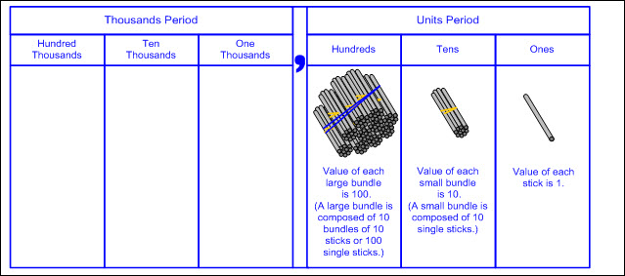  - Base-10 blocks (proportional representation of the magnitude of a number with 1-to-10 relationship)  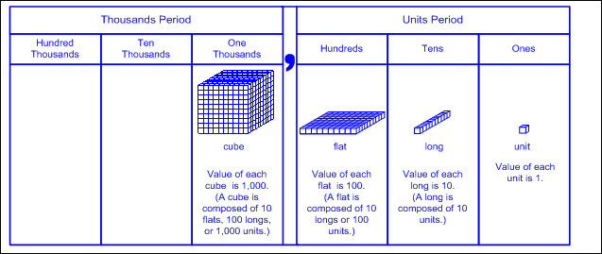  - Non-proportional models – a visual representation that does not maintain the proportional relationship of size, meaning the size of each place value model is not 10 times larger than the place value model to the right (e.g., the value of each place value disk is indicated by the numerical label and color but does not change in size)  - Place value disks (non-proportional representation with a 1-to-10 relationship)  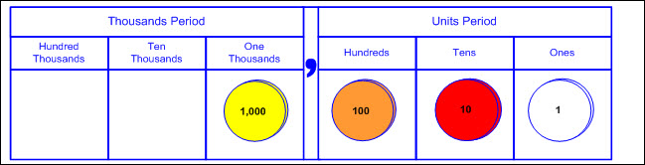  - Pictorial models  - Base-10 block representations  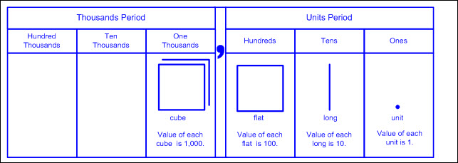  - Place value disk representations  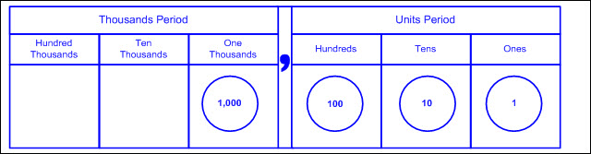  - Open number line – an empty number line where tick marks are added to represent landmarks of numbers, often indicated with arcs above the number line (referred to as jumps) demonstrating approximate proportional distances  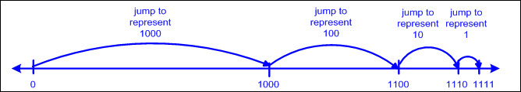  To Compose, To Decompose  NUMBERS UP TO 1,200 IN MORE THAN ONE WAY AS A SUM OF SO MANY THOUSANDS, HUNDREDS, TENS, AND ONES  Including, but not limited to:  - Whole numbers (0 – 1,200)  - Counting (natural) numbers – the set of positive numbers that begins at one and increases by increments of one each time {1, 2, 3, ..., n}  - Whole numbers – the set of counting (natural) numbers and zero {0, 1, 2, 3, ..., n}  - Compose numbers – to combine parts or smaller values to form a number  - Decompose numbers – to break a number into parts or smaller values  - Compose a number in more than one way using concrete and pictorial models.  - As a sum of so many thousands, hundreds, tens, and ones  - Ex:  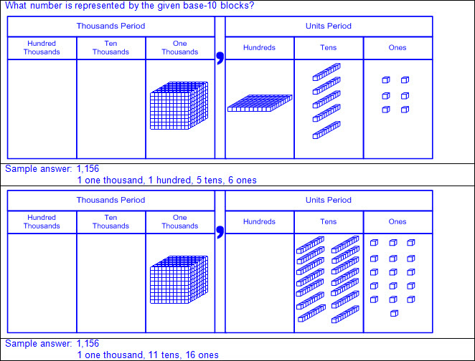  - Decompose a number in more than one way using concrete and pictorial models.  - As a sum of so many thousands, hundreds, tens, and ones  - Ex:  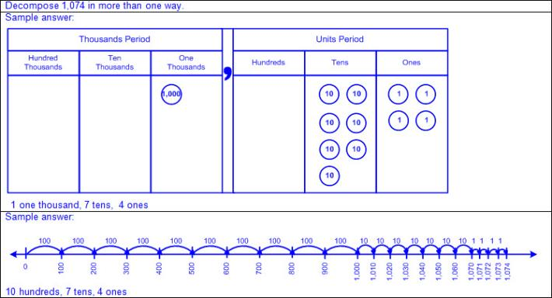  Note(s):  - Grade Level(s):  - Grade 1 used concrete and pictorial models to compose and decompose numbers up to 120 and used objects, pictures and expanded and standard forms to represent numbers.  - Grade 3 will compose and decompose numbers up to 100,000 using objects, pictorial models, and numbers, including expanded notation as appropriate.  - Various mathematical process standards will be applied to this student expectation as appropriate.  - TxRCFP:  - Developing proficiency in the use of place value within the base-10 numeration system  - TxCCRS:  - I. Numeric Reasoning  - IX. Communication and Representation
2.2B | Use standard, word, and expanded forms to represent numbers up to 1,200.  Use standard, word, and expanded forms to represent numbers up to 1,200.  Use  STANDARD, WORD, AND EXPANDED FORMS TO REPRESENT NUMBERS UP TO 1,200  Including, but not limited to:  - Whole numbers (0 – 1,200)  - Counting (natural) numbers – the set of positive numbers that begins at one and increases by increments of one each time {1, 2, 3, ..., n}  - Whole numbers – the set of counting (natural) numbers and zero {0, 1, 2, 3, ..., n}  - Place value – the value of a digit as determined by its location in a number, such as ones, tens, hundreds, one thousands, etc.  - Standard form – the representation of a number using digits (e.g., 1,200)  - Period – a three-digit grouping of whole numbers where each grouping is composed of a ones place, a tens place, and a hundreds place, and each grouping is separated by a comma  - Thousands period is composed of the one thousands place, ten thousands place, and hundred thousands place.  - Units period is composed of the ones place, tens place, and hundreds place.  - The word “thousand” after the numerical value of the thousands period is stated when read.  - A comma between the thousands period and the units period is recorded when written but not stated when read.  - The word “unit” after the numerical value of the units period is not stated when read.  - The word “hundred” in each period is stated when read.  - The words “ten” and “one” in each period are not stated when read.  - The tens place digit and ones place digit in each period are stated as a two-digit number when read.  - Zeros are used as place holders between digits as needed to maintain the value of each digit (e.g., 1,075).  - Leading zeros in a whole number are not commonly used in standard form, but are not incorrect and do not change the value of the number (e.g., 037 equals 37).  - Ex:  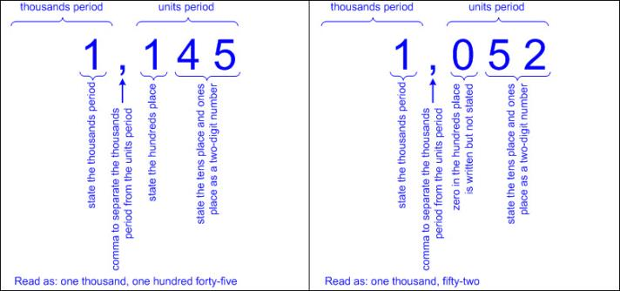  - Word form – the representation of a number using written words (e.g., 1,152 as one thousand, one hundred fifty-two)  - The word “thousand” after the numerical value of the thousands period is stated when read and recorded when written.  - A comma between the thousands period and the units period is not stated when read but is recorded when written.  - The word “unit” after the numerical value of the units period is not stated when read and not recorded when written.  - The word “hundred” in each period is stated when read and recorded when written.  - The words “ten” and “one” in each period are not stated when read and not recorded when written.  - The tens place digit and ones place digit in each period are stated as a two-digit number when read and recorded using a hyphen, where appropriate, when written (e.g., twenty-three, thirteen, etc.).  - The zeros in a whole number are not stated when read and are not recorded when written (e.g., 1,005 in standard form is read and written as one thousand, five in word form).  - Ex:  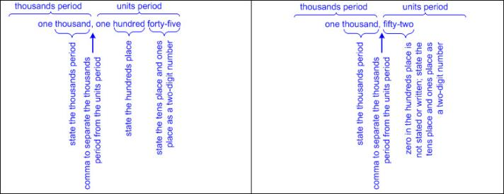  - Expanded form – the representation of a number as a sum of place values (e.g., 1,189 as 1,000 + 100 + 80 + 9)  - Zero may or may not be written as an addend to represent the digit 0 in a number (e.g., 1,075 as 1,000 + 0 + 70 + 5 or 1,000 + 70 + 5).  - Multiple representations  - Ex:  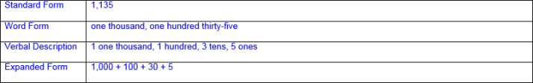  - Place values presented out of order  - Ex:  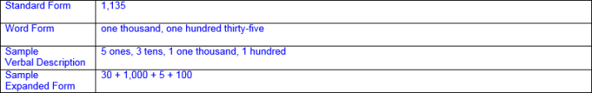  - Equivalent compositions/decompositions of numbers with the same value  - Ex:  Note(s):  - Grade Level(s):  - Grade 1 used objects, pictures, and expanded and standard forms to represent numbers up to 120.  - Grade 3 will compose and decompose numbers up to 100,000 using objects, pictorial models, and numbers, including expanded notation as appropriate.  - Grades 1 and 2 student expectations refer to expanded, standard, and word form, whereas Grades 3, 4, and 5 student expectations refer to expanded notation.  - Various mathematical process standards will be applied to this student expectation as appropriate.  - TxRCFP:  - Developing proficiency in the use of place value within the base-10 numeration system  - TxCCRS:  - I. Numeric Reasoning  - IX. Communication and Representation
2.2C | Generate a number that is greater than or less than a given whole number up to 1,200.  Generate a number that is greater than or less than a given whole number up to 1,200.  Generate  A NUMBER THAT IS GREATER THAN OR LESS THAN A GIVEN WHOLE NUMBER UP TO 1,200  Including, but not limited to:  - Whole numbers (0 – 1,200)  - Counting (natural) numbers – the set of positive numbers that begins at one and increases by increments of one each time {1, 2, 3, ..., n}  - Whole numbers – the set of counting (natural) numbers and zero {0, 1, 2, 3, ..., n}  - Comparative language  - Inequality language  - Greater than, more than  - Less than, fewer than  - Place value relationships  - 1 more or 1 less  - Adding 1 in the ones place will generate a number that is 1 more than the original number.  - Ex: 1,165 + 1 = 1,166  - Subtracting 1 in the ones place will generate a number that is 1 less than the original number.  - Ex: 1,165 – 1 = 1,164  - 10 more or 10 less  - Adding 1 in the tens place will generate a number that is 10 more than the original number.  - Ex: 1,165 + 10 = 1,175  - Subtracting 1 in the tens place will generate a number that is 10 less than the original number.  - Ex: 1,165 – 10 = 1,155  - 100 more or 100 less  - Adding 1 in the hundreds place will generate a number that is 100 more than the original number.  - Ex: 1,165 + 100 = 1,265  - Subtracting 1 in the hundreds place will generate a number that is 100 less than the original number.  - Ex: 1,165 – 100 = 1,065  - Numerical relationships  - Counting order  - Skip counting  - Doubles  - Concrete and pictorial models  - Hundreds chart  - Moving one place to the right will generate a number that is 1 more than the original number.  - Moving one place to the left will generate a number that is 1 less than the original number.  - Moving one row down will generate a number that is 10 more than the original number.  - Moving one row up will generate a number that is 10 less than the original number.  - Base-10 blocks  - Adding unit cubes will increase a number by increments of 1.  - Removing unit cubes will decrease a number by increments of 1.  - Adding longs will increase a number by increments of 10.  - Removing longs will decrease a number by increments of 10.  - Adding flats will increase a number by increments of 100.  - Removing flats will decrease a number by increments of 100.  - Number line  - Numbers increase from left to right.  - Numbers decrease from right to left.  Note(s):  - Grade Level(s):  - Grade 1 generated a number that is greater than or less than a given whole number up to 120.  - Grade 1 used relationships to determine the number that is 10 more and 10 less than a given number up to 120.  - Various mathematical process standards will be applied to this student expectation as appropriate.  - TxRCFP:  - Developing proficiency in the use of place value within the base-10 numeration system  - TxCCRS:  - I. Numeric Reasoning  - IX. Communication and Representation
2.2D | Use place value to compare and order whole numbers up to 1,200 using comparative language, numbers, and symbols (>, <, or =).  Use place value to compare and order whole numbers up to 1,200 using comparative language, numbers, and symbols (>, <, or =).  Use  PLACE VALUE FOR WHOLE NUMBERS UP TO 1,200  Including, but not limited to:  - Whole numbers (0 – 1,200)  - Counting (natural) numbers – the set of positive numbers that begins at one and increases by increments of one each time {1, 2, 3, ..., n}  - Whole numbers – the set of counting (natural) numbers and zero {0, 1, 2, 3, ..., n}  - Place value – the value of a digit as determined by its location in a number, such as ones, tens, hundreds, one thousands, etc.  - One thousands place  - Hundreds place  - Tens place  - Ones place  - Period – a three-digit grouping of whole numbers where each grouping is composed of a ones place, a tens place, and a hundreds place, and each grouping is separated by a comma  - Thousands period is composed of the one thousands place, ten thousands place, and hundred thousands place.  - Units period is composed of the ones place, tens place, and hundreds place.  To Compare, To Order  WHOLE NUMBERS UP TO 1,200 USING COMPARATIVE LANGUAGE, NUMBERS, AND SYMBOLS (>, <, OR =)  Including, but not limited to:  - Whole numbers (0 – 1,200)  - Counting (natural) numbers – the set of positive numbers that begins at one and increases by increments of one each time {1, 2, 3, ..., n}  - Whole numbers – the set of counting (natural) numbers and zero {0, 1, 2, 3, ..., n}  - Place value – the value of a digit as determined by its location in a number such as ones, tens, hundreds, one thousands, etc.  - Comparative language and symbols  - Inequality words and symbols  - Greater than (>)  - Less than (<)  - Equality words and symbol  - Equal to (=)  - Compare numbers – to consider the value of two numbers to determine which number is greater or less or if the numbers are equal in value  - Relative magnitude of a number describes the size of a number and its relationship to another number.  - Ex: 1,050 is closer to 0 on a number line than 1,200, so 1,050 < 1,200 and 1,200 > 1,050.  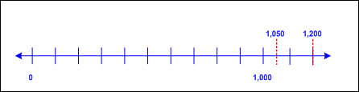  - Ex: 750 is further from 0 on a number line than 175, so 750 > 175 and 175 < 750.  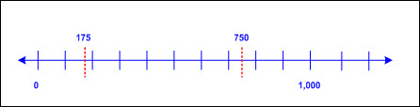  - Compare two numbers using place value charts.  - Compare digits in the same place value position beginning with the greatest place value.  - If these digits are the same, continue to the next smallest place until the digits are different.  - Ex:  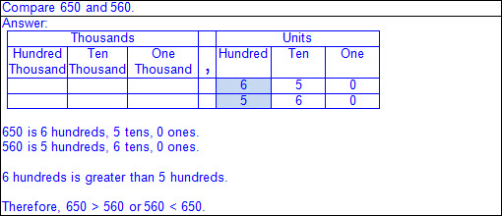  - Numbers that have common digits but are not equal in value (different place values)  - Ex:  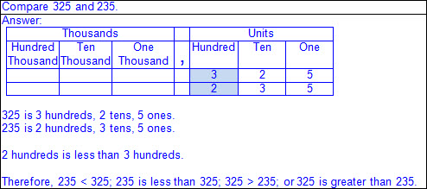  - Numbers that have a different number of digits  - Ex:  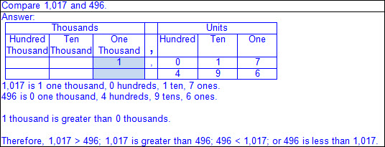  - Compare two numbers using a number line.  - Number lines (horizontal/vertical)  - Proportional number lines (pre-determined intervals with at least two labeled numbers)  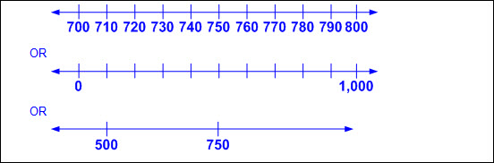  - Open number lines (no marked intervals)  - Ex:  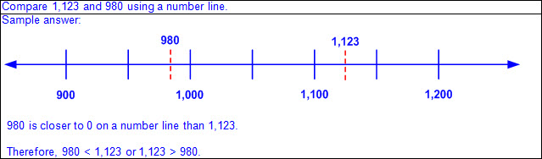  - Order numbers – to arrange a set of numbers based on their numerical value  - Numbers increase from left to right on a horizontal number line and from bottom to top on a vertical number line.  - Points to the left of a specified point on a horizontal number line are less than points to the right.  - Points to the right of a specified point on a horizontal number line are greater than points to the left.  - Points below a specified point on a vertical number line are less than points above.  - Points above a specified point on a vertical number line are greater than points below.  - Order a set of numbers on a number line.  - Ex:  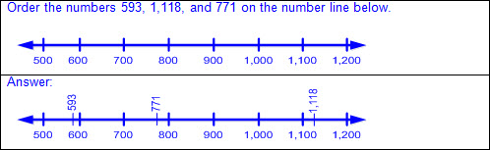  - Order a set of numbers on an open number line.  - Ex:  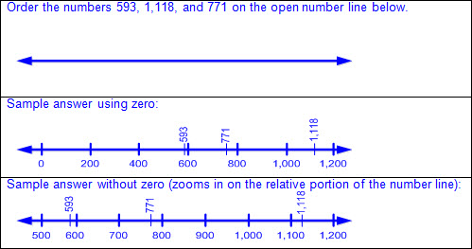  - Quantifying descriptors (e.g., between two given numbers, greatest/least, ascending/descending, tallest/shortest, warmest/coldest, fastest/slowest, longest/shortest, heaviest/lightest, closest/farthest, oldest/youngest, etc.)  - Ex:  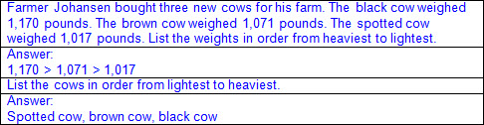  - Ex:  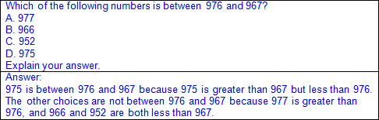  Note(s):  - Grade Level(s):  - Grade 1 used place value to compare numbers up to 120 and represented the comparison of two numbers to 100 using the symbols >, <, or =.  - Grade 3 will use compare and order whole numbers up to 100,000 and represent the comparisons using the symbols >, <, or =.  - Various mathematical process standards will be applied to this student expectation as appropriate.  - TxRCFP:  - Developing proficiency in the use of place value within the base-10 numeration system  - TxCCRS:  - I. Numeric Reasoning  - IX. Communication and Representation
2.2E | Locate the position of a given whole number on an open number line.  Locate the position of a given whole number on an open number line.  Locate  THE POSITION OF A GIVEN WHOLE NUMBER ON AN OPEN NUMBER LINE  Including, but not limited to:  - Whole numbers (0 – 1,200)  - Counting (natural) numbers – the set of positive numbers that begins at one and increases by increments of one each time {1, 2, 3, ..., n}  - Whole numbers – the set of counting (natural) numbers and zero {0, 1, 2, 3, ..., n}  - Characteristics of an open number line  - An open number line begins as a line with no intervals (or tick marks) and no positions/numbers labeled.  - Numbers/positions are placed on the empty number line only as they are needed.  - When reasoning on an open number line, the position of zero is often not placed.  - When working with larger numbers, an open number line without the constraint of distance from zero allows the ability to “zoom-in” on the relevant section of the number line.  - The placement of the first two numbers on an open number line determines the scale of the number line.  - Once the scale of the number line has been established by the placement of the first two numbers, intervals between additional numbers placed are approximately proportional.  - The differences between numbers are approximated by the distance between the positions on the number line.  - Open number lines extend infinitely in both directions (arrows indicate the number line continues infinitely).  - Numbers increase from left to right on a horizontal number line and from bottom to top on a vertical number line.  - Points to the left of a specified point on a horizontal number line are less than points to the right.  - Points to the right of a specified point on a horizontal number line are greater than points to the left.  - Points below a specified point on a vertical number line are less than points above.  - Points above a specified point on a vertical number line are greater than points below.  - Landmark (or anchor) numbers may be placed on the open number line to help locate other numbers.  - Open number line given  - Ex:  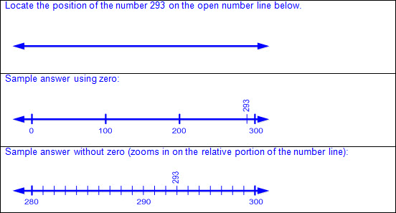  - Ex:  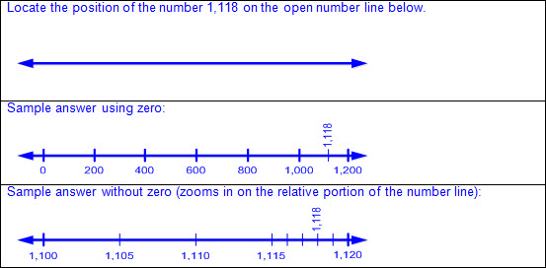  Note(s):  - Grade Level(s):  - Grade 1 ordered whole numbers up to 120 using place value and open number lines.  - Grade 3 will represent a number on a number line as being between two consecutive multiples of 10; 100; 1,000; or 10,000 and use words to describe relative size of numbers in order to round whole numbers.  - Various mathematical process standards will be applied to this student expectation as appropriate.  - TxRCFP:  - Developing proficiency in the use of place value within the base-10 numeration system  - TxCCRS:  - I. Numeric Reasoning  - IX. Communication and Representation
2.2F | Name the whole number that corresponds to a specific point on a number line.  Name the whole number that corresponds to a specific point on a number line.  Name  THE WHOLE NUMBER THAT CORRESPONDS TO A SPECIFIC POINT ON A NUMBER LINE  Including, but not limited to:  - Whole numbers (0 – 1,200)  - Counting (natural) numbers – the set of positive numbers that begins at one and increases by increments of one each time {1, 2, 3, ..., n}  - Whole numbers – the set of counting (natural) numbers and zero {0, 1, 2, 3, ..., n}  - Characteristics of a number line  - A number line begins as a line with predetermined intervals (or tick marks) with positions/numbers labeled.  - A minimum of two positions/numbers should be labeled.  - Numbers on a number line represent the distance from zero.  - The distance between the tick marks is counted rather than the tick marks themselves.  - The placement of the labeled positions/numbers on a number line determines the scale of the number line.  - Intervals between position/numbers are proportional.  - When reasoning on a number line, the position of zero may or may not be placed.  - When working with larger numbers, a number line without the constraint of distance from zero allows the ability to “zoom-in” on the relevant section of the number line.  - Number lines extend infinitely in both directions (arrows indicate the number line continues infinitely).  - Numbers increase from left to right on a horizontal number line and from bottom to top on a vertical number line.  - Points to the left of a specified point on a horizontal number line are less than points to the right.  - Points to the right of a specified point on a horizontal number line are greater than points to the left.  - Points below a specified point on a vertical number line are less than points above.  - Points above a specified point on a vertical number line are greater than points below.  - Number lines can be horizontal, vertical, or circular.  - Ex: Some thermometers are a vertical number line; analog clocks are a circular number line; etc.  - Intervals and partial labels given  - Ex:  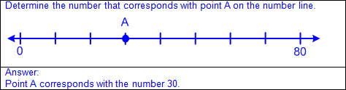  - Ex:  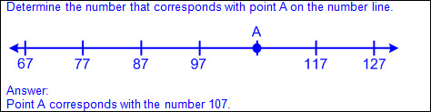  - Ex:  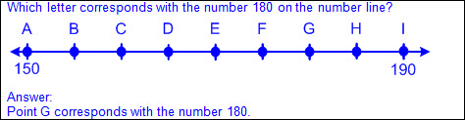  - Partial intervals and labels given  - Ex:  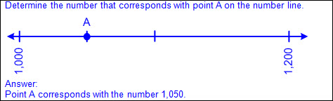  Note(s):  - Grade Level(s):  - Grade 2 will name the whole number that corresponds to a specific point on a number line.  - Grade 3 will determine the corresponding fraction greater than zero and less than or equal to one with denominators of 2, 3, 4, 6, and 8 given a specified point on a number line.  - Various mathematical process standards will be applied to this student expectation as appropriate.  - TxRCFP:  - Developing proficiency in the use of place value within the base-10 numeration system  - TxCCRS:  - I. Numeric Reasoning  - IX. Communication and Representation
2.3 | Number and operations. The student applies mathematical process standards to recognize and represent fractional units and communicates how they are used to name parts of a whole. The student is expected to:
2.3A | Partition objects into equal parts and name the parts, including halves, fourths, and eighths, using words.  Partition objects into equal parts and name the parts, including halves, fourths, and eighths, using words.  Partition  OBJECTS INTO EQUAL PARTS, INCLUDING HALVES, FOURTHS, AND EIGHTHS  Including, but not limited to:  - Fraction – a number that can be used to name part of an object or part of a set of objects  - Partition – separation or division of an object into parts  - Whole divided into two, four, or eight equal parts  - Each equal part of an object is the same size and the same shape.  - Ex:  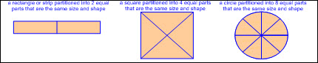  - Equal parts of identical wholes may not be the same shape.  - Ex:  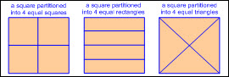  - Equal parts of non-identical wholes may not be equal in size or shape.  - Ex:  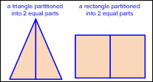  - Concrete models of whole objects  - Linear models  - Cuisenaire rods, fraction bars, linking cube trains, folded paper strips, etc.  - Ex: Cuisenaire rods  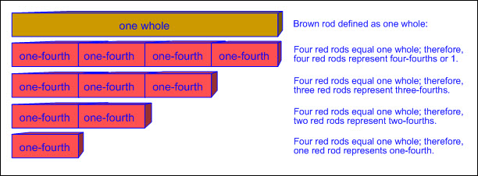  - Ex: Fraction bars  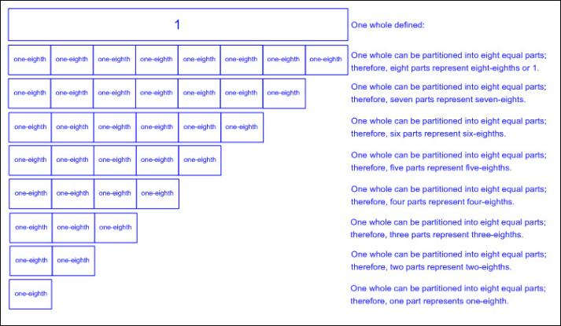  - Ex: Linking cube trains  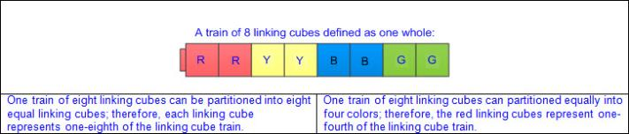  - Ex: Folded paper strip  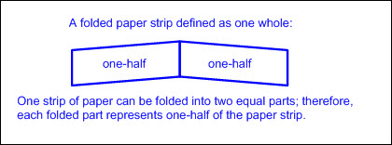  - Area models  - Fractions circles or squares, pattern blocks, geoboards, etc.  - Ex: Fractions circles or squares  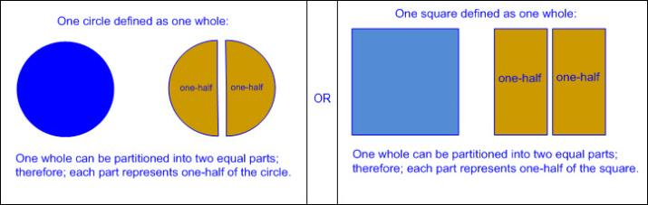  - Ex: Pattern blocks  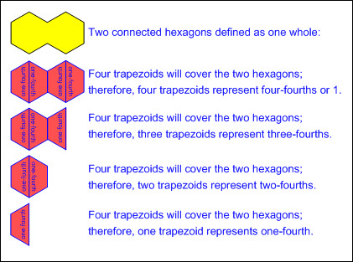  - Ex: Geoboards  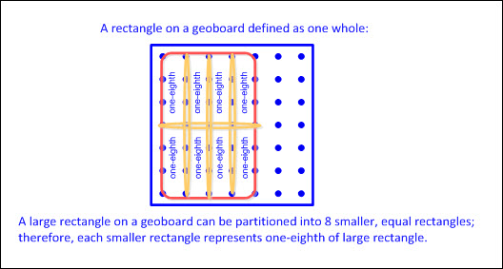  Name  THE EQUAL PARTS OF PARTITIONED OBJECTS, INCLUDING HALVES, FOURTHS, AND EIGHTHS, USING WORDS  Including, but not limited to:  - Appropriate oral and written mathematical language to name equal parts  - Hyphen used to separate the number of parts being considered from the total number of parts  - Number of parts being considered written before the hyphen and said first  - Total number of parts written after the hyphen and said last  - Two equal parts  - One-half, two-halves or one whole  - Four equal parts  - One-fourth, two-fourths, three-fourths, four-fourths or one whole  - One-quarter, two-quarters, three-quarters, four-quarters or one whole  - Eight equal parts  - One-eighth, two-eighths, three-eighths, four-eighths, five-eighths, six-eighths, seven-eighths, eight-eighths or one whole  - Relationship between ordinal numbers and the number of parts named in a fraction  Note(s):  - Grade Level(s):  - Grade 1 partitioned two-dimensional figures into two and four fair shares or equal parts and described the parts using words.  - Grade 2 is not expected to identify the relationship between equivalent fractions (e.g., two-fourths is the same as one-half, etc.).  - Grade 3 will introduce pictorial models of fractions, fractional parts of a set of objects, and fraction symbols.  - Various mathematical process standards will be applied to this student expectation as appropriate.  - TxRCFP:  - Applying knowledge of two-dimensional shapes and three-dimensional solids, including exploration of early fraction concepts  - TxCCRS:  - I. Numeric Reasoning  - IX. Communication and Representation
2.3B | Explain that the more fractional parts used to make a whole, the smaller the part; and the fewer the fractional parts, the larger the part.  Explain that the more fractional parts used to make a whole, the smaller the part; and the fewer the fractional parts, the larger the part.  Explain  THE MORE FRACTIONAL PARTS USED TO MAKE A WHOLE, THE SMALLER THE PART; AND THE FEWER THE FRACTIONAL PARTS, THE LARGER THE PART  Including, but not limited to:  - Fraction – a number that can be used to name part of an object or part of a set of objects  - Inverse relationship between the size of the fractional part and the number of equal parts in the whole when given the same size whole  - The greater the number of parts, the smaller the size of the parts  - The smaller the number of parts, the greater the size of the parts  - Whole divided into two, four, or eight equal parts  - Concrete models of whole objects  - Linear models  - Cuisenaire rods, fraction bars, linking cube trains, folded paper strips, etc.  - Area models  - Fractions circles or squares, pattern blocks, geoboards, etc.  - Ex:  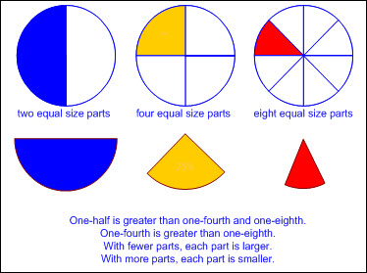  Note(s):  - Grade Level(s):  - Grade 1 partitioned two-dimensional figures into two and four fair shares or equal parts and described the parts using words.  - Grade 3 will introduce pictorial models of fractions, fractional parts of a set of objects, and fraction symbols.  - Grade 3 will explain that the unit fraction represents the quantity formed by one part of a whole that has been partitioned into b equal parts where b is a non-zero whole number.  - Various mathematical process standards will be applied to this student expectation as appropriate.  - TxRCFP:  - Applying knowledge of two-dimensional shapes and three-dimensional solids, including exploration of early fraction concepts  - TxCCRS:  - I. Numeric Reasoning  - IX. Communication and Representation
2.3C | Use concrete models to count fractional parts beyond one whole using words and recognize how many parts it takes to equal one whole.  Use concrete models to count fractional parts beyond one whole using words and recognize how many parts it takes to equal one whole.  Use  CONCRETE MODELS TO COUNT FRACTIONAL PARTS BEYOND ONE WHOLE USING WORDS  Including, but not limited to:  - Fraction – a number that can be used to name part of an object or part of a set of objects  - Relationship between counting whole numbers and counting fractional parts of a whole  - Hierarchical inclusion – concept of nested numbers, meaning each prior number in the counting sequence is included in the set as the set increases (e.g., 18 is 17 increased by 1; 18 decreased by 1 is 17; etc.)  - Ex:  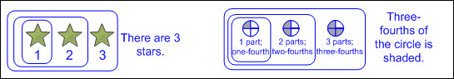  - Appropriate oral and written mathematical language  - Wholes divided into two, four, or eight equal parts  - Concrete models of whole objects  - Linear models  - Cuisenaire rods, fraction bars, linking cube trains, folded paper strips, etc.  - Area models  - Fractions circles or squares, pattern blocks, geoboards, etc.  - Count fractional parts up to one whole using concrete models  - Determination of the number of parts that equal one whole  - Two-halves equal one whole; four-fourths equal one whole; eight-eighths equal one whole  - Determination of the number of parts being counted  - Correct sequence of fractional names  - Two equal parts  - One-half, two-halves or one whole  - Ex:  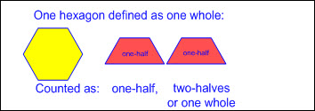  - Four equal parts  - One-fourth, two-fourths, three-fourths, four-fourths or one whole  - One-quarter, two-quarters, three-quarters, four-quarters or one whole  - Ex:  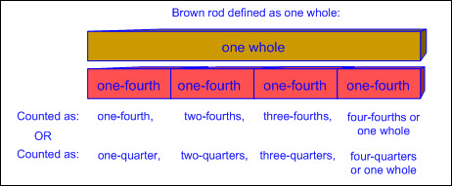  - Eight equal parts  - One-eighth, two-eighths, three-eighths, four-eighths, five-eighths, six-eighths, seven-eighths, eight-eighths or one whole  - Ex:  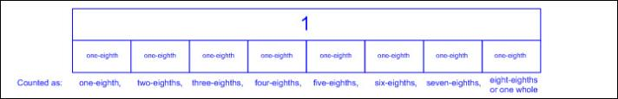  - Count fractional parts beyond one whole using concrete models  - Determination of the number of parts that equal one whole  - Two-halves equal one whole; four-fourths equal one whole; eight-eighths equal one whole  - Determination of the number of parts being counted  - Correct sequence of fractional names  - Two equal parts  - One-half, two-halves, three-halves, four-halves, five-halves, etc.  - One-half, one whole, one and one-half, two wholes, two and one-half, etc.  - Ex:  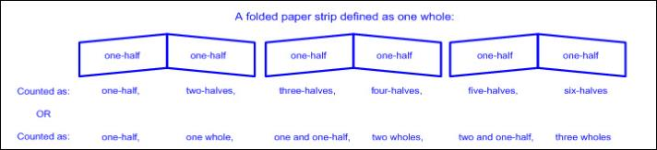  - Four equal parts  - One-fourth, two-fourths, three-fourths, four-fourths, five-fourths, six-fourths, seven-fourths, eight-fourths, nine-fourths, etc.  - One-fourth, two-fourths, three-fourths, one whole, one and one-fourth, one and two-fourths, one and three-fourths, two wholes, two and one-fourth, etc.  - One-quarter, two-quarters, three-quarters, four-quarters, five-quarters, six-quarters, seven-quarters, eight-quarters, nine-quarters, etc.  - One-quarter, two-quarters, three-quarters, one whole, one and one-quarter, one and two-quarters, one and three-quarters, two wholes, two and one-quarter, etc.  - Ex:  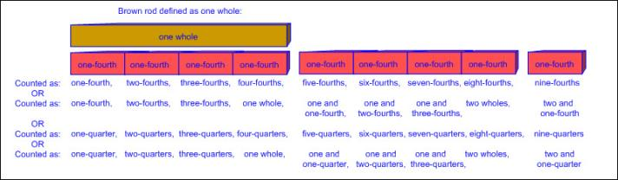  - Eight equal parts  - One-eighth, two-eighths, three-eighths, four-eighths, five-eighths, six-eighths, seven-eighths, eight-eighths, nine-eighths, ten-eighths, eleven-eighths, twelve-eighths, thirteen-eighths, fourteen-eighths, fifteen-eighths, sixteen-eighths, seventeen-eighths, etc.  - One-eighth, two-eighths, three-eighths, four-eighths, five-eighths, six-eighths, seven-eighths, one whole, one and one-eighth, one and two-eighths, one and three-eighths, one and four-eighths, one and five-eighths, one and six-eighths, one and seven-eighths, two wholes, two and one-eighth, etc.  - Ex:  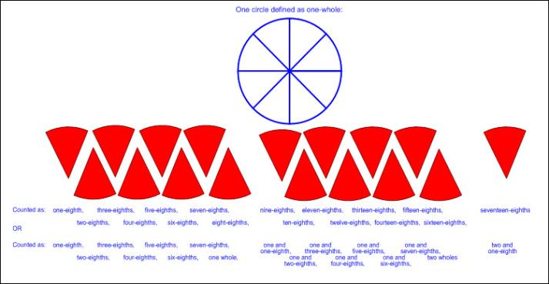  Recognize  HOW MANY PARTS IT TAKES TO EQUAL ONE WHOLE  Including, but not limited to:  - Recognition of the whole  - Recognition of the number of parts that equal one whole  - Two-halves equal one whole; four-fourths equal one whole; eight-eighths equal one whole  - Recognition of the number of parts being considered  - Number of parts being considered within one whole  - Ex:  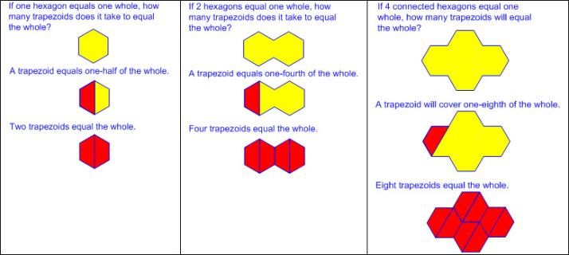  - Number of parts being considered beyond one whole  - Ex:  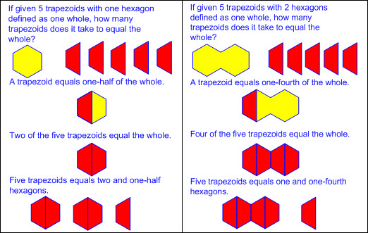  Note(s):  - Grade Level(s):  - Grade 3 will represent fractions greater than zero and less than or equal to one with denominators of 2, 3, 4, 6, and 8 using concrete objects and pictorial models, including strip diagrams and number lines.  - Grade 3 will solve problems involving partitioning an object or a set of objects among two or more recipients using pictorial representations of fractions with denominators of 2, 3, 4, 6, and 8.  - Various mathematical process standards will be applied to this student expectation as appropriate.  - TxRCFP:  - Applying knowledge of two-dimensional shapes and three-dimensional solids, including exploration of early fraction concepts  - TxCCRS:  - I. Numeric Reasoning  - IX. Communication and Representation
2.3D | Identify examples and non-examples of halves, fourths, and eighths.  Identify examples and non-examples of halves, fourths, and eighths.  Identify  EXAMPLES AND NON-EXAMPLES OF HALVES, FOURTHS, AND EIGHTHS  Including, but not limited to:  - Fraction – a number that can be used to name part of an object or part of a set of objects  - Whole divided into two, four, or eight equal parts  - Examples of halves, fourths, and eighths  - Equal parts or fair shares that equal the given one whole  - Ex:  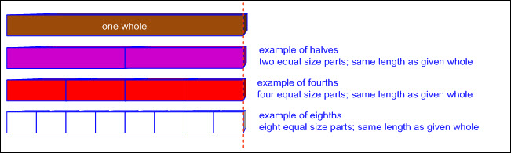  - Non-examples of halves, fourths, and eighths  - Unequal parts that equal the given one whole  - Ex:  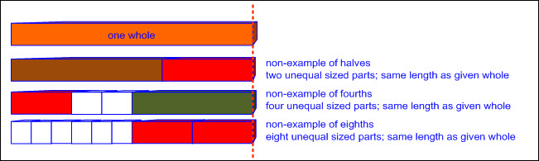  - Equal or unequal parts that are less than the given one whole  - Ex:  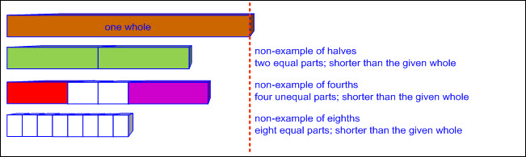  - Equal or unequal parts that are more than the given one whole  - Ex:  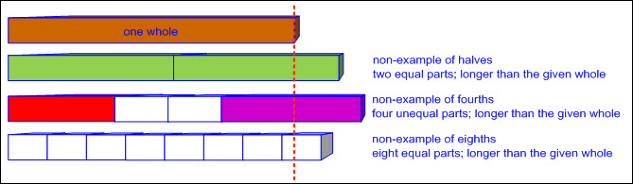  - Concrete models of whole objects  - Linear models  - Cuisenaire rods, fraction bars, linking cube trains, folded paper strips, etc.  - Area models  - Fractions circles or squares, pattern blocks, geoboards, etc.  Note(s):  - Grade Level(s):  - Grade 3 will represent fractions greater than zero and less than or equal to one with denominators of 2, 3, 4, 6, and 8 using concrete objects and pictorial models, including strip diagrams and number lines.  - Various mathematical process standards will be applied to this student expectation as appropriate.  - TxRCFP:  - Applying knowledge of two-dimensional shapes and three-dimensional solids, including exploration of early fraction concepts  - TxCCRS:  - I. Numeric Reasoning  - IX. Communication and Representation
2.4 | Number and operations. The student applies mathematical process standards to develop and use strategies and methods for whole number computations in order to solve addition and subtraction problems with efficiency and accuracy. The student is expected to:
2.4A | Recall basic facts to add and subtract within 20 with automaticity.  Recall basic facts to add and subtract within 20 with automaticity.  Recall With Automaticity  BASIC FACTS TO ADD WITHIN 20  Including, but not limited to:  - Whole numbers  - Counting (natural) numbers – the set of positive numbers that begins at one and increases by increments of one each time {1, 2, 3, ..., n}  - Whole numbers – the set of counting (natural) numbers and zero {0, 1, 2, 3, ..., n}  - Automaticity – executing a basic fact with little or no conscious effort  - Addition  - Sum – the total when two or more addends are joined  - Addend – a number being added or joined together with another number(s)  - Addition of whole numbers within 20  - Solutions recorded with a number sentence  - Number sentence – a mathematical statement composed of numbers, and/or an unknown(s), and/or an operator(s), and an equality or inequality symbol  - Equal sign at beginning or end  - Ex: 10 = 6 + 4; 6 + 4 = 10  - Decompose numbers – to break a number into parts or smaller values  - Compose numbers – to combine parts or smaller values to form a number  - Basic fact strategies for addition  - Making 10  - Composing two addends to form a sum of 10  - Ex: 0 + 10 = 10; 1 + 9 = 10; 2 + 8 = 10; etc.  - Ex: 10 = 0 + 10; 10 = 1 + 9; 10 = 2 + 8; etc.  - Hidden tens  - Decomposing a number leading to a 10  - Ex:  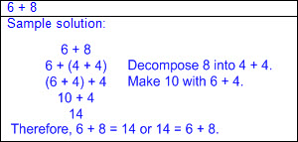  - Plus 9  - Adding 9 is equivalent to adding 10 and subtracting 1.  - Ex:  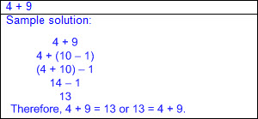  - Plus 10  - Add 1 ten in the tens place and add 0 in the ones place.  - Ex:  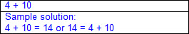  - Doubles  - Adding doubles always results in an even sum, regardless of whether the addends are even or odd.  - Ex:  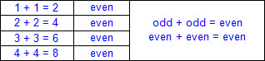  - Double plus/minus 1  - Consecutive addends  - Double the smaller addend and add 1, or double the larger addend and subtract 1.  - Ex:  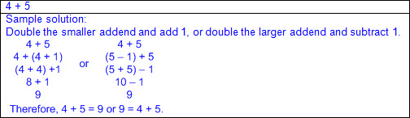  - Adding doubles plus/minus 1 always results in an odd sum.  - Ex:  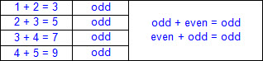  - Hidden doubles  - Decompose an addend to form a doubles fact.  - Ex:  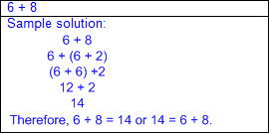  - In-betweens  - Addends have exactly one number between them consecutively.  - Double the number between the addends.  - Ex:  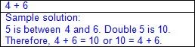  - Fact families – related number sentences using the same set of numbers  - Recognition of addition and subtraction as inverse operations  - Ex:  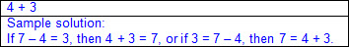  - Commutative property  - Sum does not change when the order of the addends are switched.  - Ex:  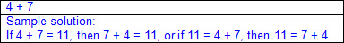  - Plus 0 (additive identity)  - Adding zero to a number does not affect the total.  - Ex: 1 + 0 = 1; 2 + 0 = 2; 3 + 0 = 3; etc.  - Ex: 1 = 1 + 0; 2 = 2 + 0; 3 = 3 + 0; etc.  - Plus 1  - Adding 1 related to sequential counting  - Ex: 9 + 1 = 10 or 10 = 9 + 1  - Counting on  - Begin with one addend and count on the amount of the other addend.  - Ex:  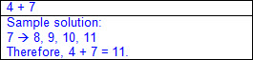  Recall With Automaticity  BASIC FACTS TO SUBTRACT WITHIN 20  Including, but not limited to:  - Whole numbers  - Counting (natural) numbers – the set of positive numbers that begins at one and increases by increments of one each time {1, 2, 3, ..., n}  - Whole numbers – the set of counting (natural) numbers and zero {0, 1, 2, 3, ..., n}  - Automaticity – executing a basic fact with little or no conscious effort  - Subtraction  - Difference – the remaining amount after the subtrahend has been subtracted from the minuend  - Minuend – a number from which another number will be subtracted  - Subtrahend – a number to be subtracted from a minuend  - Subtraction of whole numbers within 20  - Solutions recorded with a number sentence  - Number sentence – a mathematical statement composed of numbers, and/or an unknown(s), and/or an operator(s), and an equality or inequality symbol  - Equal sign at beginning or end  - Ex: 6 = 10 – 4; 10 – 4 = 6  - Decompose numbers – to break a number into parts or smaller values  - Basic fact subtraction strategies leading to automaticity  - Counting back  - Begin with the minuend and count back the amount of the subtrahend.  - Ex:  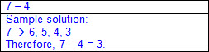  - Counting up  - Begin with the subtrahend and count up to the minuend.  - Ex:  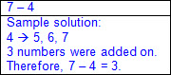  - Fact families – related number sentences using the same set of numbers  - Recognition of addition and subtraction as inverse operations  - Ex:  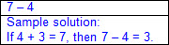  - Inverse doubles  - The minuend will be even, and the subtrahend and difference will either both be even or both be odd.  - Ex:  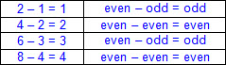  - Inverse double plus/minus 1  - The minuend will be odd, and if the subtrahend is even, then the difference will be odd.  - The minuend will be odd, and if the subtrahend is odd, then the difference will be even.  - Ex:  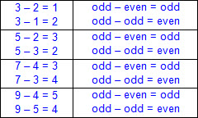  - Minus 0 (additive identity)  - Subtracting 0 from a number does not affect the total.  - Ex: 9 – 0 = 9 or 9 = 9 – 0  - Minus 1  - Subtracting 1 related to sequentially counting backward once  - Ex: 9 – 1 = 8 or 8 = 9 – 1; counted 9, 8  - Minus 2  - Subtracting 2 related to sequentially counting backward twice  - Ex: 9 – 2 = 7 or 7 = 9 – 2; counted 9, 8, 7  - Minus 9  - Subtracting 9 is equivalent to subtracting 10 and adding 1.  - Ex:  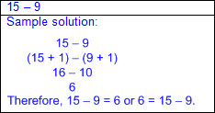  - Decompose the subtrahend  - Decompose the subtrahend to form a known fact.  - Ex:  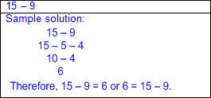  - Decompose the minuend  - Decompose the minuend to form a known fact.  - Ex:  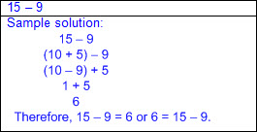  Note(s):  - Grade Level(s):  - Grade 1 applied basic fact strategies to add and subtract within 20, including making 10 and decomposing a number leading to a 10.  - Grade 2 is accountable for recalling addition and subtraction facts within 20 with automaticity.  - Various mathematical process standards will be applied to this student expectation as appropriate.  - TxRCFP:  - Using place value and properties of operations to solve problems involving addition and subtraction of whole numbers within 1,000  - TxCCRS:  - I. Numeric Reasoning  - IX. Communication and Representation
2.4B | Add up to four two-digit numbers and subtract two-digit numbers using mental strategies and algorithms based on knowledge of place value and properties of operations.  Add up to four two-digit numbers and subtract two-digit numbers using mental strategies and algorithms based on knowledge of place value and properties of operations.  Add  UP TO FOUR TWO-DIGIT NUMBERS USING MENTAL STRATEGIES AND ALGORITHMS BASED ON KNOWLEDGE OF PLACE VALUE AND PROPERTIES OF OPERATIONS  Including, but not limited to:  - Whole numbers  - Counting (natural) numbers – the set of positive numbers that begins at one and increases by increments of one each time {1, 2, 3, ..., n}  - Whole numbers – the set of counting (natural) numbers and zero {0, 1, 2, 3, ..., n}  - Addition  - Sum – the total when two or more addends are joined  - Addend – a number being added or joined together with another number(s)  - Sums of up to four two-digit whole numbers  - With and without regrouping  - Mental strategies based on place value  - Application of basic facts within each place value  - Ex:  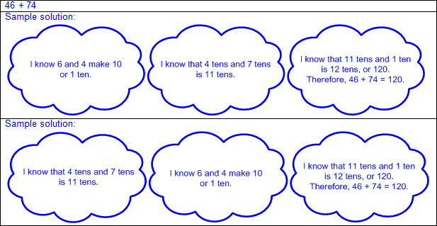  - Ex:  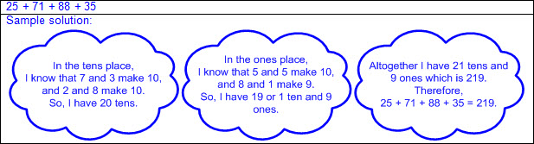  - Composition/decomposition of numbers to form friendly numbers  - Ex:  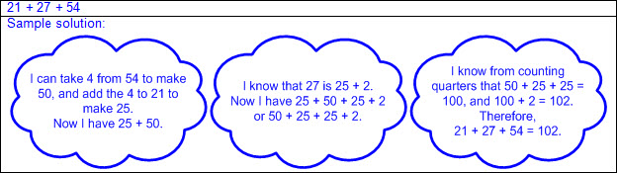  - Algorithms based on place value  - With and without regrouping  - Partial sums  - Addition of numbers in expanded form  - Ex:  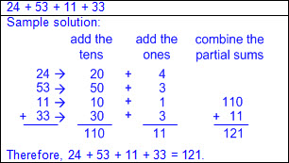  - Partial sums recorded vertically  - Ex:  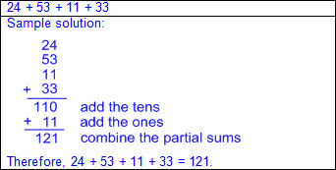  - Traditional algorithm  - Ex:  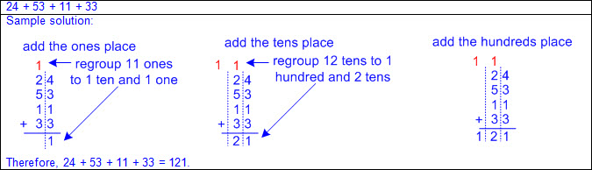  - Properties of operations  - Addends may be added in any order to produce the same sum.  - Ex: 53 + 71 + 16 will produce the same sum as 71 + 53 + 16, etc.  - Addends may be decomposed and grouped in any order to produce the same sum.  - Ex:  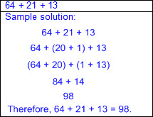  - Relationships between addition using mental strategies, algorithms, and properties of operations to addition using concrete models  - Ex:  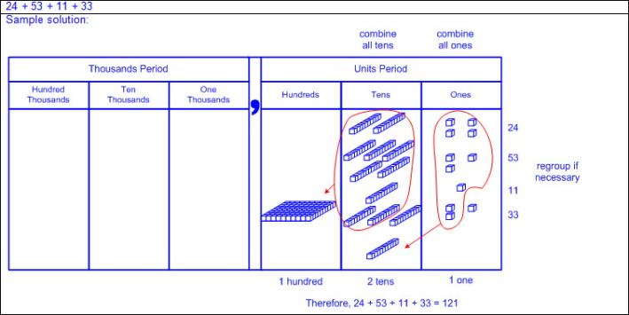  - Relationships between addition using mental strategies, algorithms, and properties of operations to addition using open number lines  - Ex:  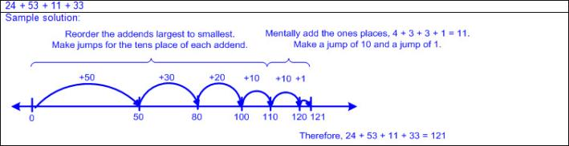  Subtract  TWO-DIGIT NUMBERS USING MENTAL STRATEGIES AND ALGORITHMS BASED ON KNOWLEDGE OF PLACE VALUE AND PROPERTIES OF OPERATIONS  Including, but not limited to:  - Whole numbers (0 – 1,000)  - Counting (natural) numbers – the set of positive numbers that begins at one and increases by increments of one each time {1, 2, 3, ..., n}  - Whole numbers – the set of counting (natural) numbers and zero {0, 1, 2, 3, ..., n}  - Subtraction  - Difference – the remaining amount after the subtrahend has been subtracted from the minuend  - Minuend – a number from which another number will be subtracted  - Subtrahend – a number to be subtracted from a minuend  - Difference of two-digit whole numbers  - With and without regrouping  - Mental strategies based on place value  - Application of basic facts within each place value  - Ex:  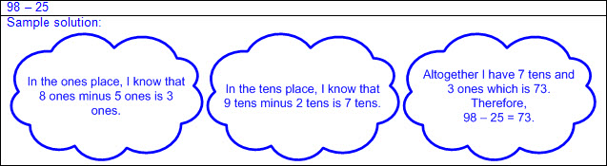  - Composition/decomposition of numbers to form friendly numbers  - Ex:  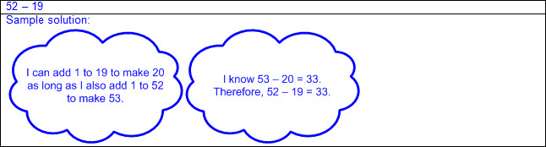  - Ex:  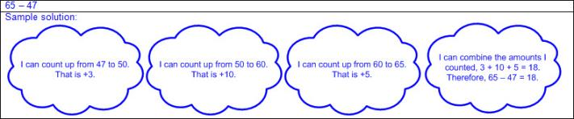  - Algorithms based on place value  - With and without regrouping  - Partial differences  - Subtraction of numbers in expanded form  - Ex:  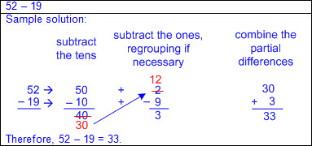  - Traditional algorithm  - Ex:  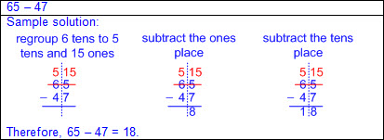  - Properties of operations  - Minuend and/or subtrahend may be decomposed to produce friendly numbers.  - Ex:  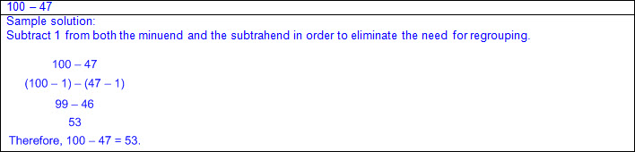  - Relationships between subtraction using mental strategies, algorithms, and properties of operations to subtraction using concrete models  - Ex:  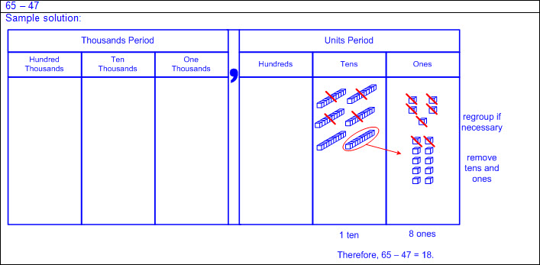  - Relationships between subtraction using mental strategies, algorithms, and properties of operations to subtraction using open number lines  - Ex:  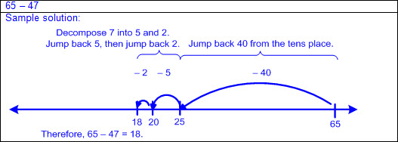  Note(s):  - Grade Level(s):  - Grade 1 explained strategies used to solve addition and subtraction problems up to 20 using spoken words, objects, pictorial models, and number sentences.  - Grade 2 will solve one-step and multi-step word problems involving addition and subtraction within 1,000 using a variety of strategies based on place value, including algorithms.  - Grade 3 will solve with fluency one-step and two-step problems involving addition and subtraction within 1,000 using strategies based on place value, properties of operations, and the relationship between addition and subtraction.  - Various mathematical process standards will be applied to this student expectation as appropriate.  - TxRCFP:  - Using place value and properties of operations to solve problems involving addition and subtraction of whole numbers within 1,000  - TxCCRS:  - I. Numeric Reasoning  - IX. Communication and Representation
2.4C | Solve one-step and multi-step word problems involving addition and subtraction within 1,000 using a variety of strategies based on place value, including algorithms.  Solve one-step and multi-step word problems involving addition and subtraction within 1,000 using a variety of strategies based on place value, including algorithms.  Solve  ONE-STEP AND MULTI-STEP WORD PROBLEMS INVOLVING ADDITION AND SUBTRACTION WITHIN 1,000 USING A VARIETY OF STRATEGIES BASED ON PLACE VALUE, INCLUDING ALGORITHMS  Including, but not limited to:  - Whole numbers  - Counting (natural) numbers – the set of positive numbers that begins at one and increases by increments of one each time {1, 2, 3, ..., n}  - Whole numbers – the set of counting (natural) numbers and zero {0, 1, 2, 3, ..., n}  - Mathematical and real-world problem situations  - One-step and multi-step problems  - Addition  - Sum – the total when two or more addends are joined  - Addend – a number being added or joined together with another number(s)  - Addition of whole numbers within 1,000  - Sums of up to four two-digit whole numbers  - Sums of two three-digit whole numbers  - With or without regrouping  - Subtraction  - Difference – the remaining amount after the subtrahend has been subtracted from the minuend  - Minuend – a number from which another number will be subtracted  - Subtrahend – a number to be subtracted from a minuend  - Subtraction of whole numbers within 1,000  - Differences of two- or three-digit whole numbers  - With or without regrouping  - Strategies based on place value and properties of operations in mathematical and real-world problem situations  - With or without concrete models  - With or without pictorial models or open number lines  - Ex:  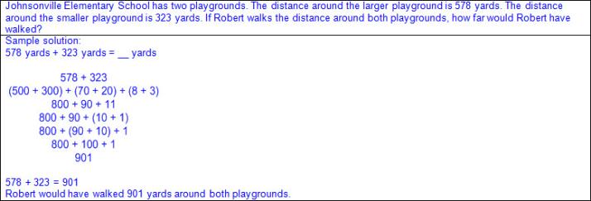  - Ex:  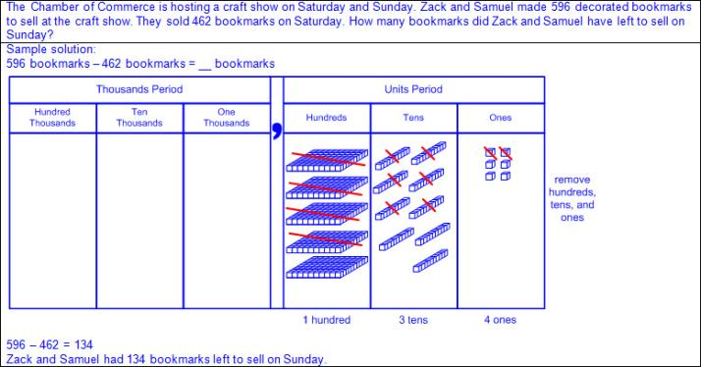  - One-step and multi-step problems  - Ex:  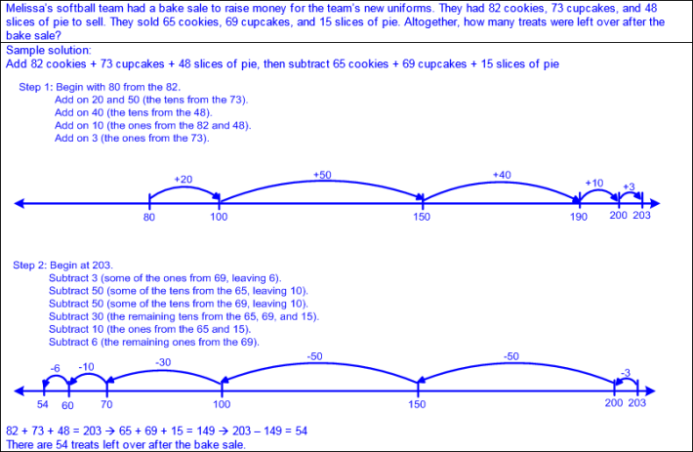  - Algorithms based on place value in mathematical and real-world problem situations  - Partial sums  - Addition of numbers in expanded form  - Ex:  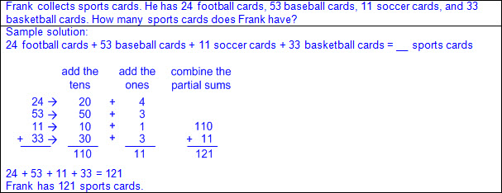  - Partial sums recorded vertically  - Ex:  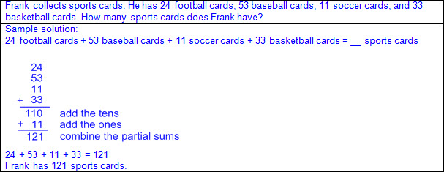  - Traditional addition algorithm  - Ex:  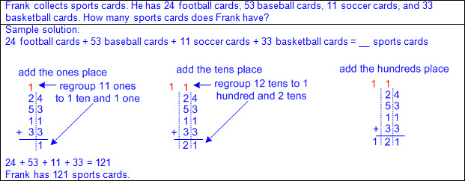  - Partial differences  - Subtraction of numbers in expanded form  - Ex:  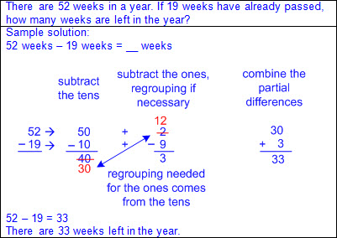  - Traditional subtraction algorithm  - Ex:  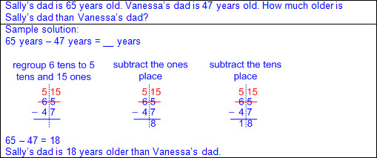  - One-step and multi-step problems  - Ex:  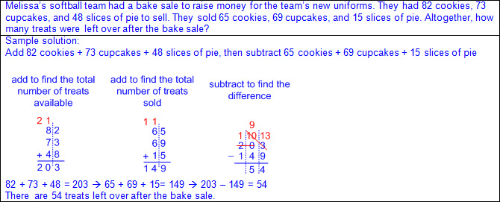  Note(s):  - Grade Level(s):  - Grade 1 explained strategies used to solve addition and subtraction problems up to 20 using spoken words, objects, pictorial models, and number sentences.  - Grade 2 introduces the standard algorithm for addition and subtraction.  - Grade 2 introduces regrouping.  - Grade 2 will solve one-step and multi-step word problems involving addition and subtraction within 1,000 using a variety of strategies based on place value, including algorithms.  - Grade 3 will solve with fluency one-step and two-step problems involving addition and subtraction within 1,000 using strategies based on place value, properties of operations, and the relationship between addition and subtraction.  - Various mathematical process standards will be applied to this student expectation as appropriate.  - TxRCFP:  - Using place value and properties of operations to solve problems involving addition and subtraction of whole numbers within 1,000  - TxCCRS:  - I. Numeric Reasoning  - VIII. Problem Solving and Reasoning  - IX. Communication and Representation  - X. Connections
2.4D | Generate and solve problem situations for a given mathematical number sentence involving addition and subtraction of whole numbers within 1,000.  Generate and solve problem situations for a given mathematical number sentence involving addition and subtraction of whole numbers within 1,000.  Generate, Solve  PROBLEM SITUATIONS FOR A GIVEN MATHEMATICAL NUMBER SENTENCE INVOLVING ADDITION AND SUBTRACTION OF WHOLE NUMBERS WITHIN 1,000  Including, but not limited to:  - Whole numbers  - Counting (natural) numbers – the set of positive numbers that begins at one and increases by increments of one each time {1, 2, 3, ..., n}  - Whole numbers – the set of counting (natural) numbers and zero {0, 1, 2, 3, ..., n}  - Addition  - Sum – the total when two or more addends are joined  - Addend – a number being added or joined together with another number(s)  - Addition of whole numbers within 1,000  - Sums of up to four two-digit whole numbers  - Sums of two three-digit whole numbers  - With or without regrouping  - Subtraction  - Difference – the remaining amount after the subtrahend has been subtracted from the minuend  - Minuend – a number from which another number will be subtracted  - Subtrahend – a number to be subtracted from a minuend  - Subtraction of whole numbers within 1,000  - Differences of two- or three-digit whole numbers  - With or without regrouping  - Number sentence – a mathematical statement composed of numbers, and/or an unknown(s), and/or an operator(s), and an equality or inequality symbol  - Number sentences, or equations, with an equal sign at the beginning or end  - Ex: 10 = 6 + 4; 6 + 4 = 10  - Ex: 6 = 10 – 4; 10 – 4 = 6  - Unknown in any position  - Ex: a + b = __; a + __ = c; __ + b = c; a – b = __; a – __= c; __ – b = c  - Generate and solve mathematical and real-world problem situations when given an addition number sentence.  - One-step problems  - Appropriate mathematical language  - Connection between information in the problem and problem type  - Addition situations  - Ex:  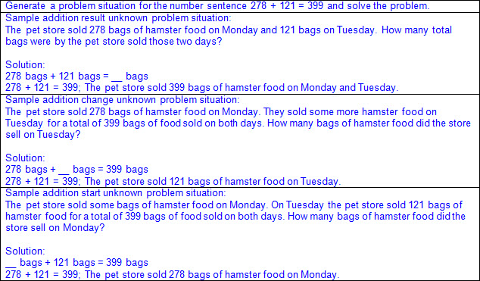  - Part-part-whole situations  - Ex:  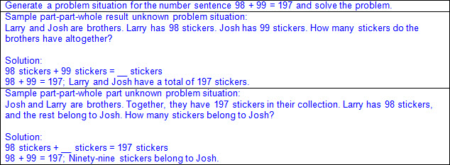  - Comparison situations  - Ex:  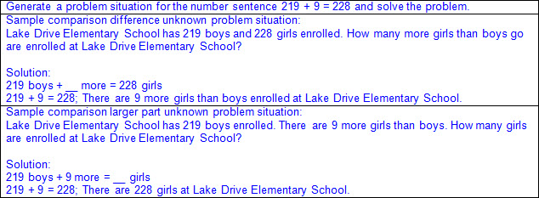  - Start unknown situations  - Ex:  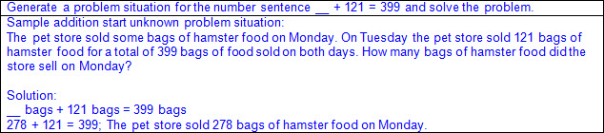  - Change unknown situations  - Ex:  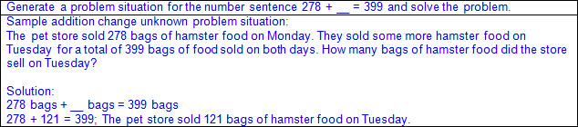  - Result unknown situations  - Ex:  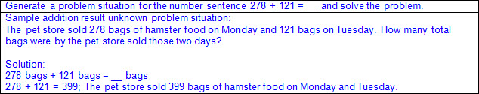  - Generate and solve problem mathematical and real-world situations when given a subtraction number sentence  - One-step problems  - Appropriate mathematical language  - Connection between information in the problem and problem type  - Subtraction situations  - Ex:  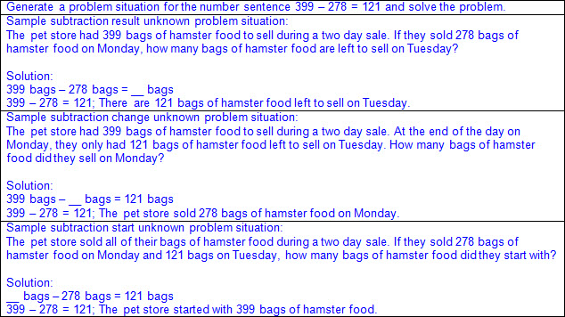  - Part-part-whole situations  - Ex:  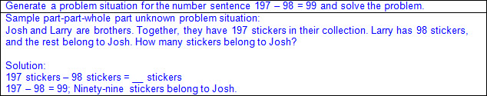  - Comparison situations  - Ex:  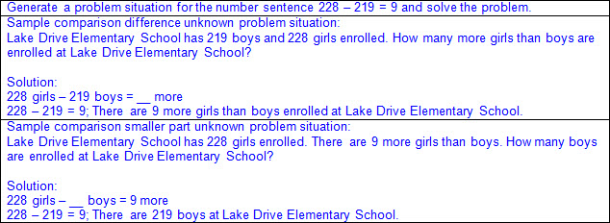  - Start unknown situations  - Ex:  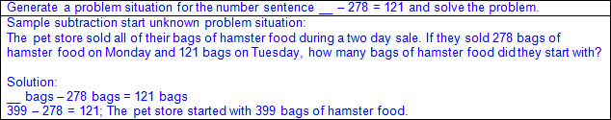  - Change unknown situations  - Ex:  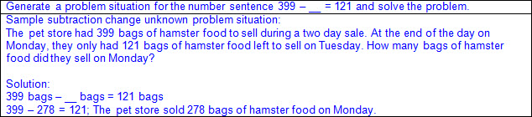  - Result unknown situations  - Ex:  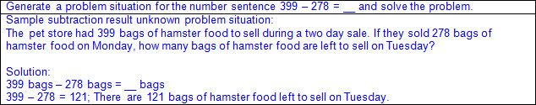  - Generate and solve problem mathematical and real-world situations when given a multi-operation number sentence  - Multi-step problems  - Appropriate mathematical language  - Ex:  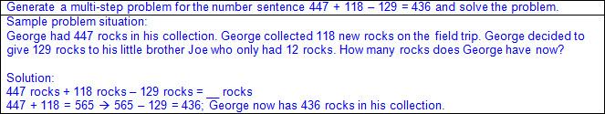  Note(s):  - Grade Level(s):  - Grade 1 generated and solved problem situations when given a number sentence involving addition or subtraction of numbers within 20.  - Grade 2 will solve one-step and multi-step word problems involving addition and subtraction within 1,000 using a variety of strategies based on place value, including algorithms.  - Grade 3 will solve with fluency one-step and two-step problems involving addition and subtraction within 1,000 using strategies based on place value, properties of operations, and the relationship between addition and subtraction.  - Various mathematical process standards will be applied to this student expectation as appropriate.  - TxRCFP:  - Using place value and properties of operations to solve problems involving addition and subtraction of whole numbers within 1,000  - TxCCRS:  - I. Numeric Reasoning  - VIII. Problem Solving and Reasoning  - IX. Communication and Representation  - X. Connections
2.5 | Number and operations. The student applies mathematical process standards to determine the value of coins in order to solve monetary transactions. The student is expected to:
2.5A | Determine the value of a collection of coins up to one dollar.  Determine the value of a collection of coins up to one dollar.  Determine  THE VALUE OF A COLLECTION OF COINS UP TO ONE DOLLAR  Including, but not limited to:  - Coins  - Penny: 1¢  - Nickel: 5¢  - Dime: 10¢  - Quarter: 25¢  - Half-dollar: 50¢  - Concrete and pictorial models  - Traditional and newly released designs  - Views of both sides of coins  - Relationships by value  - Penny to nickel, dime, quarter, half-dollar  - 5 pennies = 1 nickel; 10 pennies = 1 dime; 25 pennies = 1 quarter; 50 pennies = 1 half-dollar  - 1 penny < 1 nickel; 1 penny < 1 dime; 1 penny < 1 quarter; 1 penny < 1 half-dollar  - Nickel to penny, dime, quarter, half-dollar  - 1 nickel = 5 pennies; 2 nickels = 1 dime; 5 nickels = 1 quarter; 10 nickels = 1 half-dollar  - 1 nickel > 1 penny; 1 nickel < 1 dime; 1 nickel < 1 quarter; 1 nickel < 1 half-dollar  - Dime to penny, nickel, quarter, half-dollar  - 1 dime = 10 pennies; 1 dime = 2 nickels; 5 dimes = 2 quarters; 5 dimes = 1 half-dollar  - 1 dime > 1 penny; 1 dime > 1 nickel; 1 dime < 1 quarter; 1 dime < 1 half-dollar  - Quarter to penny, nickel, dime, half-dollar  - 1 quarter = 25 pennies; 1 quarter = 5 nickels; 2 quarters = 5 dimes; 2 quarters = 1 half-dollar  - 1 quarter > 1 penny; 1 quarter > 1 nickel; 1 quarter > 1 dime; 1 quarter < 1 half-dollar  - Half-dollar to penny, nickel, dime, quarter  - 1 half-dollar = 50 pennies; 1 half-dollar = 10 nickels; 1 half-dollar = 5 dimes; 1 half-dollar = 2 quarters  - 1 half-dollar > 1 penny; 1 half-dollar > 1 nickel; 1 half-dollar > 1 dime; 1 half-dollar > 1 quarter  - Skip counting to determine the value of a collection of mixed coins up to one dollar  - Coins in like groups (e.g., half-dollars, quarters, dimes, nickels, pennies)  - By ones or twos to determine the value of a collection of pennies  - 1¢, 2¢, 3¢, 4¢, …, 97¢, 98¢, 99¢, 100¢  - 2¢, 4¢, 6¢, 8¢, …, 94¢, 96¢, 98¢, 100¢  - By fives to determine the value of a collection of nickels  - 5¢, 10¢, 15¢, 20¢, 25¢, 30¢, …, 95¢, 100¢  - By tens to determine the value of a collection of dimes  - 10¢, 20¢, 30¢, 40¢, 50¢, …, 80¢, 90¢, 100¢  - By twenty-fives to determine the value of a collection of quarters  - 25¢, 50¢, 75¢, $1.00  - By fifties to determine the value of a collection of half-dollars  - 50¢, $1.00  - Compound counting to determine the value of a collection of mixed coins up to one dollar  - Separate coins into like groups prior to counting (e.g., half-dollars, quarters, dimes, nickels, pennies).  - Begin by counting the largest denomination of coins and then count on each denomination of coins in order from largest to smallest.  - Count half-dollars by fifties, count on quarters by twenty-fives, count on dimes by tens, count on nickels by fives, count on pennies by twos or ones.  - Ex:  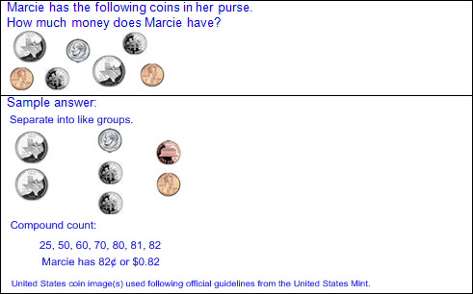  - Exchange of coins to other denominations based on relationships between values  - Ex: 2 dimes and 1 nickel can be exchanged for 1 quarter.  - Ex: 5 dimes can be exchanged for 2 quarters.  - Create a collection of coins for a given value.  - Comparison of the values of two collections of coins  - Number of coins may not be proportional to the value of the collection.  - Ex: 2 quarters have a greater value than 5 nickels, even though 2 quarters are fewer coins than 5 nickels.  - Multiple combinations of the same value  - Ex:  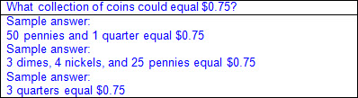  - Ex:  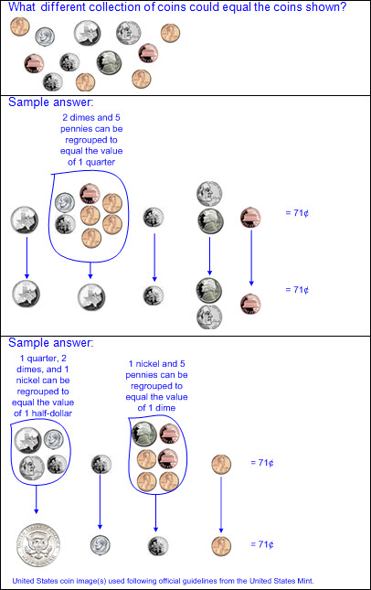  - Minimal set  - Least number of coins to equal a given value  - Ex:  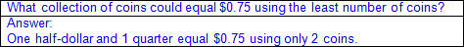  Note(s):  - Grade Level(s):  - Grade 1 used relationships to count by twos, fives, and tens to determine the value of a collection of pennies, nickels, and/or dimes.  - Grade 3 will determine the value of a collection of coins and bills.  - Various mathematical process standards will be applied to this student expectation as appropriate.  - TxRCFP:  - Developing proficiency in the use of place value within the base-10 numeration system  - TxCCRS:  - IX. Communication and Representation  - X. Connections
2.5B | Use the cent symbol, dollar sign, and the decimal point to name the value of a collection of coins.  Use the cent symbol, dollar sign, and the decimal point to name the value of a collection of coins.  Use  THE CENT SYMBOL, DOLLAR SIGN, AND THE DECIMAL POINT TO NAME THE VALUE OF A COLLECTION OF COINS  Including, but not limited to:  - Value of a collection of coins named with numbers and symbols  - Cent symbol not used in conjunction with dollar symbol and decimal  - Cent symbol (¢)  - Cent symbol written to the right of the numerical value  - Cent label read and written after numerical value  - Ex: Fifty-two cents is written 52¢ and read 52 cents.  - Values equal to or greater than 100 written with cent symbol not customary, but acceptable  - Ex: 100¢  - Dollar symbol ($) and decimal  - Dollar symbol written to the left of the dollar amount  - Decimal separates whole dollar amount from cent amount, or part of a dollar amount  - Dollar label read after dollar amount  - Decimal read as “and”  - Zero written for the dollar amount, but not read, if value is less than one dollar  - Ex: $0.79 is read seventy-nine cents.  - Multiple representations of the same value  - Ex: $0.94, 94¢, 94 cents  Note(s):  - Grade Level(s):  - Grade 1 wrote a number with the cent symbol to describe the value of a coin.  - Grade 2 introduces the dollar sign and decimal point to name the value of a collection of coins.  - Various mathematical process standards will be applied to this student expectation as appropriate.  - TxRCFP:  - Developing proficiency in the use of place value within the base-10 numeration system  - TxCCRS:  - IX. Communication and Representation  - X. Connections
2.6 | Number and operations. The student applies mathematical process standards to connect repeated addition and subtraction to multiplication and division situations that involve equal groupings and shares. The student is expected to:
2.6A | Model, create, and describe contextual multiplication situations in which equivalent sets of concrete objects are joined.  Model, create, and describe contextual multiplication situations in which equivalent sets of concrete objects are joined.  Model, Create, Describe  CONTEXTUAL MULTIPLICATION SITUATIONS IN WHICH EQUIVALENT SETS OF CONCRETE OBJECTS ARE JOINED  Including, but not limited to:  - Recognition of combining equivalent sets of objects in contextual situations  - Recognition of repeated addition of sets of objects in contextual situations  - Model and describe contextual multiplication situations using concrete objects.  - Organized to represent equal sized groups  - Sets up to 10 equal groups of 10  - Oral description  - Appropriate labels for number of groups and amount in each group  - Stated as: “___ equal groups of ___”  - Ex: 3 tables with 8 plates on each table equals 24 plates, or 3 equal groups of 8 equals 24.  - Written description  - Recorded as: ____ equal groups of ___  - Recorded as repeated addition  - Ex:  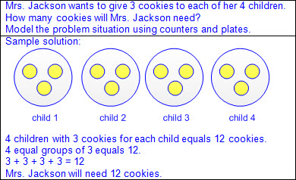  - Ex:  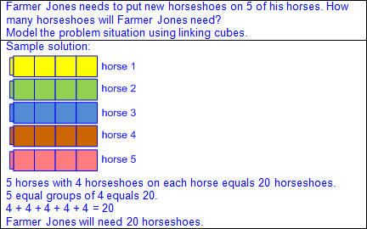  - Create and describe contextual multiplication situations.  - Combination of equally-sized groups  - Sets up to 10 equal groups of 10  - Oral description  - Appropriate labels for number of groups and amount in each group  - Stated as: “___ equal groups of ___”  - Ex: 3 tables with 8 plates on each table equals 24 plates, or 3 equal groups of 8 equals 24.  - Written description  - Recorded as: ____ equal groups of ___  - Recorded as repeated addition  - Ex:  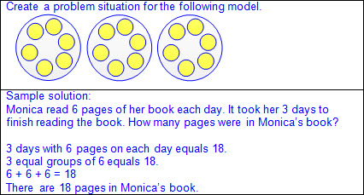  - Ex:  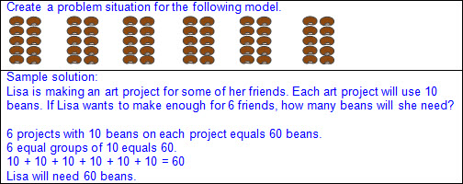  - Connection between skip counting (by 2s, 3s, etc.) and counting equivalent sets of objects  - Comparisons of different equivalent groupings  - Same number of groups with different amounts in each group  - Ex: 4 equal groups of 5 compared to 4 equal groups of 7  - Different number of groups with same amount in each group  - Ex: 5 equal groups of 3 compared to 4 equal groups of 3  - Different number of groups and/or different amount in each group, but same total number of objects  - Ex: 4 bags with 3 marbles in each bag equals 12 marbles, and 2 bags with 6 marbles in each equals 12 marbles.  Note(s):  - Grade Level(s):  - Grade 2 introduces contextual multiplication situations.  - Grade 3 will determine the total number of objects when equally-sized groups of objects are combined or arranged in arrays up to 10 x 10.  - Grade 3 will introduce the multiplication symbol.  - Various mathematical process standards will be applied to this student expectation as appropriate.  - TxRCFP:  - Grade Level Connections (reinforces previous learning and/or provides development for future learning)  - TxCCRS:  - I. Numeric Reasoning  - IX. Communication and Representation  - X. Connections
2.6B | Model, create, and describe contextual division situations in which a set of concrete objects is separated into equivalent sets.  Model, create, and describe contextual division situations in which a set of concrete objects is separated into equivalent sets.  Model, Create, Describe  CONTEXTUAL DIVISION SITUATIONS IN WHICH A SET OF CONCRETE OBJECTS IS SEPARATED INTO EQUIVALENT SETS  Including, but not limited to:  - Recognition of separating or sharing a set of objects into equivalent sets in contextual situations  - Partitive division  - Total amount known  - Number of groups known  - Size or measure of each group unknown  - Quotative division (also known as Measurement division)  - Total amount known  - Size or measure of each group known  - Number of groups unknown  - Recognition of repeated subtraction of sets of objects in contextual situations  - Model and describe contextual division situations using concrete objects.  - Organized to represent equal sized groups  - Sets up to 10 equal groups of 10  - Oral description  - Appropriate labels for number of groups and amount in each group  - Stated as: “___ separated into ___ equal groups equals groups of ___,” or “___ separated into groups of ___ equals ___ equal groups”  - Ex: 24 plates placed on 3 tables equals 8 plates on each table, or 24 separated into 3 equal groups equals groups of 8.  - Ex: 24 plates placed with 8 plates on a table equals 3 tables, or 24 separated into groups of 8 equals 3 equal groups.  - Written description  - Recorded as: ___ separated into ____ equal groups of ___, or ___ separated into groups of ___ equals ___ equal groups  - Recorded as repeated subtraction  - Ex: Partitive division  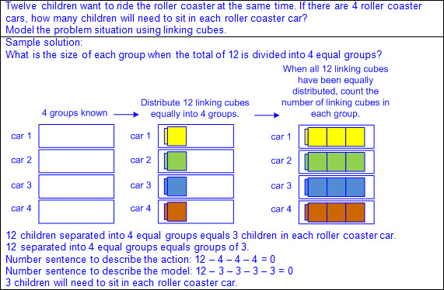  - Ex: Quotative division (also known as Measurement division)  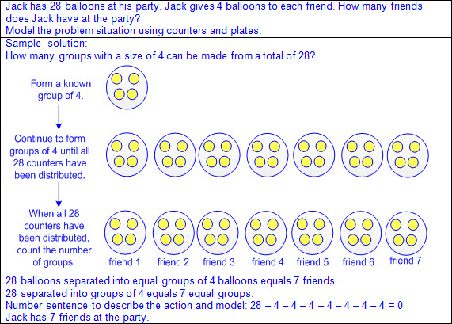  - Create and describe contextual division situations.  - Separation into equally-sized groups  - Sets of up to 10 equal groups of 10  - Oral description  - Appropriate labels for number of groups and amount in each group  - Stated as: “___ separated into ___ equal groups equals groups of ___,” or “___ separated into groups of ___ equals ___ equal groups”  - Ex: 24 plates placed on 3 tables equals 8 plates on each table, or 24 separated into 3 equal groups equals groups of 8.  - Ex: 24 plates placed with 8 plates on a table equals 3 tables, or 24 separated into groups of 8 equals 3 equal groups.  - Written description  - Recorded as: ___ separated into ____ equal groups of ___, or ___ separated into groups of ___ equals ___ equal groups  - Recorded as repeated subtraction  - Ex:  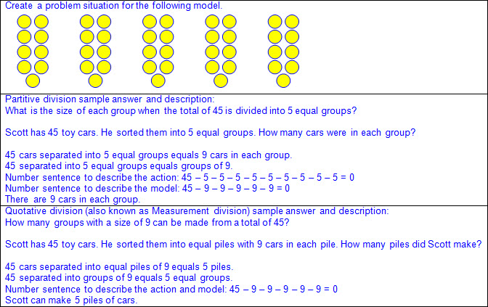  Note(s):  - Grade Level(s):  - Grade 2 introduces contextual division situations.  - Grade 3 will determine the number of objects in each group when a set of objects is partitioned into equal shares or a set of objects is shared equally.  - Grade 3 will introduce the division symbol.  - Various mathematical process standards will be applied to this student expectation as appropriate.  - TxRCFP:  - Grade Level Connections (reinforces previous learning and/or provides development for future learning)  - TxCCRS:  - I. Numeric Reasoning  - IX. Communication and Representation  - X. Connections
2.7 | Algebraic reasoning. The student applies mathematical process standards to identify and apply number patterns within properties of numbers and operations in order to describe relationships. The student is expected to:
2.7A | Determine whether a number up to 40 is even or odd using pairings of objects to represent the number.  Determine whether a number up to 40 is even or odd using pairings of objects to represent the number.  Determine  WHETHER A NUMBER UP TO 40 IS EVEN OR ODD USING PAIRINGS OF OBJECTS TO REPRESENT THE NUMBER  Including, but not limited to:  - Whole numbers (0 – 40)  - Counting (natural) numbers – the set of positive numbers that begins at one and increases by increments of one each time {1, 2, 3, ..., n}  - Whole numbers – the set of counting (natural) numbers and zero {0, 1, 2, 3, ..., n}  - Concrete objects organized in pairs to represent a number  - Ex:  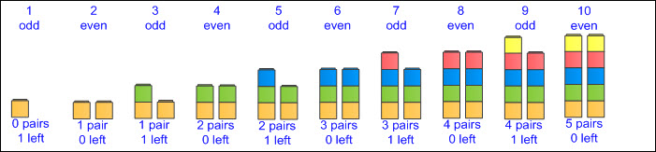  - Ex:  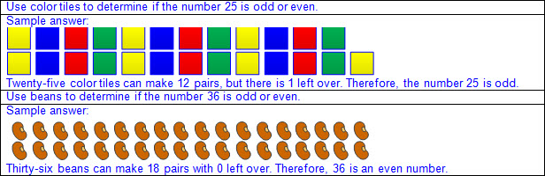  - Even number – a number represented by objects that when paired have zero left over  - If a number of objects are paired with zero left over, the number represented by the objects is even.  - Zero is not considered odd or even.  - Odd number – a number represented by objects that when paired have one left over  - If the number of objects are paired with one left over, the number represented by the objects is odd.  - Relationships in addition and subtraction  - Relationship between doubles facts and even numbers  - Ex:  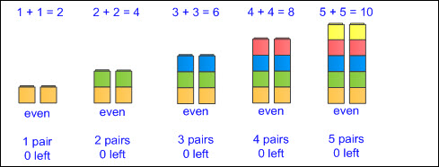  - Adding doubles always results in an even sum, regardless of whether the addends are even or odd  - Ex:  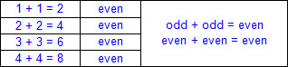  - Inverse doubles  - The minuend will be even, and the subtrahend and difference will either both be even or both be odd.  - Ex:  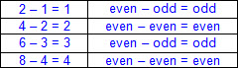  - Relationship between doubles plus/minus 1 facts and odd numbers  - Ex:  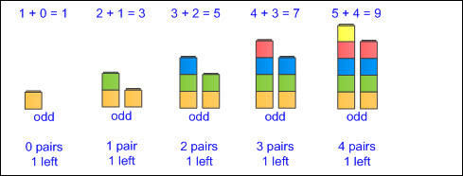  - Adding doubles plus/minus 1 always results in an odd sum.  - Ex:  - Inverse doubles plus/minus 1  - The minuend will be odd, and if the subtrahend is even, then the difference will be odd.  - The minuend will be odd, and if the subtrahend is odd, then the difference will be even.  - Ex:  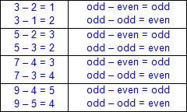  Note(s):  - Grade Level(s):  - Grade 1 skip counted by twos, fives, and tens to determine the total number of objects up to 120 in a set.  - Grade 2 introduces determining whether a number up to 40 is even or odd using pairings of objects to represent the number.  - Grade 3 will determine if a number is even or odd using divisibility rules.  - Various mathematical process standards will be applied to this student expectation as appropriate.  - TxRCFP:  - Grade Level Connections (reinforces previous learning and/or provides development for future learning)  - TxCCRS:  - IX. Communication and Representation
2.7B | Use an understanding of place value to determine the number that is 10 or 100 more or less than a given number up to 1,200.  Use an understanding of place value to determine the number that is 10 or 100 more or less than a given number up to 1,200.  Use  AN UNDERSTANDING OF PLACE VALUE TO DETERMINE THE NUMBER THAT IS 10 OR 100 MORE OR LESS THAN A GIVEN NUMBER UP TO 1,200  Including, but not limited to:  - Whole numbers (0 – 1,200)  - Counting (natural) numbers – the set of positive numbers that begins at one and increases by increments of one each time {1, 2, 3, ..., n}  - Whole numbers – the set of counting (natural) numbers and zero {0, 1, 2, 3, ..., n}  - Place value – the value of a digit as determined by its location in a number such as ones, tens, hundreds, one thousands, etc.  - One thousands place  - Hundreds place  - Tens place  - Ones place  - Comparative language  - Greater than, more than  - Less than, fewer than  - Relationships based on place value  - 10 more or 10 less  - Adding 1 in the tens place will generate a number that is 10 more than the original number.  - Ex:  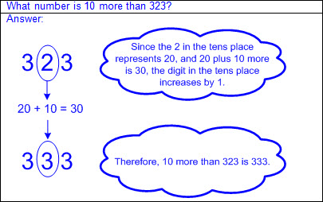  - Subtracting 1 in the tens place will generate a number that is 10 less than the original number.  - Ex:  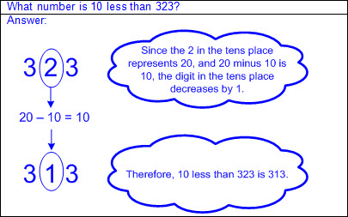  - 100 more or 100 less  - Adding 1 in the hundreds place will generate a number that is 100 more than the original number.  - Ex:  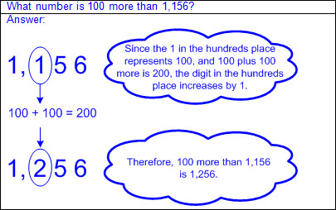  - Subtracting 1 in the hundreds place will generate a number that is 100 less than the original number.  - Ex:  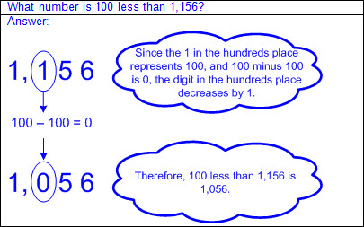  Note(s):  - Grade Level(s):  - Grade 1 used relationships to determine the number that is 10 more and 10 less than a given number up to 120.  - Various mathematical process standards will be applied to this student expectation as appropriate.  - TxRCFP:  - Developing proficiency in the use of place value within the base-10 numeration system  - Using place value and properties of operations to solve problems involving addition and subtraction of whole numbers within 1,000  - TxCCRS:  - I. Numeric Reasoning  - IX. Communication and Representation  - X. Connections
2.7C | Represent and solve addition and subtraction word problems where unknowns may be any one of the terms in the problem.  Represent and solve addition and subtraction word problems where unknowns may be any one of the terms in the problem.  Represent, Solve  ADDITION AND SUBTRACTION WORD PROBLEMS WHERE UNKNOWNS MAY BE ANY ONE OF THE TERMS IN THE PROBLEM  Including, but not limited to:  - Whole numbers  - Counting (natural) numbers – the set of positive numbers that begins at one and increases by increments of one each time {1, 2, 3, ..., n}  - Whole numbers – the set of counting (natural) numbers and zero {0, 1, 2, 3, ..., n}  - Addition  - Sum – the total when two or more addends are joined  - Addend – a number being added or joined together with another number(s)  - Addition of whole numbers within 1,000  - With or without regrouping  - Subtraction  - Difference – the remaining amount after the subtrahend has been subtracted from the minuend  - Minuend – a number from which another number will be subtracted  - Subtrahend – a number to be subtracted from a minuend  - Subtraction of whole numbers within 1,000  - With or without regrouping  - Term – a number and/or an unknown in an expression separated by an operation symbol(s)  - Expression – a mathematical phrase, with no equal sign, that may contain a number(s), an unknown(s), and/or an operator(s)  - Number sentence – a mathematical statement composed of numbers, and/or an unknown(s), and/or an operator(s), and an equality or inequality symbol  - Number sentences, or equations, with an equal sign at the beginning or end  - Ex: 10 = 6 + 4; 6 + 4 = 10  - Ex: 6 = 10 – 4; 10 – 4 = 6  - Represent mathematical and real-world problem situations  - Concrete models  - Objects represent the quantities described in the problem situation.  - Base-10 blocks, place value disks, etc.  - Pictorial models  - Pictures drawn represent the quantities described in the problem situation.  - Base-10 pictorials, number lines, strip diagrams, etc.  - Numbers  - Numbers represent the quantities described in the problem situation.  - Oral and written descriptions  - Explanation of relationship between objects, pictorials, and numbers and the information in the problem situation  - Solve mathematical and real-world problem situations with the result unknown.  - One-step problems  - Connection between information in the problem and problem type  - Addition result unknown  - a + b = __  - Ex:  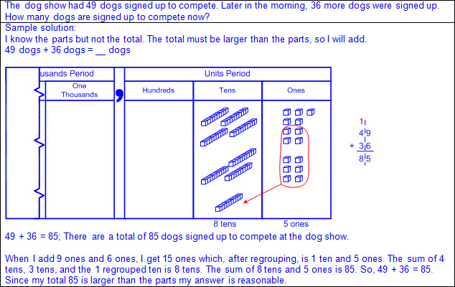  - Part-part-whole whole unknown  - a + b = __  - Ex:  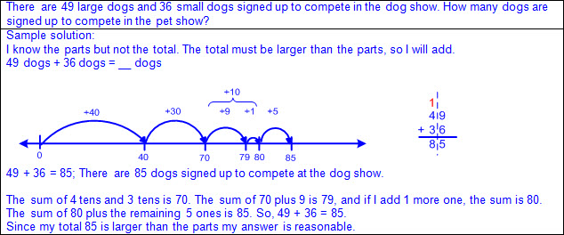  - Comparison larger quantity unknown  - a + b = __  - Ex:  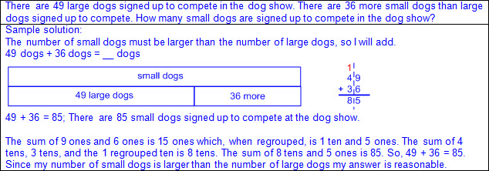  - Subtraction result unknown  - a – b = __  - Ex:  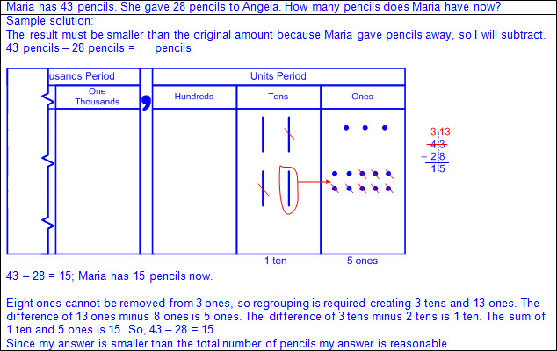  - Part-part-whole part unknown  - a – b = __  - Ex:  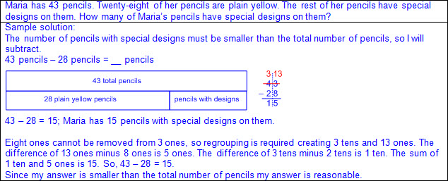  - Comparison difference unknown  - a – b = __  - Ex:  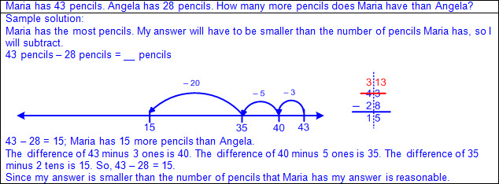  - Comparison smaller part unknown  - a – b = __  - Ex:  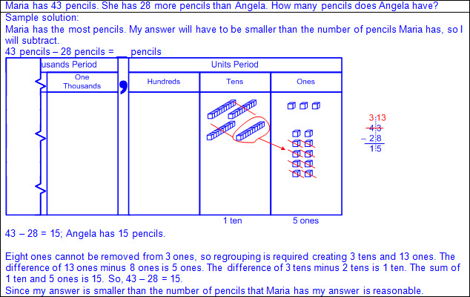  - Solve mathematical and real-world problem situations with the change unknown.  - One-step problems  - Connection between information in the problem and problem type  - Connection between solution strategies for similar problem types  - Addition change unknown  - a + __ = c  - Can be solved as c – a = __  - Ex:  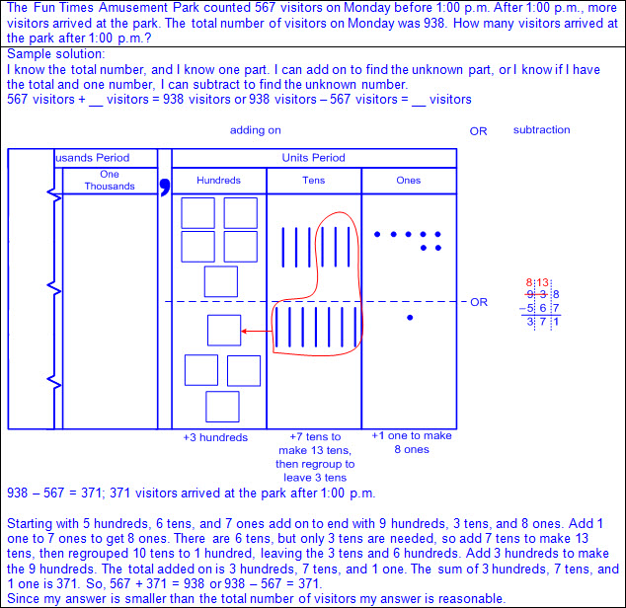  - Part-part-whole part unknown  - a + __ = c  - Can be solved as c – a = __  - Ex:  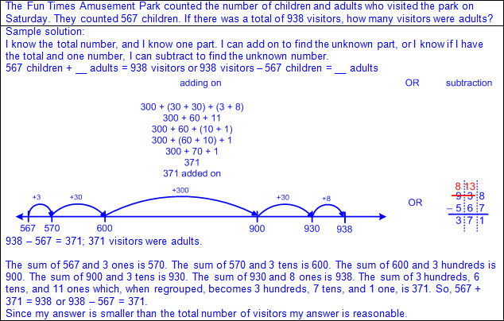  - Comparison difference unknown  - a + __ = c  - Can be solved as c – a = __  - Ex:  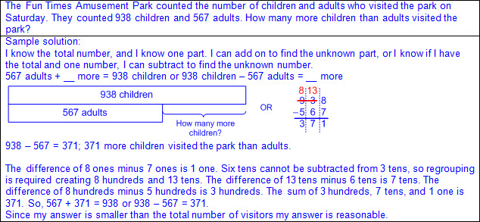  - Subtraction change unknown  - a – __ = c  - Can be solved as c – a = __  - Ex:  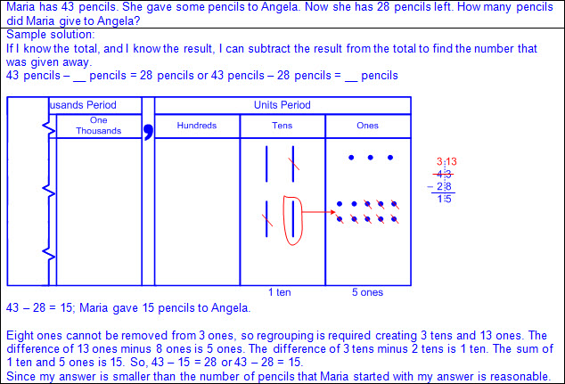  - Solve mathematical and real-world problem situations with the start unknown.  - One-step problems  - Connection between information in the problem and problem type  - Connection between solution strategies for similar problem types  - Addition start unknown  - __ + b = c  - Can be solved as c – b = __  - Ex:  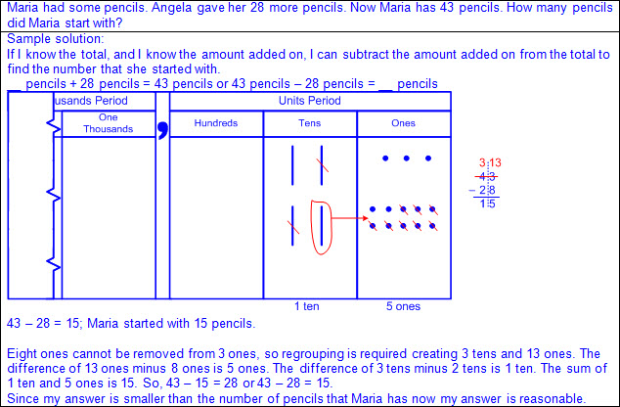  - Subtraction start unknown  - __ – b = c  - Can be solved as c + b = __  - Ex:  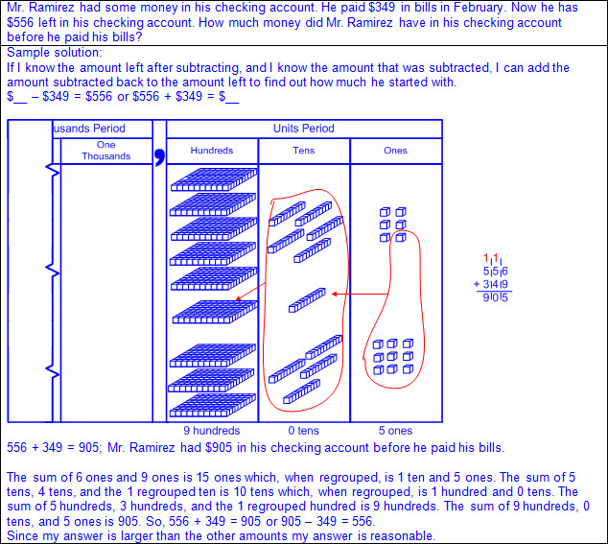  - Solve mathematical and real-world problem situations with multiple operations.  - Multi-step problem situations  - Ex:  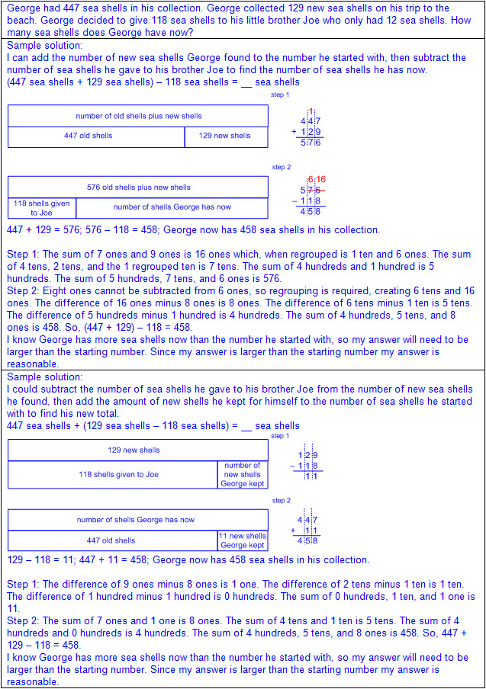  Note(s):  - Grade Level(s):  - Grade 1 determined the unknown whole number in an addition or subtraction equation when the unknown may be any one of the three or four terms in the equation.  - Grade 3 will represent one and two-step problems involving addition and subtraction of whole numbers to 1,000 using pictorial models, number lines, and equations.  - Various mathematical process standards will be applied to this student expectation as appropriate.  - TxRCFP:  - Using place value and properties of operations to solve problems involving addition and subtraction of whole numbers within 1,000  - TxCCRS:  - I. Numeric Reasoning  - II.D. Algebraic Reasoning – Representations  - VIII. Problem Solving and Reasoning  - IX. Communication and Representation  - X. Connections
2.8 | Geometry and measurement. The student applies mathematical process standards to analyze attributes of two-dimensional shapes and three-dimensional solids to develop generalizations about their properties. The student is expected to:
2.8A | Create two-dimensional shapes based on given attributes, including number of sides and vertices.  Create two-dimensional shapes based on given attributes, including number of sides and vertices.  Create  TWO-DIMENSIONAL SHAPES BASED ON GIVEN ATTRIBUTES, INCLUDING NUMBER OF SIDES AND VERTICES  Including, but not limited to:  - Variety of materials and drawings  - Computer programs  - Art materials  - Ex: crayons, chenille sticks, toothpicks, yarn, paint, geoboard, cutting paper, dot paper, grid paper, etc.  - Two-dimensional figure – a figure with two basic units of measure, usually length and width  - Polygon – a closed figure with at least 3 sides, where all sides are straight (no curves)  - Ex:  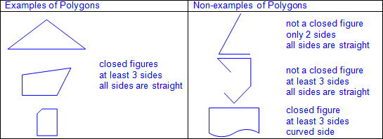  - Spatial visualization – creation and manipulation of mental representations of shapes  - Attributes of two-dimensional figures – characteristics that define a geometric figure (e.g., sides, vertices, etc.)  - Attributes of two-dimensional figures  - Side – a straight outer boundary between two vertices (line segment) of a two-dimensional figure  - Number of sides  - Length of sides  - Vertex (vertices) in a two-dimensional figure – the point (corner) where two sides of a two-dimensional figure meet  - Number of vertices  - Types of corners  - Square corners  - Square corners can be determined using the corner of a known square or rectangle (e.g., sticky note, sheet of paper, etc.).  - Ex:  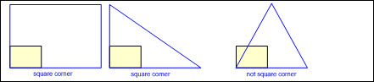  - May have a box in corner to represent square corner  - Ex:  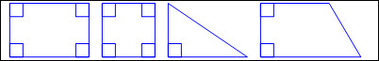  - Not square corners  - Opposite corners  - Attributes that do not identify two-dimensional figures  - Orientation  - Size  - Color  - Texture  - Regular figure – a polygon with all side lengths and corners equal  - Irregular figure – a polygon with side lengths and/or corners that are not all equal  - Create regular and irregular two-dimensional figures based on attributes.  - Circle  - A figure formed by a closed curve with all points equal distance from the center  - No straight sides  - No vertices  - Ex:  - Triangle  - 3 sides  - 3 vertices  - Ex:  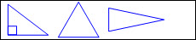  - Rectangle  - 4 sides  - 4 vertices  - Opposite sides equal in length  - 4 square corners  - Ex:  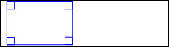  - Rhombus  - 4 sides  - 4 vertices  - All sides equal in length  - Opposite corners equal  - Ex:  - Square (a special type of rectangle and a special type of rhombus)  - 4 sides  - 4 vertices  - All sides equal in length  - Opposite sides equal in length  - 4 square corners  - Opposite corners equal  - Ex:  - Pentagon  - 5 sides  - 5 vertices  - Ex:  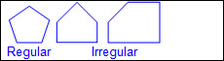  - Hexagon  - 6 sides  - 6 vertices  - Ex:  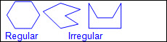  - Heptagon or septagon  - 7 sides  - 7 vertices  - Ex:  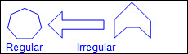  - Octagon  - 8 sides  - 8 vertices  - Ex:  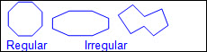  - Nonagon or enneagon  - 9 sides  - 9 vertices  - Ex:  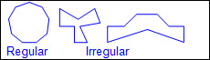  - Decagon  - 10 sides  - 10 vertices  - Ex:  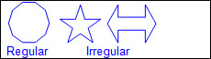  - Undecagon or hendecagon  - 11 sides  - 11 vertices  - Ex:  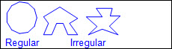  - Dodecagon  - 12 sides  - 12 vertices  - Ex:  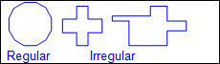  Note(s):  - Grade Level(s):  - Grade 1 created two-dimensional figures, including circles, triangles, rectangles, and squares, as special rectangles, rhombuses, and hexagons.  - Grade 1 identified two-dimensional shapes, including circles, triangles, rectangles, and squares, as special rectangles, rhombuses, and hexagons and describe their attributes using formal geometric language.  - Grade 3 will use attributes to recognize rhombuses, parallelograms, trapezoids, rectangles, and squares as examples of quadrilaterals and draw examples of quadrilaterals that do not belong to any of these subcategories.  - Various mathematical process standards will be applied to this student expectation as appropriate.  - TxRCFP:  - Applying knowledge of two-dimensional shapes and three-dimensional solids, including exploration of early fraction concepts  - TxCCRS:  - III.A. Geometric Reasoning – Figures and their properties  - IX. Communication and Representation
2.8B | Classify and sort three-dimensional solids, including spheres, cones, cylinders, rectangular prisms (including cubes as special rectangular prisms), and triangular prisms, based on attributes using formal geometric language.  Classify and sort three-dimensional solids, including spheres, cones, cylinders, rectangular prisms (including cubes as special rectangular prisms), and triangular prisms, based on attributes using formal geometric language.  Classify, Sort  THREE-DIMENSIONAL SOLIDS, INCLUDING SPHERES, CONES, CYLINDERS, RECTANGULAR PRISMS (INCLUDING CUBES AS SPECIAL RECTANGULAR PRISMS), AND TRIANGULAR PRISMS, BASED ON ATTRIBUTES USING FORMAL GEOMETRIC LANGUAGE  Including, but not limited to:  - Three-dimensional figure – a figure that has measurements including length, width (depth), and height  - Sort – grouping objects or figures by a shared characteristic or attribute  - Classify – applying an attribute to categorize a sorted group  - Attributes of three-dimensional figures – characteristics that define a geometric figure (e.g., faces, curved surfaces, edges, vertices, etc.)  - Properties of three-dimensional figures – relationship of attributes within a geometric figure (e.g., a rectangular prism has 6 faces and each pair of opposite faces are the same size and shape, etc.) and between a group of geometric figures (e.g., a cube and a rectangular prism both have 6 faces with opposite faces equal in size and shape; however, a cube has only square faces but a rectangular prism can have square or rectangular faces; etc.)  - Attributes of three-dimensional figures  - Surfaces  - Curved surface  - Flat surface  - Face of a prism – a polygon that forms a surface of a prism  - Number of faces  - Shape of faces  - Edge – where the sides of two faces meet on a three-dimensional figure  - Number of edges  - Vertex (vertices) in a three-dimensional figure – the point (corner) where three or more edges of a three-dimensional figure meet  - Number of vertices  - Curved surface three-dimensional figures  - Cone  - 1 flat surface shaped like a circle  - 1 curved surface  - 1 vertex  - Ex:  - Cylinder  - 2 equal, opposite, flat surfaces shaped like circles  - 1 curved surface  - Ex:  - Sphere  - 1 curved surface with all points on the surface equal distance from the center  - Ex:  - Prisms  - Triangular prism  - 5 faces (2 triangular faces, 3 rectangular faces)  - 9 edges  - 6 vertices  - Ex:  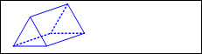  - Rectangular prism  - 6 rectangular faces  - 12 edges  - 8 vertices  - Ex:  - Cube (special rectangular prism)  - 6 square faces  - 12 edges  - 8 vertices  - Ex:  - Concrete models (e.g., wood or plastic figures, etc.), real-world objects (e.g., a cereal box, can of beans, etc.), and pictorial models (e.g., drawings, images, etc.)  - Collection of three-dimensional figures  - Sort and justify  - Rule used for sorting expressed  - Attributes and properties of geometric figures expressed  - Existence (have) and absence (do not have) of attributes and properties expressed (e.g., figures that have “a common attribute” and figures that do not have “a common attribute”)  - Ex:  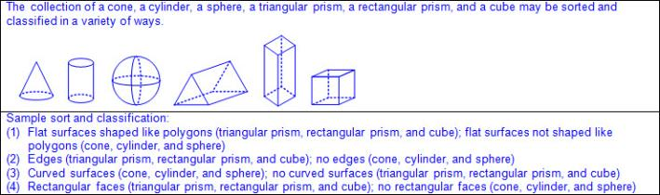  Note(s):  - Grade Level(s):  - Grade 1 classified and sorted regular and irregular two-dimensional shapes based on attributes using informal geometric language.  - Grade 3 will classify and sort two- and three-dimensional figures, including cones, cylinders, spheres, triangular and rectangular prisms, and cubes, based on attributes using formal geometric language.  - Various mathematical process standards will be applied to this student expectation as appropriate.  - TxRCFP:  - Applying knowledge of two-dimensional shapes and three-dimensional solids, including exploration of early fraction concepts  - TxCCRS:  - III.A. Geometric Reasoning – Figures and their properties  - IX. Communication and Representation
2.8C | Classify and sort polygons with 12 or fewer sides according to attributes, including identifying the number of sides and number of vertices.  Classify and sort polygons with 12 or fewer sides according to attributes, including identifying the number of sides and number of vertices.  Classify, Sort  POLYGONS WITH 12 OR FEWER SIDES ACCORDING TO ATTRIBUTES, INCLUDING IDENTIFYING THE NUMBER OF SIDES AND NUMBER OF VERTICES  Including, but not limited to:  - Two-dimensional figure – a figure with two basic units of measure, usually length and width  - Sort – grouping objects or figures by a shared characteristic or attribute  - Classify – applying an attribute to categorize a sorted group  - Attributes of two-dimensional figures – characteristics that define a geometric figure (e.g., sides, vertices, etc.)  - Properties of two-dimensional figures – relationship of attributes within a geometric figure (e.g., a square has 4 sides equal in length and 4 square corners, etc.) and between a group of geometric figures (e.g., a square and a rectangle both have 4 sides and 4 square corners; however, a square has 4 sides equal in length but a rectangle has only opposite sides equal in length; etc.)  - Regular figure – a polygon with all side lengths and corners equal  - Irregular figure – a polygon with side lengths and/or corners that are not all equal  - Attributes of two-dimensional figures  - Side – a straight outer boundary between two vertices (line segment) of a two-dimensional figure  - Number of sides  - Length of sides  - Vertex (vertices) in a two-dimensional figure – the point (corner) where two sides of a two-dimensional figure meet  - Number of vertices  - Types of corners  - Square corners  - Square corners can be determined using the corner of a known square or rectangle (e.g., sticky note, sheet of paper, etc.).  - Ex:  - May have a box in corner to represent square corner  - Ex:  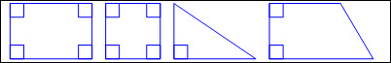  - Not square corners  - Opposite corners  - Polygon – a closed figure with at least 3 sides, where all sides are straight (no curves)  - Ex:  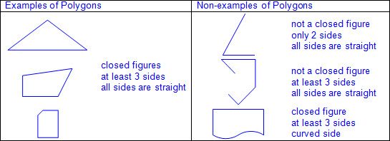  - Types of polygons  - Triangle  - 3 sides  - 3 vertices  - Ex:  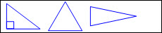  - Rectangle  - 4 sides  - 4 vertices  - Opposite sides equal in length  - 4 square corners  - Ex:  - Rhombus  - 4 sides  - 4 vertices  - All sides equal in length  - Opposite corners equal  - Ex:  - Square (a special type of rectangle and a special type of rhombus)  - 4 sides  - 4 vertices  - All sides equal in length  - Opposite sides equal in length  - 4 square corners  - Opposite corners equal  - Ex:  - Pentagon  - 5 sides  - 5 vertices  - Ex:  - Hexagon  - 6 sides  - 6 vertices  - Ex:  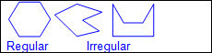  - Heptagon or septagon  - 7 sides  - 7 vertices  - Ex:  - Octagon  - 8 sides  - 8 vertices  - Ex:  - Nonagon or enneagon  - 9 sides  - 9 vertices  - Ex:  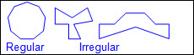  - Decagon  - 10 sides  - 10 vertices  - Ex:  - Undecagon or hendecagon  - 11 sides  - 11 vertices  - Ex:  - Dodecagon  - 12 sides  - 12 vertices  - Ex:  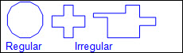  - Concrete models (e.g., wood or plastic figures, etc.) and pictorial models (e.g., drawings, images, etc.)  - Collection of two-dimensional figures  - Sort and justify  - Rule used for sorting expressed  - Attributes and properties of geometric figures expressed  - Existence (have) and absence (do not have) of attributes and properties expressed (e.g., figures that have “a common attribute” and figures that do not have “a common attribute”)  - Ex:  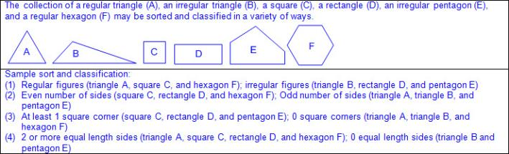  Note(s):  - Grade Level(s):  - Grade 1 classified and sorted regular and irregular two-dimensional shapes based on attributes using informal geometric language.  - Grade 3 will classify and sort two- and three-dimensional figures, including cones, cylinders, spheres, triangular and rectangular prisms, and cubes, based on attributes using formal geometric language.  - Various mathematical process standards will be applied to this student expectation as appropriate.  - TxRCFP:  - Applying knowledge of two-dimensional shapes and three-dimensional solids, including exploration of early fraction concepts  - TxCCRS:  - III.A. Geometric Reasoning – Figures and their properties  - IX. Communication and Representation
2.8D | Compose two-dimensional shapes and three-dimensional solids with given properties or attributes.  Compose two-dimensional shapes and three-dimensional solids with given properties or attributes.  Compose  TWO-DIMENSIONAL SHAPES WITH GIVEN PROPERTIES OR ATTRIBUTES  Including, but not limited to:  - Two-dimensional figure – a figure with two basic units of measure, usually length and width  - Spatial visualization – creation and manipulation of mental representations of shapes  - Compose figures – to combine smaller geometric figures to form a larger geometric figure  - Attributes of two-dimensional figures – characteristics that define a geometric figure (e.g., sides, vertices, etc.)  - Properties of two-dimensional figures – relationship of attributes within a geometric figure (e.g., a square has 4 sides equal in length and 4 square corners, etc.) and between a group of geometric figures (e.g., a square and a rectangle both have 4 sides and 4 square corners; however, a square has 4 sides equal in length but a rectangle has only opposite sides equal in length; etc.)  - Regular figure – a polygon with all side lengths and corners equal  - Irregular figure – a polygon with side lengths and/or corners that are not all equal  - Attributes of two-dimensional figures  - Side – a straight outer boundary between two vertices (line segment) of a two-dimensional figure  - Number of sides  - Length of sides  - Vertex (vertices) in a two-dimensional figure – the point (corner) where two sides of a two-dimensional figure meet  - Number of vertices  - Types of corners  - Square corners  - Square corners can be determined using the corner of a known square or rectangle (e.g., sticky note, sheet of paper, etc.).  - Ex:  - May have a box in corner to represent square corner  - Ex:  - Not square corners  - Opposite corners  - Attributes that do not identify a two-dimensional figure  - Orientation  - Size  - Color  - Texture  - Compose two-dimensional figures using a variety of concrete models.  - Ex: Color tiles, pattern blocks, tangrams, attribute shapes, etc.  - Compose regular and irregular figures based on attributes.  - Ex: Compose a two-dimensional figure with square corners when given unit squares.  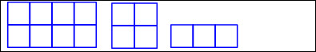  - Ex: Compose a two-dimensional figure with square corners when given two triangles.  - Ex: Compose a two-dimensional figure with all sides equal in length when given two regular triangles.  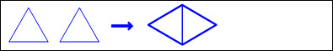  - Ex: Compose two-dimensional figure with four vertices and opposite sides equal in length when given four triangles.  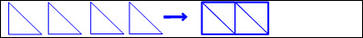  - Ex: Compose a six-sided figure when given 3 rhombuses.  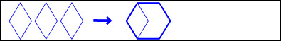  - Ex: Compose a six-sided figure when given a square and a rectangle.  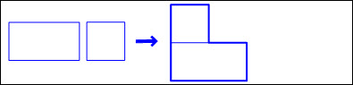  - Ex: Compose a six-sided figure when given a square and two triangles.  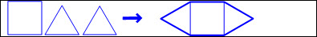  Compose  THREE-DIMENSIONAL SOLIDS WITH GIVEN PROPERTIES OR ATTRIBUTES  Including, but not limited to:  - Three-dimensional figure – a figure that has measurements including length, width (depth), and height  - Spatial visualization – creation and manipulation of mental representations of shapes  - Compose figures – to combine smaller geometric figures to form a larger geometric figure  - Attributes of three-dimensional figures – characteristics that define a geometric figure (e.g., faces, curved surfaces, edges, vertices, etc.)  - Properties of three-dimensional figures – relationship of attributes within a geometric figure (e.g., a rectangular prism has 6 faces and each pair of opposite faces are the same size and shape, etc.) and between a group of geometric figures (e.g., a cube and a rectangular prism both have 6 faces with opposite faces equal in size and shape; however, a cube has only square faces but a rectangular prism can have square or rectangular faces; etc.)  - Attributes of three-dimensional figures  - Surfaces  - Curved surface  - Flat surface  - Face of a prism – a polygon that forms a surface of a prism  - Number of faces  - Shape of faces  - Edge – where the sides of two faces meet on a three-dimensional figure  - Number of edges  - Vertex (vertices) in a three-dimensional figure – the point (corner) where three or more edges of a three-dimensional figure meet  - Number of vertices  - Attributes that do not identify a three-dimensional figure  - Orientation  - Size  - Color  - Texture  - Compose three-dimensional figures using a variety of concrete models.  - Ex: Unit cubes, color tiles, pattern blocks, tangrams, attribute shapes, etc.  - Compose three-dimensional figures based on attributes.  - Ex: Build a three-dimensional solid with 6 faces and 8 vertices when given unit cubes.  - Ex: Compose a three-dimensional solid when given two triangles and three rectangles.  Note(s):  - Grade Level(s):  - Grade 1 composed two-dimensional shapes by joining two, three, or four figures to produce a target shape in more than one way if possible.  - Various mathematical process standards will be applied to this student expectation as appropriate.  - TxRCFP:  - Applying knowledge of two-dimensional shapes and three-dimensional solids, including exploration of early fraction concepts  - TxCCRS:  - III.A. Geometric Reasoning – Figures and their properties  - IX. Communication and Representation
2.8E | Decompose two-dimensional shapes such as cutting out a square from a rectangle, dividing a shape in half, or partitioning a rectangle into identical triangles and identify the resulting geometric parts.  Decompose two-dimensional shapes such as cutting out a square from a rectangle, dividing a shape in half, or partitioning a rectangle into identical triangles and identify the resulting geometric parts.  Decompose  TWO-DIMENSIONAL SHAPES  Including, but not limited to:  - Two-dimensional figure – a figure with two basic units of measure, usually length and width  - Spatial visualization – creation and manipulation of mental representations of shapes  - Decompose figures – to break a geometric figure into two or more smaller geometric figures  - Decompose two-dimensional figures by cutting, dividing, or partitioning.  - Such as cutting a square from a rectangle  - Such as dividing a shape in half  - Such as partitioning a rectangle into identical triangles  - Resulting shapes equal or not equal  - Ex:  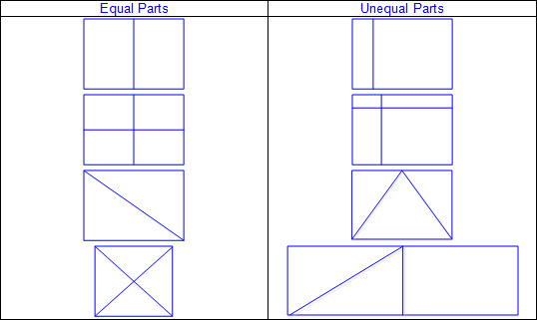  - Decompose two-dimensional shapes using a variety of concrete models and materials.  - Ex: Color tiles, pattern blocks, tangrams, attribute shapes, paper, scissors, etc.  Identify  THE RESULTING GEOMETRIC PARTS OF A DECOMPOSED TWO-DIMENSIONAL SHAPE  Including, but not limited to:  - Two-dimensional figure – a figure with two basic units of measure, usually length and width  - Name resulting geometric figures (e.g., a rectangle partitioned into smaller rectangles that may or may not be equal in size or shape; a rectangle partitioned into triangles that may or may not be equal in size or shape; etc.)  - Ex:  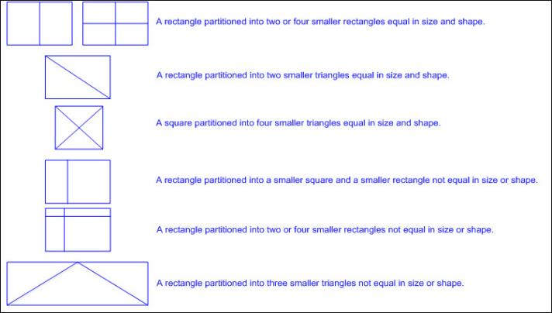  Note(s):  - Grade Level(s):  - Various mathematical process standards will be applied to this student expectation as appropriate.  - TxRCFP:  - Applying knowledge of two-dimensional shapes and three-dimensional solids, including exploration of early fraction concepts  - TxCCRS:  - III.A. Geometric Reasoning – Figures and their properties  - IX. Communication and Representation
2.9 | Geometry and measurement. The student applies mathematical process standards to select and use units to describe length, area, and time. The student is expected to:
2.9A | Find the length of objects using concrete models for standard units of length.  Find the length of objects using concrete models for standard units of length.  Find  THE LENGTH OF OBJECTS USING CONCRETE MODELS FOR STANDARD UNITS OF LENGTH  Including, but not limited to:  - Length – the measurement attribute that describes a continuous distance from end to end  - Unit of length – the object or unit used to measure length  - Concrete models that represent standard units of length  - Typically used customary units of length  - Inch represented by a color tile, etc.  - Foot represented by a 12 inch ruler as a single unit, etc.  - Yard represented by a yardstick as a single unit, etc.  - Typically used metric units of length  - Centimeter represented by a base-10 unit cube, etc.  - Decimeter represented by a base-10 long, orange Cuisenaire rod, etc.  - Meter represented by a meter stick as a single unit, etc.  - Length described to the nearest whole unit using a number and a unit  - Linear measurement – the measurement of length along a continuous line or curve  - Starting point and ending point defined  - Ex:  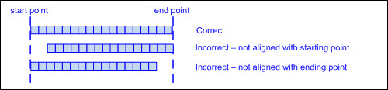  - Equal sized units of length placed end to end along the distance being measured  - Ex:  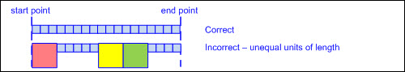  - Equal sized units of length iterated (repeated) with no gaps or overlays  - Ex:  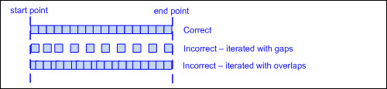  - Length measured using one-dimensional units of length (e.g., if measuring with a color tile, measure with the edge, not the area of the color tile; if measuring with a color tile, measure with the same dimension of the color tile; etc.)  - Ex:  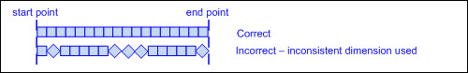  - Equal sized units of length counted to the nearest whole unit  - Last unit is not counted if the end point falls less than half-way along the unit.  - Last unit is counted if the end point falls half-way, or more than half-way, along the unit.  - Ex:  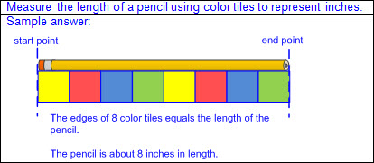  - Ex:  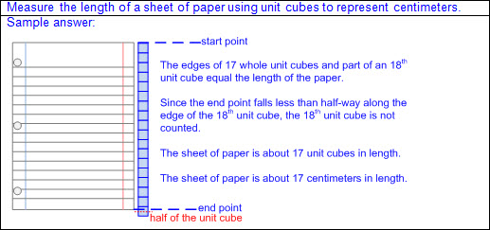  - Ex:  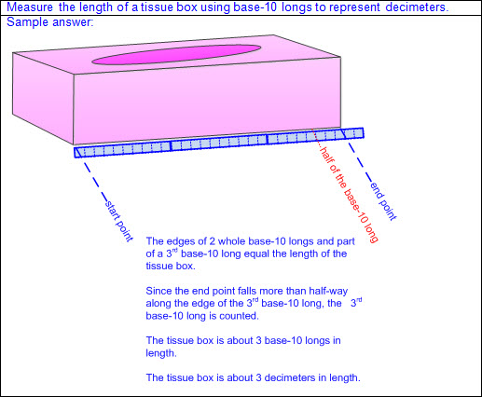  - Unit of length selected for efficiency  - Smaller unit of length to measure shorter objects or distances  - Ex:  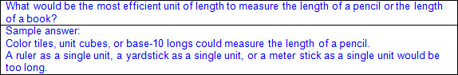  - Larger unit of length to measure longer objects or distances  - Ex:  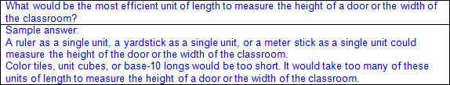  - Unit of length selected for precision  - Smaller unit of length results in a more precise measurement when measuring to the whole unit  - Larger unit of length results in a less precise measurement when measuring to the whole unit  Note(s):  - Grade Level(s):  - Grade 1 illustrated that the length of an object is the number of same-size units of length that, when laid end-to-end with no gaps or overlaps, reach from one end of the object to the other.  - Grade 1 described a length to the nearest whole unit using a number and a unit.  - Various mathematical process standards will be applied to this student expectation as appropriate.  - TxRCFP:  - Measuring length  - TxCCRS:  - IV.A Measurement Reasoning – Measurement involving physical and natural attributes  - IX. Communication and Representation
2.9B | Describe the inverse relationship between the size of the unit and the number of units needed to equal the length of an object.  Describe the inverse relationship between the size of the unit and the number of units needed to equal the length of an object.  Describe  THE INVERSE RELATIONSHIP BETWEEN THE SIZE OF THE UNIT AND THE NUMBER OF UNITS NEEDED TO EQUAL THE LENGTH OF AN OBJECT  Including, but not limited to:  - Length – the measurement attribute that describes a continuous distance from end to end  - Unit of length – the object or unit used to measure length  - Concrete models that represent standard units of length  - Typically used customary units of length  - Inch represented by a color tile, etc.  - Foot represented by a 12 inch ruler as a single unit, etc.  - Yard represented by a yardstick as a single unit, etc.  - Typically used metric units of length  - Centimeter represented by a base-10 unit cube, etc.  - Decimeter represented by a base-10 long, orange Cuisenaire rod, etc.  - Meter represented by a meter stick as a single unit, etc.  - Inverse relationship between the size of the unit and the number of units needed  - Measure the same object with different sized units of length.  - The shorter the unit of length, the more units needed  - The longer the unit of length, the fewer units needed  - Ex:  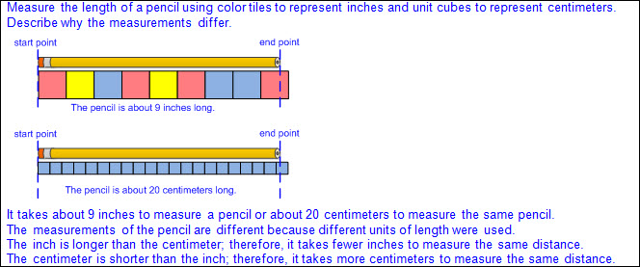  Note(s):  - Grade Level(s):  - Grade 1 measured the same object/distance with units of two different lengths and described how and why the measurements differ.  - Various mathematical process standards will be applied to this student expectation as appropriate.  - TxRCFP:  - Measuring length  - TxCCRS:  - IV.A Measurement Reasoning – Measurement involving physical and natural attributes  - IX. Communication and Representation
2.9C | Represent whole numbers as distances from any given location on a number line.  Represent whole numbers as distances from any given location on a number line.  Represent  WHOLE NUMBERS AS DISTANCES FROM ANY GIVEN LOCATION ON A NUMBER LINE  Including, but not limited to:  - Characteristics of a number line  - A number line begins as a line with predetermined intervals (or tick marks) with positions/numbers labeled.  - A minimum of two positions/numbers should be labeled.  - Numbers on a number line represent the distance from zero.  - The distance between the tick marks is counted rather than the tick marks themselves.  - The placement of the labeled positions/numbers on a number line determines the scale of the number line.  - Intervals between position/numbers are proportional.  - When reasoning on a number line, the position of zero may or may not be placed.  - When working with larger numbers, a number line without the constraint of distance from zero allows the ability to “zoom-in” on the relevant section of the number line.  - Number lines extend infinitely in both directions (arrows indicate the number line continues infinitely).  - Numbers increase from left to right on a horizontal number line and from bottom to top on a vertical number line.  - Points to the left of a specified point on a horizontal number line are less than points to the right.  - Points to the right of a specified point on a horizontal number line are greater than points to the left.  - Points below a specified point on a vertical number line are less than points above.  - Points above a specified point on a vertical number line are greater than points below.  - Whole numbers represented as equally spaced lengths or distances from zero on a number line  - Relationship between a whole number represented using a strip diagram to a whole number represented on a number line  - Ex:  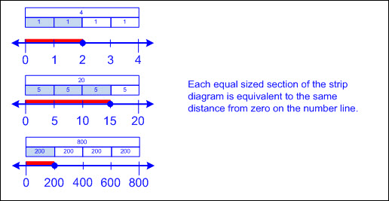  - Number lines beginning with a number other than zero  - Distance from zero to first marked increment is assumed even when not visible on the number line.  - Ex:  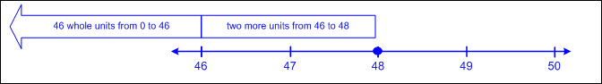  - Relationship between whole numbers as distances from zero on a number line to whole unit measurements as distances from zero on a customary ruler, yardstick, or measuring tape  - Ex:  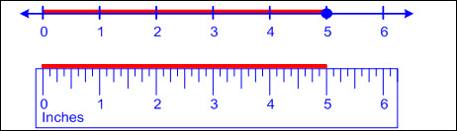  - Measuring a specific length using a distance other than zero on a ruler, yardstick, or measuring tape  - Distance from zero to first marked increment not counted  - Length determined by number of whole units between starting point and ending point  - Ex:  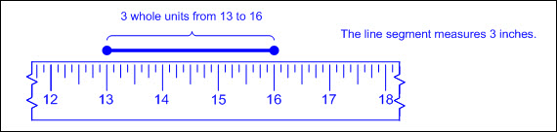  - Relationship between distances from zero on a number line, distances from zero on the scale of a bar graph, and heights of the bars within the graph  - Bar graph – a graphical representation to organize data that uses solid bars that do not touch each other to show the frequency (number of times) that each category occurs  - Ex:  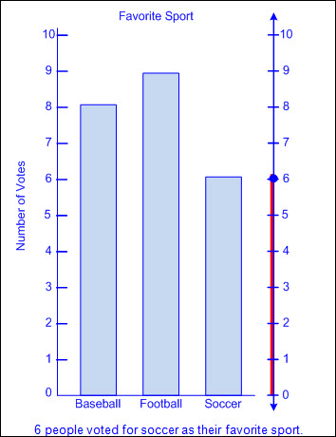  Note(s):  - Grade Level(s):  - Grade 3 will represent fractions of halves, fourths, and eighths as distances from zero on a number line.  - Various mathematical process standards will be applied to this student expectation as appropriate.  - TxRCFP:  - Measuring length  - TxCCRS:  - IV.A Measurement Reasoning – Measurement involving physical and natural attributes  - IX. Communication and Representation
2.9D | Determine the length of an object to the nearest marked unit using rulers, yardsticks, meter sticks, or measuring tapes.  Determine the length of an object to the nearest marked unit using rulers, yardsticks, meter sticks, or measuring tapes.  Determine  THE LENGTH OF AN OBJECT TO THE NEAREST MARKED UNIT USING RULERS, YARDSTICKS, METER STICKS, OR MEASURING TAPES  Including, but not limited to:  - Length – the measurement attribute that describes a continuous distance from end to end  - Unit of length – the object or unit used to measure length  - Linear measurement – the measurement of length along a continuous line or curve  - Standard linear measurement tools  - Typically used customary linear measurement tools  - Ruler with inches, yardstick, measuring tape  - Typically used metric linear measurement tools  - Ruler with centimeters, meter stick, measuring tape  - Standard units of length  - Typically used customary units of length  - Inches, feet, yards  - Typically used metric units of length  - Centimeters, meters  - Relationship between finding the length of objects using concrete models for standard units of length to whole unit measurements on a customary ruler, yardstick, or measuring tape  - Ex:  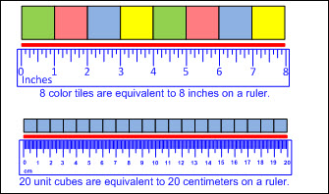  - Relationship between whole numbers as distances from zero on a number line to whole unit measurements as distances from zero on a customary ruler, yardstick, or measuring tape  - Ex:  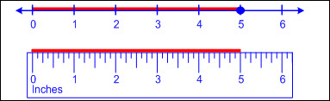  - Determine length to the nearest whole unit.  - Starting point and ending point defined  - Edge of measuring tool placed along the distance being measured, aligned with the start point of the distance being measured  - Equal sized units of length counted to the nearest whole unit  - Last unit is not counted if the end point falls less than half-way along the unit.  - Last unit is counted if the end point falls half-way, or more than half-way, along the unit.  - Ex:  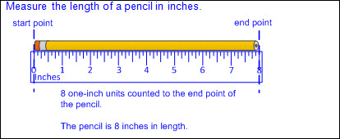  - Ex:  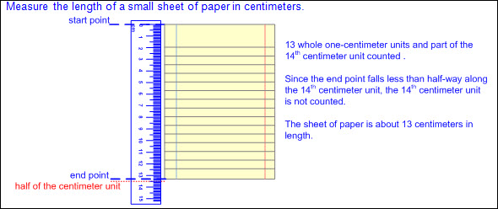  - Ex:  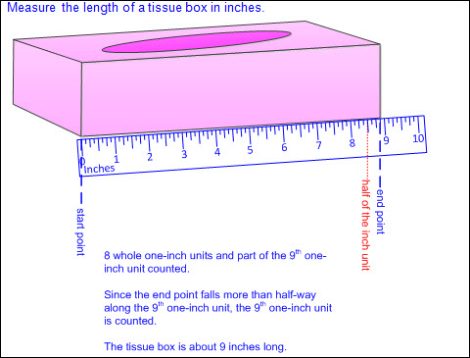  - Measuring a specific length using a starting point other than zero on a ruler, yardstick, or measuring tape  - Distance from zero to first marked increment not counted  - Length determined by number of whole units between starting point and ending point  - Ex:  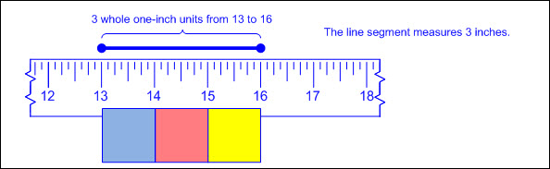  Note(s):  - Grade Level(s):  - Grade 1 used non-standard measuring tools to measure the length of objects to reinforce the continuous nature of linear measurement.  - Various mathematical process standards will be applied to this student expectation as appropriate.  - TxRCFP:  - Measuring length  - TxCCRS:  - IV.A Measurement Reasoning – Measurement involving physical and natural attributes  - IX. Communication and Representation
2.9E | Determine a solution to a problem involving length, including estimating lengths.  Determine a solution to a problem involving length, including estimating lengths.  Determine  A SOLUTION TO A PROBLEM INVOLVING LENGTH, INCLUDING ESTIMATING LENGTHS  Including, but not limited to:  - Length – the measurement attribute that describes a continuous distance from end to end  - Mathematical and real-world problem situations  - Recognition of attributes of length embedded in mathematical and real-world problem situations (e.g., distance traveled from one place to another, length of an object, perimeter, etc.)  - Ex: Robert walked from his house to his friend’s house. How far did he walk? (Solved by measuring the distance from Robert’s house to his friend’s house.)  - Ex: Sherri bought a giant pencil at the fall festival. Will the giant pencil fit in Sherri’s backpack? (Solved by measuring and comparing the length of the pencil and the length of the backpack.)  - Ex: Ms. Ricke hung a decorative border along the top edge of her bulletin board. How much decorative border did she use? (Solved by measuring the length of the top edge of the bulletin board.)  - One-step or multi-step problems  - Measurement of one or more distances/lengths  - Multiple operations  - Addition and/or subtraction of whole unit measurements  - Solutions recorded to the nearest whole unit with a number and a unit label  - Ex:  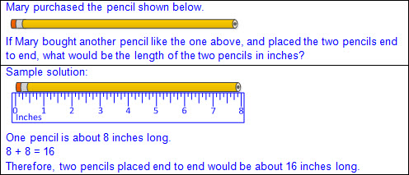  - Ex:  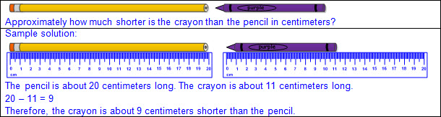  - Ex:  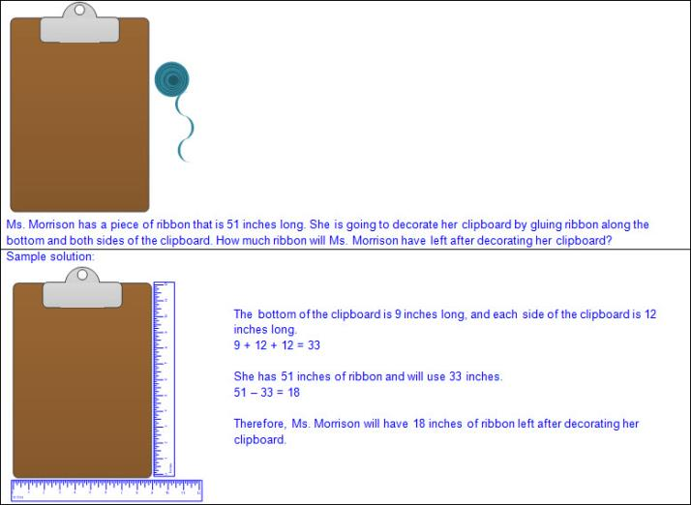  - Estimation – reasoning to determine an approximate value  - Estimation prior to solving problem  - Estimation compared to actual measurement  - Benchmarks for units of length  - Finger joint (thumb works best) = approximately 1 inch  - Tip of your finger = approximately 1 centimeter  - Span of your palm = approximately 1 decimeter  - Elbow to wrist = approximately 1 foot  - Nose to fingertip of extended arm = approximately 1 yard  - Nose to fingertip of extended arm with head turned away = approximately 1 meter  - Language related to estimation  - About, a little less than, a little more than, almost, nearly, approximately, etc.  Note(s):  - Grade Level(s):  - Grade 3 will determine the perimeter of a polygon or a missing length when given perimeter and remaining side lengths in problems.  - Various mathematical process standards will be applied to this student expectation as appropriate.  - TxRCFP:  - Measuring length  - TxCCRS:  - IV.A Measurement Reasoning – Measurement involving physical and natural attributes  - VIII. Problem Solving and Reasoning  - IX. Communication and Representation
2.9F | Use concrete models of square units to find the area of a rectangle by covering it with no gaps or overlaps, counting to find the total number of square units, and describing the measurement using a number and the unit.  Use concrete models of square units to find the area of a rectangle by covering it with no gaps or overlaps, counting to find the total number of square units, and describing the measurement using a number and the unit.  Use  CONCRETE MODELS OF SQUARE UNITS TO FIND THE AREA OF A RECTANGLE BY COVERING IT WITH NO GAPS OR OVERLAPS, COUNTING TO FIND THE TOTAL NUMBER OF SQUARE UNITS, AND DESCRIBING THE MEASUREMENT USING A NUMBER AND THE UNIT  Including, but not limited to:  - Area – the measurement attribute that describes the number of square units a figure or region covers  - Square unit – an object or unit, shaped like a square, used to measure area  - Concrete models of non-standard square units  - Flat surface of color tiles, unit cubes, base-10 flats, square sticky notes, etc.  - Area of a rectangle (including squares as special rectangles)  - Boundary of rectangle defined  - Equal sized square units iterated (repeated) in rows and columns inside the boundary of the rectangle being measured  - Ex:  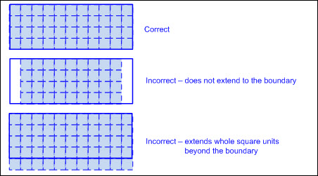  - Equal sized square units iterated (repeated) in rows and columns with no gaps or overlays  - Ex:  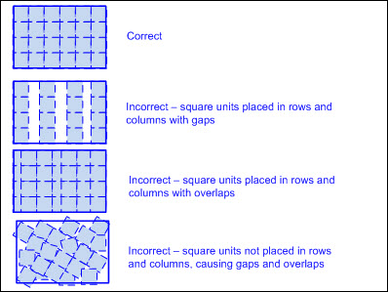  - Area measured using two-dimensional square units (e.g., if measuring with a color tile, measure with the square surface of the color tile, not the side of the color tile, etc.)  - Equal sized square units counted to the nearest whole unit  - Last square unit in each row/column is not counted if the boundary of the rectangle falls less than half-way through the square unit(s).  - Last square unit in each row/column is counted if the boundary of the rectangle falls more than half-way through the square unit(s).  - Measurement determined by counting the number of whole units within the defined boundary  - Determined by counting each whole unit individually  - Determined by counting length of one row and it’s iteration (e.g., skip counting the number of units in each row to the last row such as 3 rows of 5 square units would be 5, 10, 15 or using repeated addition 5 + 5 + 5 = 15, etc.)  - Measurement described using a number and the label square unit(s)  - Ex:  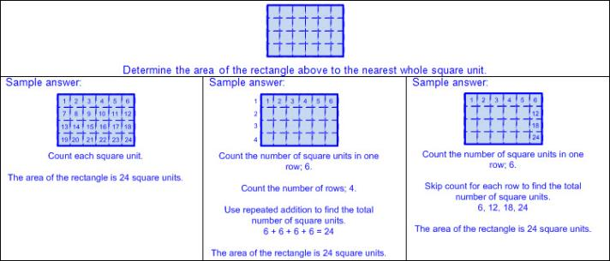  - Ex:  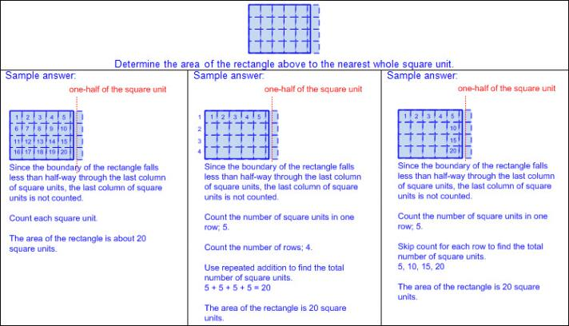  - Ex:  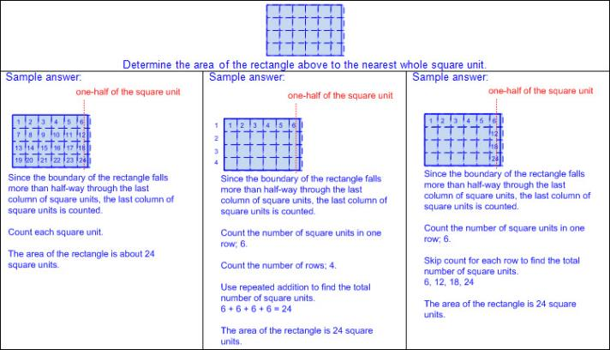  - Appropriate square unit selected  - Square unit selected for efficiency  - Smaller square unit to measure smaller rectangles  - Larger square unit to measure larger rectangles  - Square unit selected for precision  - Smaller square unit results in a more precise measurement when measuring to the whole unit  - Larger square unit results in a less precise measurement when measuring to the whole unit  - Inverse relationship between the size of the square unit and the number of square units needed  - Measure a rectangle with a small square unit and then measure the same rectangle with a large square unit  - The smaller the square unit, the more square units needed  - The larger the square unit, the fewer square units needed  Note(s):  - Grade Level(s):  - Grade 2 introduces using concrete models of square units to find the area of a rectangle by covering it with no gaps or overlaps, counting to find the total number of square units, and describing the measurement using a number and the unit.  - Grade 3 will determine the area of rectangles with whole number side lengths in problems using multiplication related to the number of rows times the number of unit squares in each row.  - Various mathematical process standards will be applied to this student expectation as appropriate.  - TxRCFP:  - Grade Level Connections (reinforces previous learning and/or provides development for future learning)  - TxCCRS:  - IV.A Measurement Reasoning – Measurement involving physical and natural attributes  - IX. Communication and Representation
2.9G | Read and write time to the nearest one-minute increment using analog and digital clocks and distinguish between a.m. and p.m.  Read and write time to the nearest one-minute increment using analog and digital clocks and distinguish between a.m. and p.m.  Read, Write  TIME TO THE NEAREST ONE-MINUTE INCREMENT USING ANALOG AND DIGITAL CLOCKS  Including, but not limited to:  - Clocks used to describe the measurement attribute of time  - Analog clock  - A circular number line representing 12 one-hour increments, labeled 1 – 12  - Numbers increase in a clockwise direction (from left to right when starting at the top) around the circle.  - Each one-hour increment also represents 5 one-minute increments that are not labeled with numbers.  - One full rotation of the face of the clock  - One full rotation of the hour hand represents 12 hours.  - One full rotation of the minute hand represents 60 minutes.  - Skip counting by 5 from the 12 all the way around to the 12 equals 60 minutes.  - One full rotation of the second hand represents 60 seconds.  - Hour hand  - Shorter than the minute hand and second hand  - Moves slower than the minute hand and second hand  - One full rotation of the minute hand moves the hour hand to the next labeled hour.  - Minute hand  - Longer than the hour hand and usually about the same length as, but thicker than, the second hand  - Moves faster than the hour hand but slower than the second hand  - One full rotation of the minute hand moves the hour hand to the next labeled hour.  - Second hand  - Longer than the hour hand and usually about the same length as, but thinner than, the minute hand  - Moves faster than the hour hand and the minute hand  - One full rotation of the second hand moves the minute hand to the next minute increment.  - Not all analog clocks include a second hand  - Read and write time to the minute  - Hour determined by the location of the hour hand  - Hour determined by the labeled number when hour hand falls on a marked increment  - Hour determined by the labeled number just passed when hour hand falls between marked increments, regardless of which increment it is closest to  - Minute determined by the location of the minute hand  - Skip count by 5 for each numbered increment, and then count on by 1 for each unmarked minute increment.  - Ex:  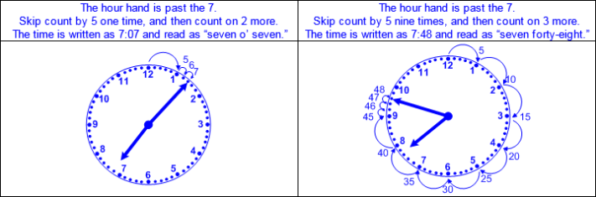  - Digital clock  - Colon used to separate the hour from the minutes  - Hour (1 – 12) displayed to the left of the colon  - Hour increases by 1 for every 60 minutes  - Minutes (00 – 59) displayed to the right of the colon  - Minute increases by 1 for every 60 seconds  - One minute after 59 is displayed as :00  - Read and write time to the minute as displayed.  - Ex:  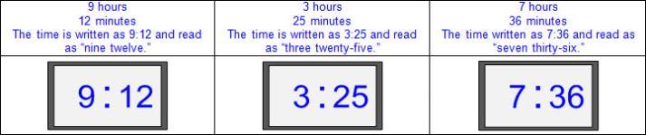  - Parts of hours represented with fraction names  - 15 minutes read and written as “a quarter past” or “a quarter after”  30 minutes read and written as “half past”  45 minutes read and written as “a quarter ‘til” or “a quarter to”  - Match time on an analog clock and a digital clock.  - Ex:  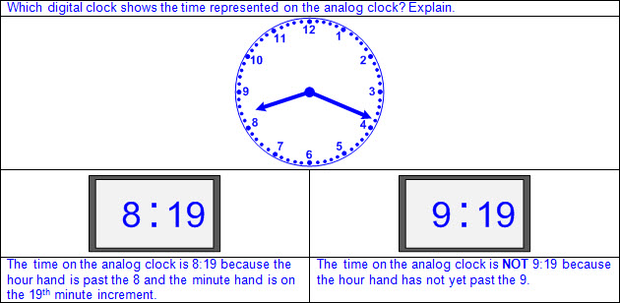  - Ex:  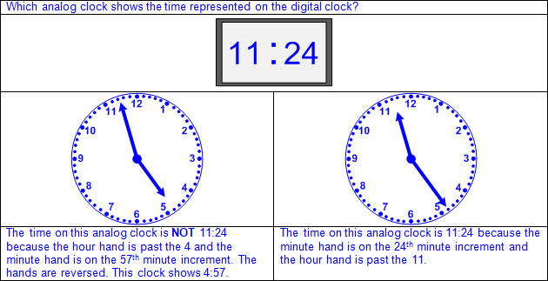  Distinguish  BETWEEN a.m. AND p.m.  Including, but not limited to:  - One day equals 24 hours.  - One 24 hour day is divided into two 12 hour time periods.  - a.m. – the abbreviation for ante meridiem or ante meridian, meaning before noon or mid-day  - Begins at midnight (12:00 a.m.), ends one minute before noon (11:59 a.m.)  - Possible abbreviations: a.m.; am; A.M.; AM  - p.m. – the abbreviation for post meridiem or post meridian, meaning after noon or mid-day  - Begins at noon (12:00 p.m.), ends one minute before midnight (11:59 p.m.)  - Possible abbreviations: p.m.; pm; P.M.; PM  - One full rotation of hours on the clock equals 12 hours.  - One full rotation for a.m. and one full rotation for p.m.  - Language related to 12:00  - 12:00 p.m. is noon or mid-day and occurs in the daylight.  - 12:00 a.m. is midnight and occurs in the dark.  - Language related to a.m.  - Morning, sunrise, dawn, daybreak, etc.  - Language related to p.m.  - Afternoon, evening, dusk, sunset, etc.  Note(s):  - Grade Level(s):  - Grade 1 told time to the hour and half hour using analog and digital clocks.  - Grade 3 will determine the solutions to problems involving addition and subtraction of time intervals in minutes using pictorial models or tools such as a 15-minute event plus a 30-minute event equals 45 minutes.  - Various mathematical process standards will be applied to this student expectation as appropriate.  - TxRCFP:  - Grade Level Connections (reinforces previous learning and/or provides development for future learning)  - TxCCRS:  - IX. Communication and Representation  - X. Connections
2.10 | Data analysis. The student applies mathematical process standards to organize data to make it useful for interpreting information and solving problems. The student is expected to:
2.10A | Explain that the length of a bar in a bar graph or the number of pictures in a pictograph represents the number of data points for a given category.  Explain that the length of a bar in a bar graph or the number of pictures in a pictograph represents the number of data points for a given category.  Explain  THAT THE LENGTH OF A BAR IN A BAR GRAPH OR THE NUMBER OF PICTURES IN A PICTOGRAPH REPRESENTS THE NUMBER OF DATA POINTS FOR A GIVEN CATEGORY  Including, but not limited to:  - Graph – a visual representation of the relationships between data collected  - Organization of data used to interpret data, draw conclusions, and make comparisons  - Bar graph – a graphical representation to organize data that uses solid bars that do not touch each other to show the frequency (number of times) that each category occurs  - Length of the bar in a bar graph represents the number of data points for a given category.  - Scale of the axis may be intervals of one or more, and scale intervals are proportionally displayed.  - Length of the bar represents the distance from zero on the scale of the axis.  - The scale of the axis is a number line.  - Value of the data represented by the bar is determined by reading the number associated with its length (distance from zero) on the axis scale.  - Ex: Determine the value of the data in each category.  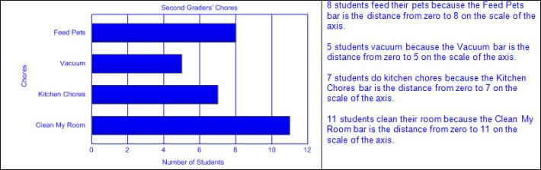  - Pictograph – a graphical representation to organize data that uses a picture or symbol, where each picture or symbol may represent one or more than one unit of data, to show the frequency (number of times) that each category occurs  - Number of pictures or symbols in a pictograph represents the number of data points for a given category.  - A key is used to identify the value of each picture or symbol.  - Value of each picture or symbol may be one or more.  - Partial symbols represent the fractional value of the whole picture or whole symbol.  - Ex:  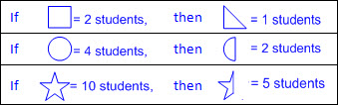  - Value of the data in each category is determined by the total value of the pictures or symbols in that category.  - Ex: Determine the value of the data in each category. 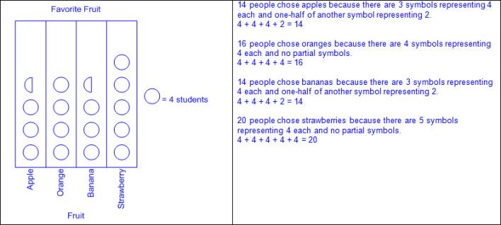  - Ex: Determine the value of the symbol based on the given total value for the category.  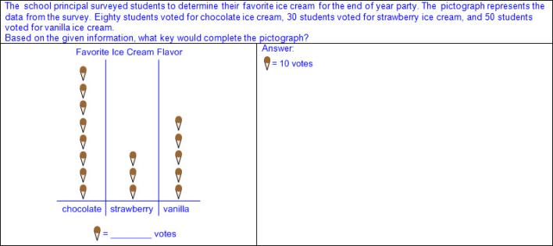  Note(s):  - Grade Level(s):  - Grade 2 introduces bar graphs and pictographs.  - Various mathematical process standards will be applied to this student expectation as appropriate.  - TxRCFP:  - Developing proficiency in the use of place value within the base-10 numeration system  - TxCCRS:  - IX. Communication and Representation
2.10B | Organize a collection of data with up to four categories using pictographs and bar graphs with intervals of one or more.  Organize a collection of data with up to four categories using pictographs and bar graphs with intervals of one or more.  Organize  A COLLECTION OF DATA WITH UP TO FOUR CATEGORIES USING PICTOGRAPHS AND BAR GRAPHS WITH INTERVALS OF ONE OR MORE  Including, but not limited to:  - Graph – a visual representation of the relationships between data collected  - Organization of data used to interpret data, draw conclusions, and make comparisons  - Data – information that is collected about people, events, or objects  - Categorical data – data that represents the attributes of a group of people, events, or objects  - Ex: What is your favorite color? Represented on a graph with colors as category labels (e.g., red, yellow, blue, and green)  - Ex: Do you have a brother? Represented on a graph with yes and no as category labels  - Ex: Which sporting event do you prefer? Represented on a graph with names of sports as category labels (e.g., basketball, baseball, football, and soccer)  - Categorical data may represent numbers or ranges of numbers.  - Ex: How many pets do you have? Represented on a graph with numbers as category labels (e.g., 0 – 1, 2, 3, and 4 or more)  - Ex: How many letters are in your name? Represented on a graph with ranges of numbers as category labels (e.g., 1 – 3, 4 – 6, 7 – 9, and 10 or more)  - Data organized into up to four categories  - Pictograph – a graphical representation to organize data that uses a picture or symbol, where each picture or symbol may represent one or more than one unit of data, to show the frequency (number of times) that each category occurs  - Characteristics of a pictograph  - Title clarifies the meaning of the data represented.  - Categorical data is represented with labels.  - Horizontal or vertical linear arrangement  - One picture or symbol is used to represent all categories.  - A key is used to identify the value of each picture or symbol.  - Number of pictures and partial-pictures or symbols represents the number of data points for a given category.  - Ex:  - Ex:  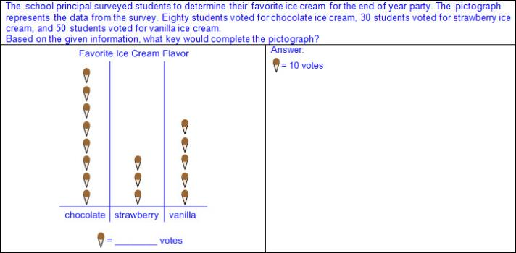  - Value of the data in each category is determined by the total value of the pictures or symbols in that category.  - Ex:  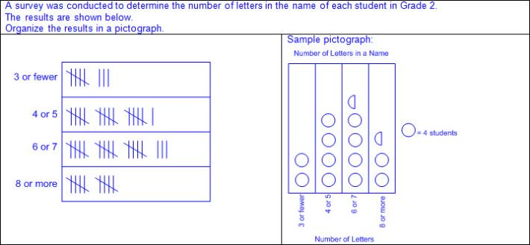  - Ex:  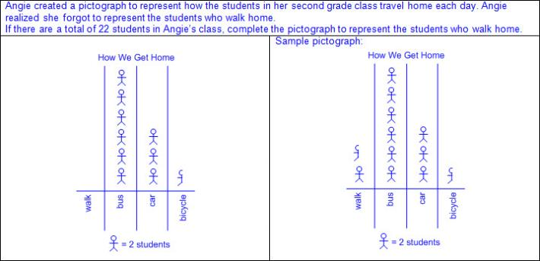  - Bar graph – a graphical representation to organize data that uses solid bars that do not touch each other to show the frequency (number of times) that each category occurs  - Characteristics of a bar graph  - Title clarifies the meaning of the data represented.  - Subtitles clarify the meaning of the data represented on each axis.  - Categorical data is represented with labels.  - Horizontal or vertical linear arrangement  - Bars are solid.  - Bars do not touch.  - Scale of the axis may be intervals of one or more, and scale intervals are proportionally displayed.  - The scale of the axis is a number line.  - Length of the bar represents the number of data points for a given category.  - Length the bar represents the distance from zero on the scale of the axis.  - Value of the data represented by the bar is determined by reading the number associated with its length (distance from zero) on the axis scale.  - Ex:  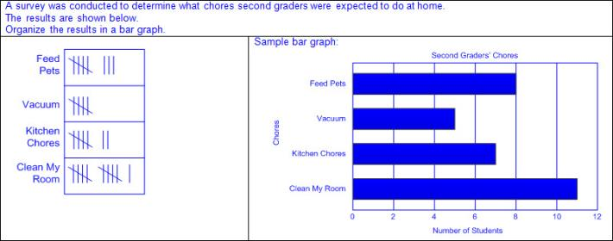  - Ex:  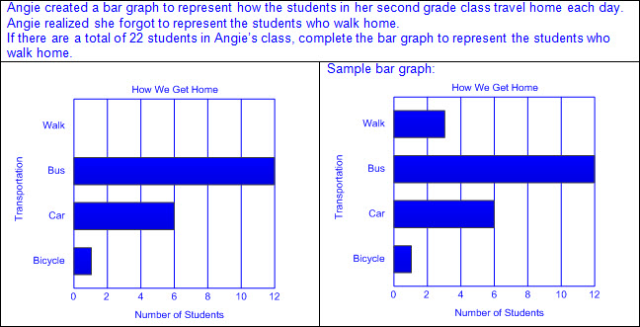  Note(s):  - Grade Level(s):  - Grade 1 used data to create picture and bar-type graphs.  - Graph 3 will summarize a data set with multiple categories using a frequency table, dot plot, pictograph, or bar graph with scaled intervals.  - Various mathematical process standards will be applied to this student expectation as appropriate.  - TxRCFP:  - Developing proficiency in the use of place value within the base-10 numeration system  - TxCCRS:  - IX. Communication and Representation
2.10C | Write and solve one-step word problems involving addition or subtraction using data represented within pictographs and bar graphs with intervals of one.  Write and solve one-step word problems involving addition or subtraction using data represented within pictographs and bar graphs with intervals of one.  Write, Solve  ONE-STEP WORD PROBLEMS INVOLVING ADDITION OR SUBTRACTION USING DATA REPRESENTED WITHIN PICTOGRAPHS AND BAR GRAPHS WITH INTERVALS OF ONE  Including, but not limited to:  - Graph – a visual representation of the relationships between data collected  - Organization of data used to interpret data, draw conclusions, and make comparisons  - Data – information that is collected about people, events, or objects  - Categorical data – data that represents the attributes of a group of people, events, or objects  - Ex: What is your favorite color? Represented on a graph with colors as category labels (e.g., red, yellow, blue, and green)  - Ex: Do you have a brother? Represented on a graph with yes and no as category labels  - Ex: Which sporting event do you prefer? Represented on a graph with names of sports as category labels (e.g., basketball, baseball, football, and soccer)  - Categorical data may represent numbers or ranges of numbers.  - Ex: How many pets do you have? Represented on a graph with numbers as category labels (e.g., 0 – 1, 2, 3, and 4 or more)  - Ex: How many letters are in your name? Represented on a graph with ranges of numbers as category labels (e.g., 1 – 3, 4 – 6, 7 – 9, and 10 or more)  - Write and solve mathematical and real-world problems using data represented within pictographs and bar graphs.  - Pictograph – a graphical representation to organize data that uses a picture or symbol, where each picture or symbol may represent one or more than one unit of data, to show the frequency (number of times) that each category occurs  - Up to four categories  - Each picture or symbol limited to representing one unit of data  - Bar graph – a graphical representation to organize data that uses solid bars that do not touch each other to show the frequency (number of times) that each category occurs  - Up to four categories  - Scale of the axis limited to intervals of one  - One-step problems  - Addition or subtraction  - Ex:  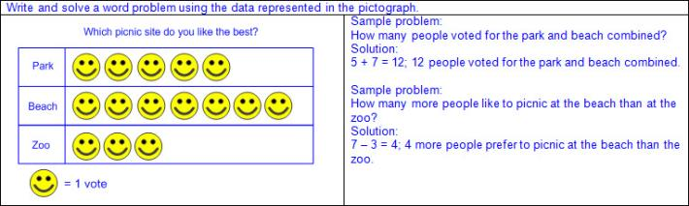  - Ex:  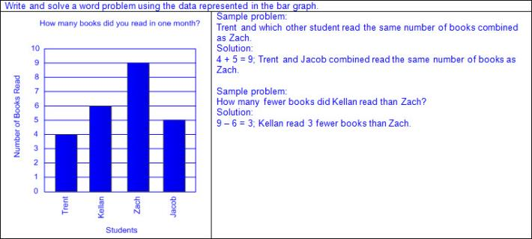  Note(s):  - Grade Level(s):  - Grade 3 will solve one- and two-step problems using categorical data represented with a frequency table, dot plot, pictograph, or bar graph with scaled intervals.  - Various mathematical process standards will be applied to this student expectation as appropriate.  - TxRCFP:  - Using place value and properties of operations to solve problems involving addition and subtraction of whole numbers within 1,000  - TxCCRS:  - VIII. Problem Solving and Reasoning  - IX. Communication and Representation  - X. Connections
2.10D | Draw conclusions and make predictions from information in a graph.  Draw conclusions and make predictions from information in a graph.  Draw  CONCLUSIONS FROM INFORMATION IN A GRAPH  Including, but not limited to:  - Graph – a visual representation of the relationships between data collected  - Organization of data used to interpret data, draw conclusions, and make comparisons  - Data – information that is collected about people, events, or objects  - Categorical data – data that represents the attributes of a group of people, events, or objects  - Factual data – actual quantities represented in a graph used to interpret data, draw conclusions, and make comparisons  - Pictograph – a graphical representation to organize data that uses a picture or symbol, where each picture or symbol may represent one or more than one unit of data, to show the frequency (number of times) that each category occurs  - Up to four categories  - Each picture or symbol represents one or more units of data.  - Bar graph – a graphical representation to organize data that uses solid bars that do not touch each other to show the frequency (number of times) that each category occurs  - Up to four categories  - Scale of the axis in intervals of one or more  - Description of data represented  - Identification of title and category labels  - Explanation of what the graph represents  - Conclusions related to the question that led to the data collection  - Numerical conclusions in the data  - Quantities represented by the data  - Number in each category represented  - Number represented in a category(s) may be zero.  - Combined total represented  - Ex:  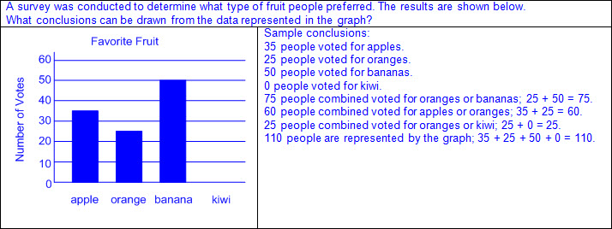  - Comparisons of data represented  - Comparative language used with numbers  - Ex: 10 more than, 25 greater than, 2 less than, 15 fewer than, etc.  - Comparative language used without numbers  - Ex: More than, less than, fewer than, the most, the least, the same as, equal to, etc.  - Ex:  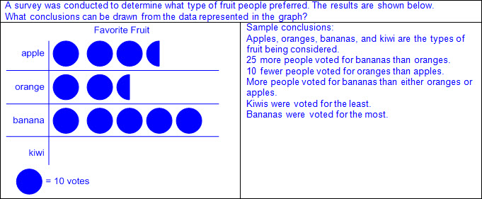  - Changes in orientation do not affect the data.  - Ex:  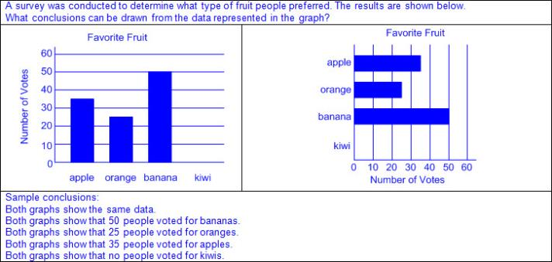  Make  PREDICTIONS FROM INFORMATION IN A GRAPH  Including, but not limited to:  - Graph – a visual representation of the relationships between data collected  - Organization of data used to interpret data, draw conclusions, and make comparisons  - Data – information that is collected about people, events, or objects  - Categorical data – data that represents the attributes of a group of people, events, or objects  - Inferential data – existing data used to make predictions about future data  - Pictograph – a graphical representation to organize data that uses a picture or symbol, where each picture or symbol may represent one or more than one unit of data, to show the frequency (number of times) that each category occurs  - Up to four categories  - Each picture or symbol represents one or more units of data.  - Bar graph – a graphical representation to organize data that uses solid bars that do not touch each other to show the frequency (number of times) that each category occurs  - Up to four categories  - Scale of the axis in intervals of one or more  - Make predictions based on patterns in the data collected.  - Ex:  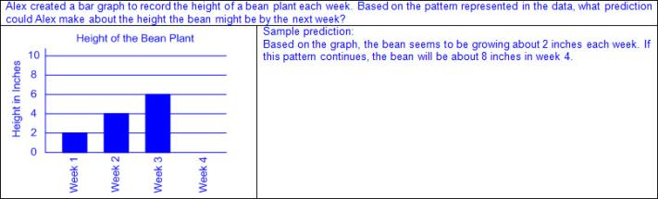  - Make predictions based on comparisons of quantities in the data collected.  - Ex:  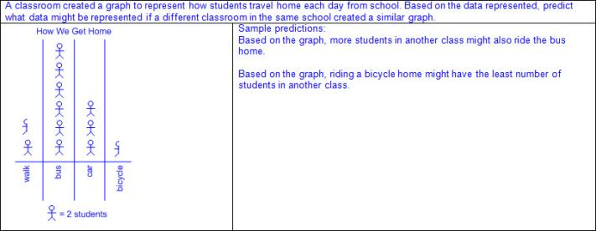  - Make predictions about future actions based on the purpose of the data collection.  - Ex:  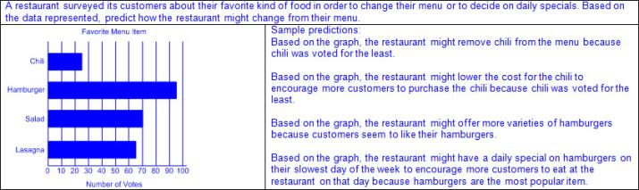  Note(s):  - Grade Level(s):  - Grade 1 drew conclusions and generated and answered questions using information from picture and bar-type graphs.  - Various mathematical process standards will be applied to this student expectation as appropriate.  - TxRCFP:  - Using place value and properties of operations to solve problems involving addition and subtraction of whole numbers within 1,000  - TxCCRS:  - IX. Communication and Representation
2.11 | Personal financial literacy. The student applies mathematical process standards to manage one's financial resources effectively for lifetime financial security. The student is expected to:
2.11A | Calculate how money saved can accumulate into a larger amount over time.  Calculate how money saved can accumulate into a larger amount over time.  Calculate  HOW MONEY SAVED CAN ACCUMULATE INTO A LARGER AMOUNT OVER TIME  Including, but not limited to:  - Saving – setting aside money earned or received for future use  - Saving can result in an increase of money over time.  - Money may be saved in a bank account, piggy bank, etc.  - Money saved in a bank account may earn interest.  - Interest earned – money received for saving money in a bank account  - Calculate savings over time.  - Relationship between saving money and addition  - Saving money is equivalent to adding money to a bank account, piggy bank, etc.  - Adding money to a bank account or piggy bank will result in a larger amount of money.  - Adding interest to a bank account will result in a larger amount of money.  - Ex:  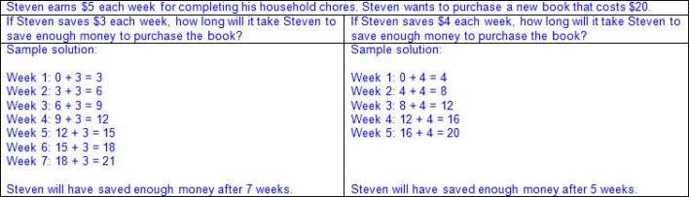  - Ex:  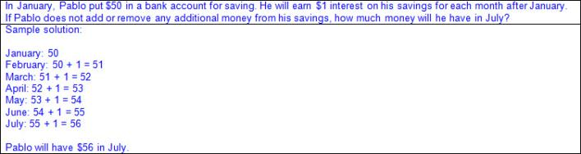  Note(s):  - Grade Level(s):  - Grade 1 distinguished between spending and saving.  - Grade 3 will list reasons to save and explain the benefit of a savings plan, including for college.  - Various mathematical process standards will be applied to this student expectation as appropriate.  - TxRCFP:  - Financial Literacy  - TxCCRS:  - I. Numeric Reasoning  - VIII. Problem Solving and Reasoning  - IX. Communication and Representation  - X. Connections
2.11B | Explain that saving is an alternative to spending.  Explain that saving is an alternative to spending.  Explain  THAT SAVING IS AN ALTERNATIVE TO SPENDING  Including, but not limited to:  - Money earned may be spent or saved.  - Spending – purchasing goods and services to satisfy wants and needs  - Spending results in a decrease in the amount of money you have.  - Saving – setting aside money earned or received for future use  - Saving results in no decrease in the amount of money you have.  - Saving may result in an increase in the amount of money you have.  - Money may be saved in a bank account, piggy bank, etc.  - Reasons for spending money earned  - Meet current wants or needs  - Charitable giving  - Reasons for saving  - Meet future wants or needs  - Earn additional money through interest  - Possibility of future income decreasing  Note(s):  - Grade Level(s):  - Grade 1 distinguished between spending and saving.  - Grade 3 will identify the costs and benefits of planned and unplanned spending decisions.  - Various mathematical process standards will be applied to this student expectation as appropriate.  - TxRCFP:  - Financial Literacy  - TxCCRS:  - IX. Communication and Representation  - X. Connections
2.11C | Distinguish between a deposit and a withdrawal.  Distinguish between a deposit and a withdrawal.  Distinguish  BETWEEN A DEPOSIT AND A WITHDRAWAL  Including, but not limited to:  - Money may be stored in a bank account.  - Checking account usually used for frequent transactions  - Savings account usually used for less frequent transactions or for earning interest  - Terminology for bank transactions  - Deposit – money put into an account  - Add to previous balance  - Withdrawal – money taken out of an account  - Subtract from previous balance  - Balance – the amount of money that is in a bank account after a deposit or withdrawal  - New total after adding or subtracting  - Distinguish between a deposit and a withdrawal in mathematical and real-world problem situations.  - Ex:  - Ex:  - Ex:  - Ex:  Note(s):  - Grade Level(s):  - Grade 2 introduces distinguishing between a deposit and a withdrawal.  - Various mathematical process standards will be applied to this student expectation as appropriate.  - TxRCFP:  - Financial Literacy  - TxCCRS:  - IX. Communication and Representation  - X. Connections
2.11D | Identify examples of borrowing and distinguish between responsible and irresponsible borrowing.  Identify examples of borrowing and distinguish between responsible and irresponsible borrowing.  Identify  EXAMPLES OF BORROWING  Including, but not limited to:  - Borrowing – receiving money or goods now that will be returned or paid for in the future  - Examples of borrowing in mathematical and real-world problem situations (e.g., borrowing money, borrowing property or goods, etc.)  - Ex: Borrowing money from a friend and paying the money back in a month.  - Ex: Borrowing your sister’s shirt and returning it when you are finished wearing it.  Distinguish  BETWEEN RESPONSIBLE AND IRRESPONSIBLE BORROWING  Including, but not limited to:  - Borrowing – receiving money or goods now that will be returned or paid for in the future  - Responsible borrowing  - Borrowing only the amount of money you will be able to repay in a given time period  - Maintaining the care of borrowed goods until they are returned  - Irresponsible borrowing  - Borrowing more than you can pay back in a given time period  - Not maintaining the care of borrowed goods until they are returned  - Distinguish between responsible and irresponsible borrowing in mathematical and real-world problem situations.  - Ex:  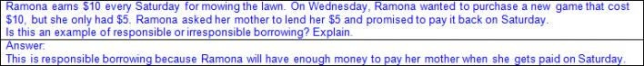  - Ex:  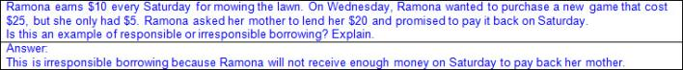  Note(s):  - Grade Level(s):  - Grade 3 will explain that credit is used when wants or needs exceed the ability to pay and that it is the borrower's responsibility to pay it back to the lender, usually with interest.  - Various mathematical process standards will be applied to this student expectation as appropriate.  - TxRCFP:  - Financial Literacy  - TxCCRS:  - IX. Communication and Representation  - X. Connections
2.11E | Identify examples of lending and use concepts of benefits and costs to evaluate lending decisions.  Identify examples of lending and use concepts of benefits and costs to evaluate lending decisions.  Identify  EXAMPLES OF LENDING  Including, but not limited to:  - Lending – providing others with money or goods now that will be returned or paid back in the future  - Examples of lending in mathematical and real-world problem situations (e.g., lending money, lending property or goods, etc.)  - Ex: Lending money to a friend with the expectation that they will repay the money in a month.  - Ex: Allowing your friend to borrow your bicycle until they can get theirs fixed.  Use  CONCEPTS OF BENEFITS AND COSTS TO EVALUATE LENDING DECISIONS  Including, but not limited to:  - Lending – providing others with money or goods now that will be returned or paid back in the future  - Benefits of lending  - Helping others  - Developing a new relationship  - Possible interest earned  - Costs or risks of lending  - Borrower not paying the money back  - Borrower damaging or losing goods loaned  - Ruining a relationship  - Not having enough money for your own future needs  - Considerations prior to lending money or goods  - Benefits vs. costs or risks  - Ex: Do you have enough money to lend while still meeting your own needs or wants?  - Ex: How will it affect you if the money or goods are not returned?  - Ex: Is the borrower a responsible person?  - Evaluate real-world lending decisions.  - Ex:  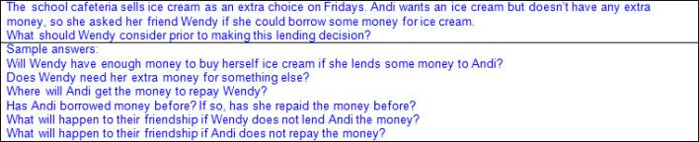  - Ex:  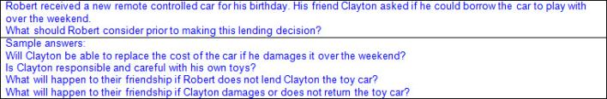  Note(s):  - Grade Level(s):  - Grade 2 introduces identifying examples of lending and using concepts of benefits and costs to evaluate lending decisions.  - Various mathematical process standards will be applied to this student expectation as appropriate.  - TxRCFP:  - Financial Literacy  - TxCCRS:  - IX. Communication and Representation  - X. Connections
2.11F | Differentiate between producers and consumers and calculate the cost to produce a simple item.  Differentiate between producers and consumers and calculate the cost to produce a simple item.  Differentiate  BETWEEN PRODUCERS AND CONSUMERS  Including, but not limited to:  - Producers – people who make goods or provide services  - Consumers – people who buy goods and services  - Differentiate between producers and consumers.  - People can be both producers and consumers.  - Ex: A shoe factory is a producer when they make shoes to sell, but is a consumer when they purchase the leather needed to make the shoes.  - Ex: A policeman is a producer when he is providing security at the football game, but is a consumer when he pays to watch his son play football.  Calculate  THE COST TO PRODUCE A SIMPLE ITEM  Including, but not limited to:  - Produce – to manufacture or create goods or provide services  - Costs of production  - Materials  - Labor  - Calculate the cost to produce a simple item.  - Add all costs of production.  - Ex:  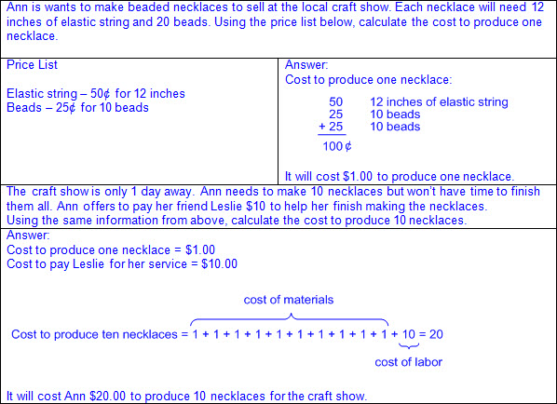  Note(s):  - Grade Level(s):  - Grade 2 introduces differentiating between producers and consumers and calculating the cost to produce a simple item.  - Grade 3 will describe the relationship between the availability or scarcity of resources and how that impacts cost.  - Various mathematical process standards will be applied to this student expectation as appropriate.  - TxRCFP:  - Financial Literacy  - TxCCRS:  - IX. Communication and Representation  - X. Connections
Bibliography:
Texas Education Agency & Texas Higher Education Coordinating Board. (2009). Texas college and career readiness standards. Retrieved from http://www.thecb.state.tx.us/collegereadiness/crs.pdf

Texas Education Agency. (2013). Introduction to the revised mathematics TEKS – kindergarten-algebra I vertical alignment. Retrieved from
http://www.projectsharetexas.org/sites/default/files/resources/documents/K-AlgebraIVAChart.pdf

Texas Education Agency. (2013). Texas response to curriculum focal points for kindergarten through grade 8 mathematics. Retrieved from
http://projectsharetexas.org/resource/txrcfp-texas-response-curriculum-focal-points-k-8-mathematics-revised-2013
Bold black text in italics: Knowledge and Skills Statement (TEKS); Bold black text: Student Expectation (TEKS)
Blue text: Supporting information / Clarifications from TCMPC (Specificity)
Black text: Texas Education Agency (TEA); Texas College and Career Readiness Standards (TxCCRS)

